Supplementary Figure S1
Caption. Representative Example of the Velocity-Based Event-Detection Procedure.
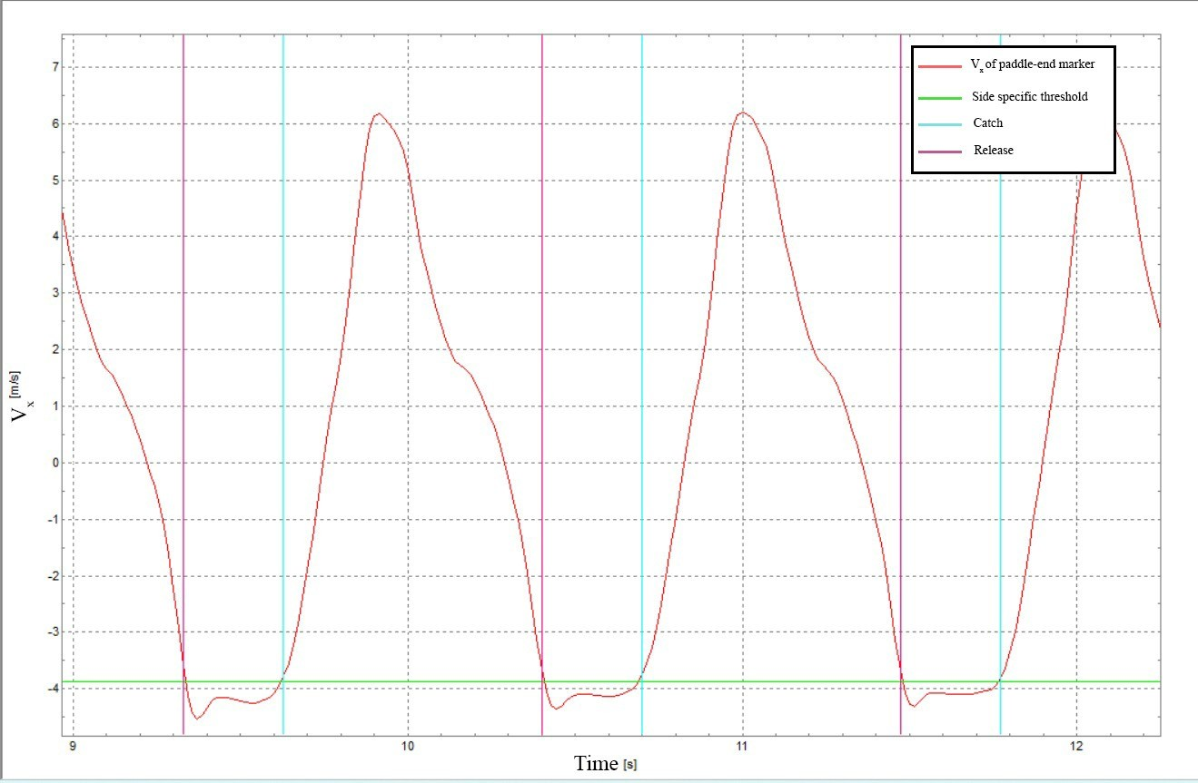 The red curve represents the anteroposterior velocity component (vₓ) of the right paddle-end marker over time. The horizontal green line indicates the side-specific threshold used to identify the pull phase. Vertical magenta lines indicate catch events, defined as the last sample immediately before vₓ crossed below the threshold. Vertical cyan lines indicate release events, defined as the first sample immediately after vₓ crossed back above the threshold.

