Additional file 1
Childhood Immunization Coverage in Primary Care in Sakarya Province, Türkiye: A Multilevel and Spatial Analysis at the Service-Delivery-Unit and District Level
This document is the online supplementary material for the main article and contains the tables and figures referenced as S1–S6 in the main text. This file contains no separate reference list; all references are listed in the main article.
Abbreviations used throughout: FMU, family medicine unit; FHC, family health centre; TC, total coverage; TiC, timely coverage; OS, off-schedule administration; SD, standard deviation; ICC, intraclass correlation coefficient; R²m, marginal R²; R²c, conditional R²; LRT, likelihood-ratio test. Vaccine-dose units: BCG (Bacille Calmette-Guérin); HepA (hepatitis A); MMR (measles–mumps–rubella); PCV (pneumococcal conjugate vaccine); VAR (varicella).

S1. Detailed descriptive statistics of the coverage measures
Table S1a. Total coverage (TC) — distribution across FMU-months
Unit | n | Valid | Mean | SD | Median | Q1 | Q3 | ≥95% | Pooled
BCG dose 1 | 7,865 | 7,143 | 0.937 | 0.169 | 1.000 | 1.000 | 1.000 | 0.826 | 0.938
HepA dose 1 | 7,869 | 7,167 | 0.914 | 0.191 | 1.000 | 1.000 | 1.000 | 0.761 | 0.913
HepA dose 2 | 7,869 | 7,222 | 0.908 | 0.192 | 1.000 | 0.875 | 1.000 | 0.739 | 0.906
MMR dose 1 | 7,869 | 7,163 | 0.925 | 0.179 | 1.000 | 1.000 | 1.000 | 0.792 | 0.925
MMR dose 2 | 7,869 | 7,381 | 0.902 | 0.194 | 1.000 | 0.833 | 1.000 | 0.713 | 0.902
PCV dose 1 | 7,865 | 7,152 | 0.936 | 0.171 | 1.000 | 1.000 | 1.000 | 0.825 | 0.938
PCV dose 2 | 7,869 | 7,134 | 0.931 | 0.175 | 1.000 | 1.000 | 1.000 | 0.810 | 0.932
PCV booster | 7,869 | 7,159 | 0.923 | 0.182 | 1.000 | 1.000 | 1.000 | 0.785 | 0.923
VAR dose 1 | 7,869 | 7,157 | 0.924 | 0.181 | 1.000 | 1.000 | 1.000 | 0.788 | 0.924
Table S1b. Timely coverage (TiC) — distribution across FMU-months
Unit | n | Valid | Mean | SD | Median | Q1 | Q3 | ≥95% | Pooled
BCG dose 1 | 7,865 | 7,143 | 0.933 | 0.173 | 1.000 | 1.000 | 1.000 | 0.826 | 0.934
HepA dose 1 | 7,869 | 7,167 | 0.907 | 0.199 | 1.000 | 0.889 | 1.000 | 0.761 | 0.906
HepA dose 2 | 7,869 | 7,222 | 0.900 | 0.200 | 1.000 | 0.857 | 1.000 | 0.739 | 0.898
MMR dose 1 | 7,869 | 7,163 | 0.919 | 0.186 | 1.000 | 1.000 | 1.000 | 0.792 | 0.919
MMR dose 2 | 7,869 | 7,381 | 0.890 | 0.205 | 1.000 | 0.818 | 1.000 | 0.713 | 0.891
PCV dose 1 | 7,865 | 7,152 | 0.932 | 0.175 | 1.000 | 1.000 | 1.000 | 0.825 | 0.934
PCV dose 2 | 7,869 | 7,134 | 0.927 | 0.179 | 1.000 | 1.000 | 1.000 | 0.810 | 0.928
PCV booster | 7,869 | 7,159 | 0.918 | 0.186 | 1.000 | 1.000 | 1.000 | 0.785 | 0.918
VAR dose 1 | 7,869 | 7,157 | 0.918 | 0.187 | 1.000 | 1.000 | 1.000 | 0.788 | 0.918
Table S1c. Off-schedule administration (OS) — distribution across FMU-months
Unit | n | Valid | Mean | SD | Median | Q1 | Q3 | Pooled
BCG dose 1 | 7,865 | 7,033 | 0.004 | 0.044 | 0.000 | 0.000 | 0.000 | 0.005
HepA dose 1 | 7,869 | 7,023 | 0.008 | 0.066 | 0.000 | 0.000 | 0.000 | 0.008
HepA dose 2 | 7,869 | 7,093 | 0.009 | 0.066 | 0.000 | 0.000 | 0.000 | 0.009
MMR dose 1 | 7,869 | 7,046 | 0.007 | 0.058 | 0.000 | 0.000 | 0.000 | 0.007
MMR dose 2 | 7,869 | 7,247 | 0.013 | 0.081 | 0.000 | 0.000 | 0.000 | 0.012
PCV dose 1 | 7,865 | 7,038 | 0.004 | 0.042 | 0.000 | 0.000 | 0.000 | 0.004
PCV dose 2 | 7,869 | 7,021 | 0.004 | 0.041 | 0.000 | 0.000 | 0.000 | 0.004
PCV booster | 7,869 | 7,036 | 0.005 | 0.047 | 0.000 | 0.000 | 0.000 | 0.006
VAR dose 1 | 7,869 | 7,035 | 0.006 | 0.055 | 0.000 | 0.000 | 0.000 | 0.007
Note. n, total FMU-months; Valid, FMU-months with a defined (>0) denominator. Mean, SD, median, Q1 and Q3 are computed over FMU-month proportions; Pooled = Σ administered / Σ due. The ≥95% column does not apply to the OS measure.

S2. Model fit and variance structure (mixed-model diagnostics)
Each row summarises one generalised linear mixed model. Variances are the variance components of the random intercepts; ICC is the between-level share of variance (total); marginal R² is the variance explained by the fixed effects and conditional R² by the fixed plus random effects (Nakagawa and Schielzeth). AIC and logLik are fit measures; the LRT is the likelihood-ratio test of the full model against the null model (χ² with 12 df; asterisks: * p < 0.05; ** p < 0.01; *** p < 0.001). The reference distribution family is indicated for every model.
Table S2a. Total coverage (TC) models — fit and variance structure
Unit | Family | n | Var(FMU) | Var(FHC) | ICC | R²m | R²c | AIC | logLik | LRT χ²(12)
BCG dose 1 | Binomial | 7,143 | 0.109 | 0.019 | 0.037 | 0.033 | — | 7,133 | −3,550 | 26.0*
HepA dose 1 | Binomial | 7,167 | 0.087 | 0.048 | 0.039 | 0.049 | — | 8,987 | −4,478 | 34.6*
HepA dose 2 | Binomial | 7,222 | 0.088 | 0.058 | 0.043 | 0.035 | 0.162 | 9,562 | −4,765 | 20.8
MMR dose 1 | Binomial | 7,163 | 0.087 | 0.040 | 0.037 | 0.043 | — | 8,107 | −4,038 | 30.1
MMR dose 2 | Binomial | 7,381 | 0.061 | 0.082 | 0.042 | 0.030 | — | 10,452 | −5,210 | 28.2
PCV dose 1 | Binomial | 7,152 | 0.132 | 0.017 | 0.043 | 0.035 | — | 7,201 | −3,584 | 29.0
PCV dose 2 | Binomial | 7,134 | 0.108 | 0.030 | 0.040 | 0.047 | — | 7,554 | −3,761 | 33.4*
PCV booster | Binomial | 7,159 | 0.085 | 0.038 | 0.036 | 0.043 | — | 8,241 | −4,104 | 34.4*
VAR dose 1 | Beta-binomial | 7,157 | 0.076 | 0.031 | 0.032 | —ᵃ | — | 8,220 | −4,093 | 34.9*
All (pooled) | Binomial | 64,678 | 0.214 | 0.064 | 0.086 | 0.031 | 0.261 | 73,527 | −36,747 | 65.6*
Table S2b. Timely coverage (TiC) models — fit and variance structure
Unit | Family | n | Var(FMU) | Var(FHC) | ICC | R²m | R²c | AIC | logLik | LRT χ²(12)
BCG dose 1 | Binomial | 7,143 | 0.111 | 0.014 | 0.036 | 0.032 | — | 7,431 | −3,700 | 26.6
HepA dose 1 | Binomial | 7,167 | 0.085 | 0.046 | 0.038 | 0.044 | — | 9,469 | −4,718 | 31.4
HepA dose 2 | Binomial | 7,222 | 0.099 | 0.054 | 0.044 | 0.039 | — | 10,014 | −4,991 | 20.2
MMR dose 1 | Binomial | 7,163 | 0.102 | 0.035 | 0.040 | 0.041 | — | 8,531 | −4,249 | 29.3
MMR dose 2 | Binomial | 7,381 | 0.060 | 0.097 | 0.046 | 0.028 | 0.172 | 11,058 | −5,513 | 33.1*
PCV dose 1 | Binomial | 7,152 | 0.116 | 0.018 | 0.039 | 0.034 | — | 7,466 | −3,717 | 28.3
PCV dose 2 | Binomial | 7,134 | 0.104 | 0.033 | 0.040 | 0.045 | — | 7,796 | −3,882 | 30.9
PCV booster | Binomial | 7,159 | 0.096 | 0.034 | 0.038 | 0.043 | — | 8,558 | −4,263 | 32.0
VAR dose 1 | Binomial | 7,157 | 0.100 | 0.027 | 0.037 | 0.043 | — | 8,592 | −4,280 | 32.6
All (pooled) | Binomial | 64,678 | 0.193 | 0.059 | 0.081 | 0.031 | 0.249 | 77,045 | −38,506 | 53.5*
Table S2c. Off-schedule administration (OS) models — fit and variance structure
Unit | Family | n | Var(FMU) | Var(FHC) | ICC | R²m | R²c | AIC | logLik | LRT χ²(12)
BCG dose 1 | Beta-binomial | 7,033 | 1.014 | 0.000 | 0.236 | —ᵃ | — | 990 | −478 | 12.2
HepA dose 1 | Beta-binomial | 7,023 | 0.487 | 0.000 | 0.129 | —ᵃ | — | 1,578 | −772 | 22.1*
HepA dose 2 | Beta-binomial | 7,093 | 0.407 | 0.488 | 0.214 | —ᵃ | — | 1,699 | −833 | 9.2
MMR dose 1 | Beta-binomial | 7,046 | 0.073 | 0.000 | 0.022 | —ᵃ | — | 1,454 | −710 | 18.8
MMR dose 2 | Beta-binomial | 7,247 | 0.221 | 0.350 | 0.148 | —ᵃ | — | 2,303 | −1,134 | 25.7*
PCV dose 1 | Beta-binomial | 7,038 | 0.000 | 0.000 | 0.000 | —ᵃ | — | 910 | −438 | 19.1
PCV dose 2 | Binomial | 7,021 | 1.002 | 0.000 | 0.233 | —ᵃ | — | 892 | −430 | 17.0
PCV booster | Beta-binomial | 7,036 | 0.161 | 0.000 | 0.047 | —ᵃ | — | 1,218 | −592 | 17.3
VAR dose 1 | Beta-binomial | 7,035 | 0.555 | 0.000 | 0.144 | —ᵃ | — | 1,329 | −648 | 17.5
All (pooled) | Binomial | 63,572 | 0.536 | 0.171 | 0.201 | 0.048 | 0.465 | 12,056 | −6,011 | 54.5*
Note. Var(FMU), variance of the district/FHC/FMU nested intercept; Var(FHC), variance of the district/FHC intercept. ᵃ The Nakagawa marginal R² is not reported for beta-binomial fits (and for the strongly zero-weighted off-schedule distributions), because it cannot be reliably defined; for these models explanatory power should be assessed via the ICC and LRT. Conditional R² is given only for models in which it could be computed. The district-level variance was ≈0 (boundary) in all models and is therefore not shown separately in the table.

S3. Spatial autocorrelation and local clustering (primary, k = 3)
Table S3. Global Moran’s I and LISA cluster counts by vaccine-dose unit (k = 3)
Unit | Moran’s I | p | LL | HH | HL | LH | Isolation r
BCG dose 1 | −0.061 | 0.747 | 2 | 0 | 2 | 1 | 0.125
HepA dose 1 | 0.102 | 0.063 | 2 | 4 | 1 | 2 | 0.136
HepA dose 2 | 0.150 | 0.013* | 0 | 3 | 4 | 2 | 0.214
MMR dose 1 | 0.073 | 0.121 | 2 | 0 | 2 | 2 | 0.147
MMR dose 2 | −0.013 | 0.495 | 1 | 0 | 4 | 0 | 0.197
PCV dose 1 | −0.045 | 0.689 | 2 | 0 | 1 | 2 | 0.121
PCV dose 2 | 0.030 | 0.290 | 1 | 2 | 2 | 4 | 0.175
PCV booster | 0.056 | 0.209 | 1 | 0 | 2 | 2 | 0.176
VAR dose 1 | 0.085 | 0.092 | 2 | 1 | 2 | 2 | 0.154
All (pooled) | 0.066 | 0.137 | 0 | 0 | 3 | 3 | 0.190
Note. Moran’s I, Monte Carlo test with 999 permutations; * p < 0.05. LL, low–low (cold spot); HH, high–high (hot spot); HL, high–low; LH, low–high local cluster counts (LISA, α = 0.05). Isolation r, Pearson correlation between isolation and coverage.

S4. Sensitivity to the neighbourhood definition (k = 3 / k = 4 / k = 5)
Table S4. Sensitivity of global Moran’s I to the number of neighbours
Unit | k=3 I | k=3 p | k=4 I | k=4 p | k=5 I | k=5 p | Significance
BCG dose 1 | −0.061 | 0.747 | −0.048 | 0.710 | −0.034 | 0.625 | Not significant in any
HepA dose 1 | 0.102 | 0.063 | 0.075 | 0.111 | 0.092 | 0.050 | Not significant in any
HepA dose 2 | 0.150 | 0.013* | 0.123 | 0.024* | 0.149 | 0.005* | Significant in all three
MMR dose 1 | 0.073 | 0.121 | 0.052 | 0.163 | 0.079 | 0.073 | Not significant in any
MMR dose 2 | −0.013 | 0.495 | −0.006 | 0.451 | −0.016 | 0.517 | Not significant in any
PCV dose 1 | −0.045 | 0.689 | −0.028 | 0.589 | −0.031 | 0.610 | Not significant in any
PCV dose 2 | 0.030 | 0.290 | 0.040 | 0.194 | 0.030 | 0.223 | Not significant in any
PCV booster | 0.056 | 0.209 | 0.037 | 0.198 | 0.067 | 0.100 | Not significant in any
VAR dose 1 | 0.085 | 0.092 | 0.061 | 0.132 | 0.090 | 0.047* | Significant at k=5 only
All (pooled) | 0.066 | 0.137 | — | — | 0.070 | 0.086 | Not significant in any
Note. The primary analysis uses k = 3; k = 4 and k = 5 are sensitivity measures. * p < 0.05. For the pooled analysis, k = 4 was not computed (—). HepA dose 2 is significant under all three neighbourhood definitions; HepA dose 1 and VAR dose 1 are significant only at k = 5.

S5. Selection of the model distribution family
Table S5. Reference distribution family by unit and response variable
Unit | TC | TiC | OS
BCG dose 1 | Binomial | Binomial | Beta-binomial
HepA dose 1 | Binomial | Binomial | Beta-binomial
HepA dose 2 | Binomial | Binomial | Beta-binomial
MMR dose 1 | Binomial | Binomial | Beta-binomial
MMR dose 2 | Binomial | Binomial | Beta-binomial
PCV dose 1 | Binomial | Binomial | Beta-binomial
PCV dose 2 | Binomial | Binomial | Binomial
PCV booster | Binomial | Binomial | Beta-binomial
VAR dose 1 | Beta-binomial | Binomial | Beta-binomial
All (pooled) | Binomial | Binomial | Binomial
Note. The reference family was selected on the basis of overdispersion diagnostics: when overdispersion was detected under the binomial model, a beta-binomial model was tried; when overdispersion persisted under the beta-binomial model as well, the binomial model was taken as the reference (see Methods).

S6. Supporting figures

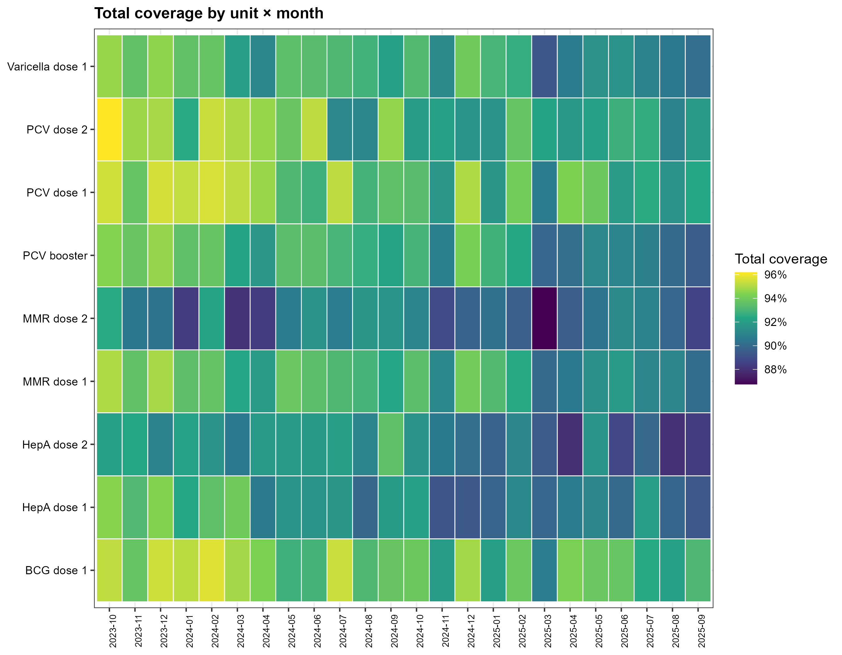
Figure S1. Heatmap of total coverage by unit × month
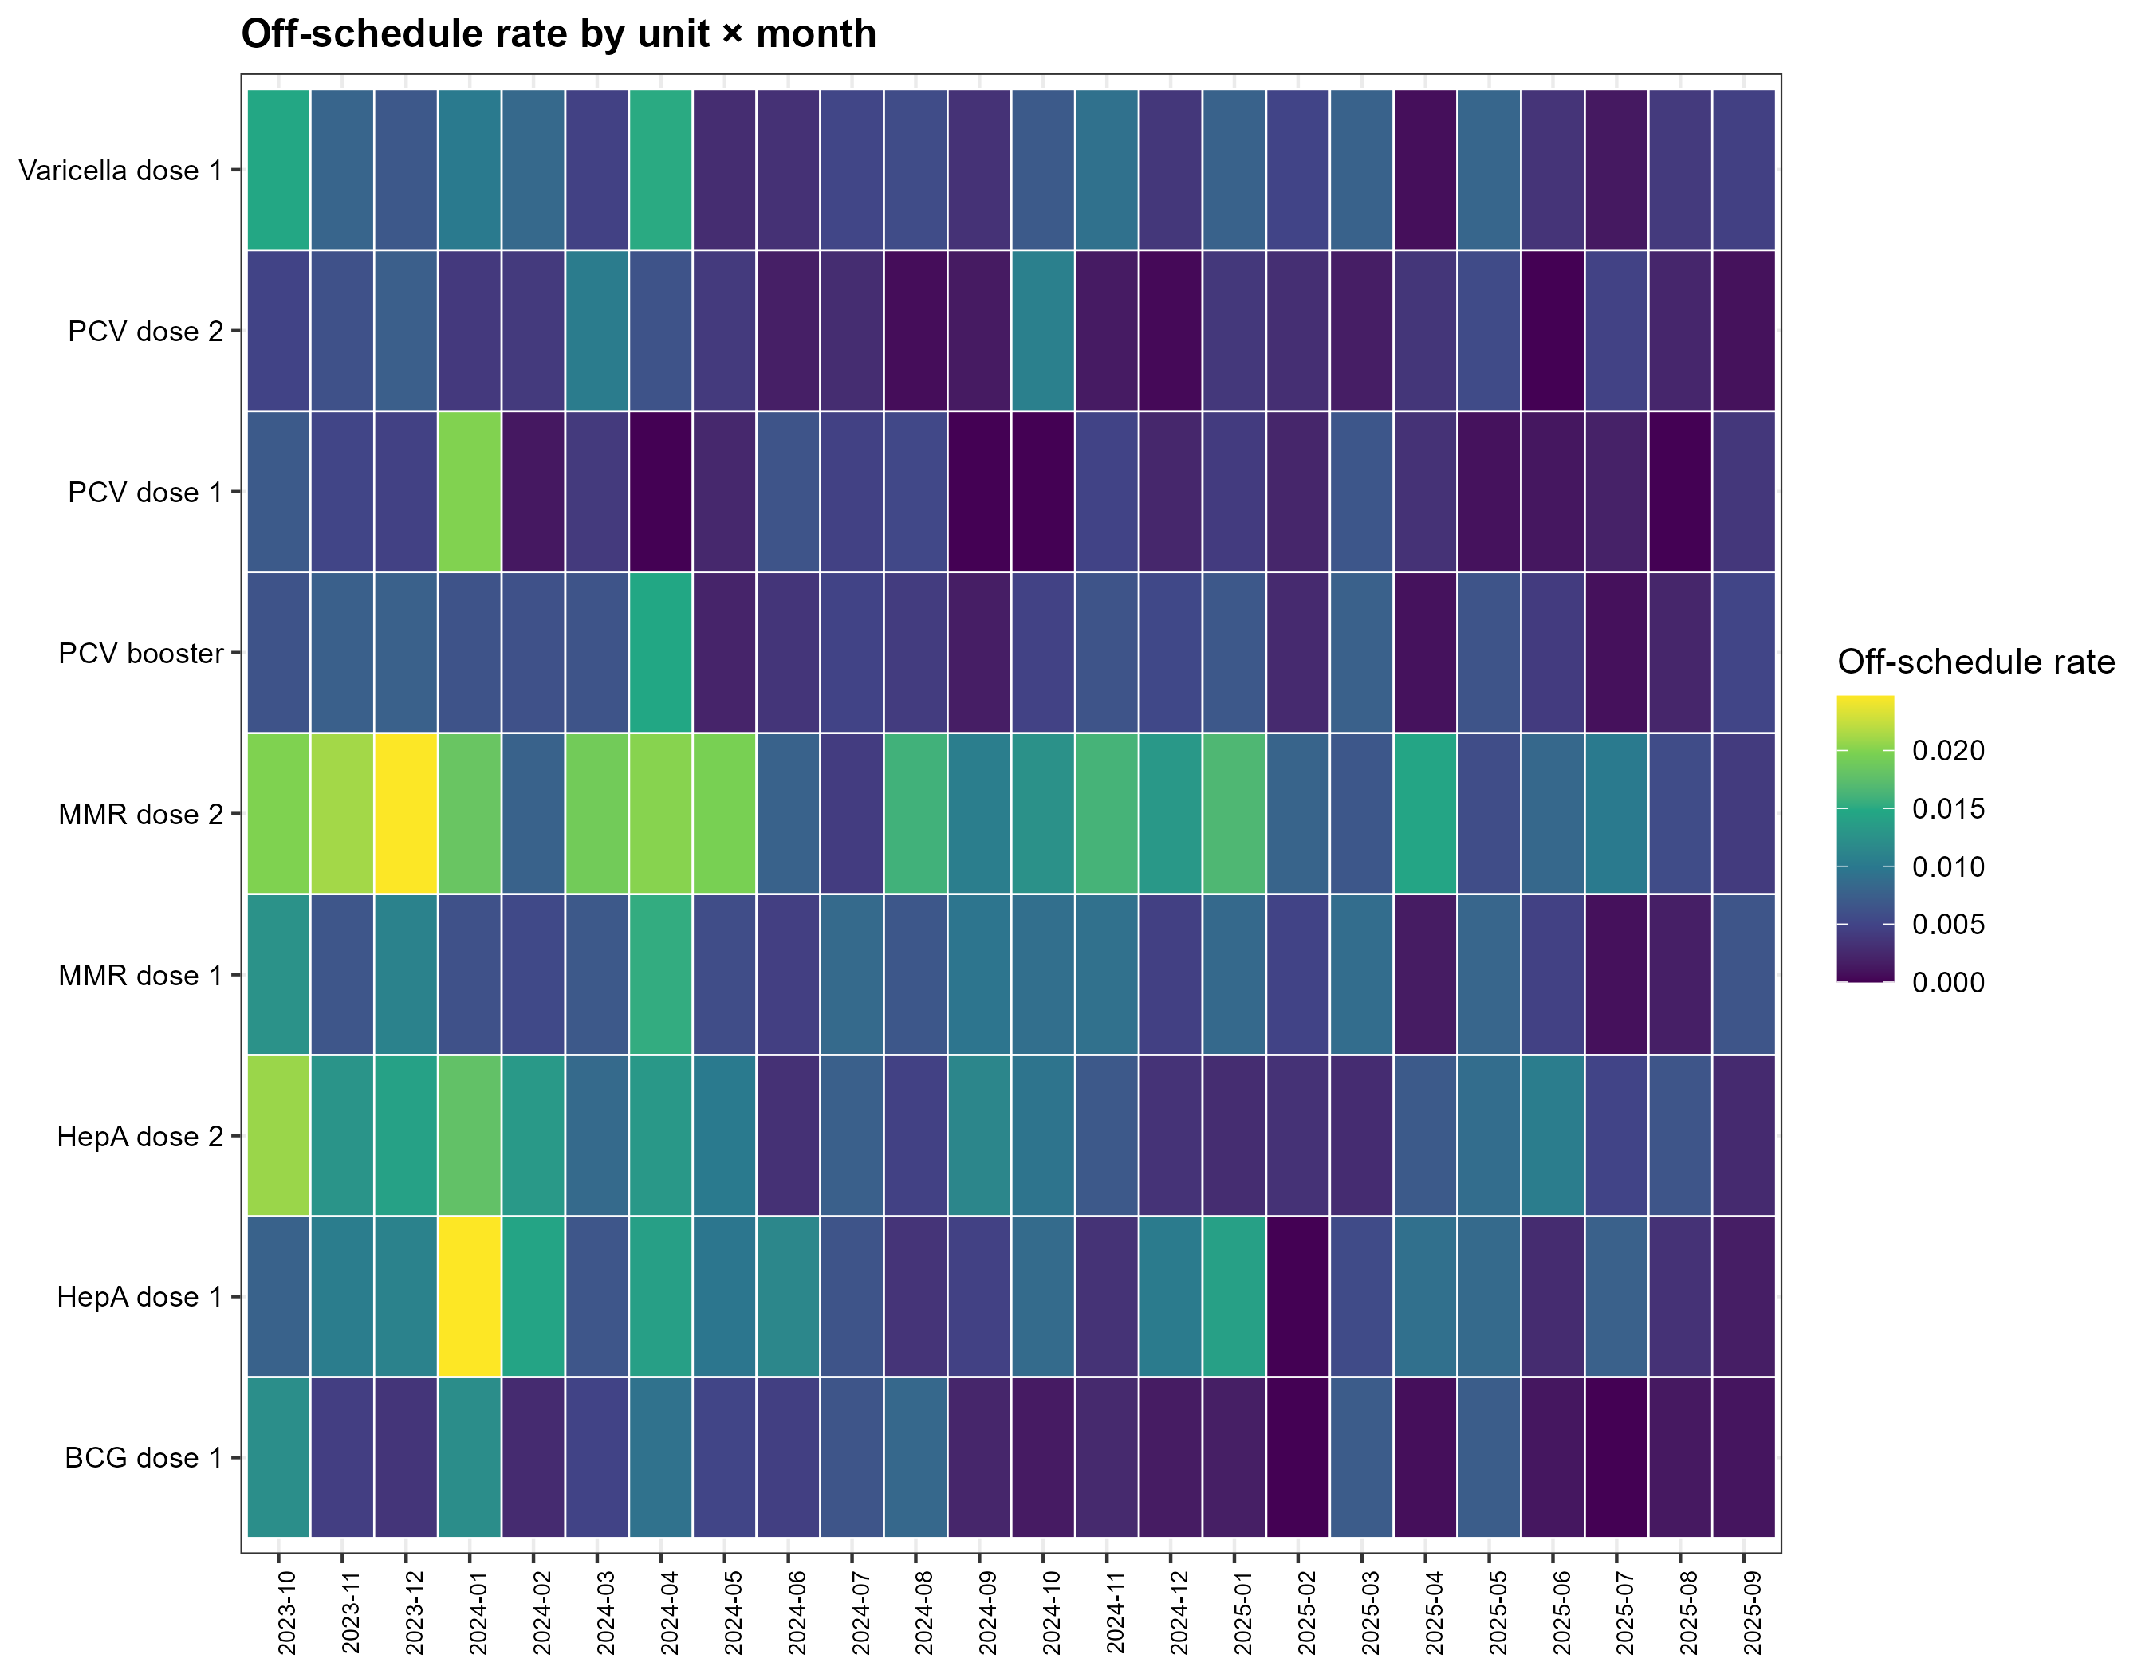
Figure S2. Heatmap of off-schedule administration by unit × month
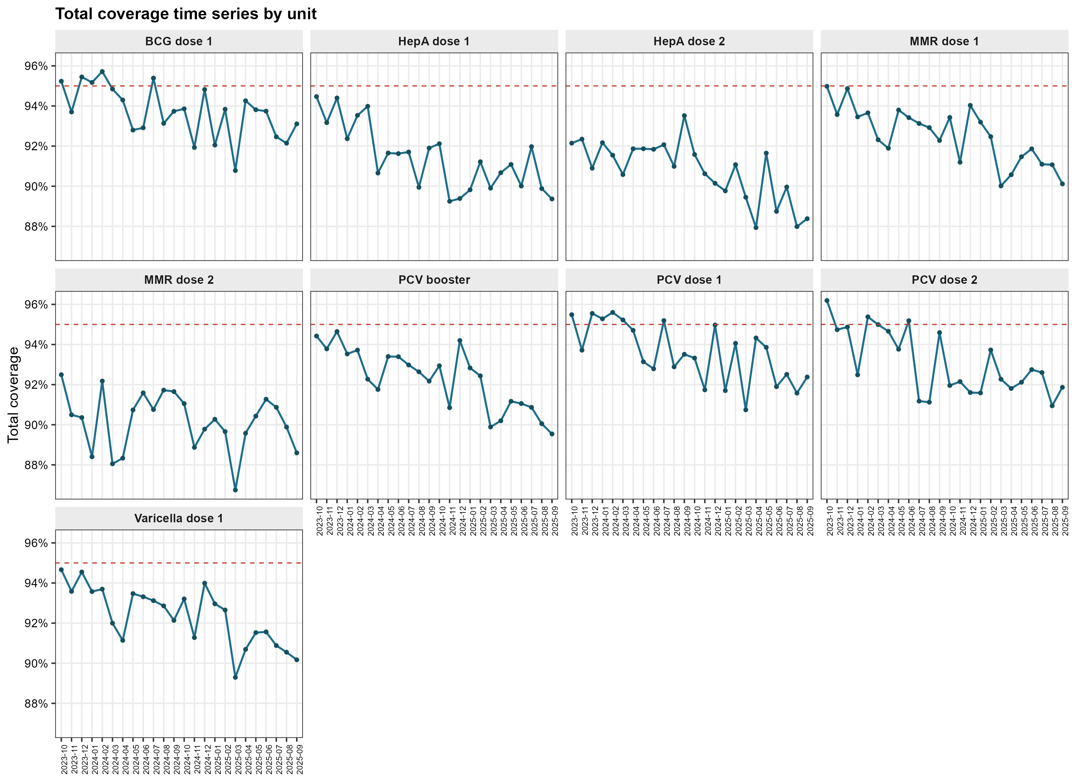
Figure S3. Monthly trajectory of total coverage by unit

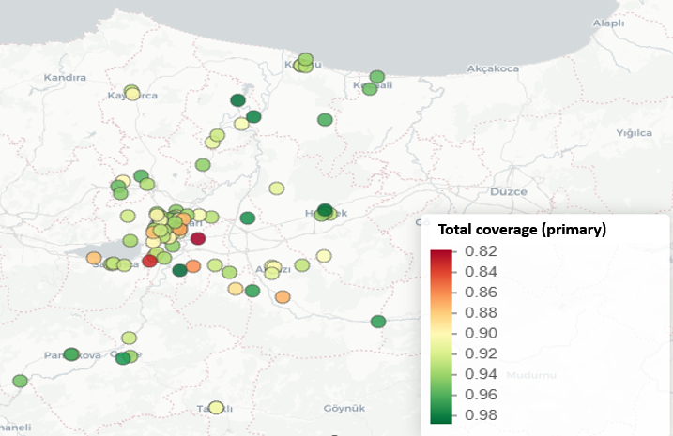
Figure S4. Global Moran scatterplot for pooled coverage (k = 3)
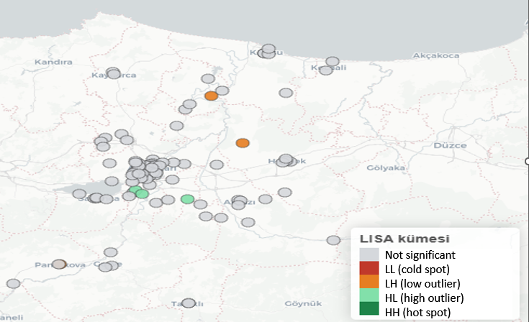
Figure S5. LISA clusters for pooled coverage (k = 3)
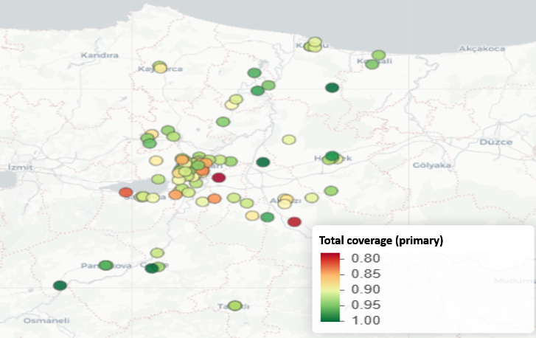

Figure S6. Global Moran scatterplot for HepA dose 2 (k = 3)

