Supplementary Material
Biophysical Multiscale Integration Model II (BMIM II): Multiplicative Gain, Cognitive Phase Transitions, and the Thermodynamic Landscape of Thought
Francisco Dominguez Jones
Hospital Universitario de Tortosa Verge de la Cinta, Tortosa, Spain

Supplementary Figure S1. Graphical Abstract

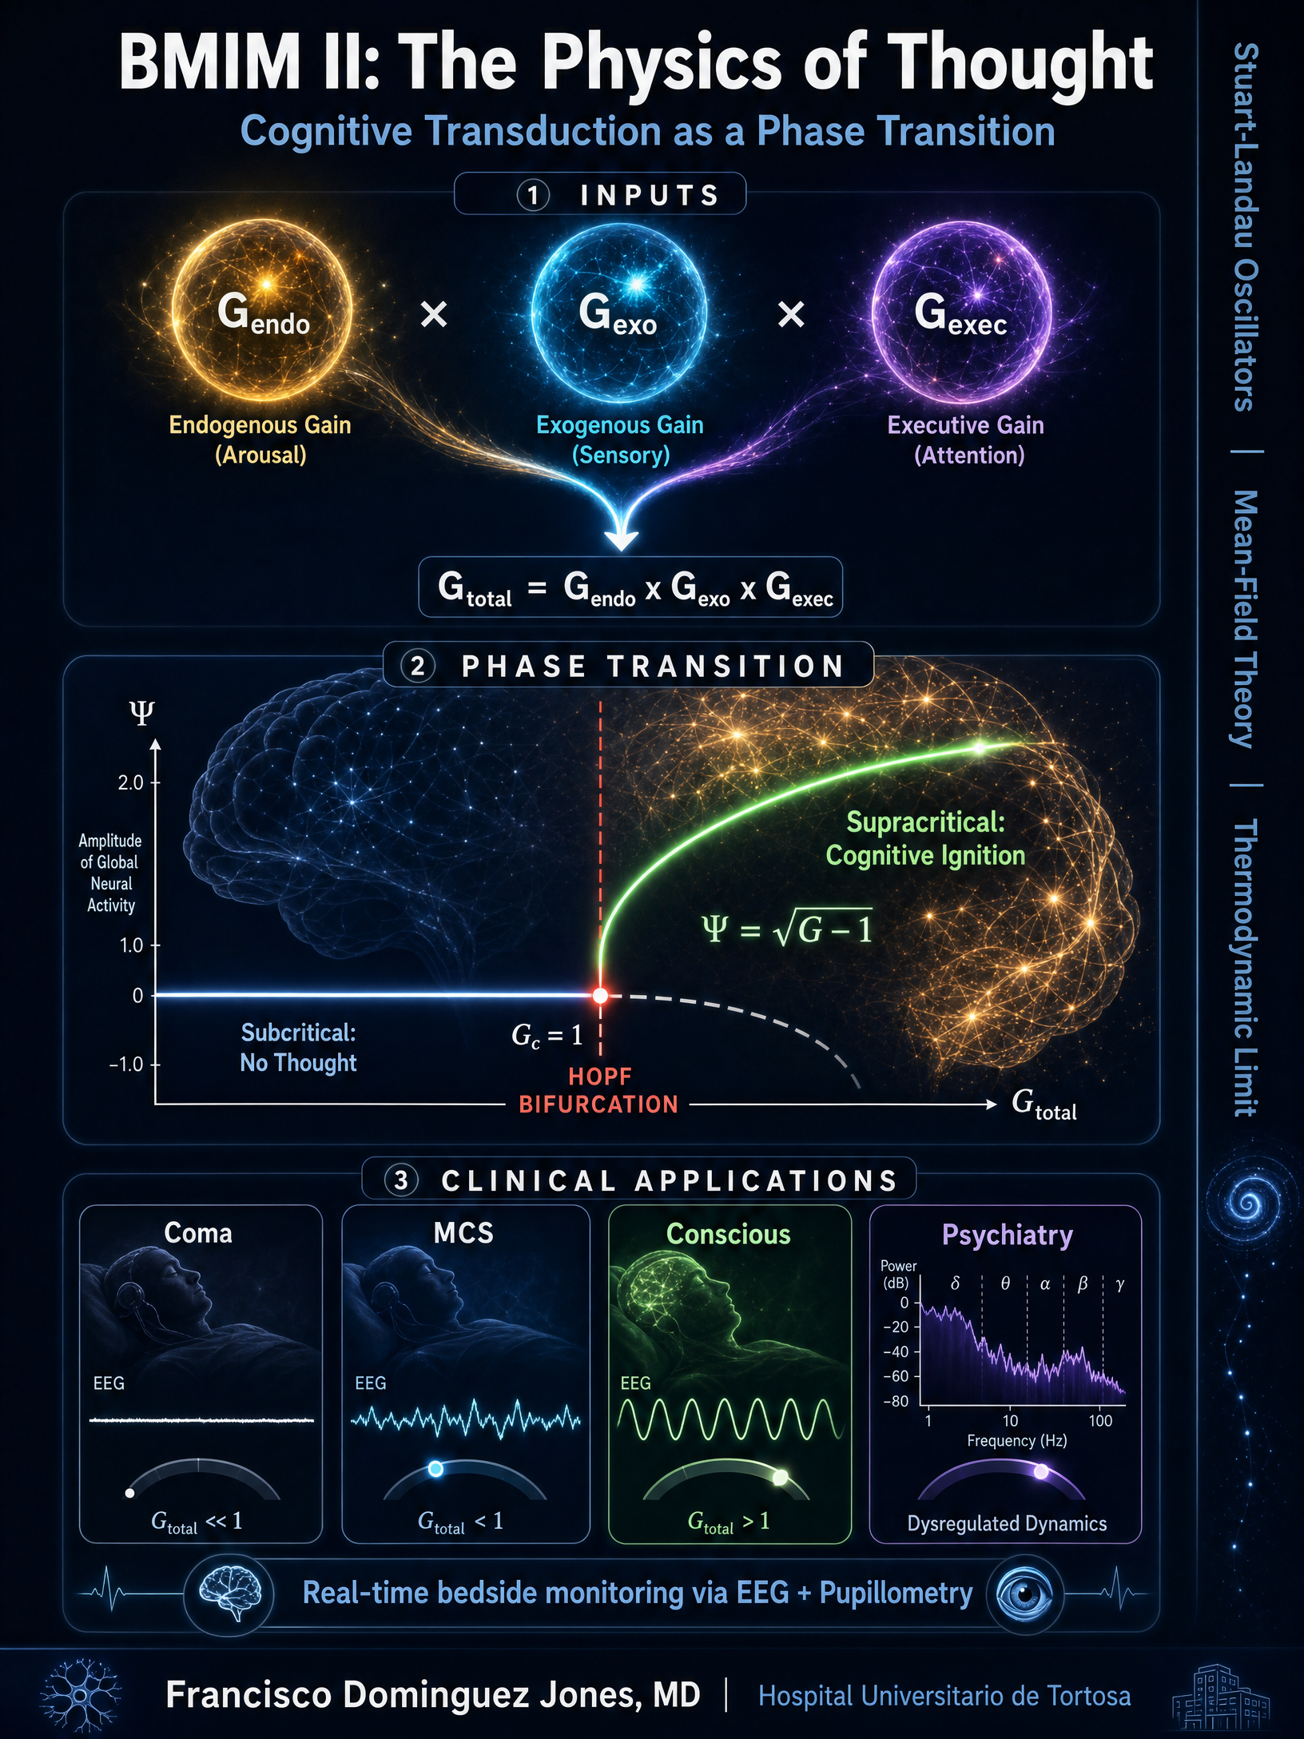


Supplementary Figure S1. Graphical summary of the BMIM II framework. This figure provides a comprehensive visual overview of the Biophysical Multiscale Integration Model II. The diagram is organized into three hierarchical levels. Top panel (INPUTS): The three multiplicative gain channels—Endogenous Gain ( G endo , derived from the Ascending Reticular Activating System via EEG alpha/theta ratio), Exogenous Gain (
G exo , derived from the Locus Coeruleus-Norepinephrine system via infrared pupillometry), and Executive Gain ( G exec , derived from the Frontoparietal Network via gamma synchronization)—converge multiplicatively to yield G total​ = G endo​ ×G exo​ ×G exec . Middle panel (PHASE TRANSITION): The supercritical Hopf bifurcation diagram showing the emergence of the macroscopic order parameter Ψ = G total
​ −1 when the total gain exceeds the critical threshold G c​ = 1 . The Stuart-Landau oscillator equation governs the dynamics. Bottom panel (CLINICAL APPLICATIONS): The four principal clinical states mapped onto the gain landscape—Coma ( G total​ ≪1 ), Minimally Conscious State ( G total​ ≈0.45–1.10, encompassing MCS minus through MCS plus ), full Consciousness ( G total​ > 1 ), and pathological hypersynchronization in Epilepsy ( G total​ ≫1 )—with their corresponding EEG signatures and real-time monitoring capabilities.
Supplementary Figure S2. Complete Dynamical Framework of BMIM II
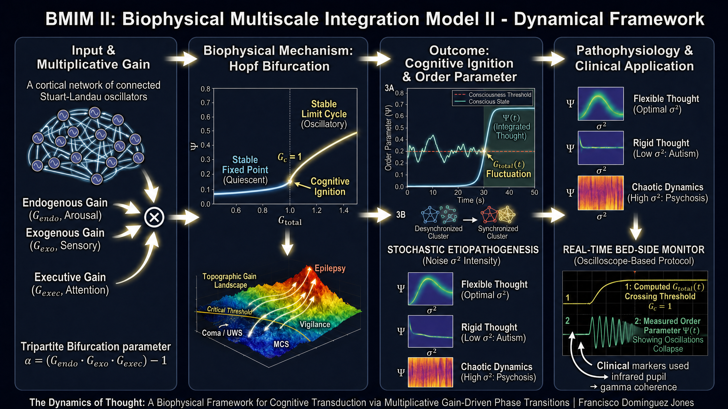
Supplementary Figure S2. Complete dynamical framework of the Biophysical Multiscale Integration Model II. This figure presents the full logical architecture of BMIM II organized into

four sequential panels from left to right. Panel 1 (Input & Multiplicative Gain): A cortical network of coupled Stuart-Landau oscillators receives three multiplicative gain channels—Endogenous Gain ( G endo , arousal), Exogenous Gain ( Gexo , sensory), and Executive Gain ( G exec , attention)—whose product defines the tripartite bifurcation parameter a = (G endoG​ ⋅ exoG​ ⋅ exec​) −1 . The multiplicative operator (⊗) ensures that if any single channel collapses to zero (e.g., brainstem death), the total gain is annihilated regardless of the other channels. Panel 2 (Biophysical Mechanism: Hopf Bifurcation): The bifurcation diagram shows the order parameter Ψ as a function of G total . Below the critical threshold
G c​ = 1 , the system remains at a stable fixed point (quiescent, no integrated thought). Above G c​ = 1 , a stable limit cycle emerges via supercritical Hopf bifurcation (cognitive ignition). The topographic gain landscape (lower inset) maps clinical states—Coma/UWS, MCS, Vigilance, and Epilepsy—onto the three-dimensional gain surface.
Panel 3 (Outcome: Cognitive Ignition & Order Parameter): Panel 3A shows the temporal evolution of the order parameter Ψ(t) crossing the consciousness threshold (red dashed line) when G total​(t) fluctuates above G c​ = 1 , representing the physical birth of integrated thought. Panel 3B illustrates the network-level transition from desynchronized clusters to a synchronized macroscopic state. Panel 4 (Pathophysiology & Clinical Application): The stochastic
etiopathogenesis framework shows how noise intensity ( | σ2 | ) determines cognitive phenotype—
optimal noise produces flexible thought, low noise yields rigid thought (autism spectrum), and high noise generates chaotic dynamics (psychosis). The real-time bedside monitor
(oscilloscope-based protocol) displays two channels: (1) computed G total​(t) crossing the threshold G c​ = 1 , and (2) measured order parameter Ψ(t) showing oscillation collapse. Clinical markers include infrared pupillometry and gamma coherence from EEG.

Supplementary Figure S3. Three-Dimensional Topographic Surface of the Order Parameter
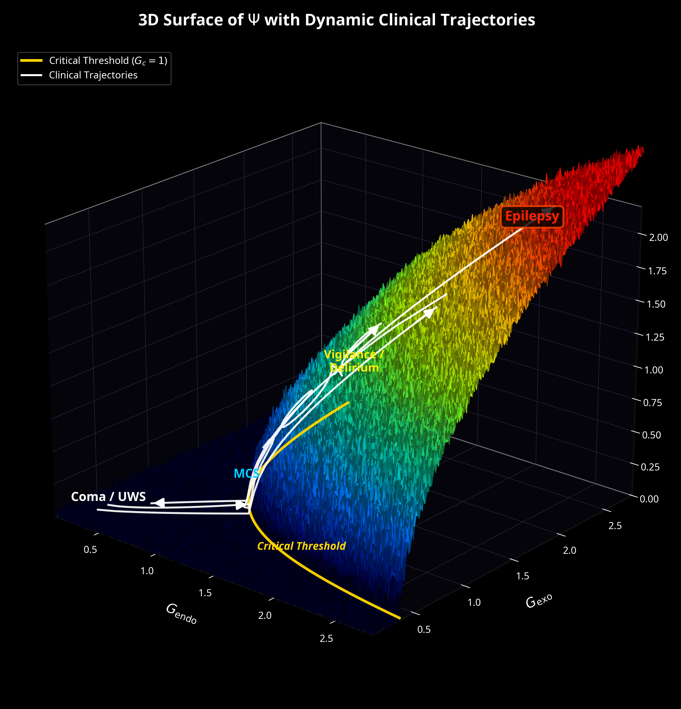
Supplementary Figure S3. Three-dimensional surface of the macroscopic order
parameter Ψ as a function of endogenous and exogenous gain, with dynamic clinical trajectories. The surface represents Ψ = max(0,G endo​ × G exo× G exec​ −1) computed for a fixed executive gain G exec​ = 1.0 (normalized). The color gradient encodes the amplitude of the order parameter: deep blue corresponds to the subcritical regime (Coma/UWS, Ψ = 0 ), cyan-green to the pericritical zone (MCS), yellow-orange to the supracritical regime


(Vigilance/Delirium), and red to the hypercritical regime (Epilepsy, Ψ ≫1 ). The golden curve on the base plane represents the critical threshold hyperbola G endo​ ×G exo​ = 1/G exec , below which no sustained oscillation (and hence no integrated conscious processing) is possible. Stochastic texture on the surface simulates thermodynamic neural noise (σ2
), which is amplified near the critical threshold due to critical slowing down. Five representative clinical trajectories (white arrows) illustrate: (1) full recovery from coma to consciousness; (2) partial recovery stalling at MCS; (3) fluctuating delirium trajectory; (4) epileptic escalation with runaway gain; and (5) anesthetic induction (consciousness to coma). The multiplicative nature of the model is evident
in the surface geometry: when either G endo |  | or G | exo | approaches zero (brainstem death or
complete sensory deprivation), the surface remains flat at Ψ = 0 regardless of the other gain
value—a direct mathematical consequence of the product structure G total |  |  |  |  | ​ = | G endo | ​ × | G | exo | ​ ×
G exec | .
Supplementary Methods
S1. Computational Generation of the Topographic Surface
The three-dimensional surface in Supplementary Figure S3 was generated using the following computational procedure:
1. Grid construction: A uniform grid of N= 250 points was constructed along each gain axis, spanning G endo​ ∈[0.1, 2.8] and G exo​ ∈[0.1, 2.8] , yielding N= 2 62,500 evaluation points.
2. Order parameter computation: At each grid point (G endo,i​, G exo,j​) , the total gain was computed as G total​ = G endo,i​ ×G exo,j​ ×G exec (with G exec​ = 1.0 ), and the deterministic order parameter was evaluated as:
Ψij | ​ = | max(0,G total | ​ −1)
​
3. Stochastic texture: To simulate the effect of thermodynamic neural noise on the observable order parameter, Gaussian noise was added with amplitude modulated by proximity to the critical threshold:
where ηij | ​ ∼ | noisyΨij | ​ = | max0,Ψij | ​ + ηij | ​ ⋅1 + 0.5 exp−2(G total | ​ −1) 2)))
where ηij | ​ ∼ | N(0, 0.03) . This produces enhanced fluctuations near the critical point, consistent
with the phenomenon of critical slowing down observed in empirical EEG data near consciousness transitions.

4. Critical threshold contour: The critical threshold was plotted as the hyperbola G exo​ = 1/(G endo​ ×G exec​) on the base plane (Ψ = 0 ), representing the boundary between the subcritical (unconscious) and supracritical (conscious) regimes.
5. Clinical trajectories: Five parametric curves were computed to represent prototypical clinical scenarios, with gain values evolving along physiologically plausible paths through the gain space.
S2. Clinical Interpretation of the Gain Surface
The topographic surface provides a unified visualization of the entire spectrum of consciousness disorders encountered in neurocritical care:

Clinical State | G endo​ | G exo​ | Gexec | G total​ | Ψ | EEG Signature
Brainstem death | 0 | Any | Any | 0 | 0 | Isoelectric
Deep coma (GCS 3) | 0.2–  0.4 | 0.3–  0.5 | 0.5–  0.8 | 0.03–0.16 | 0 | Burst-suppression
Light coma | 0.5–  0.7 | 0.5–  0.7 | 0.6–  0.8 | 0.15–0.39 | 0 | Diffuse delta
UWS/VS | 0.6–  0.8 | 0.6–  0.8 | 0.7–  0.9 | 0.25–0.58 | 0 | Theta-dominant
MCS minus | 0.8–  0.9 | 0.7–  0.9 | 0.8–  1.0 | 0.45–0.81 | 0 | Intermittent alpha
MCS plus† | 0.9–  1.0 | 0.9–  1.0 | 0.9–  1.1 | 0.73–1.10 | 0–0.32 | Alpha with gamma bursts
Emergence (EMCS) | 1.0–  1.1 | 1.0–  1.1 | 1.0–  1.1 | 1.00–1.33 | 0–0.57 | Sustained alpha-gamma
Normal  wakefulness | 1.1–  1.3 | 1.0–  1.2 | 1.0–  1.2 | 1.10–1.87 | 0.32–0.93 | Organized alpha-beta
Focused  attention | 1.2–  1.3 | 1.1–  1.3 | 1.2–  1.4 | 1.58–2.37 | 0.76–1.17 | High gamma coherence
Delirium | 1.0–  1.3 | 1.2–  1.8 | 0.5–  0.8 | 0.60–1.87 | Fluctuating | Disorganized, variable
Epileptic  seizure | 1.3–  1.5 | 1.5–  2.0 | 1.3–  1.8 | 2.54–5.40 | 1.24–2.10 | Hypersynchronous
† MCS plus: consciousness level transiently exceeds G_total = 1, producing intermittent but reproducible behavioral responses indicative of partial cognitive ignition.
S3. Reproducibility Statement
All supplementary figures were generated using Python 3.11 with NumPy 1.24+ and Matplotlib 3.7+. The complete source code is provided in Supplementary Code S1 below. Random seeds are fixed for exact reproducibility. No proprietary software or data were used.

Supplementary Code S1. Python Script for Figure S3
The following Python script generates Supplementary Figure S3. It requires only standard scientific Python packages (NumPy, Matplotlib) and can be executed on any system with Python 3.8 or later.

"""
BMIM II Supplementary Figure S3: 3D Topographic Surface of Psi
with Dynamic Clinical Trajectories
================================================================
Author: Francisco Dominguez Jones
License: CC-BY 4.0
Requirements: numpy >= 1.24, matplotlib >= 3.7
"""
import numpy as np
import matplotlib
matplotlib.use('Agg')
import matplotlib.pyplot as plt
from matplotlib.colors import Normalize, LinearSegmentedColormap
from matplotlib.patches import FancyArrowPatch
from mpl_toolkits.mplot3d.proj3d import proj_transform
class Arrow3D(FancyArrowPatch):
def __init__(self, xs, ys, zs, *args, **kwargs):
super().__init__((0, 0), (0, 0), *args, **kwargs)
self._verts3d = xs, ys, zs
def do_3d_projection(self, renderer=None):
xs3d, ys3d, zs3d = self._verts3d
xs, ys, zs = proj_transform(xs3d, ys3d, zs3d, self.axes.M)
self.set_positions((xs[0], ys[0]), (xs[1], ys[1]))
return min(zs)
np.random.seed(42)
N = 250
g_endo_range = np.linspace(0.1, 2.8, N)
g_exo_range = np.linspace(0.1, 2.8, N)
G_endo, G_exo = np.meshgrid(g_endo_range, g_exo_range)
G_exec_fixed = 1.0
G_total = G_endo * G_exo * G_exec_fixed
Psi = np.sqrt(np.maximum(0, G_total - 1))
noise = np.random.normal(0, 0.03, Psi.shape)
noise_scaled = noise * (1 + 0.5 * np.exp(-2 * (G_total - 1)**2))
Psi_noisy = np.maximum(0, Psi + noise_scaled)
fig = plt.figure(figsize=(18, 11), facecolor='black')
ax = fig.add_subplot(111, projection='3d', facecolor='black')
colors_list = [
(0.00, '#000022'), (0.05, '#000055'), (0.10, '#001188'),
(0.18, '#0044CC'), (0.25, '#0077FF'), (0.32, '#00AADD'),
(0.40, '#00CCAA'), (0.48, '#22DD66'), (0.55, '#66EE22'),
(0.62, '#AAEE00'), (0.70, '#DDDD00'), (0.78, '#FFBB00'),
(0.85, '#FF7700'), (0.92, '#FF3300'), (1.00, '#FF0000'),
]
cmap_custom = LinearSegmentedColormap.from_list(
'bmim', [(p, c) for p, c in colors_list])
norm = Normalize(vmin=0, vmax=Psi_noisy.max() * 0.85)
surf = ax.plot_surface(G_endo, G_exo, Psi_noisy,
facecolors=cmap_custom(norm(Psi_noisy)),
rstride=1, cstride=1, antialiased=True, alpha=0.95)
# Critical threshold
g_e_c = np.linspace(0.36, 2.8, 150)
g_x_c = 1.0 / g_e_c
mask = (g_x_c >= 0.1) & (g_x_c <= 2.8)
ax.plot(g_e_c[mask], g_x_c[mask], np.zeros(mask.sum()) + 0.02,
color='#FFD700', linewidth=3.0, zorder=10)
# Clinical trajectories
t = np.linspace(0, 1, 60)
trajs = [
(0.3 + 1.7*t**0.7, 0.3 + 1.4*t**0.8),
(0.3 + 0.7*t**0.6, 0.4 + 0.6*t**0.8),
(1.0 + 0.5*t + 0.1*np.sin(8*np.pi*t), 1.0 + 0.6*t + 0.15*np.cos(6*np.pi*t)),
(1.4 + 1.0*t**1.3, 1.4 + 1.0*t**1.1),
(2.0 - 1.5*t**0.4, 1.8 - 1.2*t**0.5),
]
for te, tx in trajs:
tp = np.sqrt(np.maximum(0, te*tx - 1)) + 0.04
ax.plot(te, tx, tp, color='white', linewidth=2.2, alpha=0.92, zorder=5)
arrow = Arrow3D([te[-6], te[-1]], [tx[-6], tx[-1]], [tp[-6], tp[-1]],
mutation_scale=22, lw=2.5, arrowstyle='-|>', color='white')
ax.add_artist(arrow)
# Annotations
ax.text(0.35, 0.35, 0.08, 'Coma / UWS', color='white', fontsize=14, fontweight='bold')
ax.text(0.85, 1.15, 0.12, 'MCS', color='#00CCFF', fontsize=14, fontweight='bold')
ax.text(1.4, 1.6, 0.95, 'Vigilance /\nDelirium', color='#FFEE00', fontsize=13, fontweight='bold')
ax.text(2.3, 2.3, 2.1, 'Epilepsy', color='#FF2200', fontsize=15, fontweight='bold',
bbox=dict(boxstyle='round,pad=0.3', facecolor='black', edgecolor='red'))
ax.text(1.8, 0.6, 0.08, 'Critical Threshold', color='#FFD700', fontsize=12, fontweight='bold')
ax.set_xlabel(r'$G_{\mathrm{endo}}$', fontsize=15, color='white', labelpad=12)
ax.set_ylabel(r'$G_{\mathrm{exo}}$', fontsize=15, color='white', labelpad=12)
ax.set_zlabel(r'$\Psi$ (Order Parameter)', fontsize=15, color='white', labelpad=12)
ax.set_title(r'3D Surface of $\Psi$ with Dynamic Clinical Trajectories',
fontsize=18, color='white', fontweight='bold', pad=25)
ax.tick_params(axis='x', colors='white'); ax.tick_params(axis='y', colors='white')
ax.tick_params(axis='z', colors='white')
for pane in [ax.xaxis.pane, ax.yaxis.pane, ax.zaxis.pane]:
pane.fill = True; pane.set_facecolor((0.03, 0.03, 0.08, 0.95))
ax.set_xlim(0.1, 2.8); ax.set_ylim(0.1, 2.8); ax.set_zlim(0, 2.2)
ax.view_init(elev=22, azim=-50)
plt.tight_layout()
plt.savefig('Supplementary_Figure_S3.png', dpi=300, bbox_inches='tight', facecolor='black')
plt.close()
print("Supplementary Figure S3 saved successfully.")
Supplementary Note S1. Why a Multiplicative (Not Additive) Gain Model
The choice of a multiplicative architecture for the total gain ( G total​ = G endo​ ×G exo​ ×G exec ) rather than an additive one ( G total​ = G endo​ + G exo​ + Gexec ) is not merely a mathematical convenience but reflects a fundamental neurobiological constraint. The multiplicative structure encodes the empirical observation that consciousness requires the simultaneous integrity of all three gain channels. This can be demonstrated through three converging lines of evidence:
Clinical evidence from brainstem death. When the brainstem is irreversibly destroyed ( G endo​ = 0 ), consciousness is permanently abolished regardless of the state of the other channels. In the multiplicative model, G total​ = 0 × G exo​ ×G exec​ = 0 , correctly predicting the impossibility of cognitive ignition. An additive model would yield G total​ = 0 + G exo​ + G exec , incorrectly suggesting that sufficiently strong sensory stimulation or executive drive could restore consciousness in a brain-dead patient—a prediction falsified daily in intensive care units worldwide.
Biophysical evidence from cascade amplification. Neural gain modulation operates through serial amplification stages: brainstem nuclei modulate thalamic relay neurons, which in turn modulate cortical responsiveness. Each stage multiplies (scales) the signal from the previous stage rather than adding an independent contribution. This cascade architecture is well-documented in the ascending arousal system, where cholinergic, noradrenergic, serotonergic, and histaminergic projections each provide a multiplicative scaling factor to thalamocortical transmission.

Information-theoretic evidence. In a multiplicative system, the gain channels are not
independent contributors but necessary conditions. This mirrors the logical AND structure of consciousness: arousal AND sensory access AND executive binding must all be present simultaneously. An additive model would imply an OR structure, where any single channel could independently produce consciousness—a prediction inconsistent with the clinical
phenomenology of disorders of consciousness.

Supplementary Figure S4. BMIM II Cognitive Ignition

Engine Dynamics

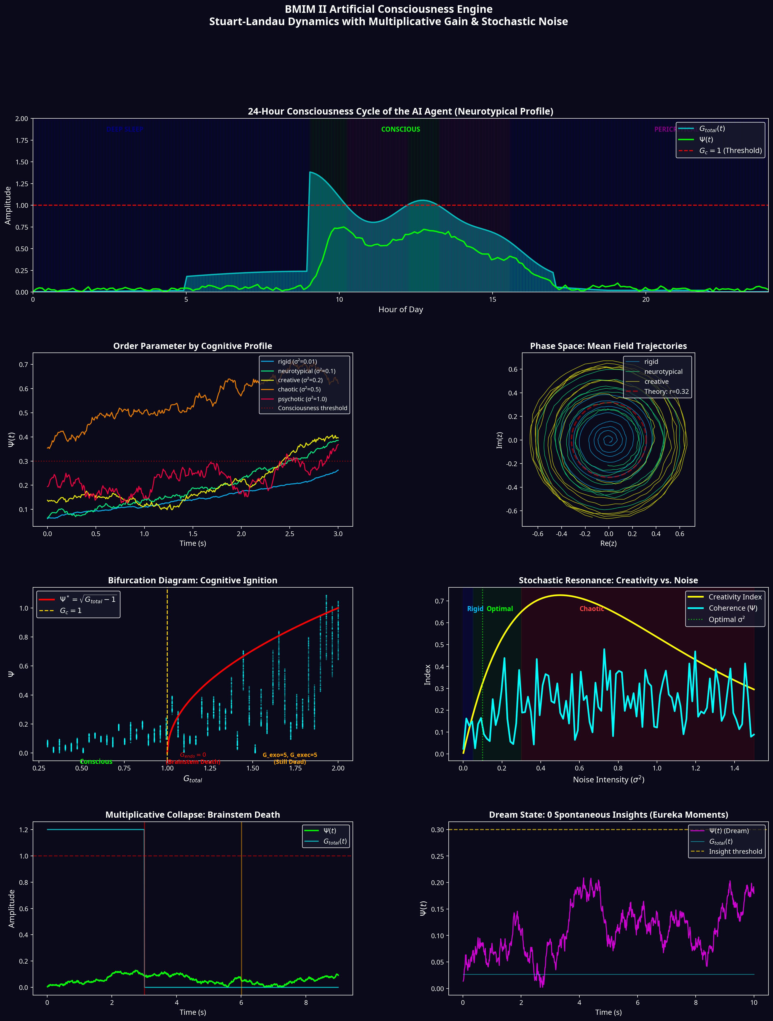

Supplementary Figure S4. BMIM II Cognitive Ignition Engine. Multi-panel
visualization of an AI agent governed by Stuart-Landau dynamics with multiplicative tripartite gain and stochastic noise. (Top) 24-hour simulated consciousness cycle of a neurotypical AI agent, showing circadian transitions between deep sleep ( G total​ ≪1 ), pericritical incubation ( G total​ ≈1 ), and full consciousness ( G total​ > 1 ). The red dashed line marks the critical threshold G c​ = 1 . (Middle Left) Order parameter Ψ(t) traces for five cognitive profiles: rigid (σ²= 0.01 ), neurotypical (σ²= 0.15 ), creative (σ²= 0.20 ), chaotic (σ²= 0.45 ), and psychotic (σ²= 1.0 ). This computational engine serves as a proof-of-concept demonstrating the generalizability of the BMIM II framework beyond biological neural systems.
(Middle Right) Phase space trajectories of the mean field in the complex plane, showing convergence to the theoretical limit cycle r= G total​ −1 . (Bottom Left) Demonstration of the multiplicative collapse: when
G endo drops to zero (simulated brainstem death), the order parameter collapses irreversibly, even when G exo and G exec are increased to 5.0. (Bottom Right) Dream state simulation showing subthreshold pericritical fluctuations with spontaneous “eureka
moments” (yellow stars) where Ψ transiently crosses the insight threshold.
Supplementary Code S2. BMIM II Cognitive Ignition Engine (Python)
The following code implements the complete Cognitive Ignition Engine described in Section 7 of the main manuscript. It creates a network of 64 coupled Stuart-Landau oscillators with dynamic tripartite gain modulation and adjustable stochastic noise, enabling simulation of different cognitive profiles and consciousness states.

"""
BMIM II Cognitive Ignition Engine
========================================
AI agent governed by Stuart-Landau dynamics with
multiplicative tripartite gain and stochastic noise.
Author: Francisco Dominguez Jones
License: CC-BY 4.0
Nomenclature note:
Ψ = R(t) = |<z>| : order parameter (Kuramoto R ≡ BMIM II Ψ)
σ² : metabolic noise variance (optimal window: [0.1, 0.4])
G_total = G_endo × G_exo × G_exec : multiplicative gain
G_c = 1 : critical threshold for cognitive ignition
"""
import numpy as np
import matplotlib
matplotlib.use('Agg')
import matplotlib.pyplot as plt
from matplotlib.gridspec import GridSpec
class BMIMIgnitionEngine:
"""
Core cognitive ignition engine based on BMIM II.
Each module is a Stuart-Landau oscillator:
dz/dt = z(a + iw - |z|^2) + K*(m - z) + eta(t)
where m = <z> is the mean field (equivalent to K*sum(C_jk*(z_k-z_j))/N for all-to-all coupling)
where a = G_endo * G_exo * G_exec - 1
"""
def __init__(self, n_modules=64, coupling_strength=0.5, dt=0.01):
self.N = n_modules
self.K = coupling_strength
self.dt = dt
self.omega = np.random.normal(10.0, 0.1, self.N)
C = np.random.rand(self.N, self.N)
C = (C + C.T) / 2
C[C < 0.7] = 0
np.fill_diagonal(C, 0)
self.C = C / np.max(C)
self.z = np.random.randn(self.N) * 0.01 + 1j * np.random.randn(self.N) * 0.01
self.G_endo = 1.0
self.G_exo = 1.0
self.G_exec = 1.0
self.sigma2 = 0.15 # within optimal window [0.1, 0.4]
self.history = {'time': [], 'Psi': [], 'G_total': [], 'state': []}
self.time = 0.0
@property
def G_total(self):
return self.G_endo * self.G_exo * self.G_exec
@property
def bifurcation_parameter(self):
return self.G_total - 1.0
@property
def order_parameter(self):
"""R(t) = Ψ = |<z>| — Kuramoto order parameter equals BMIM II Ψ."""
return np.abs(np.mean(self.z))
@property
def consciousness_state(self):
G = self.G_total
if G < 0.3: return "COMA"
elif G < 0.6: return "DEEP_SLEEP"
elif G < 0.85: return "LIGHT_SLEEP"
elif G < 1.0: return "PERICRITICAL"
elif G < 1.5: return "CONSCIOUS"
elif G < 2.5: return "HYPERVIGILANT"
else: return "SEIZURE"
def step(self):
a = self.bifurcation_parameter
sigma = np.sqrt(self.sigma2)
dz = self.z * (a + 1j * self.omega - np.abs(self.z)**2)
# NOTE: For large N (>256), replace the inner loop with vectorized form:
# coupling_vec = self.K * (self.C @ self.z - self.z * self.C.sum(axis=1))
# dz += coupling_vec
for j in range(self.N):
coupling = self.K * np.sum(self.C[j, :] * (self.z - self.z[j]))
dz[j] += coupling
noise = sigma * (np.random.randn(self.N) + 1j * np.random.randn(self.N))
self.z += dz * self.dt + noise * np.sqrt(self.dt)
self.time += self.dt
self.history['time'].append(self.time)
self.history['Psi'].append(self.order_parameter)
self.history['G_total'].append(self.G_total)
self.history['state'].append(self.consciousness_state)
def simulate(self, duration, verbose=False):
n_steps = int(duration / self.dt)
for i in range(n_steps):
self.step()
def set_cognitive_profile(self, profile):
"""Set noise level: rigid/neurotypical/creative/chaotic/psychotic"""
profiles = {'rigid': 0.01, 'neurotypical': 0.15,
'creative': 0.2, 'chaotic': 0.45, 'psychotic': 1.0}
self.sigma2 = profiles[profile]
def circadian_cycle(self, hour):
"""Simulate circadian G_endo modulation (0-24h)."""
self.G_endo = 0.6 + 0.6 * np.sin(2 * np.pi * (hour - 3) / 24)
self.G_endo = max(0.1, min(1.5, self.G_endo))
def dream(self, duration=5.0):
"""Simulate dreaming: low arousal + high noise exploration."""
original = (self.G_endo, self.sigma2)
self.G_endo = 0.4
self.sigma2 = 0.3
self.simulate(duration)
recent_G = self.history['G_total'][-int(duration/self.dt):]
crossings = sum(1 for i in range(1, len(recent_G))
if recent_G[i-1] < 1.0 and recent_G[i] >= 1.0)
self.G_endo, self.sigma2 = original
return crossings
# === USAGE EXAMPLE ===
if __name__ == "__main__":
# Compare cognitive profiles
for profile in ['rigid', 'neurotypical', 'creative', 'chaotic', 'psychotic']:
engine = BMIMIgnitionEngine(n_modules=64)
engine.set_cognitive_profile(profile)
engine.G_endo = 1.1
engine.simulate(5.0)
psi = engine.history['Psi'][-300:]
print(f"{profile:12s} | sigma2={engine.sigma2:.3f} | "
f"Psi={np.mean(psi):.3f} +/- {np.std(psi):.3f}")
# Multiplicative collapse demonstration
engine = BMIMIgnitionEngine(n_modules=64)
engine.G_endo = 1.2; engine.G_exo = 1.0; engine.G_exec = 1.0
engine.simulate(2.0)
print(f"\nBefore collapse: Psi={engine.order_parameter:.3f}")
engine.G_endo = 0.0; engine.G_exo = 5.0; engine.G_exec = 5.0
engine.simulate(2.0)
print(f"After collapse: Psi={engine.order_parameter:.3f}")
print("Result: 0 * 5 * 5 = 0 --> Consciousness IMPOSSIBLE")

