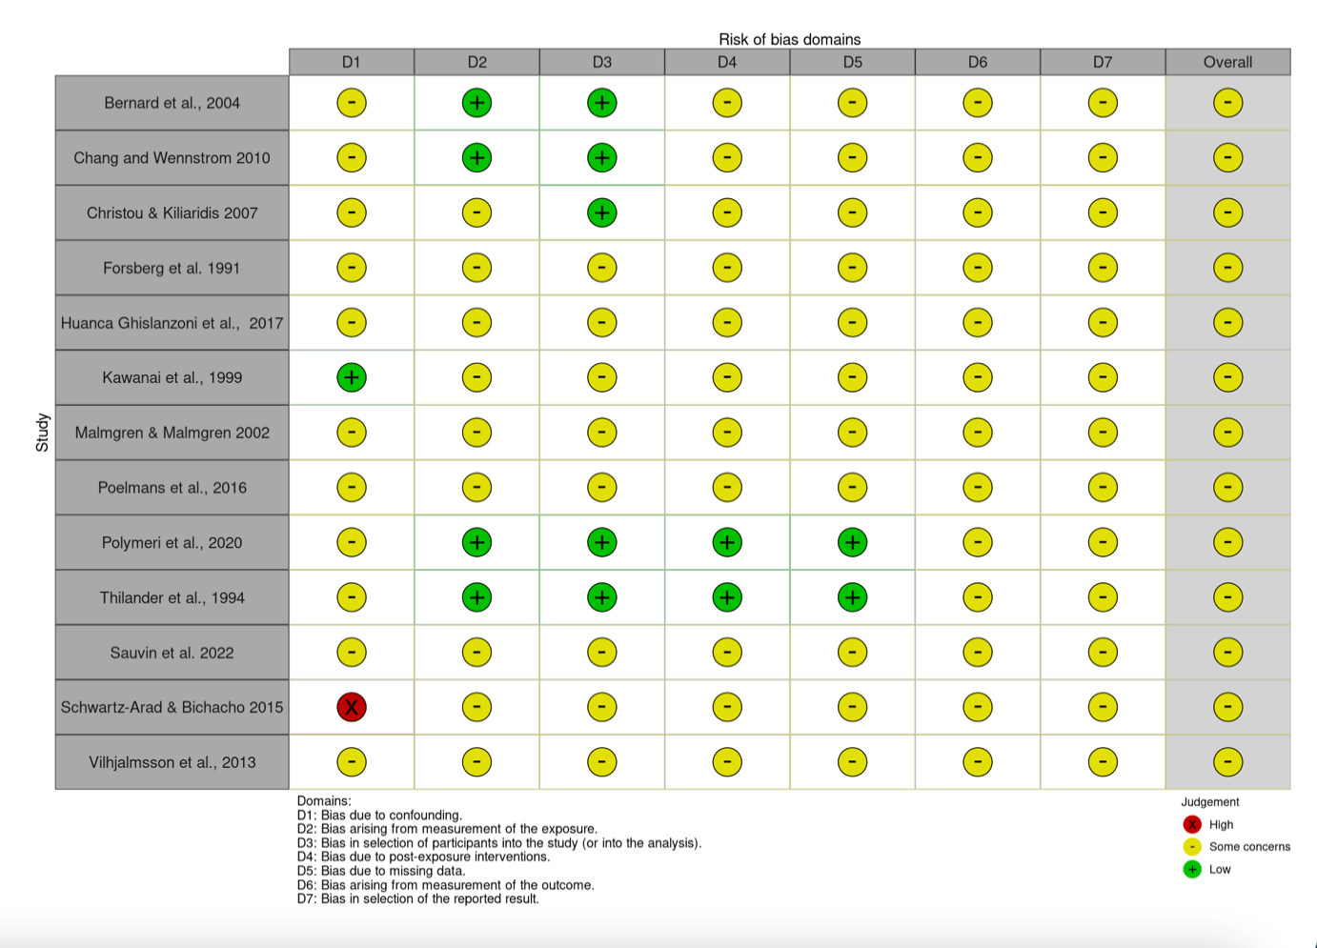
TABLE 1: Risk of Bias
Created using the software available on riskofbias.info/welcome/robvis-visualization-tool
r

TABLE 2: Result of studies in the qualitative synthesis

TABLE 3. Results of quantitative syntheses (meta-analyses) and single- study estimates for teeth eruption across ages and follow up years of assessment [all changes represent final versus baseline measurement].

Tooth groups (maxillary- mandibular, anterior- posterior) and follow- up years are presented only when data are available at least for one study. P- value indicates statistically significant difference from null (ie, no eruption potential).

