Supplementary Information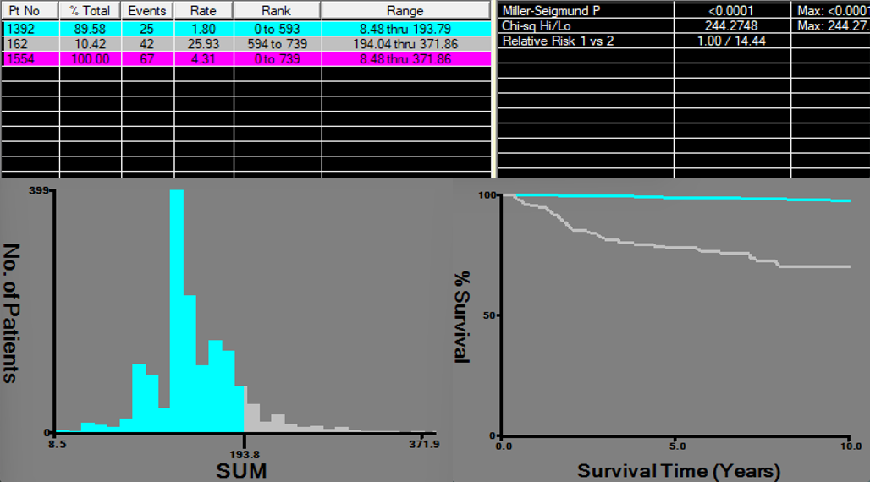
Figure S1 Patients in external cohort were stratified into low-risk and high-risk groups using the optimal cut-off value determined by the X-tile algorithm: low risk (nomogram score＜194.04) and high risk (≥194.04).

