Electronic Supplementary Information
A singlet-oxygen pulse awakens endogenous neural stem cells to rebuild injured brain circuits
Yifan Da^{1,†}, Xiaohui Li^{2,5,†}, Ziyu Li¹, Mingwei Guo³, Yuandong Liu¹, Jing Sun¹, Jingjing Wan¹, Qiangqiang Zhang^{6,7}, Xinran Ma^{3*}, Yudan Chi^{2,5*}, Yang Tian^{1,4*}
¹Department of Chemistry, School of Chemistry and Molecular Engineering, East China Normal University. Shanghai, 200241, China.
²Department of Neurosurgery, Huashan Hospital, State Key Laboratory of Medical Neurobiology, MOE Frontiers Center for Brain Science, Fudan University; Shanghai, 200032, China.
³Shanghai Key Laboratory of Regulatory Biology, Institute of Biomedical Sciences, School of Life Sciences, East China Normal University, Shanghai 200241, China
⁴Institute of Magnetic Resonance and Molecular Imaging in Medicine, East China Normal University; Shanghai, 200241, China
⁵Institute for Translational Brain Research, MOE Innovative Center for New Drug Development of Immune Inflammatory Diseases, Fudan University; Shanghai, 200032, China.
⁶Advanced Model Animal Research Center, Department of Biotechnology and Biomedicine, Yangtze Delta Region Institute of Tsinghua University; Zhejiang, 314006, China.
⁷Zhejiang Key Laboratory of Multiomics and Molecular Enzymology, Yangtze Delta Region Institute of Tsinghua University; Zhejiang, 314006, China.
† These authors contributed equally: Yifan Da, Xiaohui Li.
*Corresponding authors: xrma@bio.ecnu.edu.cn (X.M), chiy@fudan.edu.cn (Y.C), ytian@chem.ecnu.edu.cn (Y.T)

Synthesis and characterization of organic compounds
Synthesis and characterization of ITC
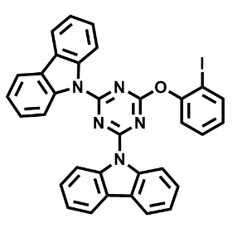
Synthesis of ITC. This molecule was prepared according to the previously reported literature (30). In a nitrogen-filled two-necked flask with 9H-carbazole (5 g, 29.9 mmol), 40 mL anhydrous and degassed THF was slowly injected. Afterward, n-butyllithium (20.5 mL, 1.6 mol/L in hexane) was added dropwise at 0°C. The resulting mixture was stirred at room temperature for 2 h. Following the same procedure, a solution of 2,4,6-trichloro-1,3,5-triazine (2.7 g, 14.9 mmol) in THF (10 mL) was prepared. Subsequently, these two solutions were slowly blended under nitrogen atmosphere at 80°C and stirred for about 8 h. Once the reaction was completed, the mixture was filtered and washed with cold acetone. Faint yellow powder (9,9'-(6-chloro-1,3,5-triazine-2,4-diyl)bis(9H-carbazole), CzDClT, 3 g, 6.7 mmol) was obtained in 45% yield. To a solution of o-iodophenol (2.2 g, 10.1 mmol) and anhydrous THF (15 mL), a freshly prepared solution of sodium hydroxide (0.56 g, 2.0 mol/L in DI water) was slowly added and stirred at 25°C for 1 h. The mixture was then added into a round-bottomed flask charged with CzDClT (3 g in 50 mL anhydrous THF), and the solution was stirred and refluxed at 77°C for 1 h. The crude solution was evaporated and extracted with dichloromethane for three times. The resulting organic layer was dried using anhydrous sodium sulfate. After the solvent was removed by rotary evaporation, the residue was purified by flash column chromatography to give ITC (2.9 g, 68%) as a white solid. Before using, the white solid was recrystallized by a mixed solvent (chloroform/ethanol). ¹H NMR (600 MHz, 298K, Chloroform-d): δ 8.77–8.75 (m, 4H), 8.11–8.06 (m, 5H), 7.64–7.61 (m, 1H), 7.50–7.42 (m, 9H), 7.27–7.25 (m, 1H). ¹³C NMR (151 MHz, 298 K, Chloroform-d): δ 171.26, 165.54, 153.01, 139.97, 138.77, 130.03, 127.93, 126.99, 126.67, 123.64, 119.64, 117.93, 91.41. HR-MS (ESI): m/z calcd for C₃₃H₂₀IN₅NaO [M+Na] ⁺: 652.0605; found: 652.0610.

Synthesis and characterization of CTAD

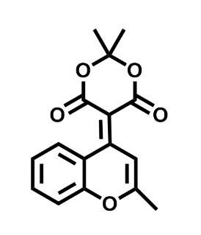
Synthesis of Compound 1. This molecule was prepared according to the previously reported literature (55). To a solution of TiCl₄ (460.5 μL, 4.2 mmol) in anhydrous THF (10 mL) was added dropwise a solution of Meldrum’s acid (345.9 mg, 2.4 mmol) and 2-methyl-4Hchromen-4-one (320.1 mg, 2 mmol) in anhydrous THF (10 mL) at 0°C under an argon atmosphere and stirred for 1 h. Then, pyridine (644.4 μL, 8 mmol) was added dropwise into the reaction and stirred overnight. After completing the reaction, the mixture was extracted with EtOAc (100 mL × 3) and brine (100 mL × 3). The organic layer was collected, dried with anhydrous Na₂SO₄, and concentrated in vacuo to give the crude product. The crude product was then further purified by silica gel chromatography using hexane/EtOAc to afford Compound 1 as a yellow solid (297.5 mg, 52%). ¹H NMR (600 MHz, 298 K, Chloroform-d): δ 8.60 (s, 1H), 7.99–7.98 (dd, J₁ = 8.4 Hz, J₂ = 1.8 Hz, 1H), 7.75–7.73 (m, 1H), 7.56–7.55 (dd, J₁ = 8.4 Hz, J₂ = 1.2 Hz, 1H), 7.42–7.40 (m, 1H), 2.62 (s, 3H), 1.90 (s, 6H). ¹³C NMR (151 MHz, 298 K, Chloroform-d): δ 164.83, 163.80, 158.76, 154.69, 134.43, 130.06, 124.93, 119.60, 118.29, 110.79, 102.72, 93.70, 27.02, 21.26. HR-MS (ESI): m/z calcd for C₁₆H₁₄NaO₅ [M+Na] ⁺: 309.0733; found: 309.0731.

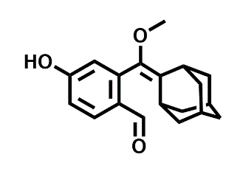
Synthesis of Compound 2. Compound 2 was synthesized according to the reported procedure (56) for the preparation of the corresponding aldehyde derivative. The corresponding starting material was prepared according to the same method as described in the reference. Specifically, the precursor compound (4.5 g, 9.7 mmol) was dissolved in THF (20 mL) under N₂ atmosphere. The solution was cooled to -78°C and n-BuLi (7.8 mL, 2.5 M in Hex) was added. After 15 min of stirring, DMF (2.7 mL) was added. The reaction mixture was heated to room temperature with stirring for 30 min and monitored by TLC. After completion, saturated solution of ammonium chloride (5 mL) was added. The mixture was extracted with EtOAc (100 mL × 3). The combined organic layer was washed with brine (25 mL), dried over Na₂SO₄ and evaporated under reduced pressure. The product was purified by column chromatography to give 3 g of yellow solid (72% yield). Spectral data were consistent with those reported in the literature. ¹H NMR (600 MHz, 298K, DMSO-d6): δ 9.97 (s, 1H), 7.77–7.76 (d, J = 8.4 Hz, 1H), 6.92–6.90 (m, 1H), 6.70 (d, J = 2.4 Hz, 1H), 3.23 (s, 3H), 2.14 (s, 1H), 1.94–1.90 (m, 4H), 1.82–1.72 (m, 6H), 1.61 (s, 2H). ¹³C NMR (151 MHz, 298 K, DMSO-d₆): δ 190.36, 162.97, 141.49, 139.26, 132.55, 129.66, 127.03, 117.64, 116.39, 57.18, 38.78, 36.87, 32.61, 29.71, 28.03. HR-MS (ESI): m/z calcd for C₁₉H₂₂NaO₃ [M+Na] ⁺: 321.1461; found: 321.1452.

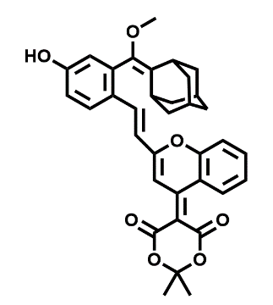
Synthesis of Compound 3. The mixture of compound 1 (57.2 mg, 0.2 mmol), compound 2 (59.6 mg, 0.2 mmol), and piperidine (7.9 μL, 0.08 mmol) was dissolved in anhydrous acetonitrile (ACN, 4 mL) under an argon atmosphere and refluxed for 1 h. The mixture was cooled to room temperature. The mixture was extracted with brine (50 × 2 mL) and dichloromethane (50 × 2 mL), then the organic solution was collected and dried over anhydrous Na₂SO₄ to obtain the crude product. The crude product was further purified by HPLC using ACN/H₂O as the eluent to afford an orange solid compound 3 (104.2 mg, 92% yield). ¹H NMR (600 MHz, 298 K, Chloroform-d): δ 8.64 (s, 1H), 8.12–8.10 (d, J = 16.2 Hz, 1H), 7.99–7.98 (d, J = 9.6 Hz, 1H), 7.78–7.75 (m, 1H), 7.71–7.70 (d, J = 9.0 Hz, 1H), 7.54–7.50 (d, J = 7.2 Hz, 1H), 7.45–7.42 (m, 1H), 6.93–6.91 (dd, J₁ = 8.4 Hz, J₂ = 2.4 Hz, 1H), 6.87–6.84 (m, 1H), 6.82(d, J = 3.0 Hz, 3H), 3.43 (s, 1H), 3.35 (s, 3H), 2.18–2.17 (t, J = 3 Hz, 1H), 2.01 (s, 3H), 1.94–1.74 (m, 15H). ¹³C NMR (151 MHz, 298 K, Chloroform-d): δ 164.53, 162.27, 159.68, 159.10, 154.14, 139.87, 139.74, 139.42, 134.71, 132.71, 130.11, 127.94, 126.35, 125.15, 120.52, 118.19, 118.06, 116.87, 116.34, 113.63, 103.08, 102.94, 91.30, 57.09, 38.51, 37.20, 36.99, 33.34, 32.70, 29.91, 29.69, 28.25, 26.90. HR-MS (ESI): m/z calcd for C₃₅H₃₄NaO₇ [M+Na] ⁺: 589.2197; found: 589.2200.

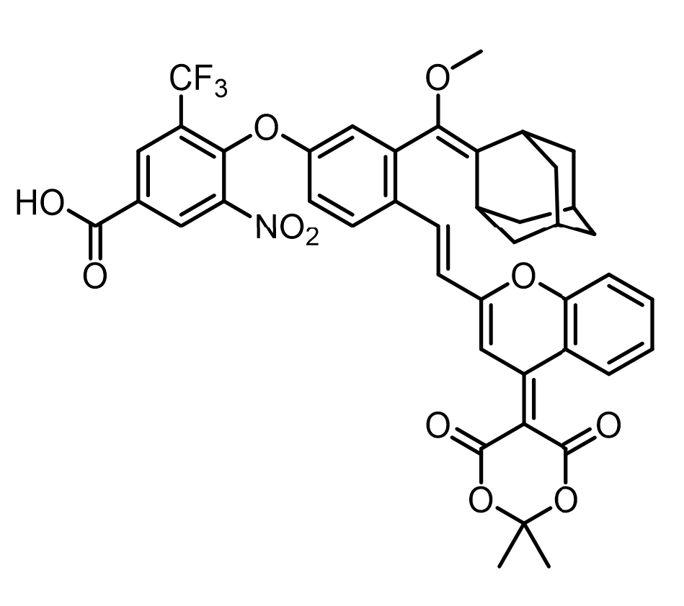
Synthesis of CTAD. Compound 3 (85 mg, 0.15 mmol), 4-(bromomethyl)-5-nitro-2-(trifluoromethyl)benzoic acid (49 mg, 0.15 mmol), and potassium acetate (KOAc) (16 mg, 0.165 mmol) were added to anhydrous THF (5 mL) under a nitrogen atmosphere. The mixture was heated to 50°C and stirred for 12 h. Upon completion, the reaction was cooled to room temperature, quenched with water, and extracted. The organic phase was dried over anhydrous sodium sulfate, filtered, and concentrated under reduced pressure. The crude product was purified by silica gel column chromatography to afford compound 4 as a red solid (50 mg, 42% yield). ¹H NMR (600 MHz, 298K, DMSO-d6): δ 14.11 (s, 1H), 8.79 (s, 1H), 8.61 (s, 1H), 8.56 (s, 1H), 8.16 (d, J = 8.4 Hz, 1H), 7.94–7.80 (m, 3H), 7.56–7.44 (m, 3H), 7.22 (d, J = 6.0 Hz, 1H), 6.80 (s, 1H), 3.18 (s, 3H), 1.97 (s, 2H), 1.91 (s, 4H), 1.80 (s, 5H), 1.73 (s, 2H), 1.65 (s, 2H).¹³C NMR (151 MHz, 298 K, DMSO-d₆): δ 164.61, 163.03, 160.29, 158.15, 157.01, 153.66, 148.26, 143.42, 139.38, 138.50, 136.35, 135.59, 131.87, 131.71, 130.52, 130.45, 130.02, 129.16, 125.55, 120.84, 119.65, 118.07, 117.46, 112.20, 102.91, 94.80, 56.80, 40.51, 38.55, 36.85, 32.67, 29.67, 28.04, 27.00. HR-MS (ESI): m/z calcd for C₄₃H₃₆F₃NNaO₁₁ [M+Na] ⁺: 822.2133; found: 822.2141.

Assembly and characterization of the developed nanovesicles
Assembly of XSingletO Nanovesicles
As illustrated in fig. S3, the XSingletO nanovesicle was conducted through a three-step process to achieve targeted delivery and real-time self-reporting of ¹O₂ in NSC niches. First, the polypeptide GelLink containing Lys (K) and Cys (C) repeat sequences (CGGK LVAKGGC) was synthesized via solid-phase peptide synthesis. The amino (-NH₂) and thiol (-SH) groups of GelLink were covalently conjugated with a ¹O₂-responsive chemiluminescent molecule (CTAD) and a reference fluorophore (Cy7-maleimide), respectively, to construct the RatioCL probe. Subsequently, the RatioCL probe and the X-ray-excitable ¹O₂-generating molecule (ITC) were co-encapsulated into a gelatin matrix using an emulsion crosslinking technique, forming hydrogel nanospheres with a hydrophobic core and a crosslinked gelatin shell. The surface amino (-NH₂) groups of the nanospheres were functionalized with maleimide linkers via maleimide-PEG₄-NHS, yielding Maleimide-nanospheres. Finally, the Maleimide-nanospheres were decorated with two functional peptides through thiol-maleimide reactions: (1) angiopep-2 (ANG) (TFFYGGSRGKRNNFKTEEYC), a blood-brain barrier (BBB)-penetrating peptide, and (2) NFL-TBS (YSSYSAPVSSSLSVRRSYSSSSGSC), an NSC-targeting peptide. The resulting dual-functionalized nanovesicles, termed XSingletO, acquired the ability to traverse the BBB and specifically bind to NSCs. Upon encountering MMP-2-enriched microenvironments (e.g., near NSCs), the nanovesicles underwent site-specific enzymatic cleavage of the MMP-2-cleavable motifs, releasing ITC and the RatioCL probe. X-ray irradiation triggered ITC activation for spatially controlled ¹O₂ generation in vivo, while the fluorescence ratio (F₇₂₀/F₇₇₃) of the RatioCL probe enabled real-time monitoring of ¹O₂ concentration.

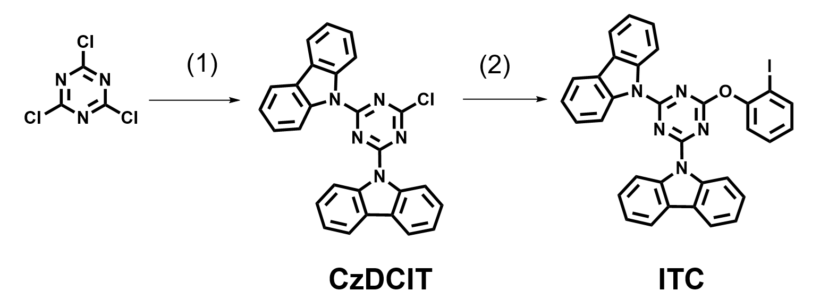
Supplementary Fig. 1 Molecular structures and the synthetic routes of ITC molecule.

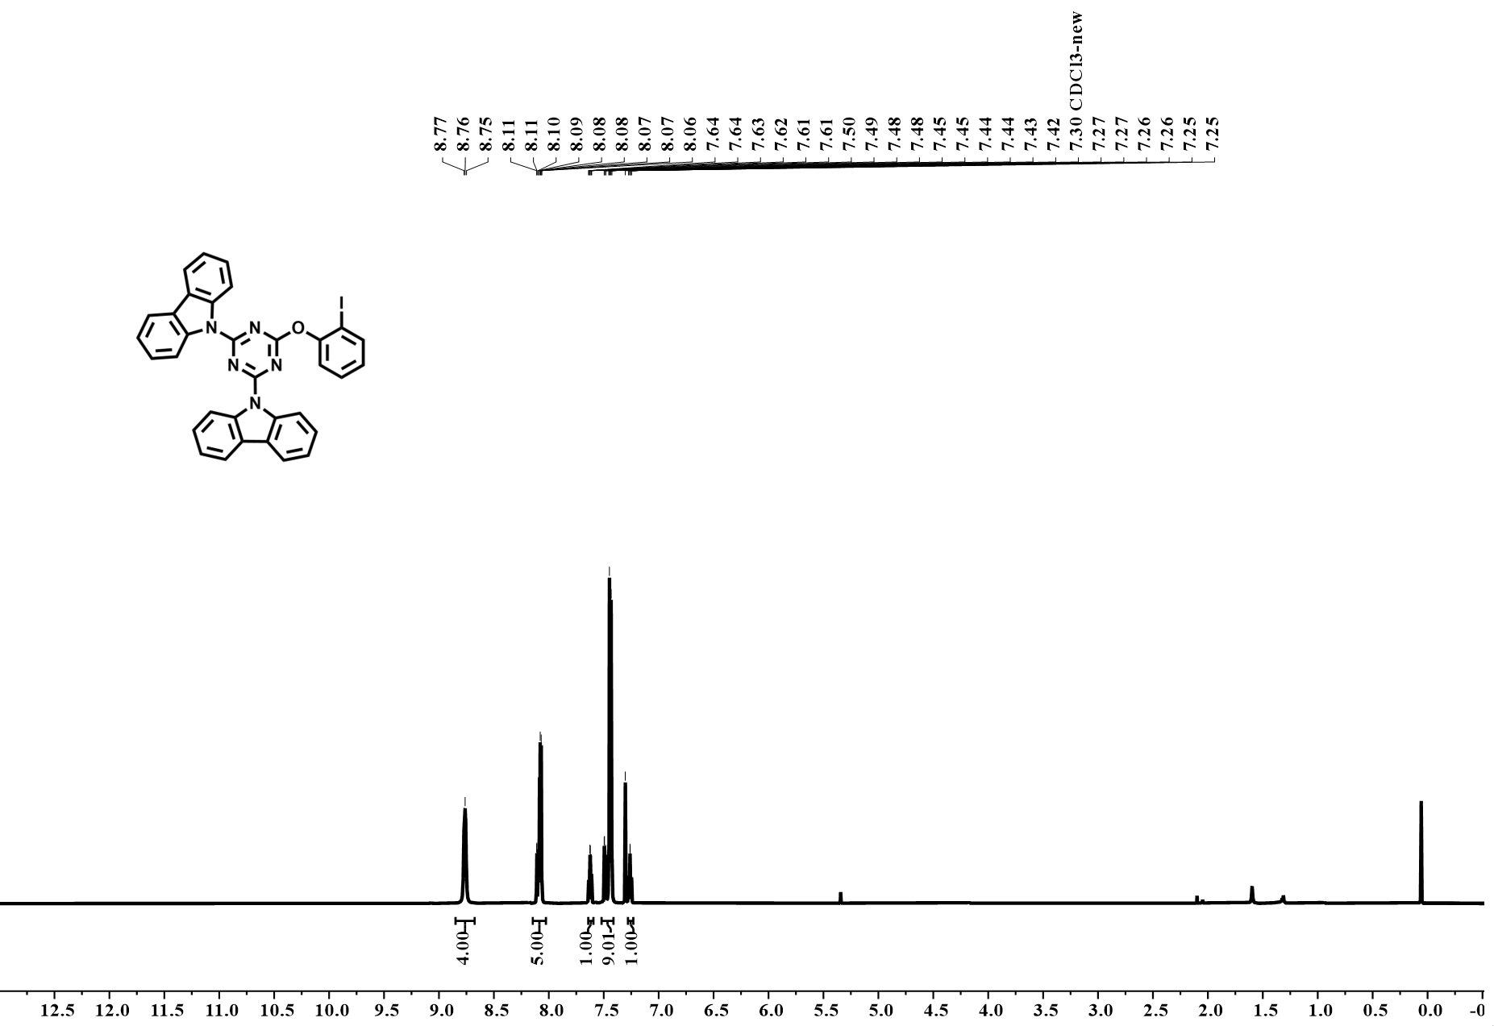
Supplementary Fig. 2 ¹H NMR spectrum of ITC in CDCl₃ (600 MHz, 298 K), δ (ppm, referenced to residual solvent peak).

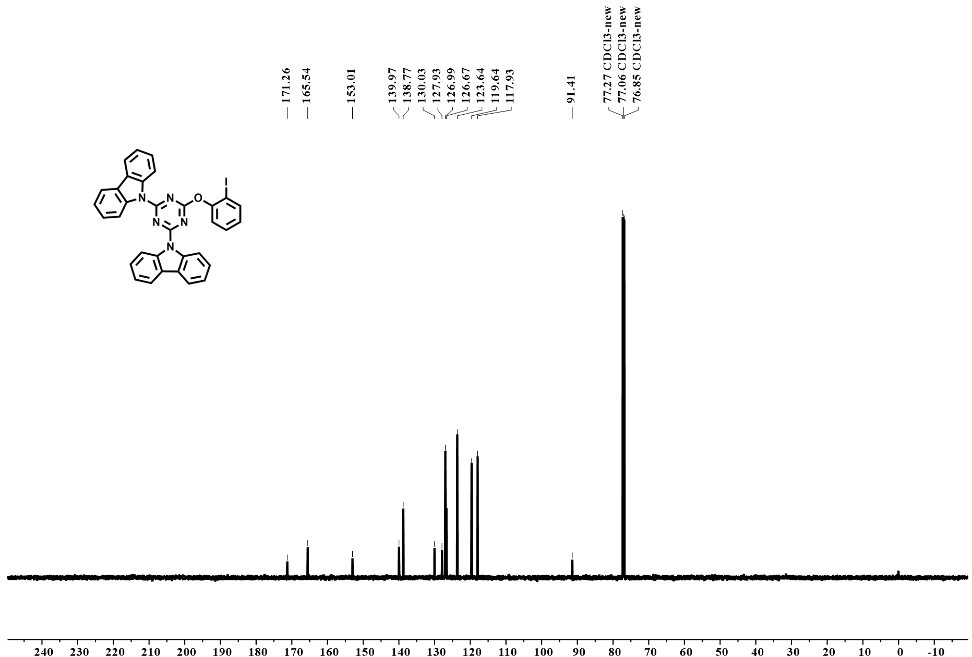
Supplementary Fig. 3 ¹³C NMR spectrum of ITC in CDCl₃ (150 MHz, 298 K), δ (ppm, referenced to residual solvent peak).

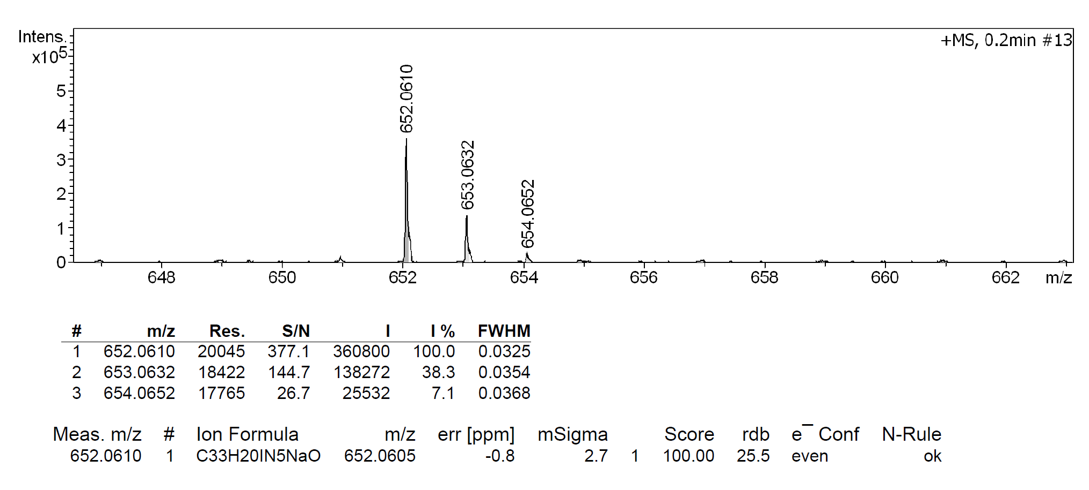
Supplementary Fig. 4 HR-ESI-MS spectrum of ITC.

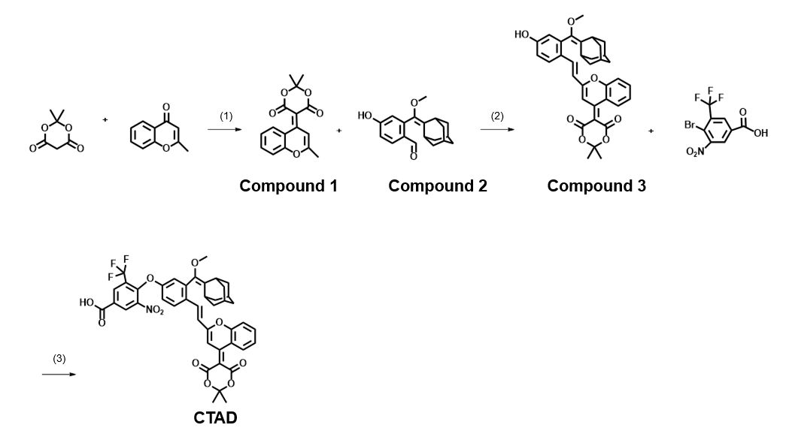
Supplementary Fig. 5 Molecular structures and the synthetic routes of CTAD molecule.

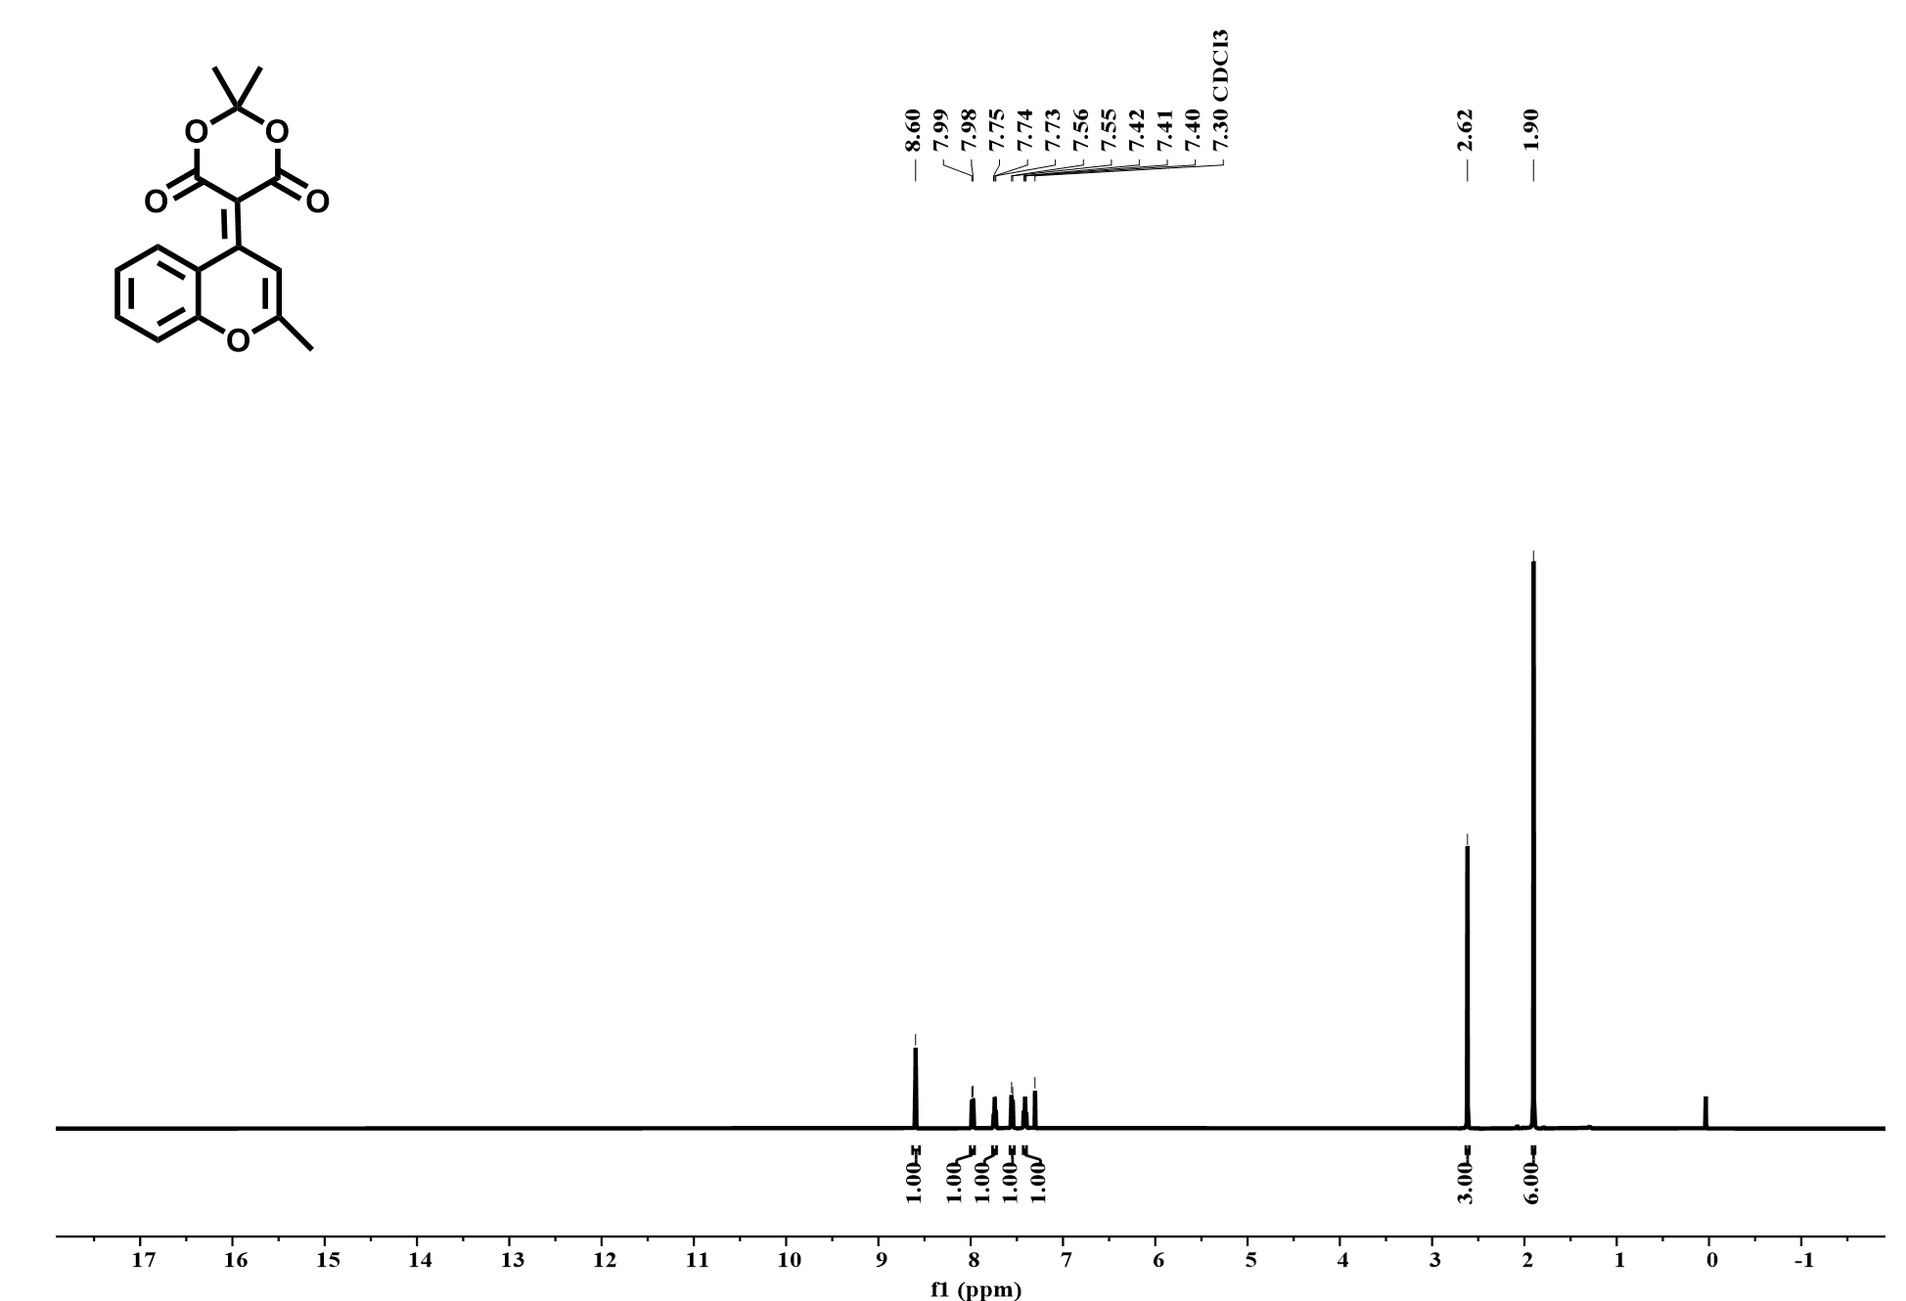
Supplementary Fig. 6 ¹H NMR spectrum of Compound 1 in CDCl₃ (600 MHz, 298 K), δ (ppm, referenced to residual solvent peak).

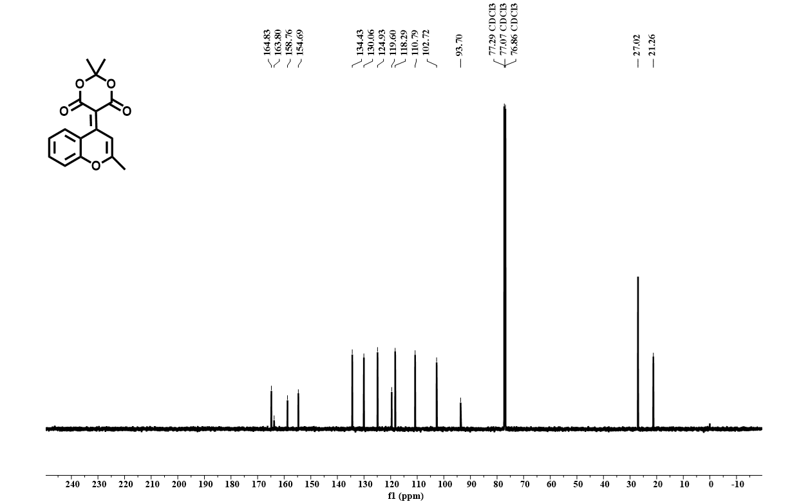
Supplementary Fig. 7 ¹³C NMR spectrum of Compound 1 in CDCl₃ (150 MHz, 298 K), δ (ppm, referenced to residual solvent peak).

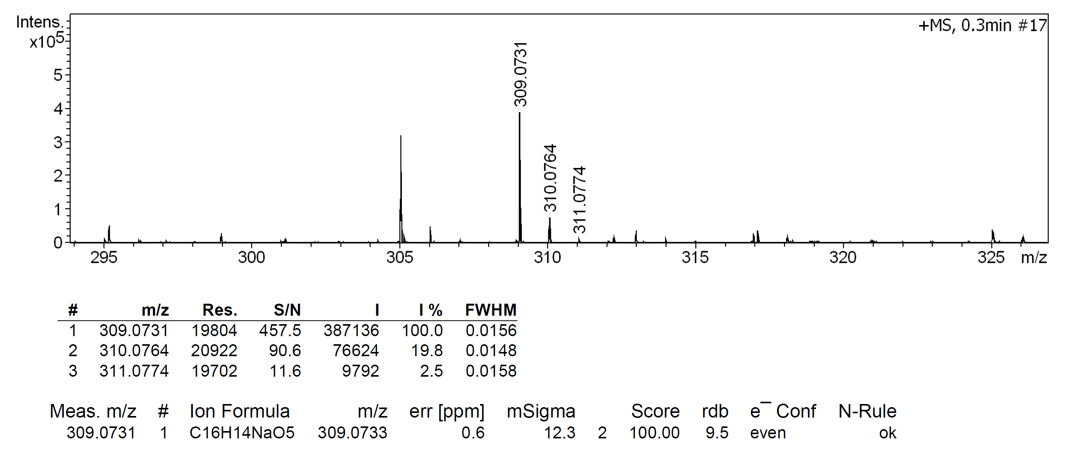
Supplementary Fig. 8 HR-ESI-MS spectrum of Compound 1.

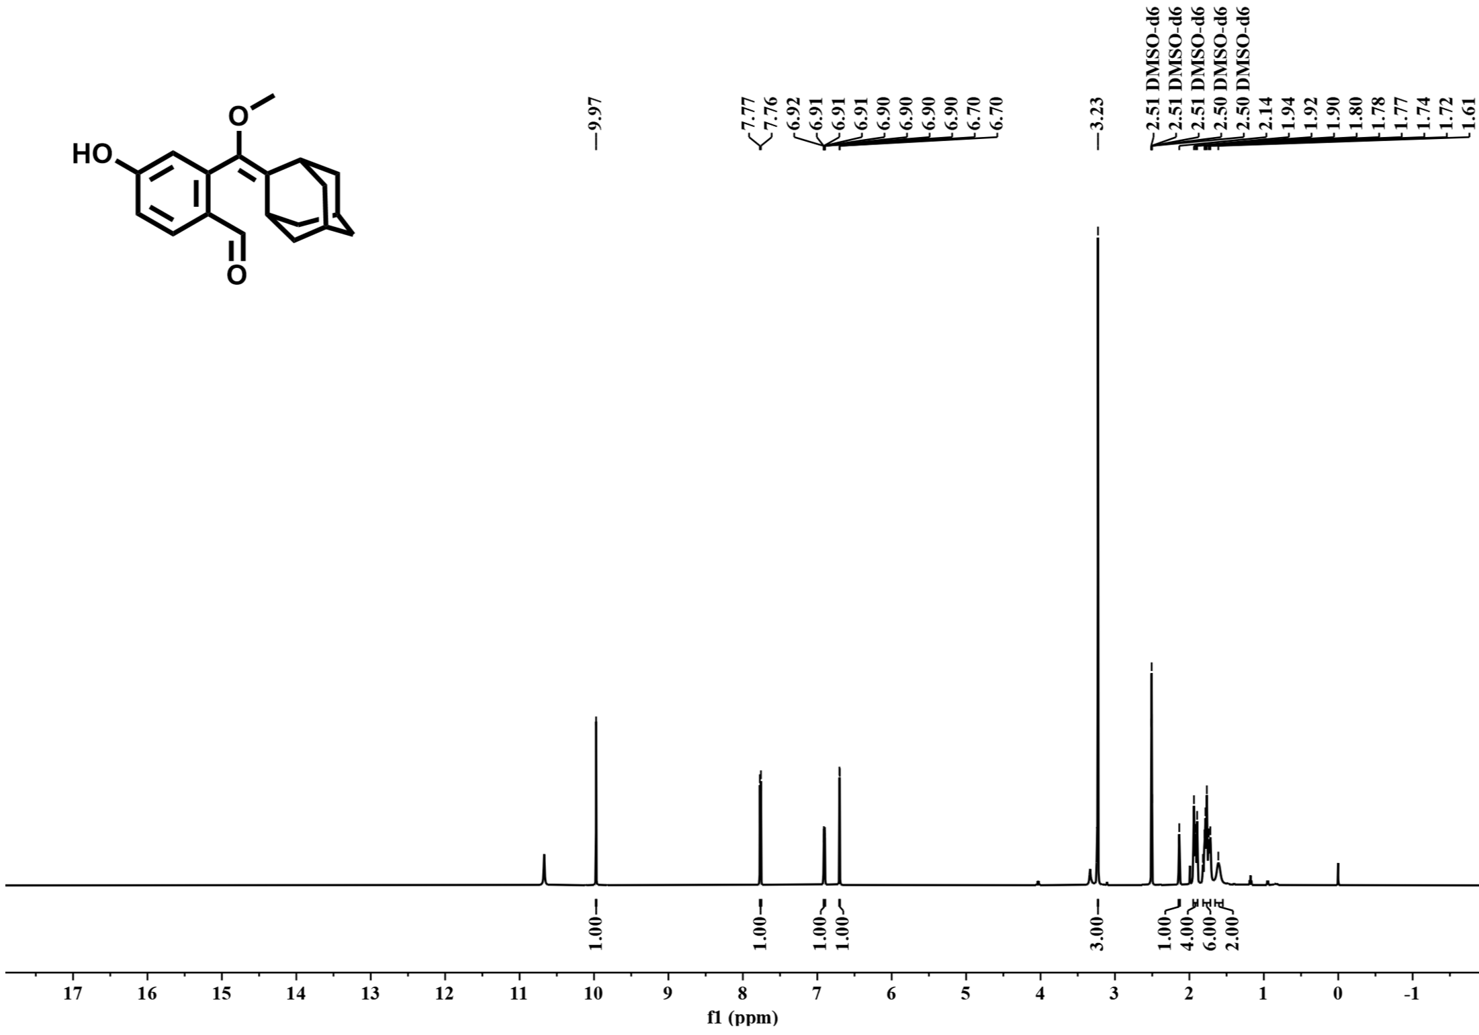
Supplementary Fig. 9 ¹H NMR spectrum of Compound 2 in DMSO-d₆ (600 MHz, 298 K), δ (ppm, referenced to residual solvent peak).
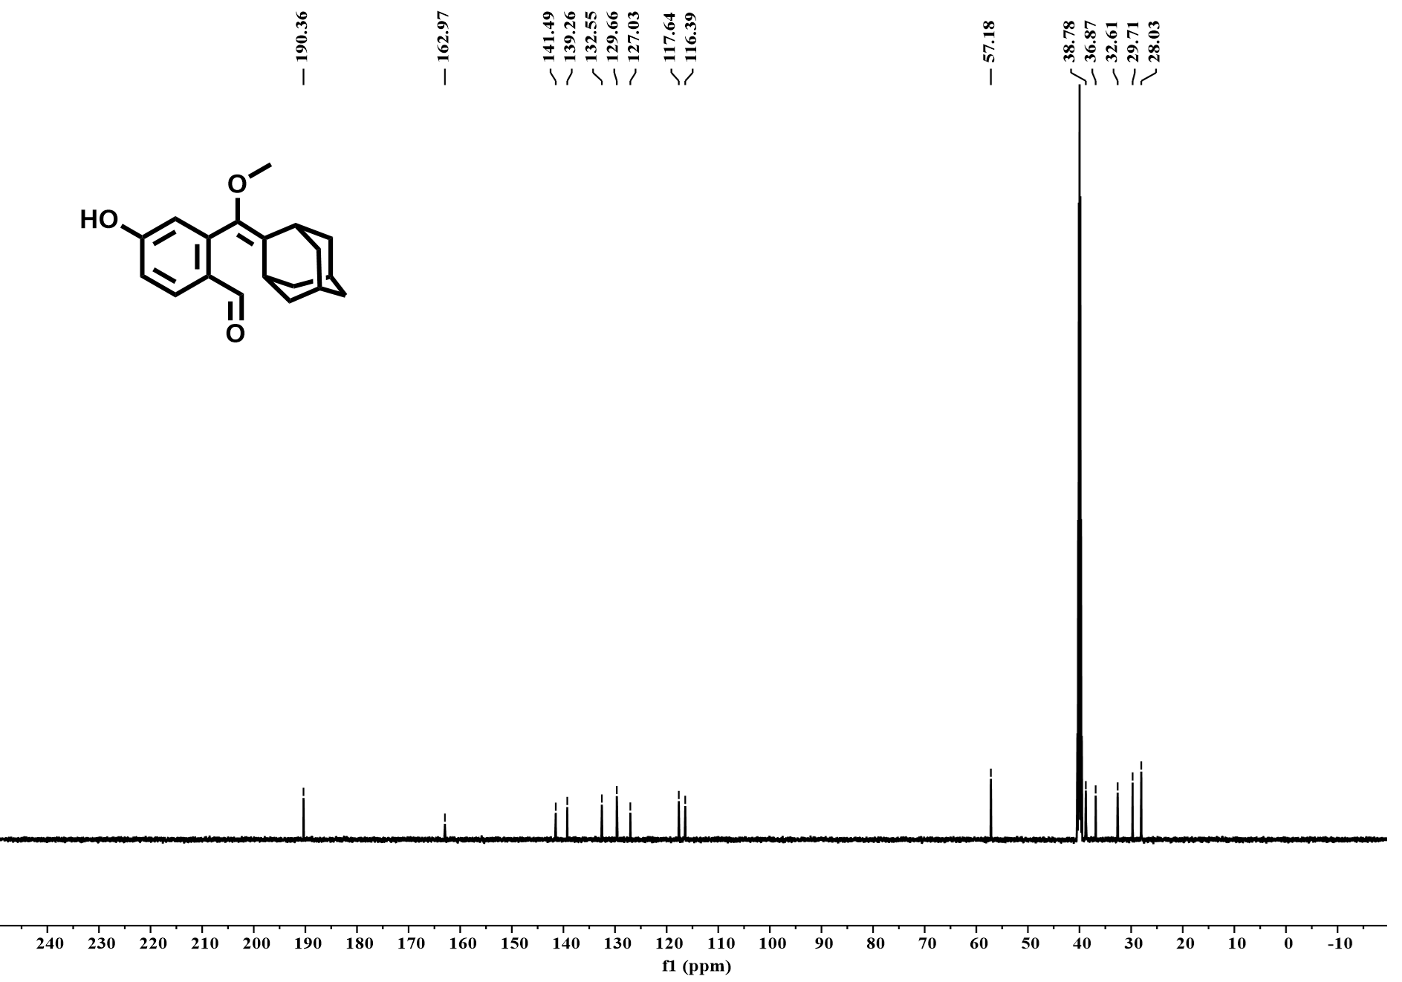
Supplementary Fig. 10 ¹³C NMR spectrum of Compound 2 in DMSO-d₆ (600 MHz, 298 K), δ (ppm, referenced to residual solvent peak).

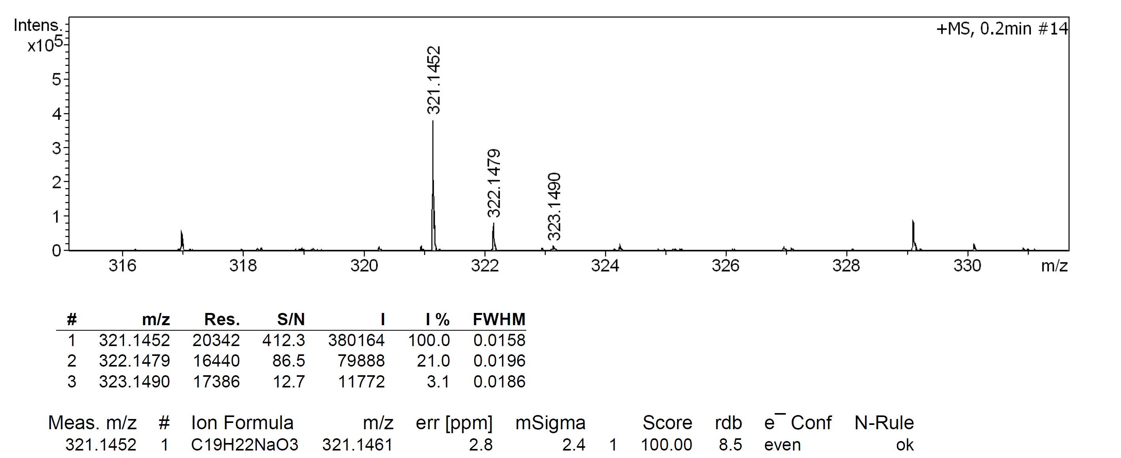
Supplementary Fig. 11 HR-ESI-MS spectrum of Compound 2.

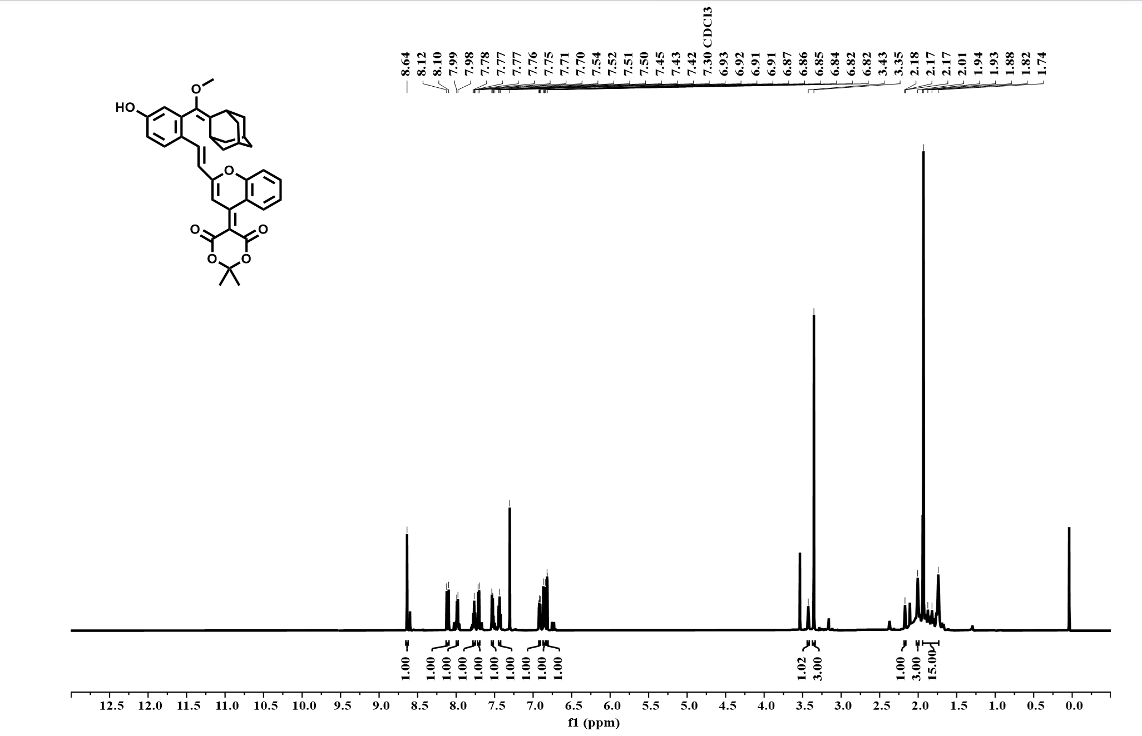
Supplementary Fig. 12 ¹H NMR spectrum of Compound 3 in CDCl₃ (600 MHz, 298 K), δ (ppm, referenced to residual solvent peak).

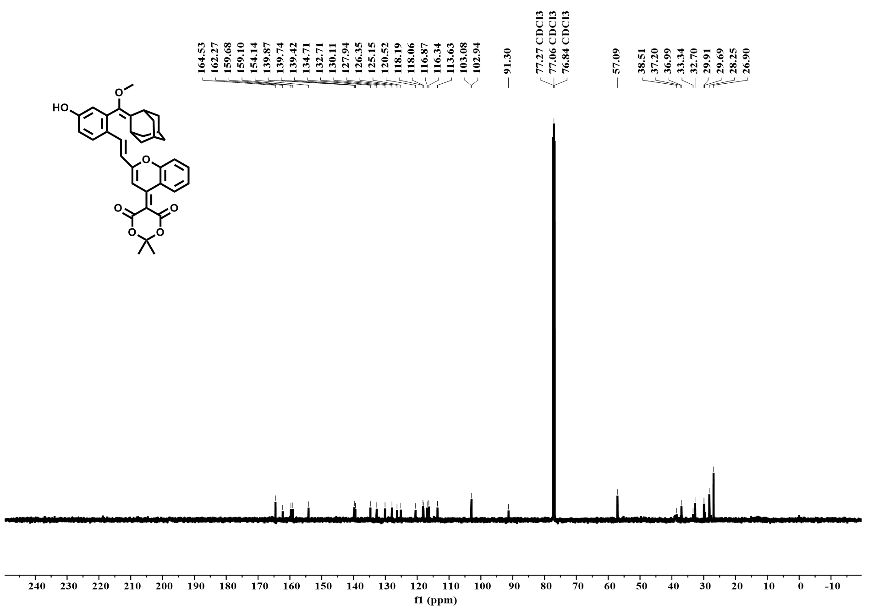
Supplementary Fig. 13 ¹³C NMR spectrum of Compound 3 in CDCl₃ (150 MHz, 298 K), δ (ppm, referenced to residual solvent peak).
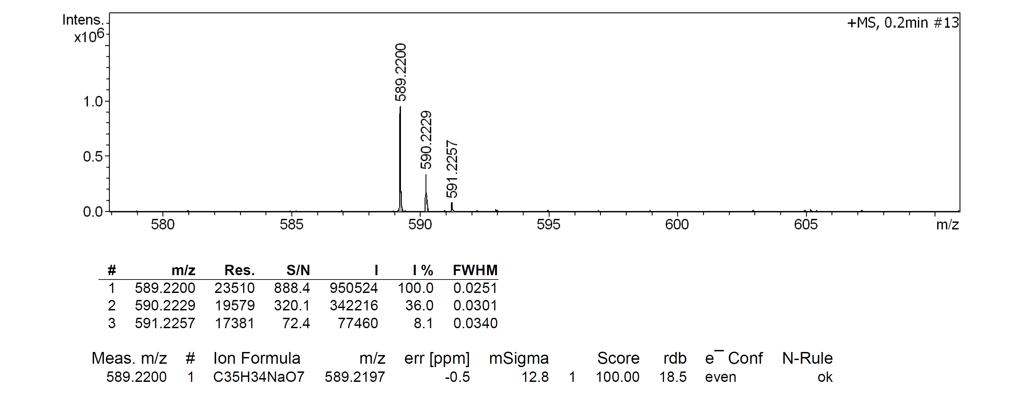
Supplementary Fig. 14 HR-ESI-MS spectrum of Compound 3.

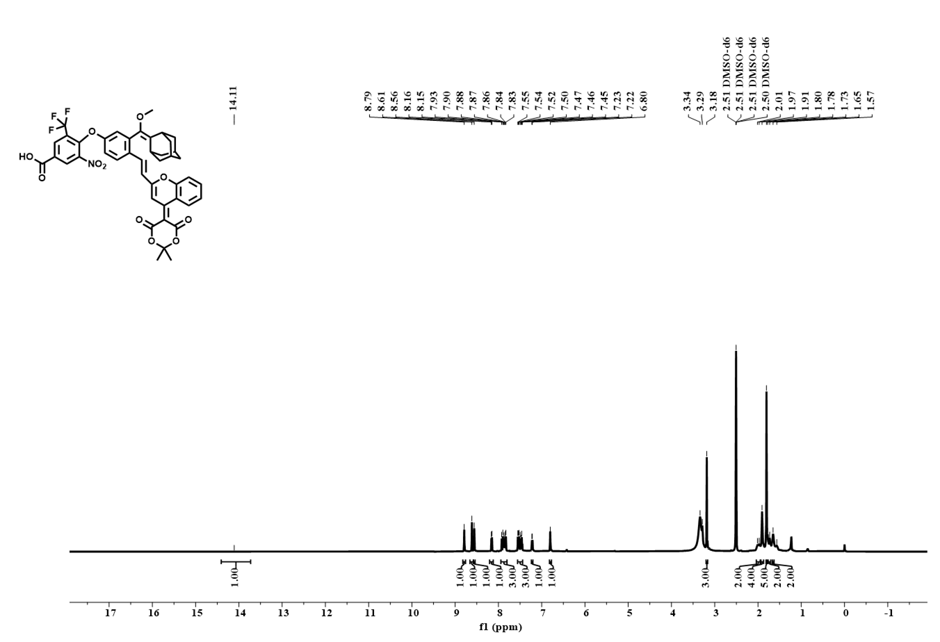
Supplementary Fig. 15 ¹H NMR spectrum of CTAD in DMSO-d₆ (600 MHz, 298 K), δ (ppm, referenced to residual solvent peak).
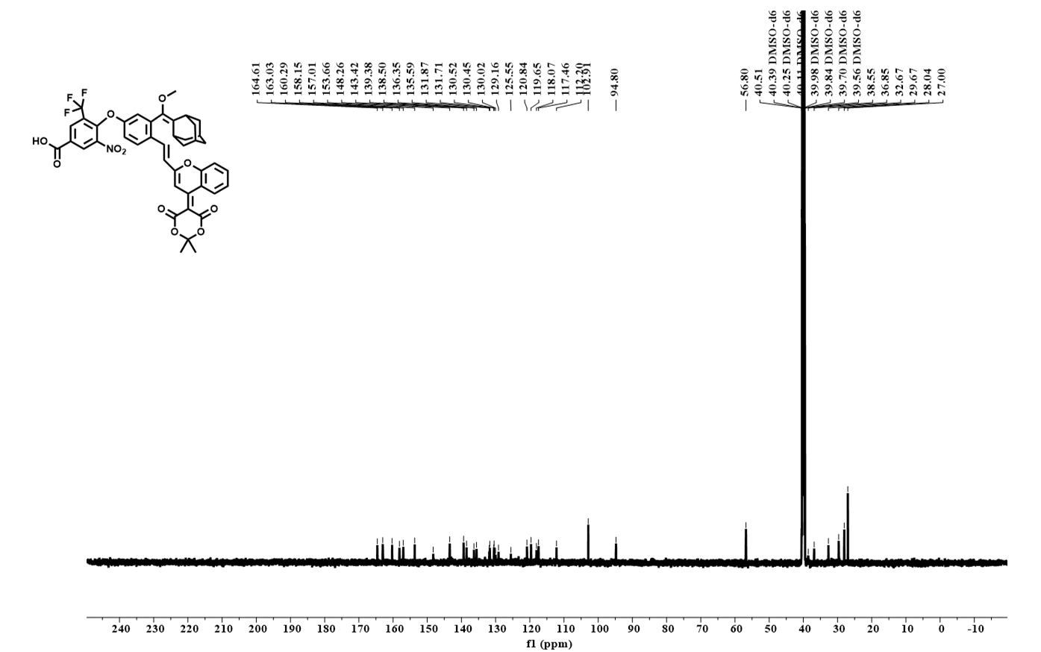
Supplementary Fig. 16 ¹³C NMR spectrum of CTAD in DMSO-d₆ (150 MHz, 298 K), δ (ppm, referenced to residual solvent peak).

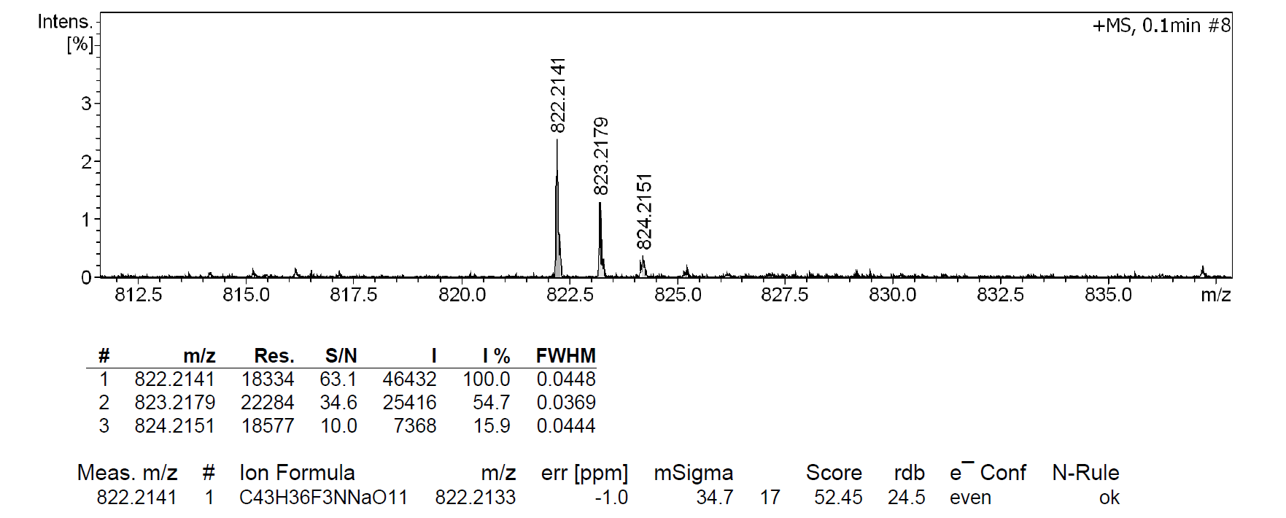
Supplementary Fig. 17 HR-ESI-MS spectrum of CTAD.

Supplementary Fig. 18 Neurotransmitter subtype specificity analysis.
Co-localization of regenerated neurons (EGFP⁺) with glutamatergic (VGLUT1⁺), GABAergic (GAD67⁺), and dopaminergic (TH⁺) markers. n = 3 independent experiments/biological replicates with n = 3 technical replicates each. Scale bars: 100 µm.

Supplementary Fig. 19 Heatmap of representative marker genes across major brain cell types.
Heatmap showing scaled expression of representative lineage marker genes across annotated major brain cell types. For visualization, 90 cells were randomly sampled from each major cell type. Distinct expression patterns support the annotation of oligodendrocytes, neurons, astrocytes, microglial cells, OPCs, and endothelial cells.

Supplementary Fig. 20 Marker gene expression patterns across neuronal subclusters. a, Dot plot showing representative marker genes across seven neuronal subclusters, N1–N7. Dot color indicates average scaled expression, and dot size represents the percentage of cells expressing each gene. b, Violin plots showing expression levels of canonical neuronal subtype markers across N1–N7, including excitatory neuron-associated markers, inhibitory neuron-associated markers, and interneuron-related markers. Distinct marker expression patterns support the annotation of excitatory and inhibitory neuronal subclusters.
Supplementary Fig. 21 Heatmap of representative marker genes across neuronal subclusters.
Heatmap showing scaled expression of representative marker genes across annotated neuronal subclusters. For visualization, 120 cells were randomly sampled from each neuronal subcluster. Cluster-enriched expression patterns support the transcriptional heterogeneity of neuronal subtypes.
Supplementary Table 1 Curated mouse gene signatures used for module-score analysis.
Gene set | Mouse genes
NSC-related gene set | Nes, Sox2, Msi1, Prom1, Pax6
Neurogenesis-related gene set | Neurod1, Dcx, Tubb3, Rbfox3, Map2
NSC proliferation-related gene set | Nes, Sox2, Msi1, Prom1, Pax6, Mki67, Mcm2
Early neuronal differentiation-related gene set | Dcx, Tubb3, Neurod1
Note: Mouse gene symbols are shown using standard mouse nomenclature. Gene-set scores were calculated using the indicated curated signatures
Supplementary Fig. 22 Gene-signature scores across neuronal subclusters. UMAP feature plots showing module scores for four curated mouse gene signatures in neurons. Gene set 1, NSC markers; Gene set 2, Neuronal differentiation/maturation markers; Gene set 3, proliferative NSC/NPCs; and Gene set 4, early neuronal differentiation. b, Violin plots showing the distribution of the corresponding module scores across seven neuronal subclusters, N1–N7. Gene signatures are defined in Table S1.

Supplementary Fig. 23 Pseudotime trajectory analysis of neuronal subclusters during TBI repair. a, Trajectory plot of neuronal subclusters projected in reduced-dimensional component space and colored by pseudotime, showing the inferred progression of neuronal states along the trajectory. b, Trajectory plot colored by experimental group/time point, including control, TBI, Week 3, Week 9, and Week 15, showing the temporal distribution of neuronal cells along the inferred trajectory during injury-to-repair progression.
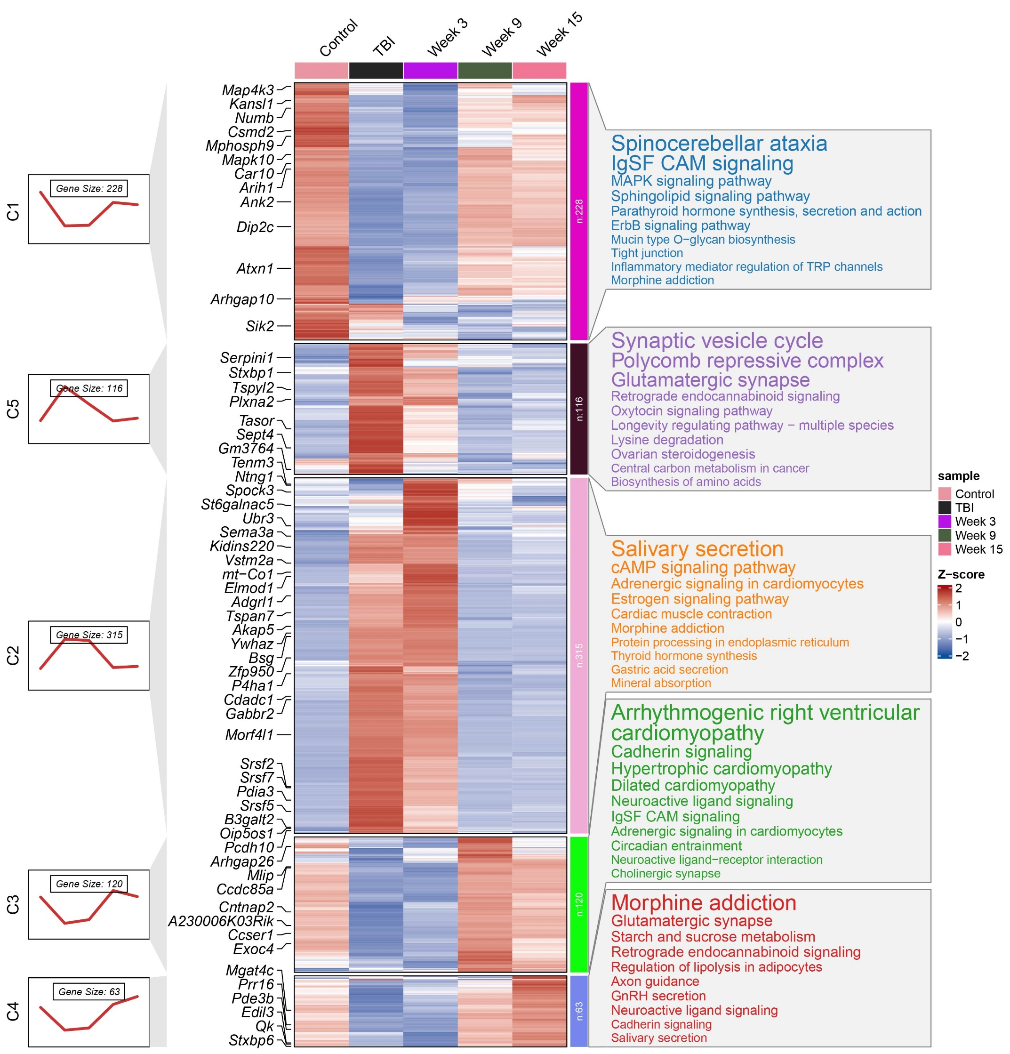
Supplementary Fig. 24 KEGG pathway heatmap showing dynamic pathway activities across TBI progression and ¹O₂-mediated repair.

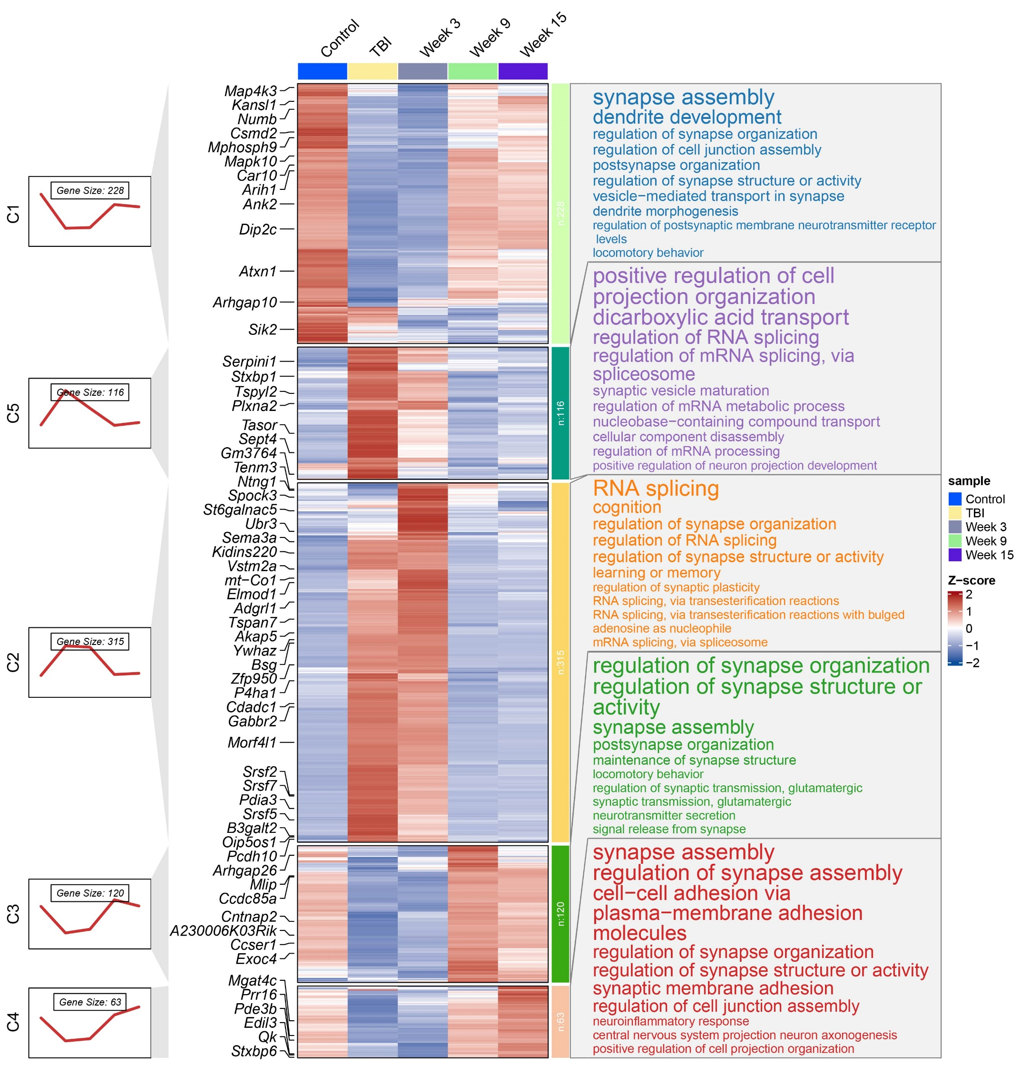
Supplementary Fig. 25 GO biological-process heatmap showing dynamic pathway activities across TBI progression and ¹O₂-mediated repair.

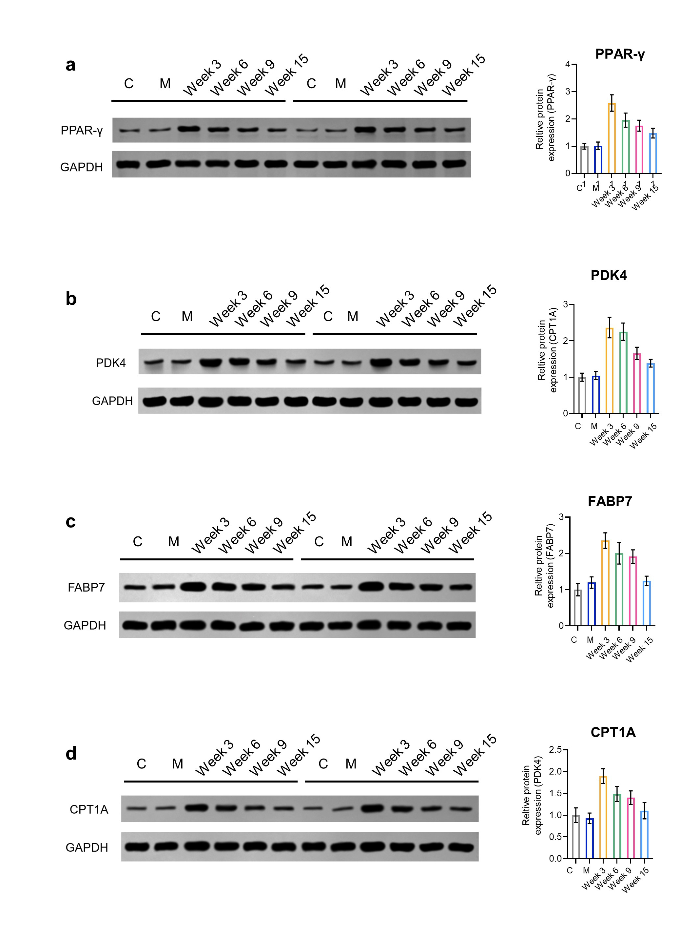
Supplementary Fig. 26 Validation of PPAR signaling pathway by western blot after TBI and treatment. a-d, Representative Western blot images showing protein expression of PPAR-γ (a), PDK4 (b), FABP7 (c), and CPT1A (d) in different groups: healthy control mice (C), TBI mice (M), and treatment cohorts at Week 3 (Week 3), Week 6 (Week 6), Week 9 (Week 9), and Week 15 (Week 15). GAPDH was used as a loading control. e, Quantification of relative protein expression levels normalized to GAPDH, revealing temporal regulation of PPAR signaling-related proteins following TBI and during repair. Data are shown as mean ± s.d., n = 3 independent experiments/biological replicates with n = 3 technical replicates each.

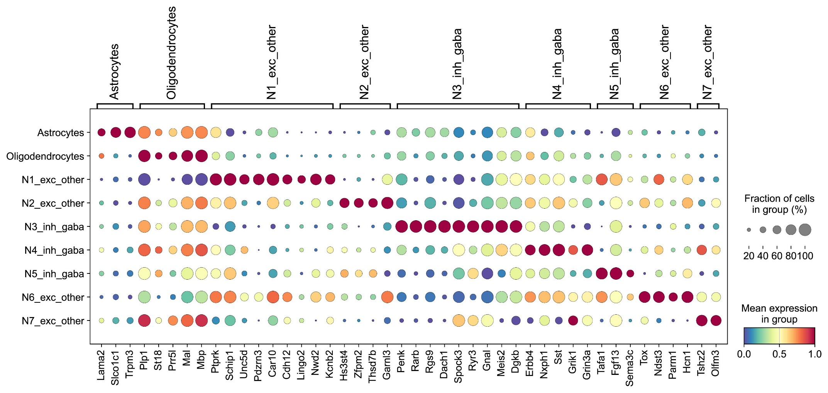
Supplementary Fig. 27 Marker-gene validation of snRNA-seq-to-spatial transcriptomics cell-state mapping.
Dot plot showing the expression of representative marker genes across snRNA-seq-defined cell states after mapping onto spatial transcriptomic spots. Rows indicate mapped cell states, including astrocytes, oligodendrocytes, and N1–N7 neuronal subclusters; columns indicate marker genes grouped by their corresponding cell-state annotations. The selective enrichment of astrocyte, oligodendrocyte, excitatory-neuron, and inhibitory/GABAergic-neuron markers in their matched mapped states supports the consistency of cell-state transfer from snRNA-seq to spatial transcriptomics. Dot size indicates the fraction of cells or spots expressing each gene within the group, and color indicates mean expression level.
Supplementary Fig. 28 Spatial transcriptomic mapping of pathway activities during post-TBI neurorepair. a, Spatial distribution of Gene set1 activity in peri-lesional regions at TBI, Week 3, Week 9, and Week 15, showing dynamic spatial reorganization. b, Spatial activity maps of the PPAR signaling pathway, revealing early activation and sustained responses across regeneration stages. c, Spatial activity of the axon guidance pathway, indicating progressive involvement from injury (TBI) to late repair phases (Week 15). d, Spatial activation of the calcium signaling pathway, enriched along lesion borders at Week 3 and Week 9, consistent with directed neuronal migration.

Supplementary Fig. 29 Spatial feature plots and temporal quantification of NMF-defined niches during TBI repair.
Spatial feature plots showing changes in the spatial enrichment of six NMF-defined niches across TBI, Week 3, Week 9, and Week 15. Niche scores were projected onto spatial transcriptomic coordinates, with warmer colors indicating higher niche enrichment. Line charts on the right show the mean niche score of each niche at the indicated time points. These niches were identified by non-negative matrix factorization based on spatial co-occurrence patterns of annotated cell types.

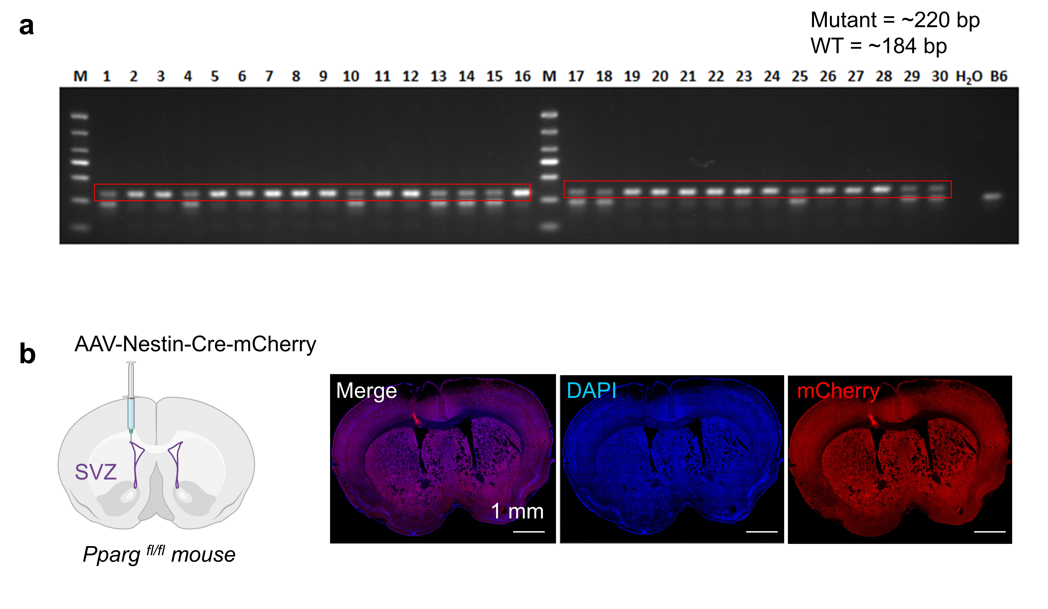

Supplementary Fig. 30 Genotyping and anatomical validation of SVZ-targeted AAV-Nestin-Cre-mCherry delivery in Pparg^{fl/fl} mice. a, Tail genomic PCR genotyping of Pparg^{fl/fl} mice. The floxed Pparg allele was detected at approximately 220 bp, whereas the wild-type allele was detected at approximately 184 bp. Representative PCR products from candidate mice are shown; H₂O served as the no-template control, and B6 genomic DNA served as the wild-type control. b, Schematic and representative coronal brain images showing AAV-Nestin-Cre-mCherry delivery into the SVZ of Pparg^{fl/fl} l mice. DAPI labels nuclei, and mCherry indicates the viral injection region. The localized mCherry signal confirms successful anatomical targeting of the SVZ. Scale bar, 1 mm.

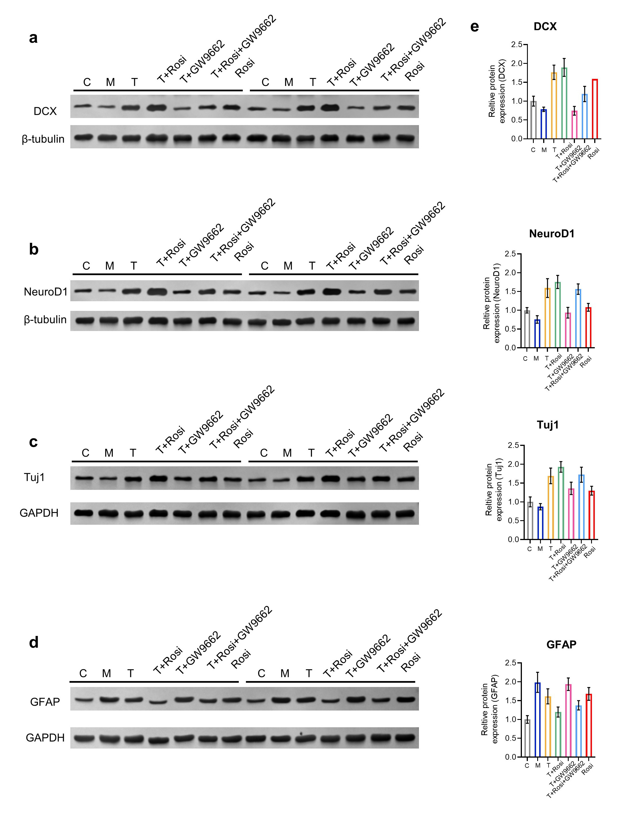
Supplementary Fig. 31 Western blot analysis of neuronal markers after pharmacological modulation of PPARγ. a-d, Representative Western blot images for DCX (a), NeuroD1 (b), Tuj1 (c), and GFAP (d) in healthy control mice (C), injury model mice (M), therapy-treated mice (T), therapy plus the PPARγ agonist rosiglitazone (T+Rosi), therapy plus the PPARγ antagonist GW9662 (T+GW9662), therapy plus combined rosiglitazone and GW9662 treatment (T+Rosi+GW9662), and rosiglitazone alone (Rosi). e, Quantification of relative protein expression levels normalized to β-tubulin or GAPDH. Data are shown as mean ± s.d., n = 3 independent experiments/biological replicates with n = 3 technical replicates each.

