Supplementary Materials Online

Sleep in progressive supranuclear palsy: A systematic review and meta-analysis of polysomnographic findings

Jiaxue Huang ^{1#}; Meiou Wang ^{1#}; Wenxin Bao ¹; Wenqi Lyu ¹; Yongming Wang¹; Shuyao Wu ¹; Xiangdong Tang ¹; Rong Ren ^{1,*}; Ye Zhang ^{1,*}

¹ Sleep Medicine Center, Mental Health Center, National Center for Mental Disorders, Sleep Research Laboratory, West China Hospital, Sichuan University, Chengdu, China
# Contributed equally

*Address correspondence to:
Ye Zhang, MD, PhD, Sleep Medicine Center, Mental Health Center, National Center for Mental Disorders, Sleep Research Laboratory, West China Hospital, Sichuan University, Dian Xin Nan Jie 28#, Chengdu 610041, China; Email: 569389672@qq.com;

Rong Ren, MD, PhD, Sleep Medicine Center, Mental Health Center, National Center for Mental Disorders, Sleep Research Laboratory, West China Hospital, Sichuan University, Dian Xin Nan Jie 28#, Chengdu 610041, China; Email: 498880651@qq.com.
Table S1. Ovid MEDLINE(R) and Epub Ahead of Print, In-Process, In-Data-Review & Other Non-Indexed Citations, Daily and Versions 1946 to Mar 31, 2026 (Up to Apr 1, 2026).
# | Searches | Results
1. | exp Supranuclear Palsy, Progressive/ | 3457
2. | (progressive supranuclear palsy or PSP).ab,ti. | 11416
3. | exp Polysomnography/ | 28114
4. | (polysomnogra* or PSG or sleep architect* or sleep monit* or sleep stage*).ab,ti. | 34847
5. | 1 or 2 | 11833
6. | 3 or 4 | 45068
7. | 5 and 6 | 55
8. | exp animal/ not human/ | 5441203
9. | 7 not 8 | 54

Table S2. Embase via OVID 1974 to 2026 March 9 (Up to Mar 10, 2026).
# | Searches | Results
1. | exp progressive supranuclear palsy/ | 10985
2. | (progressive supranuclear palsy or PSP).ab,ti. | 17973
3. | 1 or 2 | 20476
4. | exp polysomnography/ | 59904
5. | (polysomnogra* or PSG or sleep architect* or sleep monit* or sleep stage*).ab,ti. | 63959
6. | 4 or 5 | 79797
7. | 3 and 6 | 162
8. | exp animal/ not human/ | 6091847
9. | 7 not 8 | 162

Table S3. EBM Reviews - Cochrane Database of Systematic Reviews 2005 to SEP , 2024, Database Field Guide EBM Reviews - ACP Journal Club 1991 to August 2023, Database Field Guide EBM Reviews - Database of Abstracts of Reviews of Effects 1st Quarter 2016, Database Field Guide EBM Reviews - Cochrane Clinical Answers August 2023, Database Field Guide EBM Reviews - Cochrane Central Register of Controlled Trials July 2023, Database Field Guide EBM Reviews - Cochrane Methodology Register 3rd Quarter 2012, Database Field Guide EBM Reviews - Health Technology Assessment 4th Quarter 2016, Database Field Guide EBM Reviews - NHS Economic Evaluation Database 1st Quarter 2016 (Up to Mar 9, 2026).
# | Searches | Results
1. | (progressive supranuclear palsy or PSP).ab,ti. | 935
2. | (polysomnogra* or PSG or sleep architect* or sleep monit* or sleep stage*).ab,ti. | 7012
3. | 1 and 2 | 1

Table S4. Web of Science (Search in: All Databases; Collections: All) (Up to Mar 9, 2026).
# | Searches | Results
1. | (TI=(progressive supranuclear palsy or PSP)) OR AB=(progressive supranuclear palsy or PSP) and Preprint Citation Index (Exclude – Database) | 29179
2. | (TI=(polysomnogra* or PSG or sleep architect* or sleep monit* or sleep stage*)) OR AB=(polysomnogra* or PSG or sleep architect* or sleep monit* or sleep stage*) and Preprint Citation Index (Exclude – Database) | 113723
3. | #2 AND #1 and Preprint Citation Index (Exclude – Database) | 122

Table S5. Studies excluded with reasons.
Studies | Reasons
Miyamoto et al., 2008 [1] | No target outcome
Boini et al., 2022 [2] | No target outcome
Borroni et al., 2008 [3] | No target outcome
Gama et al., 2010 [4] | No target outcome
Munhoz et al., 2014 [5] | No target outcome
Quadalti et al., 2021 [6] | No target outcome
Chen et al., 2025 [7] | No target outcome
Woo et al., 2022 [8] | No target outcome
Perret et al., 1980 [9] | No target control
Ruppert et al., 2025 [10] | No target outcome
Nomura et al., 2008 [11] | No target control
Sixel-Döring et al., 2008 [12] | No target control
Levendowski et al., 2023 [13] | Overlapping data
Oh et al., 2022 [14] | Overlapping data

References of excluded studies

1. Miyamoto T, Miyamoto M, Suzuki K, Nishibayashi M, Iwanami M, Hirata K. 123I-MIBG cardiac scintigraphy provides clues to the underlying neurodegenerative disorder in idiopathic REM sleep behavior disorder. Sleep. 2008;31(5):717-23. Comment in: Sleep. 2008 Dec;31(12):1627. doi: 10.1093/sleep/31.12.1627 PMID: 19090317 [https://pubmed.ncbi.nlm.nih.gov/19090317]. doi:https://dx.doi.org/10.1093/sleep/31.5.717
2. Boini SY, Mahale R, Venkata SD, et al. Oculomotor abnormalities and its association with sleep stages in progressive supranuclear palsy. SLEEP MEDICINE. OCT 2022;98:34-38. doi:10.1016/j.sleep.2022.06.008
3. Borroni B, Turla M, Bertasi V, Agosti C, Gilberti N, Padovani A. Cognitive and behavioral assessment in the early stages of neurodegenerative extrapyramidal syndromes. Article. ARCHIVES OF GERONTOLOGY AND GERIATRICS. 2008 JUL-AUG 2008;47(1):53-61. doi:10.1016/j.archger.2007.07.005
4. Gama RL, Távora DG, Bomfim RC, Silva CE, de Bruin VM, de Bruin PFC. Sleep disturbances and brain MRI morphometry in Parkinson's disease, multiple system atrophy and progressive supranuclear palsy - a comparative study. PARKINSONISM & RELATED DISORDERS. MAY 2010;16(4):275-279. doi:10.1016/j.parkreldis.2010.01.002
5. Munhoz RP, Teive HA. REM sleep behaviour disorder: How useful is it for the differential diagnosis of parkinsonism? CLINICAL NEUROLOGY AND NEUROSURGERY. DEC 2014;127:71-74. doi:10.1016/j.clineuro.2014.09.014
6. Quadalti C, Calandra-Buonaura G, Baiardi S, et al. Neurofilament light chain and α-synuclein RT-QuIC as differential diagnostic biomarkers in parkinsonisms and related syndromes. NPJ PARKINSONS DISEASE. OCT 11 2021;7(1)93. doi:10.1038/s41531-021-00232-4
7. Chen Y, Li YM, Huang JM, Cai YJ, Chen XC, Ye QY. Comparative study of nonmotor symptoms in progressive supranuclear palsy and Parkinson's disease. BMC NEUROLOGY. MAY 19 2025;25(1)213. doi:10.1186/s12883-025-04225-1
8. Woo KA, Shin JY, Kim H, Ahn J, Jeon B, Lee JY. Peripapillary retinal nerve fiber layer thinning in patients with progressive supranuclear palsy. JOURNAL OF NEUROLOGY. JUN 2022;269(6):3216-3225. doi:10.1007/s00415-021-10936-5
9. Perret JL, Jouvet M. STUDY OF SLEEP IN PROGRESSIVE SUPRANUCLEAR PALSY. Article. ELECTROENCEPHALOGRAPHY AND CLINICAL NEUROPHYSIOLOGY. 1980 1980;49(3-4):323-329. doi:10.1016/0013-4694(80)90226-6
10. Ruppert E, Mix N, Kesper K, et al. Deceleration Capacity as a Marker of Autonomic Cardiac Modulation in Prodromal and Manifest Parkinson's Disease, Multiple System Atrophy, and Progressive Supranuclear Palsy. EUROPEAN JOURNAL OF NEUROLOGY. NOV 2025;32(11)e70395. doi:10.1111/ene.70395
11. Nomura T, Inoue Y, Uemura Y, et al. Comparison of REM sleep behaviour disorder related symptoms and polysomnographic findings between patients with progressive supranuclear palsy and Parkinson's disease. Meeting Abstract. EUROPEAN JOURNAL OF NEUROLOGY. 2008 AUG 2008;15:99-99.
12. Sixel-Doring F, Schweitzer M, Mollenhauer B, Trenkwalder C. Polysomnographic findings, video-based sleep analysis and sleep perception in progressive supranuclear palsy. Sleep Medicine. 2009;10(4):407-415. doi:https://dx.doi.org/10.1016/j.sleep.2008.05.004
13. Levendowski DJ, Walsh CM, Boeve BF, et al. Non-REM sleep with hypertonia in Parkinsonian Spectrum Disorders: A pilot investigation. Sleep Medicine. 2022;100:501-510. doi:https://dx.doi.org/10.1016/j.sleep.2022.09.025
14. Oh JY, Walsh CM, Ranasinghe K, et al. Subcortical Neuronal Correlates of Sleep in Neurodegenerative Diseases. JAMA Neurology. 2022;79(5):498-508. doi:https://dx.doi.org/10.1001/jamaneurol.2022.0429

Table S6. Risk of bias assessment based on a Quality Appraisal Criteria - adapted from Joanna Briggs Institute making comparisons between individuals with PSP and controls
Study | Group comparability | Matching | Criteria consistency | Confounders identified | Strategies confounding | Outcome assessment validity | Statistical methodology
Baschieri et al., 2026 | NO | NO | YES | NO | NO | YES | YES
Arnulf et al., 2005 | YES | YES | YES | YES | YES | YES | YES
Boini et al., 2022 | YES | YES | YES | YES | YES | YES | YES
De Cock et al., 2007 | YES | YES | YES | YES | YES | YES | YES
Levendowski et al., 2022 | YES | YES | YES | YES | YES | YES | YES
Lu et al., 2025 | YES | YES | YES | YES | YES | YES | YES
Walsh et al., 2017 | YES | YES | YES | YES | YES | YES | YES
Montplaisir et al., 1997 | YES | YES | YES | YES | YES | YES | YES

Figure S1. Funnel plot for meta-analysis of studies estimating the difference in total sleep time between PSP individuals and controls; Egger test p value=0.259.
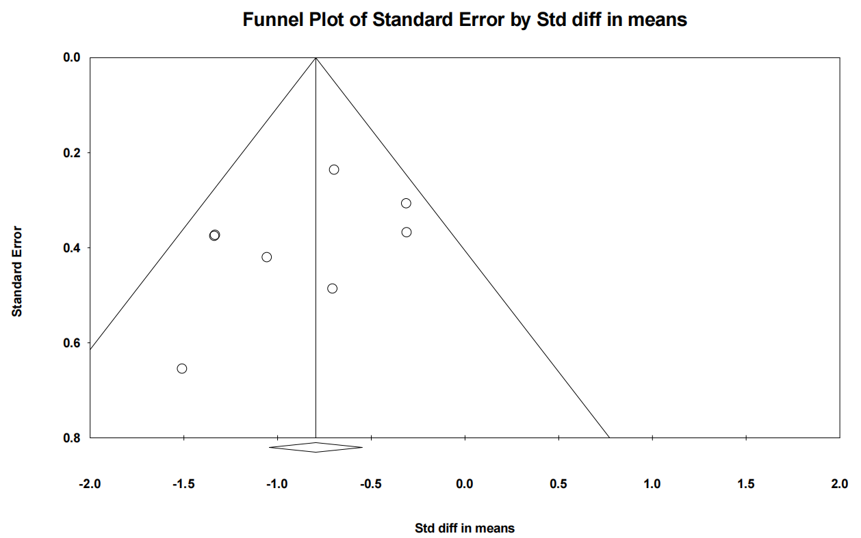

Figure S2. Funnel plot for meta-analysis of studies estimating the difference in wake after sleep onset between PSP individuals and controls; Egger test p value=0.601.
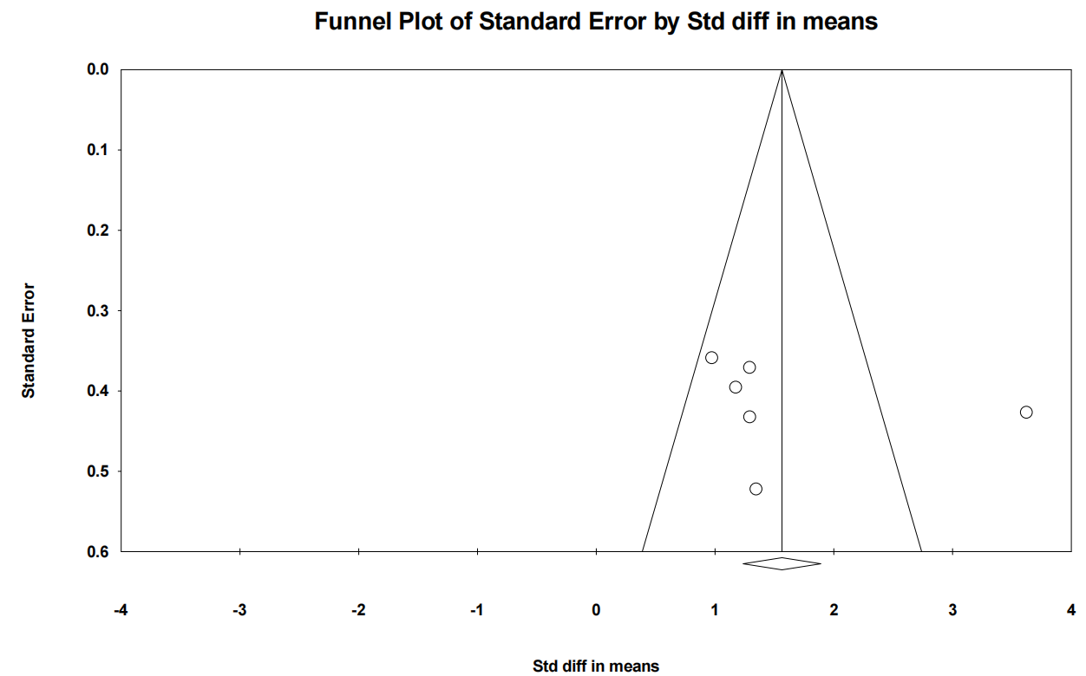
Figure S3. Funnel plot for meta-analysis of studies estimating the difference in sleep efficiency between PSP individuals and controls; Egger test p value=0.237.
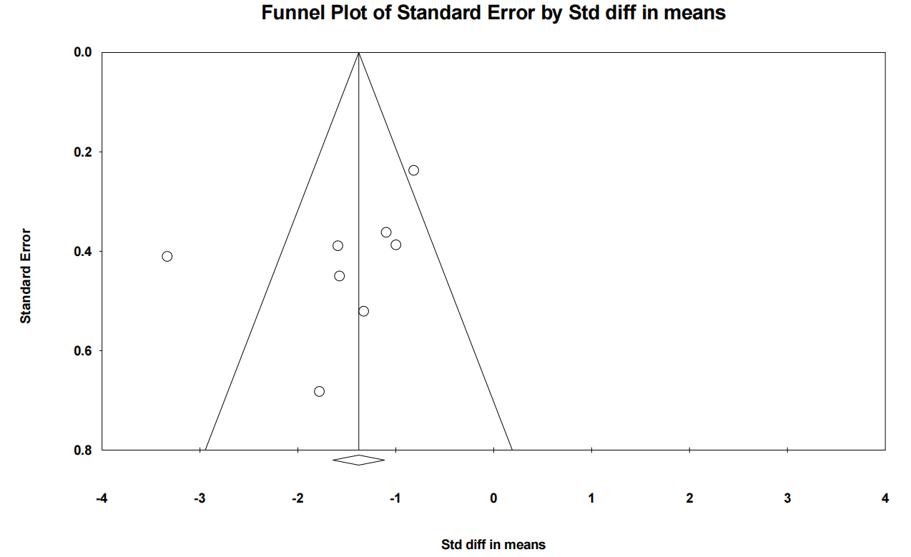

Figure S4. Funnel plot for meta-analysis of studies estimating the difference in sleep latency between PSP individuals and controls; Egger test p value=0.868.
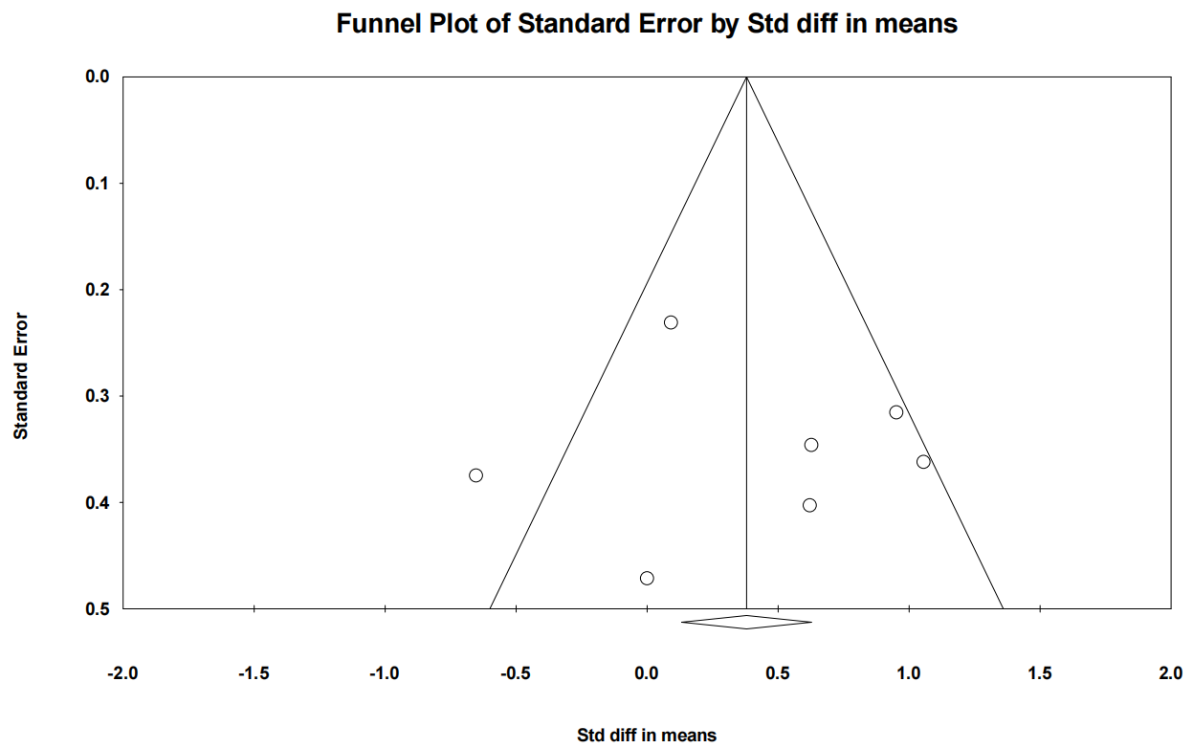
Figure S5. Funnel plot for meta-analysis of studies estimating the difference in N1 percentage between PSP individuals and controls; Egger test p value=0.025.
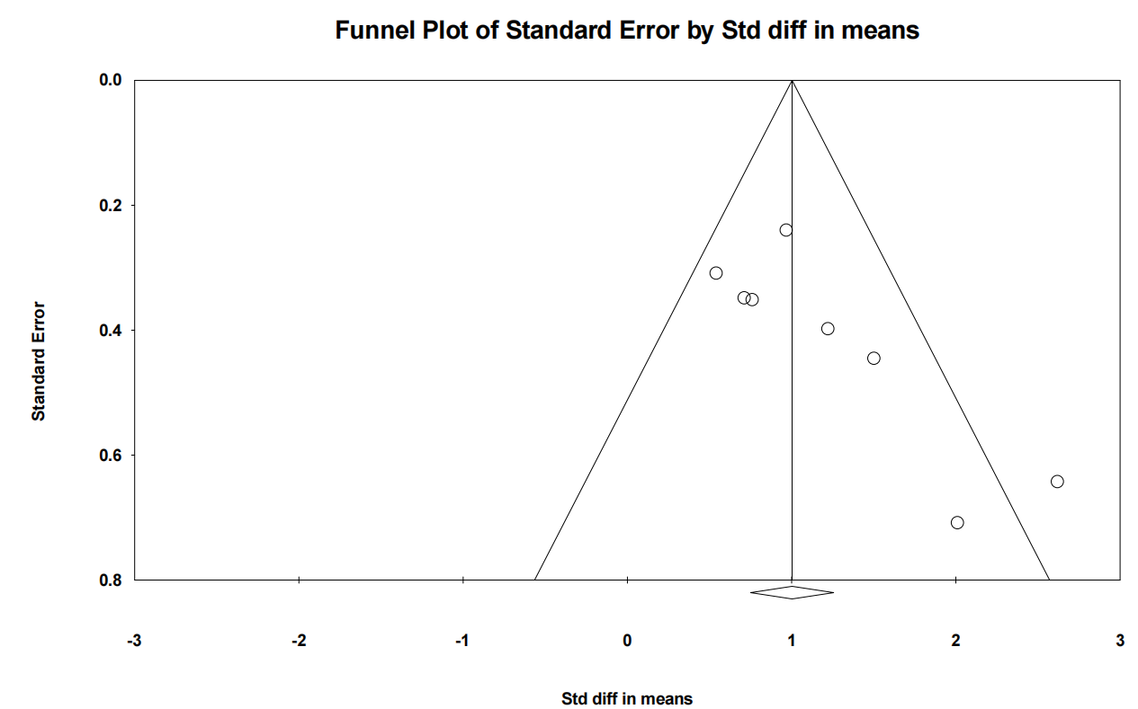

Figure S6. Funnel plot for meta-analysis of studies estimating the difference in N2 percentage between PSP individuals and controls; Egger test p value=0.101.
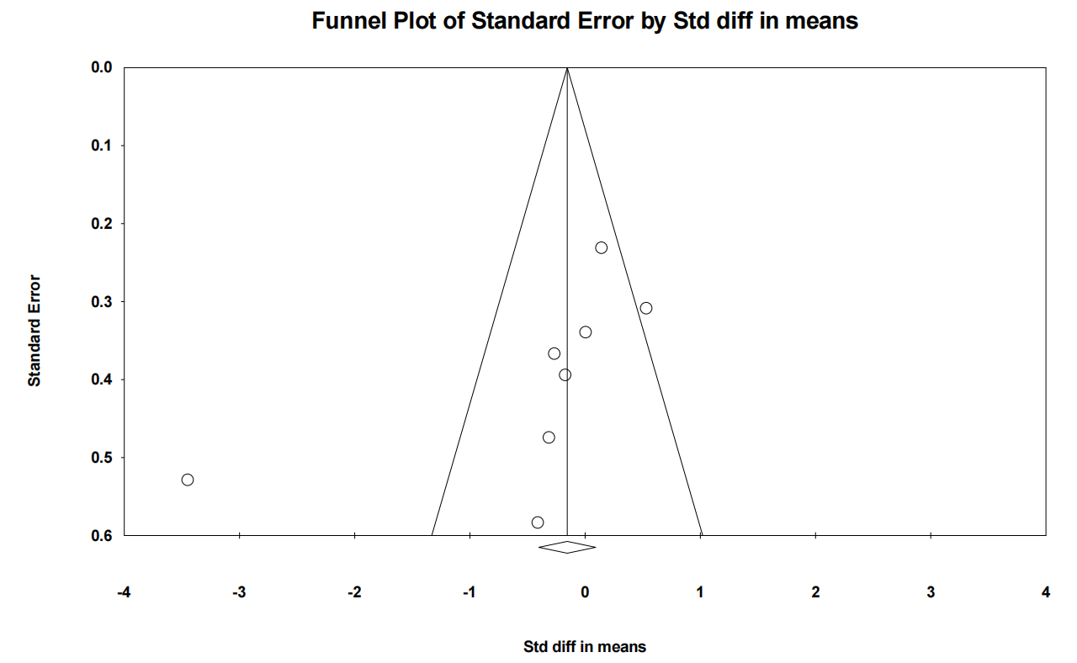
Figure S7. Funnel plot for meta-analysis of studies estimating the difference in N3 percentage between PSP individuals and controls; Egger test p value=0.086.
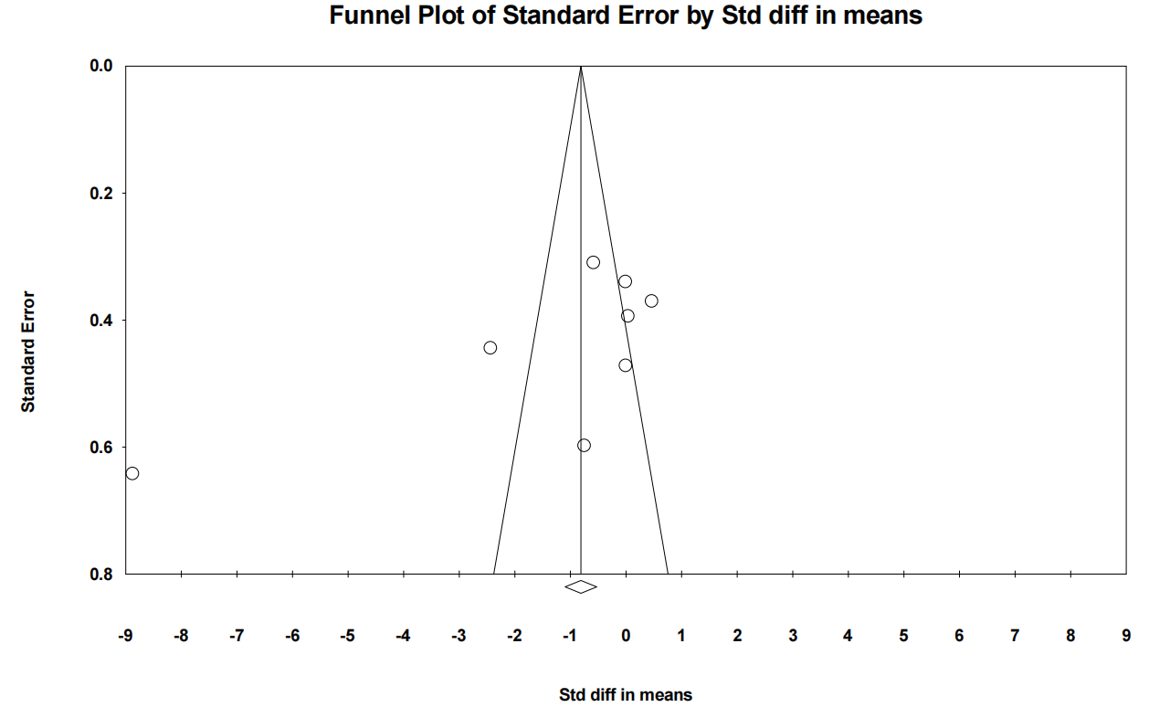

Figure S8. Funnel plot for meta-analysis of studies estimating the difference in REM percentage between PSP individuals and controls; Egger test value=0.011.
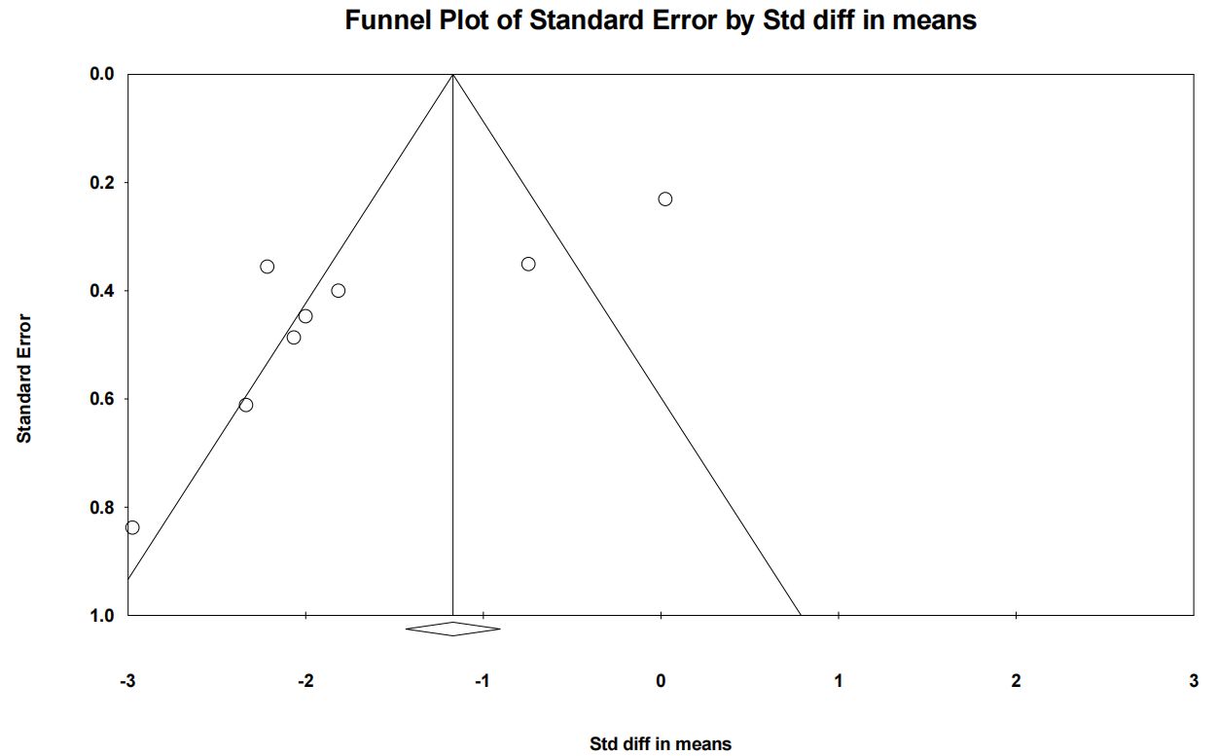
Figure S9. Funnel plot for meta-analysis of studies estimating the difference in REM latency between PSP individuals and controls; Egger test p value=0.015.
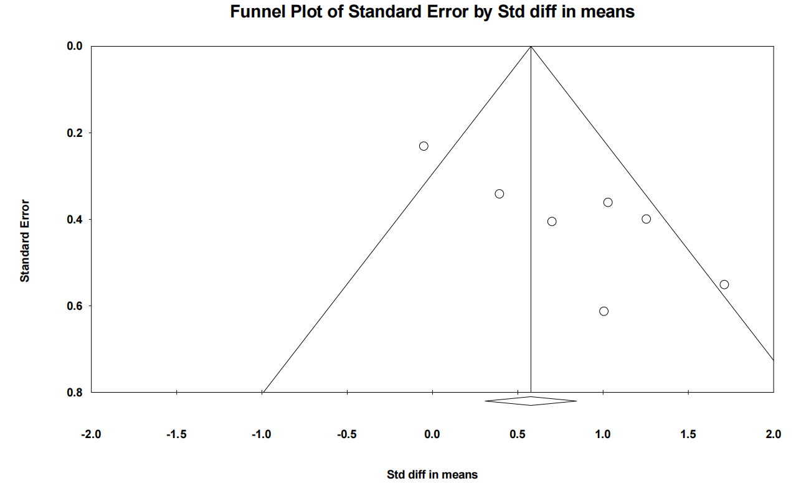

Figure S10. Funnel plot for meta-analysis of studies estimating the difference in arousal index between PSP individuals and controls; Egger test p value=0.297.
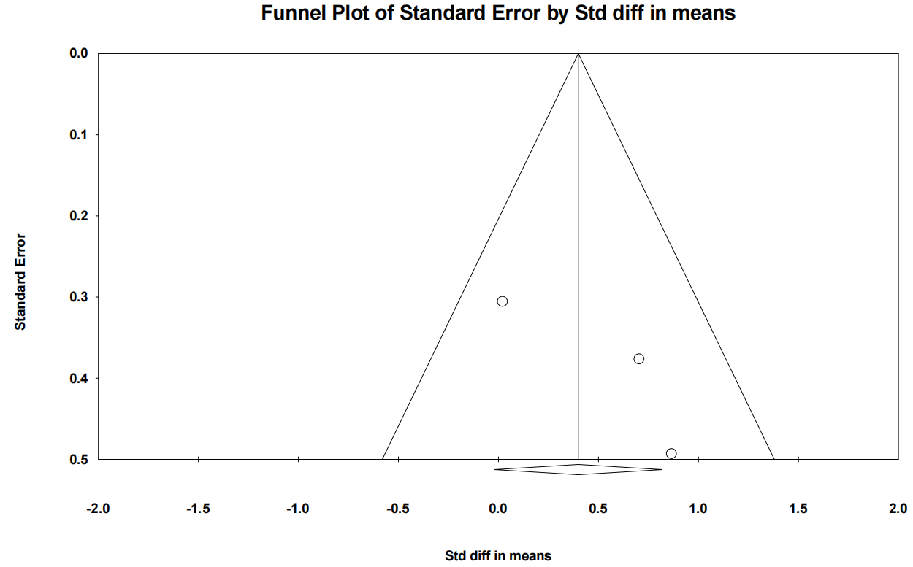

Figure S11. Funnel plot for meta-analysis of studies estimating the difference in apnea-hypopnea index between PSP individuals and controls; Egger test p value=0.856.
