Graphical Abstract
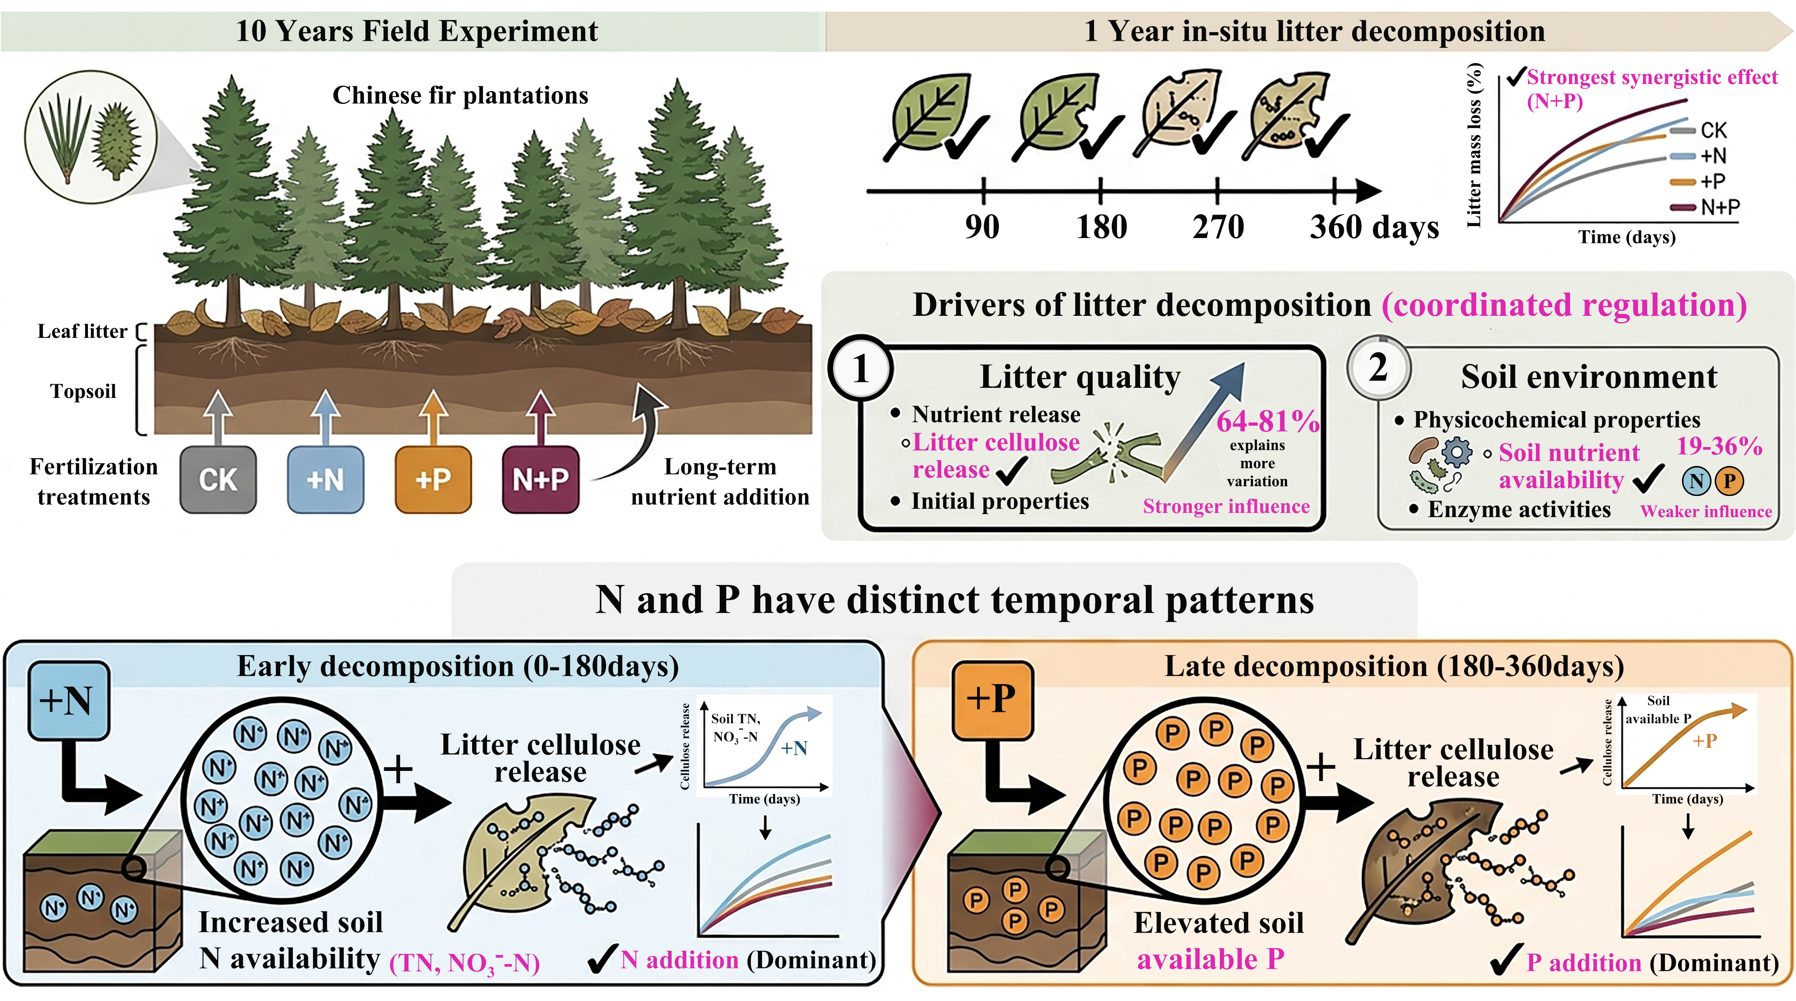
Schematic diagram suggesting the changes of litter decomposition under long-term nitrogen and phosphorus addition and its driving factors in a Chinese fir plantation.

