Water Quality Under Stress: Population Pressure, Environmental Degradation, and Climate Impact: Evidence from Refugee Camps in Cox’s Bazar District, Bangladesh (2016-2024)

Maurizio Teobaldelli¹, Anna Rosińska²*, Caterina Cacciatori², Bernd Manfred Gawlik² and Jan Loeschner²

1 Arcadia SIT s.r.l., Italy
2 European Commission, Joint Research Centre
* Correspondence: dr.anna.maria.rosinska@gmail.com

Supplementary Material

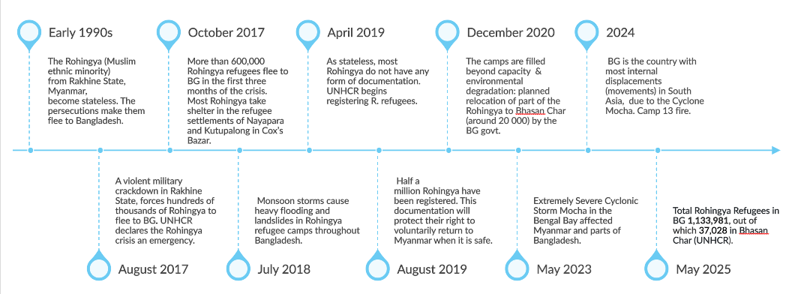
Figure S1. Timeline of Rohingya refugees’ presence in Bangladesh from the early 1990s to May 2025.

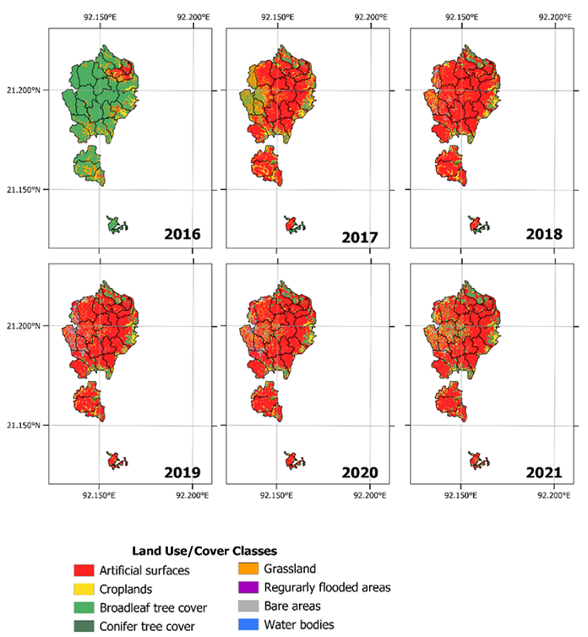
Figure s2. Land use/cover changes (Rosinska, Teobaldelli, 2025) occurred in the refugee camps in Cox’s Bazar (Bangladesh) from 2016 to 2021, modified after ARICA (Centrum UNEP/GRID-Warszawa, 2021). Here and only for reference purposes, refugee camp borders are those reported by official agencies in May 2018 (HDX, 2026).

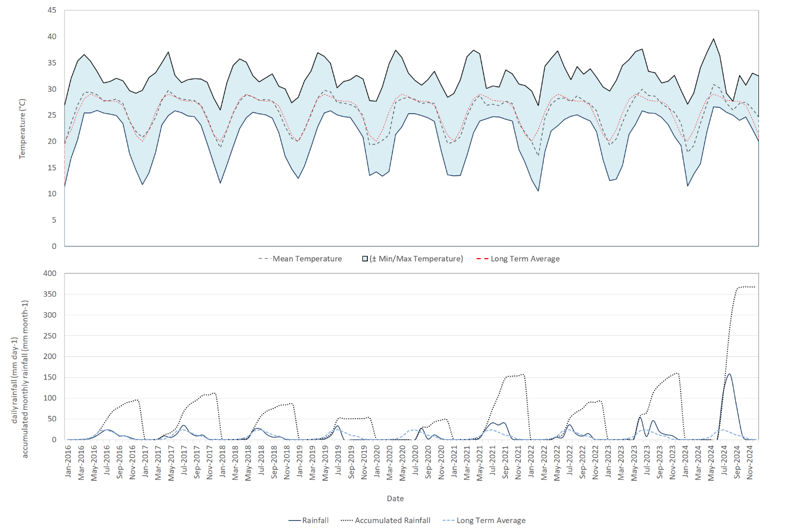
(A)
(B)
Figure S3. Interannual monthly variation of (A) temperature (min, max, mean, accumulated, and long-term average) and (B) rainfall (daily mean rate, monthly accumulated rate and long-term average) in Cox’s Bazar district for the period 2016-2024 (ICIMOD, 2026).

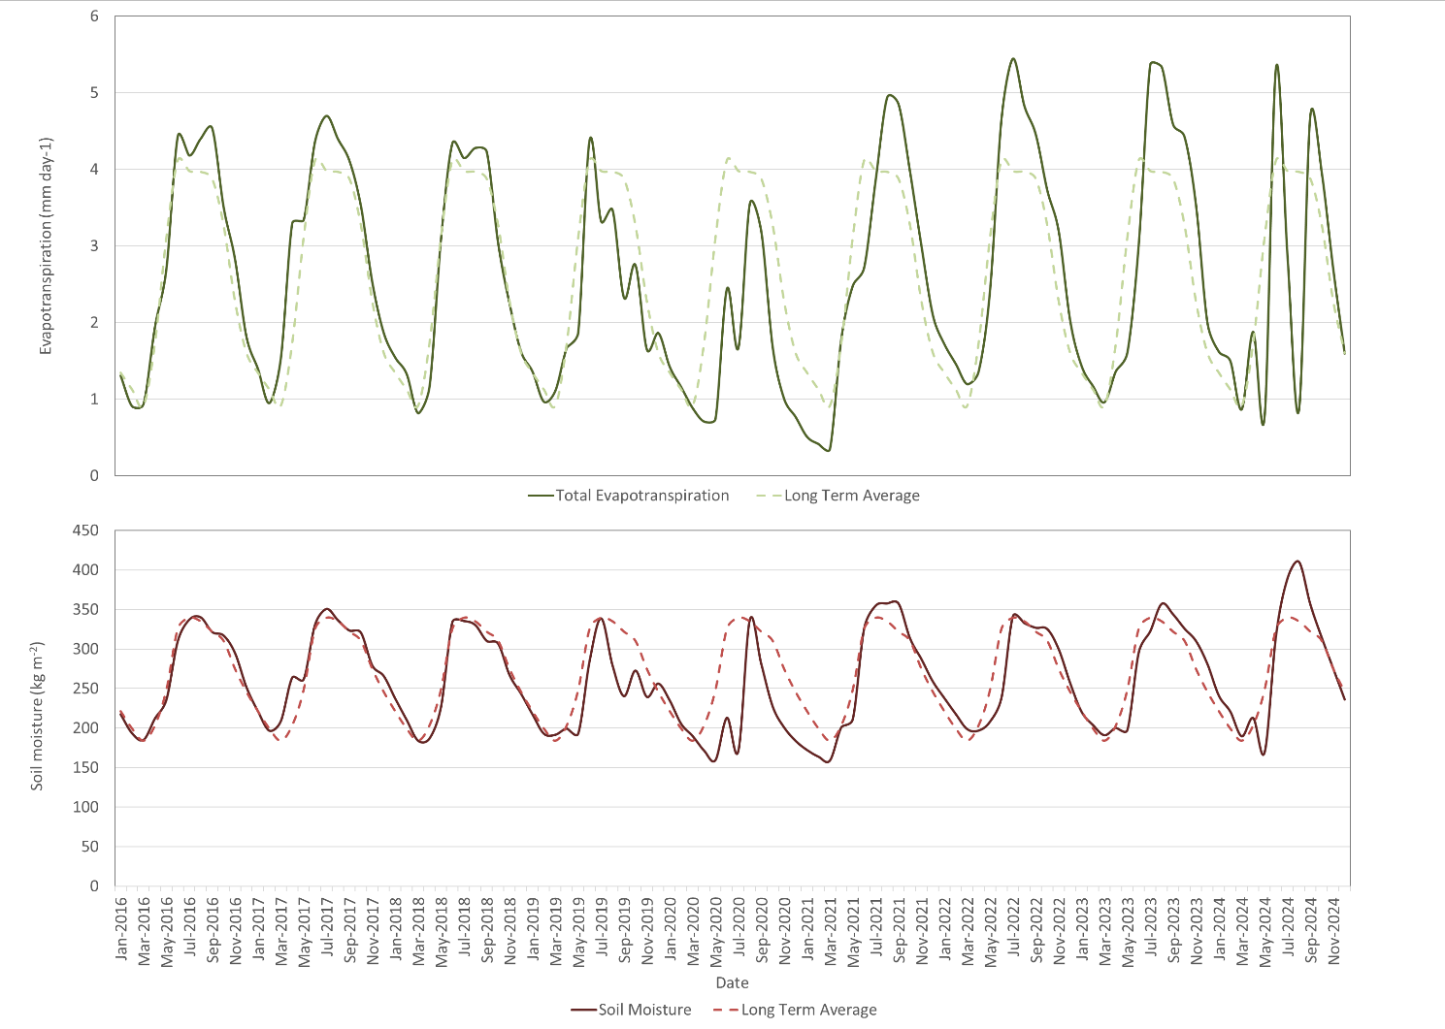
(A)
(B)
Figure S4. Interannual monthly variation of (A) evapotranspiration (total and long-term average) and (B) soil moisture (mean and long-term average) in Cox’s Bazar district for the period 2016-2024 (ICIMOD, 2026).

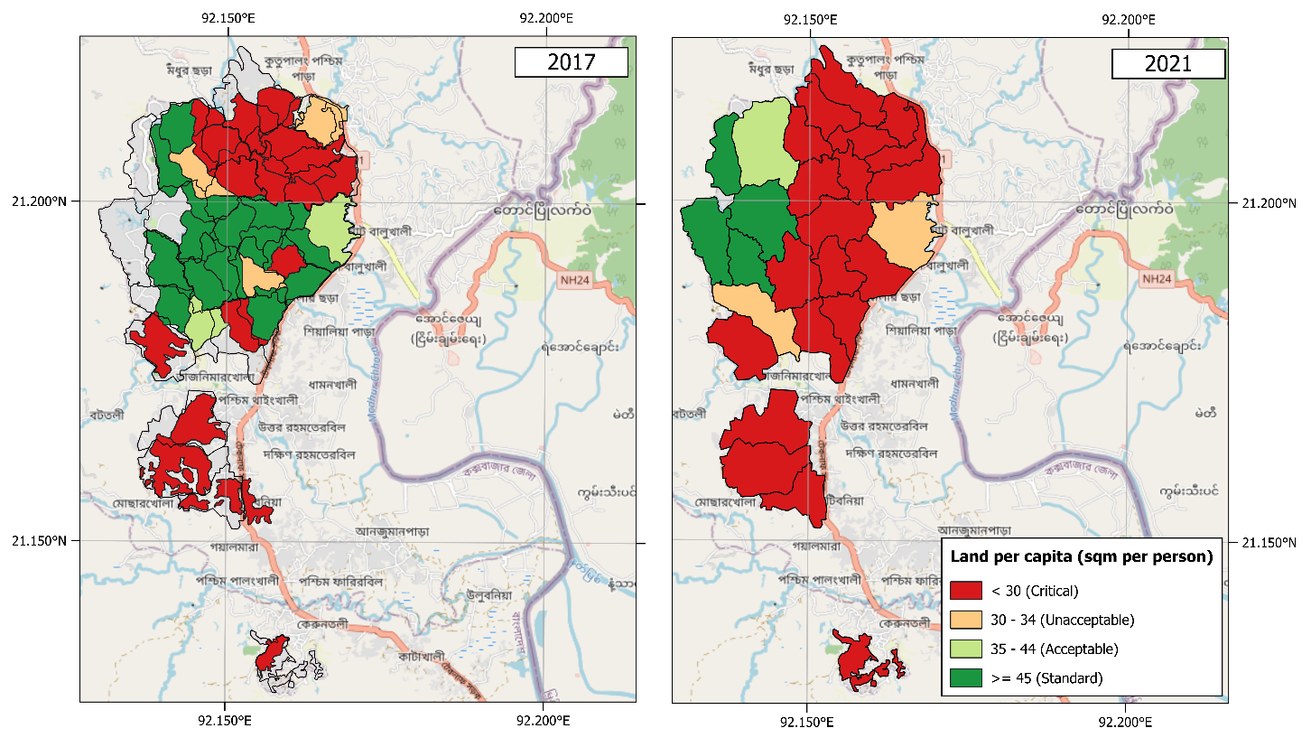
Figure S5. Land per capita in 2017 (left) and 2021 (right) in refugee camps of Cox's Bazar (Rosinska, Teobaldelli, 2025)

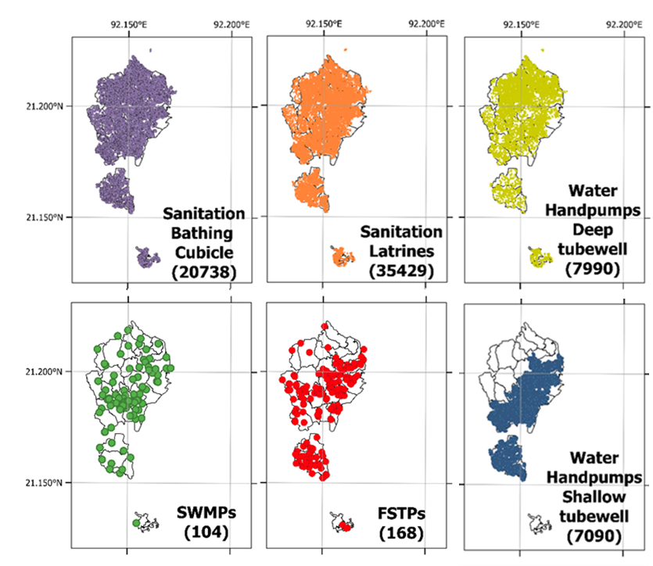
Figure S6. WASH, SWMPs, and FSTPs infrastructure (total number and location) reported in July-August 2024 in selected refugee camps in Cox’s Bazar (Bangladesh) (UNHCR, 2026c). SWMP: “Solid Waste Management Plant”; FSTP: “Faecal Sludge Treatment Plant”.

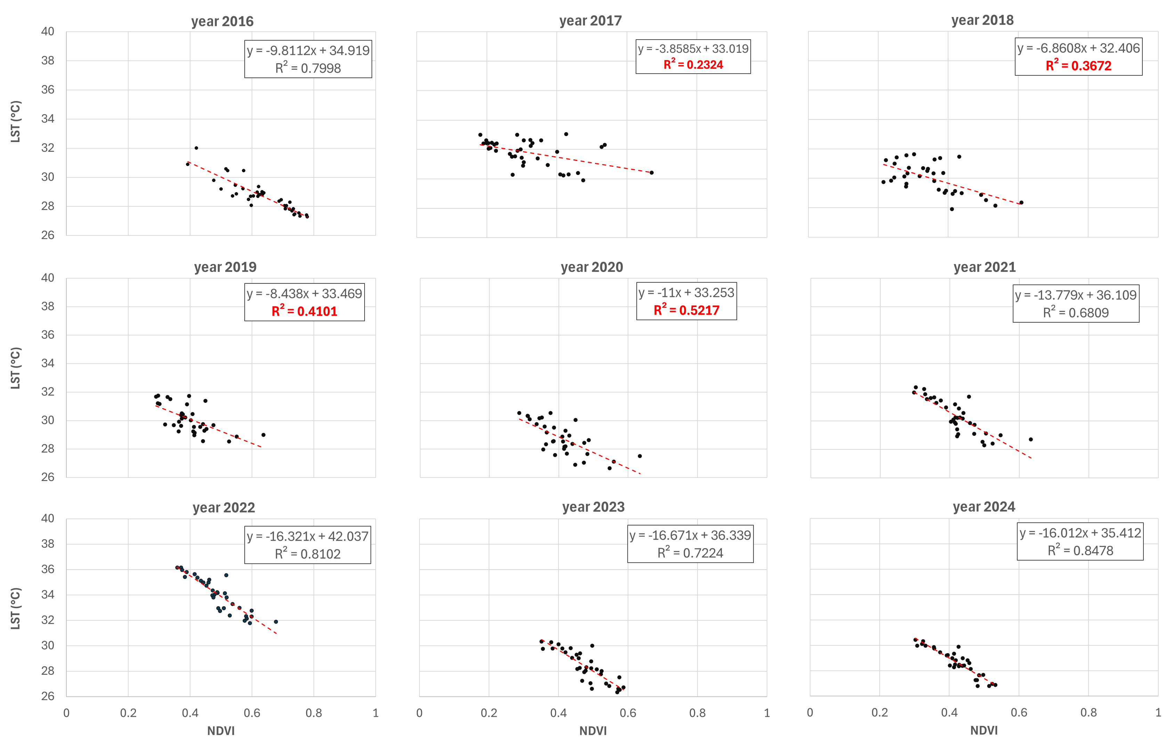
Figure S7. Yearly relationship between LST and NDVI in refugee Camps in Cox’s Bazar for the year 2016-2024

Table S1. Refugee camps in Cox’s Bazar included in this study
Location | Year
Location | 2017 | 2018 | 2019 | 2020 | 2021 | 2022 | 2023 | 2024
Balukhali MS | ● | ○ | ○ | ○ | ○ | ○ | ○ | ○
Chakmarkul | ● | ○ | ○ | ○ | ○ | ○ | ○ | ○
Hakimpara | ● | ○ | ○ | ○ | ○ | ○ | ○ | ○
Jamtoli | ● | ○ | ○ | ○ | ○ | ○ | ○ | ○
Moynarghona | ● | ○ | ○ | ○ | ○ | ○ | ○ | ○
Nayapara Extension | ● | ○ | ○ | ○ | ○ | ○ | ○ | ○
Shamlapur | ● | ○ | ○ | ○ | ○ | ○ | ○ | ○
Thangkhali | ● | ○ | ○ | ○ | ○ | ○ | ○ | ○
Unchiprang | ● | ○ | ○ | ○ | ○ | ○ | ○ | ○
Zone AA | ● | ○ | ○ | ○ | ○ | ○ | ○ | ○
Zone BB | ● | ○ | ○ | ○ | ○ | ○ | ○ | ○
Zone CC | ● | ○ | ○ | ○ | ○ | ○ | ○ | ○
Zone DD | ● | ○ | ○ | ○ | ○ | ○ | ○ | ○
Zone EE | ● | ○ | ○ | ○ | ○ | ○ | ○ | ○
Zone FF | ● | ○ | ○ | ○ | ○ | ○ | ○ | ○
Zone GG | ● | ○ | ○ | ○ | ○ | ○ | ○ | ○
Zone HH | ● | ○ | ○ | ○ | ○ | ○ | ○ | ○
Zone II | ● | ○ | ○ | ○ | ○ | ○ | ○ | ○
Zone JJ | ● | ○ | ○ | ○ | ○ | ○ | ○ | ○
Zone KK | ● | ○ | ○ | ○ | ○ | ○ | ○ | ○
Zone LL | ● | ○ | ○ | ○ | ○ | ○ | ○ | ○
Zone MM | ● | ○ | ○ | ○ | ○ | ○ | ○ | ○
Zone NN | ● | ○ | ○ | ○ | ○ | ○ | ○ | ○
Zone OO | ● | ○ | ○ | ○ | ○ | ○ | ○ | ○
Zone PP | ● | ○ | ○ | ○ | ○ | ○ | ○ | ○
Zone QQ | ● | ○ | ○ | ○ | ○ | ○ | ○ | ○
Zone RR | ● | ○ | ○ | ○ | ○ | ○ | ○ | ○
Zone SS | ● | ○ | ○ | ○ | ○ | ○ | ○ | ○
Zone TT | ● | ○ | ○ | ○ | ○ | ○ | ○ | ○
Zone UU | ● | ○ | ○ | ○ | ○ | ○ | ○ | ○
Zone WW | ● | ○ | ○ | ○ | ○ | ○ | ○ | ○
Zone XX | ● | ○ | ○ | ○ | ○ | ○ | ○ | ○
Zone YY | ● | ○ | ○ | ○ | ○ | ○ | ○ | ○
Zone ZA | ● | ○ | ○ | ○ | ○ | ○ | ○ | ○
Zone ZZ | ● | ○ | ○ | ○ | ○ | ○ | ○ | ○
Kutupalong MS | ● | ○ | ○ | ○ | ○ | ○ | ○ | ○
Kutupalong RC | ● | ● | ● | ● | ● | ● | ● | ●
Nayapara RC | ○ | ● | ● | ● | ● | ● | ● | ●
Camp 1E | ○ | ● | ● | ● | ● | ● | ● | ●
Camp 1W | ○ | ● | ● | ● | ● | ● | ● | ●
Camp 2E | ○ | ● | ● | ● | ● | ● | ● | ●
Camp 2W | ○ | ● | ● | ● | ● | ● | ● | ●
Camp 3 | ○ | ● | ● | ● | ● | ● | ● | ●
Camp 4 | ○ | ● | ● | ● | ● | ● | ● | ●
Camp 4 Extension | ○ | ● | ● | ● | ● | ● | ● | ●
Camp 5 | ○ | ● | ● | ● | ● | ● | ● | ●
Camp 6 | ○ | ● | ● | ● | ● | ● | ● | ●
Camp 7 | ○ | ● | ● | ● | ● | ● | ● | ●
Camp 8E | ○ | ● | ● | ● | ● | ● | ● | ●
Camp 8W | ○ | ● | ● | ● | ● | ● | ● | ●
Camp 9 | ○ | ● | ● | ● | ● | ● | ● | ●
Camp 10 | ○ | ● | ● | ● | ● | ● | ● | ●
Camp 11 | ○ | ● | ● | ● | ● | ● | ● | ●
Camp 12 | ○ | ● | ● | ● | ● | ● | ● | ●
Camp 13 | ○ | ● | ● | ● | ● | ● | ● | ●
Camp 14 | ○ | ● | ● | ● | ● | ● | ● | ●
Camp 15 | ○ | ● | ● | ● | ● | ● | ● | ●
Camp 16 | ○ | ● | ● | ● | ● | ● | ● | ●
Camp 17 | ○ | ● | ● | ● | ● | ● | ● | ●
Camp 18 | ○ | ● | ● | ● | ● | ● | ● | ●
Camp 19 | ○ | ● | ● | ● | ● | ● | ● | ●
Camp 20 | ○ | ● | ● | ● | ● | ● | ● | ●
Camp 20 Extension | ○ | ● | ● | ● | ● | ● | ● | ●
Camp 21 | ○ | ● | ● | ● | ● | ● | ● | ●
Camp 22 | ○ | ● | ● | ● | ● | ● | ● | ●
Camp 23 | ○ | ● | ● | ● | ○ | ○ | ○ | ○
Camp 24 | ○ | ● | ● | ● | ● | ● | ● | ●
Camp 25 | ○ | ● | ● | ● | ● | ● | ● | ●
Camp 26 | ○ | ● | ● | ● | ● | ● | ● | ●
Camp 27 | ○ | ● | ● | ● | ● | ● | ● | ●

Supplementary Material File S1: Ecological metrics
The biodiversity/landscape‑heterogeneity indices were based on digital images for the period 2018–2022 of land use and land cover classes and ecosystem functional types created for the study area within the ARICA project (Centrum UNEP/GRID-Warszawa, 2021; Table 1).
Therefore, starting from the digital images, the proportions of the classes present in each polygon or analysis cell (10 m x 10 m resolution) were extracted for each field over the period considered.
Furthermore, to characterize the landscape structure and its ecological heterogeneity and uniformity in fields and surrounding areas, two diversity indices, the Shannon index and Evenness index, commonly used in landscape ecology, were calculated (Table 1).
Shannon index (H′) measures the overall diversity of land use/land cover classes (LULC) or ecological functional types (EFT) (Shannon, 1948; Spellerberg and Fedor, 2003; Magurran, 2004):
$H^{'}= - \sum_{i=1}^{s}{p_{i}\ln\left(p_{i}\right)}$ (9)
Whereas the Evenness index (J′), or fairness, quantifies how uniformly the different classes are represented within the analysed area (Pielou, 1966; Magurran, 2004):
$J^{'}= \frac{H^{'}}{\ln\left(s\right)}$ (10)
where $p_{i}$ is the proportion of class $i,$ and $S$ is the total number of classes present.
$H^{'}= - \sum_{i=1}^{s}{p_{i}\ln\left(p_{i}\right)}$

Supplementary Material File S2: Spectral/biophysical remote‑sensing indices

Satellite data and preprocessing
Multi-temporal optical satellite imagery from Landsat-8 Operational Land Imager (OLI) (Earth Resources Observation and Science Center, 2013; Table S1) was used to derive spatial indicators describing settlement density and environmental conditions within refugee camps.
Table S2. Level 2, Tier 1 Surface Reflectance product from the Landsat 8 Operational Land Imager (OLI) and Thermal Infrared Sensor (TIRS), acquired from December 2016 to 2024 (Earth Resources Observation and Science Center, 2013)
Year | Scene ID | Path/Row, (Cloud Cover %) | Notes
2016 | LC08_L2SP_136045_20161225_20200905_02_T1 | 136/45 (1.48) | Each image has been acquired in December, and it covers the area of Cox's Bazar, Bangladesh, and has a spatial resolution of 30 meters for the OLI bands and 100 meters for the TIRS bands. Each image is in the UTM projection, zone 46N.
2017 | LC08_L2SP_136045_20171228_20200902_02_T1 | 136/45 (5.66)
2018 | LC08_L2SP_136045_20181231_20200830_02_T1 | 136/45 (0.01)
2019 | LC08_L2SP_135046_20191211_20200824_02_T1 | 135/46 (0.30)
2020 | LC08_L2SP_136045_20201220_20210310_02_T1 | 136/45 (1.08)
2021 | LC09_L2SP_136045_20211231_20230503_02_T1 | 136/45 (0.08)
2022 | LC08_L2SP_135046_20221203_20221212_02_T1 | 135/46 (0.56)
2023 | LC08_L2SP_136045_20231229_20240108_02_T1 | 136/45 (0.64)
2024 | LC08_L2SP_136045_20241231_20250110_02_T1 | 136/45 (0.28)
All analyses were conducted for the period 2016-2024 in a common projected coordinate reference system (EPSG:32646) to ensure spatial consistency between raster data and camp boundaries. For each year, the most cloud-free imagery available during the dry season (December) was selected to minimize atmospheric contamination and seasonal variability in vegetation and surface moisture (Liu et al., 2015; Hasan et al., 2023).

Radiometric Scaling, Thermal Conversion, and Quality Masking
Landsat-8 Collection 2 Level-2 surface reflectance products (Table S1) were radiometrically scaled following USGS specifications (Earth Resources Observation and Science Center, 2024):
$ρ= 0.0000275 ×DN-0.2$ (1)
where $DN$is the digital number and $ρ$the surface reflectance.
Land Surface Temperature (LST) was derived from the Landsat-8 Thermal Infrared Sensor (TIRS) Band 10 (ST_B10) Level-2 product (Table S1). Surface temperature in Kelvin was obtained using the official USGS scaling factor and offset (Earth Resources Observation and Science Center, 2024):
$LST(K)=DN×0.00341802+149.0$ (2)
and converted to degrees Celsius:
$LST(°C)=LST(K)-273.15$ (3)
The Collection 2 Level-2 Surface Temperature product is atmospherically corrected and generated using a single-channel algorithm incorporating surface emissivity estimates (USGS, 2022). LST represents daytime surface “skin” temperature at approximately 10:30 local time (Landsat overpass) (Earth Resources Observation and Science Center, 2024).
To remove contaminated observations, a pixel-level quality mask was applied using the QA_PIXEL band (Earth Resources Observation and Science Center, 2024). Pixels flagged as fill, cloud, cirrus, cloud shadow, dilated cloud, or snow (bits 0–5) were excluded from further analysis.

Spectral indices
For each sensor, spectral indices were computed at the pixel level to characterize land surface properties within camp boundaries:
Normalized Difference Vegetation Index (NDVI) (Tucker, 1979):
$NDVI=\frac{NIR-RED}{NIR+RED}$ (4)
Normalized Difference Built-up Index (NDBI) (Zha et al., 2003):
$NDBI=\frac{SWIR-NIR}{SWIR+NIR}$ (5)
Normalized Difference Water Index (NDWI) (McFeeters, 1996; Gao, 1996):
$NDWI=\frac{GREEN-NIR}{GREEN+NIR}$ (6)
These indices were selected to characterize vegetation cover, built-up intensity, and surface moisture conditions within camp boundaries.
In addition to spectral indices, mean Land Surface Temperature (LST) was extracted within each camp boundary to characterize surface thermal conditions. LST was analysed jointly with vegetation and moisture indices to evaluate vegetation-mediated thermal regulation effects and surface–climate interactions.

Camp-level aggregation and fractional indicators
Pixel-level indices were aggregated to the camp scale using camp polygons as spatial units. For each camp and year, the following indicators were derived:
- Mean NDVI: proxy for vegetation cover and ecological buffering capacity
- Mean NDWI: proxy for surface wetness and moisture accumulation
- NDVI bare-soil fraction (Price, 1995; Montandon and Small, 2008):
$NDVI_{\text{bare_frac}}=\frac{\#(NDVI<0.2)}{\#\text{pixels}}$ (7)
representing the proportion of bare or sparsely vegetated surfaces
- NDWI fraction positive (S. K. McFeeters, 1996, 2013):
$NDWI_{\text{frac_positive}}=\frac{\#(NDWI>0)}{\#\text{pixels}}$ (8)
highlighting areas with persistent surface water or saturation. These fractional indicators capture sub-camp heterogeneity that is not fully represented by mean index values.

Table S3. Results of non‑parametric tests for Shannon diversity and evenness across ecosystem functional types (EFT) and land‑use/land‑cover (LULC) categories (N = 312). The table reports the results from Kruskal‑Wallis χ² statistics and Dunn post‑hoc results with Holm correction.
Response | N | p (S-W) | p (K-W) | Post-hoc (Dunn)
Shannon diversity (EFT) | 312 | 0.336 | <0.001 | <0.001
Shannon diversity (LULC) | 312 | 0.0287 | 0.087 | 0.077
Evenness (EFT) | 312 | 0.226 | <0.001 | <0.001
Evenness (LULC) | 312 | 0.0317 | 0.034 | 0.041

Table S4. Results of non-parametric tests for satellites-derived indices (N = 312). The table reports the results from Kruskal‑Wallis χ² statistics and Dunn post‑hoc with Holm correction.
Response | N | p (S-W) | p (Levene) | χ² (K-W) | p (K-W) | Post-hoc (Dunn)
NDVI | 312 | <0.001 | 0.0189 | 147.9 | <0.001 | <0.001
NDBI | 312 | <0.001 | 0.0469 | 157.04 | <0.001 | <0.001
NDWI | 312 | 0.00162 | 0.0377 | 127.31 | <0.001 | <0.001
LST | 312 | <0.001 | 0.101 | 196.01 | <0.001 | <0.001
NDVI bare soil fraction | 312 | <0.001 | <0.001 | 185.39 | <0.001 | <0.001
NDWI fraction positive | 312 | <0.001 | 0.522 | 16.03 | 0.042 | 0.146

