Predicting the potential geographic distribution of the invasive ambrosia beetles, Xylosandrus crassiusculus (Coleoptera, Curculionidae) under climate change
Chenyu Liu^{1,#}, Kang Luo^{1,#}, Yongcheng Wang¹, Qinghua Xu¹, Fangling Xu¹, Runa Zhao²*, Chengxu Wu^{2,}*, Zaihua Yang^{3,}*
¹ College of Forestry, Guizhou University, Guiyang 550025, China.
² College of Agriculture, Guizhou University, Guiyang 550025, China.
³ Guizhou Academy of Forestry, Guiyang 550005, China.
* Correspondence:cxwu3@gzu.edu.cn(C.-X.W.); yangzaihua008@126.com(Z.-H.Y.)
# These two authors contributed equally to this work.

Supplementary Table S1. Model performance metrics
Model | AUC | TSS | Boyce Index | Optimal Threshold | Performance Rating
MaxEnt | 0.9586 | 0.8701 | 0.90 | 0.2002 | Excellent
BRT | 0.9805 | 0.8945 | - | 0.0490 | Excellent
Difference | 0.0219 | 0.0244 | - | - | Highly Consistent
Supplementary Table S2. Bioclimatic variables retained after VIF screening (VIF < 10) for modeling Xylosandrus crassiusculus distribution.
Variable | Description | Unit | VIF Value | Contribution (%) | Response Curve
Bio18 | Precipitation of Warmest Quarter | mm | 5.39 | 39.17 | Yes (a)
Bio14 | Precipitation of Driest Month | mm | 3.49 | 28.47 | Yes (b)
Bio9 | Mean Temperature of Driest Quarter | °C | 7.77 | 11.60 | Yes (c)
Bio4 | Temperature Seasonality | - | 4.01 | 7.72 | Yes (d)
Bio2 | Mean Diurnal Range | °C | 2.18 | 2.09 | Yes (e)
Bio8 | Mean Temperature of Wettest Quarter | °C | 5.45 | 1.52 | No
Bio13 | Precipitation of Wettest Month | mm | 6.20 | 1.21 | No
Bio15 | Precipitation Seasonality | - | 2.17 | 0.82 | No
Bio19 | Precipitation of Coldest Quarter | mm | 3.43 | 0.51 | No

Supplementary Table S3. Variable importance under future climate scenarios (2061-2080)
Variable | Description | BCC_SSP245 | BCC_SSP585 | MIROC_SSP245 | MIROC_SSP585 | MRI_SSP245 | MRI_SSP585 | Mean ± SD
Bio18 | Precipitation of Warmest Quarter | 46.28 | 20.90 | 41.95 | 41.84 | 43.05 | 41.02 | 39.17 ± 9.35
Bio14 | Precipitation of Driest Month | 25.91 | 35.58 | 29.49 | 27.57 | 26.43 | 25.83 | 28.47 ± 3.68
Bio9 | Mean Temperature of Driest Quarter | 10.03 | 11.93 | 9.76 | 11.68 | 13.10 | 13.09 | 11.60 ± 1.45
Bio4 | Temperature Seasonality | 7.93 | 7.07 | 7.78 | 8.74 | 7.03 | 7.79 | 7.72 ± 0.56
Bio19 | Precipitation of Coldest Quarter | 4.13 | 9.79 | 4.43 | 4.27 | 3.95 | 4.33 | 5.15 ± 2.28
Bio2 | Mean Diurnal Range | 2.13 | 3.04 | 2.22 | 1.65 | 2.21 | 1.28 | 2.09 ± 0.60
Bio8 | Mean Temperature of Wettest Quarter | 1.78 | 1.30 | 2.90 | 2.60 | 2.70 | 2.94 | 2.37 ± 0.66
Bio13 | Precipitation of Wettest Month | 1.10 | 10.16 | 1.29 | 1.55 | 1.42 | 3.64 | 3.19 ± 3.56
Bio15 | Precipitation Seasonality | 0.72 | 0.22 | 0.19 | 0.09 | 0.11 | 0.08 | 0.24 ± 0.24
Supplementary Figure 1. Model performance evaluation for the MaxEnt model predicting Xylosandrus crassiusculus distribution.
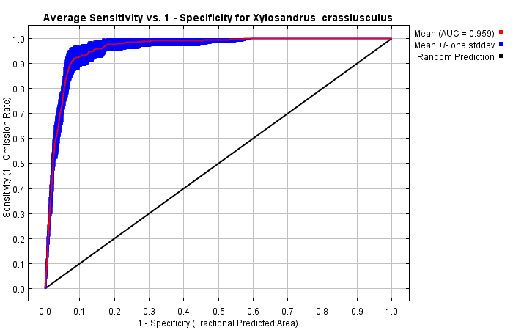
Supplementary Figure 2. Response curves for the top five environmental variables influencing the distribution of Xylosandrus crassiusculus.

