APPENDIX: A comparative study to investigate the impact of novel house design on indoor air quality in rural Tanzania

Table A: Description of novel and control house features.
Novel House Name | No. of  Stories | Wall construction | Cooking area | Flooring material in sensor location
Bamboo Single  (Appendix Fig. A1) | 1 | Bamboo panelling + monkeywire | Covered with open walls, west of bedrooms | Timber
Bamboo Double  (Appendix Fig. A2) | 2 | Bamboo panelling + monkeywire | Covered with open walls, below bedrooms | Timber
Shadenet Single  (Appendix Fig. A3) | 1 | Shadenet + monkeywire | Covered with open walls, west of bedrooms | Concrete
Shadenet Double  (Appendix Fig. A4) | 2 | Shadenet + monkeywire | Covered with open walls, below bedrooms | Concrete

Control House Name | Wall construction | Roofing Material | Cooking Area | Flooring material in sensor location
Control House 01  (Appendix Fig. A5) | Earth | Thatch | Outside under covered entrance porch | Cement screed floor
Control House 02  (Appendix Fig. A6) | Burnt brick | Corrugated metal | In separate kitchen building | Earth
Control House 03  (Appendix Fig. A7) | Burnt brick | Thatch | Inside | Earth

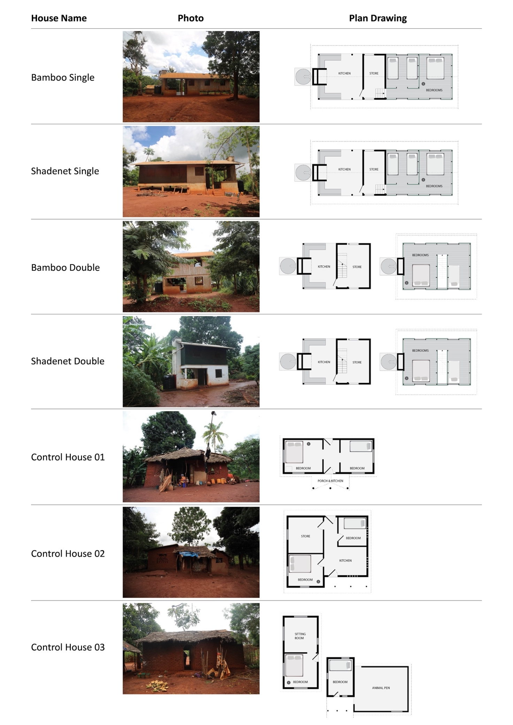
Figure A: Photos and plan drawings of study houses. The red circle indicates sensor location.

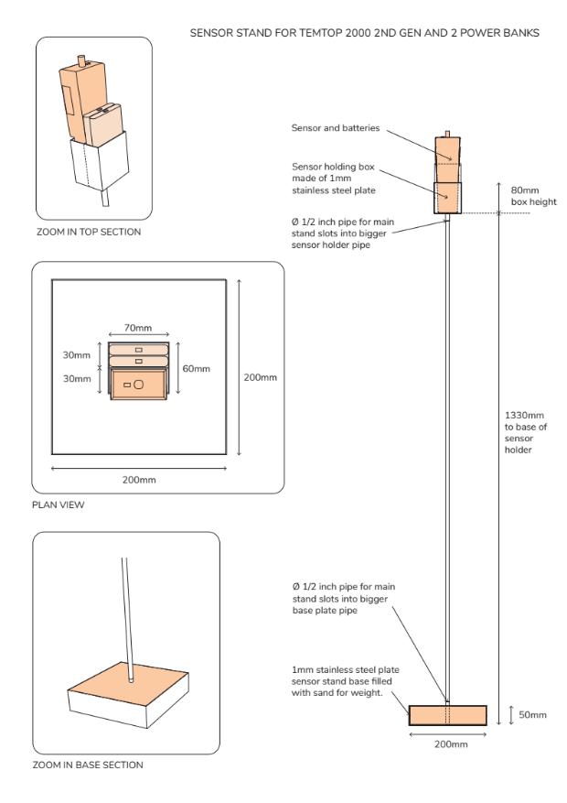
Figure B: Diagram of stand constructed to hold Temptop 2000 2ND Gen air quality monitor, to maintain the same height across the study sites.

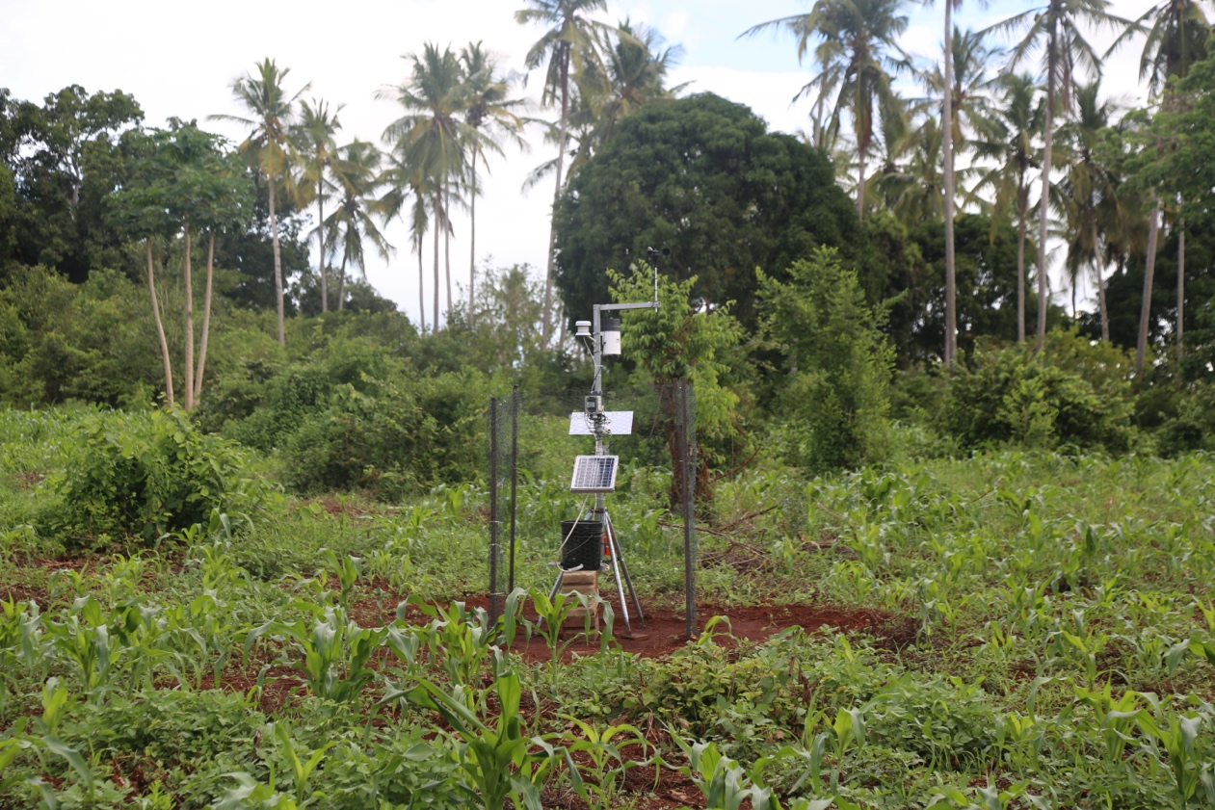
Figure C: Photograph showing the weather station installed in an unobstructed area. Sensors were set up above the level of the fence to avoid obstruction of readings.

Table B: summary of the (24 hour) daily mean PM_{2·5} and PM₁₀ for each of the novel houses and the control houses combined.
House type | PM_{2·5} | PM₁₀
 | Mean (95% CI) | Mean (95% CI)
Control houses (combined) | 50 (45 to 55) | 71 (64 to 77)
Novel houses Combined | 13(12 to 14) | 19(18 to 20)
Bamboo Double | 12 (11 to 14) | 18 (17 to 20)
Bamboo Single | 17 (16 to 18) | 26 (24 to 28)
Shadenet Double | 12(11 to 13) | 18 (16 to 20)
Shadenet Single | 11(10 to 12) | 17 (15 to 18)
Control House 01 | 81(72 to 90) | 111 (98 to 123)
Control House 02 | 40(34 to 45) | 58(51 to 65)
Control House 03 | 28(24 to 33) | 42(36 to 48)

Table C: Comparison of the (24 hour) daily mean PM_{2·5} and PM₁₀ between the novel houses and the control houses using a random effects model.
Parameter | House type | Slope (95% CI) | P-value
PM_{2·5} | Novel houses (combined) | Reference
 | Control houses (combined) | 37(14 to 59) | 0·001
 | Control houses (combined) | Reference
 | Bamboo Double | -37(-71 to -4) | 0·030
 | Bamboo Single | -33(-66 to 1) | 0·058
 | Shadenet Double | -38(-71 to -4) | 0·028
 | Shadenet Single | -38(-72 to -5) | 0·025
PM₁₀ | Novel houses (combined) | Reference | 0·001
 | Control houses (combined) | 51(22 to 80)
 | Control houses (combined) | Reference
 | Bamboo Double | -52(-96 to -9) | 0·018
 | Bamboo Single | -44(-88 to -1) | 0·046
 | Shadenet Double | -52(96 to -9) | 0·018
 | Shadenet Single | -54 (-97 to -10) | 0·015

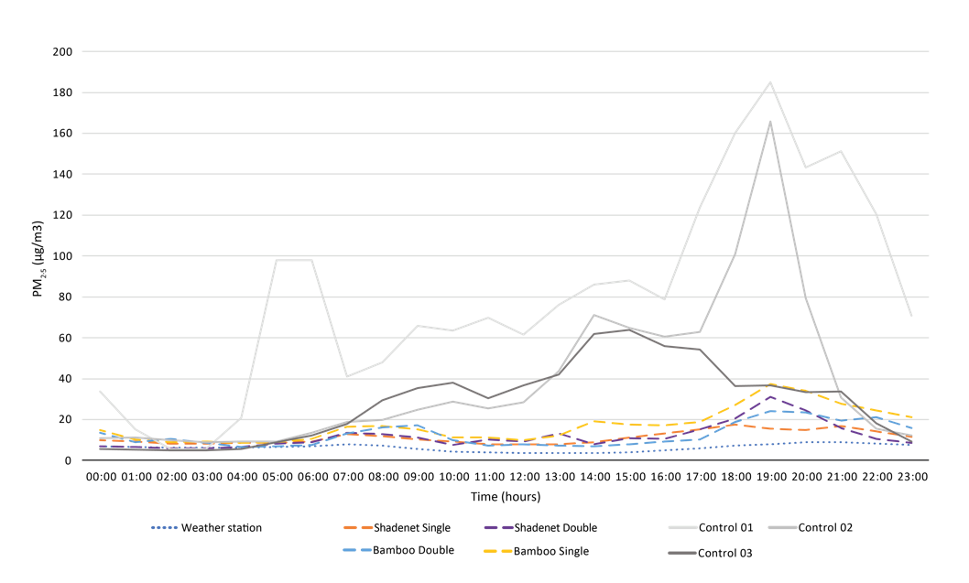
Figure D: Comparison of the hourly mean PM_{2·5} for the weather station, each of the control and novel houses.
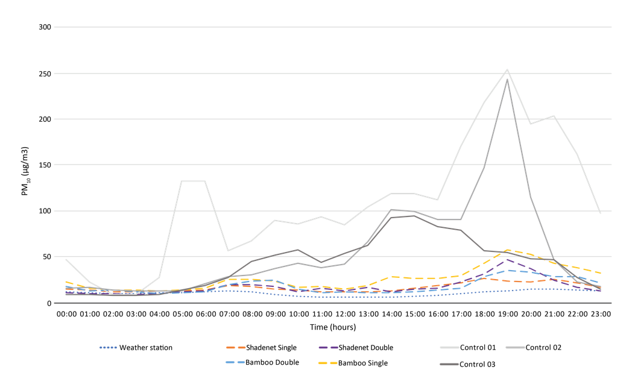
Figure E: Comparison of the hourly mean PM₁₀ for the weather station, each of the control and novel houses.

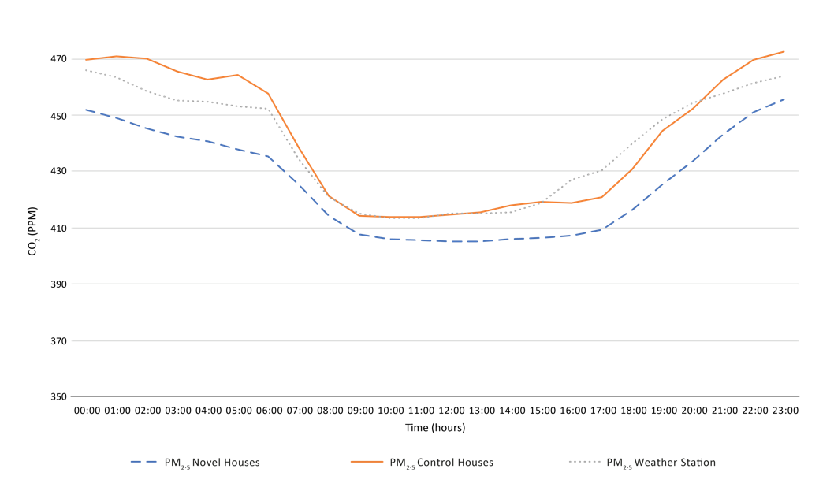
Figure F: Comparison of the hourly mean CO₂ levels for the weather station, each of the control and novel houses.

Impregnated bamboo (bambusa vulgaris).

