Fig. S1 Boxplots presenting distributions of CSF measures between CSF profile groups. Levels of CSF a) NFL, b) YKL-40, c) S100B and d) GFAP by CSF profile groups. NS. No significance (p>0.05)

Table S1 Accuracy in distinguishing between AD and non-AD CSF profiles – Univariable ROC analyses stratified by gender
 |  |  | Males, n=33 |  | Females, n=19
 |  |  | AUC | 95% CI (AUC)* | AUC | 95% CI (AUC)*
CSF measuresᵃ
 |  | GFAP (ng/ml) | 0.58 | 0.38-0.79 | 0.76 | 0.54-0.99
 |  | YKL-40 (ng/ml) | 0.48 | 0.28-0.69 | 0.89 | 0.64-1.00
 |  | NFL (ng/ml) | 0.50 | 0.29-0.71 | 0.86 | 0.68-0.98
 |  | S100B (pg/ml) | 0.61 | 0.46-0.77 | 0.72 | 0.46-0.98
Cognitive domains
 | Verbal episodic memory
 |  | Composite z-score | 0.74 | 0.56-0.92 | 0.93 | 0.82-1.00
 |  | RAVLT delayed recall, score | 0.73 | 0.54-0.91 | 0.93 | 0.81-1.00
 |  | Story delayed recall, score | 0.72 | 0.53-0.90 | 0.85 | 0.66-1.00
 |  | RAVLT immediate recall, score | 0.64 | 0.44-0.83 | 0.90 | 0.77-1.00
 |  | RAVLT recognition-fp, score | 0.67 | 0.48-0.86 | 0.86 | 0.69-1.00
 |  | Story immediate recall, score | 0.71 | 0.53-0.89 | 0.78 | 0.57-0.99
 | Non-verbal episodic memory
 |  | Composite z-score | 0.55 | 0.34-0.75 | 0.83 | 0.61-1.00
 |  | ROCF immediate recall, score | 0.56 | 0.35-0.76 | 0.83 | 0.63-1.00
 |  | ROCF delayed recall, score | 0.55 | 0.34-0.75 | 0.81 | 0.56-1.00
 | Executive functions
 |  | Composite z-score | 0.56 | 0.36-0.76 | 0.78 | 0.57-1.00
 |  | TMT-B, sec.ᵃ | 0.53 | 0.33-0.74 | 0.81 | 0.58-1.00
 |  | DSST, scoreᵃ | 0.65 | 0.46-0.85 | 0.49 | 0.20-0.78
 |  | Stroop 4th/3rd part, sec. ᵃ | 0.45 | 0.24-0.65 | 0.72 | 0.48-0.96
 | Language
 |  | Composite z-score | 0.60 | 0.40-0.80 | 0.58 | 0.29-0.87
 |  | Verbal fluency animals, score | 0.65 | 0.46-0.84 | 0.70 | 0.44-0.97
 |  | Verbal fluency H+S, score | 0.45 | 0.25-0.66 | 0.57 | 0.30-0.85
 | Processing speed
 |  | Composite z-score | 0.55 | 0.34-0.75 | 0.43 | 0.15-0.71
 |  | TMT-A, sec. ᵃ | 0.53 | 0.33-0.74 | 0.72 | 0.48-0.96
 |  | Stroop test – part I, sec. ᵃ | 0.57 | 0.36-0.77 | 0.53 | 0.24-0.82
Abbreviations: AD Alzheimer’s disease, AUC Area under curve, CI Confidence Intervals, CSF Cerebrospinal fluid, DDST Digit symbol substitution test, fp false positives, RAVLT Rey Auditory-Verbal Learning Test, ROCF Rey–Osterrieth complex figure, SE Sensitivity, SP Specificity, TMT Trail Making Test
AUC is the probability that a randomly selected pair of subjects from each CSF profile group is correctly classified, *Confidence intervals calculated with DeLong method, ᵅValues are natural log-transformed

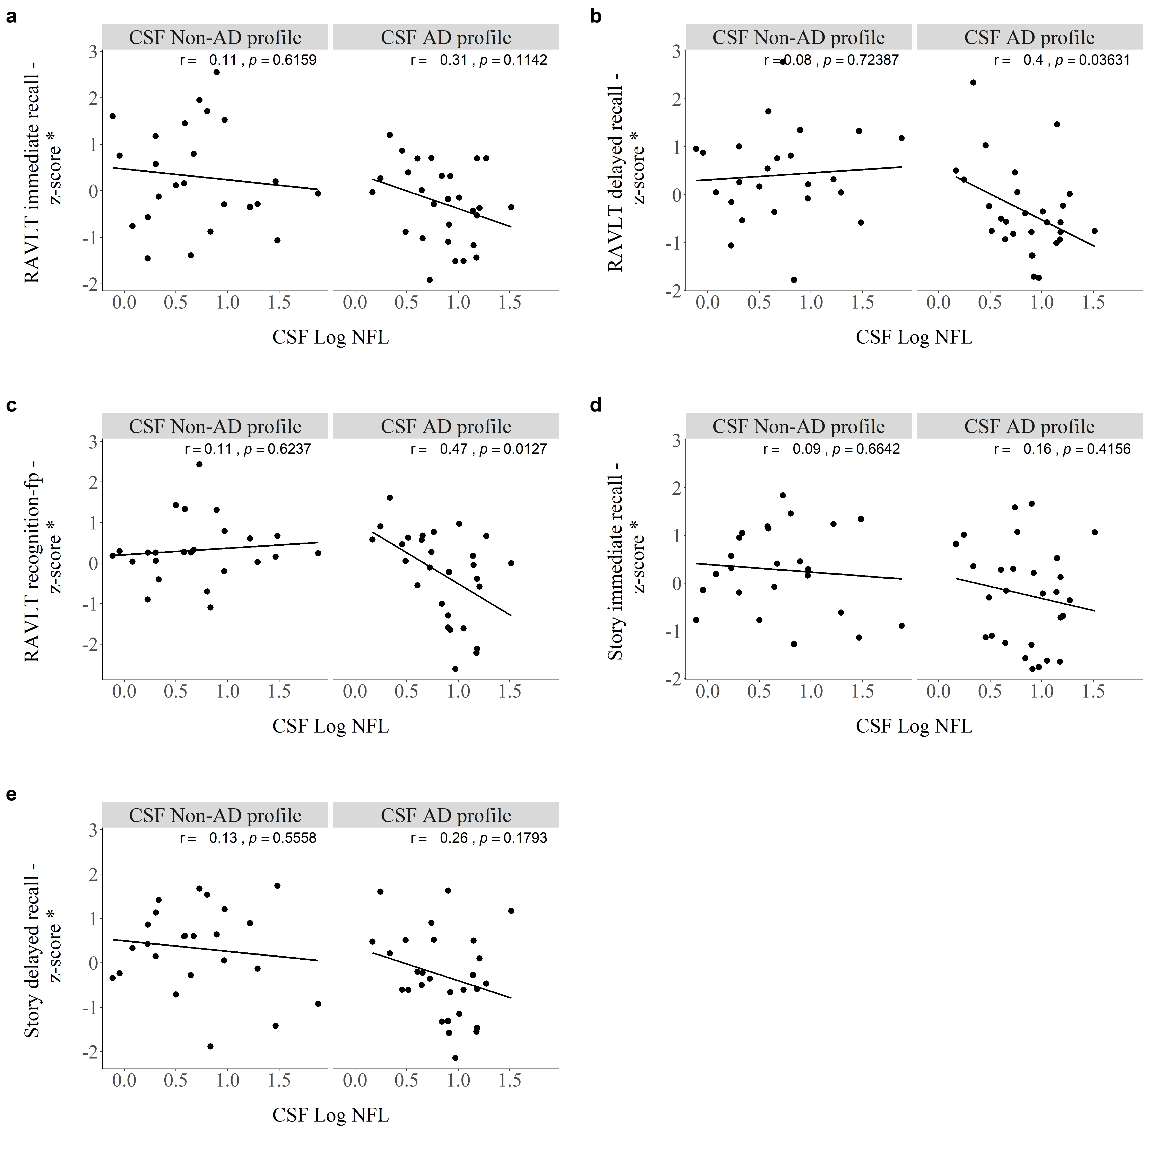

Fig. S2 Pearson‘s correlations between levels of CSF NFL with a) RAVLT immediate recall, b) RAVLT delayed recall, c) RAVLT recognition – fp, d) Story immediate recall and e) Story delayed recall by CSF profile. *Cognitive domains were adjusted for covariates (age and education)

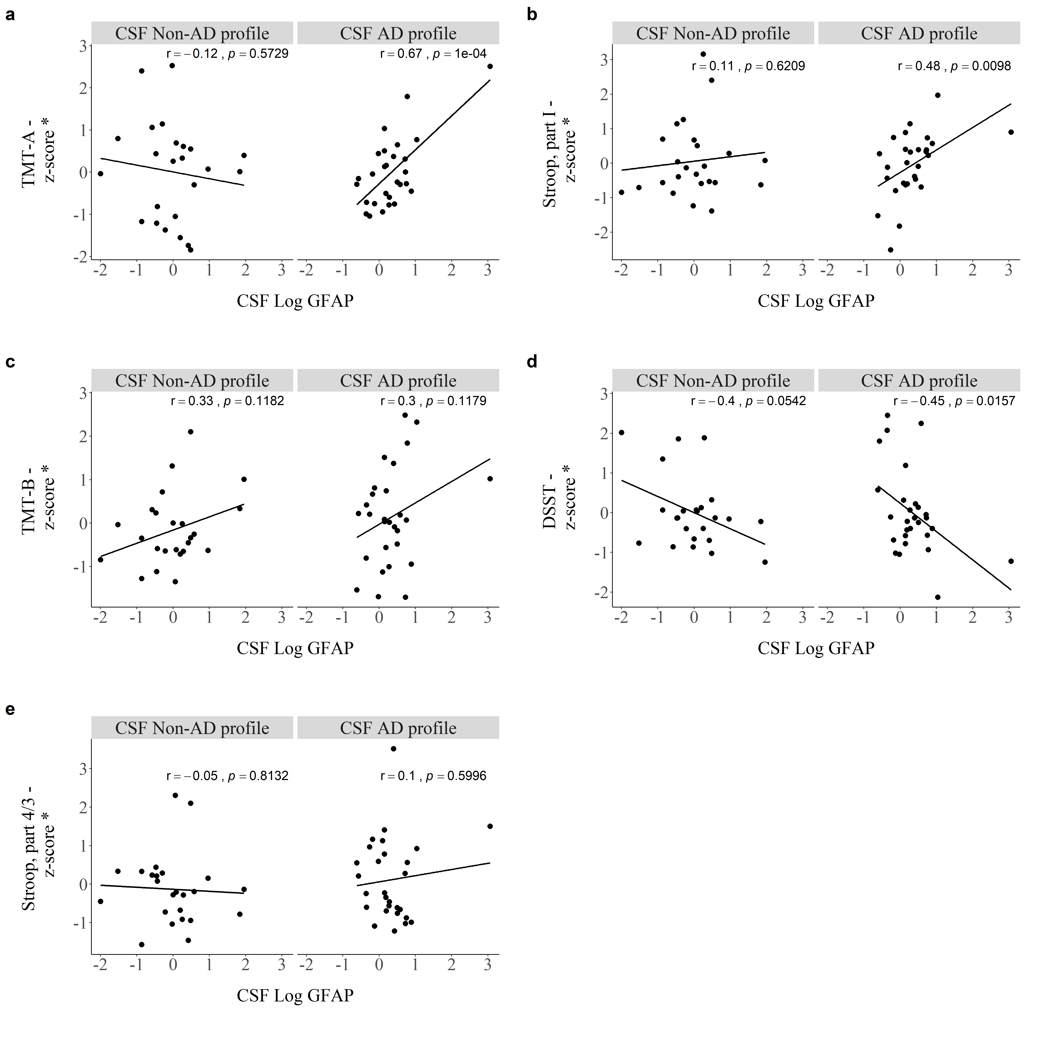
Fig. S3 Pearson‘s correlations between levels of CSF GFAP with a) TMT-A, b) Stroop, part I,
c) TMT-B, d) DSST and e) Stroop, part 4th/3rd by CSF profile. *Cognitive domains were adjusted for covariates (age and education)
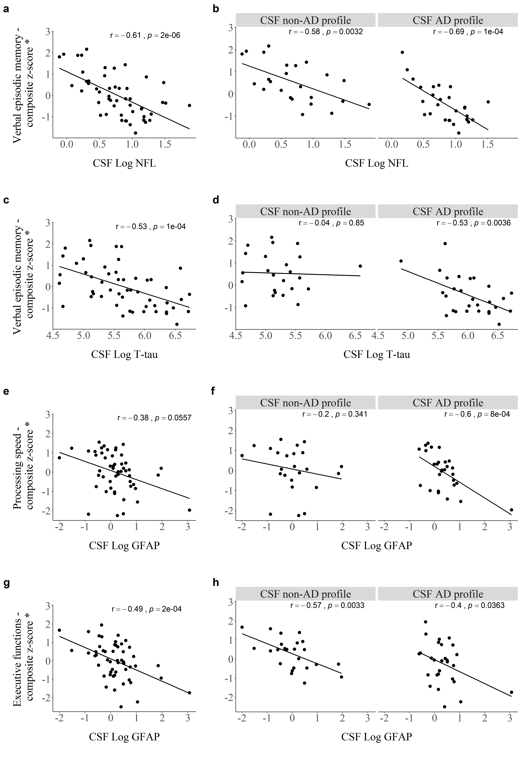

Fig. S4 Pearson‘s correlations between CSF levels of NFL and verbal episodic memory (a,b), T-tau and verbal episodic memory (c,d), GFAP and processing speed (e,f) and GFAP and executive functions (g,h) within the whole cohort and by CSF profile. *Cognitive domains were not adjusted for covariates (age and education)

Table S2. Pearson‘s correlations between CSF markers, age, education and compozite z-scores for each cognitive domain
 | Verbal episodic memory |  | Non-verbal episodic memory |  | Language |  | Processing  speed |  | Executive functions
 | Unadj. | Adj. | Unadj. | Adj. | Unadj. | Adj. | Unadj. | Adj. | Unadj. | Adj.
Aβ₄₂ | 0.23 | 0.22 | 0.26 | 0.26 | -0.04 | -0.11 | 0.15 | 0.14 | 0.12 | 0.08
T-tau | -0.53*** | -0.28* | -0.23 | 0.03 | -0.31* | -0.10 | -0.06 | 0.15 | -0.25 | -0.04
NFL | -0.61*** | -0.26 | -0.48*** | -0.12 | -0.38** | -0.19 | -0.44** | -0.10 | -0.24 | -0.02
YKL-40 | -0.30* | 0.18 | -0.27 | 0.11 | -0.27 | -0.02 | -0.33* | -0.02 | -0.21 | 0.03
S100B | -0.35* | -0.13 | -0.32* | -0.13 | -0.34* | -0.18 | -0.36** | -0.20 | -0.26 | -0.13
GFAP | -0.38** | -0.18 | -0.27 | -0.09 | -0.33* | -0.16 | -0.38** | -0.27 | -0.49*** | -0.37**
Age | -0.66*** | 0.00 | -0.59*** | 0.00 | -0.37** | 0.00 | -0.51*** | 0.00 | -0.37** | 0.00
Education | 0.39** | 0.00 | 0.16 | 0.00 | 0.40** | 0.00 | 0.03 | 0.00 | 0.33* | 0.00
Unadj. Unadjusted, Adj. Adjusted.
*p<0.05, **p<0.01, ***p<0.001. Numbers present Pearson‘s correlations coefficients. CSF markers were natural log-transformed. Scores were unadjusted or adjusted for age and education. For the adjustment, linear regression models were created with each test score as the dependent variable and age and education as independent variables. The residual for each subject was subsequently calculated (observed minus predicted score)

