Supporting Information
An Fe–Ti bimetallic MOF-functionalized electrospun PVDF-HFP separator for homogeneous Li⁺ flux in thermally robust, fast-charging LiFePO₄ batteries
Keying Wu^{a,b,*}, Wenda Xie^{a,*}, Xingjian Liu^{b}, Jing Chen^{b}, Haitao Pu^{b}, Bing Luoª
ª Application Research Center of Smart Energy Technology of Mianyang City College, Mianyang 621000, Sichuan, PR China
^{b} Meishan Vocational & Technical College, Meishan 620010, Sichuan, PR China
* Corresponding authors. E-mail: kywu601@163.com (K. Wu); wendellxie2020@163.com (W. Xie)

1. Supplementary Experimental Methods
Density functional theory (DFT) calculations: All spin-polarized DFT calculations were performed using the Vienna Ab initio Simulation Package (VASP) with the Perdew–Burke–Ernzerhof (PBE) generalized gradient approximation (GGA) functional. The projector-augmented wave (PAW) method was used to describe ion-electron interactions, with a kinetic energy cutoff of 450 eV for plane-wave basis sets. The DFT-D3 dispersion correction was applied to account for van der Waals interactions. A 3×3×1 Monkhorst-Pack k-point mesh was used for Brillouin zone sampling. The Fe–Ti MOF (101) surface was modeled by a 2×2 supercell with a 15 Å vacuum layer to avoid interlayer interactions. All atoms were relaxed until the residual forces were less than 0.02 eV Å⁻¹, and the energy convergence criterion was set to 10⁻⁵ eV. The adsorption energy (E_{ads}) was calculated as E_{ads} = E_{total} - E_{substrate} - E_{adsorbate}, where E_total is the total energy of the adsorbate-substrate system, E_{substrate} is the energy of the clean substrate, and E_{adsorbate} is the energy of the isolated adsorbate. More negative E_{ads} indicates stronger adsorption.
Materials characterization: Nitrogen adsorption-desorption isotherms were measured at 77 K using a Micromeritics ASAP 2460 analyzer, and specific surface areas were calculated by the Brunauer-Emmett-Teller (BET) method. Micropore size distributions were obtained by non-local density functional theory (NLDFT) analysis of the adsorption branch, and mesopore size distributions were derived from the adsorption branch using the Barrett-Joyner-Halenda (BJH) model. X-ray photoelectron spectroscopy (XPS) was performed on a Thermo ESCALAB 250Xi spectrometer with Al Kα radiation (1486.6 eV), and binding energies were calibrated using the C 1s peak at 284.8 eV.
Electrochemical measurements: Electrochemical impedance spectroscopy (EIS) was measured over a frequency range of 10⁻² to 10⁵ Hz with an AC amplitude of 10 mV on a CHI 760E electrochemical workstation. The EIS spectra were fitted using the ZView software with an equivalent circuit consisting of bulk resistance (RΩ), charge transfer resistance (Rct), and a constant phase element (CPE). Li|separator|Li symmetric cells were assembled for Li⁺ transference number measurement using the Bruce-Vincent method, with a DC polarization voltage of 10 mV.

2. Supplementary Figures
Fig. S1
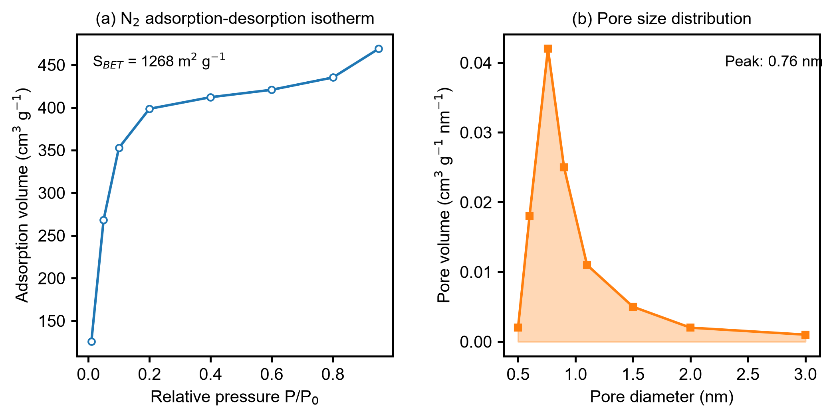
(a) N₂ adsorption-desorption isotherm of as-synthesized Fe–Ti bimetallic MOF at 77 K, showing a typical type I isotherm characteristic of microporous materials, with a BET specific surface area of 1268 m² g⁻¹. (b) Corresponding pore size distribution, showing a dominant micropore peak centered at 0.76 nm, which is smaller than the solvated Li⁺ diameter (~1 nm), enabling size-sieving of solvated species while allowing bare Li⁺ transport.
Fig. S2
Full survey XPS spectra of pristine Fe–Ti MOF (blue) and PVDF-HFP/MOF-10 composite membrane (red, vertically offset for clarity). The spectra confirm the presence of C, O, Ti, Fe in both samples, with an additional F 1s peak in the composite membrane originating from the PVDF-HFP polymer matrix, confirming successful integration of MOF into the polymer fiber matrix.
Fig. S3
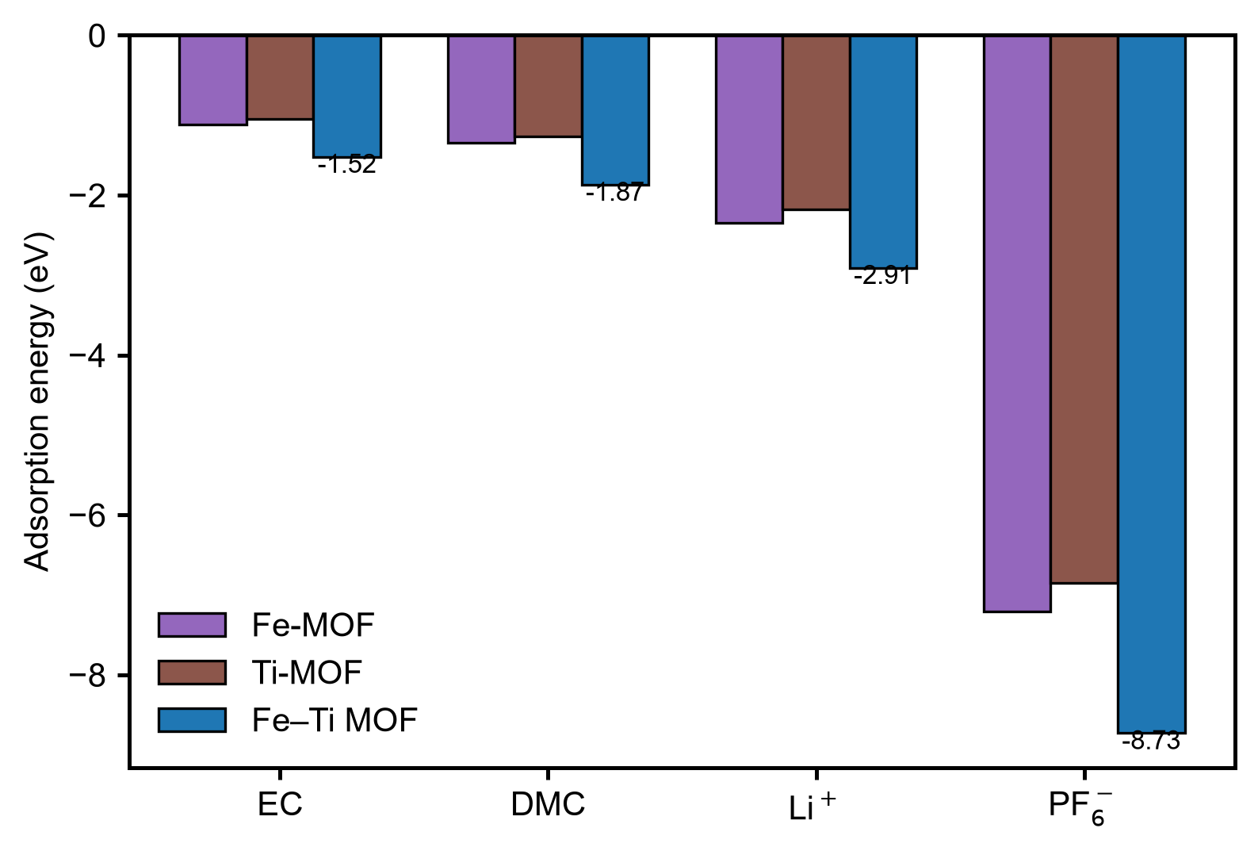
Comparison of DFT-calculated adsorption energies of EC, DMC, Li⁺, and PF₆⁻ on single-metal Fe-MOF, single-metal Ti-MOF, and bimetallic Fe–Ti MOF surfaces. The Fe–Ti bimetallic MOF exhibits significantly stronger adsorption for all species compared to single-metal MOFs, confirming the synergistic effect between Fe and Ti centers which enhances Lewis acidity and improves electrolyte affinity and anion anchoring capability.
Fig. S4
Long-term cycling performance at 1 C of LiFePO₄||Li coin cells (CR2032, 2.5–4.0 V) assembled with Celgard, pristine PVDF-HFP and PVDF-HFP/MOF-10 separators. Left axis: discharge capacity; right axis: Coulombic efficiency. After 500 cycles the PVDF-HFP/MOF-10 cell retains 141.2 mAh g⁻¹ (92.3% of its initial capacity) with an average Coulombic efficiency above 99.8%, whereas the pristine PVDF-HFP and Celgard cells retain 75.6% and 58.2% of their initial capacities, respectively

3. Supplementary Tables
Table S1
DFT-calculated adsorption energies (eV) of Li⁺, PF₆⁻, EC and DMC on PP, on the constituent units of PVDF-HFP, and on the Fe–Ti bimetallic MOF. More negative values indicate stronger adsorption. The corresponding optimized configurations are shown in Fig. 4d and Fig. 5c, d of the main text.
Substrate | Li⁺ | PF₆⁻ | EC | DMC
PP | −0.28 | −1.69 | −0.01 | −0.02
CH₂CF₂ | −1.74 | −0.25 | −0.02 | −0.06
CH₂CF₂H | −0.25 | −0.36 | −0.05 | −0.06
HFP | −1.74 | −1.44 | −0.07 | −0.15
Fe–Ti MOF | −2.91 | −8.73 | −1.19 | −1.49
Compared with PP and the PVDF-HFP units, the Fe–Ti MOF binds PF₆⁻ far more strongly than Li⁺, which underpins the anion-anchoring and Li⁺-flux-homogenization effect discussed in the main text.
Table S2
Equivalent circuit fitting parameters of EIS spectra for LiFePO₄||Li cells with different separators.
Sample | R_{Ω} (Ω) | R_{ct} (Ω) | CPE (F)
Celgard | 5.2 | 210 | 3.2E-05
PVDF-HFP | 4.5 | 158 | 4.5E-05
PVDF-HFP/MOF-5 | 4.1 | 112 | 5.8E-05
PVDF-HFP/MOF-10 | 3.8 | 62 | 7.2E-05
PVDF-HFP/MOF-15 | 4.0 | 89 | 6.3E-05

R_{Ω}: Ohmic bulk resistance; R_{ct}: Charge transfer resistance; CPE: Constant phase element. The PVDF-HFP/MOF-10 separator exhibits the lowest R_{Ω} and R_{ct}, indicating fast ion transport and low interfacial resistance, consistent with its high ionic conductivity and excellent rate performance.

