Biogeographic patterns of gooseneck barnacles Pollicipes pollicipes over its species range with a specific focus on metapopulation dynamics at the scale of Brittany using indirect genetic and larval dispersal modeling tools.

Thiébaut, E., Feis, M., Ballenghien, M., Dumont, P. A., Parrondo, M., Le Port, A. S., Chiekhna Lemrabott, S. Y., González-Ortegón, E., Fernandes, J. N., Acuna, J.L., Queiroga, H., Borell, Y. J., Nicolle, A. & Jollivet, D.

Supplementary information in the Material & Methods

Larval dispersal model’s validation

The validation of the model configuration focuses on several physical quantities: the sea surface height (SSH) to assess how tides which are one of the main drivers of hydrodynamics on the continental shelf are simulated, currents and, the surface temperature (SST) which controls the larval lifespan.
The free-surface elevation is validated using the ATLNE2000 configuration of Ifremer’s MARC2D model (Figure S1). The comparison of our configuration with a two-dimensional horizontal model is acceptable given the spatial extent under consideration with a mean bias generally lower than 10 cm. Note, however, that only the dominant processes are tested in this way. Phenomena on smaller scales near the coast in shallow waters, or at the slope may lead to marked differences exceeding 20 cm. The ATLNE2000 model has a horizontal resolution of 2 km. The data are therefore interpolated onto the grid of our configuration, and a total of 62,405 non-empty grids are compared. The spatial distribution of the errors reveals localized structures, which are examined in the following section. The time series of the spatial root mean square error (RMSE) varies relatively little around the mean value of 10 cm with a standard deviation of 8 cm for the year 2016. The comparison of statistical indicators calculated over the entire modeled region and only on the shelf (bathymetry less than 200 m) shows no major differences, either spatially or temporally, between 2016 and 2017 (Table 1). These results are consistent with the realistic modeling of the Bay of Biscay using MARS3D by Lazure and Dumas (2008), in terms of magnitude, but also in terms of temporal consistency.

Table S1: Time-averaged 1st, 2nd, and 3rd quartiles of the absolute value of the difference in free-surface elevation between MARC2D and MARS3D, on the plateau (<200 m) and across the entire study area, for the years 2016 and 2017.

cm |  | 1st quartile | 2nd quartile | 3rd quartile
2016 | Shelf | 5 | 7 | 9
2016 | Total | 5 | 7 | 10
2017 | Shelf | 5 | 6 | 8
2017 | Total | 5 | 7 | 9

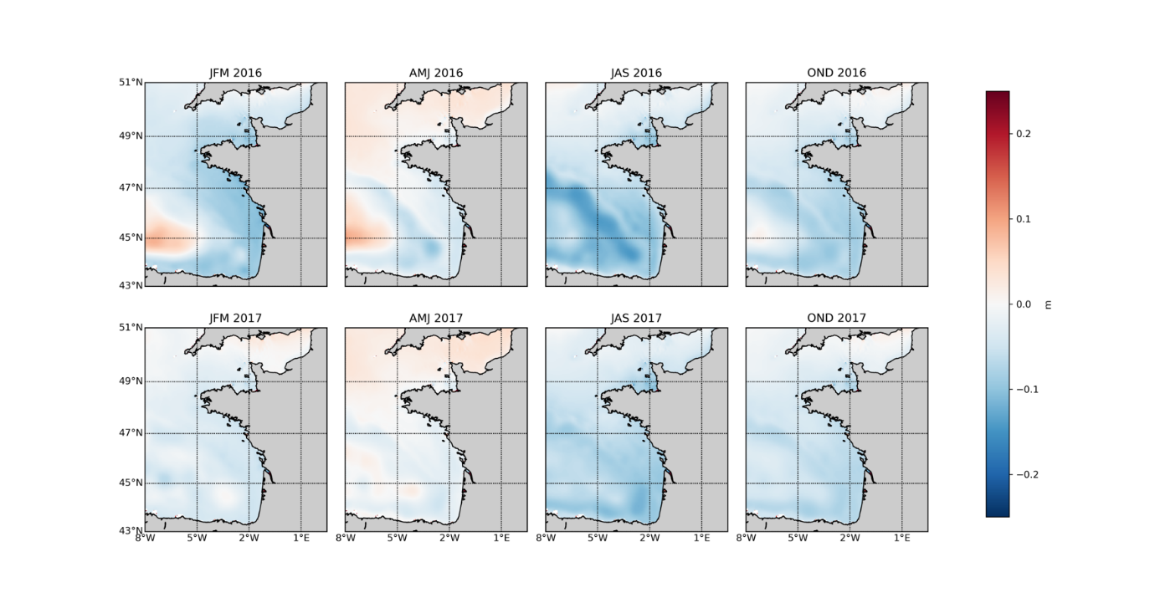
Figure S1: Mean Bias (m) in Sea Surface Height between the validated MARC2D model and the configuration under study (MARC - MANGAE) in 2016 and 2017. for different seasons. The differences are averaged over time for three-month periods (JFM: January–February–March, AMJ: April–May–June, JAS: July–August–September, OND: October–November–December).

As with the SSH, the current fields are compared to the outputs of the Ifremer ATLNE2000 model, which requires taking precautions in the immediate vicinity of the coast, as well as along the continental slope. Since the MARC model is two-dimensional in the horizontal plane, we compare the barotropic components of the current fields. This time, we will focus on the spatial distribution of the
discrepancies, illustrated in Figure S2.

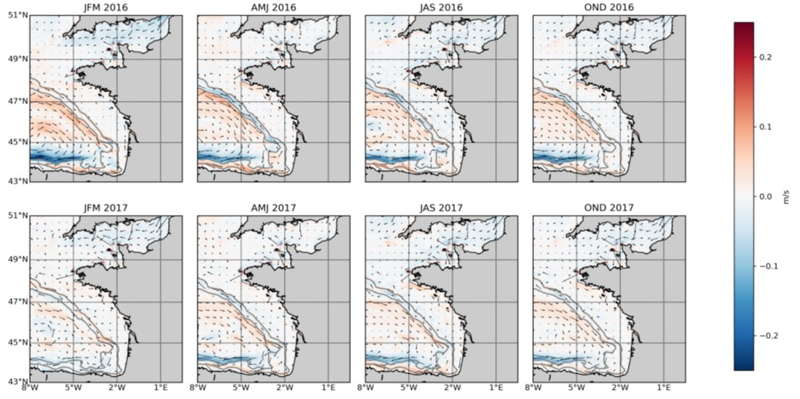
Figure S2: Difference between the zonal velocities estimated by the validated MARC2D model and the configuration under study (MARC - MANGAE). The differences are averaged over time for three-month periods (January–February–March, April–May–June, July–August–September, October–November–December) for the years 2016 and 2017. The vectors indicate the direction and magnitude of the deviations. The grey lines represent the 200- and 2000-meter isobaths.

The largest errors are observed at the continental slope. According to Pingree and Le Cann (1990), the residual slope current in the Bay of Biscay is generally weak (on the order of 5 to 10 cm.s⁻¹). The driving force of this current varies by region. Off the coast of France, the meridional density gradient induces northward transport, which increases in intensity with distance. Off the coast of northern Spain, since the slope is zonal, the meridional density gradient cannot explain the current. Frictional effects slow down this current, which had accelerated as it moved northward along Portugal. These idealized cases are generally intertwined, and a balance is established between friction and the density gradient. This is the JEBAR theory (joint effect of baroclinicity and bottom relief) developed by Huthnance (1984). The largest errors appear north of Spain. Note that off the coast of France, the current is meridional; the largest errors would therefore pertain to the v component, but the divergence panel for this component, reported in Figure S3, shows only low-intensity structures. In light of the preceding explanations, it would appear that the error relates to the estimation of frictional terms. Nevertheless, the error decreases in intensity from 2016 to 2017, which discredits this hypothesis, unless the slope current also decreases in speed over this period, which is not the case based on the sections analyzed, which show speeds on the order of 10 cm.s⁻¹ for a zonal section at 46.75°N.
A second hypothesis concerns the very nature of the compared data. A fundamental difference between 2D and 3D models at the slope concerns the tidal rectification process. The nonlinear interaction of tidal currents with the slope current induces a residual current, contributing to the total slope current. This rectification is largely dependent on bottom friction (Huthnance, 1973; Loder, 1980), which leads to a first difference between the two compared models: the resolution is 500 m smaller for MARC2D than for our configuration, implying a different resolution of frictional effects (Laanaia et al., 2010). More generally, Zimmerman (2013) highlights the differences in the rectification result between 2D and 3D models, linked to the very method of resolving these processes. Since we have no information on the parameters of MARC 2D, it seems difficult to estimate the order of magnitude of this phenomenon. Nevertheless, we would expect it to generate an error of similar magnitude across the entire slope; there is no a priori reason for this difference to be amplified in northern Spain. However, according to Pérenne and Pichon (1999), the amplitude of the residual current depends on the slope and the forcing, that is, at a given location primarily on the VE-ME cycle. Since we calculate averages over three months, variations related to this cycle should be smoothed out, and the error should be constant over time at a given point, which is not the case. Tidal correction therefore does not appear to be the main cause of the differences between these two models. The choice to use generalized sigma coordinates may also be the source of these errors. Errors associated with calculating the pressure gradient in sigma coordinates near a slope are well-known and extensively documented (Mellor et al., 1994, 1998). According to Lazure and Dumas (2008), the choice to calculate the internal pressure gradient using the method of Shchepetkin and McWilliams (2003) helps mitigate this problem in the MARS3D model. However, by increasing the resolution in the 10 layers above the seabed, we simultaneously increase the slope of the sigma levels at the toe of the slope. This increase is such that we potentially run into the problem of pressure gradient calculation error once again. This error results in erroneous velocities along the slope, which are reflected in our model. Furthermore, Mellor et al. (1994) note that this error tends to decrease over time, a trend we observe in our errors. Nevertheless, it is difficult to assess the timescale required for this decrease, which would allow us to validate this hypothesis. However, we initially note (January to July 2016) the presence of a mesoscale structure offshore, particularly in the meridional velocity differences. This structure is not present in either MARC2D or satellite observations (not shown here). One hypothesis is that instabilities during the model’s startup are responsible for this structure, and that it gradually disappears. This cyclonic vortex drives an easterly flow along the slope, which contributes to the meridional velocity difference previously described in northern Spain. This observation, along with that in the previous paragraph, suggests that the model’s spin-up phase was not fully complete during the first half of 2016 (the model was initialized on October 1, 2015). This spin-up phase appears unusually long, compared to the findings of other similar studies, which estimate it to last a few months. This is also our assessment based on the kinetic energy time series across the entire domain. However, it appears that instabilities persist for longer, as illustrated by this vortex

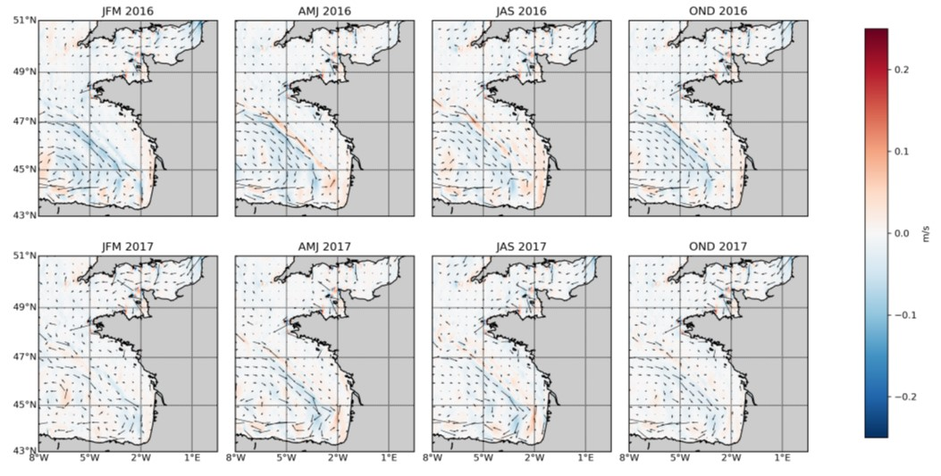

Figure S3: Difference between the meridional velocities estimated by the validated MARC2D model and the configuration under study (MARC - MANGAE). The differences are averaged over time for three-month periods (January–February–March, April–May–June, July–August–September, October–November–December) for the years 2016 and 2017. The vectors indicate the direction and magnitude of the deviations. The grey lines represent the 200- and 2000-meter isobaths.

The model's surface temperature is compared with satellite observations post-processed by Ifremer and interpolated onto a grid with a resolution of 0.04 km (Figure S4). This L4-level product is provided by the CMEMS (Copernicus Marine Environment Monitoring Service), and has an uncertainty of 0.5 K. The difference maps shown in Figure S4 indicate that the modelled temperature is generally in good agreement with the observations. Offshore, we observe the known tendency of MARS to slightly overestimate the surface temperature (Lazure et al., 2009). Along the coasts, the temperature is significantly underestimated, particularly south of the Gironde estuary in the summer of 2016. This underestimation by the model can be explained by a tendency of the model to overestimate coastal upwelling, and thus an excessive upwelling of cold water from the bottom to the surface during a period of strong stratification. Conversely, the temperature is overestimated in the Iroise Sea in summer, which may be due to poor modelling of the mixing induced by the Ushant front. On the other hand, we note that the continental slope is relatively poorly resolved on these maps (except in the summer 2016), suggesting that the mixing induced by internal waves at the slope is relatively well resolved. Regarding barnacle larvae, which are mainly advected onto the continental shelf, the underestimation of temperature will tend to overestimate the larval lifespan. Nevertheless, this tendency is limited. In fact, along the trajectory of a larva advected from June to August, the average temperature error is less than 1°C. Consequently, the model outputs can be considered sufficiently realistic to be used in this Lagrangian transport study.

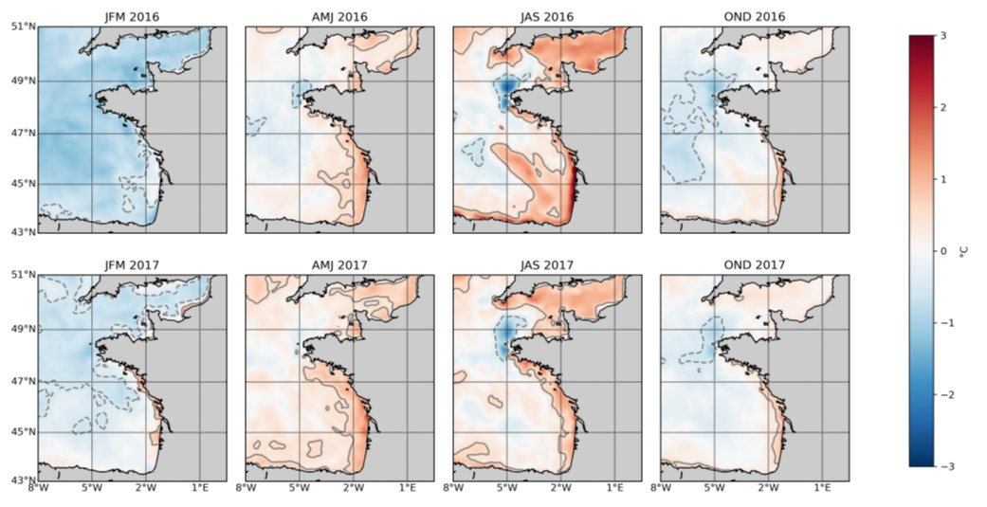

Figure S4. Mean Bias in temperature (°C) between satellite data and modelled data in 2017 for different seasons. The differences are averaged over time for three-month periods (JFM: January–February–March, AMJ: April–May–June, JAS: July–August–September, OND: October–November–December).

Associated References

Huthnance JM (1973) Tidal currents asymmetries over the Norfolk sandbanks. Est Coast Shelf Sci 1(1):89-99. https://doi.org/10.1016/0302-3524(73)90061-3
Huthnance JM (1984) Slope currents and “jebar”. J Phys Oceanogr 14(4):795-810. https://doi.org/10.1175/1520-0485(1984)014%3C0795:SCA%3E2.0.CO;2
Laanaia N, Wirth A, Molines JM Barnier B, Verron J (2010) On the numerical resolution of the bottom layer in simulations of oceanic gravity currents. Ocean Sci 6(2):563-572. https://doi.org/10.5194/os-6-563-2010
Lazure P, Dumas F (2008) An externa-internal mode coupling for a 3D hydrodynamical model for applications at regional scale (Mars). Adv Water Res 31(2):233-250. https://doi.org/10.1016/j.advwatres.2007.06.010
Lazure P, Garnier V, Dumas F, Herry C, Chifflet M (2009) Development of a hydrodynamic model of the Bay of Biscay: validation of hydrology. Cont Shelf Res 29(8):985-997. https://doi.org/10.1016/j.csr.2008.12.017
Loder JW (1980) Topographic rectification of tidal currents on the sides of Georges Bank. J Phys Oceanogr 10(9):1399-1416. https://doi.org/10.1175/1520-0485(1980)010%3C1399:TROTCO%3E2.0.CO;2
Mellor GL, Oey LY, Ezer T (1994) Sigma coordinate pressure gradient errors and the seamount problem. J Atmos Ocean Tech 15(5):1122-1131. https://doi.org/10.1175/1520-0426(1998)015%3C1122:SCPGEA%3E2.0.CO;2
Pérenne N, Pichon A (1999) Effect of barotropic tidal rectification on low-frequency circulation near the shelf break in the northern Bay of Biscay. J Geophys Res Oceans 104(C6):13489-13506. https://doi.org/10.1029/1999JC900050
Pingree RD, Le Cann B (1990) Structure, strength and seasonality of the slope currents in the Bay of Biscay region. J Mar Biol Ass UK 70(4):857-885. https://doi.org/10.1017/S0025315400059117
Shchepetkin AF, McWilliams JC (2003) A method for computing horizontal pressure-gradient force in an oceanic model with a nonaligned vertical coordinate. J Geophys Res Oceans 108(C3): 3090. https://doi.org/10.1029/2001JC001047
Zimmerman JTF (2013) Principles differences between 2D- and vertically averaged 3D-models of topographic tidal rectification. In Lecture Notes on Coastal and Estuarine Studies (pp. 120–129). American Geophysical Union. https://doi.org/10.1029/ln016p0120

Supplementary tables to the results section

Table S2. Overall genetic diversity locus by locus for Pollicipes pollicipes at the regional scale

loc | RF12 | OV100 | RF17 | OV113 | VG49 | VG89 | VG55 | OV122 | OV121 | OV81 | OV103 | RF03 | Ppol1 | Ppol3 | Ppol5 | Ppol9 | Ppol8 | Ppol2 | Ppol7
Na | 32 | 78 | 12 | 65 | 49 | 15 | 20 | 29 | 36 | 45 | 22 | 70 | 11 | 20 | 11 | 36 | 51 | 16 | 13
AR | 21.3 | 41.7 | 5.3 | 44.6 | 24.0 | 7.6 | 11.6 | 19.7 | 21.1 | 32.9 | 12.2 | 33.7 | 6.5 | 13.6 | 8.5 | 31.8 | 41.9 | 13.8 | 7.5
Ho | 0.709 | 0.865 | 0.591 | 0.489 | 0.863 | 0.274 | 0.358 | 0.710 | 0.770 | 0.882 | 0.332 | 0.396 | 0.572 | 0.406 | 0.547 | 0.892 | 0.916 | 0.765 | 0.677
He | 0.896 | 0.956 | 0.604 | 0.948 | 0.919 | 0.398 | 0.499 | 0.764 | 0.885 | 0.948 | 0.575 | 0.786 | 0.568 | 0.586 | 0.561 | 0.919 | 0.962 | 0.769 | 0.672
Fis | 0.209  *** | 0.097  *** | 0.021  NS | 0.485  *** | 0.062  *** | 0.310  *** | 0.320&  *** | 0.068  *** | 0.130  *** | 0.070  *** | 0.416  *** | 0.486  *** | -0.006 NS | 0.303  *** | 0.018  NS | 0.031  *** | 0.048  *** | 0.008  NS | -0.011  NS
p-val | 0.001 | 0.001 | 0.067 | 0.001 | 0.001 | 0.001 | 0.001 | 0.001 | 0.001 | 0.001 | 0.001 | 0.001 | 0.760 | 0.001 | 0.100 | 0.001 | 0.001 | 0.299 | 0.936
Fst | 0.001  * | 0.003  *** | 0.000  NS | 0.002  *** | 0.001  *** | 0.001  NS | 0.014  *** | 0.001  NS | 0.001  * | 0.000  NS | 0.002  * | 0.006  *** | 0.005  *** | 0.001  NS | 0.001  NS | 0.018  *** | 0.000  NS | 0.007  *** | 0.000  NS
p-val | 0.048 | 0.001 | 0.560 | 0.001 | 0.001 | 0.626 | 0.001 | 0.138 | 0.029 | 0.884 | 0.040 | 0.001 | 0.001 | 0.115 | 0.085 | 0.001 | 0.092 | 0.001 | 0.354
MicC | NULL | NO | NO | NULL | NO | NULL | NULL | NO | NULL | NULL | NULL | NULL | NO | NULL | NO | NO | NO | NO | NO

Loc: locus names: RF=designed by Roscoff (France), OV=designed by Oviedo (Spain), VG=designed by Vigo (Portugal) and Ppol=designed by Joana N. Fernandes (see Parrondo-Lombardia et al. 2023 for the methods used to develop these microsatellite markers). *: detection of null alleles (NULL) using MicroChecker v2.2.3 (MicC) over the whole sample set with at least one of the 4 methods with NO = no null allele detected. Allelic richness (AR), Ho, He as estimated from Hs, Fis and Fst were obtained by hierfstat basic statistics. Both overall population Fis and Fst were tested for each locus against zero with Genetix v4.05 using 1000 permutations of alleles between genotypes within populations or of genotypes between populations, respectively.
Table S3. AMOVA obtained with 3 levels of spatial hierarchy using the glob_variance function of the hierfstat R package. Region: Africa, Iberic peninsula, France, Groups within regions: Morocco & Mauritania (Africa), Cadiz & Portugal, Galicia, Asturias (Iberia) and Gascogne, Morbihan, South and North Finistere (France) and localities within geographic groups: Portugal = 5 localities, Galicia = 5 localities, Asturias = 5 localities, Gascogne = 2 localities, Morbihan = 3 localities, South Finistere = 3 localities and North Finistere = 5 localities.

AMOVA : Hierarchical levels | F-Statistics | Significance (1000 perm.)
Regions within Total (FCT level1) | 0.0200 | 0.003 **
Groups within Regions (FSC level 2) | 0.0193 | 0.001 ***
Populations within Groups (FSC level 3) | 0.0304 | 0.001 ***
Individuals within Populations (FIS) | 0.0440 | 0.001 ***

* : p_values of Fst departures toward zero estimated from 1000 permutations of genotypes between the different levels of population groupings (level 1, 2 and 3) using the test.within, test.between and test.between.within of hierfstat.

Table S4. Overall genetic diversity of loci for Pollicipes pollicipes along the French coast

Loc* | RF12 | OV100 | RF17 | OV113 | VG49 | VG89 | VG55 | OV122 | OV121 | OV81 | OV103 | RF03 | Ppol1 | Ppol3 | Ppol5 | Ppol9 | Ppol8 | Ppol2 | Ppol7
Na | 28 | 71 | 5 | 58 | 41 | 11 | 18 | 28 | 27 | 44 | 18 | 59 | 9 | 19 | 10 | 36 | 48 | 16 | 11
AR | 12.5 | 21.3 | 3.7 | 19.4 | 14.3 | 4.6 | 5.0 | 11.2 | 12.3 | 18.2 | 6.6 | 10.5 | 3.7 | 7.0 | 5.4 | 18.7 | 22.3 | 7.8 | 5.3
Ho | 0.720 | 0.839 | 0.617 | 0.456 | 0.835 | 0.267 | 0.239 | 0.717 | 0.814 | 0.897 | 0.353 | 0.395 | 0.535 | 0.396 | 0.552 | 0.917 | 0.919 | 0.750 | 0.655
He | 0.899 | 0.958 | 0.615 | 0.946 | 0.919 | 0.388 | 0.429 | 0.765 | 0.885 | 0.946 | 0.591 | 0.751 | 0.547 | 0.606 | 0.568 | 0.945 | 0.963 | 0.734 | 0.662
Fis | 0.190  *** | 0.115  *** | 0.009  NS | 0.508  *** | 0.081  *** | 0.295  *** | 0.419  *** | 0.062  *** | 0.069  *** | 0.050  *** | 0.435  *** | 0.479  ** | 0.019  NS | 0.343  *** | 0.016  NS | 0.029  ** | 0.048  *** | -0.018  NS | -0.009  NS
P_val | 0.001 | 0.001 | 0.307 | 0.001 | 0.001 | 0.001 | 0.001 | 0.001 | 0.001 | 0.001 | 0.001 | 0.001 | 0.274 | 0.001 | 0.274 | 0.003 | 0.001 | 0.884 | 0.689
Fst | 0.000  NS | 0.000  NS | 0.000  NS | 0.001  NS | 0.002  * | 0.002  NS | 0.003  NS | 0.000  NS | 0.001  NS | 0.001  NS | 0.003  NS | 0.006  ** | 0.003  NS | 0.000  NS | -0.001  NS | 0.000  NS | -0.001  NS | 0.002  NS | 0.000  NS
P_val | 0.772 | 0.544 | 0.659 | 0.274 | 0.032 | 0.188 | 0.198 | 0.578 | 0.657 | 0.395 | 0.091 | 0.006 | 0.152 | 0.504 | 0.887 | 0.627 | 0.990 | 0.067 | 0.607

Loc*: locus names: RF=designed by Roscoff (France), OV=designed by Oviedo (Spain), VG=designed by Vigo (Portugal) and Ppol=designed by Joana N. Fernandes (see Parrondo-Lombardia et al. 2023 for the methods used to develop these microsatellite markers). * p_values for Fis and Fst are obtained from 1000 permutations of alleles between genotypes within a locus and 1000 permutations of genotypes between populations using Genetix v4.05: *: p<0.05, **<0.01, ***<0.001.

Table S5. Choice of the best constrained metapopulation models using the Bayes factor. * LBF 1 : Ln(Bayes factor) with the full (free) matrix model, ** LBF 2: Ln(Bayes factor) without the full (free) matrix model.

Model | Bezier lmL | Order | LBF 1* | Model prob | Rescaled prob | LBF 2** | Model prob | Rescaled prob
1: full matrix | -16734,96 | 1 | 0 | 1,000 | 1,000 | NA | NA | NA
2: mixed* | -23553,5 | 2 | -6818,54 | 0,000 | 0,000 | 0 | 1,000 | 1,000
3: Metacentric | -24638,05 | 2 | -7903,09 | 0,000 | 0,000 | -1084,55 | 0,000 | 0,000
4: Hydrodynamic | -24820,67 | 3 | -8085,71 | 0,000 | 0,000 | -1277,17 | 0,000 | 0,000
5: Source-sinks | -26318,05 | 3 | -9583,09 | 0,000 | 0,000 | -2764,55 | 0,000 | 0,000
6: Stepping stones | -27285,36 | 4 | -10550,4 | 0,000 | 0,000 | -3731,86 | 0,000 | 0,000

Table S6. Observed and expected heterozygosities estimated for each locus together with Fis and Fst across juveniles and adult references at different sampling dates with recruits less than 1.6 mm collected in November 2018 and 2019.

locus | Ppol1 | Ppol9 | Ppol5 | Ppol3 | Ppol2 | Ppol7 | Ppol8
Na | 7 | 33 | 10 | 17 | 15 | 10 | 46
Ho | 0.54 | 0.91 | 0.54 | 0.40 | 0.72 | 0.69 | 0.89
He | 0.55 | 0.94 | 0.55 | 0.58 | 0.72 | 0.67 | 0.96
Fis | 0.019^{NS} | 0.036** | 0.029^{NS} | 0.306*** | 0.003^{NS} | -0.029^{NS} | 0.071***
P_val | 0.472 | 0.010 | 0.214 | <0.001 | 0.585 | 0.792 | <0.001
Fst | 0.003^{NS} | -0.001^{NS} | 0.005^{NS} | -0.002^{NS} | 0.000^{NS} | -0.002^{NS} | -0.001^{NS}
P_val | 0.367 | 0.733 | 0.144 | 0.380 | 0.273 | 0.675 | 0.476

Supplementary figures to the results section

Figure S5. Scatterplot of the genetic differentiation of French adult individuals of Pollicipes pollicipes along the Gulf of Gascogne and the western English Channel using a DAPC analysis

Figure S6. Heatmap of the proportion of French Pollicipes pollicipes individuals which have an assignment probability greater than 0.1 for a given region (one individual can therefore be assigned to several regions). The proportion gradually varies from 0 (dark blue color) to 1 (yellow) using the viridis 50 color panel of R. Based on the threshold of 0.1, a non-negligible number of individuals from the North Finistère are not assigned to any of the regions (non-assigned line). Individual counts have been Log10 transformed to better visualize slight differences between regions.

Figure S7. Heatmap of the proportion of French Pollicipes pollicipes adults best assigned to each of the localities sampled along the French coastline. The proportion gradually varies from 0 (dark blue color) to 1 (yellow) using the viridis 50 color panel of R. Individual counts have been Log10 transformed to better visualize slight differences between the French localities.

Figure S8. Principal Components analysis of the spatio-temporal genetic variance of Pollicipes pollicipes adults and settlers sampled at Quiberon and La Torche in November 2017, 2018 and 2019.

Figure S9. Numbers of settlers of Quiberon or La Torche best-assigned to their sampling locality or another geographic region (Portugal, Morocco/Mauritania, Galicia, Asturias, Biarritz/Yeu, South Brittany, North Brittany).

- Quiberon 2018 B. Quiberon 2019

- La Torche 2018 D. La Torche 2019

