Supplementary data

1. Supplementary tables and figures
- Table S1. Number of participants with a correlation coefficient > 0.5 with the group-average gradient.
- Table S2. Spearman correlations and descriptive statistics for raw scores of behavioral variables in the MRI subsample.
- Table S3. BIBO cohort profile.
- Table S4. Left amygdala-hippocampal gradient as a moderator of the association between maternal depressive symptoms and adolescent depressive symptoms.
- Table S5. Left amygdala-hippocampal gradient as a moderator of the association between maternal anxiety symptoms and adolescent depressive symptoms.
- Table S6. Spatial voxel-wise correlations of group-level amygdala–hippocampal connectivity topography in BIBO and Healthy Brain Study cohorts.
- Figure S1. Group-level amygdala–hippocampal connectivity modes.
- Figure S2. Metanalytic functional decoding results of the projection maps of the left and right ROIs using LDA-based decoder in NeuroSynth database.
2. Confirmatory analysis and results
3. Sensitivity analyses
4. Spatial correspondence between third-order connectivity mode and 5-HT1A receptor distribution

1. Supplementary tables and figures

Table S1. Number of participants with a correlation coefficient > 0.5 with the group-average connectivity gradient.
Gradient index | Numbers
Left evec 0 | 60
Left evec 1 | 60
Left evec 2 | 60
Left evec 3 | 57
Left evec 4 | 54
Right evec 0 | 60
Right evec 1 | 60
Right evec 2 | 60
Right evec 3 | 58
Right evec 4 | 54
Note. The original sample size was 60.

Table S2. Spearman correlations and descriptive statistics for raw scores of behavioral variables in the MRI subsample (N = 60).
 | 1 | 2 | 3 | 4 | 5
1. Maternal depressive symptoms age 8 (EPDS) | 1 | 0.463*** | 0.602*** | 0.360** | 0.059
2. Maternal depressive symptoms age 10 (EPDS) |  | 1 | 0.430** | 0.742*** | 0.334**
3. Maternal anxiety symptoms age 8 (STAI−S) |  |  | 1 | 0.415** | 0.192
4. Maternal anxiety symptoms age 10 (STAI−S) |  |  |  | 1 | 0.334*
5. Adolescent depressive symptoms age 13.5 (CES-D) |  |  |  |  | 1
Mean | 4.45 | 3.47 | 29.02 | 30.45 | 11.80
SD | 2.95 | 3.28 | 6.67 | 7.76 | 5.86
Min | 0 | 0 | 20 | 20 | 3
Max | 11 | 14 | 48 | 59 | 27
Note. EPDS = Edinburgh Postnatal Depression Scale; STAI-S = State version of the State-Trait Anxiety Inventory; CES-D = Center for Epidemiological Studies Depression Scale for Children. Total scores from each scale were used in all analyses. SD = Standard Deviation. *p < 0.05; **p < 0.01; ***p < 0.001.

Table S3. BIBO cohort profile.
 | Behavioral sample, n = 105 | MRI subsample, n = 60
Age 8, years | 8.06 (0.08) | 8.05 (0.06)
Age 10, years | 10.04 (0.20), missing = 5 (4.8%) | 10.05 (0.19), missing = 2 (3.3%)
Age 12.5, years | – | 12.71 (0.30)
Age 13.5, years | 13.59 (0.40), missing = 6 (5.7%) | 13.59 (0.38), missing = 2 (3.3%)
Female, % | 54.3 | 53.3
Ethnicity, % | Caucasian | –
Birthweight, g | 3584 (459), missing = 10 (9.5%) | 3597 (466), missing = 3 (5%)
Maternal education level, %
Primary school, VMBO/LBO | 0 | 0
MAVO, MBO, HAVO, VWO | 18.1 | 15
HBO, university | 78.1 | 80
Missing, % | 3.8 | 5
Maternal age, years | 32.51 (3.62), missing = 10 (9.5%) | 32.72 (3.74), missing = 3 (5%)
Siblings, %
First born | 37.1 | 40
At least one sibling | 52.4 | 55
Missing, % | 10.5 | 5
Smoking during pregnancy, %
No | 85.7 | 90
Yes | 1.9 | 1.7
Missing, % | 12.4 | 8.3
Alcohol during pregnancy, %
No | 73.3 | 81.7
Yes | 14.3 | 10
Missing, % | 12.4 | 8.3
Note. MRI data is a subsample of the behavioral cohort. Analyses were conducted using all available data. Missing values are reported where applicable.

Table S4. Left amygdala-hippocampal gradient as a moderator of the association between maternal depressive symptoms and adolescent depressive symptoms.
Dependent variable | Independent variables | Model 3  Moderator = Left evec 3 y quadratic |  |  |  |  | Model 4  Moderator = Left evec 3 y cubic
Dependent variable | Independent variables | β | SE (HC3) | t | p |  | β | SE (HC3) | t | p
Depressive symptoms | Sex | −0.462 | 0.265 | −1.74 | 0.088 |  | −0.495 | 0.272 | −1.82 | 0.074
Depressive symptoms | Maternal depressive symptoms | 0.196 | 0.122 | 1.60 | 0.115 |  | 0.142 | 0.127 | 1.12 | 0.269
Depressive symptoms | Moderator | −0.197 | 0.150 | −1.31 | 0.197 |  | −0.105 | 0.141 | −0.74 | 0.460
Depressive symptoms | Maternal depressive symptoms × Moderator | 0.285* | 0.101 | 2.83 | 0.007 |  | 0.190 | 0.097 | 1.96 | 0.056
Depressive symptoms | F (HC3) | 4.095** |  |  |  |  | 2.943*
Depressive symptoms | R² | 0.207 |  |  |  |  | 0.139
Note. A heteroscedasticity consistent standard error and covariance matrix estimator was used. Male was coded as 1.

Table S5. Left amygdala-hippocampal gradient as a moderator of the association between maternal anxiety symptoms and adolescent depressive symptoms.
Dependent variable | Independent variables | Model 5  Moderator = Left evec 3 y quadratic |  |  |  |  | Model 6  Moderator = Left evec 3 y cubic
Dependent variable | Independent variables | β | SE (HC3) | t | p |  | β | SE (HC3) | t | p
Depressive symptoms | Sex | −0.506 | 0.271 | −1.87 | 0.068 |  | −0.501 | 0.270 | −1.86 | 0.069
Depressive symptoms | Maternal anxiety symptoms | 0.199 | 0.138 | 1.44 | 0.155 |  | 0.236 | 0.130 | 1.82 | 0.074
Depressive symptoms | Moderator | −0.174 | 0.180 | −0.97 | 0.338 |  | −0.052 | 0.148 | −0.35 | 0.728
Depressive symptoms | Maternal anxiety symptoms  × Moderator | 0.245* | 0.118 | 2.07 | 0.043 |  | 0.209* | 0.104 | 2.02 | 0.049
Depressive symptoms | F (HC3) | 4.304** |  |  |  |  | 4.206**
Depressive symptoms | R² | 0.197 |  |  |  |  | 0.168
Note. A heteroscedasticity consistent standard error and covariance matrix estimator was used. Male was coded as 1.

Table S6. Spatial voxel-wise correlations of group-level amygdala–hippocampal connectivity topography in BIBO and Healthy Brain Study cohorts.
 | HBS resting-state 1 | HBS resting-state 2 | HBS resting-state 3
BIBO Left evec 0 | 0.897 | 0.896 | 0.896
BIBO Left evec 1 | 0.854 | 0.847 | 0.849
BIBO Left evec 2 | 0.733 | 0.694 | 0.701
BIBO Left evec 3 | 0.923 | 0.919 | 0.921
BIBO Left evec 4 | 0.691 | 0.650 | 0.649
BIBO Right evec 0 | 0.526 | 0.463 | 0.478
BIBO Right evec 1 | 0.945 | 0.944 | 0.944
BIBO Right evec 2 | 0.845 | 0.842 | 0.844
BIBO Right evec 3 | 0.729 | 0.720 | 0.731
BIBO Right evec 4 | 0.900 | 0.885 | 0.892
Note. HBS = Healthy Brain Study [Healthy Brain Study 1]. HBS sample size was 418 (mean ± SD age = 33.6 ± 2.8 years; 59.6% female). BIBO sample size was 60 (mean ± SD age = 12.7 ± 0.3 years; 50% female). Voxel-wise Pearson correlations are presented as absolute values.

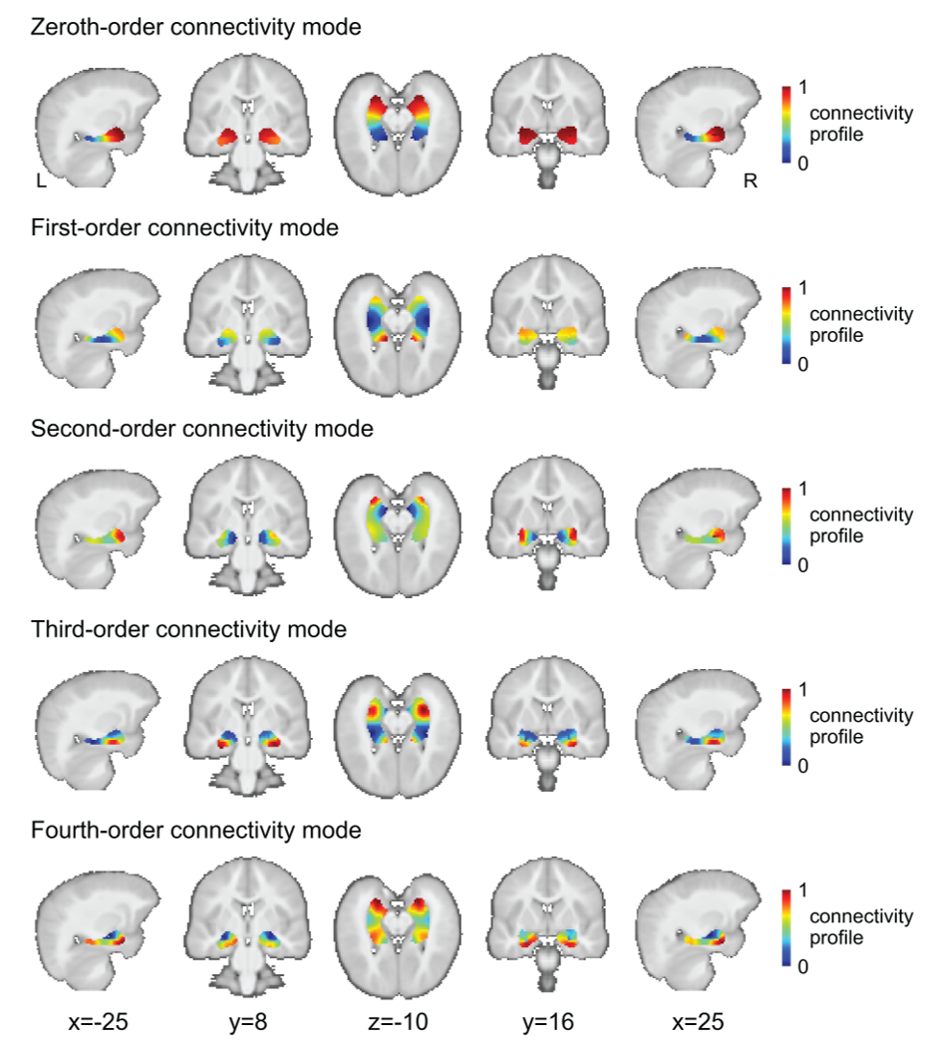
Figure S1. Group-level amygdala–hippocampal connectivity modes. Similar colors indicate similar functional connectivity of voxels in the ROIs with the rest of the brain.
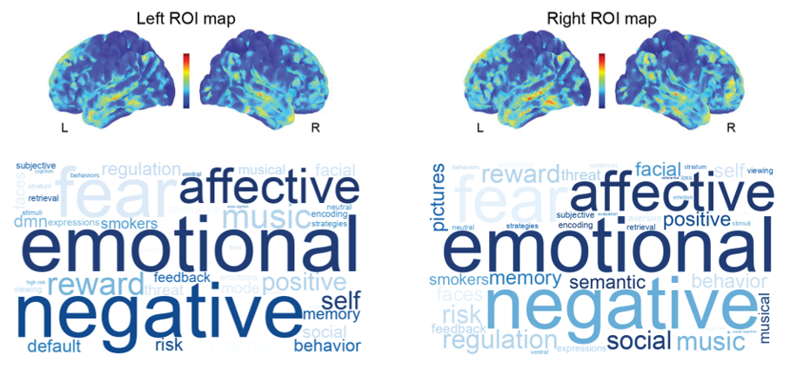

Figure S2. Metanalytic functional decoding results of the projection maps of the left and right ROIs using LDA-based decoder in NeuroSynth database. The top 16 topics and the top 3 terms in each topic are visualized in the word cloud. Larger font size indicates higher relevance to the functional term. Word weights in the projection map are indicated by blue intensity, with darker words representing higher weights and lighter words lower weights.

2. Confirmatory analysis and results

2.1 Practical considerations
This study only partially overlaps with our pre-registration; therefore, we describe it in the main manuscript as an exploratory analysis. Here, we report the results of the confirmatory analysis that followed the preregistered plan, after explaining how we deviated from this original preregistration.
Namely, when receiving the data in preparation of the analysis, we encountered some complications with the preregistered analysis. Due to the unavailability of some planned variables, as well as practical considerations regarding the dataset, both childhood stress and child functioning during the pandemic were constructed using variables that differed from those specified in the preregistration. All these considerations and changes were made before the execution of the analysis. Figure S3 and Table S7 present the pre-registered plan and the deviations in the confirmatory analysis.

Figure S3. Pre-registered plan and deviations in analysis of childhood stress

Table S7. Summary of practical considerations.
Variables | Notes
Peer relations | This subdomain of childhood stress was excluded because: 1) Data for the peer relations subscale are unavailable in the implemented version of the Child Behavior Checklist [CBCL/6-18; 2] at ages 8 and 10; 2). We attempted to find an alternative from the subscale of the Strengths and Difficulties Questionnaire [SDQ; 3], but these items describe peer relations in a more neutral manner rather than being considered as “problems.”
Maternal financial status and family or friends’ relationships | We used the Vragenlijst Recent Meegemaakte Gebeurtenissen [VRMG; English: Recent Events Questionnaire; 4] total scores due to their broader coverage of recent life events, e.g., work and health. Additionally, the distribution of the total VRMG scores is approximately normal.
Maternal daily hassles | We included daily hassles as a milder form of maternal stress in daily life compared to the more significant changes captured by the VRMG.
Maternal stress | The Perceived Stress Scale [PSS; 5]) is a global measure of subjective stress. We excluded it due to its overlap with recent life events and daily hassles, as we aimed for analysis of different constructs.
COVID-19 Symptoms and Psychological Experience [CASPE; 6] | This scale is from an unpublished manuscript, and most items are descriptive. We could not identify cognitive or emotional subscales, nor could we determine scoring.
Mediation models | In addition to the mediation models, moderation models were tested as an additional, exploratory analyses that were not included in the pre-registered plan.

2.2 Measures

2.2.1 Childhood stress
Based on the practical considerations outlined above, childhood stress at child ages 8 to 10 was summed based on following three subdomains: 1) Maternal distress, 2) Maternal life events and 3) Maternal daily hassles.
Maternal distress was measured via maternal self-reported depression and anxiety symptoms when the child was aged 8 and 10 (as preregistered). Maternal depressive symptoms was assessed using the Edinburgh Postnatal Depression Scale [EPDS; 7]. Maternal anxiety symptoms was measured using the state version of the State-Trait Anxiety Inventory [STAI; 8, 9]. Higher scores indicate greater anxiety symptoms at the moment of filling in the questionnaire. Given the common co-occurrence between postnatal depression and anxiety [10], the current analysis combined depressive and anxiety symptoms into an indicator to represent the overall level of maternal psychological distress. More specifically, total scores on the EPDS and STAI were first averaged separately across the two years (child ages 8 and 10) to obtain a mean depression score and a mean anxiety score for each participant. These two mean scores were then standardized, and maternal psychological distress was defined as the average of the two standardized scores. The original plan was to create an aggregated score including the PSS, which we did not include for its overlap with life events and hassles.
Maternal life events were assessed via maternal report on the Vragenlijst Recent Meegemaakte Gebeurtenissen [VRMG; English: Recent Events Questionnaire; 4] at child ages 8 and 10. The VRMG consists of 59 items covering events related to significant changes in work, health, relationships with family, partner, or friends, living or personal circumstances, and financial status. Mothers indicated whether they had experienced each event and rated how pleasant and unpleasant they found it. The difference score was computed by subtracting the total pleasantness rating from the total unpleasantness rating. The average of the VRMG difference scores between child ages 8 and 10 was used as an indicator of maternal life events. This is different from the preregistered approach due to the fact that the data structure of the questionnaire was different than expected. We chose to not separate into two scores as opposed to the planned approach.
Maternal daily hassles were measured at child age 10 using the 49-item Alledaagse Problemen Lijst [APL; English: Everyday Problems List; 11]. Mothers were asked to report whether certain negative events or situations occurred in the past two months, and how much they were bothered by each event on a 4-point scale. Maternal daily hassles were represented by a total negative valence score, calculated by summing ratings across all 49 items, with higher scores indicating more frequent negative daily experiences. We included this as an additional element of childhood stress.
Finally, a composite score reflecting children’s stress between ages 8 to 10 was calculated by summing the standardized scores of the three subcategories described above. Daily hassles and life events were treated as distinct subcategories of stress exposure in the present study, as they differ in temporal proximity, duration, and intensity, and each contributes unique variance to adaptive outcomes [12, 13].
In relation to the results described in the main manuscript, the variables for which we implemented the strongest changes did not lead to significant results.

2.2.2 Functioning during the pandemic
Children’s functioning during pandemics at age 13.5 was summed by following subdomains: 1) Depressive symptoms, 2) COVID-19 stress and concerns, and 3) Social connectedness. A total score reflecting children’s functioning during pandemic was calculated by summing the standardized scores of the three subcategories described below.
Depressive symptoms was reported by children at 13.5 years old via the Center for Epidemiological Studies Depression Scale for Children [CES-DC; 14]. Higher scores reflect more depressive symptoms during the first lockdown of COVID-19 pandemic.
COVID-19 stress and concerns was measured by COVID-19 adolescent symptoms and psychological experience questionnaire [CASPE; 6]. The subscales described in the preregistration (emotional and cognitive) could not be constructed as the variable structure was different than anticipated, no scoring guideline could be found and no intuitive scoring rule presented itself. Therefore, the current study calculated a sum score based on four items: stress due to uncertainty, stress due to disruptions, worry about possible illness, and concern about events, to create a measure of pandemic-related stress. Higher scores indicate greater stress during the pandemic.
Social connectedness was measured by the Adolescent Social Connectedness during the COVID-19 outbreak scale [ASC; 15]. In this study, a sum score was calculated based on six items, including how socially connected participants felt through physical gatherings with friends, scrolling through social media, viewing and following people online whom they did not know personally, and contacting friends, peers, and family members without seeing them in person. Higher scores represent greater social connectedness.

2.3 Results

2.3.1 Examining associations between childhood stress and functioning during the pandemic
Spearman correlation analysis revealed that the aggregated score of childhood stress at ages 8 to 10 was not significantly associated with total functioning at 13.5 years during the pandemic in the behavioral sample (r = 0.120, p = 0.223), as well as in the MRI subsample (r = 0.130, p = 0.322). Partial Spearman correlation analyses showed that these associations remained non-significant after adjusting for child sex and age at the 13.5-year assessment (behavioral sample: partial r = 0.131, p = 0.201; MRI subsample: partial r = 0.156, p = 0.250).
Exploratory Spearman correlation analyses across subdomains of childhood stress and subdomain functioning revealed two significant stress-functioning associations in both samples: 1) maternal distress and adolescent depressive symptoms (behavioral sample: r = 0.244, p = 0.012; MRI subsample: r = 0.299, p = 0.020) and 2) maternal life events and social connectedness (behavioral sample: r = 0.250, p = 0.010; MRI subsample: r = 0.294, p = 0.023). These associations remained significant after controlling for child sex and age measured at the 13.5-year assessment: 1) maternal distress and adolescent depressive symptoms (behavioral sample: partial r = 0.267, p = 0.008; MRI subsample: partial r = 0.292, p = 0.029) and 2) maternal life events and social connectedness (behavioral sample: partial r = 0.210, p = 0.039; MRI subsample: partial r = 0.346, p = 0.009).
In addition, maternal distress was associated with COVID-19 related stress and concerns in the MRI subsample (r = 0.266, p = 0.040) but not in the behavioral sample (r = 0.128, p = 0.193). These correlations were non-significant after controlling for child sex and age in both samples (behavioral sample: partial r = 0.141, p = 0.168; MRI subsample: partial r = 0.258, p = 0.055).

2.3.2 Identifying childhood stress related amygdala-hippocampal gradients
Based on three established associations between subdomains of childhood stress and functioning during the pandemic above (i.e., maternal distress and adolescent depressive symptoms, maternal distress and COVID-19-related stress and concerns, maternal life events and social connectedness), Spearman correlation analyses were performed to identify these subdomain stress-related connectivity gradients of the amygdala-hippocampus complex. Results showed that maternal distress was significantly associated with the third-order mode of connectivity along the y-axis in the left (y quadratic: r = −0.301, p = 0.043; y cubic: r = −0.294, p = 0.048) and right complex (y linear: r = 0.301, p = 0.047; y quadratic: r = −0.303, p = 0.047; y cubic: r = −0.307, p = 0.047). Maternal life events were related to the zeroth order of connectivity mode (right x cubic: r = −0.315, p = 0.050).
Although no significant associations were found between aggregated childhood stress and children’s functioning during the pandemic, we conducted additional Spearman correlation analyses with FDR correction to explore whether aggregated childhood stress is related to cortico-limbic connectivity gradients in pre-adolescence. This analysis only revealed a significant association between aggregated childhood stress and the third-order connectivity mode in the right amygdala–hippocampus complex (y quadratic: r = −0.344, p = 0.010), which partially overlapped with the connectivity associated with maternal distress. This finding suggests that the third-order cortico-limbic connectivity may not be specific to a single subtype of maternal psychological stress, but may imply a more general sensitivity of this connectivity pattern to early environmental stress exposure.

2.3.3 Testing mediation models with amygdala-hippocampal gradients as mediators
Build upon the associations between subdomains of stress and functioning, as well as subdomain stress-identified connectivity modes (right zeroth-order and bilateral third-order), a set of mediation models was tested to examine the mediating effect of 12.5-year connectivity in the relationship between subdomain stress at child ages 8 to 10 and functioning at age 13.5 during the pandemic, while adjusting for child sex. In summary, no significant indirect effect was found (for details see Table S8).
Table S8. Summary of mediation models with connectivity as mediators.
Independent variables | Dependent variables | Mediators | Indirect effect | BootSE | 95% CI
 |  |  |  |  | Lower | Upper
Mediator = Left third-order mode
Maternal distress | Adolescent depressive symptoms | y quadratic | 0.047 | 0.057 | −0.056 | 0.175
Maternal distress | Adolescent depressive symptoms | y cubic | 0.026 | 0.052 | −0.068 | 0.144
Maternal distress | COVID-19 related stress and concerns | y quadratic | 0.024 | 0.049 | −0.069 | 0.135
Maternal distress | COVID-19 related stress and concerns | y cubic | 0.017 | 0.047 | −0.071 | 0.125
Mediator = Right third-order mode
Maternal distress | COVID-19 related stress and concerns | y linear | −0.028 | 0.049 | −0.143 | 0.063
Maternal distress | COVID-19 related stress and concerns | y quadratic | −0.047 | 0.037 | −0.129 | 0.010
Maternal distress | COVID-19 related stress and concerns | y cubic | −0.040 | 0.047 | −0.144 | 0.045
Maternal distress | COVID-19 related stress and concerns | y linear | −0.075 | 0.052 | −0.192 | 0.008
Maternal distress | COVID-19 related stress and concerns | y quadratic | −0.024 | 0.033 | −0.098 | 0.040
Maternal distress | COVID-19 related stress and concerns | y cubic | −0.068 | 0.051 | −0.187 | 0.010
Mediator = Right zeroth-order mode
Maternal life events | Social connectedness | x cubic | −0.015 | 0.048 | −0.189 | 0.090
Notes. Each row represents an independent mediation model. The indirect effect reflects the effect of the independent variable on the dependent variable through the mediator. Sex was included as a covariate (male = 1, female = 0). Age was not included as a covariate due to the narrow age range of participants.

3. Sensitivity analysis
Three main analyses were performed including outliers: 5 outliers in the behavioral sample (original N = 110) and 3 outliers in the MRI subsample (original N = 63). Results of Spearman correlations revealed that maternal distress at child ages 8 to 10 remained positively associated with adolescent depressive symptoms (behavioral sample: r = 0.260, p = 0.006; MRI subsample: r = 0.254, p = 0.045). Similarly, for maternal distress-related gradients, maternal distress was related to the trend coefficients of third-order gradients in left (y quadratic: r_{s} = −0.304, FDR-corrected p = 0.033; y cubic: r_{s} = −0.310, FDR-corrected p = 0.031) and right ROIs (y linear: r_{s} = 0.305, FDR-corrected p = 0.042; y cubic: r_{s} = −0.318, FDR-corrected p = 0.033).
In the mediation models, the mediating effect of maternal distress–related connectivity remained non-significant in the association between maternal distress and adolescent depressive symptoms (indirect effect of X on Y through the mediator: Left y quadratic: β = 0.036, BootSE = 0.049, 95% CI [−0.043, 0.155]; Left y cubic: β = 0.038, BootSE = 0.049, 95% CI [−0.043, 0.153]; Right y linear: β = −0.029, BootSE = 0.051, 95% CI [−0.150, 0.064]; Right y cubic: β = −0.037, BootSE = 0.051, 95% CI [−0.159, 0.0.047]).
In moderation models, the interaction between maternal distress and its related left amygdala-hippocampal connectivity gradient significantly predicted adolescent depressive symptoms during the pandemic (y quadratic: β = 0.280, SE = 0.131, t = 2.15, p = 0.036; y cubic: β = 0.226, SE = 0.105, t = 2.16, p = 0.035), and the effect of right gradient remained non-significant (y linear: β = −0.044, SE = 0.163, t =−0.27, p = 0.790; y cubic: β = 0.048, SE = 0.159, t = 0.30, p = 0.764).

4. Spatial correspondence between third-order connectivity mode and 5-HT1A receptor distribution
Similar to connectivity topography within the amygdala–hippocampus and following the analysis of Oldehinkel, Llera [16], we also applied Trend Surface Modeling (TSM) to PET and SPECT images of different neurotransmitters from the JuSpace toolbox (https://github.com/juryxy/JuSpace), which resulted in nine trend coefficients quantifying the spatial variance of each neurotransmitter distribution. Results of correlations between TSM coefficients of each neurotransmitter and connectivity modes revealed that the third-order group-level connectivity mode showed a high similarity with the group-level serotonin 5-HT1A receptor distribution [17], as quantified by correlations (left: Z = 1.591, exceed the Bonferroni-corrected threshold of Z = 1.573; right: Z = 1.705, exceed the FDR-corrected threshold of Z = 1.584; thresholds derived from 10,000 permutation tests).

5. SReferences
1. Healthy Brain Study Consortium, et al., Protocol of the Healthy Brain Study: An accessible resource for understanding the human brain and how it dynamically and individually operates in its bio-social context. Plos one, 2021. 16(12): p. e0260952.
2. Achenbach, T.M. and L.A. Rescorla, Manual for the ASEBA preschool forms and profiles. Vol. 30. 2000: Burlington, VT: University of Vermont, Research center for children, youth ….
3. Goodman, R., The Strengths and Difficulties Questionnaire: a research note. Journal of child psychology and psychiatry, 1997. 38(5): p. 581-586.
4. Van de Willige, G., et al., Het meten van" life events": de Vragenlijst Recent Meegemaakte Gebeurtenissen (VRMG). Nederlands Tijdschrift voor de Psychologie en haar Grensgebieden, 1985.
5. Cohen, S., T. Kamarck, and R. Mermelstein, A global measure of perceived stress. Journal of health and social behavior, 1983: p. 385-396.
6. Ladouceur, C.D., COVID-19 adolescent symptom & psychological experience questionnaire. 2020.
7. Cox, J.L., J.M. Holden, and R. Sagovsky, Detection of postnatal depression: development of the 10-item Edinburgh Postnatal Depression Scale. The British journal of psychiatry, 1987. 150(6): p. 782-786.
8. Spielberger, C.D., et al., Manual for the state-trait anxiety inventory. Palo Alto, CA: Consulting Psychologists, 1983.
9. Van der Ploeg, H., P. Defares, and C. Spielberger, Manual for the Self-assessment Questionnaire, STAI-DY, addendum. Handleiding bij de Zelf-beoordelings Vragenlijst, ZBV; Addendum, 1981.
10. Falah-Hassani, K., R. Shiri, and C.-L. Dennis, The prevalence of antenatal and postnatal co-morbid anxiety and depression: a meta-analysis. Psychological medicine, 2017. 47(12): p. 2041-2053.
11. Vingerhoets, A., A. Jeninga, and L. Menges, Het meten van chronische en alledaagse stressoren: II. Eerste onderzoekservaringen met de Alledaagse Problemen Lijst (APL). Gedrag & Gezondheid: Tijdschrift voor Psychologie en Gezondheid, 1989.
12. Arnold, R. and D. Fletcher, Stressors, hassles, and adversity. Stress, well-being, and performance in sport, 2021: p. 31-62.
13. Rowlison, R.T. and R.D. Felner, Major life events, hassles, and adaptation in adolescence: confounding in the conceptualization and measurement of life stress and adjustment revisited. Journal of personality and social psychology, 1988. 55(3): p. 432.
14. Radloff, L.S., The CES-D scale: A self-report depression scale for research in the general population. Applied psychological measurement, 1977. 1(3): p. 385-401.
15. Pfeifer, J., adolescent social connection & coping during COVID-19 Questionnaire (ASC). Adolescent Social Connection & Coping during COVID-19 Questionnaire (ASC), 2020.
16. Oldehinkel, M., et al., Mapping dopaminergic projections in the human brain with resting-state fMRI. Elife, 2022. 11: p. e71846.
17. Savli, M., et al., Normative database of the serotonergic system in healthy subjects using multi-tracer PET. Neuroimage, 2012. 63(1): p. 447-459.

