Supplementary Materials.

Supplementary Figure 1.
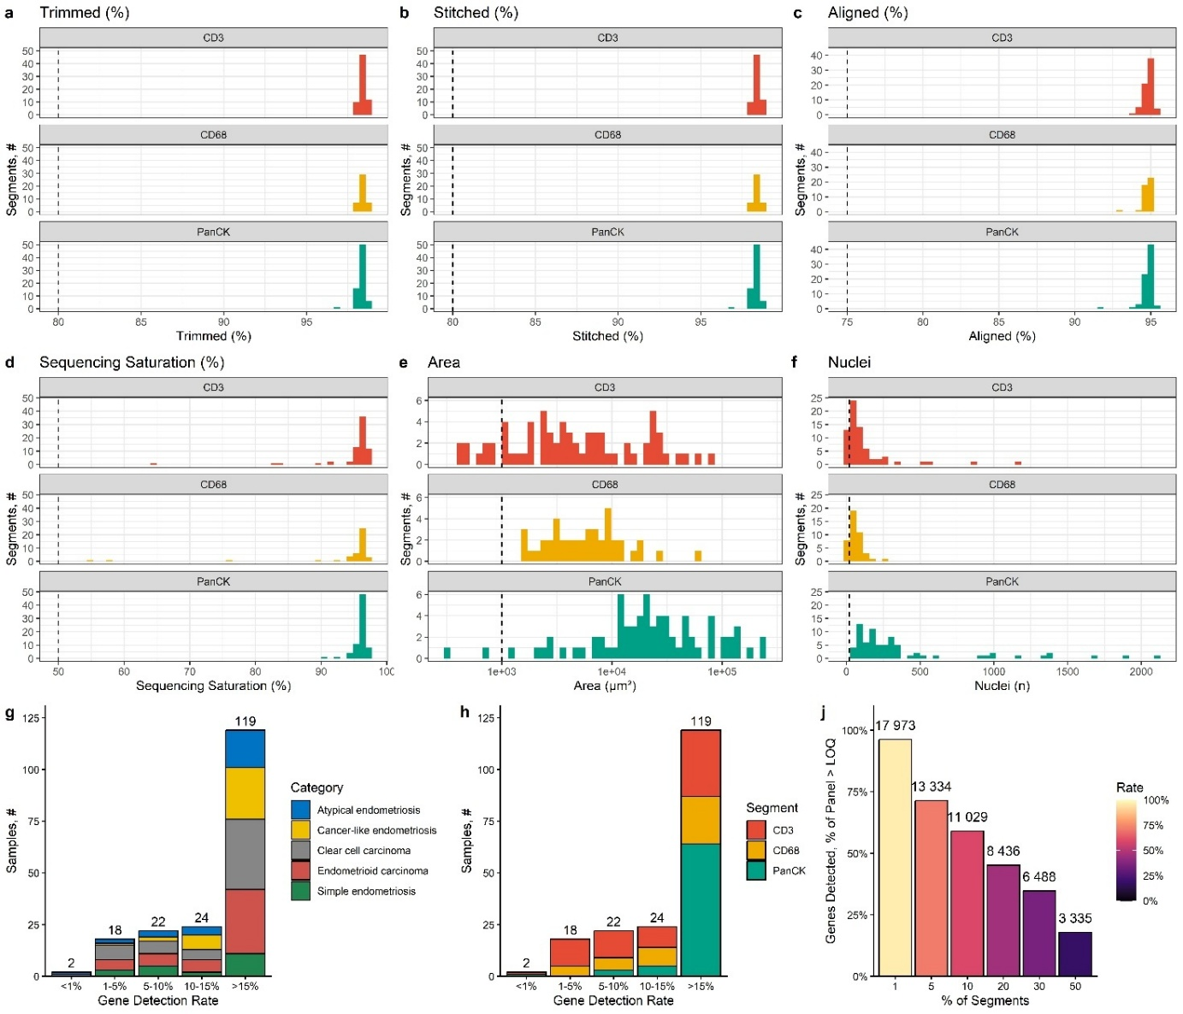
Supplementary Figure 1 ∣ ROI‐level quality control metrics.
a–e. Histograms of segment‐level QC metrics for each marker (CD3, CD68, PanCK). Dashed vertical lines indicate the recommended QC thresholds (Methods). a. Percentage of reads retained after low‐quality base trimming (“Trimmed %”). b. Percentage of trimmed reads successfully stitched into paired fragments (“Stitched %”). c. Percentage of stitched reads that aligned to the reference transcriptome (“Aligned %”). d. Sequencing saturation of each ROI (“Sequencing saturation %”). e. Area of each ROI segment in µm² ("Area”). f. Number of nuclei per ROI. g–h. Stacked barplots of the number of ROI segments achieving specified gene‐detection rates (percentage of panel genes detected above limit of quantification). g. Stratified by category. h. Stratified by marker. Counts above each bar indicate total segments in that bin. i. Cumulative distribution of genes passing the limit of quantification (LoQ) across all segments. For each percentile cutoff, the number of genes detected in at least that fraction of segments (bar height), with colour gradient showing the corresponding detection rate.
Supplementary Figure 2.
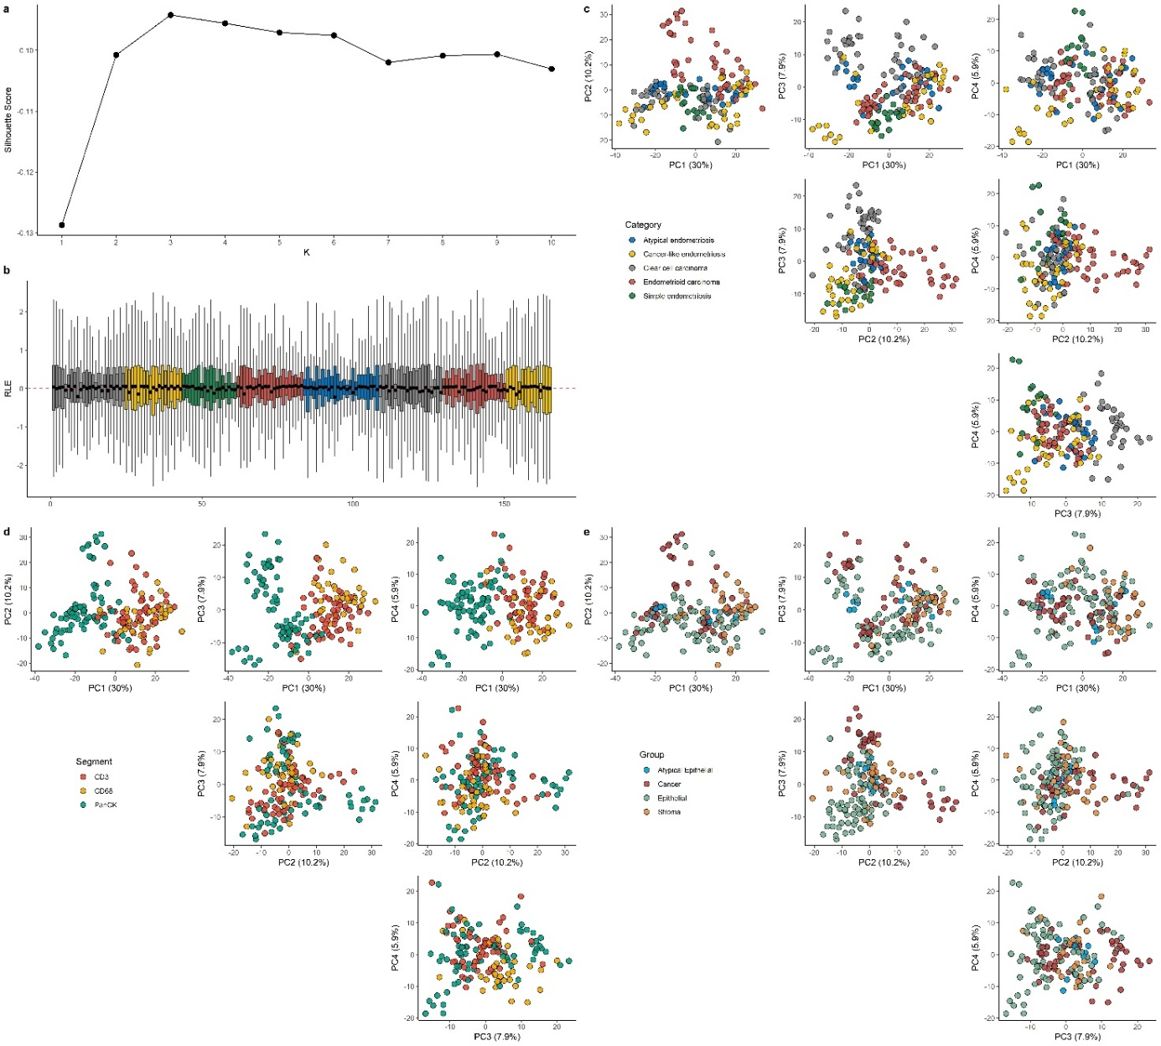
Supplementary Figure 2 ∣ Assessment of RUV‐based batch removal and downstream PCA.
a. Silhouette scores after removing increasing numbers of unwanted variation factors (k = 1–10) via RUV; the optimum at k = 3 (arrow) was used for batch correction. b. Relative log‐expression (RLE) boxplots across all ROI segments after TMM normalization and RUV correction with k = 3. The red dashed line denotes zero. c–e. Pairwise PCA scatterplots of RUV‐corrected log CPM across the first four PCs, illustrating segregation of samples. c. Category. d. Cell-specific marker (“Segment). e. tissue compartment (“Group”).

Supplementary Figure 3.
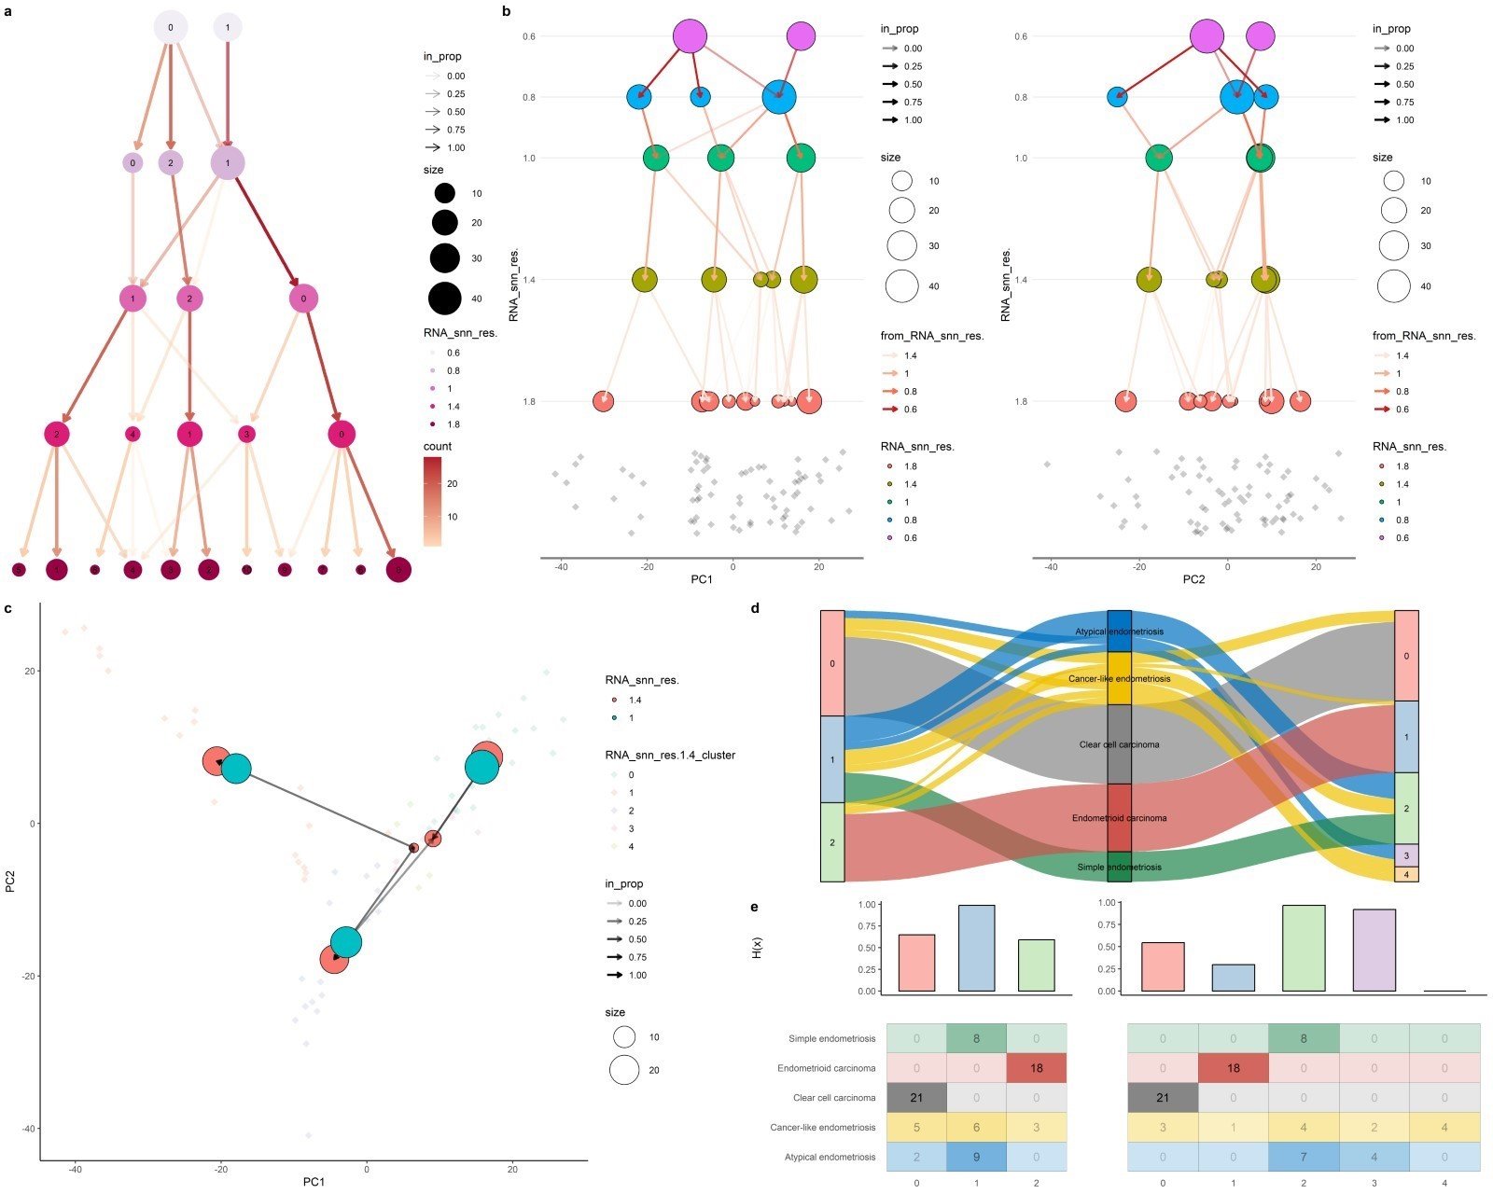
Supplementary Figure 3 | Clustering analysis and overlap for PanCK+ ROIs across categories.
a. Hierarchical organization of ROIs clusters. A graph-based clustering was performed using Leiden algorithm with different resolution parameters (from 0.6 to 1.8). Nodes represent clusters, with size proportional to the number of ROIs and edge thickness reflecting the proportion of shared ROIs between clusters. b. Cluster relationships projected onto the PC1 (left) and PC2 (right) of the PCA space, illustrating transitions and connectivity between clusters at different resolution levels. Arrows indicate the direction and strength of transitions between clusters. c. Minimum spanning tree connecting cluster centroids in PCA space. Resolutions for which 3 and 5 clusters were determined are reported. d. Sankey diagram showing the correspondence between identified clusters and pre-defined categories. e. Quantification of cluster purity for 3 and 5 clusters. Barplots represent Shannon entropy (Hx) and contingency tables the distribution of categories for each cluster.

Supplementary Figure 4.
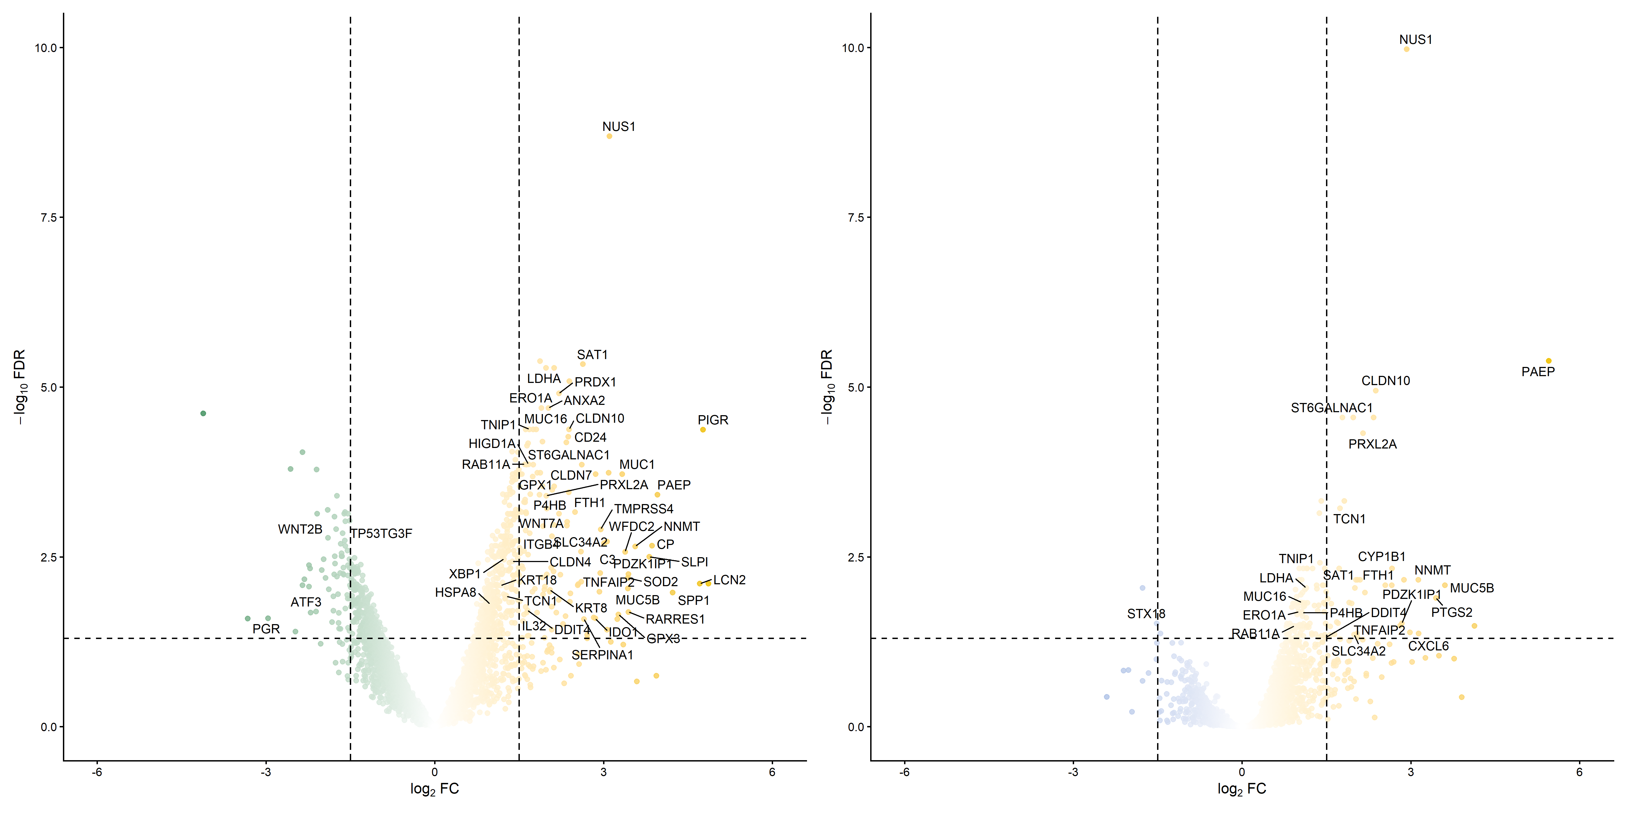
Supplementary Figure 4 | Differential expression of PanCK+ AOIs for ovarian endometriosis, after adjustment for menstrual phase and combined oral contraceptive use.
a. Volcano plots comparing CLE (right) vs SE (left). Dashed line indicates log₂ FC > |1.5| and FDR <0.05. b. Volcano plots comparing CLE (right) vs AE (left). Dashed line indicates log₂ FC > |1.5| and FDR<0.05.

Supplementary Figure 5.
Supplementary Figure 5 ∣ Comparative transcriptomic and pathway‐level analysis of clear cell and endometrioid carcinoma relative to adjacent epithelium.
a-d. Clear cell carcinoma. e-h. Endometrioid carcinoma. Volcano plots of differential gene expression between tumor and surrounding non-malignant epithelium in clear-cell (a) and endometrioid (e) carcinoma. Positive log2FC indicates enrichment in tumor. Dashed vertical lines mark |log₂ FC| = 1.5 and the horizontal line marks FDR = 0.05. The top 15 genes are labeled. GSEA dot-plots of the top enriched gene sets for Gene Ontology Biological Processes (b, f), MSigDB Hallmark signatures (c, g), and MSigDB oncogenic (C6) signature (d, h) collections. Positive Normalized Enrichment Scores (NES) indicate enrichment in tumor while negative NES indicate enrichment in epithelium. Dot size reflects the number of leading‐edge genes and color denotes FDR-adjusted p-value.

Supplementary Figure 6.

Supplementary Figure 6 | Extended spatial deconvolution results of CD68⁺ regions.

a. Stacked bar‐plot of relative cell‐type proportions for each region of interest (ROI), after deconvolution using safeTME. b. Heatmap of cell proportions across all ROIs, with hierarchical clustering of ROIs (columns) and cell types (rows).

Supplementary Figure 7.
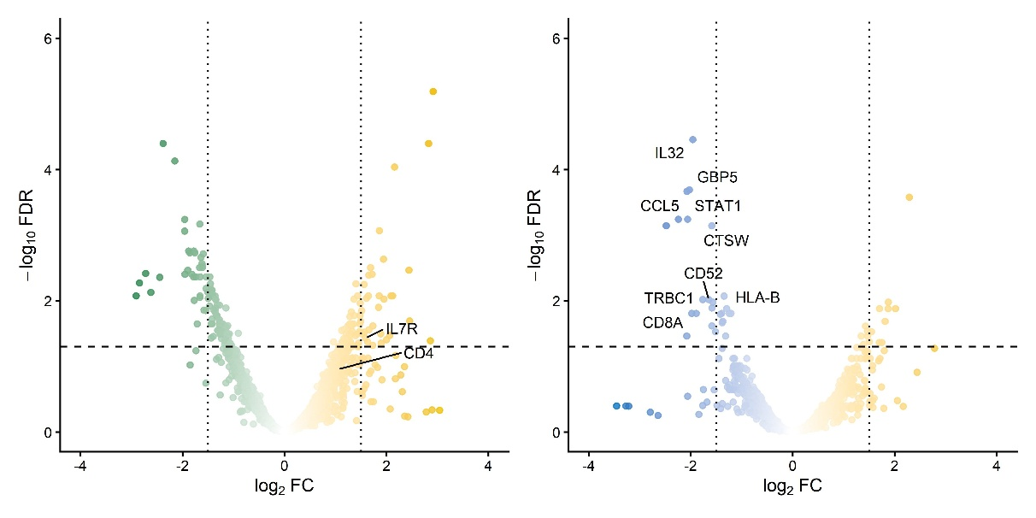
Supplementary Figure 7 | DGE of CD3+ ROI.
Volcano plots comparing CLE to SE (left) and AE (right) for CD68+ ROIs. Dashed line indicates Log₂ FC > |1.5| and FDR <0.05.

Supplementary Figure 8.

Supplementary Figure 8 | Extended spatial deconvolution results of CD3⁺ regions.
a. Stacked bar‐plot of relative cell‐type proportions for each region of interest (ROI), after deconvolution using safeTME. b. Heatmap of cell proportions across all ROIs, with hierarchical clustering of ROIs (columns) and cell types (rows).

Supplementary Table 1.
Category | Age | Parity | Mestrual phase | Stage | Surgical procedures | History of PID | Hystory of COC
Simple endometriosis | 49 | 1011 | Secretory | - | Hysterectomy | 0 | 1
Simple endometriosis | 48 | 0000 | Secretory | - | Bilateral adnexectomy | 0 | 0
Cancer-like endometriosis | 37 | 0000 | Secretory | - | Cyst enucleation | 0 | 0
Cancer-like endometriosis | 38 | 0000 | Secretory | - | Cyst enucleation | 0 | 0
Cancer-like endometriosis | 45 | 2002 | Secretory | - | Bilateral adnexectomy | 0 | 1
Cancer-like endometriosis | 39 | 2002 | Proliferative | - | Monolateral adnexectomy | 0 | 0
Atypical endometriosis | 45 | 0000 | Secretory | - | Hysterectomy | 0 | 0
Atypical endometriosis | 34 | 0000 | Secretory | - | Hysterectomy | 0 | 1
Clear cell carcinoma | 50 | 2002 | Secretory | IB | Radical Surgery | 0 | 0
Clear cell carcinoma | 50 | 0000 | Proliferative | IIA | Radical Surgery | 0 | 0
Clear cell carcinoma | 49 | 0000 | Secretory | IC2 | Radical Surgery | 0 | 0
Endometrioid carcinoma | 50 | 1001 | Secretory | IC1 | Radical Surgery | 0 | 0
Endometrioid carcinoma | 49 | 2002 | Secretory | IIA | Radical Surgery | 0 | 0
Endometrioid carcinoma | 48 | 0000 | Proliferative | IIB | Radical Surgery | 0 | 0

Supplementary Table 1 | Patients’ characteristics.
PID = Pelvic inflammatory disease. COC = Combined oral contraceptives.

Supplementary Table 2.
 | CD3 | CD68 | PanCK
Atypical endometriosis | 5 | 9 | 11
Cancer-like endometriosis | 13 | 7 | 14
Clear cell carcinoma | 11 | 13 | 21
Endometrioid carcinoma | 19 | 6 | 18
Simple endometriosis | 7 | 3 | 8

Supplementary Table 2. Total number of AOIs for cell-types.

Supplementary Table 3.
Category | CD3 | CD4 | CD8 | CD68 | PD-L1 TPS | PD-L1 CPS | PD1 | PD-L1 IRS  Epithelium | PD-L1 IRS  Immune/Stroma
Simple endometriosis | 60 | 10 | 90 | 25 | - | - | - | 0 | 0
Simple endometriosis | 60 | 10 | 90 | 35 | - | - | - | 0 | 0
Cancer-like endometriosis | 60 | 10 | 50 | 90 | - | - | - | 6 | 6
Cancer-like endometriosis | 20 | 10 | 10 | 75 | - | - | - | 4 | 4
Cancer-like endometriosis | 30 | 5 | 95 | 35 | - | - | - | 2 | 4
Cancer-like endometriosis | 5 | 50 | 50 | 20 | - | - | - | 0 | 4
Atypical endometriosis | 25 | 5 | 95 | 30 | - | - | - | 0 | 2
Atypical endometriosis | 15 | 5 | 95 | 10 | - | - | - | 0 | 2
Clear cell carcinoma | 15 | 5 | 10 | 25 | 0 | 2 | - | 2 | 4
Clear cell carcinoma | 30 | 0 | 99 | 45 | 5 | 10 | 5 | 4 | 6
Clear cell carcinoma | 80 | 50 | 50 | 40 | 5 | 40 | 20 | 6 | 8
Endometrioid carcinoma | 45 | 10 | 35 | 80 | 0 | 10 | - | 4 | 4
Endometrioid carcinoma | 10 | 5 | 95 | 40 | 0 | 5 | 0 | 0 | 2
Endometrioid carcinoma | 50 | 20 | 80 | 25 | 0 | 2 | 0 | 0 | 2

Supplementary Table 3 | Summary of immunoistochemistry results.
TPS=Tumor proportion score. CPS=Combined positive score. IRS= immunoreactivity score.

Supplementary Table 4
Category | PC | PC value | p-value
Atypical endometriosis | PC1 | 1.69829385 | 0.08945231
Atypical endometriosis | PC2 | 1.87572951 | 0.06069243
Atypical endometriosis | PC3 | -3.40484425 | 0.00066202
Cancer-like endometriosis | PC1 | 1.79451824 | 0.07273049
Cancer-like endometriosis | PC2 | 2.54821593 | 0.01082754
Cancer-like endometriosis | PC3 | -2.27959348 | 0.02263181
Clear cell carcinoma | PC1 | 2.1215873 | 0.03387241
Clear cell carcinoma | PC2 | 3.14007989 | 0.00168902
Clear cell carcinoma | PC3 | 0.51239741 | 0.60837291
Endometrioid carcinoma | PC1 | -1.46904454 | 0.14182071
Endometrioid carcinoma | PC2 | 3.12293754 | 0.00179056
Endometrioid carcinoma | PC3 | -2.28812784 | 0.02213008

Supplementary Table 4 | Multinomial regression for PCA
PC=principal component.

Supplementary Table 5.
[A]
AOI | Category | PanCK+/MUC5B+ | PanCK+/MUC5B- | PanCK | MUC5B (%)
Pt1_1 | CLE | 31 | 0 | 31 | 1
Pt1_2 | CLE | 34 | 1 | 35 | 0.9714
Pt1_3 | CLE | 12 | 0 | 12 | 1
Pt2_1 | SE | 0 | 31 | 31 | 0
Pt2_2 | SE | 1 | 41 | 42 | 0.023
Pt2_3 | SE | 0 | 45 | 45 | 0
Pt3_1 | CLE | 42 | 6 | 48 | 0.875
Pt3_2 | CLE | 25 | 3 | 28 | 0.8928
Pt3_3 | CLE | 43 | 11 | 54 | 0.7962
Pt4_1 | SE | 0 | 39 | 39 | 0
Pt4_2 | SE | 0 | 64 | 64 | 0
Pt4_3 | SE | 1 | 50 | 51 | 0.0196
Pt5_1 | CLE | 66 | 29 | 95 | 0.6947
Pt5_2 | CLE | 56 | 2 | 58 | 0.9655
Pt5_3 | CLE | 36 | 2 | 38 | 0.9473

[B]
AOI | Category | PanCK+/MUC5B+ | PanCK+/MUC5B | PanCK | MUC5B (%)
Pt1 | CLE | 31 | 0 | 31 | 1
Pt2 | SE | 0 | 41 | 42 | 0
Pt3 | CLE | 42 | 6 | 48 | 0.875
Pt4 | SE | 0 | 50 | 51 | 0
Pt5 | CLE | 56 | 2 | 58 | 0.9473

Supplementary Table 5 | Immunofluorescence results for PanCK cells.

Supplementary Table 6.
[A]
AOI | Category | CD66b+/MPO+/ARG- | CD66b+/MPO+/ARG+ | Other | CD66b+ | Non PanCK | CD66b+ (%)
Pt1_1 | CLE | 5 | 11 | 214 | 16 | 230 | 0.0695
Pt1_2 | CLE | 6 | 16 | 135 | 22 | 157 | 0.1401
Pt1_3 | CLE | 20 | 54 | 57 | 74 | 131 | 0.5648
Pt2_1 | SE | 0 | 2 | 393 | 2 | 395 | 0.0050
Pt2_2 | SE | 1 | 1 | 316 | 2 | 318 | 0.0062
Pt2_3 | SE | 2 | 1 | 497 | 3 | 500 | 0.006
Pt3_1 | CLE | 2 | 19 | 230 | 21 | 251 | 0.0836
Pt3_2 | CLE | 1 | 18 | 212 | 19 | 231 | 0.0822
Pt3_3 | CLE | 2 | 15 | 184 | 17 | 201 | 0.0845
Pt4_1 | SE | 1 | 1 | 135 | 2 | 137 | 0.0145
Pt4_2 | SE | 3 | 0 | 173 | 3 | 176 | 0.0170
Pt4_3 | SE | 1 | 1 | 209 | 2 | 211 | 0.0094
Pt5_1 | CLE | 33 | 166 | 274 | 199 | 473 | 0.4207
Pt5_2 | CLE | 21 | 116 | 239 | 137 | 376 | 0.3643
Pt5_3 | CLE | 17 | 141 | 222 | 158 | 380 | 0.4157

[B]
AOI | Category | CD66b+/MPO+/ARG- | CD66b+/MPO+/ARG+ | Other | CD66b+ | Non PanCK | CD66b+ (%)
Pt1 | CLE | 6 | 16 | 135 | 22 | 157 | 0.1401
Pt2 | SE | 1 | 1 | 393 | 2 | 395 | 0.006
Pt3 | CLE | 2 | 18 | 212 | 19 | 231 | 0.0836
Pt4 | SE | 1 | 1 | 173 | 2 | 176 | 0.0145
Pt5 | CLE | 21 | 141 | 239 | 158 | 380 | 0.4157

Supplementary Table 6 | Immunofluorescence results for immune cells.

Supplementary Note 1. List of genes used to assign module scores.

Proliferative | "SOX9", "SLC7A11", "DKK1", "PHLDA1", "KMO", "IHH", "EMID1", "IL32", "WNT7A", "LGR5", "MMP7", "TNF"
Secretory | HPRT1", "SUFU", "OPRK1", "CBR3", "S100P", "SCGB2A2", "ABCG1", "PAEP", "DPP4", "GPX3", "PTPRR", "FGF7", "FXYD2", "VTCN1", "CLDN22", "SULT1E1", "LEFTY1", "LGR5", "PTGS1", "IL6"
Ciliated | "CCNO", "CDC20B", "MUC12", "PIFO", "FOXJ1", "TP73", "C1orf194", "RSPH1"
MUC5B | "MUC5B", "TFF3", "BPIFB1", "SAA1", "LCN2", "LTF"
Hormone response | "PGR", "AR", "ESR1"

Marečková, M. et al. An integrated single-cell reference atlas of the human endometrium. Nat. Genet. 56, 1925–1937 (2024).

Supplementary Note 2. Hierarchical gating for immunofluorescence.

Level 0 | Level 1 | DAPI | ARG1 | CD66b | PDL1 | MUC5B | MPO | PanCK
all | PanCK+ | - | - | - | - | - | - | pos
all | CD66b+ | - | - | allpos | - | - | allpos | -
PanCK+ | PanCK+/MUC5B+ | - | - | - | - | allpos | - | allpos
PanCK+ | PanCK+/MUC5B- | - | - | - | - | neg | - | pos
CD66b+ | CD66b+/MPO+/ARG- | - | neg | allpos | - | - | allpos | -
CD66b+ | CD66b+/MPO+/ARG+ | - | allpos | allpos | - | - | allpos | -

Allpos = all markers should be positive to assign a phenotype. Pos = at least one should be positive to assigne phenotype. Neg = marker should be negative to assign phenotype.

Research Resource Identifiers.

IHC antibodyes
- CD3: RRID:AB_2335978
- CD4: RRID:AB_443672
- CD8: RRID:AB_2335985
- PD-1: RRID:AB_3697949
- PD-L1: RRID:AB_2819099
- CD15: RRID:AB_563502

GeoMx:
- SYTO13 and PanCK from GeoMx Solid Tumor TME Morphology Kit Human Protein Compatible (Catalog number 121300301): RRID:AB_2935724
- CD3: RRID:AB_321245
- CD68: RRID:AB_2801637

Opal antibodyes
- CD66b: RRID:AB_3097803
- ARGINASE-1: RRID:AB_10678968
- MPO: RRID:AB_2798516
- MUC5B: RRID:AB_1854203
- PD-L1: RRID:AB_2687655
- PanCK: RRID:AB_3662123

Softwares and tools:
- Nanostring GeomX: RRID:SCR_021660
- Akoya Opal: RRID:SCR_023772
- R Studio: RRID:SCR_001905
- Python: RRID:SCR_008394
- QuPath: RRID:SCR_018257

