Sex-specific upper airway morphological alterations are associated with obstructive sleep apnea severity in Down syndrome
Luis Miguel Echeverry-Quiceno^{1*}, Sergi Llambrich¹, Sandra Giménez^{2,3}, Mateus Rozalem-Aranha^{3,4}, Yann Heuzé⁵, Xavier Sevillano⁶, Juan Fortea³, Neus Martínez-Abadías¹

¹Departament de Biologia Evolutiva, Ecologia i Ciències Ambientals (BEECA), Facultat de Biologia, Universitat de Barcelona (UB), Spain.
²Multidisciplinary Sleep Unit Department of Respiratory Medicine and Allergy, Hospital de la Sant Creu i Sant Pau. Institut de Recerca Sant Pau (IR SANT PAU), Barcelona, Spain.

³Sant Pau Memory Unit, IR SANT PAU, Hospital de la Santa Creu i Sant Pau, Barcelona, 08025, Spain. Centro de Investigación Biomédica en Red en Enfermedades Neurodegenerativas (CIBERNED), Madrid, Spain.
⁴Neuroradiology Section, Department of Radiology, Hospital de la Santa Creu i Sant Pau, Universitat Autònoma de Barcelona, Barcelona, Spain.
⁵Univ. Bordeaux, CNRS, Ministère de la Culture, PACEA, UMR5199, Pessac, France.
⁶HER - Human-Environment Research Group, La Salle - Universitat Ramon Llull, Barcelona, Spain.

* Corresponding author. Departament de Biologia Evolutiva, Ecologia i Ciències Ambientals (BEECA), Facultat de Biologia, Universitat de Barcelona (UB), Avinguda Diagonal, 643, Les Corts, 08028 Barcelona, España.
E-mail address: lechevqu7@alumnes.ub.edu (Luis Miguel Echeverry-Quiceno).

Supplementary Information

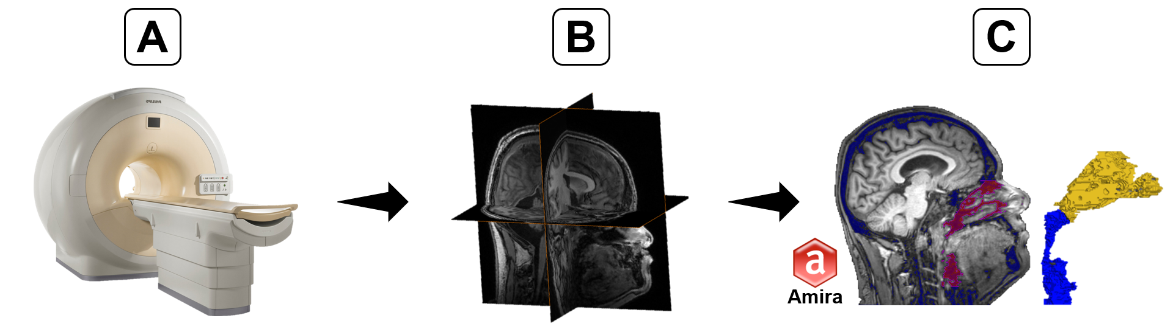
Supplementary Fig. S1. Pipeline to create three-dimensional (3D) upper airway models from magnetic resonance images (MRI). A) 3T scanner, B) Structural head MRI and C) 2D segmentation and 3D upper airway model.

Supplementary Table S1. Results of permutation-based ANOVAs evaluating the influence of the Body Mass Index (BMI) on volume and shape of the entire upper airway, nasal cavity and pharynx in the Down syndrome (DS) population.
Only DS
Region | Test Type | Variable | MS | Rsq | F | Z | p-value
Entire Upper Airway | Linear model (Volume) | BMI (Males) | 85350441 | 0.07088 | 3.9667 | 1.5871 | 0.05029
Entire Upper Airway | Linear model (Volume) | BMI (Females) | 3094075 | 0.01129 | 0.3653 | -0.096545 | 0.5485
Entire Upper Airway | Procrustes ANOVA (Shape) | BMI (Males) | 0.0126215 | 0.03104 | 1.6658 | 1.3899 | 0.08229
Entire Upper Airway | Procrustes ANOVA (Shape) | BMI (Females) | 0.0060619 | 0.02599 | 0.8539 | -0.13984 | 0.5516
Nasal cavity | Linear model (Volume) | BMI (Males) | 16770276 | 0.01301 | 0.6855 | 0.27378 | 0.4074
Nasal cavity | Linear model (Volume) | BMI (Females) | 6948046 | 0.00942 | 0.3043 | -0.17107 | 0.5755
Nasal cavity | Procrustes ANOVA (Shape) | BMI (Males) | 0.0098157 | 0.01517 | 0.8007 | -0.20935 | 0.5817
Nasal cavity | Procrustes ANOVA (Shape) | BMI (Females) | 0.013163 | 0.03214 | 1.0626 | 0.38089 | 0.351
Pharynx | Linear model (Volume) | BMI (Males) | 36272361 | 0.05478 | 3.0134 | 1.343 | 0.08959
Pharynx | Linear model (Volume) | BMI (Females) | 4313682 | 0.00862 | 0.2783 | -0.22883 | 0.5975
Pharynx | Procrustes ANOVA (Shape) | BMI (Males) | 0.026496 | 0.04128 | 2.2389 | 1.5736 | 0.06009
Pharynx | Procrustes ANOVA (Shape) | BMI (Females) | 0.0126253 | 0.03887 | 1.2942 | 0.71998 | 0.2336

Supplementary Table S2. Definitions of the upper airway landmarks used for geometric morphometric and univariate/multivariate analyses.
Landmark number | Definition
1 | Right-most point of the superior border of the nasal cavity
2 | Anterior-most point of the superior border of the nasal cavity
3 | Left-most point of the superior border of the nasal cavity
4 | Posterior-most point of the superior border of the nasal cavity
5 | Midline point of the superior border of the nasal cavity
6 | Tip of the right nostril (anterior-most point)
7 | Tip of the left nostril (anterior-most point)
8 | Right-most lateral boundary of the nasal cavity (axial view)
9 | Left-most lateral boundary of the nasal cavity
10 | Right lateral boundary of the choanal opening
11 | Left lateral boundary of the choanal opening
12 | Midline point of the choanal opening
13 | Anterior midline point at the narrowest pharynx (uvular level)
14 | Right anterior corner of the inferior pharynx
15 | Left anterior corner of the inferior pharynx
16 | Right posterior corner of the inferior pharynx
17 | Left posterior corner of the inferior pharynx
18 | Posterior midline point at the narrowest pharynx (uvular level)
19 | Right posterior boundary of the pharynx at the choanal level
20 | Left posterior boundary of the pharyngeal airway at the choanal level.
21 | Right lateral point of the posterior nasal cavity
22 | Midline point of the posterior nasal cavity
23 | Left lateral point of the posterior nasal cavity

Supplementary Table S3. Results of permutation-based ANOVAs evaluating the influence of sex on volume and shape of the entire upper airway, nasal cavity and pharynx in euploid (EU) and DS populations.
EU + DS
Region | Test Type | Variable | MS | Rsq | F | Z | p-value
Entire Upper Airway | Linear model (Volume) | Sex | 0.41739 | 0.06053 | 11.984 | 2.7466 | 0.0007999***
Entire Upper Airway | Procrustes ANOVA (Shape) | Sex | 0.041647 | 0.02761 | 4.998 | 3.7439 | 0.00009999***
Nasal cavity | Linear model (Volume) | Sex | 0.7049 | 0.04578 | 7.7726 | 2.2528 | 0.006099**
Nasal cavity | Procrustes ANOVA (Shape) | Sex | 0.082006 | 0.0377 | 6.8374 | 3.9976 | 0.00009999***
Pharynx | Linear model (Volume) | Sex | 0.00153 | 0.00009 | 0.0144 | -1.4027 | 0.00904***
Pharynx | Procrustes ANOVA (Shape) | Sex | 0.056018 | 0.02226 | 4.1028 | 2.7308 | 0.0034**

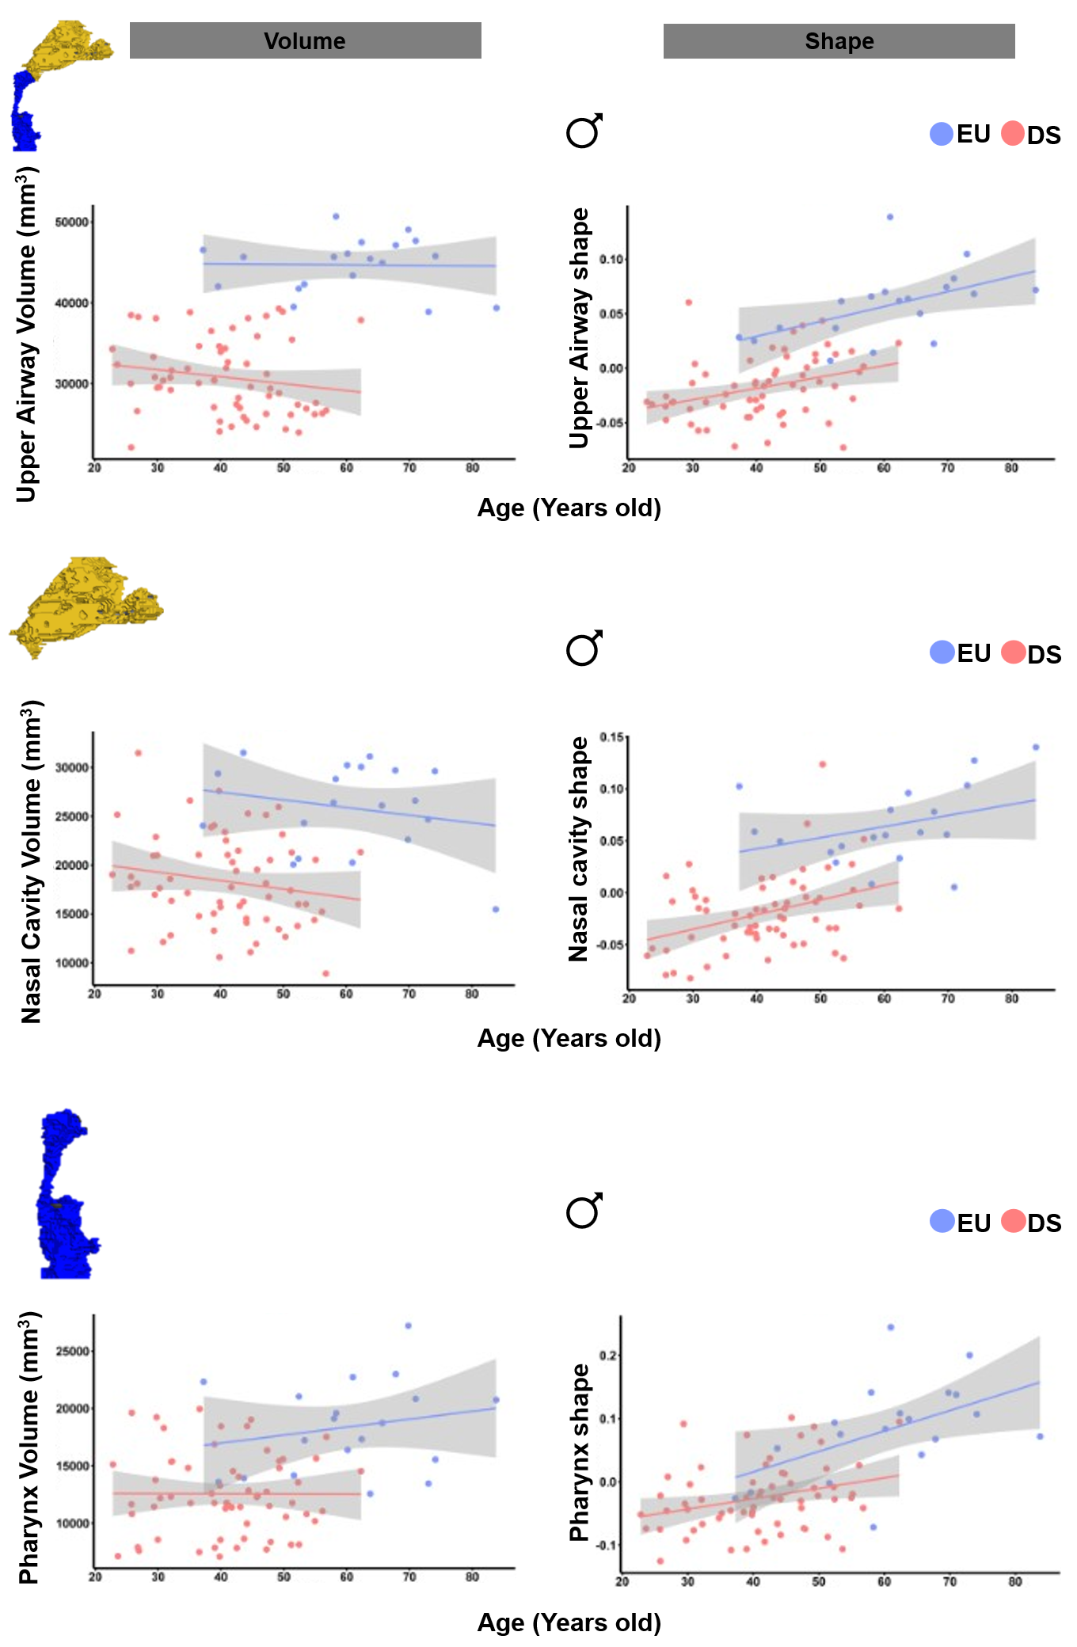
Supplementary Fig. S2. Ontogenetic variation in upper airway volume and shape in male participants. Univariate and multivariate regression analyses of volume and shape with age for A) the entire upper airway, B) the nasal cavity and C) the pharynx.

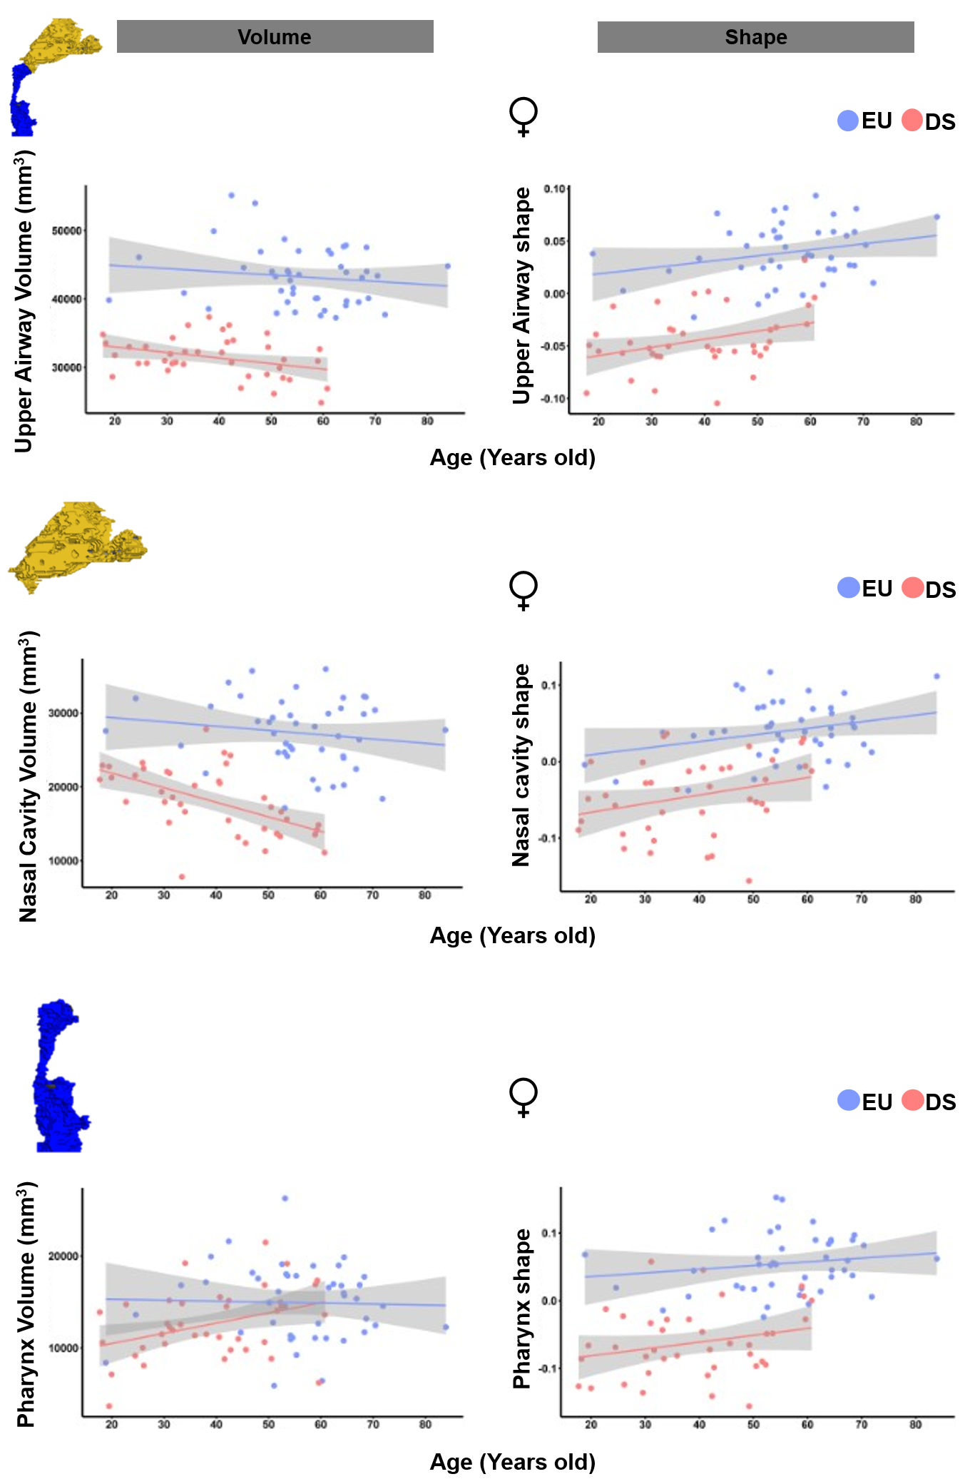
Supplementary Fig. S3. Ontogenetic variation in upper airway volume and shape in female participants. Univariate and multivariate regression analyses of volume and shape with age for A) the entire upper airway, B) the nasal cavity and C) the pharynx.

Supplementary Table S4. Results of permutation-based ANOVAs evaluating ontogeny on volume and shape of the entire upper airway, nasal cavity and pharynx in the EU controls group.
Only EU
Region | Test Type | Variable | MS | Rsq | F | Z | p-value
Entire Upper Airway | Linear model (Volume) | Age (Males) | 98970 | 0.0005 | 0.0085 | -1.5423 | 0.9303
Entire Upper Airway | Linear model (Volume) | Age (Females) | 14412146 | 0.01847 | 0.7901 | 0.35477 | 0.3806
Entire Upper Airway | Procrustes ANOVA (Shape) | Age (Males) | 0.0096539 | 0.05967 | 1.0788 | 0.36481 | 0.3608
Entire Upper Airway | Procrustes ANOVA (Shape) | Age (Females) | 0.0076198 | 0.02466 | 1.0617 | 0.32037 | 0.3779
Nasal cavity | Linear model (Volume) | Age (Males) | 16201604 | 0.0444 | 0.7899 | 0.31882 | 0.3933
Nasal cavity | Linear model (Volume) | Age (Females) | 22198541 | 0.02376 | 1.0221 | 0.52851 | 0.3216
Nasal cavity | Procrustes ANOVA (Shape) | Age (Males) | 0.013027 | 0.06519 | 1.1855 | 0.57049 | 0.2835
Nasal cavity | Procrustes ANOVA (Shape) | Age (Females) | 0.011474 | 0.02766 | 1.1946 | 0.59262 | 0.2758
Pharynx | Linear model (Volume) | Age (Males) | 12771186 | 0.04433 | 0.7885 | 0.33866 | 0.3825
Pharynx | Linear model (Volume) | Age (Females) | 732652 | 0.00102 | 0.0428 | -1.0471 | 0.8393
Pharynx | Procrustes ANOVA (Shape) | Age (Males) | 0.030884 | 0.09962 | 1.881 | 1.1966 | 0.1213
Pharynx | Procrustes ANOVA (Shape) | Age (Females) | 0.012497 | 0.02426 | 1.0443 | 0.27998 | 0.3934

Supplementary Table S5. Results of permutation-based ANOVAs evaluating ontogeny on volume and shape of the entire upper airway, nasal cavity and pharynx in the DS population.
Only DS
Region | Test Type | Variable | MS | Rsq | F | Z | p-value
Entire Upper Airway | Linear model (Volume) | Age (Males) | 40404542 | 0.03066 | 1.8981 | 0.97306 | 0.1737
Entire Upper Airway | Linear model (Volume) | Age (Females) | 39557722 | 0.12364 | 5.2202 | 1.8123 | 0.0289*
Entire Upper Airway | Procrustes ANOVA (Shape) | Age (Males) | 0.0088657 | 0.01898 | 1.1607 | 0.56732 | 0.2855
Entire Upper Airway | Procrustes ANOVA (Shape) | Age (Females) | 0.0098867 | 0.03573 | 1.3711 | 0.91608 | 0.1819
Nasal cavity | Linear model (Volume) | Age (Males) | 41392433 | 0.03052 | 1.8886 | 0.98599 | 0.1706
Nasal cavity | Linear model (Volume) | Age (Females) | 232239315 | 0.30585 | 16.302 | 3.0058 | 0.0005***
Nasal cavity | Procrustes ANOVA (Shape) | Age (Males) | 0.016821 | 0.02316 | 1.4227 | 0.94606 | 0.1698
Nasal cavity | Procrustes ANOVA (Shape) | Age (Females) | 0.017846 | 0.03854 | 1.4832 | 1.0156 | 0.1572
Pharynx | Linear model (Volume) | Age (Males) | 13915 | 0.00002 | 0.0011 | -1.9842 | 0.9754
Pharynx | Linear model (Volume) | Age (Females) | 73401998 | 0.13858 | 5.9523 | 1.9347 | 0.0173*
Pharynx | Procrustes ANOVA (Shape) | Age (Males) | 0.018821 | 0.02564 | 1.5791 | 1.0339 | 0.1523
Pharynx | Procrustes ANOVA (Shape) | Age (Females) | 0.015225 | 0.03724 | 1.4311 | 0.9052 | 0.1848

Supplementary Table S6. Results of permutation-based ANOVAs evaluating the influence of the apnea-hypopnea index (AHI) on volume and shape of the entire upper airway, nasal cavity and pharynx in the DS population.
Only DS
Region | Test Type | Variable | MS | Rsq | F | Z | p-value
Entire Upper Airway | Linear model (Volume) | AHI (Males) | 714893872 | 0.56012 | 68.761 | 4.9658 | 0.00009999***
Entire Upper Airway | Linear model (Volume) | AHI (Females) | 45308652 | 0.16096 | 6.3307 | 1.9777 | 0.0175*
Entire Upper Airway | Procrustes ANOVA (Shape) | AHI (Males) | 0.0097803 | 0.02297 | 1.2693 | 0.73505 | 0.2317
Entire Upper Airway | Procrustes ANOVA (Shape) | AHI (Females) | 0.008523 | 0.03557 | 1.217 | 0.65331 | 0.2622
Nasal cavity | Linear model (Volume) | AHI (Males) | 402920546 | 0.31071 | 24.342 | 3.4863 | 0.00009999***
Nasal cavity | Linear model (Volume) | AHI (Females) | 122621953 | 0.16326 | 6.4387 | 2.01 | 0.0151*
Nasal cavity | Procrustes ANOVA (Shape) | AHI (Males) | 0.017056 | 0.02563 | 1.4203 | 0.92462 | 0.1832
Nasal cavity | Procrustes ANOVA (Shape) | AHI (Females) | 0.015117 | 0.03616 | 1.238 | 0.67038 | 0.2523
Pharynx | Linear model (Volume) | AHI (Males) | 33324659 | 0.04751 | 2.6937 | 1.2556 | 0.1046
Pharynx | Linear model (Volume) | AHI (Females) | 1220 | 0 | 0.0001 | -2.2862 | 0.9919
Pharynx | Procrustes ANOVA (Shape) | AHI (Males) | 0.013231 | 0.02002 | 1.1032 | 0.4265 | 0.3325
Pharynx | Procrustes ANOVA (Shape) | AHI (Females) | 0.0159951 | 0.04683 | 1.6214 | 1.1559 | 0.1273

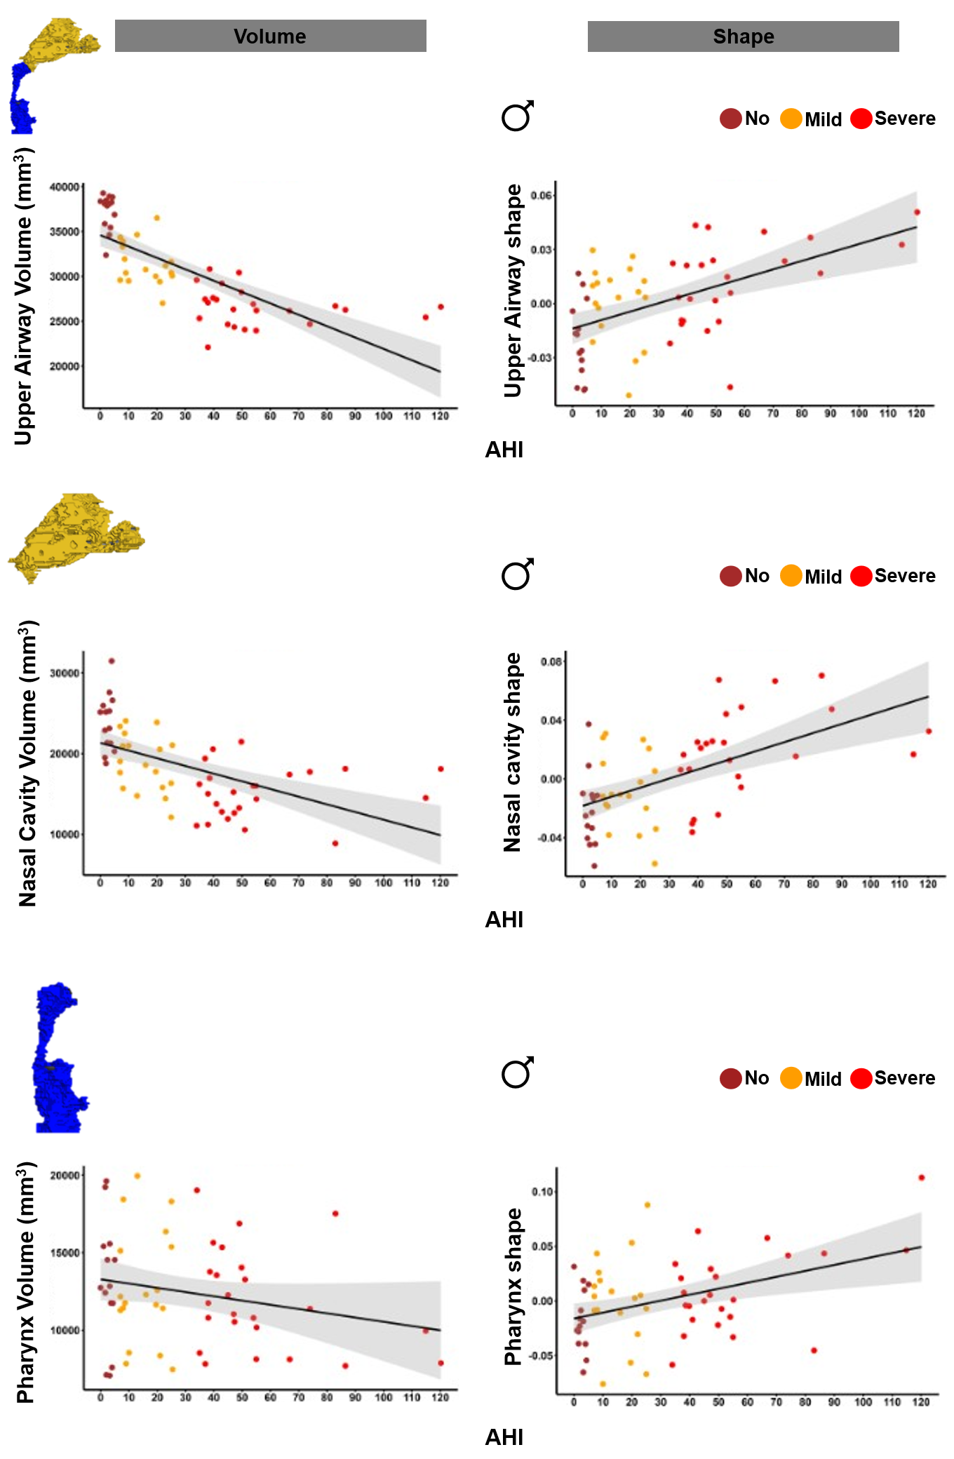
Supplementary Fig. S4. Associations between upper airway morphology and the apnea–hypopnea index (AHI) in male participants with DS. Univariate and multivariate regression analyses of volume and shape with the AHI for A) the entire upper airway, B) the nasal cavity and C) the pharynx.

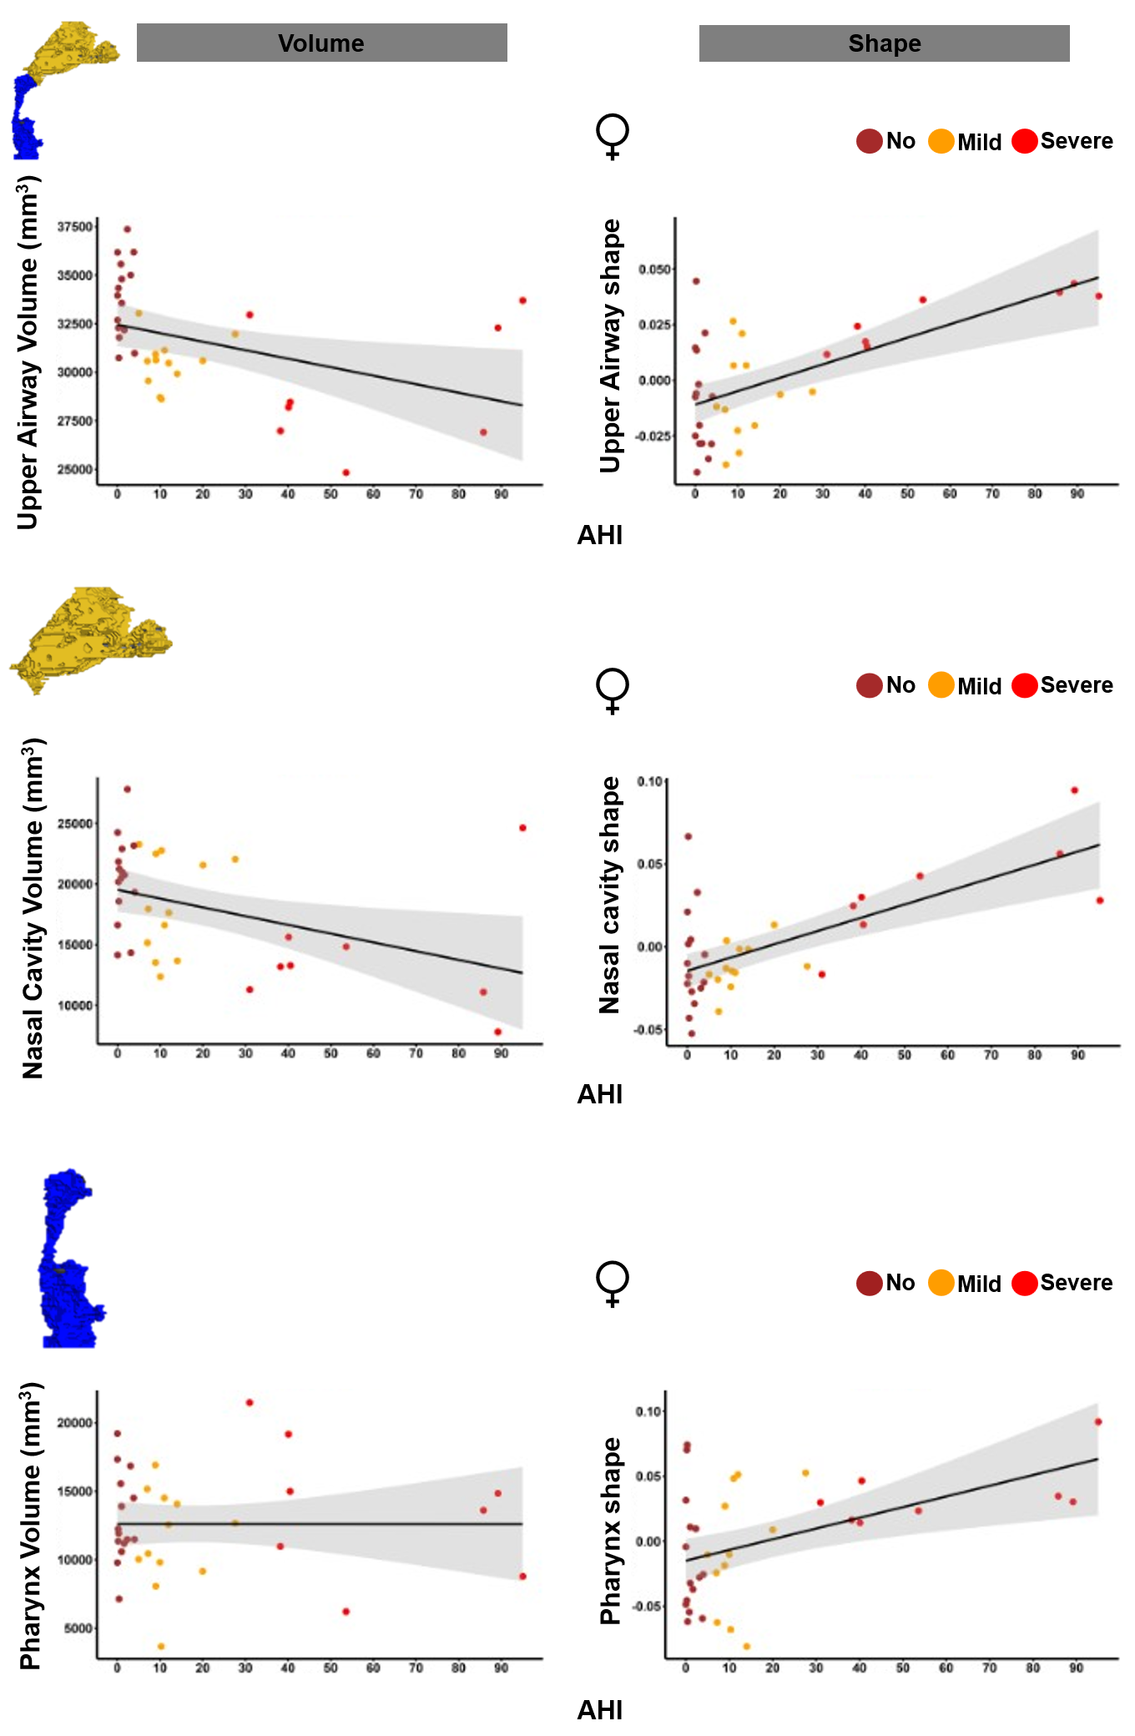
Supplementary Fig. S5. Associations between upper airway morphology and the AHI in female participants with DS. Univariate and multivariate regression analyses of volume and shape with the AHI for A) the entire upper airway, B) the nasal cavity and C) the pharynx.

