Supplementry information
Design and Characterization of Formazonate Transition Metal Complexes for Emerging Optoelectronic Applications
Pravendra Kumarª, Brijeshª, Sushmita Gupta^{*a}, Prashant Kumar Palª
ª Department of Applied Chemistry, Faculty of Engineering and Technology, M J P Rohilkhand University, Bareilly (U.P.), 243006
Corresponding author: Sushmita Gupta
Corresponding author e-mail: drsushmitagupta12@gmail.com

- FT-IR Spectra of ligand(L-1) and Complexes:
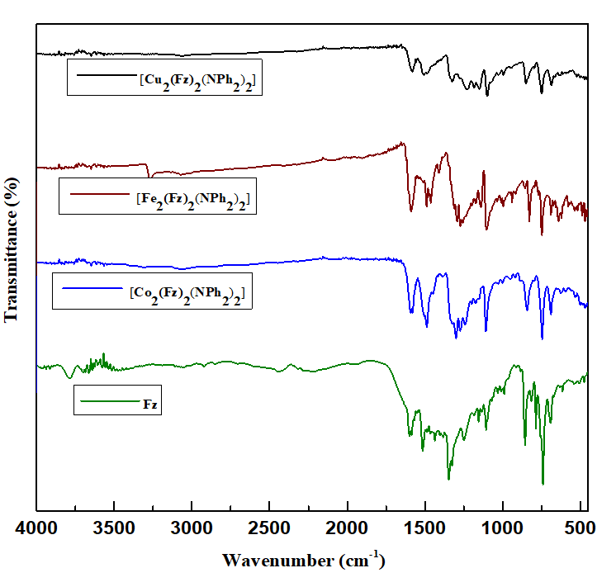
Figure-1: FT-IR spectra of complexes and formazan(L-1).

- ¹H-NMR Spectra of ligand and Complexes:

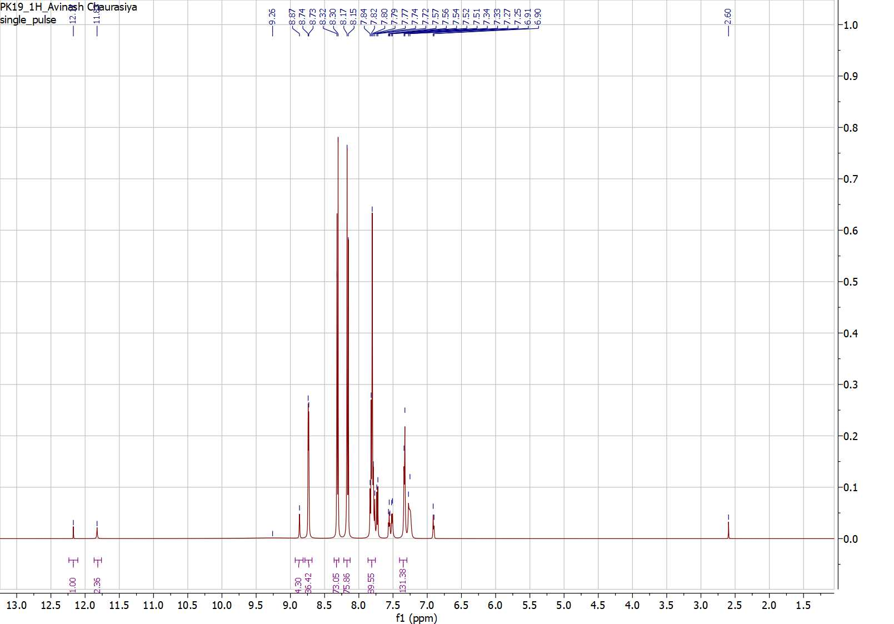
Figure-2: ¹H- NMR of 1-(p-nitrophenyl)-3-(o-hydroxyphenyl)-5-phenyl formazan
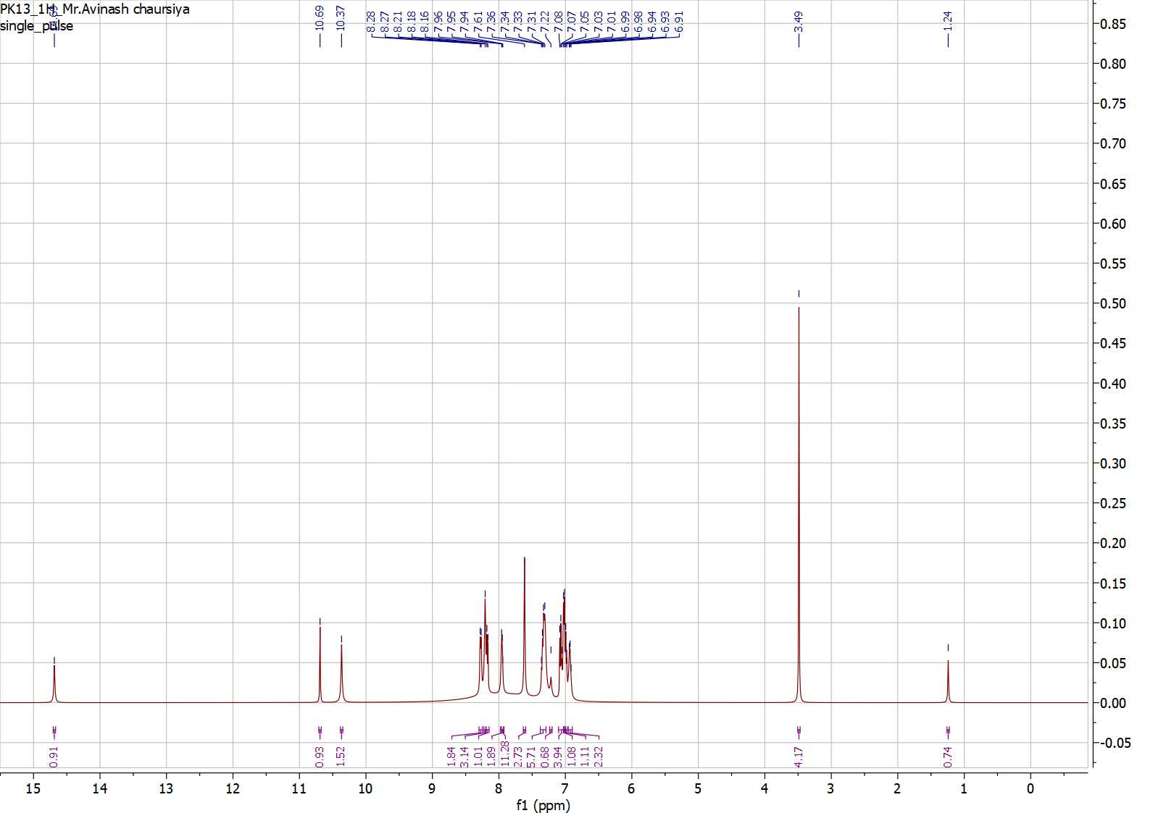
Figure-3: ¹H- NMR of [Fe₂(Fz)₂(NPh₂)₂] complex
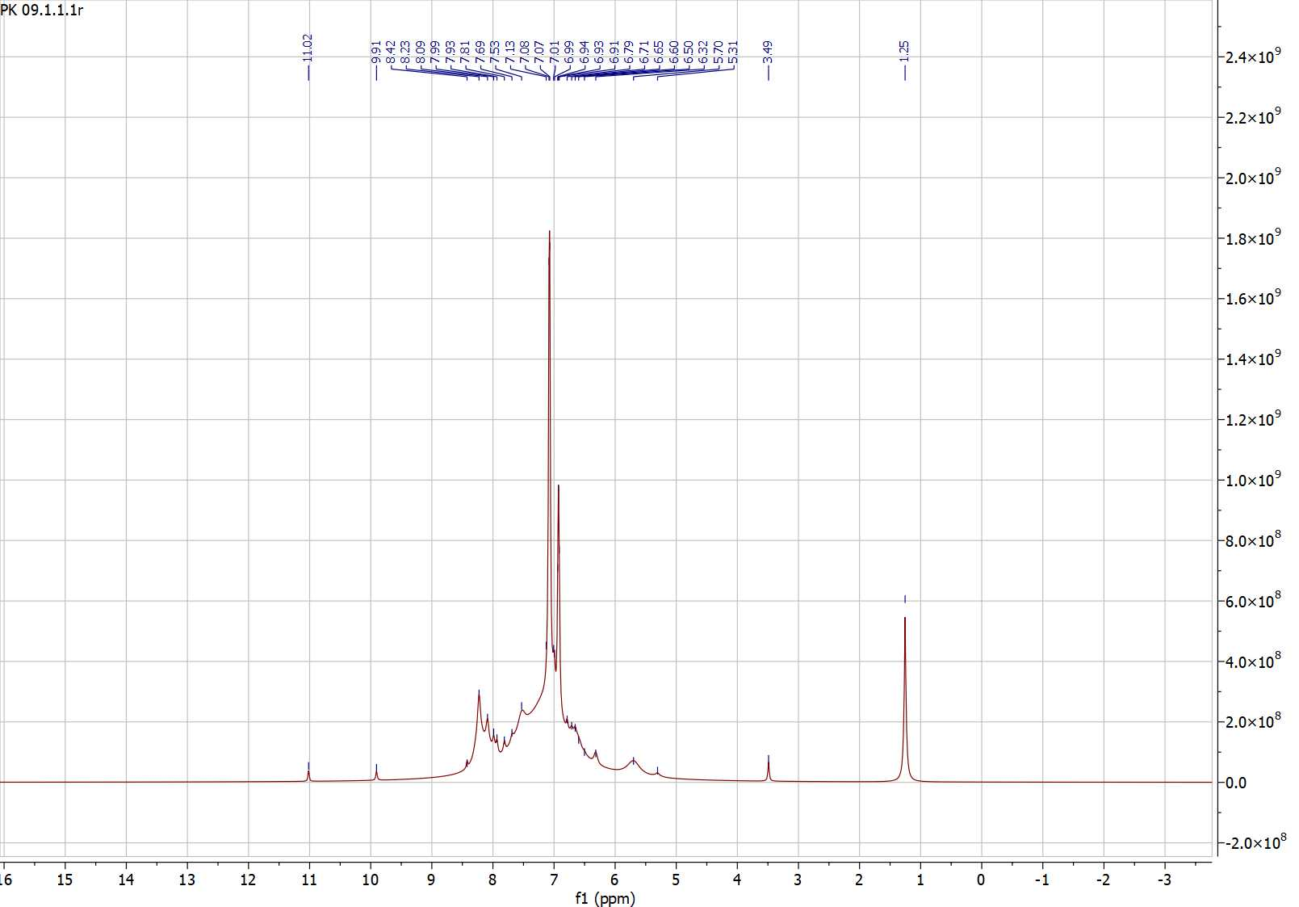

Figure-4: ¹H- NMR of [Co₂(Fz)₂(NPh₂)₂] complex

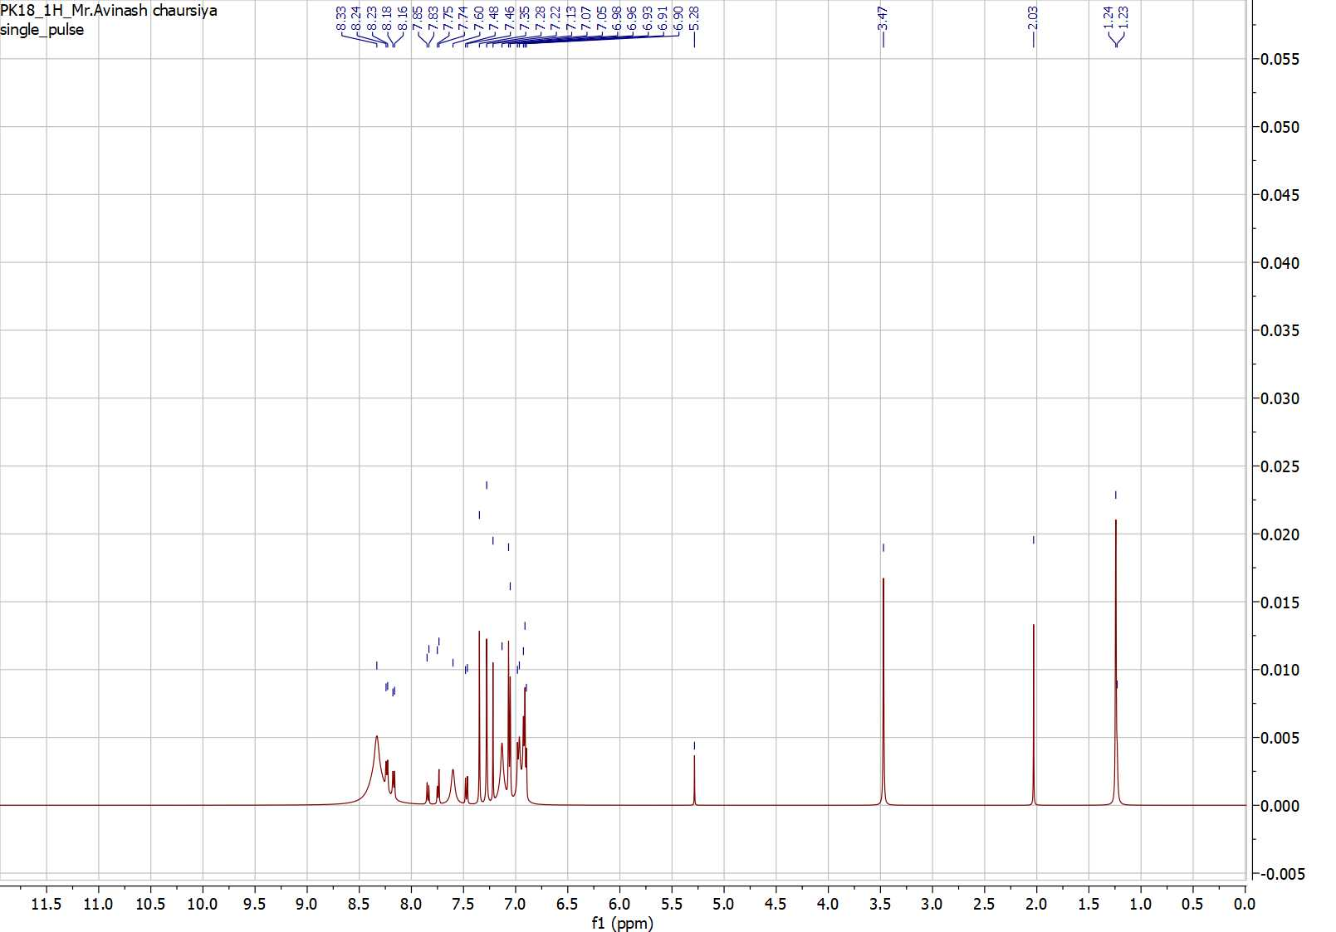

Figure-5: ¹H- NMR of [Cu₂(Fz)₂(NPh₂)₂] complex

- Thermo Gravimetric analysis

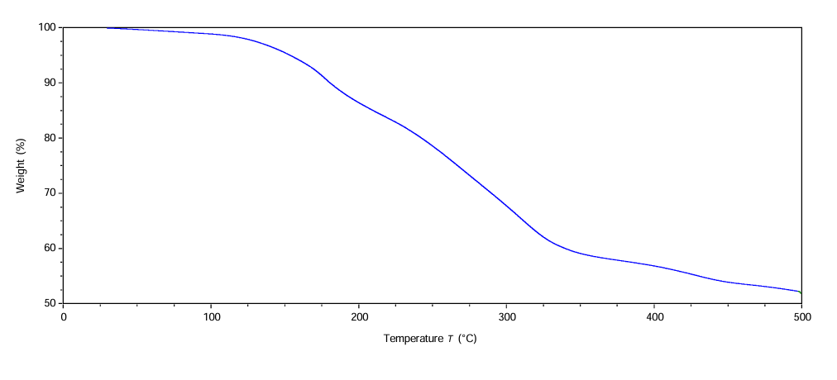
Figure-6: Thermogram for [Co₂(Fz)₂(NPh₂)₂] complex
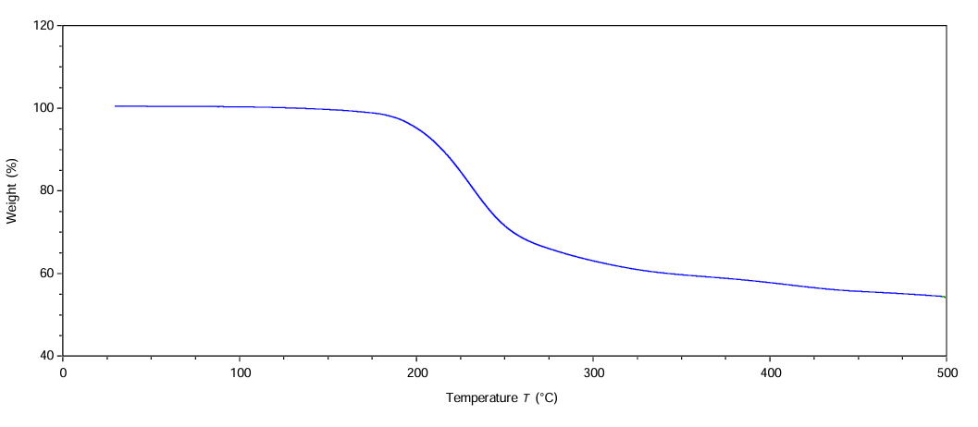
Figure-7: Thermogram for [Fe₂(Fz)₂(NPh₂)₂] complex
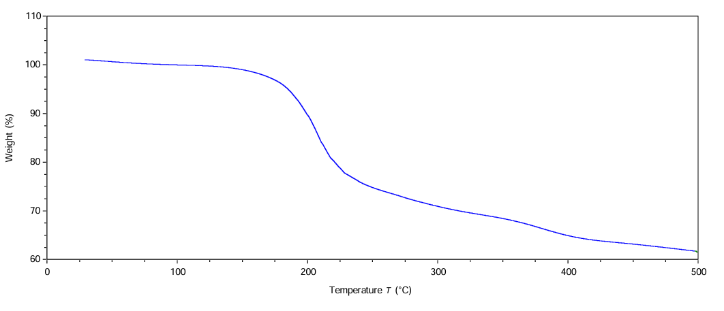
Figure-8: Thermogram for [Cu₂(Fz)₂(NPh₂)₂] complex

I-V Curve for DSSC assembly
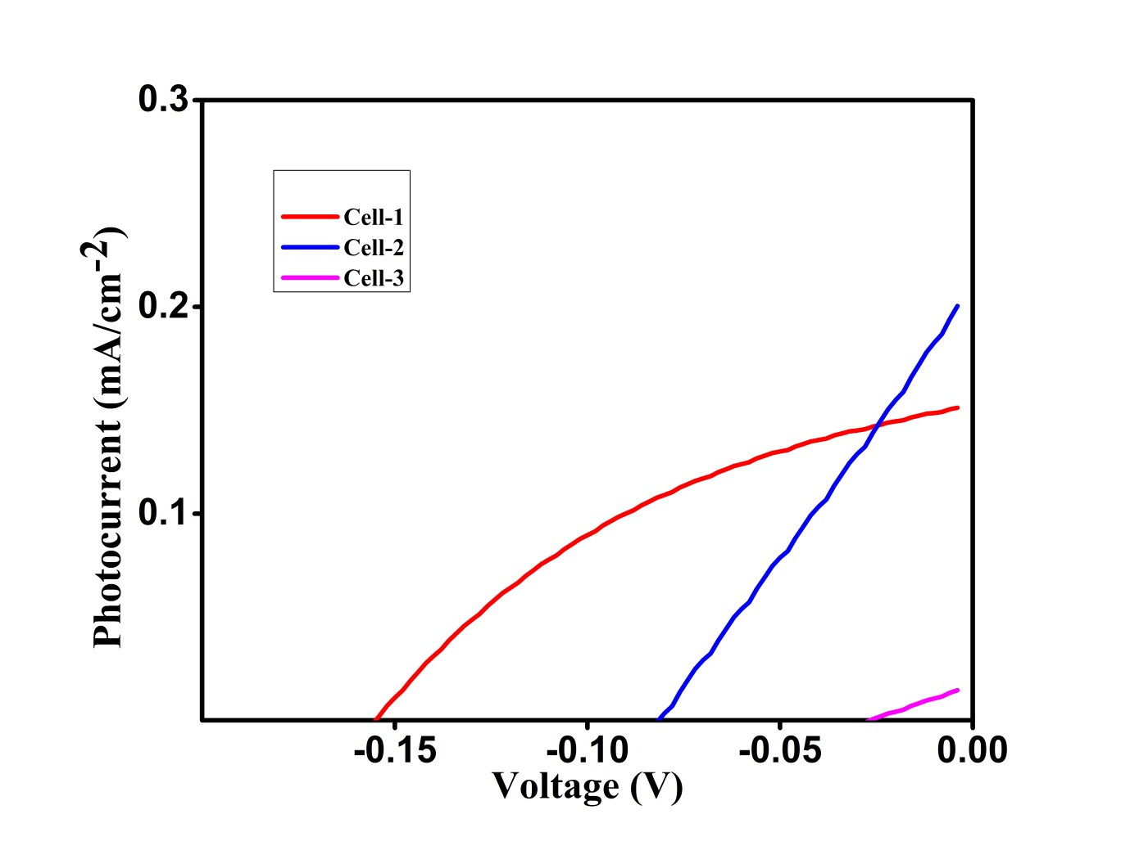
Figure-9 I-V Curve for DSSC assembly for different Dye.
Table: Cell Assembly with Dye and contact area
S. No. | Cell | Area (cm$×$cm) | Dye
1. | Cell-1 | 1.5$×$1.0 | [CO₂(Fz)₂(NPh₂)₂]
2. | Cell-2 | 1.5$×$1.5 | [Fe₂(Fz)₂(NPh₂)₂]
3. | Cell-3 | 1.0$×$1.0 | [Cu₂(Fz)₂(NPh₂)₂]

