Supplementary Methods
Outcome availability was summarised separately for each series. Total ED volume and emergency surgical procedure data were available for 906 of 908 calendar dates. Missing outcomes and exposures were neither replaced by zero nor imputed. Descriptive analyses used all available observations, whereas regression and prediction analyses were restricted to complete records for the variables included in each model.
Prespecified sensitivity analyses varied the degrees of freedom used to control long-term and seasonal trends, examined alternative exposure-lag windows, incorporated non-linear meteorological terms, excluded Spring Festival and extreme-volume days, and fitted selected two-pollutant models. Overdispersion was assessed using the ratio of residual deviance to residual degrees of freedom. Residual autocorrelation was examined using autocorrelation functions and Ljung–Box tests. Large outcome-by-pollutant matrices were considered exploratory and were interpreted primarily from effect estimates and 95% CIs rather than isolated nominal p values.
For the internal prediction analysis, dates were ordered chronologically before lagged predictors were generated. After construction of lag-1, lag-7, and preceding 7-day mean ED-volume features and restriction to complete records, the first 80% of analysable dates formed the development set and the final 20% formed the temporal-validation set. This procedure yielded a validation period of 179 days from 30 December 2025 to 26 June 2026.
Ordinary least-squares regression models were fitted using the base-R stats::lm function with squared-error loss. Historical-demand predictors comprised ED volume at lags 1 and 7 and the preceding 7-day mean. Day of week and calendar category were included as treatment-coded categorical variables. Continuous environmental predictors were retained on their original scales. No regularisation, hyperparameter tuning, or internal resampling was applied. Models sequentially added meteorological variables, pollutant-specific PM2.5, PM10, NO2, and O3 AQI values, or both, to the history-plus-calendar model. Because observed target-day environmental data were included, the analysis was interpreted as retrospective contemporaneous prediction rather than a deployable day-ahead forecast.
Prediction performance was evaluated using MAE, RMSE, MAPE, mean bias, and observed–predicted correlation. Incremental performance was assessed relative to the history-plus-calendar model. Permutation importance was calculated as the mean increase in validation-set MAE across 100 repeated 7-day moving-block permutations while holding the fitted model fixed. A fixed random seed of 2026 was used. Permutation importance was interpreted as an indicator of model reliance rather than causal importance.
Environmental profiles were derived without reference to ED outcomes. Lag 0–2 mean meteorological variables and pollutant-specific AQI values were standardised as z scores and grouped using k-means clustering with Euclidean distance, 100 random initialisations, and a maximum of 1000 iterations. Candidate solutions containing two to eight clusters were compared using within-cluster sum of squares, average silhouette width, the gap statistic, cluster size, and interpretability of the exposure centroids. Four clusters were retained on the basis of concordance across these criteria and were labelled cool, warm-ozone, cool-pollution, and humid-rainy. Cluster stability was assessed using 500 bootstrap resamples and clusterwise Jaccard similarity. Profile analyses were considered exploratory and require temporal or external validation.
Analyses were conducted in R. Data management and visualisation used dplyr, tidyr, lubridate, and ggplot2; linear prediction models and time-series diagnostics used the base stats package; clustering diagnostics and stability analyses used cluster and fpc. Exact R and package versions were recorded using sessionInfo() and archived in an renv lockfile accompanying the analysis code. All statistical tests were two-sided.

Supplementary Table S1. Reproducibility information for the internal prediction analysis
Item | Manuscript specification
Prediction target | Total ED visits on day t
Prediction setting | Retrospective contemporaneous prediction using observed target-day environmental data
Analyzable sample | Complete records after chronological ordering and construction of lagged and rolling-demand features
Temporal split | First 80% of analyzable dates for development and final 20% for temporal validation
Validation period | 30 December 2025 to 26 June 2026; 179 analyzable days
Historical features | ED visits at lag 1, ED visits at lag 7, and the preceding 7-day mean
Calendar features | Day of week and calendar category
Environmental features | Temperature, wind speed, precipitation, relative humidity, and pollutant-specific PM2.5, PM10, NO2, and O3 AQI values
Estimator | Ordinary least-squares linear regression using stats::lm
Loss function | Squared-error loss
Preprocessing | Chronological ordering, construction of lagged and rolling features, and complete-case restriction
Continuous predictors | Retained on their original scales
Categorical predictors | Treatment-coded indicator variables
Regularization | None
Hyperparameter tuning | None
Internal resampling | None
Random seed | 2026
Permutation importance | Mean increase in validation-set MAE across 100 repeated 7-day moving-block permutations
Model-comparison reference | History-plus-calendar model
Software | R; stats, dplyr, tidyr, lubridate, and ggplot2
Reproducibility record | Exact R and package versions archived using sessionInfo() and renv.lock

Supplementary Figure S1. Additional descriptive patterns of ED activity.
(A) Monthly mean ED visits. (B) Mean daily visits by month and weekday. (C) Mean daily operational volumes. (D) Total counts and frequency of low-frequency acute events.
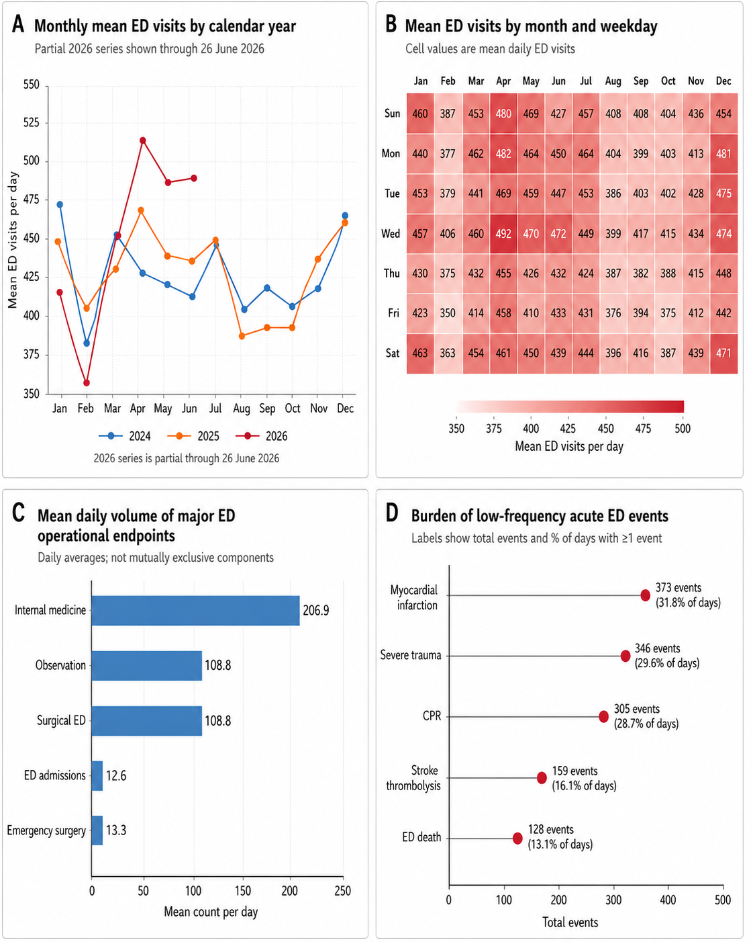

Supplementary Figure S2. Supporting analyses for meteorological associations and surgical-trauma procedure activity.
(A) Estimated absolute changes per 1°C. (B) Piecewise temperature associations. (C) Monthly procedure counts verified against source records. Sparse-event estimates are exploratory.
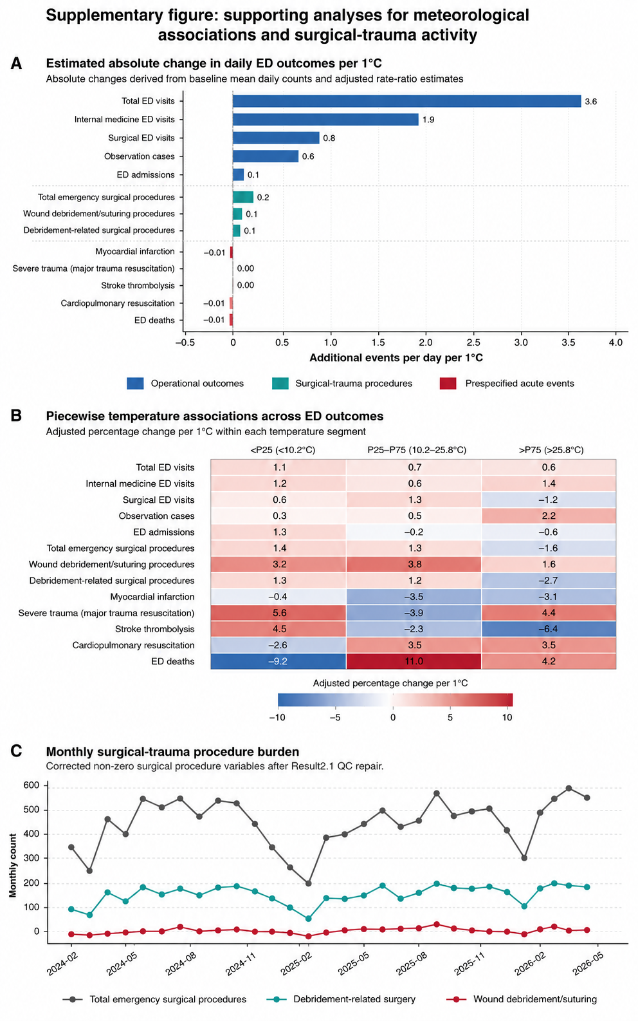

Supplementary Figure S3. Supporting analyses for air pollution and ED activity.
Panels show temporal pollutant-specific AQI patterns, correlations, exposure–response curves, lag-window estimates, observed volume by pollutant AQI quartile, and an exploratory outcome–pollutant matrix. AQI values are unitless indices rather than direct mass concentrations. The matrix should be interpreted from effect sizes and 95% CIs; stars denote nominal p values and do not establish confirmatory significance after multiple comparisons.
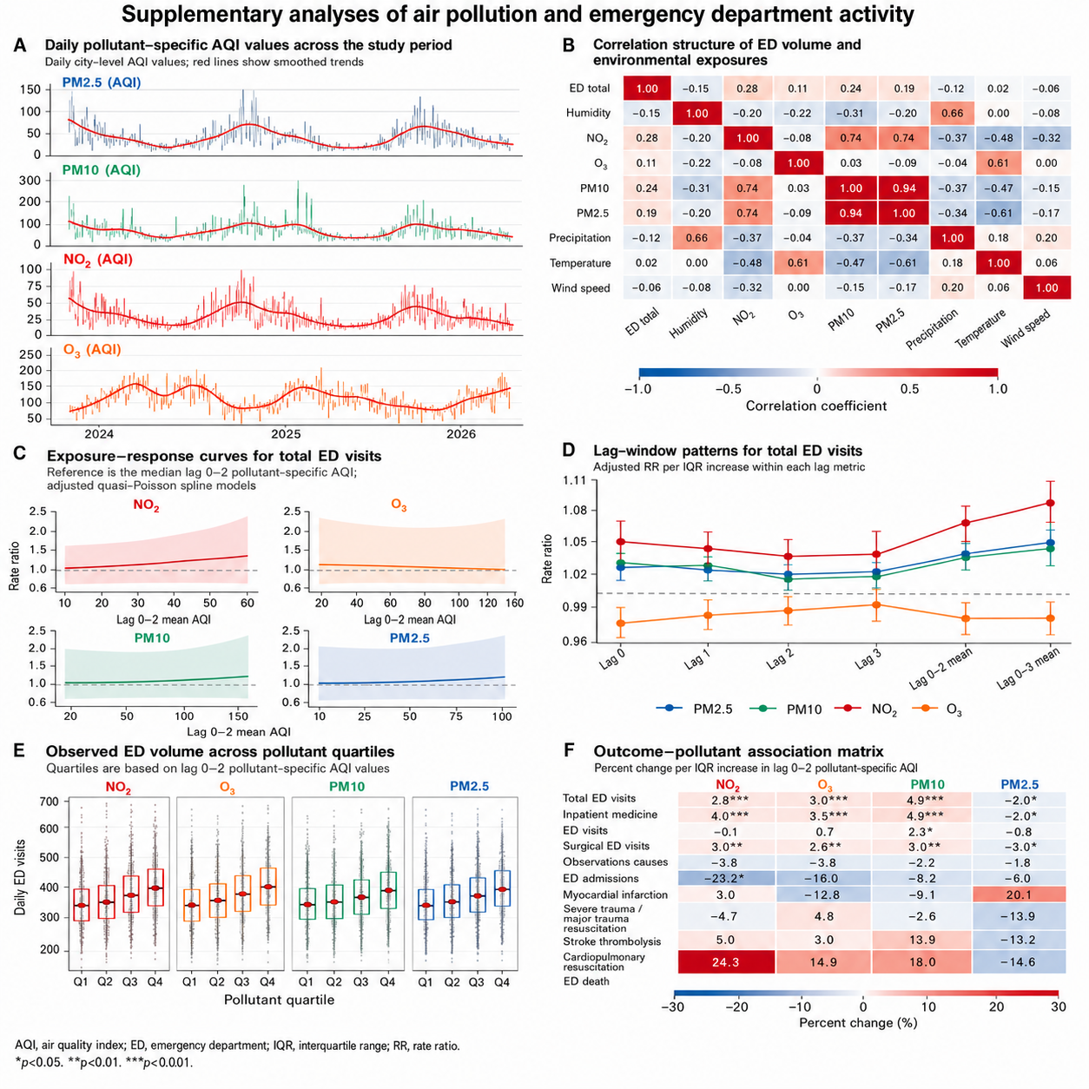
Supplementary Figure S4. Prediction diagnostics and secondary-outcome analyses.
Residuals are observed minus predicted visits. Permutation importance is the increase in validation-set MAE after predictor permutation. The analysis used observed target-day environmental data and therefore represents retrospective contemporaneous prediction rather than prospective forecasting.

Supplementary Figure S5. Supporting analyses for environmental profiles and high-demand ED days.
(A) ED volume by profile. (B) Temporal distribution of high-demand days. (C) High-demand frequency by compound exposure burden. (D) Sensitivity to P85, P90, and P95 thresholds. All profile analyses are descriptive and require temporal or external validation.

