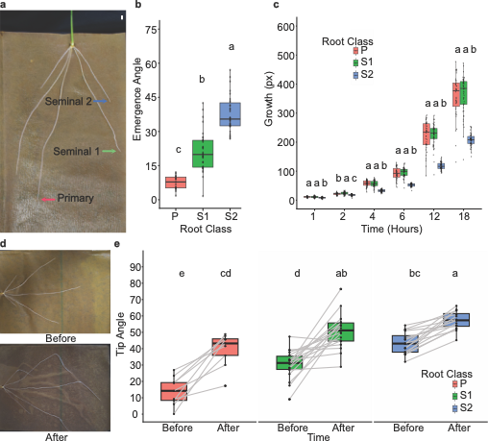

Extended Data Fig. 1 | Root class-specific growth dynamics and GSA in wheat.
a, Representative image of a wheat (Triticum aestivum cv. Cadenza) root system grown in growth pouches, highlighting primary and seminal root classes. b, Emergence angles of primary, seminal 1, and seminal 2 roots. c, Vertical growth dynamics following transfer to plates, shown for each root class across time. Data are shown as box plots with individual data points overlaid (n = 30 plants). Different letters indicate statistically significant differences between root classes within each treatment (one-way ANOVA, α = 0.05). d, Representative images of initial and after 48 hours of 90° gravistimulation. e, Root class-wise comparison of tip angles before and after 48 hours of 90° gravistimulation. Data are shown as box plots with paired points (n = 10 plants) to indicate their initial and post-rotation GSA. Different letters indicate statistically significant differences between time points within each root class (one-way ANOVA, α = 0.05). Scale bar represents 5mm.

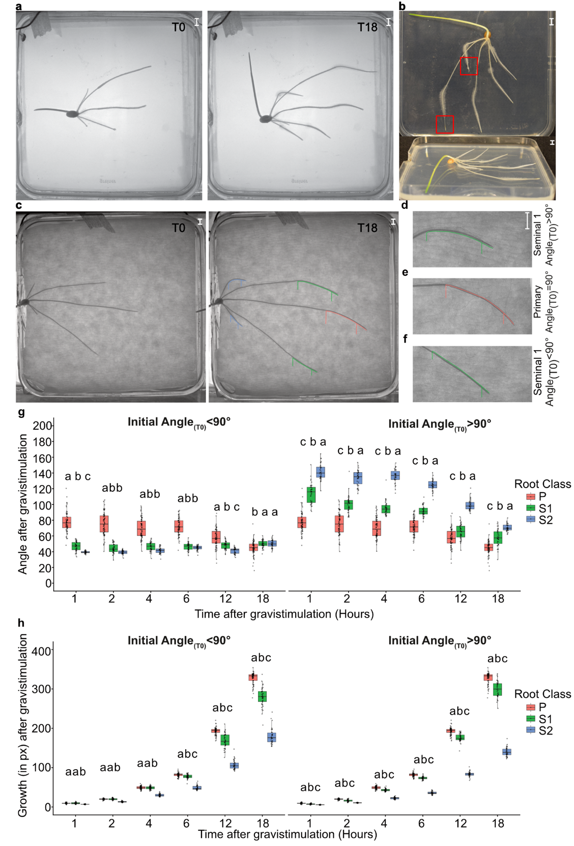
Extended Data Fig. 2 | Improved assay for quantifying root gravitropic responses in cereals.
a, Representative images of a wheat (Triticum aestivum cv. Cadenza) root system following 90° reorientation in agar-only plate assays at 0 and 18 h timepoints. b, Representative images showing increased root hair formation and growth arrest as roots exit the agar surface in conventional plate assays. c, Representative images of 90° reorientation in an integrated growth pouch-agar plate system at initial and final timepoints. Root growth trajectories of each class are highlighted post-reorientation (red, green, and blue lines), showing continued growth across all root classes. See Supplementary Note 1 for assay development and application in gravitropic and antigravitropic response measurements. d-f, Representative initial and final timepoint images of root tips experiencing different gravistimuli; (d) Seminal 1 root experiencing >90° gravistimulus (e) Primary root tip experiencing ~90° gravistimulus (f) Seminal 1 root experiencing <90° gravistimulus. g-h, Root angle (g) and growth dynamics (h) of primary and seminal roots over 18 h following reorientation. Data are shown as box plots with individual data points overlaid (n = 30 plants). Different letters indicate statistically significant differences between root classes within each treatment (one-way ANOVA, α = 0.05). Scale bar represents 5 mm.
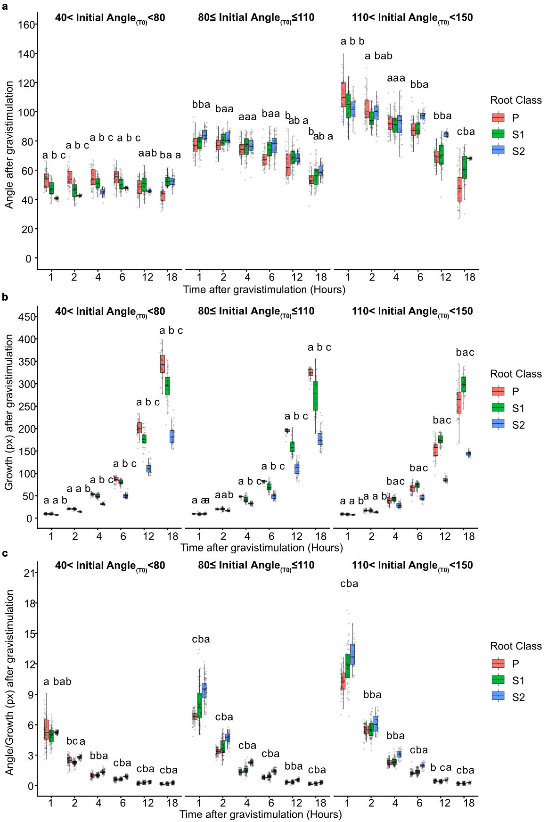

Extended Data Fig. 3 | Matched gravistimulus conditions resolve intrinsic gravitropic responses across root classes.
a-c, Time-course analysis of root tip angle (a), growth rate (b) and growth rate normalised tip angle (c) for roots grouped according to experienced gravistimulus (0-80°, aligned; 80-110°, intermediate; 110-200°, opposed), enabling comparisons under matched stimulus conditions. Gravistimulus ranges were generated following 45°, 90° or 120° reorientation (see Methods). Data are shown as box plots with individual data points overlaid (n = 30 plants). Different letters indicate statistically significant differences between root classes within each treatment (one-way ANOVA, α = 0.05).

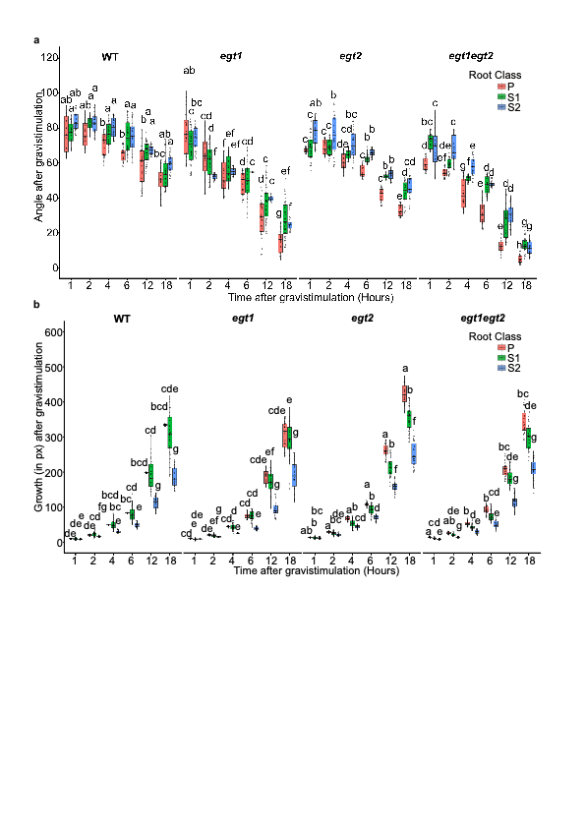
Extended Data Fig. 4 | Genotype-dependent gravitropic responses under matched gravistimulus conditions.
a-b, Time-course analysis of root tip angle (a), and growth rate (b) for WT, egt1, egt2 and egt1 egt2 roots grouped according to similar gravistimulus (80-110°), enabling comparisons under matched stimulus conditions. Data are shown as box plots with individual data points overlaid (n = 30 plants). Different letters indicate statistically significant differences between genotypes within each treatment (one-way ANOVA, α = 0.05).

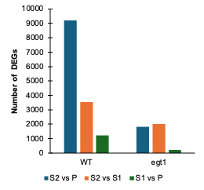
Extended Data Fig. 5 | Loss of AGO reduces transcriptional divergence between root classes.
Bar plots showing the number of differentially expressed genes (DEGs) between pairwise root class comparisons within each genotype (WT and egt1). Differential expression analysis was performed using three biological replicates per root class. DEGs were defined using a ≥2-fold expression change, false discovery rate (FDR)-corrected P < 0.05, and a minimum expression threshold of 1 FPKM to exclude lowly expressed genes. Wild type exhibited pronounced transcriptional divergence between root classes, whereas egt1 showed substantially reduced numbers of DEGs across comparisons, indicating convergence of root class-specific transcriptional states.

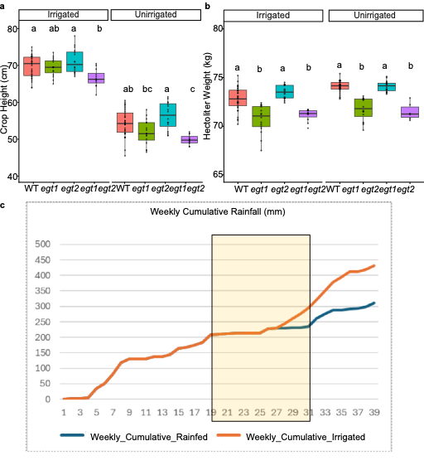
Extended Data Fig. 6 | Loss of AGO affect agronomic performance.
a-b, Field trial data from irrigated and unirrigated plots. (a) Crop height across all genotypes, (b) Hectoliter Weight (HLW) across all genotypes. Different letters denote significant differences between genotypes within each treatment (one-way ANOVA, α = 0.05). Whisker plots show distributions with individual data points overlaid (n = 24 plots). c. Weekly cumulative rainfall received by rainfed and irrigated plots.

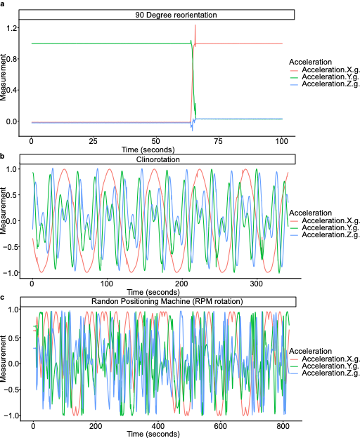

Extended Data Fig. 7 | Acceleration profiles during gravistimulation and simulated microgravity assays.
a, Accelerometer output from a growth plate following 90° reorientation. b, Acceleration experienced by an accelerometer positioned at the centre of the OpenClino device operating in clinostat mode. c, Acceleration experienced by an accelerometer positioned at the centre of the OpenClino device operating in random positioning machine (RPM) mode.

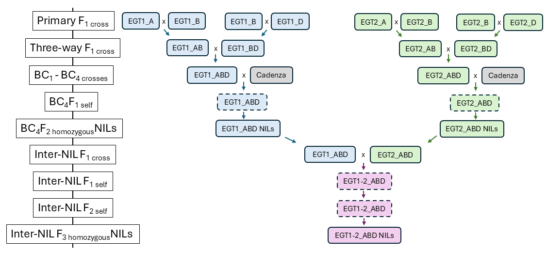
Extended Data Fig. 8 | Crossing strategy for generation of near-isogenic lines (NILs) for EGT1 and EGT2.
Schematic overview of the multi-step crossing and backcrossing strategy used to generate NILs in the wheat cv. Cadenza genetic background. Homoeologue-specific TILLING alleles in the A, B and D genomes were first intercrossed to generate three-way F₁ plants carrying mutations across all homoeologues. These were subsequently backcrossed to cv. Cadenza for four generations (BC₁–BC₄) with marker-assisted selection at each generation using KASP markers to retain target alleles and reduce background mutations. Heterozygous BC₄F₁ plants were selfed to generate segregating BC₄F₂ populations, from which homozygous triple-mutant NILs were selected. To generate combined egt1 and egt2 genotypes, homozygous NILs were intercrossed and selfed to obtain segregating progeny containing wild type, single-mutant and double-mutant combinations used in downstream analyses.

Extended Data Table 1 | Summary of TILLING alleles and genotyping resources used for generation of egt1 and egt2 near-isogenic lines.
List of homoeologue-specific TILLING mutations in the A, B and D genomes used to generate loss-of-function alleles of EGT1 and EGT2 in wheat cv. Cadenza. The table includes sequences and corresponding Ensembl Plants gene identifiers. KASP primer sequences used for marker-assisted selection and links to publicly available mutation resources are also provided.

