Supplementary Information

Growth angles of distinct root classes in wheat are determined by a gradient of anti-gravitropic activity

Atish Bansod¹, James Simmonds², Gizem Dimlioglu¹, Darren M Wells¹, Adam Binns¹, Jonathan A Atkinson¹, Brian Atkinson¹, Craig Sturrock¹, Cristobal Uauy², Rahul Bhosale^{1,#}

¹ School of Biosciences, University of Nottingham, LE12 5RD Nottingham, United Kingdom
²John Innes Centre, Norwich Research Park, NR4 7UH Norwich, United Kingdom

# Author to whom correspondence is to be addressed: rahul.bhosale@nottingham.ac.uk

Supplementary Note 1

Studying root angle regulation in cereal crops such as wheat presents distinct challenges due to their complex fibrous root systems, which comprise primary, seminal, lateral, and crown roots. These root classes differ in developmental origin (embryonic or post-embryonic), emergence timing, elongation rates, and gravitropic set-point angles. As a result, root angle dynamics in cereals must be interpreted in a root-class-specific manner over time.

Existing agar-based gravitropism assays, originally optimised for simple taproot systems such as Arabidopsis, are not well suited to cereals. In particular, the greater diameter of cereal roots disrupts formation of a stable water meniscus at the agar interface, often leading to excessive root hair formation, root detachment from the agar surface, escape into the air, and premature cessation of growth. In addition, asynchronous emergence and heterogeneous growth rates across root classes complicate longitudinal imaging and quantitative analysis of gravitropic and anti-gravitropic offset (AGO) responses.

To address these limitations, we developed an integrated growth-pouch and agar-plate assay (Supplementary Figure 1) that enables controlled, continuous observation of multiple wheat root classes under defined gravistimulation and clinostat generated microgravity conditions.

Supplementary Note 2

The 3D Clinostat was based on the OpenClino design¹ with custom software to utilise acceleration and deceleration profiles as required. 3D-printed and mechanical components are as Version 0.2.1. Each axis is driven by a hybrid permanent magnet high torque stepper motor (892-8732, RS Components) with a 1.8° step angle. Each motor is controlled by a digital stepper driver (DM542, StepperOnline) set to 3200 microsteps/revolution. The drivers were powered from a 36V 120W power supply and controlled via a microcontroller (Arduino R4 Minima) powered from the main supply via a buck converter. Software written in the Arduino IDE controls motor movement in two modes (constant motion and random positioning, selectable via a toggle switch on the main electronics housing. User-defined values for axis speed and step range for random positioning are set in the software. Software available for download at: https://github.com/UoNMakerSpace/3D-Clinostat.
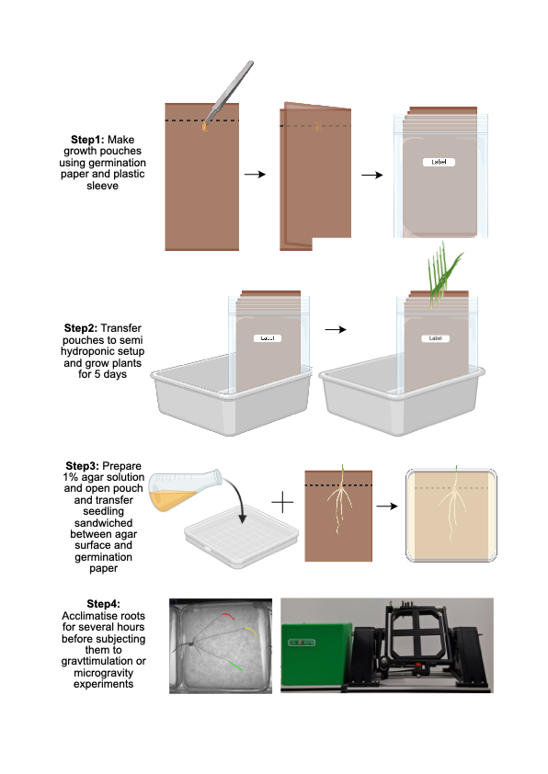

Supplementary Figure 1 | Integrated growth-pouch and agar-plate assay for analysing gravitropic and AGO responses in wheat root systems.
Schematic overview of the experimental workflow. Steps 1-2, wheat seedlings are germinated and grown in paper growth pouches, enabling the development of primary, seminal, lateral, and crown roots under stable and minimally disruptive conditions. Step 3, seedlings are transferred to agar plates using an agar-paper support system that maintains root-surface contact and continuous growth. Step 4, seedlings are subjected to gravistimulation at defined orientation angles (e.g. 0-360°) and imaged using infrared illumination, enabling automated time-lapse acquisition and quantification of root growth and bending dynamics across multiple root classes. The system is also compatible with 3D clinostat-based re-orientation experiments (Supplementary Note 2), allowing imaging of roots before and after clinorotation using the same robotic imaging platform.

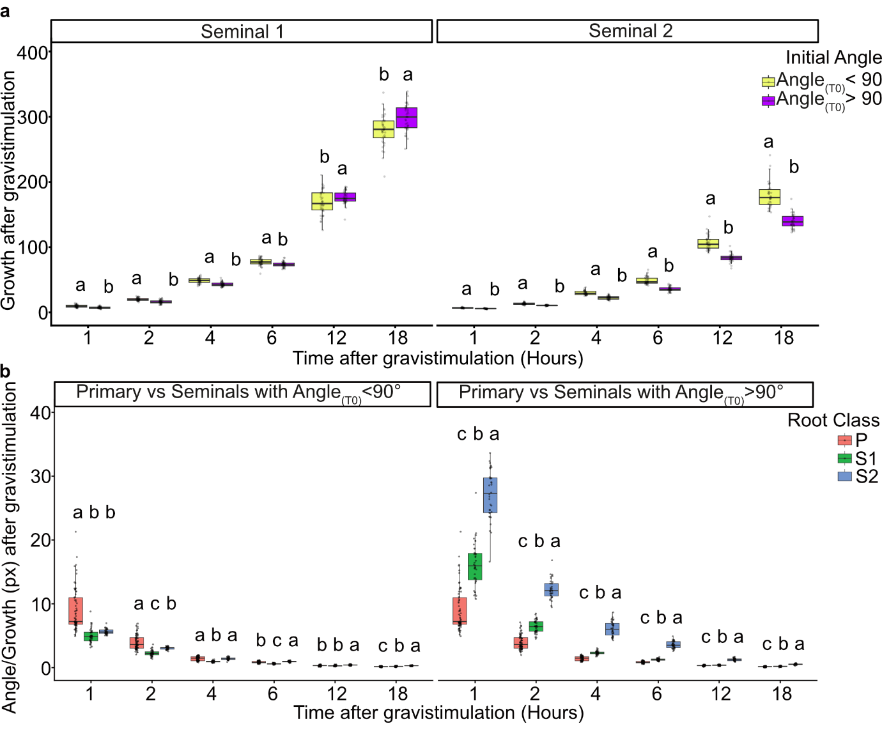

Supplementary Figure 2 | Growth rate is affected by gravistimulus, and normalisation reveals root class-specific behaviour.
(a) Time course analysis of seminal 1 and seminal 2 root growth after gravistimulation at different gravistimulus shows roots experiencing higher magnitude of gravistimulus grow slower than roots experiencing lower magnitude of gravistimulus. (b) Angle after gravistimulation normalised according to growth after gravistimulation. Data are shown as box plots with individual data points overlaid (n = 30 plants). Different letters indicate statistically significant differences between root classes within each treatment (one-way ANOVA, α = 0.05).

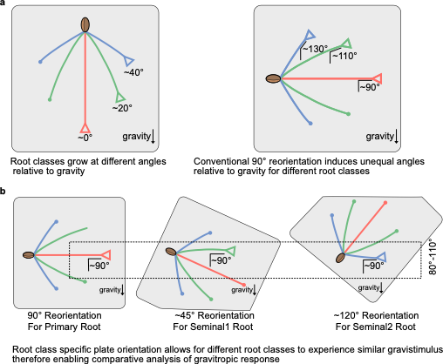

Supplementary Figure 3 | Comparison of conventional and bin-based gravitropism assays across root classes.
a, Schematic showing the conventional gravitropism method does not account for root classes at different root growth angles. b, Schematic showing the bin method developed to induce similar gravistimulus on each root class to enable comparisons of different root classes.

Supplementary table 1| List of 184 Differentially expressed scalar genes between WT and egt1 root tips.

GeneID
TraesCAD_EIv1_0_1857930
TraesCAD_EIv1_0_1723210
TraesCAD_EIv1_0_0064300
TraesCAD_EIv1_0_1590080
TraesCAD_EIv1_0_0793700
TraesCAD_EIv1_0_0648900
TraesCAD_EIv1_0_2145440
TraesCAD_EIv1_0_0500200
TraesCAD_EIv1_0_0185180
TraesCAD_EIv1_0_1412610
TraesCAD_EIv1_0_1886420
TraesCAD_EIv1_0_2440680
TraesCAD_EIv1_0_0867370
TraesCAD_EIv1_0_0465180
TraesCAD_EIv1_0_1412620
TraesCAD_EIv1_0_2595980
TraesCAD_EIv1_0_2072920
TraesCAD_EIv1_0_0119450
TraesCAD_EIv1_0_1412400
TraesCAD_EIv1_0_0280280
TraesCAD_EIv1_0_1436810
TraesCAD_EIv1_0_1412660
TraesCAD_EIv1_0_1197650
TraesCAD_EIv1_0_1227910
TraesCAD_EIv1_0_2390160
TraesCAD_EIv1_0_0107800
TraesCAD_EIv1_0_1631930
TraesCAD_EIv1_0_0068280
TraesCAD_EIv1_0_0457490
TraesCAD_EIv1_0_1249080
TraesCAD_EIv1_0_1412630
TraesCAD_EIv1_0_0701770
TraesCAD_EIv1_0_0223430
TraesCAD_EIv1_0_1059640
TraesCAD_EIv1_0_0085500
TraesCAD_EIv1_0_0361180
TraesCAD_EIv1_0_2395220
TraesCAD_EIv1_0_0122080
TraesCAD_EIv1_0_2628650
TraesCAD_EIv1_0_1249090
TraesCAD_EIv1_0_0159920
TraesCAD_EIv1_0_1151050
TraesCAD_EIv1_0_1472670
TraesCAD_EIv1_0_0632970
TraesCAD_EIv1_0_0223560
TraesCAD_EIv1_0_0231420
TraesCAD_EIv1_0_0934690
TraesCAD_EIv1_0_2283710
TraesCAD_EIv1_0_0928940
TraesCAD_EIv1_0_0306210
TraesCAD_EIv1_0_1757800
TraesCAD_EIv1_0_2480300
TraesCAD_EIv1_0_0339120
TraesCAD_EIv1_0_1166960
TraesCAD_EIv1_0_0838270
TraesCAD_EIv1_0_2281690
TraesCAD_EIv1_0_0286680
TraesCAD_EIv1_0_1261760
TraesCAD_EIv1_0_0703010
TraesCAD_EIv1_0_0084580
TraesCAD_EIv1_0_2009370
TraesCAD_EIv1_0_0757590
TraesCAD_EIv1_0_0098600
TraesCAD_EIv1_0_1552090
TraesCAD_EIv1_0_0177930
TraesCAD_EIv1_0_2475220
TraesCAD_EIv1_0_1277990
TraesCAD_EIv1_0_1843780
TraesCAD_EIv1_0_1838400
TraesCAD_EIv1_0_0882000
TraesCAD_EIv1_0_1519550
TraesCAD_EIv1_0_0409350
TraesCAD_EIv1_0_0631450
TraesCAD_EIv1_0_1999220
TraesCAD_EIv1_0_0933560
TraesCAD_EIv1_0_0043310
TraesCAD_EIv1_0_2212190
TraesCAD_EIv1_0_1681180
TraesCAD_EIv1_0_2261440
TraesCAD_EIv1_0_1790010
TraesCAD_EIv1_0_1508100
TraesCAD_EIv1_0_0431980
TraesCAD_EIv1_0_0615740
TraesCAD_EIv1_0_1227880
TraesCAD_EIv1_0_1393420
TraesCAD_EIv1_0_0229520
TraesCAD_EIv1_0_1379950
TraesCAD_EIv1_0_1479430
TraesCAD_EIv1_0_0217240
TraesCAD_EIv1_0_2351630
TraesCAD_EIv1_0_2133970
TraesCAD_EIv1_0_0242000
TraesCAD_EIv1_0_0050200
TraesCAD_EIv1_0_1673620
TraesCAD_EIv1_0_1001920
TraesCAD_EIv1_0_2282430
TraesCAD_EIv1_0_0767050
TraesCAD_EIv1_0_0667710
TraesCAD_EIv1_0_2591380
TraesCAD_EIv1_0_1613260
TraesCAD_EIv1_0_0846030
TraesCAD_EIv1_0_1491280
TraesCAD_EIv1_0_0050040
TraesCAD_EIv1_0_2073370
TraesCAD_EIv1_0_0277090
TraesCAD_EIv1_0_1317630
TraesCAD_EIv1_0_0780050
TraesCAD_EIv1_0_0313000
TraesCAD_EIv1_0_0778860
TraesCAD_EIv1_0_0305560
TraesCAD_EIv1_0_2207570
TraesCAD_EIv1_0_0745740
TraesCAD_EIv1_0_0175560
TraesCAD_EIv1_0_1629910
TraesCAD_EIv1_0_1956440
TraesCAD_EIv1_0_1912380
TraesCAD_EIv1_0_0859460
TraesCAD_EIv1_0_0622880
TraesCAD_EIv1_0_0835480
TraesCAD_EIv1_0_2480620
TraesCAD_EIv1_0_0112010
TraesCAD_EIv1_0_0348040
TraesCAD_EIv1_0_2536390
TraesCAD_EIv1_0_2308180
TraesCAD_EIv1_0_1616960
TraesCAD_EIv1_0_1980230
TraesCAD_EIv1_0_2225710
TraesCAD_EIv1_0_1121950
TraesCAD_EIv1_0_2136650
TraesCAD_EIv1_0_0228600
TraesCAD_EIv1_0_0446240
TraesCAD_EIv1_0_0665970
TraesCAD_EIv1_0_0350760
TraesCAD_EIv1_0_0292280
TraesCAD_EIv1_0_0071170
TraesCAD_EIv1_0_1392960
TraesCAD_EIv1_0_2358320
TraesCAD_EIv1_0_0661170
TraesCAD_EIv1_0_1188230
TraesCAD_EIv1_0_0370140
TraesCAD_EIv1_0_0666710
TraesCAD_EIv1_0_1627180
TraesCAD_EIv1_0_2101260
TraesCAD_EIv1_0_0465770
TraesCAD_EIv1_0_1227890
TraesCAD_EIv1_0_2230650
TraesCAD_EIv1_0_1767760
TraesCAD_EIv1_0_0623670
TraesCAD_EIv1_0_0769930
TraesCAD_EIv1_0_0848170
TraesCAD_EIv1_0_1137930
TraesCAD_EIv1_0_1899690
TraesCAD_EIv1_0_0288130
TraesCAD_EIv1_0_2248830
TraesCAD_EIv1_0_2523850
TraesCAD_EIv1_0_0468110
TraesCAD_EIv1_0_0031870
TraesCAD_EIv1_0_1168150
TraesCAD_EIv1_0_0203410
TraesCAD_EIv1_0_1532590
TraesCAD_EIv1_0_0689680
TraesCAD_EIv1_0_0375340
TraesCAD_EIv1_0_1998040
TraesCAD_EIv1_0_0126940
TraesCAD_EIv1_0_1029630
TraesCAD_EIv1_0_2502250
TraesCAD_EIv1_0_0867970
TraesCAD_EIv1_0_2049720
TraesCAD_EIv1_0_2438730
TraesCAD_EIv1_0_1708120
TraesCAD_EIv1_0_2461750
TraesCAD_EIv1_0_1207110
TraesCAD_EIv1_0_1614200
TraesCAD_EIv1_0_0874500
TraesCAD_EIv1_0_1905530
TraesCAD_EIv1_0_1821030
TraesCAD_EIv1_0_0103730
TraesCAD_EIv1_0_1639660
TraesCAD_EIv1_0_0465800
TraesCAD_EIv1_0_0613870
TraesCAD_EIv1_0_2617130
TraesCAD_EIv1_0_0251390
TraesCAD_EIv1_0_1616410
TraesCAD_EIv1_0_2392730

Supplementary table 2| List of enriched genes grouped into categories associated with cell wall organisation, redox regulation, and growth-related processes.

Gene_id | A1(P>S1>S2) | A1(P<S1<S2) | A4(P>S1>S2) | A4(P<S1<S2) | Scalar (yes/no) | Gene_description | Family | Category
TraesCAD_EIv1_0_0648900 | 1 | 0 | 0 | 0 | 1 | TraesCAD_EIv1_0_0648900 && sp|Q84ZN6|CESA8_ORYSJ Probable cellulose synthase A catalytic subunit 8 [UDP-forming] OS=Oryza sativa subsp. japonica OX=39947 GN=CESA8 PE=1 SV=1 && PF03552:Cellulose synthase|PF14569:Zinc-binding RING-finger | LBD | Cellulose  synthase
TraesCAD_EIv1_0_2145440 | 1 | 0 | 0 | 0 | 1 | TraesCAD_EIv1_0_2145440 && sp|A2Y0X2|CESA1_ORYSI Probable cellulose synthase A catalytic subunit 1 [UDP-forming] OS=Oryza sativa subsp. indica OX=39946 GN=CESA1 PE=3 SV=1 && PF03552:Cellulose synthase|PF14569:Zinc-binding RING-finger | LBD | Cellulose  synthase
TraesCAD_EIv1_0_0500200 | 1 | 0 | 0 | 0 | 1 | TraesCAD_EIv1_0_0500200 && sp|Q84ZN6|CESA8_ORYSJ Probable cellulose synthase A catalytic subunit 8 [UDP-forming] OS=Oryza sativa subsp. japonica OX=39947 GN=CESA8 PE=1 SV=1 && PF14569:Zinc-binding RING-finger|PF03552:Cellulose synthase | LBD | Cellulose  synthase
TraesCAD_EIv1_0_2390160 | 1 | 0 | 0 | 0 | 1 | TraesCAD_EIv1_0_2390160 && sp|F4IIM1|CSI1_ARATH Protein CELLULOSE SYNTHASE INTERACTIVE 1 OS=Arabidopsis thaliana OX=3702 GN=CSI1 PE=1 SV=1 && PF00168:C2 domain | - | Cellulose  synthase
TraesCAD_EIv1_0_0050040 | 1 | 0 | 0 | 0 | 1 | TraesCAD_EIv1_0_0050040 && sp|A2ZAK8|CSLD1_ORYSI Cellulose synthase-like protein D1 OS=Oryza sativa subsp. indica OX=39946 GN=CSLD1 PE=3 SV=2 && PF14570:RING/Ubox like zinc-binding domain|PF03552:Cellulose synthase | G2-like | Cellulose  synthase
TraesCAD_EIv1_0_0277090 | 1 | 0 | 0 | 0 | 1 | TraesCAD_EIv1_0_0277090 && sp|A2ZAK8|CSLD1_ORYSI Cellulose synthase-like protein D1 OS=Oryza sativa subsp. indica OX=39946 GN=CSLD1 PE=3 SV=2 && PF03552:Cellulose synthase|PF14570:RING/Ubox like zinc-binding domain | G2-like | Cellulose  synthase
TraesCAD_EIv1_0_0465180 | 0 | 1 | 0 | 1 | 2 | TraesCAD_EIv1_0_0465180 && sp|Q96520|PER12_ARATH Peroxidase 12 OS=Arabidopsis thaliana OX=3702 GN=PER12 PE=1 SV=1 && PF00141:Peroxidase | NAC | Peroxidase
TraesCAD_EIv1_0_2595980 | 1 | 0 | 0 | 0 | 1 | TraesCAD_EIv1_0_2595980 && sp|Q9FLC0|PER52_ARATH Peroxidase 52 OS=Arabidopsis thaliana OX=3702 GN=PER52 PE=2 SV=1 && PF00141:Peroxidase | NAC | Peroxidase
TraesCAD_EIv1_0_0767050 | 1 | 0 | 0 | 0 | 1 | TraesCAD_EIv1_0_0767050 && sp|A5H453|PER42_MAIZE Peroxidase 42 OS=Zea mays OX=4577 GN=PER42 PE=2 SV=1 && PF00141:Peroxidase | NAC | Peroxidase
TraesCAD_EIv1_0_2392730 | 1 | 0 | 0 | 0 | 1 | TraesCAD_EIv1_0_2392730 && sp|P37834|PER1_ORYSJ Peroxidase 1 OS=Oryza sativa subsp. japonica OX=39947 GN=PRX74 PE=2 SV=2 && PF00141:Peroxidase | NAC | Peroxidase
TraesCAD_EIv1_0_1436810 | 1 | 0 | 0 | 0 | 1 | TraesCAD_EIv1_0_1436810 && sp|Q8L5C6|XIP1_WHEAT Xylanase inhibitor protein 1 OS=Triticum aestivum OX=4565 GN=XIPI PE=1 SV=2 && PF00704:Glycosyl hydrolases family 18 | C2H2 | Xylanase
TraesCAD_EIv1_0_1059640 | 1 | 0 | 0 | 0 | 1 | TraesCAD_EIv1_0_1059640 && sp|Q8S1V1|CLP_ORYSJ Chitinase CLP OS=Oryza sativa subsp. japonica OX=39947 GN=CLP PE=1 SV=1 && PF14541:Xylanase inhibitor C-terminal|PF14543:Xylanase inhibitor N-terminal | FAR1 | Xylanase
TraesCAD_EIv1_0_1912380 | 1 | 0 | 0 | 0 | 1 | TraesCAD_EIv1_0_1912380 && sp|Q8L5C6|XIP1_WHEAT Xylanase inhibitor protein 1 OS=Triticum aestivum OX=4565 GN=XIPI PE=1 SV=2 && PF00704:Glycosyl hydrolases family 18 | C2H2 | Xylanase
TraesCAD_EIv1_0_1532590 | 1 | 0 | 0 | 0 | 1 | TraesCAD_EIv1_0_1532590 && sp|Q0IU52|ASP1_ORYSJ Aspartic proteinase Asp1 OS=Oryza sativa subsp. japonica OX=39947 GN=ASP1 PE=2 SV=1 && PF14543:Xylanase inhibitor N-terminal|PF14541:Xylanase inhibitor C-terminal | NAC | Xylanase
TraesCAD_EIv1_0_1412610 | 1 | 0 | 0 | 0 | 1 | TraesCAD_EIv1_0_1412610 && sp|P15290|GER2_WHEAT Oxalate oxidase GF-2.8 OS=Triticum aestivum OX=4565 PE=1 SV=1 && PF00190:Cupin | bZIP | Oxalate oxidase
TraesCAD_EIv1_0_1412620 | 1 | 0 | 0 | 0 | 1 | TraesCAD_EIv1_0_1412620 && sp|P15290|GER2_WHEAT Oxalate oxidase GF-2.8 OS=Triticum aestivum OX=4565 PE=1 SV=1 && PF00190:Cupin | bZIP | Oxalate oxidase
TraesCAD_EIv1_0_1412400 | 1 | 0 | 0 | 0 | 1 | TraesCAD_EIv1_0_1412400 && sp|P45851|OXO2_HORVU Oxalate oxidase 2 OS=Hordeum vulgare OX=4513 PE=2 SV=1 && PF00190:Cupin | bZIP | Oxalate oxidase
TraesCAD_EIv1_0_1412660 | 1 | 0 | 0 | 0 | 1 | TraesCAD_EIv1_0_1412660 && sp|P45851|OXO2_HORVU Oxalate oxidase 2 OS=Hordeum vulgare OX=4513 PE=2 SV=1 && PF00190:Cupin | bZIP | Oxalate oxidase
TraesCAD_EIv1_0_1227910 | 1 | 0 | 0 | 0 | 1 | TraesCAD_EIv1_0_1227910 && sp|P15290|GER2_WHEAT Oxalate oxidase GF-2.8 OS=Triticum aestivum OX=4565 PE=1 SV=1 && PF00190:Cupin | bZIP | Oxalate oxidase
TraesCAD_EIv1_0_1249080 | 1 | 0 | 0 | 0 | 1 | TraesCAD_EIv1_0_1249080 && sp|P15290|GER2_WHEAT Oxalate oxidase GF-2.8 OS=Triticum aestivum OX=4565 PE=1 SV=1 && PF00190:Cupin | bZIP | Oxalate oxidase
TraesCAD_EIv1_0_1412630 | 1 | 0 | 0 | 0 | 1 | TraesCAD_EIv1_0_1412630 && sp|P15290|GER2_WHEAT Oxalate oxidase GF-2.8 OS=Triticum aestivum OX=4565 PE=1 SV=1 && PF00190:Cupin | bZIP | Oxalate oxidase
TraesCAD_EIv1_0_1249090 | 1 | 0 | 0 | 0 | 1 | TraesCAD_EIv1_0_1249090 && sp|P15290|GER2_WHEAT Oxalate oxidase GF-2.8 OS=Triticum aestivum OX=4565 PE=1 SV=1 && PF00190:Cupin | bZIP | Oxalate oxidase
TraesCAD_EIv1_0_1227880 | 1 | 0 | 0 | 0 | 1 | TraesCAD_EIv1_0_1227880 && sp|P45851|OXO2_HORVU Oxalate oxidase 2 OS=Hordeum vulgare OX=4513 PE=2 SV=1 && PF00190:Cupin | bZIP | Oxalate oxidase
TraesCAD_EIv1_0_1227890 | 1 | 0 | 0 | 0 | 1 | TraesCAD_EIv1_0_1227890 && sp|P15290|GER2_WHEAT Oxalate oxidase GF-2.8 OS=Triticum aestivum OX=4565 PE=1 SV=1 && PF00190:Cupin | bZIP | Oxalate oxidase

References

- Wahab Kawafi, & Dan Dragomirescu. (2026). wahabk/Clinostat: V0.6.0 - taSPG Update (0.6.0). Zenodo. https://doi.org/10.5281/zenodo.19509998

