1. Methods:

1.1 Heart Rate Variability (HRV)
Heart Rate (HR) data were analyzed using custom MATLAB scripts to identify HR peaks and calculate HRV during each experimental block (e.g., resting state, clips). The identified peaks were used to compute interbeat intervals (IBIs), which were then used to derive a time-domain HRV metric, the root-mean-square of successive differences (RMSSD)¹, for each experimental block.

1.2 Behavioral Analysis of Task – Reaction Time (RT) and Hit Rates
In addition to d-prime, we also analyzed RT and Hit Rates during the WM task for all the WM loads. We calculated RT (in seconds) and hit rates for correct responses as additional performance markers. The maximum possible hits in each block were 31.

1.3 GLM-Based BOLD Analysis
As an exploratory whole-brain analysis, pre-processed WM task-related BOLD responses were modeled using GLM implemented in SPM12. First-level analyses were performed separately for each participant and each session (aversive and neutral). The preprocessed denoised functional images were used as input to the GLM for each subject and condition. Each n-back block (2,3, and 4 back) was modeled as a single sustained block for the entire task duration, starting at 0s and lasting 286 seconds (143 volumes). The task regressor was convolved with the canonical hemodynamic response function (HRF). A high-pass filter with a cutoff of 128 s was applied to remove low-frequency signal drift. The resulting first-level parameter estimates representing the steady-state task-evoked BOLD response were computed separately for each session, yielding two contrast images per subject (aversive, neutral). Individual contrast images from the first level were entered into a second-level random-effects GLM to enable group-level inference. A 2 × 2 flexible factorial design was specified in SPM with two factors: stimulation group (active vs. sham; between-subjects) and arousal conditions (aversive vs. neutral; within-subjects), with subject included as an additional factor to account for within-subject variance. Statistical inference was performed using F-contrasts on the second-level GLM. Significance was assessed as an exploratory analysis at a voxel threshold of p < .001 (uncorrected (unc)) and at a cluster threshold of p<.05 (unc) with a minimum cluster extent of k ≥ 64 contiguous voxels. Significant clusters were anatomically labeled based on the Harvard-Oxford atlas².

1.4 Seed (vmPFC) to other Regions Connectivity Analysis
For seed-based regional connectivity, the seed was predefined as the Harvard-Oxford atlas regions (left and right frontal orbital cortex + frontal medial cortex) corresponding to the stimulation simulation regions. Seed-to-ROI connectivity (SRC) matrices were computed to quantify functional connectivity (FC) between each pair of regions based on the standard CONN atlas, utilizing the Harvard-Oxford atlas ROIs² and the AAL cerebellar atlas³, comprising 132 ROIs. The strength of functional connectivity was determined using Fisher-transformed bivariate correlation coefficients in a general linear model (GLM). For each connection, a distinct GLM was constructed using the standard CONN settings. Averaged connectivity of the seed to remaining regions was compared, and the results were subjected to a familywise FDR correction at p<0.01⁴. For details on the comparisons performed, please refer to section 1.5.

1.5 Side-Effects and Post-Experiment Film Ratings
Participants also rated their side effects experienced during (itching, tingling, burning, and pain) and after stimulation (skin redness, headache, fatigue, concentration difficulties, and nervousness) on a scale from 0 to 5, where 0 indicates no sensation, and 5 indicates extreme sensations. This questionnaire was collected after the end of each experimental session (neutral and aversive). We also collected valence-arousal ratings of the clips after each session using the self-assessment manikin questionnaire⁵, in which subjects rated their valence and arousal emotions using a cartoon manikin (rated on a scale of 1 to 9).

1.6 Data Analysis
For data analysis, SPSS version 29.0.0 (IBM Corp., Armonk, New York, USA) was used, and data were plotted with JASP (Version 0.96.0). HRV was analyzed using mixed analysis of variance (ANOVA) on baseline-corrected data to normalize for inter-individual differences in resting-state physiology, with arousal conditions (neutral and aversive) and time (8 time points corresponding to different blocks of the experiment) as within-subject factors. To check for baseline differences in HRV, we performed an additional mixed ANOVA on the first time point with arousal conditions and stimulation group as factors. To assess the effect of anodal tDCS on behavioral performance during the WM task, mixed ANOVAs were conducted on RT and Hit rate, with n-back load (2, 3, 4-back) and arousal conditions as within-subject factors, and stimulation group (active and sham) as a between-subjects factor. To further investigate the load-dependent effect of tDCS, secondary mixed ANOVAs were conducted for each WM load condition, with arousal conditions as a within-subjects factor and stimulation groups as a between-subjects factor. Additionally, mixed ANOVAs were used to also analyze side-effect ratings during and after stimulation with arousal conditions as a within-subject factor and stimulation group as a between-subject factor. Sphericity of the data was tested for all ANOVAs with the Mauchly test, and Greenhouse-Geisser corrections were applied when appropriate. For post hoc tests following significant ANOVA results, Fisher's Least Significant Difference (LSD) test was used. For comparing the valence and arousal ratings of the movie clips, a paired t-test was performed. The critical alpha level was set at 0.05 for all tests.
Regions identified by the GLM-based BOLD exploratory analysis were further analyzed by extracting activation betas using spherical ROIs centered at the coordinates specified in the Harvard-Oxford atlas. For the bilateral cuneus cortex [left (-9,-79,28); right (8,-80,27)] and bilateral supracalcarine cortex [left (-6,-75,22); right (6,-75,22)], a spherical ROI of a 6 mm radius was used. For each ROI, the mean beta value across all valid voxels within the atlas mask was computed for each subject and session. Mixed ANOVAs were conducted on these mean values with stimulation group as the between-subjects factor and arousal conditions as the within-subjects factor. One subject’s data was excluded as an extreme outlier (>3 SD). For the GLM-based analysis, refer to section 1.3. Correlation analysis of task-based fMRI findings (ROI-based activation) with task performance (d-prime) was performed using Pearson’s bivariate correlation.
Seed-to-ROI connectivity analysis was performed identically to ROI-to-ROI connectivity, in which we compared each arousal condition within each group (neutral vs aversive; active vs sham) and also compared the stimulation group for each arousal condition (active vs sham; neutral vs aversive). To assess the main effects of stimulation and arousal conditions (similar to the behavioral analysis), we analyzed arousal conditions within averaged stimulation groups (neutral vs aversive for the averaged active + sham condition) and stimulation groups within averaged arousal conditions (active vs sham; for averaged neutral and aversive conditions).

2. Results

2.1 Heart Rate Variability (HRV):
HRV was analyzed throughout the experiment in the same way as HR. No significant main or interaction effects (all F’s < 1.03; all p’s > .32) were observed for the first time point, with arousal conditions and stimulation group as factors in the ANOVA, indicating no baseline difference between groups and conditions. The ANOVA conducted on baseline corrected values revealed no significant main effect of arousal conditions [F (1, 45) = .21, p=.648, η2p =.005], or time [F (2.8, 126.7) = 1.1, p=.35, η2p =.024], and no significant interaction effect of arousal conditions and time [ F (3.8,172.6) = 1.51, p=.2, η2p=.03].
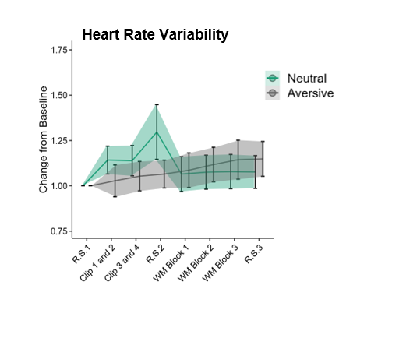
Figure 1 AVP effects on HRV are shown as line plots, separated by arousal conditions (neutral and aversive), and colored green and grey, respectively. The graph shows HR during the experiment, with the y-axis showing the change from baseline and the x-axis showing HRV calculated for different segments of the experiment. Mean values are plotted, and error bars and shaded areas denote ± SEM.

2.2 Reaction Times (RT)
We also assessed behavioral performance in the WM task based on RT (in seconds). RT was analyzed in the same way as the d-prime scores; first, a mixed-design ANOVA showed only a significant main effect of load (see Table 1). Post-hoc tests revealed lower RT at lower load conditions [2-back < 3-back; 2-back < 4-back; 3-back < 4-back (all p<0.001)].
Secondary ANOVAs for each load showed no significant main effects of arousal conditions or stimulation group, nor any interaction between them, across all load conditions (2-back, 3-back, or 4-back) (see Figure 2). Please refer to Table 1 for the statistical details of the mixed ANOVAs performed.

2.3 Hit Rate
We also assessed hit rate during the WM task. Hit rate corresponded to the number of correct presses, and the maximum possible hit rate was 31. Hit rate was also analyzed in the same way as d-prime and RT; first, a mixed-design ANOVA showed only a significant main effect of load (see Table 1). Post-hoc tests revealed lower hit rate at lower load conditions [2-back > 3-back; 2-back > 4-back; 3-back > 4-back (all p<0.05)].
Secondary ANOVAs for each load showed no significant main effects of arousal conditions or stimulation group, nor any interaction between them, across all load conditions (2-back, 3-back, or 4-back) (see Figure 2). Please refer to Table 1 for the statistical details of the mixed ANOVAs performed.
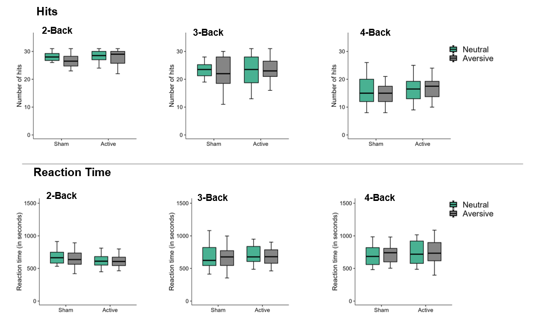
Figure 2: Behavioral data on WM task performance (Hits and Reaction Time) are shown for each n-back load as a box-and-whisker plot. The y-axis shows the number of hits and reaction time (in seconds) for both plots, respectively. The x-axis shows the stimulation groups (active and sham) separated by arousal conditions (neutral and aversive), with the groups colored green and grey, respectively. The mean values are marked by horizontal black lines, and the box plot denotes the quartile range. Whiskers denote the 95% confidence intervals of each plot.
Table 1: Main and interaction effects of the ANOVAs conducted for behavioral data of the WM task performance based on reaction time and hits. The three factors analyzed were arousal conditions (aversive vs. neutral), N-back task load (2-Back, 3-Back, and 4-Back), and stimulation group (anodal vs. sham tDCS). First, a 3-way mixed ANOVA over all WM loads, and then secondary ANOVAs for each load were performed. Significant p-values are marked in bold. d.f. = degrees of freedom, ηp2= partial eta squared.
 | Factors | d.f., Error | F Value | P - value | η_{p}²
Reaction Time (RT)
All loads | Arousal conditions | 1,46 | .429 | .516 | .009
All loads | Load | 1.6, 73.6 | 11.26 | <.001 | .197
All loads | Stimulation Group | 1,46 | .064 | .8 | .001
All loads | Arousal conditions x Load | 2, 92 | .177 | .84 | .004
All loads | Arousal conditions x Stimulation Group | 1, 46 | .012 | .9 | <.001
All loads | Stimulation group x Load | 1.6, 73.6 | 1.9 | .16 | 0.04
All loads | Arousal conditions x Load x Stimulation Group | 2, 92 | .097 | .9 | .002
2-Back | Arousal conditions | 1, 46 | .57 | .45 | .012
2-Back | Stimulation Group | 1, 46 | .58 | .45 | .013
2-Back | Arousal conditions x Stimulation Group | 1, 46 | .08 | .78 | .002
3-Back | Arousal conditions | 1, 46 | .39 | .54 | .008
3-Back | Stimulation Group | 1, 46 | .44 | .51 | .009
3-Back | Arousal conditions x Stimulation Group | 1, 46 | .04 | .84 | .001
4-Back | Arousal conditions | 1, 46 | .002 | .96 | <.001
4-Back | Stimulation Group | 1, 46 | .38 | .54 | .008
4-Back | Arousal conditions x Stimulation Group | 1, 46 | .056 | .81 | .001
Hit Rate
All loads | Arousal conditions | 1,46 | .46 | .5 | .01
All loads | Load | 2, 92 | 150 | <.001 | .76
All loads | Stimulation Group | 1, 46 | 2.15 | .15 | .045
All loads | Arousal conditions x Load | 1.6,75.16 | .36 | .66 | .008
All loads | Arousal conditions x Stimulation Group | 1, 46 | .53 | .47 | .011
All loads | Stimulation group x Load | 2, 92 | .057 | .94 | .001
All loads | Arousal conditions x Load x Stimulation Group | 1.6,75.16 | .25 | .73 | .005
2-Back | Arousal conditions | 1, 46 | 1.15 | .29 | .024
2-Back | Stimulation Group | 1, 46 | 2.9 | .092 | .06
2-Back | Arousal conditions x Stimulation Group | 1, 46 | .73 | .39 | .016
3-Back | Arousal conditions | 1, 46 | .17 | .68 | .004
3-Back | Stimulation Group | 1, 46 | 1.18 | .28 | .025
3-Back | Arousal conditions x Stimulation Group | 1, 46 | .38 | .54 | .008
4-Back | Arousal conditions | 1, 46 | .005 | 0.99 | .001
4-Back | Stimulation Group | 1, 46 | 1 | .32 | .021
4-Back | Arousal conditions x Stimulation Group | 1, 46 | .004 | .95 | .001

2.4 fMRI GLM-based analysis
Whole-brain exploratory BOLD-based GLM analysis of the n-back task was also performed. We did not find any significant clusters in the 3-back or 4-back load conditions, but did find them in the 2-back load condition. We found no significant clusters for the main effect of arousal conditions or the main effect of stimulation group. Rather, a significant cluster for the interaction between stimulation groups and arousal conditions was observed (peak MNI [6, −70, 20]; T = 4.15; k = 163 voxels; cluster p(unc) = 0.013). The cluster spanned the bilateral cuneal and supracalcarine cortices. To characterize the direction of this interaction and its relationship to behavior, activation betas were extracted from anatomically defined spherical ROIs in the cuneal and supracalcarine cortices. Because these regions were selected from the same whole-brain contrast, the ROI ANOVA is not independent of the imaging result and is reported as descriptive rather than confirmatory⁶. The interaction pattern is shown in Figure 3 and Table 2. No significant main effect of stimulation or arousal conditions was observed for any ROI’s (all F’s < 2.3, all p’s> 0.14). Post hoc analysis of the significant interaction effect showed that, for the active stimulation group, there was significantly greater activation in the aversive condition than in the neutral condition in the right cuneus (p = 0.03), left supracalcarine cortex (p = 0.03), and right supracalcarine cortex (p = 0.002). Additionally, for the right supracalcarine cortex, the sham group showed higher activation than the active group in the neutral condition (p = 0.027), whereas the reverse was observed in the aversive condition (p = 0.036) (see Figure 3).
Task performance (based on d-prime) was also correlated with the average beta activation across all ROIs. Since there was a significant interaction, we correlated aversive and neutral conditions separately. No significant correlation was observed for the neutral condition, whereas for the aversive condition, activation in the bilateral cuneal and supracalcarine cortices was significantly and positively correlated with d-prime levels (see Table 2), indicating that higher activation in the bilateral cuneal and supracalcarine cortices was associated with better performance, but only in the aversive condition.
Table 2: Interaction effects of the ANOVAs conducted for different ROIs are shown below. Each ROI underwent a 2-way mixed ANOVA with arousal conditions and stimulation groups as factors. All the ROIs had non-significant main effects, so they are not shown here; only the interaction (arousal conditions x stimulation group) statistical details are shown. d.f. = degrees of freedom, ηp2= partial eta squared. The ROI activation values were also correlated with WM performance (d-prime) for both neutral and aversive conditions, where Pearson’s correlation value (r) and the p-values are shown. Significant statistics are marked in bold.
ROI | Interaction (arousal x stimulation group) Statistics | Correlation with performance
ROI | Interaction (arousal x stimulation group) Statistics | Neutral | Aversive
Cuneus Right | F (1,44) = 6.73 p = 0.013, η_{p}²= 0.13 | r = -.03, p = .86 | r = .41, p = .005
Cuneus Left | F (1,44) = 3.3, p = 0.07, η_{p}²= 0.07 | r = -.09, p = .55 | r = .38, p = .009
Supracalcarine Right | F (1,44) = 11.15, p = 0.002, η_{p}²= 0.2 | r = -.003, p = .98 | r = .36, p = .012
Supracalcarine Left | F (1,44) = 4.4, p = 0.04, η_{p}²= 0.09 | r = -.17, p = .25 | r = .33, p = .026

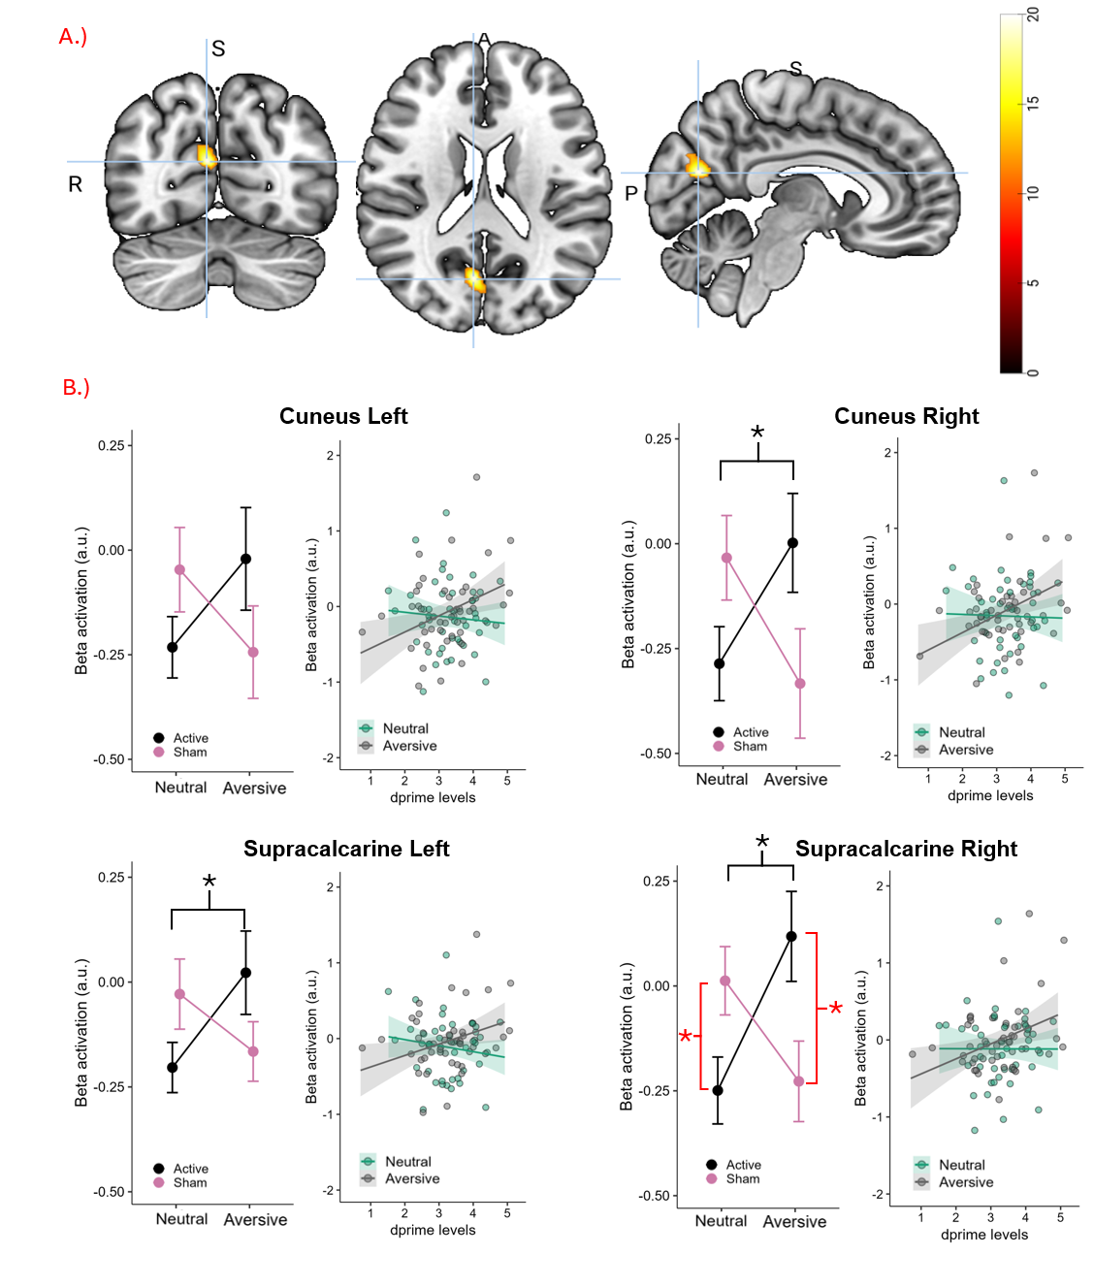
Figure 3 GLM-based whole-brain activation and ROI results during the 2-back task performance. a.) A significant cluster across the whole brain is observed for the interaction effect between stimulation group and arousal conditions. The cluster spanned visual processing areas, including the cuneal cortex and supracalcarine cortex. The color bar shows the t-value range. The peak MNI coordinates, shown with a light blue crosshair, were 6, -70, 20. b.) Averaged activation from ROIs chosen from the significant cluster is shown here for the bilateral cuneus and supracalcarine cortex. For each ROI, a line plot shows the mean activation for both arousal conditions and stimulation groups. In this plot, the x-axis represents the Beta activation value, and the y-axis shows the stimulation groups, with the black line representing the active group and the pink line representing the sham group. Asterisk (*) in red shows the significant difference between stimulation groups for respective arousal conditions, and asterisk in black shows the significant difference between arousal conditions for the active group. Error bars denote ±SEM. The x-y plot next to the line plot for each ROI shows the correlation between beta activation and 2-back performance (d-prime scores), with green points denoting the neutral condition and black points denoting the aversive condition. The fitted line, with shaded areas representing the standard error, is shown for both arousal conditions, corresponding to their colors.

2.5 Seed to region connectivity
To further assess how vmPFC stimulation led to changes in seed-to-region connectivity, we analyzed seed-to-region connectivity. The comparisons were done for each n-back load condition, similar to region-to-region connectivity analysis. For the 2-back load, we found 7 significant connections after FDR correction for the comparison of active vs sham across both arousal conditions (neutral and aversive) averaged (see Figure 4 for representation of the brain regions involved and Table 3 for the list of brain regions with significant connections). This result was consistent with our behavioral findings and the region-to-region fMRI analysis. We found reduced connectivity between seed regions and auditory and sensory processing regions in the active condition compared with the sham condition. The significant connections, along with their p-values, are shown in the table below. We did not find any significant clusters in the 3-back or 4-back load conditions
Table 3: Seed-to-region functional connectivity results from the seed-based ROI connectivity analysis for the 2-back load. Comparisons included neutral vs. aversive conditions (averaged across groups and separately for sham and active conditions), and active vs. sham (averaged across conditions and separately for neutral and aversive conditions). Significant connections after FDR correction are shown, along with ROI labels from the Harvard-Oxford atlas and t-values. Regions involved in the clusters were: PO = Parietal Operculum; PT = Planum Temporale; aSMG = Supramarginal Gyrus (ant.); pSTG = posterior superior temporal gyrus; PostCG = Postcentral Gyrus.
2-Back Seed to ROI Connectivity
Comparison | Connection Target | Beta value | T value | p-FDR
Neutral vs Aversive (Active + Sham Group) | No significant cluster
Neutral vs Aversive; Sham | No significant cluster
Neutral vs Aversive; Active | No significant cluster
Active vs Sham (Neutral + Aversive) | aSMG L | −0.20 | −4.83 | 0.002
Active vs Sham (Neutral + Aversive) | aSMG R | −0.15 | −4.48 | 0.003
Active vs Sham (Neutral + Aversive) | PO L | −0.16 | −4.18 | 0.006
Active vs Sham (Neutral + Aversive) | pSTG L | −0.15 | −4.01 | 0.007
Active vs Sham (Neutral + Aversive) | PT R | −0.14 | −3.93 | 0.007
Active vs Sham (Neutral + Aversive) | PostCG L | −0.13 | −3.80 | 0.009
Active vs Sham (Neutral + Aversive) | PO R | −0.12 | −3.77 | 0.009
Active vs Sham; Neutral | No significant cluster
Active vs Sham; Aversive | No significant cluster
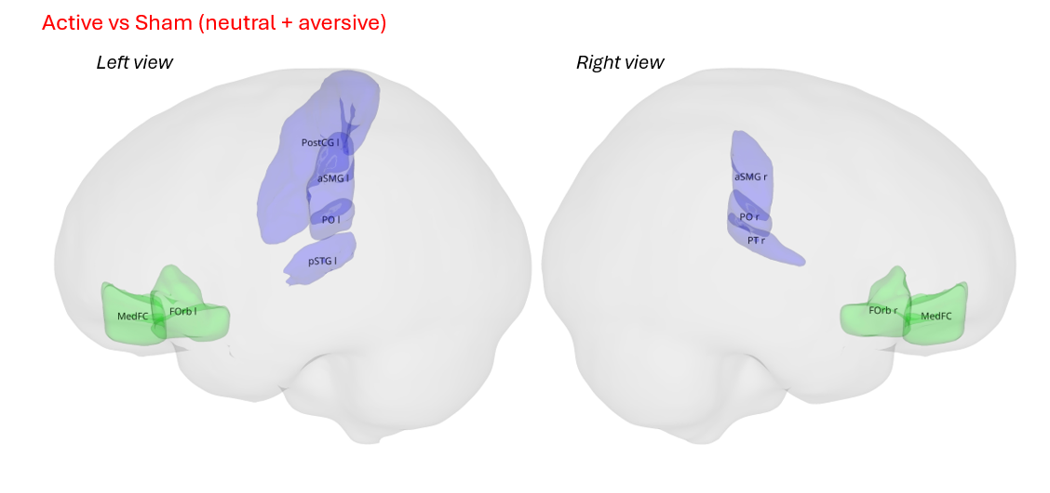
Figure 4: Significant seed-to-region functional connectivity differences during the 2-back load. a) Significant regions for the seed-based connectivity for the active vs sham comparisons across both arousal conditions combined. The significant regions are shown on a 3D glass brain in MNI space with left and right views. Regions were defined based on the Harvard-Oxford atlas. The regions in blue are those regions whose seed-based connectivity was lower in the active group than in the sham group. The regions shown in green are the selected seed regions (frontal medial cortex + left and right frontal orbital cortex).

2.6 Side Effects and Post-Experiment Questionnaire
We also assessed the side effects felt during and after stimulation. For side effects during stimulation, no significant main or interaction effects of arousal conditions or stimulation group were observed (refer to Table 4 for ANOVA results).
For side effects after stimulation, we found a significant interaction between arousal conditions and stimulation group on headache and fatigue reported after the experiment. Post-hoc analysis of headache revealed that, for the neutral condition, the sham stimulation group had higher headache than the active group (p = 0.03), and, for the sham stimulation condition, the neutral session had higher headache than the aversive condition (p = 0.037). Post-hoc analysis of fatigue levels showed that, in the sham stimulation condition, the neutral session had higher fatigue than the aversive session (p = 0.04). A significant main effect of Nervousness was also observed, with the aversive condition leading to greater nervousness after the experiment than in the neutral session (p = 0.022). Please refer to Table 4 for the ANOVA results.
We also collected valence-arousal ratings for the movie clips using a self-assessment manikin (SAM) questionnaire after the whole experiment for each session to understand the valence-arousal score for each session’s clip (see supplementary figure 4). We found that aversive clip ratings corresponded to high arousal (t = 7.33, p <.001) and negative valence (t = 7.93, p<.001) as compared to neutral clips, typical of emotions associated with disgust, fear, and anger, while neutral clip ratings corresponded to low arousal and positive valence, typical of emotions like calm, neutral, and relaxed^{7,8}.
Table 4: Main and interaction effects of ANOVAs conducted for self-reported scores of side effects during and after stimulation. Significant p-values are marked in bold. d.f. = degrees of freedom, ηp2= partial eta squared.
 |  | Factors | d.f., Error | F Value | P - value | η_{p}²
During Stimulation | Itching | Arousal conditions | 1,46 | .321 | .574 | .007
During Stimulation | Itching | Stimulation group | 1,46 | .268 | .606 | .006
During Stimulation | Itching | Arousal conditions x Stimulation group | 1,46 | .321 | .574 | .007
During Stimulation | Tingling | Arousal conditions | 1,46 | 1.42 | .238 | .03
During Stimulation | Tingling | Stimulation group | 1,46 | .004 | .95 | .0
During Stimulation | Tingling | Arousal conditions x Stimulation group | 1,46 | 2.614 | .112 | .054
During Stimulation | Burning | Arousal conditions | 1,46 | .066 | .798 | .001
During Stimulation | Burning | Stimulation group | 1,46 | .406 | .527 | .009
During Stimulation | Burning | Arousal conditions x Stimulation group | 1,46 | .018 | .895 | .000
During Stimulation | Pain | Arousal conditions | 1,46 | .284 | .597 | .006
During Stimulation | Pain | Stimulation group | 1,46 | .01 | .922 | .0
During Stimulation | Pain | Arousal conditions x Stimulation group | 1,46 | .102 | .751 | .002
After Stimulation | Redness | Arousal conditions | 1,46 | .013 | .91 | .0
After Stimulation | Redness | Stimulation group | 1,46 | .498 | .484 | .011
After Stimulation | Redness | Arousal conditions x Stimulation group | 1,46 | .322 | .573 | .007
After Stimulation | Headache | Arousal conditions | 1,46 | .023 | .88 | .001
After Stimulation | Headache | Stimulation group | 1,46 | .483 | .491 | .01
After Stimulation | Headache | Arousal conditions x Stimulation group | 1,46 | 8.345 | .006 | .154
After Stimulation | Fatigue | Arousal conditions | 1,46 | .202 | .656 | .004
After Stimulation | Fatigue | Stimulation group | 1,46 | .128 | .722 | .003
After Stimulation | Fatigue | Arousal conditions x Stimulation group | 1,46 | 6.472 | .014 | .123
After Stimulation | Concentration | Arousal conditions | 1,46 | 2.779 | .102 | .057
After Stimulation | Concentration | Stimulation group | 1,46 | .253 | .617 | .005
After Stimulation | Concentration | Arousal conditions x Stimulation group | 1,46 | .227 | .636 | .005
After Stimulation | Nervousness | Arousal conditions | 1,46 | 5.595 | .022 | .108
After Stimulation | Nervousness | Stimulation group | 1,46 | .047 | .829 | .001
After Stimulation | Nervousness | Arousal conditions x Stimulation group | 1,46 | .622 | .434 | .013
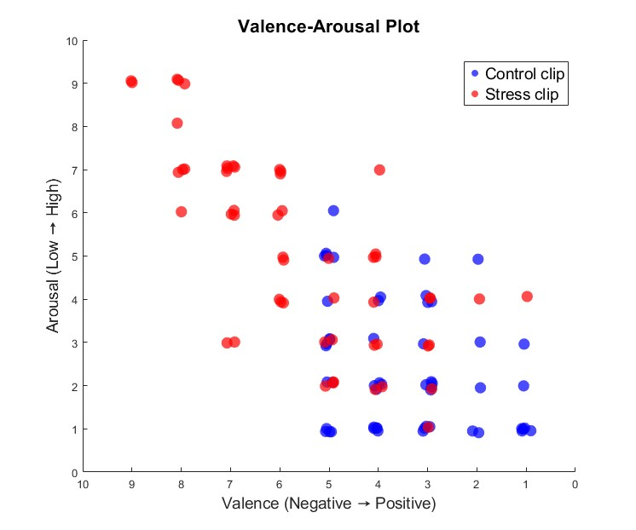
Figure 5: The x-y scatterplot shows the valence-arousal ratings for the movie clip in the neutral and aversive sessions, collected using the SAM questionnaire. The x-axis denotes the valence ratings from 10 (negative valence) to 1 (positive valence), while the y-axis represents the arousal ratings from 0 (low arousal) to 10 (high arousal). The color of the dots denotes the type of movie clip, with red indicating aversive clips and blue indicating neutral clips.

3. References
1 Shaffer F, Ginsberg JP. An Overview of Heart Rate Variability Metrics and Norms. Front Public Health 2017; 5: 258.
2 Desikan RS, Ségonne F, Fischl B, Quinn BT, Dickerson BC, Blacker D et al. An automated labeling system for subdividing the human cerebral cortex on MRI scans into gyral based regions of interest. Neuroimage 2006; 31: 968–980.
3 Rolls ET, Huang CC, Lin CP, Feng J, Joliot M. Automated anatomical labelling atlas 3. Neuroimage 2020; 206: 116189.
4 Benjamini Y, Hochberg Y. Controlling the False Discovery Rate: A Practical and Powerful Approach to Multiple Testing. Journal of the Royal Statistical Society: Series B (Methodological) 1995; 57: 289–300.
5 Bradley MM, Lang PJ. Measuring emotion: The self-assessment manikin and the semantic differential. J Behav Ther Exp Psychiatry 1994; 25: 49–59.
6 Kriegeskorte N, Simmons WK, Bellgowan PS, Baker CI. Circular analysis in systems neuroscience: the dangers of double dipping. Nature Neuroscience 2009 12:5 2009; 12: 535–540.
7 Carvalho S, Leite J, Galdo-Álvarez S, Gonçalves ÓF. The emotional movie database (EMDB): A self-report and psychophysiological study. Applied Psychophysiology Biofeedback 2012; 37: 279–294.
8 Russell JA. A circumplex model of affect. J Pers Soc Psychol 1980; 39: 1161–1178.

