Supplementary Material - Cascading Hazards, Contested Futures: Media Analysis of the 2025 Blatten Disaster in the Swiss Alps

Veruska Muccione^{1,2}, Rapahel Neukom², Saeid A. Vaghefi^{1,3,4}, Nadine Strauss⁵, Christian Huggel¹

¹Department of Geography, University of Zurich, Zurich, Switzerland

²Swiss Federal Research Institute WSL, Birmensdorf, Switzerland
³Department of Finance, University of Zurich, Zurich, Switzerland

⁴World Meteorological Organization (WMO), Geneva, Switzerland

⁵Department of Communication and Media Research, University of Zurich, Zurich, Switzerland

*Correspondence to: veruska.muccione@geo.uzh.ch
Keywords: Blatten, disaster risk management, climate change adaptation, media coverage, natural language processing

Query details
Details of the query from Swissdox@LiRi are provided in SM Fig. 1. It is worth mentioning, that after removal of duplicates or semantically similar content and data pre-processing, the media types were only reduced to five instead of nine from the initial search in Figure SM Figure 1.

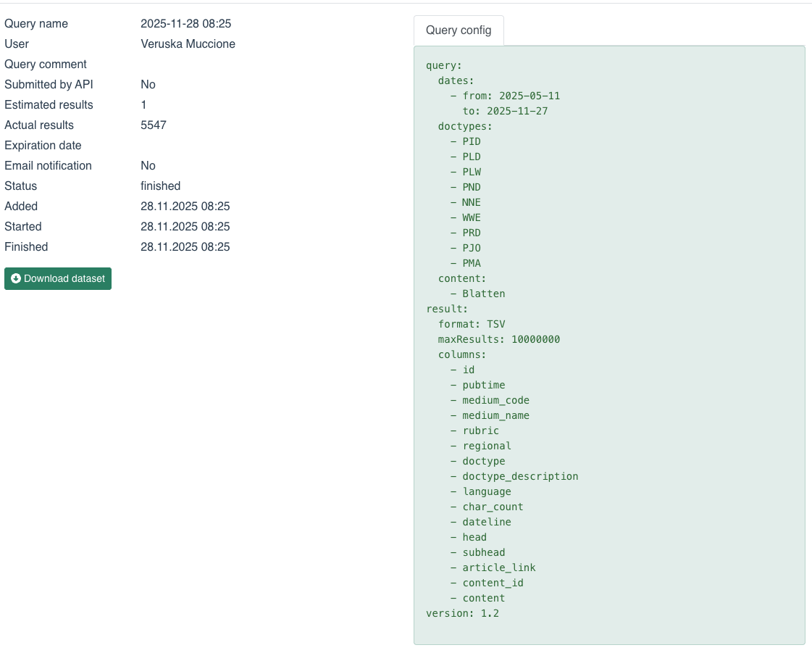
SM Fig. 1 The figure shows the query details from the Swissdox@LiRi database. The doctypes are: PID = international newspaper; PLD = local daily newspaper; PLW = local weekly newspaper; PND = national daily newspaper; NNE= news agency; WWE = online medium; PRD = national daily newspaper; PJO = regional weekly newspaper; PMA = magazine.

Performance results of SetFit
In order to exclude the irrelevant news article, a Sentence Transformer Fine-tuning (SetFit. SetFit) is a lightweight approach for text classification that uses very few labelled data. In this case, the labelled dataset consisted of 203 examples labelled under class = 1 = relevant and class = 0 = irrelevant (Tunstall et al. 2022). The dataset was split into train and test after balancing for the labelled examples if unbalanced. The train set corresponded to 162 examples and the test to 41 examples. The results are provided in SM Fig. 2. This figure shows how the SetFit classifier distinguished between news articles that were substantively about the Blatten disaster and articles that only mentioned Blatten in passing. Class 0 refers to non-relevant articles, while Class 1 refers to relevant articles. The table reports standard classification measures (Rainio et al. 2024; Opitz 2024). Precision indicates how often the model was correct when it assigned an article to a given class. Recall indicates how many of the articles belonging to a given class were successfully found by the model. The F1-score combines precision and recall into a single measure, where higher values indicate better overall performance. Support is the number of manually checked articles in each class. The confusion matrix below the table shows the actual counts: 10 non-relevant articles were correctly identified, 28 relevant articles were correctly identified, and three non-relevant articles were incorrectly retained as relevant. No relevant articles were wrongly excluded. Overall, the classifier achieved an accuracy of 0.93, indicating strong performance and a conservative tendency to retain potentially relevant articles rather than risk removing articles about the Blatten event.

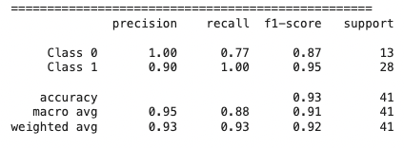

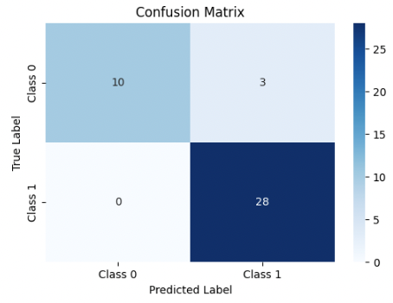
SM Fig. 2 The top table shows the standard classification metrics for binary classifier, whereas the bottom figure shows the confusion matrix.
In addition to the standard classification metrics and confusion matrix, model performance was evaluated using the receiver operating characteristic area under the curve score, i.e. ROC AUC. ROC AUC measures the ability of the classifier to distinguish between positive and negative cases across all possible classification thresholds (Saito and Rehmsmeier 2015). Unlike accuracy, precision, or recall, which depend on a specific decision threshold, ROC AUC evaluates the ranking quality of the model’s predicted scores. A value of 0.5 indicates performance equivalent to random guessing, whereas a value of 1.0 indicates perfect discrimination. We obtained a ROC AUC score of 0.9423 indicating strong performance and that the classifier was able to reliably separate the two classes in the test set.

Structured output event and strategy categories
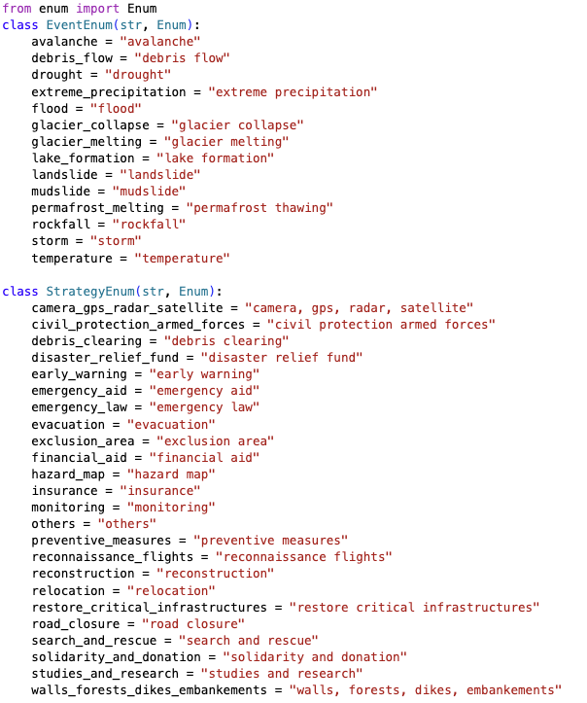
SM Fig. 3 The screenshot from the original code shows the categories of hazard (Event) and disaster response intervention (Strategy).

Model Evaluation: multi-labelling and free text
Model performance of the hazard event and disaster response interventions was evaluated against the manually annotated dataset using six complementary multi-label metrics: micro-precision, micro-recall, micro-F1, macro-F1, samples-F1, Jaccard score. Micro-precision is the sum of all true positives over the sum of all positives predictions; micro-recall is the sum of all true positives over the sum of all true positives and false negatives. Their harmonic mean, micro-F1, provides a single summary score in which frequent labels dominate, making it appropriate under class imbalance. Macro-F1 averages per-label F1 scores with equal weight and therefore acts as a diagnostic for performance on rare categories. Samples-F1 and the Jaccard score are both computed per news article and then averaged across articles, capturing how well the predicted label set matches the reference set on a per-item basis — a relevant view in the present corpus, where a single news article may legitimately carry several event or strategy labels. Together, these metrics characterise overall performance (micro-F1), behaviour on rare labels (macro-F1), per-article set agreement (samples-F1, Jaccard), the balance between over- and under-prediction (micro-precision vs. micro-recall).

SM Table 1 summarises the results of the event and strategy multilabel classification performance.
Metrics | Score Event | Score Strategy
Micro precision | 0.59 | 0.50
Micro recall | 0.71 | 0.76
Micro F1 | 0.64 | 0.60
Macro F1 | 0.48 | 0.54
Samples F1 | 0.68 | 0.59
Jaccard score | 0.58 | 0.45

In multilabel classification, the main overall score is given by the micro-F1. Here, the value means that the model is performing reasonably well across all event label assignments. The lower macro-F1 compared with micro-F1 for the event classification suggests weaker performance for less frequent hazard categories. The fact that micro recall is higher than micro precision implies that the model tends to find many true events but also predicts extra labels. The Jaccard score tells that the overlap between predicted and true labels is moderately strong.

Evaluation of the LLM-generated multilabel classification of disaster interventions against manually assigned labels shows a relatively close micro- and macro-F1 scores, which suggest that performance was somewhat more balanced across strategy categories than in the event classification task, although important variation remained at the label level. Performance was strongest for more clearly defined and frequently occurring strategies such as evacuation, reconstruction, civil protection/armed forces, and restoring critical infrastructure, whereas broader or less distinct categories such as studies and research, exclusion area, and relocation were captured less reliably. Here again the higher micro recall than the micro precision implies an overprediction of certain labels. Sample-F1 confirms that news level prediction is moderately good and Jaccard score also points at moderate overlap between predicted and true labels. Notwithstanding, the major aspects discussed in the news have been reasonably well captured giving a good and broad overview of the type of events and the associated disaster intervention approaches that were present in the news without overly interpreting their frequency.

The evaluation of the news frames is performed using semantic similarity which refers to the extent to which two texts express the same or similar meaning, even if they use different words or sentence structures. In this study, semantic similarity was used to assess how closely the LLM-generated frames matched the manually written reference frames in terms of meaning, rather than exact wording. Free-text frames can differ substantially in wording, length, and structure while still conveying the same meaning; therefore, overlap-based metrics can underestimate agreement when one text is more verbose or more summary-like. As measure of semantic similarity, the cosine similarity is commonly used. Cosine similarity is a standard measure for comparing embedding vectors in natural language processing (Jurafsky and Martin 2026). For each article with both a manual extracted frame and an LLM extracted frame, we computed sentence embeddings using a pretrained transformer embedding model Sentence Transformer BAAI/bge-large-en-v1.5 (Xiao et al. 2023). After each corresponding text was transformed into a numerical embedding vector, the cosine similarity measured how closely the manual and LLM-generated vectors pointed in the same direction in the embedding space. Since the embeddings were normalised to unit length, cosine similarity could be computed as the dot product between each pair of manual and LLM-generated embeddings. Agreement between manual and LLM frames was then quantified using cosine similarity between the two normalised embeddings (equivalent to their dot product). The resulting score typically lies between approximately –1 and 1, where higher values indicate stronger semantic alignment. Cosine similarity results are provided across the manually annotated subset using descriptive statistics (mean, median, quartiles).

Overall, the evaluation yields good results. Across the subset of news with both a manual and an LLM-generated frame text available (n = 215), semantic agreement measured via cosine similarity was generally high. The cosine similarity distribution had a mean of 0.677 and a median of 0.696, with the middle 50% of cases lying between 0.609 (25th percentile) and 0.765 (75th percentile). The lowest observed similarity was 0.317, suggesting a small set of output with substantially different framing/content (or potential data quality issues), whereas the highest similarity reached 1.000, indicating near-identical match in some instances. Even though the frames are free text (and therefore subjective), the results suggest the LLM output is consistent overall with the manual texts. Lower cosine similarity values do not necessarily indicate poor LLM performance; they often arise when the manual extracted text are not fully consistent—sometimes functioning more like detailed summaries than explicit framing—and when the LLM and manual texts differ in verbosity.

References
Jurafsky D, Martin JH (2026) peech and Language Processing: An Introduction to Natural Language Processing, Computational Linguistics, and Speech Recognition with Language Models, 3rd edn.
Opitz J (2024) A Closer Look at Classification Evaluation Metrics and a Critical Reflection of Common Evaluation Practice. Transactions of the Association for Computational Linguistics 12:820–836. https://doi.org/10.1162/tacl_a_00675
Rainio O, Teuho J, Klén R (2024) Evaluation metrics and statistical tests for machine learning. Sci Rep 14:6086. https://doi.org/10.1038/s41598-024-56706-x
Saito T, Rehmsmeier M (2015) The Precision-Recall Plot Is More Informative than the ROC Plot When Evaluating Binary Classifiers on Imbalanced Datasets. PLoS ONE 10:e0118432. https://doi.org/10.1371/journal.pone.0118432
Tunstall L, Reimers N, Jo UES, et al (2022) Efficient Few-Shot Learning Without Prompts
Xiao S, Liu Z, Zhang P, Muennighoff N (2023) C-Pack: Packaged Resources To Advance General Chinese Embedding

