Supplementary Material for “OmicFormer: a statistical priors–informed transformer for accurate and generalizable omics prediction of disease and complex traits”

Contents
Supplementary Figure 1 | Disease-group-wise performance comparison of OmicFormer across multiple omics datasets (AUC).
Supplementary Figure 2 | Disease-group-wise performance comparison of OmicFormer across multiple omics datasets (ACC).
Supplementary Figure 3 | Category-wise performance comparison of OmicFormer for continuous trait prediction across multiple omics datasets (corr).
Supplementary Figure 4 | OmicFormer for continuous trait prediction across multiple omics datasets (MSE).
Supplementary Figure 5 | Brain IDP contribution patterns in disease prediction for OmicFormer and LightGBM.
Supplementary Figure 6 | Disease-Specific ACC of UK Biobank-Trained Models in External Validation on the GNPC Cohort.

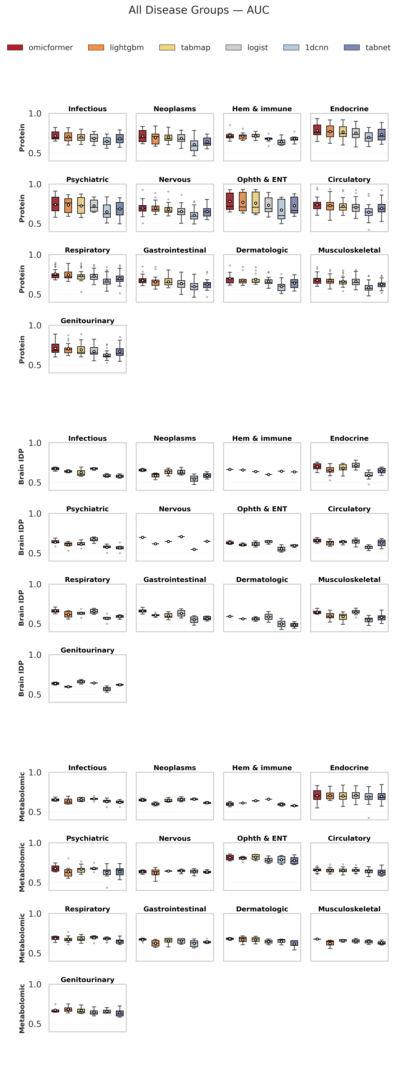

Supplementary Figure 1 | Disease-group-wise performance comparison of OmicFormer across multiple omics datasets (AUC).
Boxplots summarize AUC across major disease groups for three omics modalities, including proteomics (top block), brain imaging-derived phenotypes (Brain IDP; middle block), and metabolomics (bottom block). Each subplot corresponds to one disease category. OmicFormer is compared against LightGBM, TabMap, TabNet, logistic regression, and 1D-CNN.

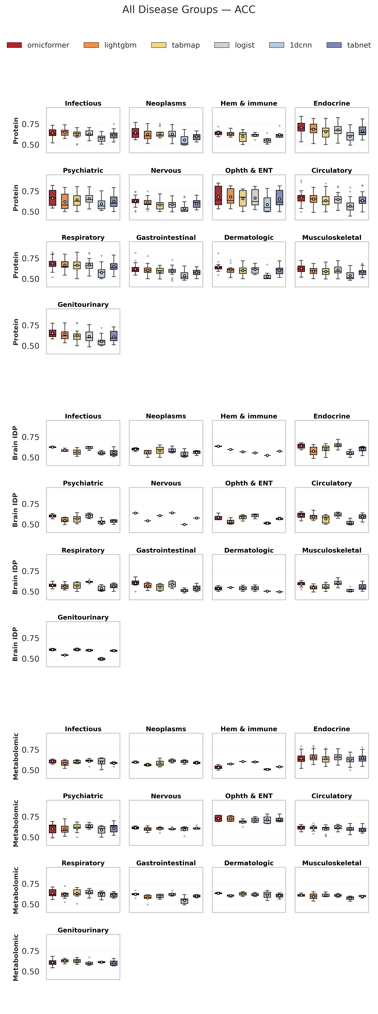
Supplementary Figure 2 | Disease-group-wise performance comparison of OmicFormer across multiple omics datasets (ACC).
Same layout and comparison setting as Supplementary Figure 1 but evaluated using ACC instead of AUC.

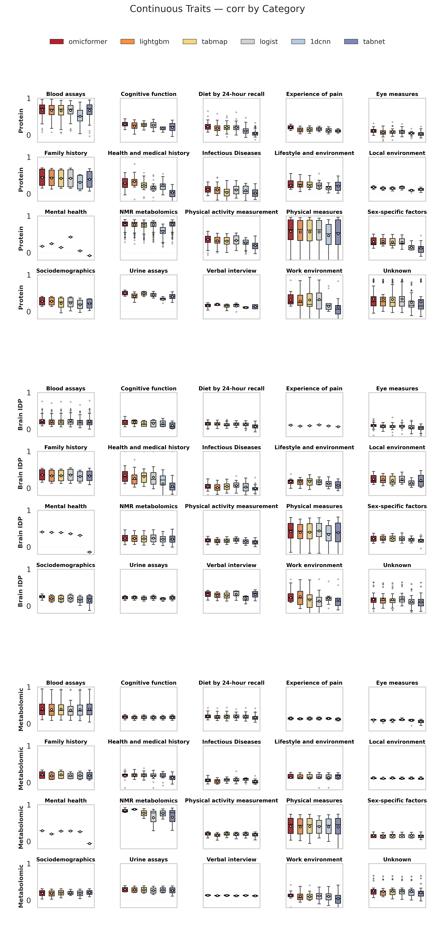

Supplementary Figure 3 | Category-wise performance comparison of OmicFormer for continuous trait prediction across multiple omics datasets.
Boxplots summarize Pearson correlation coefficients for continuous trait prediction tasks across trait categories and three omics modalities, including proteomics (top block), brain imaging-derived phenotypes (Brain IDP; middle block), and metabolomics (bottom block). Each subplot corresponds to one trait category (e.g., blood assays, cognitive function, diet by 24-hour recall, physical measures, sociodemographics, and others). OmicFormer is compared against widely used tabular learning baselines, including LightGBM, TabMap, TabNet, ridge regression, and 1D-CNN.

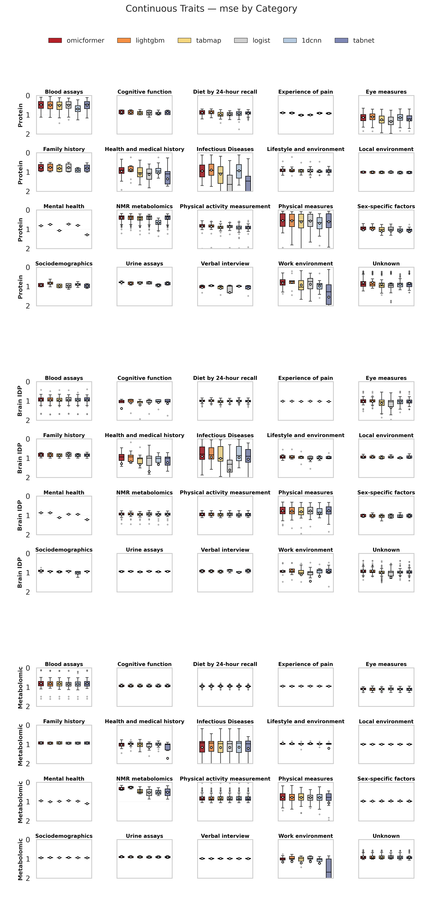

Supplementary Figure 4 | Category-wise performance comparison of OmicFormer for continuous trait prediction across multiple omics datasets (MSE).
Same layout and comparison setting as Supplementary Figure 3 but evaluated using mean squared error (MSE) instead of correlation. Lower MSE indicates better predictive performance.

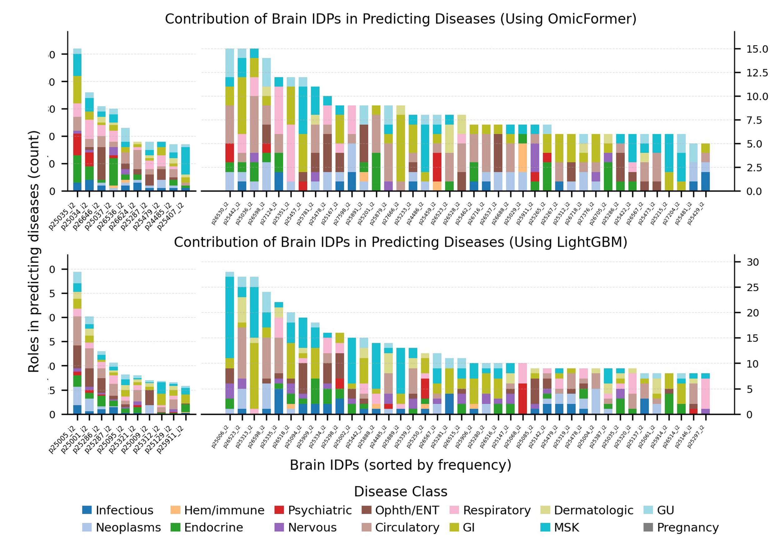
Supplementary Figure 5 | Brain IDP contribution patterns in disease prediction for OmicFormer and LightGBM.
Top panels show the frequency with which individual brain imaging-derived phenotypes (IDPs) are selected among the top-$k$ most important predictors across disease prediction tasks using OmicFormer (upper row), while the bottom panel’s report the corresponding results for LightGBM. Bars represent the number of diseases in which each brain IDP is identified as contributing substantially to prediction, with stacked colors indicating different disease groups. In both models, several brain IDPs are repeatedly selected across multiple diseases, suggesting shared predictive relevance. However, OmicFormer exhibits a more distributed and heterogeneous contribution profile, with importance spread across a broader set of IDPs, whereas LightGBM shows stronger concentration on a smaller subset of dominant features.

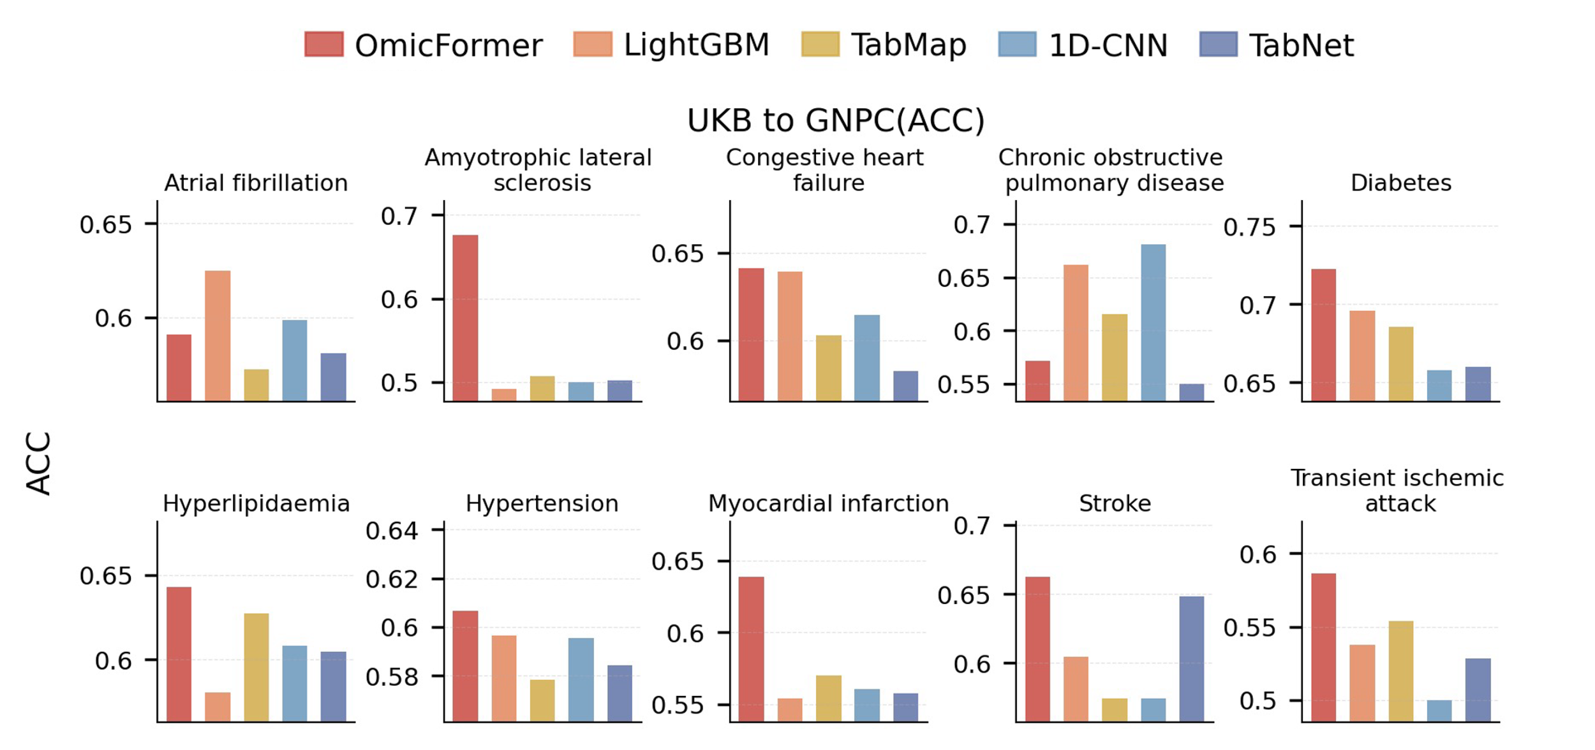
Supplementary Figure 6 | Disease-Specific ACC of UK Biobank-Trained Models in External Validation on the GNPC Cohort.
GNPC external validation. Disease-specific ACC from UK Biobank–trained models tested on GNPC. Each bar represents the mean ACC of a given model across cross-validation folds for a specific disease. Only diseases for which at least one model achieved AUC ≥ 0.65 are shown.

