SUPPLEMENTARY FIGURES FOR
BCG vaccination attenuates Schistosoma mansoni-associated rural–urban immune variation

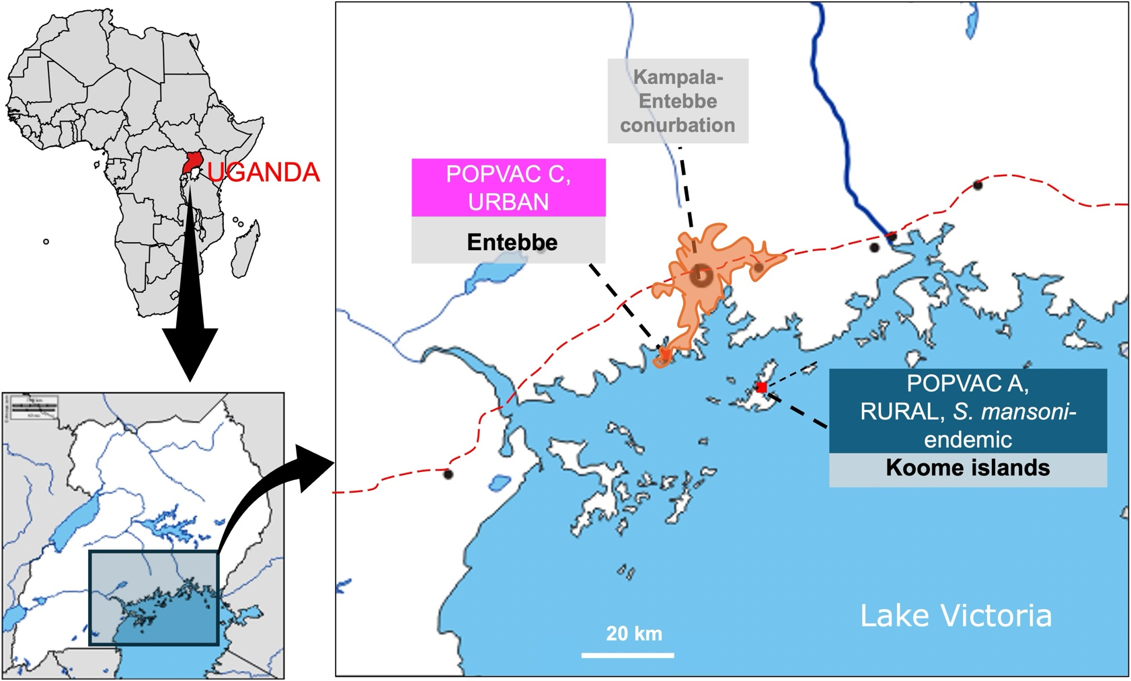
Supplementary Figure 1. Study settings. Adapted from Nassuuna, et al., 2025.¹

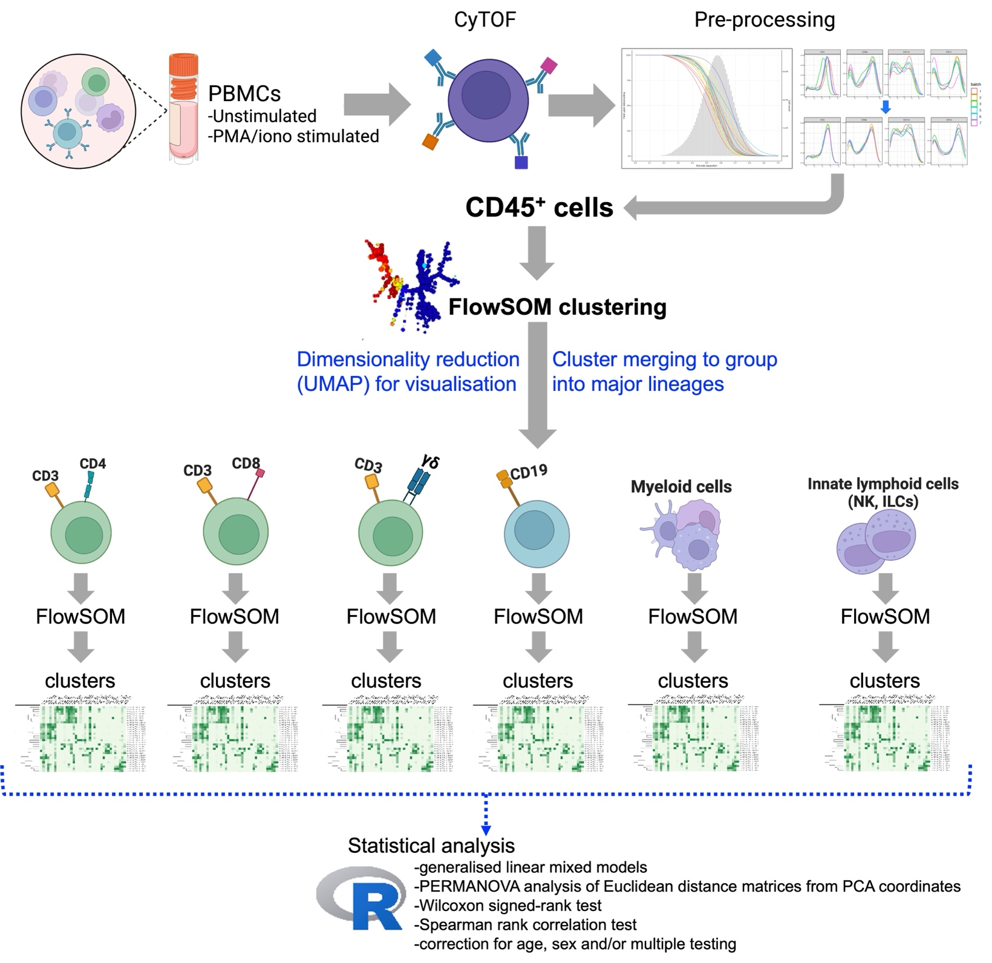
Supplementary Figure 2. Analysis pipeline.

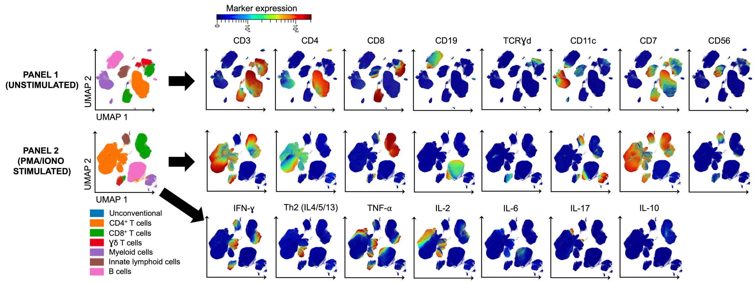
Supplementary Figure 3. Arcsinh-transformed expression of major immune lineage markers and cytokines

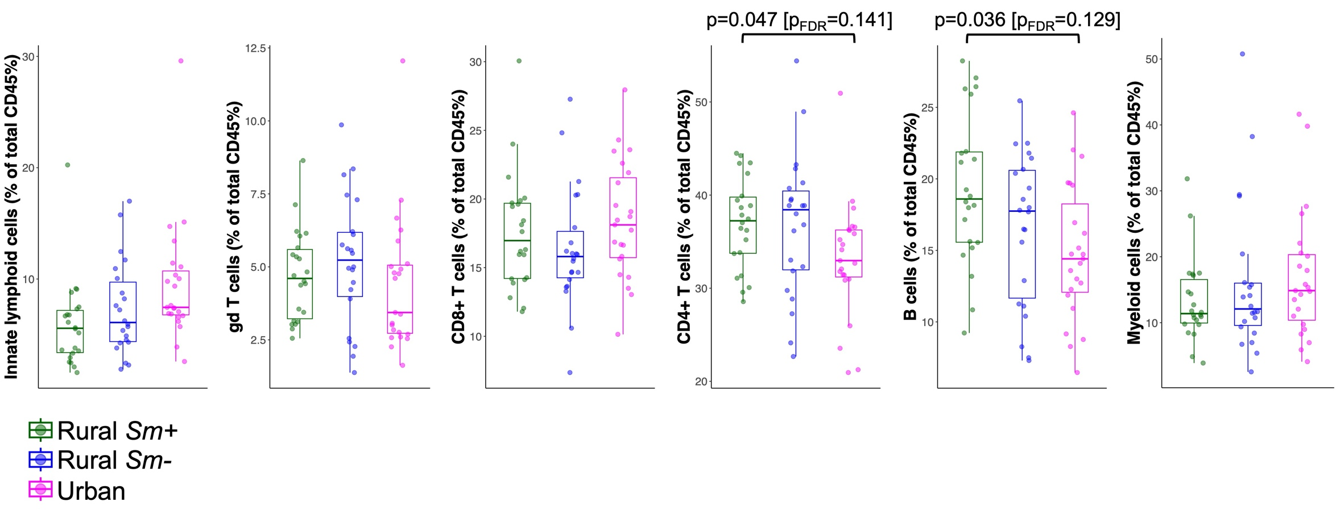

Supplementary Figure 4. Comparison of lineage proportions relative to total acquired CD45⁺ PBMCs between rural and urban participants.

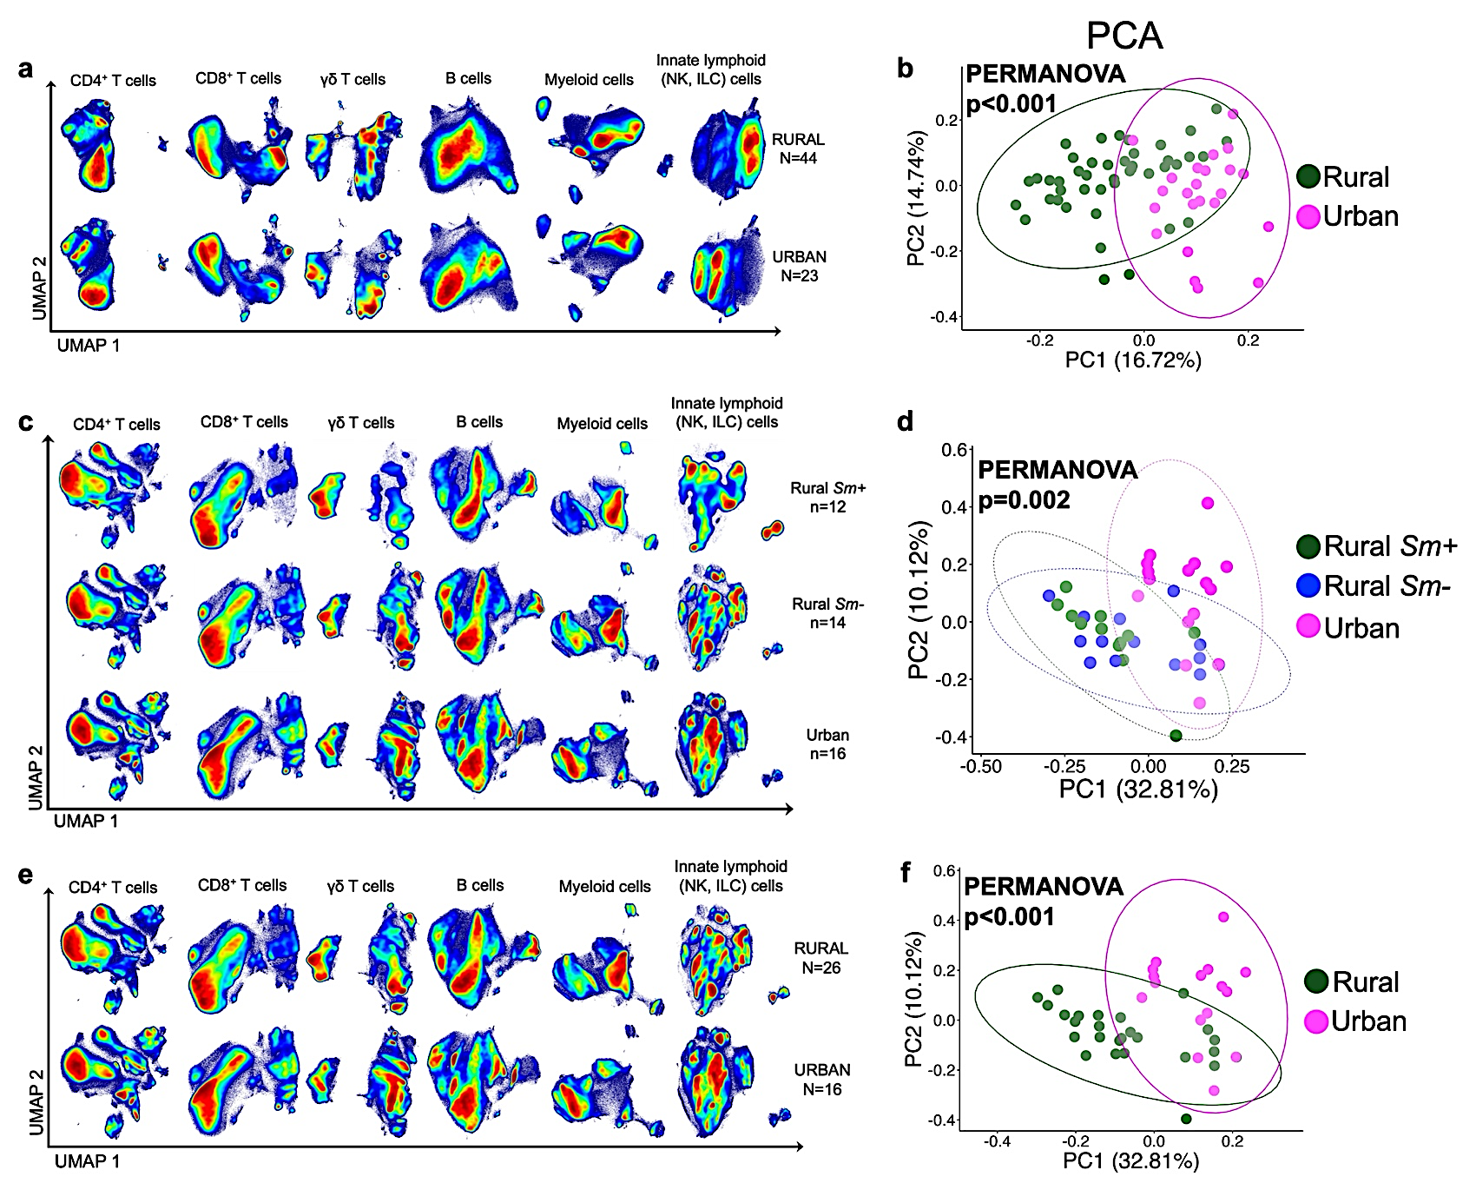
Supplementary Figure 5. Global characterisation of immune variation along the baseline rural-urban gradient.
Figure shows Uniform Manifold Approximation and Projection (UMAP) contour density plots per lineage and principal component analysis (PCA) plots for evaluation of separation of immune profiles by study setting.
(a)-(b) Unstimulated panel, rural vs urban. PCA PERMANOVA: R² = 0.26, p<0.001.
(c)-(d) PMA/ionomycin-stimulated panel, rural Sm+, rural Sm- and urban individuals. Statistical significance of PCA group separation was assessed using permutational multivariate analysis of variance (PERMANOVA) [R² = 0.33, p=0.002].
(e)-(f) PMA/ionomycin-stimulated panel, rural vs urban. PCA PERMANOVA: R² = 0.29, p<0.001.

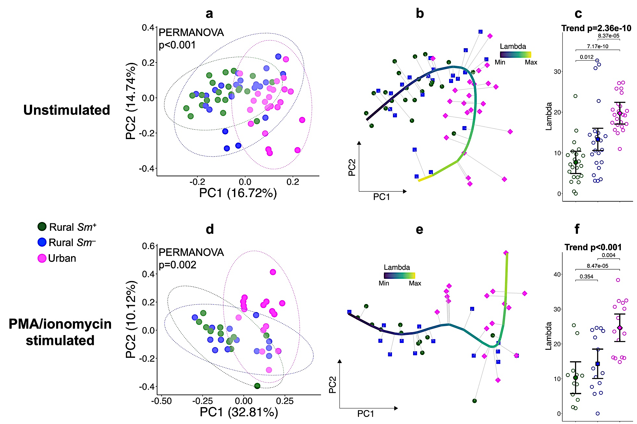
Supplementary Figure 6. Principal component analysis reveals a rural-to-urban immune trajectory.
Figures (a)-(c) show results from the unstimulated CyTOF panel and figures (d)-(f) show results from the PMA/ionomycin-stimulated panel. (a) and (d) Principal component analysis (PCA) plots constructed using immune cluster proportions relative to total acquired CD45⁺ PBMCs. Each point represents an individual sample, coloured by group (rural Sm⁺, rural Sm– and urban). Ellipses indicate group centroids. Group separation was assessed using permutational multivariate analysis of variance (PERMANOVA), with R² = 0.29 and p<0.001 for the unstimulated panel, and R² = 0.33 and p = 0.002 for the PMA/ionomycin-stimulated panel. (b) and (e) Principal curve trajectory analysis showing the projection of samples along a rural-to-urban immune trajectory across the three groups. Colour intensity reflects the lambda value (trajectory position). (c) and (f) Distribution of principal curve lambda values by group. Points represent individual samples; error bars indicate adjusted marginal means with 95% confidence intervals. P-values for the linear trend across groups and Conover post hoc pairwise comparisons are shown.

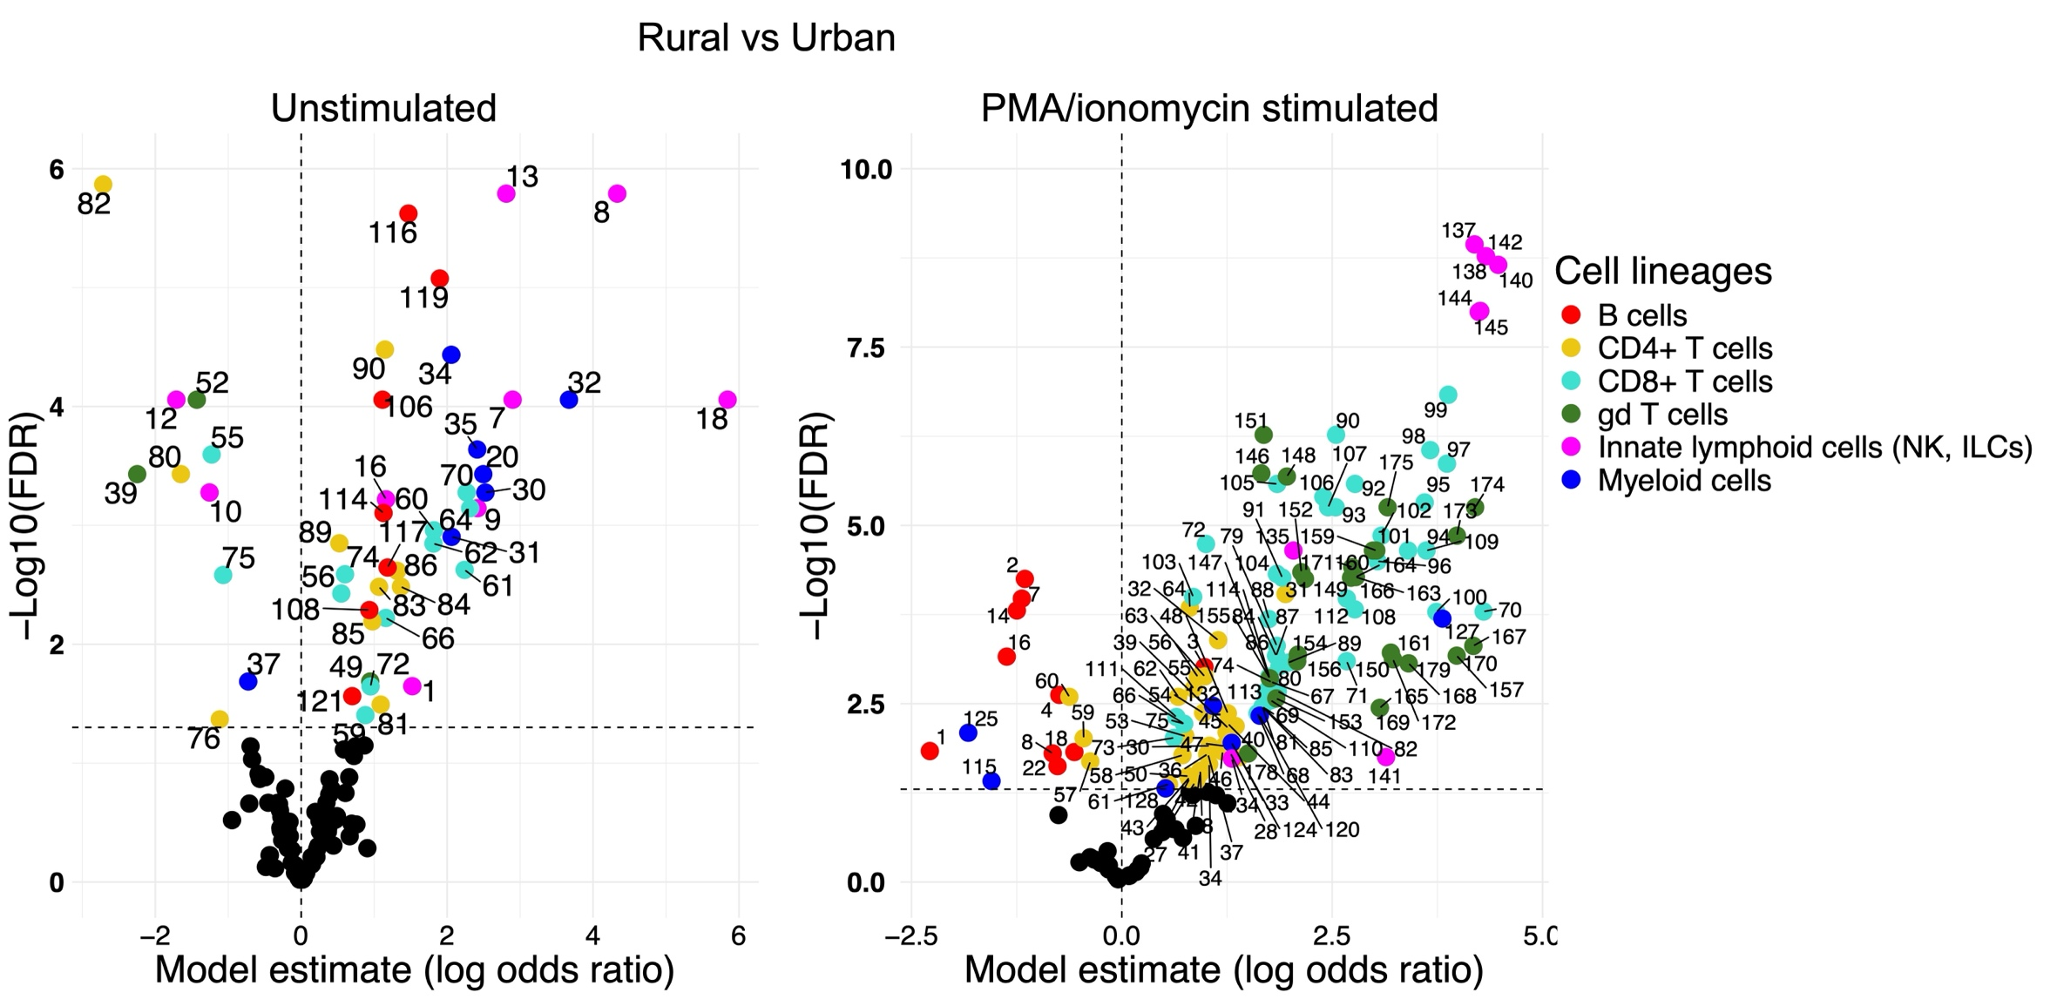
Supplementary Figure 7. Rural-urban comparison of immune profiles. Volcano plots showing log odds ratios and corresponding age- and sex-adjusted p values [−log10(FDR)] for the association between frequency of immune phenotypes (as a percentage of the total acquired CD45⁺ PBMCs per participant) and geographical setting, at the pre-vaccination (week 0) timepoint. Negative and positive log odds ratios indicate higher frequencies of immune clusters in the rural and urban settings, respectively. The left panel shows results from the unstimulated panel and the panel on the right shows results from the PMA/ionomycin-stimulated panel. Estimates were derived from a generalised binomial linear mixed model. Each point represents an immune cluster, and clusters with FDR-corrected p values of <0.05 are coloured by immune lineage and labelled with the cluster ID.

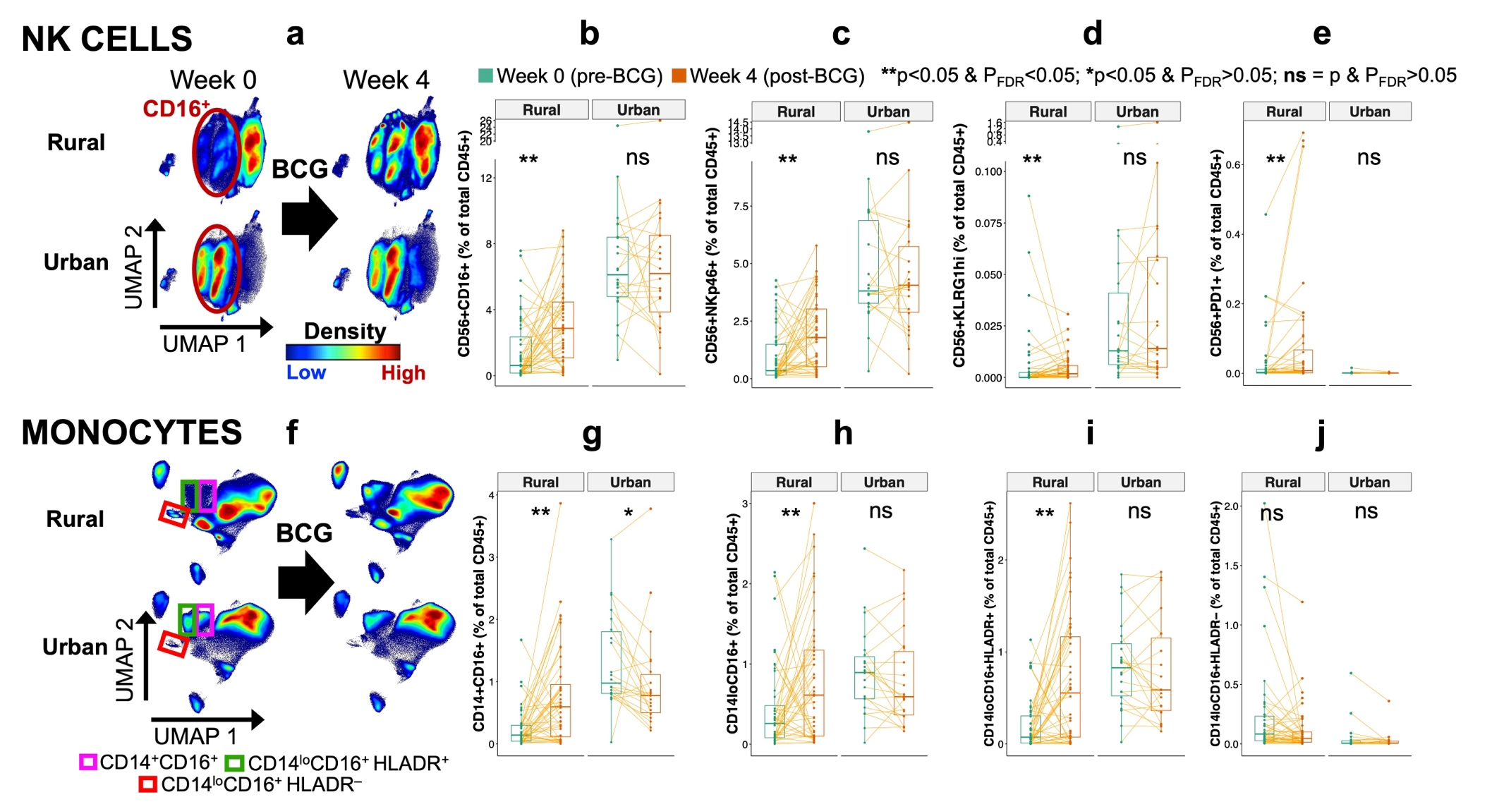
Supplementary Figure 8. Rural versus Urban NK cell and monocyte alterations four weeks post-BCG vaccination. (a) and (f) UMAP contour density plots for NK cells and monocytes, respectively, stratified by sample origin and timepoint. (b)–(e) and (g)–(j) Boxplots summarising subset frequencies expressed as a percentage of total acquired live CD45⁺ PBMCs. Paired comparisons before (week 0) and after BCG vaccination (week 4) were done using the Wilcoxon signed-rank test, with false discovery rate (FDR) correction.

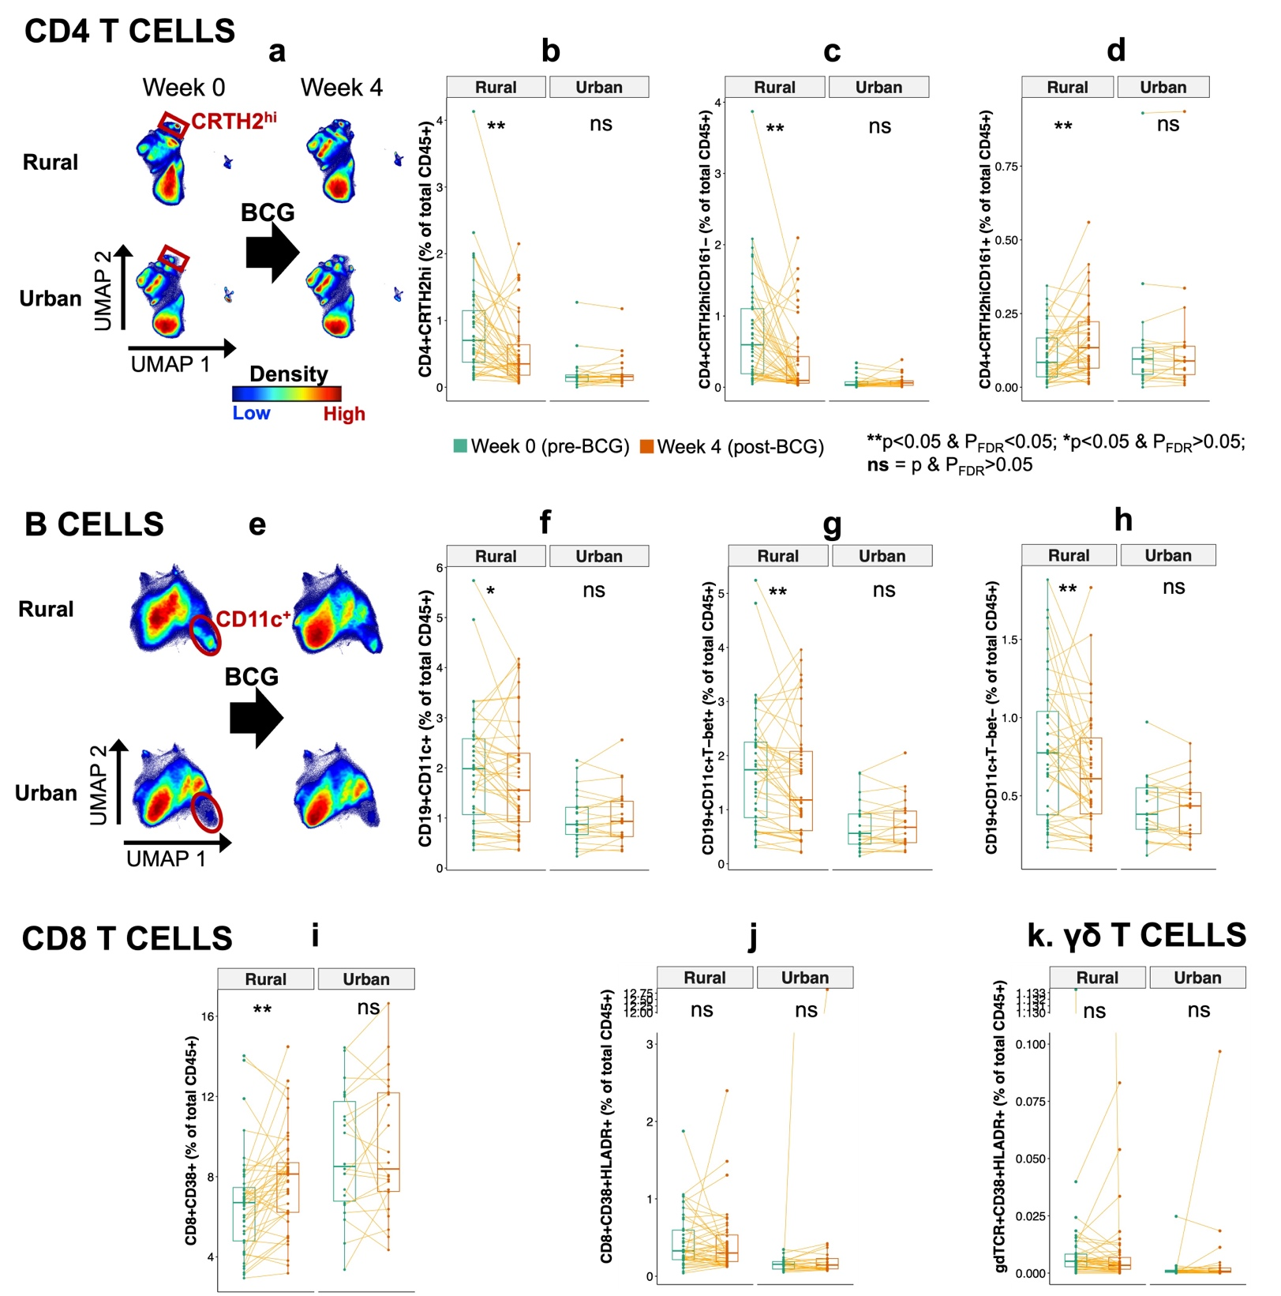
Supplementary Figure 9. Rural versus Urban lymphocyte alterations four weeks post-BCG vaccination.
(a) and (e) UMAP contour density plots for CD4⁺ T cells and B cells, respectively, stratified by sample origin and timepoint. (b)–(d) and (f)–(k) Boxplots summarising subset frequencies expressed as a percentage of total acquired live CD45⁺ PBMCs. Paired comparisons before (week 0) and after BCG vaccination (week 4) were done using the Wilcoxon signed-rank test, with false discovery rate (FDR) correction.

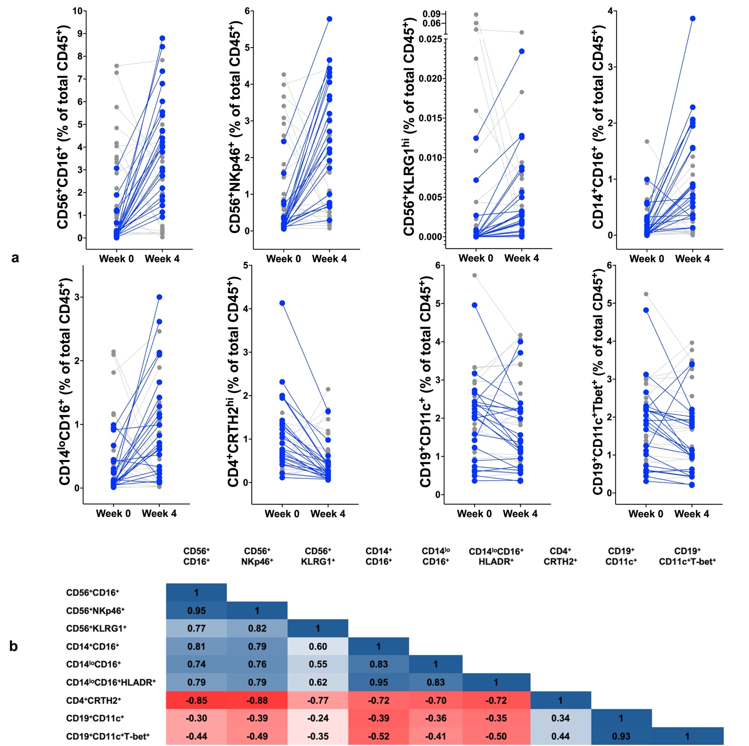
Supplementary Figure 10. Coordinated multi-compartment immune reprogramming following BCG vaccination in all rural participants.
(a) Paired changes in frequencies of selected innate and adaptive immune cell subsets in all rural participants from week 0 (pre‑BCG) to week 4 post‑BCG vaccination. Each line represents an individual. Participants exhibiting ≥2‑fold increases in CD56⁺CD16⁺ NK cells (blue) are highlighted against all other individuals (grey). Expansion of CD56⁺CD16⁺ NK cells is presented against concurrent increases in other cytotoxic NK subsets (CD56⁺NKp46⁺, CD56⁺KLRG1^{hi}) and intermediate monocytes (CD14⁺CD16⁺) and non-classical monocytes (CD14^{lo}CD16⁺), alongside reductions in adaptive phenotypes associated with helminth exposure, including CRTH2^{hi} CD4⁺ T cells and CD11c⁺ B-cell subsets. (b) Spearman correlation matrices of week 0–week 4 fold changes in immune cell subset frequencies in all rural participants. Positive (blue) and negative correlation coefficients (red) are shown.

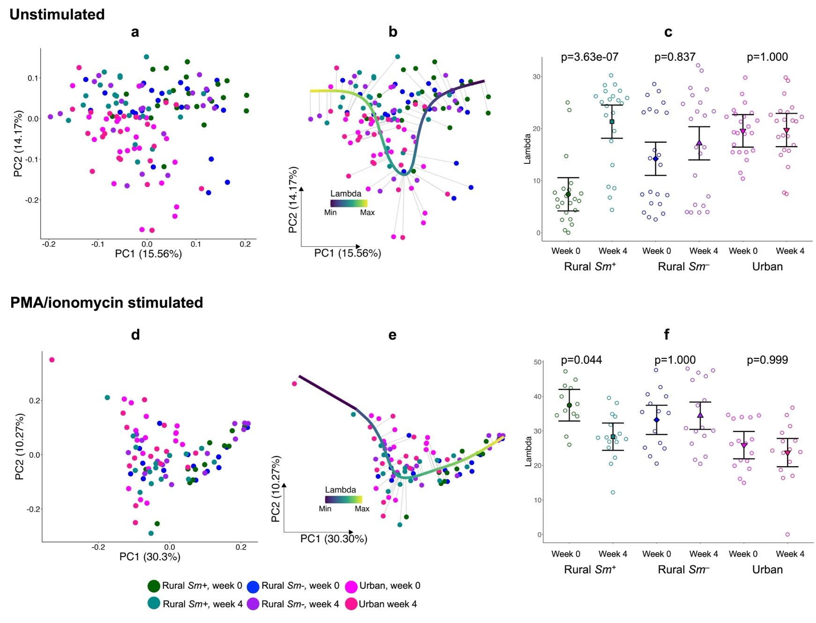
Supplementary Figure 11. Principal component analysis of pre- and post-BCG samples.
Figures (a)-(c) show results from the unstimulated CyTOF panel and figures (d)-(e) show results from the PMA/ionomycin-stimulated panel. (a) and (d) Principal component analysis (PCA) plots constructed using immune cluster proportions relative to total acquired CD45⁺ PBMCs, for all week 0 and week 4 samples. Each point represents an individual sample, coloured by group (rural Sm⁺, rural Sm– and urban) and timepoint (week 0 and week 4). b) and (e) Principal curve trajectory analysis showing the projection of samples along a rural-to-urban immune trajectory across the six groups. Colour intensity reflects the lambda value (trajectory position). (c) and (f) Distribution of principal curve lambda values by group. Points represent individual samples; error bars indicate adjusted marginal means with 95% confidence intervals. P-values for Conover post hoc pairwise comparisons are shown.

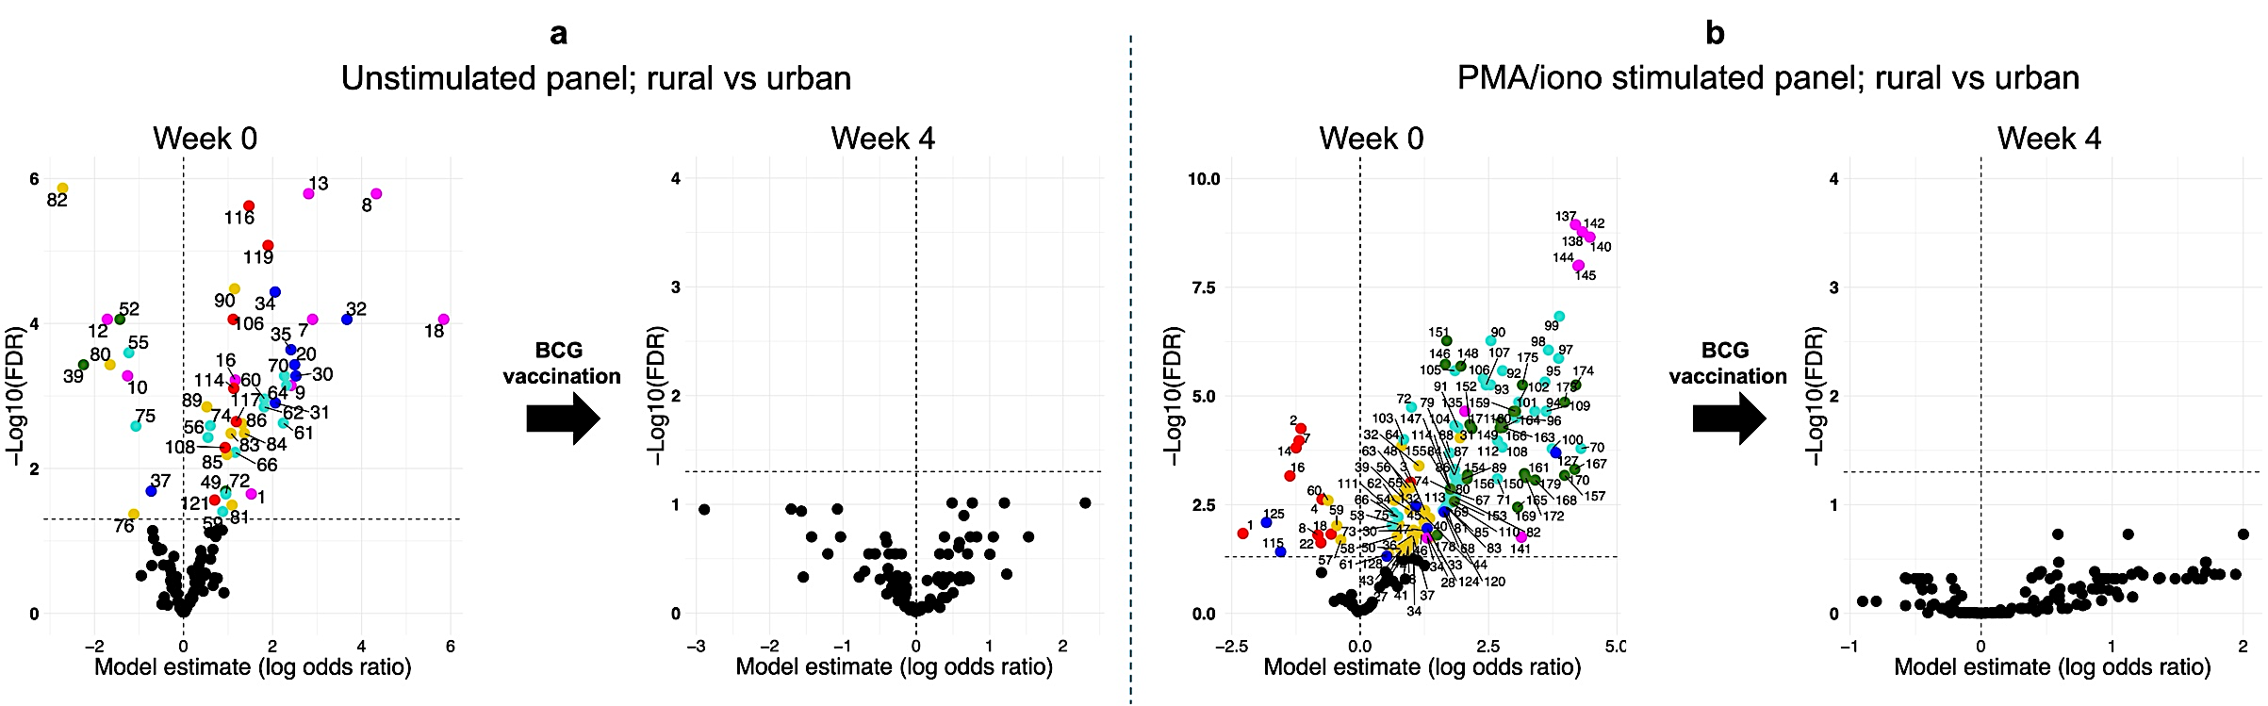
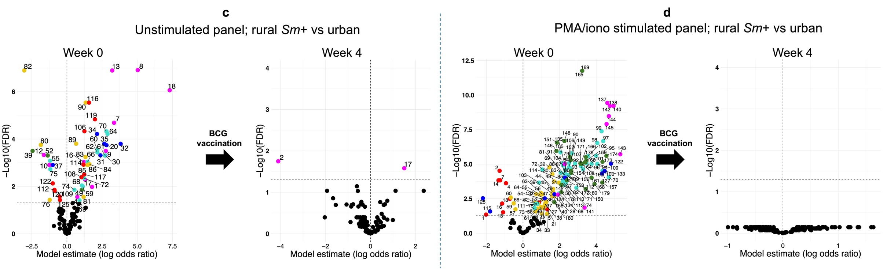
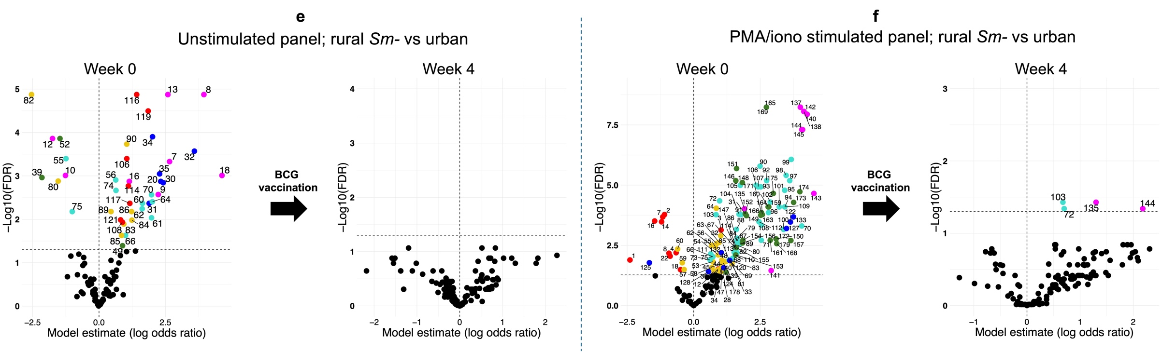
Supplementary Figure 12. Volcano plots before and after BCG vaccination, showing log odds ratios and corresponding age- and sex-adjusted and FDR-corrected p values [−log10(FDR)] for the association between frequency of immune phenotypes (as a percentage of total acquired CD45⁺ PBMCs per participant), Sm infection status and geographical setting. (a), (c) and (e) show results from the unstimulated panel and (b), (d) and (f) show results from the PMA/ionomycin-stimulated panel. Estimates were derived from a generalised binomial linear mixed model. Each point represents an immune cluster, and clusters with FDR-p<0.05 are coloured by immune lineage and labelled with the cluster ID.

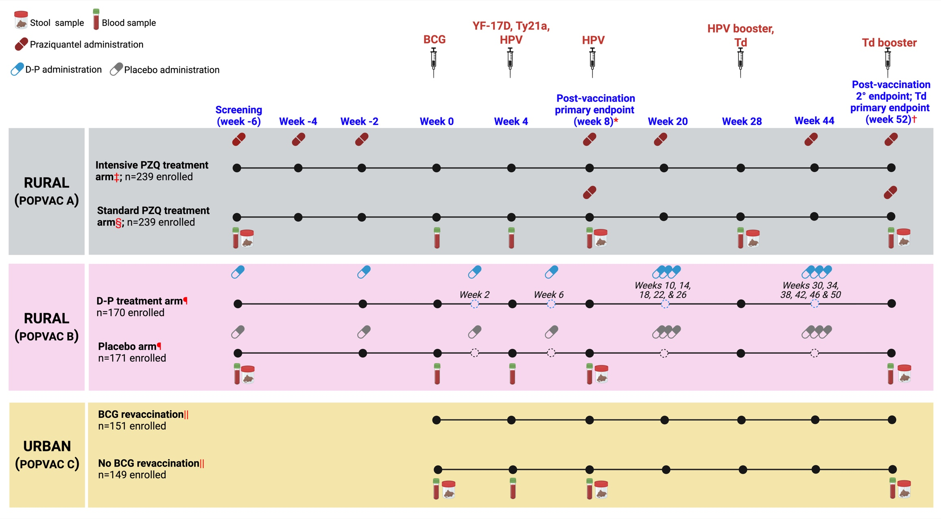
Supplementary Figure 13. POPVAC trial schedules.
Adapted from Natukunda,² Nkurunungi,³ Zirimenya,⁴ and Nassuuna et al.⁵
Cytometry by time-of-flight (CyTOF) experiments were conducted at week 0 and week 4.
*Primary timepoint following BCG, YF-17D, Ty21a, and HPV vaccination; additionally, an HPV dose given to previously unvaccinated girls aged 14 years or older.
†Secondary timepoint following BCG, YF-17D, Ty21a, and HPV vaccination. Primary timepoint following Td vaccination. Td boost was given to comply with the Uganda National Expanded Program on Immunization guidelines.
‡Intensive arm received three doses of praziquantel (40 mg/kg), each dose 2 weeks apart before week 0, followed by praziquantel at week 8 and then quarterly praziquantel until week 52.
§Standard arm received one dose of praziquantel at week 8, and a second dose at the last trial timepoint at week 52.
¶Participants received 3-day courses of either monthly dihydroartemisinin–piperaquine or placebo twice prior to week 0 and monthly during the entire follow-up period.
||Participants were randomly assigned to either receive BCG or no BCG 4 weeks before the first of the other vaccinations.
HPV=human papillomavirus. YF-17D=yellow fever vaccine. Ty21a=live oral typhoid vaccine. Td=tetanus–diphtheria vaccine. D–P=dihydroartemisinin–piperaquine. BCG=Bacille Calmette-Guérin
Created in BioRender; https://BioRender.com/iwld9fj

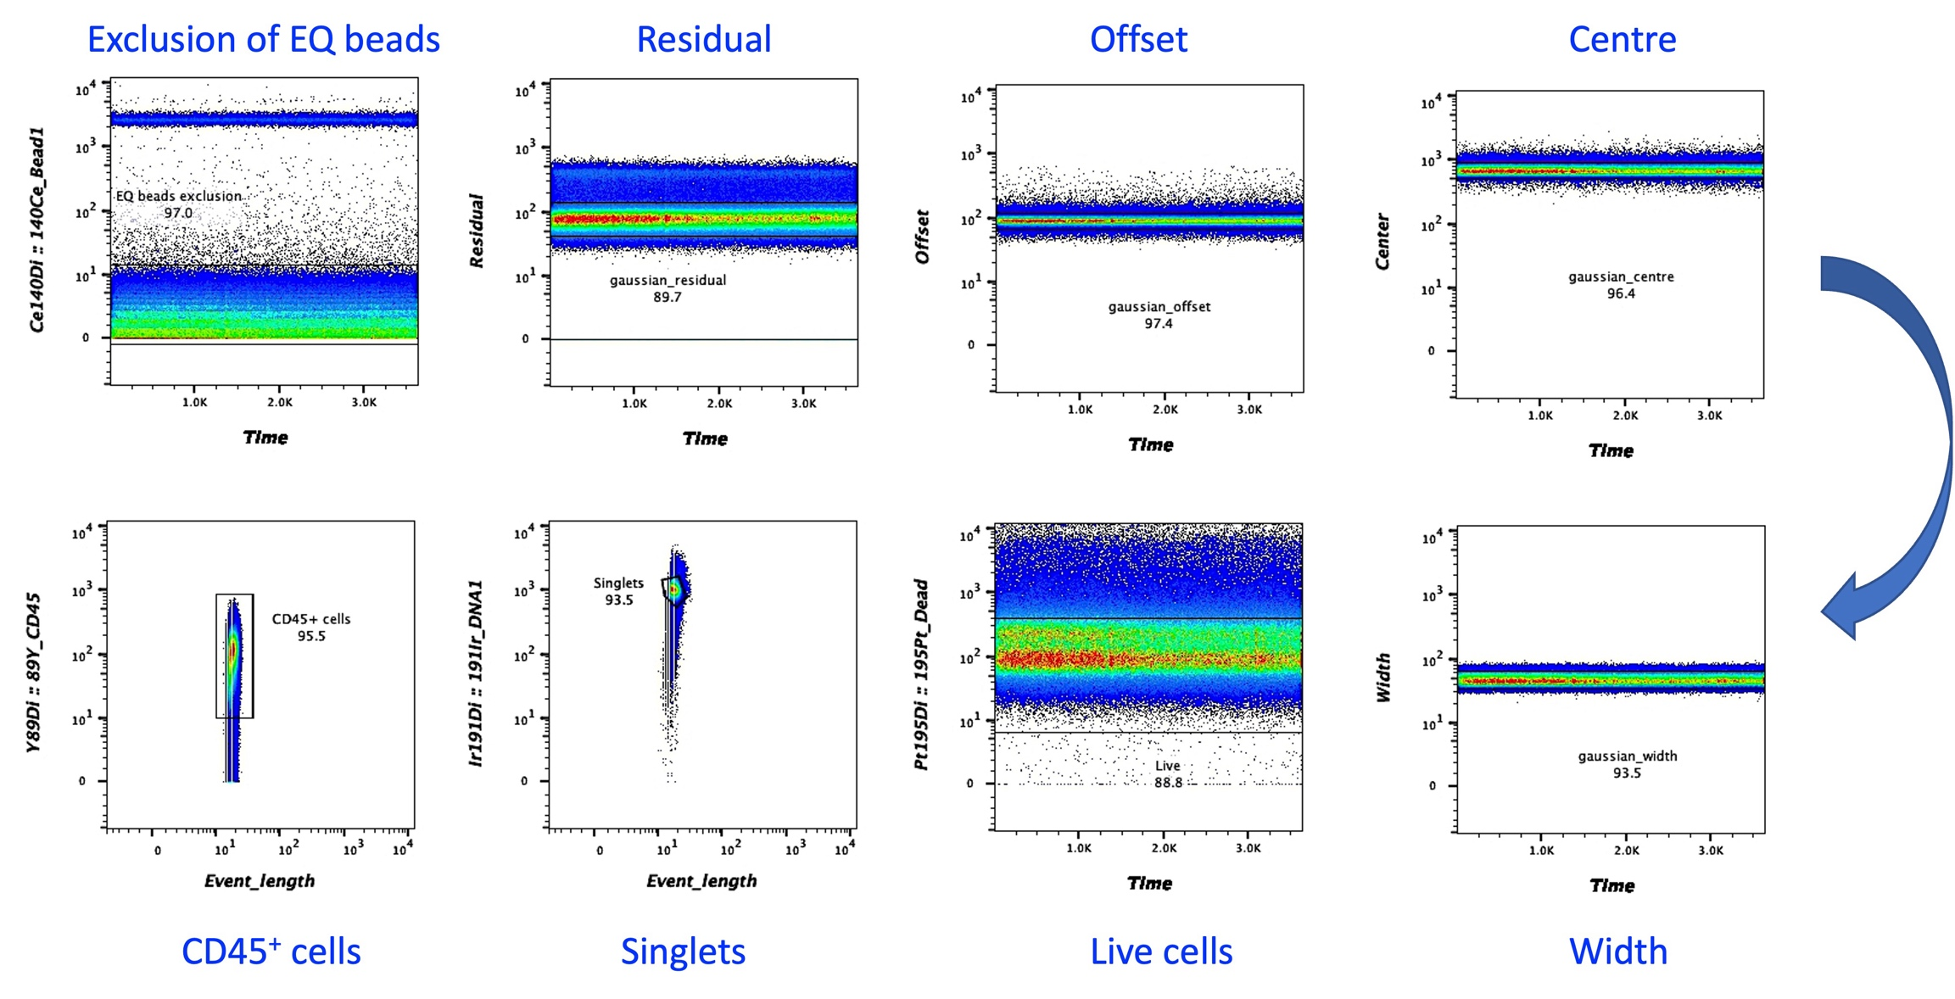
Supplementary Figure 14. CyTOF preprocessing and quality-control gating strategy.
Representative gating workflow used for preprocessing CyTOF data prior to debarcoding, compensation and downstream analyses. Gating was done using FlowJo™ software (v10). EQ calibration beads were excluded using the 140Ce channel. Events were subsequently filtered using Gaussian-derived parameters (residual, offset, centre and width) to remove acquisition artefacts and retain high-quality events. Live cells were identified by exclusion of 195Pt-positive dead cells, singlets were selected using the 191Ir DNA intercalator channel, and CD45⁺ cells were gated for further analysis. Percentages indicate the proportion of events retained at each gating step in the representative sample shown.

References

1 Nassuuna, J. et al. Helminth driven gut inflammation and microbial translocation associate with altered vaccine responses in rural Uganda. npj Vaccines 10, 56 (2025). https://doi.org/10.1038/s41541-025-01116-x
2 Natukunda, A. et al. Schistosome and malaria exposure and urban-rural differences in vaccine responses in Uganda: a causal mediation analysis using data from three linked randomised controlled trials. The Lancet Global Health 12, e1860-e1870 (2024). https://doi.org/10.1016/S2214-109X(24)00340-1
3 Nkurunungi, G. et al. The effect of intensive praziquantel administration on vaccine-specific responses among schoolchildren in Ugandan schistosomiasis-endemic islands (POPVAC A): an open-label, randomised controlled trial. The Lancet Global Health 12, e1826-e1837 (2024). https://doi.org/10.1016/S2214-109X(24)00280-8
4 Zirimenya, L. et al. The effect of intermittent preventive treatment for malaria with dihydroartemisinin–piperaquine on vaccine-specific responses among schoolchildren in rural Uganda (POPVAC B): a double-blind, randomised controlled trial. The Lancet Global Health 12, e1838-e1848 (2024). https://doi.org/https://doi.org/10.1016/S2214-109X(24)00281-X
5 Nassuuna, J. et al. The effect of BCG revaccination on the response to unrelated vaccines in urban Ugandan adolescents (POPVAC C): an open-label, randomised controlled trial. The Lancet Global Health 12, e1849-e1859 (2024). https://doi.org/10.1016/S2214-109X(24)00282-1

