Additional file 1
Dynamic Associations of a Multidimensional Healthy Lifestyle Score with the Incidence and Progression of Metabolic Dysfunction-associated Steatotic Liver Disease: Evidence from the UK Biobank
Short Title: Multidimensional Healthy Lifestyle and MASLD Progression

Table of Contents
Supplementary Tables 3
Table S1. The STROBE checklist 3
Table S2. Multi-dimensional evaluation criteria for healthy lifestyle scores 5
Table S3. Results of sensitivity analyses 7

Supplementary Figures 10
Figure S1. The selection flowchart of the UK Biobank participants included and excluded in the study 10
Figure S2. Directed Acyclic Graph for the association between healthy lifestyle and outcome 11
Figure S3. Transitions from baseline to MASLD, deterioration and death from liver disease 12

Supplementary Tables

Table S1. The STROBE checklist
 | Item No | Recommendation | Page  No
Title and abstract | 1 | (a) Indicate the study’s design with a commonly used term in the title or the abstract | 1
Title and abstract | 1 | (b) Provide in the abstract an informative and balanced summary of what was done and what was found | 2
Introduction
Background/rationale | 2 | Explain the scientific background and rationale for the investigation being reported | 3
Objectives | 3 | State specific objectives, including any prespecified hypotheses | 3
Methods
Study design | 4 | Present key elements of study design early in the paper | 3-4
Setting | 5 | Describe the setting, locations, and relevant dates, including periods of recruitment, exposure, follow-up, and data collection | 3
Participants | 6 | (a) Give the eligibility criteria, and the sources and methods of selection of participants. Describe methods of follow-up | 3-4
Participants | 6 | (b) For matched studies, give matching criteria and number of exposed and unexposed | NA
Variables | 7 | Clearly define all outcomes, exposures, predictors, potential confounders, and effect modifiers. Give diagnostic criteria, if applicable | 4-5
Data sources/ measurement | 8* | For each variable of interest, give sources of data and details of methods of assessment (measurement). Describe comparability of assessment methods if there is more than one group | 4-5
Bias | 9 | Describe any efforts to address potential sources of bias | 5
Study size | 10 | Explain how the study size was arrived at | 3-4
Quantitative variables | 11 | Explain how quantitative variables were handled in the analyses. If applicable, describe which groupings were chosen and why | 5
Statistical methods | 12 | (a) Describe all statistical methods, including those used to control for confounding | 5-6
Statistical methods | 12 | (b) Describe any methods used to examine subgroups and interactions | 6
Statistical methods | 12 | (c) Explain how missing data were addressed | 6
Statistical methods | 12 | (d) If applicable, explain how loss to follow-up was addressed | 3
Statistical methods | 12 | (e) Describe any sensitivity analyses | 6
Results
Participants | 13* | (a) Report numbers of individuals at each stage of study—eg numbers potentially eligible, examined for eligibility, confirmed eligible, included in the study, completing follow-up, and analysed | 3-4
Participants | 13* | (b) Give reasons for non-participation at each stage | 3-4
Participants | 13* | (c) Consider use of a flow diagram | 4
Descriptive data | 14* | (a) Give characteristics of study participants (eg demographic, clinical, social) and information on exposures and potential confounders | 7
Descriptive data | 14* | (b) Indicate number of participants with missing data for each variable of interest | 4-5
Descriptive data | 14* | (c) Summarise follow-up time (eg, average and total amount) | 7
Outcome data | 15* | Report numbers of outcome events or summary measures over time | 7
Main results | 16 | (a) Give unadjusted estimates and, if applicable, confounder-adjusted estimates and their precision (eg, 95% confidence interval). Make clear which confounders were adjusted for and why they were included | 7-8
Main results | 16 | (b) Report category boundaries when continuous variables were categorized | NA
Main results | 16 | (c) If relevant, consider translating estimates of relative risk into absolute risk for a meaningful time period | NA
Other analyses | 17 | Report other analyses done—eg analyses of subgroups and interactions, and sensitivity analyses | 8
Discussion
Key results | 18 | Summarise key results with reference to study objectives | 8-9
Limitations | 19 | Discuss limitations of the study, taking into account sources of potential bias or imprecision. Discuss both direction and magnitude of any potential bias | 10
Interpretation | 20 | Give a cautious overall interpretation of results considering objectives, limitations, multiplicity of analyses, results from similar studies, and other relevant evidence | 8-10
Generalisability | 21 | Discuss the generalisability (external validity) of the study results | 10
Other information
Funding | 22 | Give the source of funding and the role of the funders for the present study and, if applicable, for the original study on which the present article is based | 11

Table S2. Multi-dimensional evaluation criteria for healthy lifestyle scores
Lifestyle factors | Definition of method of measurement | Healthy  behavior (1 point) | Unhealthy behavior (0 point)
Smoking status | Self-reported current/past smoking status, categorized as never, former, or current. | No history of tobacco use. | History of current or former tobacco use.
Alcohol consumption | The study participants were asked to report their drinking frequency and the quantity of various alcoholic beverages they consumed in a week or month, including red wine, champagne plus white wine, beer plus cider, spirits, fortified wine, and other alcoholic drinks. Based on the reported averages, their daily alcohol intake in units was calculated using standard alcohol unit references. | Healthy drinking as consumption of <1 standard drinks/day for women or <2 standard drinks/day for men. | Unhealthy drinking as consumption of ≥1 standard drinks/day for women or ≥2 standard drinks/day for men or no consumption for both.
Diet | Diet information was collected using the Oxford WebQ, a web-based 24-hour recall questionnaire. A healthy diet was defined as having an adequate intake from at least five out of ten food groups (fruits, vegetables, whole grains, fish, dairy, vegetable oils, refined grains, processed meats, unprocessed meats, and sugar-sweetened beverages), as recommended by the American Heart Association. | Diet score ≥5. | Diet score <5.
Physical activity | Physical activity levels were assessed using the self-reported International Physical Activity Questionnaire (IPAQ), categorized as low, moderate, or high. | Moderate or high physical activity. | Low physical activity.
Body mass index | BMI was calculated as weight in kilograms divided by the square of height in meters, with both measurements obtained during the initial assessment center visit. Categories were defined according to the World Health Organization classification. | Keep a BMI within 18.5 - 24.9 kg/m². | Have a BMI outside the range of 18.5 - 24.9 kg/m².
Sleep duration | Total sleep duration was recorded by asking “About how many hours sleep do you get in every 24 hours? (Please include naps)”. | Sleep duration of 7 - 8 h/day. | Sleep duration <7 or Sleep duration >8.
Sedentary behavior | Participants were asked in a typical day how many hours they spent watching television, using computer and driving. This information was used as an indicator of sedentary behaviors as television watching, time spent using computers and driving are three of the most widespread leisure-time sedentary behaviors in adults. | Sedentary time ≤6 h/day. | Sedentary time >6 h/day.
Social contact | Social isolation was assessed using three questionnaire items: (1) frequency of friends/family visits, (2) leisure/social activities, and (3) number in household. Each item was scored as 0 or 1, yielding a total social isolation score ranging from 0 to 3. Loneliness was evaluated using two questions: (1) felt lonely and (2) able to confide. Responses were scored 0 or 1, resulting in a loneliness score from 0 to 2. | Social isolation score ≥2 or loneliness score = 2. | Social isolation score <2 and loneliness score <2.
Abbreviations: BMI, Body mass index

Table S3. Results of sensitivity analyses
 | Transfer | N | Model 1 |  | Model 2 |  | Model 3
 | Transfer | N | HR(95%CI) |  | HR(95%CI) |  | HR(95%CI)
Sensitivity Analysis 1 | All causes of death
Sensitivity Analysis 1 | Baseline → MASLD | 2,902 | 0.69 (0.68, 0.71) | 0.7 (0.69, 0.72) |  | 0.72 (0.70, 0.74)
Sensitivity Analysis 1 | Baseline → Death | 16,970 | 0.82 (0.81, 0.83) | 0.83 (0.82, 0.84) |  | 0.85 (0.84, 0.86)
Sensitivity Analysis 1 | MASLD → Deterioration | 240 | 0.9 (0.82, 0.99) | 0.9 (0.82, 0.99) |  | 0.92 (0.84, 1.01)
Sensitivity Analysis 1 | MASLD → Death | 327 | 0.83 (0.77, 0.9) | 0.83 (0.77, 0.91) |  | 0.85 (0.79, 0.93)
Sensitivity Analysis 1 | Deterioration → Death | 81 | 1.07 (0.89, 1.28) | 1.07 (0.89, 1.27) |  | 1.08 (0.9, 1.29)
Sensitivity Analysis 1 | Death from liver disease
Sensitivity Analysis 1 | Baseline → MASLD | 2,902 | 0.69 (0.67, 0.71) | 0.71 (0.69, 0.73) |  | 0.73 (0.71, 0.75)
Sensitivity Analysis 1 | Baseline → Death | 208 | 0.58 (0.53, 0.64) | 0.60 (0.54, 0.66) |  | 0.62 (0.56, 0.68)
Sensitivity Analysis 1 | MASLD → Deterioration | 240 | 0.93 (0.84, 1.02) | 0.94 (0.86, 1.03) |  | 0.97 (0.88, 1.06)
Sensitivity Analysis 1 | MASLD → Death | 15 | 0.78 (0.54, 1.13) | 0.79 (0.55, 1.14) |  | 0.81 (0.56, 1.17)
Sensitivity Analysis 1 | Deterioration → Death | 20 | 1.14 (0.81, 1.61) | 1.13 (0.80, 1.60) |  | 1.14 (0.80, 1.61)
Sensitivity Analysis 2 | All causes of death
Sensitivity Analysis 2 | Baseline → MASLD | 3,243 | 0.7 (0.68, 0.72) | 0.71 (0.69, 0.73) |  | 0.73 (0.71, 0.74)
Sensitivity Analysis 2 | Baseline → Death | 19,988 | 0.81 (0.81, 0.82) | 0.83 (0.82, 0.83) |  | 0.84 (0.84, 0.85)
Sensitivity Analysis 2 | MASLD → Deterioration | 147 | 0.88 (0.78, 0.998) | 0.89 (0.79, 1.002) |  | 0.91 (0.80, 1.02)
Sensitivity Analysis 2 | MASLD → Death | 385 | 0.84 (0.78, 0.91) | 0.84 (0.78, 0.91) |  | 0.86 (0.80, 0.93)
Sensitivity Analysis 2 | Deterioration → Death | 58 | 1.02 (0.84, 1.25) | 1.02 (0.84, 1.25) |  | 1.04 (0.85, 1.26)
Sensitivity Analysis 2 | Death from liver disease
Sensitivity Analysis 2 | Baseline → MASLD | 3,243 | 0.70 (0.68, 0.71) | 0.72 (0.70, 0.74) |  | 0.74 (0.72, 0.76)
Sensitivity Analysis 2 | Baseline → Death | 244 | 0.60 (0.55, 0.65) | 0.62 (0.56, 0.67) |  | 0.64 (0.58, 0.69)
Sensitivity Analysis 2 | MASLD → Deterioration | 147 | 0.91 (0.81, 1.03) | 0.93 (0.82, 1.05) |  | 0.95 (0.84, 1.07)
Sensitivity Analysis 2 | MASLD → Death | 19 | 0.77 (0.55, 1.06) | 0.77 (0.56, 1.07) |  | 0.79 (0.57, 1.10)
Sensitivity Analysis 2 | Deterioration → Death | 15 | 1.17 (0.81, 1.69) | 1.16 (0.81, 1.68) |  | 1.18 (0.81, 1.70)
Sensitivity Analysis 3 | All causes of death
Sensitivity Analysis 3 | Baseline → MASLD | 3,231 | 0.7 (0.68, 0.72) | 0.71 (0.69, 0.72) |  | 0.72 (0.71, 0.74)
Sensitivity Analysis 3 | Baseline → Death | 19,040 | 0.82 (0.81, 0.83) | 0.83 (0.82, 0.84) |  | 0.85 (0.84, 0.86)
Sensitivity Analysis 3 | MASLD → Deterioration | 260 | 0.87 (0.79, 0.96) | 0.88 (0.8, 0.96) |  | 0.90 (0.82, 0.99)
Sensitivity Analysis 3 | MASLD → Death | 363 | 0.84 (0.77, 0.90) | 0.84 (0.78, 0.91) |  | 0.86 (0.8, 0.93)
Sensitivity Analysis 3 | Deterioration → Death | 87 | 1.11 (0.93, 1.32) | 1.12 (0.94, 1.34) |  | 1.14 (0.95, 1.36)
Sensitivity Analysis 3 | Death from liver disease
Sensitivity Analysis 3 | Baseline → MASLD | 3,231 | 0.70 (0.68, 0.71) | 0.72 (0.70, 0.73) |  | 0.74 (0.72, 0.76)
Sensitivity Analysis 3 | Baseline → Death | 216 | 0.60 (0.54, 0.66) | 0.62 (0.56, 0.68) |  | 0.63 (0.58, 0.70)
Sensitivity Analysis 3 | MASLD → Deterioration | 260 | 0.90 (0.82, 0.99) | 0.92 (0.84, 1.01) |  | 0.95 (0.87, 1.04)
Sensitivity Analysis 3 | MASLD → Death | 17 | 0.72 (0.50, 1.03) | 0.74 (0.52, 1.06) |  | 0.77 (0.54, 1.09)
Sensitivity Analysis 3 | Deterioration → Death | 21 | 1.31 (0.94, 1.82) | 1.31 (0.94, 1.83) |  | 1.34 (0.96, 1.87)
Sensitivity Analysis 4 | All causes of death
Sensitivity Analysis 4 | Baseline → MASLD | 3,371 | 0.70 (0.68, 0.71) | 0.71 (0.69, 0.72) |  | 0.72 (0.71, 0.74)
Sensitivity Analysis 4 | Baseline → Death | 19,997 | 0.81 (0.81, 0.82) | 0.83 (0.82, 0.83) |  | 0.84 (0.84, 0.85)
Sensitivity Analysis 4 | MASLD → Deterioration | 272 | 0.89 (0.81, 0.97) | 0.89 (0.81, 0.97) |  | 0.91 (0.83, 0.99)
Sensitivity Analysis 4 | MASLD → Death | 386 | 0.84 (0.78, 0.91) | 0.84 (0.78, 0.91) |  | 0.86 (0.80, 0.93)
Sensitivity Analysis 4 | Deterioration → Death | 92 | 1.07 (0.91, 1.27) | 1.08 (0.91, 1.27) |  | 1.09 (0.92, 1.28)
Sensitivity Analysis 4 | Death from liver disease
Sensitivity Analysis 4 | Baseline → MASLD | 3,371 | 0.69 (0.68, 0.71) | 0.72 (0.7, 0.73) |  | 0.74 (0.72, 0.75)
Sensitivity Analysis 4 | Baseline → Death | 244 | 0.60 (0.55, 0.66) | 0.62 (0.56, 0.67) |  | 0.64 (0.58, 0.70)
Sensitivity Analysis 4 | MASLD → Deterioration | 272 | 0.91 (0.84, 0.999) | 0.93 (0.85, 1.01) |  | 0.95 (0.87, 1.04)
Sensitivity Analysis 4 | MASLD → Death | 19 | 0.77 (0.55, 1.07) | 0.77 (0.56, 1.07) |  | 0.79 (0.57, 1.10)
Sensitivity Analysis 4 | Deterioration → Death | 22 | 1.25 (0.91, 1.72) | 1.25 (0.91, 1.72) |  | 1.26 (0.92, 1.75)
The sensitivity analyses included: (1) a complete-case analysis without imputation (2) an analysis excluding participants who transitioned between different health states on the same day (3) an analysis that removed individuals developing study outcomes within the first two years of follow-up (4) For participants who transitioned between different states on the same date, we adjusted the entry date calculation by subtracting 0.5 years from the subsequent state's entry date to establish the theoretical entry date for the preceding state.
Model 1 adjusted for age and gender; Model 2 further adjusted for ethnicity and hypertension; Model 3 additionally adjusted for educational status, household income, place of residence, noise exposure, and TDI.
Abbreviations: CI, confidence interval; HR, hazard ratio; MASLD, metabolic dysfunction-associated steatotic liver disease.

Supplementary Figures

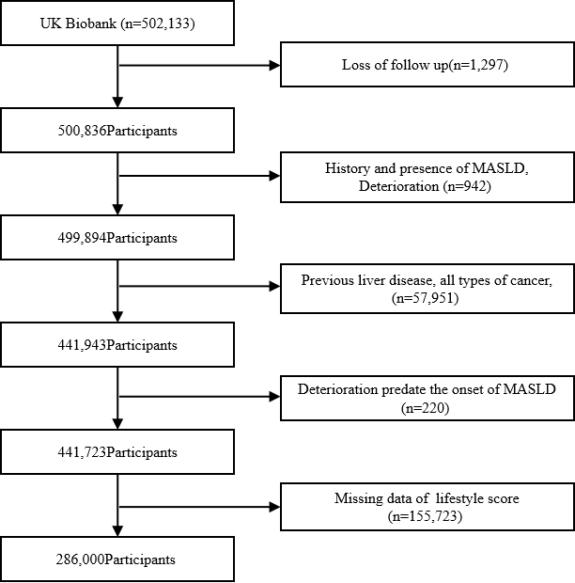

Figure S1. The selection flowchart of the UK Biobank participants included and excluded in the study.

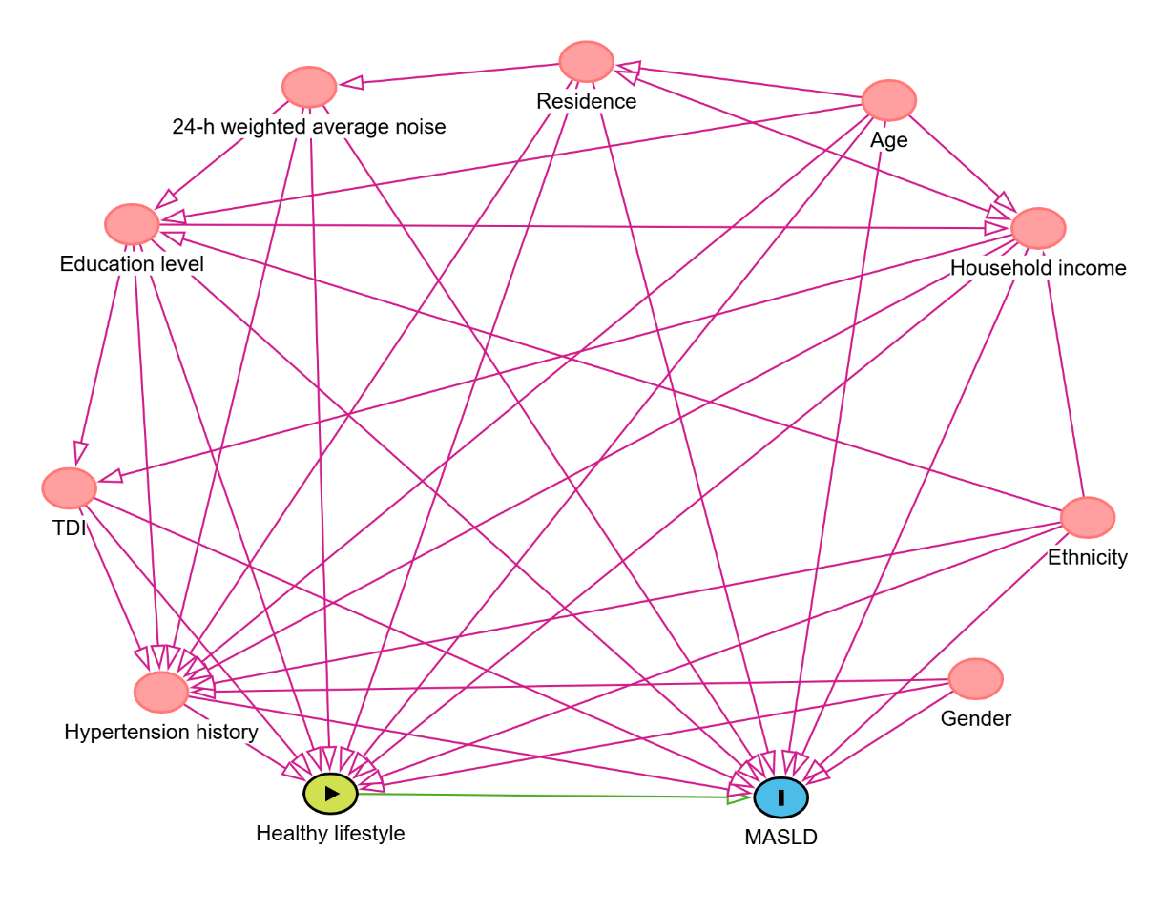

Figure S2. Directed Acyclic Graph for the association between healthy lifestyle and outcome
Variables showed as pink ovals are ancestors of exposure and outcome. Pink lines are biasing paths and the green line between the exposure and outcome is the causal path of interest.
Abbreviation: TDI, Townsend Deprivation Index; MASLD, metabolic dysfunction-associated steatotic liver disease.

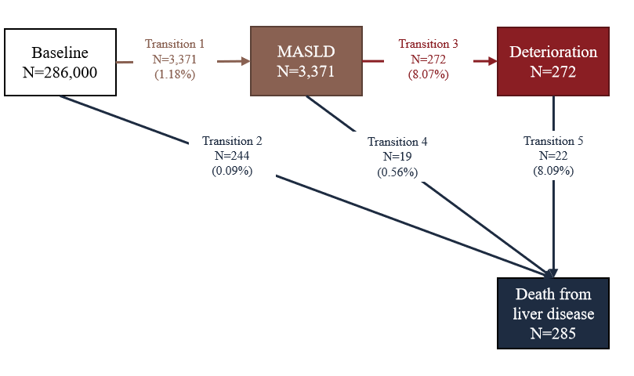

Figure S3. Transitions from baseline to MASLD, deterioration and death from liver disease
MASLD deterioration included hepatic fibrosis, hepatocellular carcinoma, biliary cirrhosis, cirrhosis of liver, other and unspecified. State-specific number of events was reported in boxes, and the transition-specific number of events and percentages (within brackets) were reported on arrows.
Abbreviation: MASLD, metabolic dysfunction-associated steatotic liver disease.

