Supplementary Material

Supplementary Figures
Supplementary Figure S1. Sequencing coverage quality across fermentation. (a) Normalized gene-body coverage profiles for the fifteen libraries, coloured by fermentation time; coverage peaks near the gene midpoint in fourteen libraries, whereas library 16hb (dashed) shows a pronounced 3′ shift. (b) Percentage of the 6,571 annotated genes covered over at least 90% of their length, plotted against fermentation time; points are individual libraries and the line shows the mean ± SD of the three biological replicates per time point.
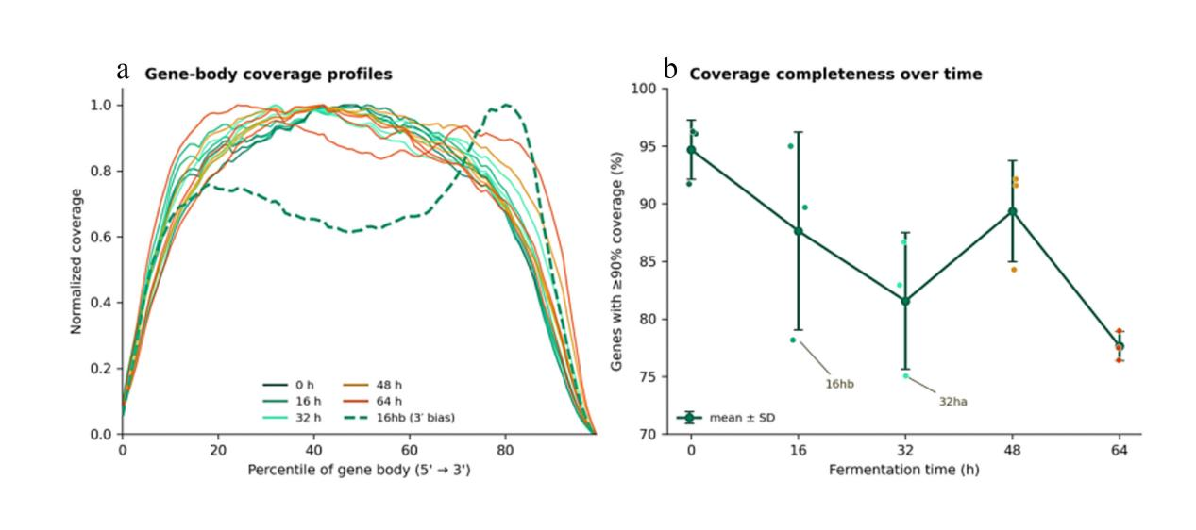
Supplementary Figure S2. Differentially expressed genes across all ten pairwise comparisons of the five fermentation stages of apricot residue by W. anomalus LY13. Stacked bars give the number of upregulated (red) and downregulated (green) genes for each comparison (|log2FC| ≥ 1, Benjamini–Hochberg-adjusted p < 0.05). Comparisons against the 0 h inoculum return the largest gene sets; comparisons among the 32, 48, and 64 h stages return the fewest.
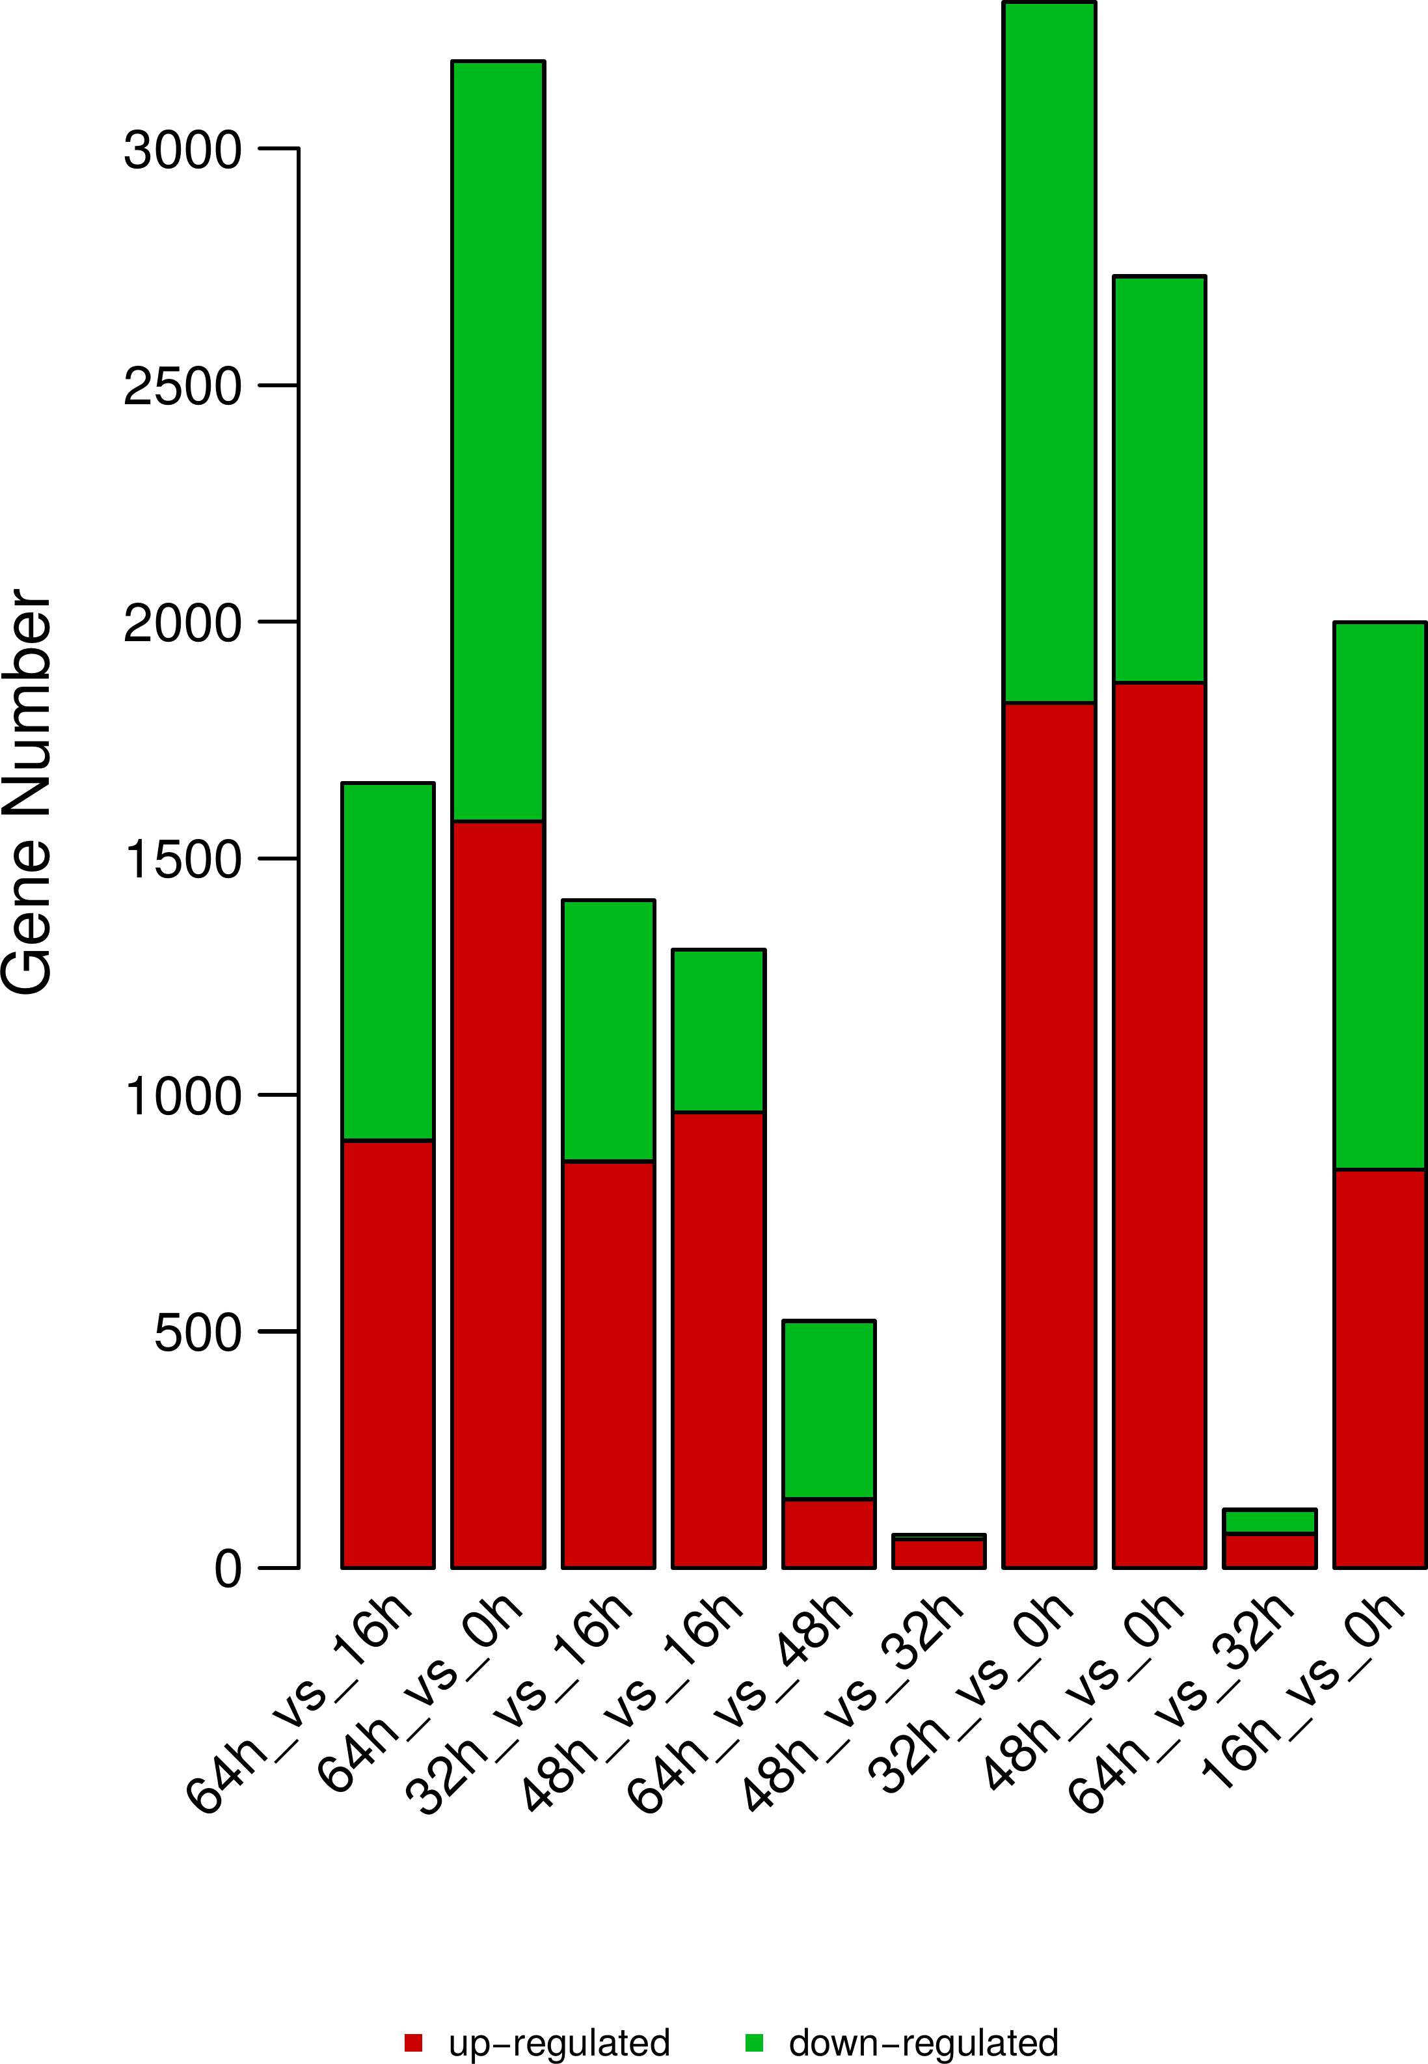
Supplementary Figure S3. Co-expression modules of the 4,799 genes differentially expressed in at least one pairwise comparison of the five fermentation stages. Each panel shows one module; grey lines are individual genes and the bold line is the module mean, plotted as gene-centred log2(TPM + 1) against fermentation time. Modules whose mean trajectory peaks at 48 h are drawn in red (modules 1, 2, 3, 4, 12, 15, 16, 18, 21, 22, and 23; 2,779 genes in total) and all others in blue. The dotted vertical line marks 48 h, the stage of maximum volatile accumulation. In every 48 h-peaking module, the mean increment from 32 to 48 h is smaller than that from 16 to 32 h. Twenty-six of the twenty-seven modules are shown; module 17, to which the clustering assigned at most a handful of genes, was not among the files supplied and is omitted.
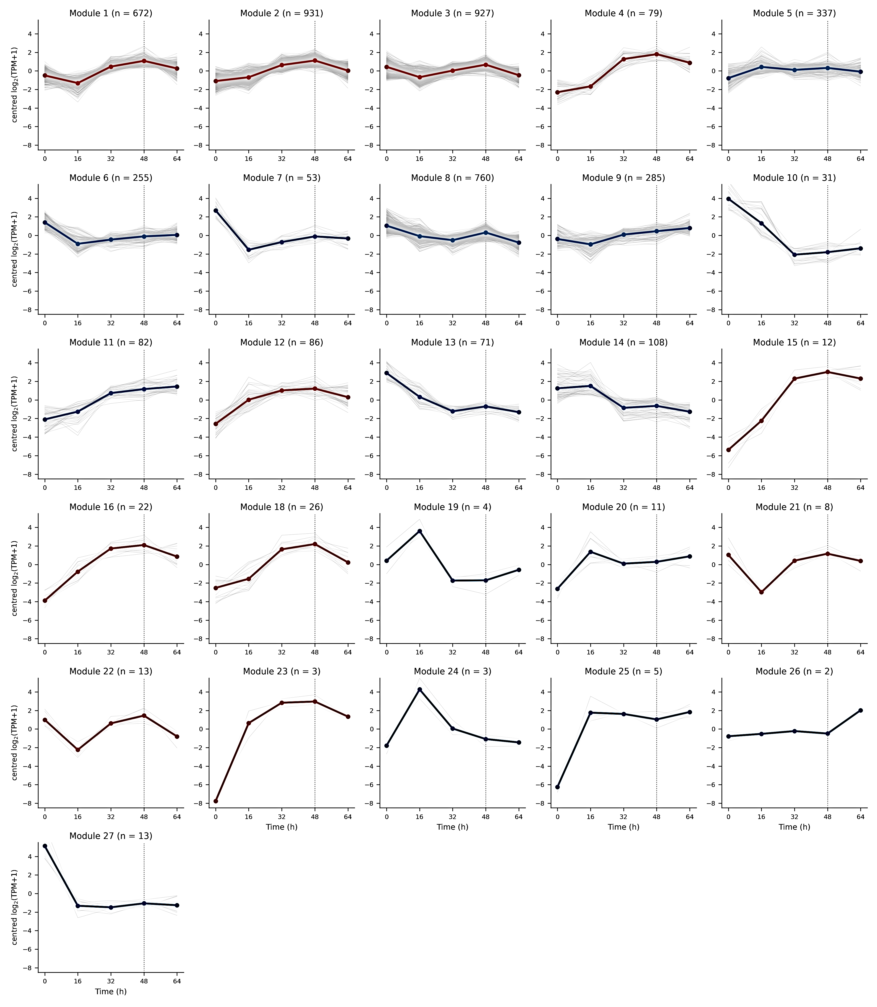

Supplementary Figure S4. Direction-resolved GO enrichment at each successive fermentation transition. For each of the four adjacent-stage comparisons, the four most significant terms enriched among upregulated genes (red) and among downregulated genes (blue) are shown. The horizontal position gives −log10 of the Benjamini–Hochberg-adjusted p-value, and the dotted line marks Q = 0.05; point area scales with the number of differentially expressed genes annotated to the term. The 32 → 48 h panel contains no downregulated terms because none reached significance among the ten downregulated genes.
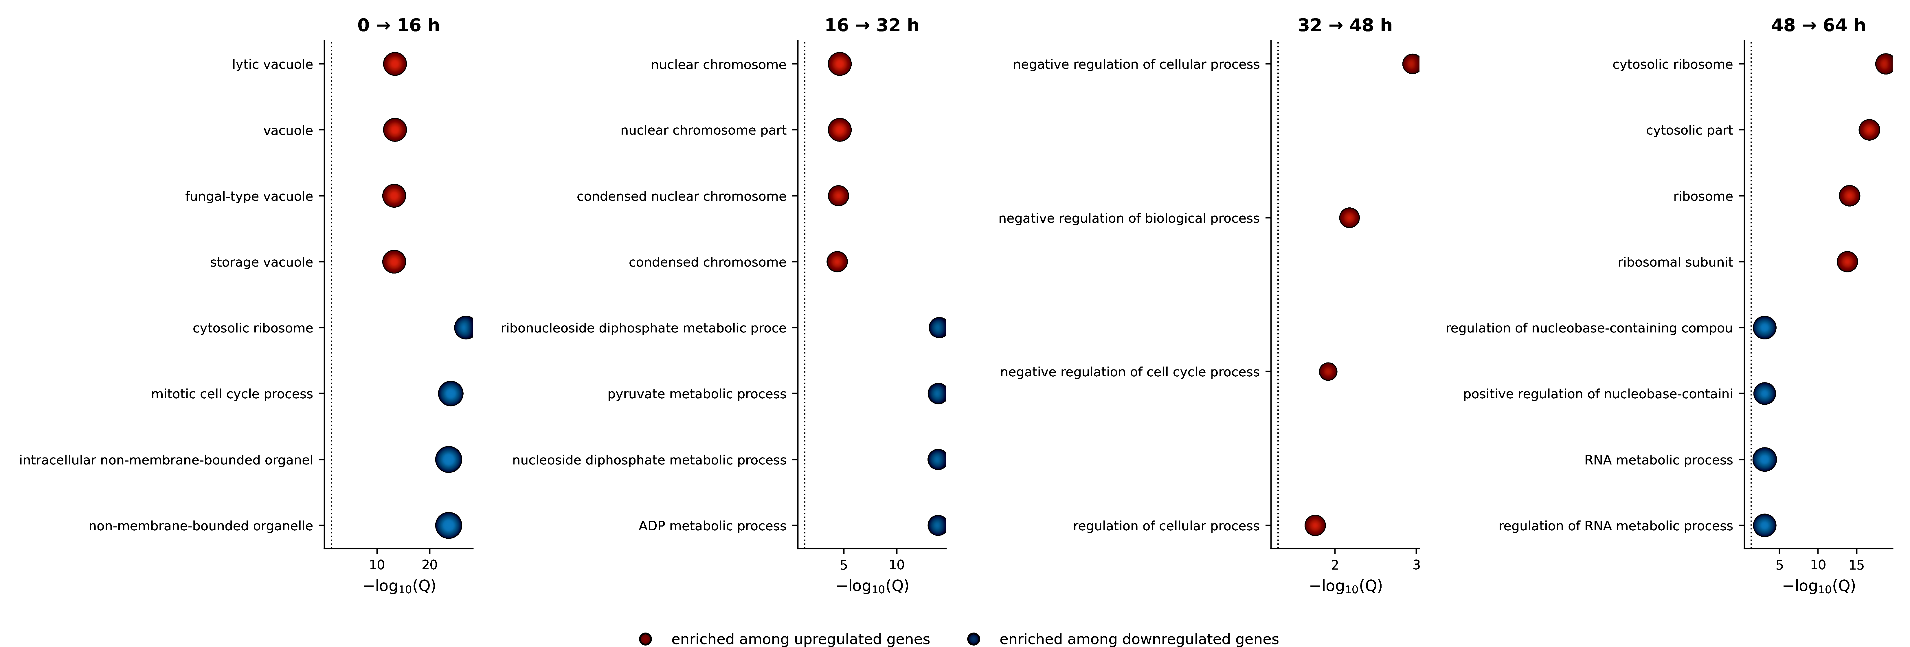

Supplementary Tables
Supplementary Table S1. Sequencing quality metrics for the fifteen RNA-Seq libraries of W. anomalus LY13 sampled at 0, 16, 32, 48, and 64 h of apricot residue fermentation (three biological replicates per time point). Raw metrics precede quality control; clean metrics are those of the trimmed reads used for all downstream analyses. Raw read length is the nominal 150 bp of the PE150 run; mean clean read length, reads retained, and bases retained are derived from the read and base counts in the same row. Q20, Q30, and GC content refer to the clean reads. Read retention exceeds 97% for every library, and the mean clean read length ranges from 144.6 bp (16hb) to 147.9 bp (0hc).
Sample | Raw reads | Raw bases | Raw read len. (bp) | Clean reads | Clean bases | Mean clean read len. (bp) | Reads ret. (%) | Bases ret. (%) | Q20 (%) | Q30 (%) | GC (%)
0ha | 51415826 | 7712373900 | 150.0 | 50210578 | 7343828559 | 146.3 | 97.66 | 95.22 | 99.57 | 98.47 | 37.52
0hb | 54384756 | 8157713400 | 150.0 | 53073986 | 7772420034 | 146.4 | 97.59 | 95.28 | 99.55 | 98.41 | 37.45
0hc | 52450444 | 7867566600 | 150.0 | 51077018 | 7553476525 | 147.9 | 97.38 | 96.01 | 99.50 | 98.20 | 37.69
16ha | 48534556 | 7280183400 | 150.0 | 47301160 | 6940991356 | 146.7 | 97.46 | 95.34 | 99.53 | 98.33 | 38.46
16hb | 47282518 | 7092377700 | 150.0 | 46177708 | 6676686857 | 144.6 | 97.66 | 94.14 | 99.54 | 98.36 | 39.59
16hc | 56054126 | 8408118900 | 150.0 | 54518314 | 7972632072 | 146.2 | 97.26 | 94.82 | 99.42 | 97.91 | 38.16
32ha | 53886518 | 8082977700 | 150.0 | 52488408 | 7689331510 | 146.5 | 97.41 | 95.13 | 99.38 | 97.81 | 41.93
32hb | 56923220 | 8538483000 | 150.0 | 55573816 | 8140715514 | 146.5 | 97.63 | 95.34 | 99.56 | 98.43 | 40.25
32hc | 47068440 | 7060266000 | 150.0 | 45745326 | 6729774558 | 147.1 | 97.19 | 95.32 | 99.47 | 98.12 | 38.80
48ha | 51370452 | 7705567800 | 150.0 | 50138690 | 7308932839 | 145.8 | 97.60 | 94.85 | 99.53 | 98.32 | 41.37
48hb | 49194736 | 7379210400 | 150.0 | 47954000 | 7038426822 | 146.8 | 97.48 | 95.38 | 99.50 | 98.21 | 39.69
48hc | 48912702 | 7336905300 | 150.0 | 47688528 | 6938787555 | 145.5 | 97.50 | 94.57 | 99.46 | 98.09 | 40.35
64ha | 44614188 | 6692128200 | 150.0 | 43450806 | 6344719463 | 146.0 | 97.39 | 94.81 | 99.52 | 98.27 | 40.91
64hb | 47612490 | 7141873500 | 150.0 | 46363866 | 6797474839 | 146.6 | 97.38 | 95.18 | 99.54 | 98.38 | 38.68
64hc | 45738118 | 6860717700 | 150.0 | 44581648 | 6507992417 | 146.0 | 97.47 | 94.86 | 99.51 | 98.27 | 40.56
Supplementary Table S2. Culture purity assessment of the RNA-Seq libraries. Ten thousand clean reads were randomly sampled from a representative library and compared against the NCBI NT database by BLASTn, retaining hits with E ≤ 1e-10, sequence identity > 90%, and query coverage > 80%. Species are listed in descending order of assigned read number. Pichia anomala is a taxonomic synonym of Wickerhamomyces anomalus; together, the two names account for 9,031 of the 10,000 sampled reads.
Species | Reads assigned
Wickerhamomyces anomalus | 8,911
Pichia anomala | 120
Wickerhamomyces ciferrii | 88
Hyphopichia burtonii | 27
Candida orthopsilosis | 19
Cyberlindnera bimundalis | 17
Hyphopichia pseudoburtonii | 15
Wickerhamomyces sydowiorum | 11
Debaryomyces hansenii | 7
Protomyces macrosporus | 4
Saccharomyces cerevisiae | 4
Wickerhamomyces strasburgensis | 4
Debaryomyces fabryi | 3
Lachancea kluyveri | 3
Supplementary Table S3. Co-expression module assignment and expression peak for the pathway genes reported in Tables 1–3 and for the seven KOG1208 short-chain alcohol dehydrogenase candidates. "Module" refers to the clusters shown in Supplementary Figure S3; "not DE" indicates a gene not differentially expressed in any pairwise comparison and therefore absent from the clustering. "Monotonic rise to 48 h" indicates that the mean TPM increased at every successive stage from 0 to 48 h, the trajectory followed by 2-phenylethanol.
Pathway | Gene | Module | Peak stage | Monotonic rise to 48 h
Acetoin / 2,3-butanediol (Table 1) | WICANDRAFT_63205 | 8 | 0 h | no
Acetoin / 2,3-butanediol (Table 1) | WICANDRAFT_34501 | 8 | 0 h | no
Acetoin / 2,3-butanediol (Table 1) | WICANDRAFT_91352 | 9 | 64 h | no
Acetoin / 2,3-butanediol (Table 1) | WICANDRAFT_34103 | 5 | 16 h | no
Acetoin / 2,3-butanediol (Table 1) | WICANDRAFT_92107 | not DE | 48 h | no
Acetoin / 2,3-butanediol (Table 1) | WICANDRAFT_27621 | 8 | 0 h | no
Acetoin / 2,3-butanediol (Table 1) | WICANDRAFT_53638 | 2 | 48 h | yes
Acetoin / 2,3-butanediol (Table 1) | WICANDRAFT_49048 | 9 | 64 h | no
Phenylacetaldehyde (Table 2) | WICANDRAFT_25789 | 11 | 48 h | yes
Phenylacetaldehyde (Table 2) | WICANDRAFT_60097 | 2 | 48 h | no
Phenylacetaldehyde (Table 2) | WICANDRAFT_84167 | 3 | 48 h | no
Phenylacetaldehyde (Table 2) | WICANDRAFT_25906 | 2 | 48 h | no
Phenylacetaldehyde (Table 2) | WICANDRAFT_46076 | 10 | 0 h | no
Isoamyl alcohol (Table 3) | WICANDRAFT_46076 | 10 | 0 h | no
Isoamyl alcohol (Table 3) | WICANDRAFT_62195 | not DE | 16 h | no
Isoamyl alcohol (Table 3) | WICANDRAFT_62190 | 2 | 48 h | yes
Isoamyl alcohol (Table 3) | WICANDRAFT_36130 | 23 | 32 h | no
Isoamyl alcohol (Table 3) | WICANDRAFT_31046 | 20 | 64 h | no
Isoamyl alcohol (Table 3) | WICANDRAFT_70287 | 2 | 48 h | yes
Isoamyl alcohol (Table 3) | WICANDRAFT_52965 | 10 | 0 h | no
Isoamyl alcohol (Table 3) | WICANDRAFT_30689 | 2 | 48 h | yes
Isoamyl alcohol (Table 3) | WICANDRAFT_32539 | 5 | 16 h | no
Isoamyl alcohol (Table 3) | WICANDRAFT_80232 | 27 | 0 h | no
Isoamyl alcohol (Table 3) | WICANDRAFT_100670 | 11 | 64 h | no
Isoamyl alcohol (Table 3) | WICANDRAFT_56320 | 12 | 16 h | no
2-Phenylethanol candidates (KOG1208) | WICANDRAFT_98376 | 5 | 48 h | yes
2-Phenylethanol candidates (KOG1208) | WICANDRAFT_25953 | 9 | 64 h | no
2-Phenylethanol candidates (KOG1208) | WICANDRAFT_25233 | 1 | 48 h | no
2-Phenylethanol candidates (KOG1208) | WICANDRAFT_86376 | 7 | 0 h | no
2-Phenylethanol candidates (KOG1208) | WICANDRAFT_35233 | 2 | 48 h | yes
2-Phenylethanol candidates (KOG1208) | WICANDRAFT_75831 | 5 | 16 h | no
2-Phenylethanol candidates (KOG1208) | WICANDRAFT_48591 | 6 | 0 h | no

Supplementary Table S4. Class-code inventory of the 1,156 novel transcribed regions recovered by StringTie assembly and classified against the reference annotation with GffCompare.
Class code | Description | Transcripts
o | Generic exonic overlap with a reference transcript | 576
u | Unknown, intergenic — no overlap with any reference feature | 342
j | Novel splice junction within a known locus | 202
c | Contained within a reference transcript | 24
i | Entirely within a reference intron | 12
Total |  | 1,156

Supplementary Table S5. Enrichment of the aroma-related and precursor-supply KEGG pathways in each pairwise comparison for which complete enrichment tables were available. Cells give the number of differentially expressed genes annotated to the pathway over the number of differentially expressed genes with any KEGG annotation, followed by the Benjamini–Hochberg-adjusted p-value recomputed from the raw hypergeometric p-values; asterisks mark Q < 0.05. "Not tested" indicates that no differentially expressed gene mapped to the pathway. Among the aroma pathways proper, only valine, leucine and isoleucine degradation (ko00280), the Ehrlich pathway, is significantly enriched, and only relative to the 0 h inoculum. The two precursor-supply pathways (ko00010, ko00620) are shown for comparison. No aroma pathway is testable at 48 h vs 32 h.
Pathway | Description | 16 h vs 0 h | 32 h vs 0 h | 48 h vs 0 h | 64 h vs 0 h | 32 h vs 16 h | 48 h vs 16 h | 64 h vs 48 h | 48 h vs 32 h
ko00360 | Phenylalanine metabolism | 7/653; Q = 1.000 | 16/1028; Q = 0.971 | 14/839; Q = 0.762 | 15/1012; Q = 0.860 | 6/447; Q = 1.000 | 6/404; Q = 0.960 | not tested | not tested
ko00400 | Phe, Tyr and Trp biosynthesis | 9/653; Q = 0.971 | 16/1028; Q = 0.604 | 15/839; Q = 0.322 | 17/1012; Q = 0.505 | 6/447; Q = 0.990 | 5/404; Q = 1.000 | 2/188; Q = 0.942 | not tested
ko00280 | Val, Leu and Ile degradation | 13/653; Q = 0.175 | 21/1028; Q = 0.002 * | 18/839; Q = 0.012 * | 17/1012; Q = 0.336 | 6/447; Q = 0.924 | 6/404; Q = 0.912 | 4/188; Q = 0.847 | not tested
ko00290 | Val, Leu and Ile biosynthesis | 2/653; Q = 1.000 | 7/1028; Q = 0.932 | 5/839; Q = 1.000 | 10/1012; Q = 0.192 | 5/447; Q = 0.565 | 4/404; Q = 0.697 | 1/188; Q = 0.942 | not tested
ko00650 | Butanoate metabolism | 7/653; Q = 1.000 | 12/1028; Q = 0.912 | 13/839; Q = 0.249 | 11/1012; Q = 0.860 | 6/447; Q = 0.835 | 6/404; Q = 0.697 | 4/188; Q = 0.847 | not tested
ko00660 | C5-Branched dibasic acid metab. | not tested | 3/1028; Q = 0.604 | 2/839; Q = 0.951 | 3/1012; Q = 0.682 | 2/447; Q = 0.680 | 1/404; Q = 0.960 | not tested | not tested
ko00010 | Glycolysis / Gluconeogenesis | 22/653; Q = 0.295 | 43/1028; Q < 0.001 * | 40/839; Q < 0.001 * | 35/1012; Q = 0.080 | 29/447; Q < 0.001 * | 27/404; Q < 0.001 * | 10/188; Q = 0.540 | 1/25; Q = 0.471
ko00620 | Pyruvate metabolism | 27/653; Q = 0.049 * | 42/1028; Q < 0.001 * | 35/839; Q = 0.006 * | 34/1012; Q = 0.336 | 20/447; Q = 0.094 | 17/404; Q = 0.245 | 11/188; Q = 0.387 | not tested

Supplementary Table S6. The seventy genes differentially expressed between 32 and 48 h (|log2FC| ≥ 1, Benjamini–Hochberg-adjusted p < 0.05), with co-expression module (Supplementary Figure S3), mean TPM at each stage, log2 fold change and KOG assignment where available. Genes are grouped by direction and ordered by decreasing fold change. An em dash indicates that no KOG assignment exists.
Gene | Direction | Module | TPM 32 h | TPM 48 h | log2FC | KOG assignment
WICANDRAFT_28430 | down | 12 | 12897.8 | 6065.62 | -1.09 | —
WICANDRAFT_84660 | down | 5 | 10.79 | 4.89 | -1.14 | —
WICANDRAFT_78480 | down | 12 | 535.06 | 224.05 | -1.26 | KOG1458-Fructose-1,6-bisphosphatase[G]
WICANDRAFT_81012 | down | 14 | 30.83 | 12.8 | -1.27 | —
WICANDRAFT_80033 | down | 10 | 3277.87 | 1188.79 | -1.46 | KOG2960-Protein involved in thiamine biosynthesis and DNA dama
WICANDRAFT_62037 | down | 14 | 686.87 | 247.74 | -1.47 | —
WICANDRAFT_83430 | down | 5 | 15589.8 | 4474.36 | -1.80 | —
WICANDRAFT_59631 | down | 25 | 1307.5 | 328.32 | -1.99 | —
WICANDRAFT_81165 | down | 10 | 10.73 | 2.69 | -2.00 | KOG1402-Ornithine aminotransferase[E]
WICANDRAFT_69563 | down | 24 | 508.92 | 73.47 | -2.79 | —
WICANDRAFT_29425 | up | 8 | 0.2 | 1.87 | +3.22 | KOG1059-Vesicle coat complex AP-3, delta subunit[U]
WICANDRAFT_98271 | up | 8 | 0.32 | 2.45 | +2.94 | KOG0615-Serine/threonine protein kinase Chk2 and related prote
WICANDRAFT_62025 | up | 8 | 0.18 | 1.28 | +2.83 | —
WICANDRAFT_70669 | up | 2 | 1.64 | 10.81 | +2.72 | KOG2426-Dihydroxyacetone kinase/glycerone kinase[G]
WICANDRAFT_61496 | up | 2 | 0.67 | 4.15 | +2.63 | KOG0254-Predicted transporter (major facilitator superfamily)[
WICANDRAFT_33037 | up | 3 | 3.2 | 18.63 | +2.54 | KOG0254-Predicted transporter (major facilitator superfamily)[
WICANDRAFT_35528 | up | 3 | 2.23 | 12.89 | +2.53 | KOG2179-Nucleotide excision repair complex XPC-HR23B, subunit
WICANDRAFT_80332 | up | 2 | 4.06 | 21.18 | +2.38 | —
WICANDRAFT_78358 | up | 8 | 3.04 | 15.4 | +2.34 | —
WICANDRAFT_14964 | up | 3 | 1.49 | 7.55 | +2.34 | KOG4652-HORMA domain[B]
WICANDRAFT_35547 | up | 2 | 4.08 | 20.35 | +2.32 | KOG0024-Sorbitol dehydrogenase[Q]
WICANDRAFT_98187 | up | 8 | 1.85 | 9.09 | +2.30 | KOG1165-Casein kinase (serine/threonine/tyrosine protein kinas
WICANDRAFT_64419 | up | 3 | 1.82 | 8.74 | +2.26 | —
WICANDRAFT_83650 | up | 8 | 1.16 | 5.24 | +2.18 | KOG1330-Sugar transporter/spinster transmembrane protein[G]
WICANDRAFT_27625 | up | 3 | 3.85 | 17.48 | +2.18 | —
WICANDRAFT_92445 | up | 8 | 1.01 | 4.36 | +2.11 | KOG2038-CAATT-binding transcription factor/60S ribosomal subun
WICANDRAFT_20400 | up | 8 | 1.33 | 5.71 | +2.10 | —
WICANDRAFT_23506 | up | 2 | 1.39 | 5.9 | +2.09 | KOG2093-Translesion DNA polymerase - REV1 deoxycytidyl transfe
WICANDRAFT_57388 | up | 1 | 3.31 | 13.8 | +2.06 | —
WICANDRAFT_39303 | up | 3 | 2.63 | 10.63 | +2.02 | KOG0597-Serine-threonine protein kinase FUSED[R]
WICANDRAFT_82620 | up | 8 | 5.71 | 22.57 | +1.98 | KOG0335-ATP-dependent RNA helicase[A]
WICANDRAFT_64350 | up | 8 | 4.51 | 17.26 | +1.94 | KOG0777-Geranylgeranyl pyrophosphate synthase/Polyprenyl synth
WICANDRAFT_53516 | up | 3 | 3.04 | 11.62 | +1.93 | KOG2267-Eukaryotic-type DNA primase, large subunit[L]
WICANDRAFT_96753 | up | 8 | 1.52 | 5.68 | +1.90 | —
WICANDRAFT_93707 | up | 1 | 13.74 | 50.61 | +1.88 | KOG1677-CCCH-type Zn-finger protein[R]
WICANDRAFT_46402 | up | 1 | 6.76 | 24.68 | +1.87 | KOG0254-Predicted transporter (major facilitator superfamily)[
WICANDRAFT_31541 | up | 3 | 1.61 | 5.49 | +1.77 | KOG2301-Voltage-gated Ca2+ channels, alpha1 subunits[PT]
WICANDRAFT_76254 | up | 1 | 26.01 | 88.88 | +1.77 | KOG0595-Serine/threonine-protein kinase involved in autophagy[
WICANDRAFT_68560 | up | 3 | 1.03 | 3.5 | +1.76 | KOG1929-Nucleotide excision repair factor NEF2, RAD4/CUT5 comp
WICANDRAFT_35733 | up | 1 | 16.71 | 56.44 | +1.76 | KOG0751-Mitochondrial aspartate/glutamate carrier protein Aral
WICANDRAFT_104211 | up | 1 | 2.29 | 7.6 | +1.73 | KOG0287-Postreplication repair protein RAD18[L]
WICANDRAFT_34822 | up | 3 | 1.33 | 4.4 | +1.73 | KOG2025-Chromosome condensation complex Condensin, subunit G[B
WICANDRAFT_61592 | up | 4 | 20.18 | 66.17 | +1.71 | KOG0254-Predicted transporter (major facilitator superfamily)[
WICANDRAFT_31794 | up | 1 | 2.74 | 8.94 | +1.71 | —
WICANDRAFT_97377 | up | 8 | 4.69 | 15.19 | +1.70 | KOG0682-Ammonia permease[P]
WICANDRAFT_54900 | up | 1 | 26.19 | 85.33 | +1.70 | KOG0100-Molecular chaperones GRP78/BiP/KAR2, HSP70 superfamily
WICANDRAFT_13786 | up | 3 | 3.17 | 10.27 | +1.70 | KOG2684-Sirtuin 5 and related class III sirtuins (SIR2 family)
WICANDRAFT_60446 | up | 1 | 3.24 | 10.28 | +1.67 | —
WICANDRAFT_79073 | up | 1 | 2.99 | 9.25 | +1.63 | KOG4011-Transcription initiation factor TFIID, subunit TAF7[K]
WICANDRAFT_26988 | up | 1 | 82.9 | 252.88 | +1.61 | KOG2462-C2H2-type Zn-finger protein[K]
WICANDRAFT_89870 | up | 1 | 10.38 | 31.56 | +1.60 | —
WICANDRAFT_62501 | up | 1 | 2.32 | 6.97 | +1.59 | —
WICANDRAFT_82756 | up | 3 | 2.36 | 7.1 | +1.59 | KOG0384-Chromodomain-helicase DNA-binding protein[K]
WICANDRAFT_77106 | up | 8 | 2.67 | 8.05 | +1.59 | —
WICANDRAFT_86353 | up | 1 | 29.29 | 87.72 | +1.58 | —
WICANDRAFT_91637 | up | 1 | 10.81 | 32.04 | +1.57 | KOG3065-SNAP-25 (synaptosome-associated protein) component of
WICANDRAFT_82242 | up | 8 | 5.9 | 17.53 | +1.57 | —
WICANDRAFT_23535 | up | 8 | 27.46 | 80.28 | +1.55 | —
WICANDRAFT_24815 | up | 8 | 3.43 | 9.95 | +1.54 | KOG1940-Zn-finger protein[R]
WICANDRAFT_86288 | up | 3 | 2.21 | 6.37 | +1.53 | KOG1820-Microtubule-associated protein[Z]
WICANDRAFT_66925 | up | 2 | 8.06 | 23.22 | +1.53 | —
WICANDRAFT_90348 | up | 8 | 9.26 | 26.49 | +1.52 | —
WICANDRAFT_70724 | up | 2 | 5.33 | 15.13 | +1.51 | —
WICANDRAFT_78414 | up | 3 | 3.97 | 11.34 | +1.51 | KOG1101-Apoptosis inhibitor IAP1 and related BIR domain protei
WICANDRAFT_15016 | up | 1 | 14.38 | 40.27 | +1.49 | KOG1657-CCAAT-binding factor, subunit C (HAP5)[K]
WICANDRAFT_12249 | up | 2 | 5.76 | 16.05 | +1.48 | KOG2383-Predicted ATPase[R]
WICANDRAFT_76598 | up | 1 | 145.06 | 396.13 | +1.45 | —
WICANDRAFT_91430 | up | 3 | 22.65 | 59.7 | +1.40 | KOG0861-SNARE protein YKT6, synaptobrevin/VAMP syperfamily[U]
WICANDRAFT_97047 | up | 1 | 10.4 | 25.95 | +1.32 | KOG1864-Ubiquitin-specific protease[O]
WICANDRAFT_102944 | up | 2 | 13.5 | 32.93 | +1.29 | —

Supplementary Table S7. KEGG pathway enrichment of the co-expression modules that contain the aroma-pathway genes of Tables 1–3. Modules are those of Supplementary Figure S3. Q is the Benjamini–Hochberg-adjusted p-value recomputed from the raw hypergeometric p-values. Two pathways with 0.05 < Q < 0.10 are retained as trends because of their mechanistic relevance and are marked accordingly. Nine further pathways reaching Q < 0.05 in modules 5 and 8 correspond to mammalian signalling or tissue-specific KEGG maps with no counterpart in yeast (renin secretion, axon guidance, T cell receptor signalling, C-type lectin receptor signalling, oxytocin signalling, long-term potentiation, chemokine signalling, PPAR signalling and p53 signalling); these arise by orthology transfer, are not interpretable in Wickerhamomyces anomalus, and are excluded from Figure 8C.
Module | Peak stage | Pathway | Description | DEGs / module size | BH Q | Representative genes
1 | 48 h | ko04141 | Protein processing in endoplasmic reticulum | 22/207 | 0.0040 | —
1 | 48 h | ko03440 | Homologous recombination | 9/207 | 0.0040 | —
1 | 48 h | ko03420 | Nucleotide excision repair | 15/207 | 0.0040 | —
1 | 48 h | ko03430 | Mismatch repair | 9/207 | 0.0064 | —
1 | 48 h | ko04120 | Ubiquitin mediated proteolysis | 14/207 | 0.0075 | —
1 | 48 h | ko04136 | Autophagy – other | 7/207 | 0.0231 | —
2 | 48 h | — | No pathway with Q < 0.05 | — | — | contains WICANDRAFT_25906, _62190, _70287, _35233
3 | 48 h | ko04111 | Cell cycle – yeast | 31/321 | 0.0036 | —
5 | 16 h, plateau to 48 h | ko00592 | alpha-Linolenic acid metabolism | 3/62 | 0.0288 | WICANDRAFT_28720, _69570, _36292
5 | 16 h, plateau to 48 h | ko01040 | Biosynthesis of unsaturated fatty acids | 4/62 | 0.0288 | WICANDRAFT_28720, _35607, _69570, _36292
5 | 16 h, plateau to 48 h | ko04146 | Peroxisome (trend) | 6/62 | 0.0974 | WICANDRAFT_29175, _13923, _25004
8 | 0 h | ko03008 | Ribosome biogenesis in eukaryotes | 23/261 | 0.0081 | —
8 | 0 h | ko00660 | C5-Branched dibasic acid metab. (trend) | 3/261 | 0.0533 | WICANDRAFT_63205, _34501, _61466

Supplementary Table S8. Functional enrichment burden across the fermentation time course. For each pairwise comparison, the number of KEGG pathways to which at least one differentially expressed gene mapped ("tested") and the number reaching Benjamini–Hochberg Q < 0.05, resolved by direction of regulation. Enrichment tables for the upregulated set of 64 h vs 0 h, and for the downregulated and combined sets of 64 h vs 32 h, were not available. The nine nominally significant pathways in the downregulated set of 48 h vs 32 h are an artefact of testing only ten pathways against three genes and are not interpreted.
Comparison | Tested (up) | Significant (up) | Tested (down) | Significant (down) | Tested (combined) | Significant (combined)
16 h vs 0 h | 199 | 21 | 224 | 11 | 250 | 11
32 h vs 0 h | 228 | 18 | 254 | 6 | 275 | 9
48 h vs 0 h | 238 | 7 | 217 | 9 | 264 | 10
64 h vs 0 h | n/a | n/a | 258 | 4 | 276 | 0
32 h vs 16 h | 194 | 8 | 171 | 15 | 236 | 2
48 h vs 16 h | 202 | 12 | 125 | 13 | 231 | 12
64 h vs 48 h | 90 | 5 | 127 | 1 | 179 | 1
48 h vs 32 h | 30 | 3 | 10 | 9 | 38 | 0
64 h vs 32 h | 66 | 15 | n/a | n/a | n/a | n/a

Supplementary Table S9. KOG functional-category enrichment of the co-expression modules that contain the aroma-pathway genes of Tables 1–3. Modules are those of Supplementary Figure S3; Q is the Benjamini–Hochberg-adjusted p-value. The sixteen module-5 genes driving the category Q enrichment are WICANDRAFT_26518, _26991, _27098, _30760, _32336, _32539, _34103, _59643, _59699, _60734, _61331, _64802, _75831, _97966, _98376 and _101624; of these, WICANDRAFT_98376 and WICANDRAFT_75831 are the two KOG1208 short-chain alcohol dehydrogenase candidates for the terminal step of 2-phenylethanol biosynthesis, WICANDRAFT_34103 is the 2,3-butanediol dehydrogenase of Table 1 and WICANDRAFT_32539 an alcohol dehydrogenase of Table 3.
Module | Peak stage | Cat. | Description | Genes/module size | BH Q
1 | 48 h | O | Posttranslational modification, protein turnover, chaperones | 69/410 | 1.13e-04
1 | 48 h | U | Intracellular trafficking, secretion, and vesicular transport | 51/410 | 3.87e-04
1 | 48 h | B | Chromatin structure and dynamics | 21/410 | 9.00e-04
1 | 48 h | L | Replication, recombination and repair | 31/410 | 0.0017
1 | 48 h | D | Cell cycle control, cell division, chromosome partitioning | 28/410 | 0.0045
1 | 48 h | K | Transcription | 38/410 | 0.0490
2 | 48 h | — | No category with Q < 0.05 | — | —
3 | 48 h | — | No category with Q < 0.05 | — | —
5 | 16 h, plateau to 48 h | Q | Secondary metabolites biosynthesis, transport and catabolism | 16/176 | 4.98e-04
5 | 16 h, plateau to 48 h | R | General function prediction only | 39/176 | 0.0236
5 | 16 h, plateau to 48 h | I | Lipid transport and metabolism | 16/176 | 0.0312
5 | 16 h, plateau to 48 h | G | Carbohydrate transport and metabolism | 18/176 | 0.0350
8 | 0 h | T | Signal transduction mechanisms | 55/501 | 0.0296
Supplementary Table S10. Read alignment statistics against the Wickerhamomyces anomalus NRRL Y-366-8 reference genome for the fifteen RNA-Seq libraries. Total, uniquely and multiply mapped reads, and reads mapped to the plus and minus strands, are given per library (HISAT2 alignment summarised with RSeQC).

Sample | Total mapped | Mutiple mapped | Uniquely mapped | Reads map to“+” | Reads map to“-”
0ha | 44919953(90.34%) | 235140  (0.47%) | 44684813(89.87%) | 22397277(45.04%) | 22287536(44.82%)
0hb | 46769812(89.90%) | 273598  (0.53%) | 46496214(89.37%) | 23302695(44.79%) | 23193519(44.58%)
0hc | 44795761(91.61%) | 245041  (0.50%) | 44550720(91.11%) | 22367735(45.74%) | 22182985(45.36%)
16ha | 40516079(89.43%) | 234581  (0.52%) | 40281498(88.91%) | 20186688(44.56%) | 20094810(44.35%)
16hb | 31543009(81.05%) | 195621  (0.50%) | 31347388(80.54%) | 15748748(40.46%) | 15598640(40.08%)
16hc | 44829794(88.79%) | 256647  (0.51%) | 44573147(88.28%) | 22330240(44.23%) | 22242907(44.05%)
32ha | 25838318(80.18%) | 260263  (0.81%) | 25578055(79.37%) | 12836727(39.83%) | 12741328(39.54%)
32hb | 33956295(80.43%) | 237294  (0.56%) | 33719001(79.87%) | 16923151(40.09%) | 16795850(39.79%)
32hc | 31836644(80.22%) | 287806  (0.70%) | 31548838(76.52%) | 15811796(38.35%) | 15737042(38.17%)
48ha | 24207689(80.77%) | 361045  (1.20%) | 23846644(79.57%) | 11954188(39.89%) | 11892456(39.68%)
48hb | 30020296(80.26%) | 339806  (0.91%) | 29680490(79.36%) | 14856007(39.72%) | 14824483(39.64%)
48hc | 27132754(80.05%) | 406426  (1.20%) | 26726328(78.85%) | 13371240(39.45%) | 13355088(39.40%)
64ha | 25601670(80.55%) | 366806  (1.13%) | 25234864(77.43%) | 12654272(38.83%) | 12580592(38.60%)
64hb | 35461646(80.03%) | 343293  (0.77%) | 35118353(79.25%) | 17621800(39.77%) | 17496553(39.49%)
64hc | 24474137(80.86%) | 147696  (0.47%) | 24326441(77.39%) | 12211594(38.85%) | 12114847(38.54%)

