Raw data for western blot experiments
1 Raw pictures for Fig 5e
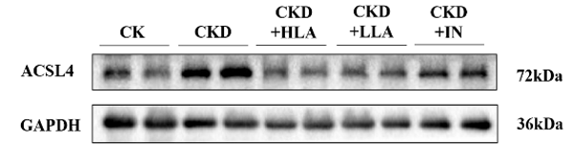

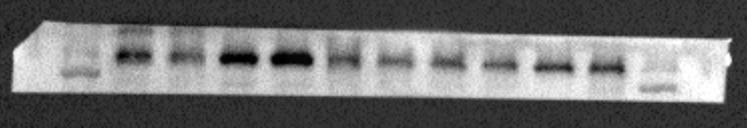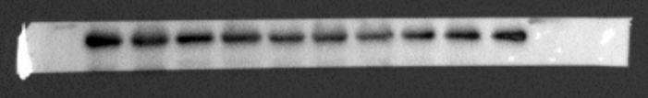
GAPDH
36kDa
ACSL4
72kDa

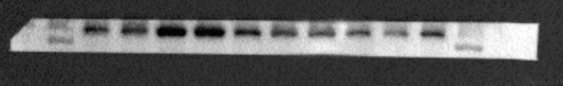
ACSL4
72kDa

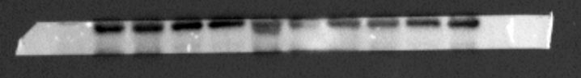
GAPDH
36kDa

2 Raw pictures for Fig 5f
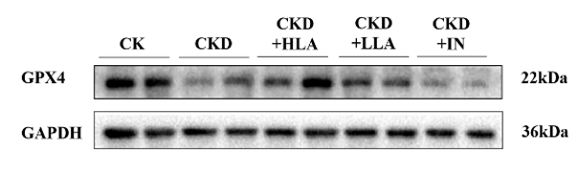

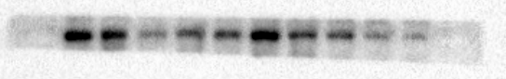
GPX4
22kDa
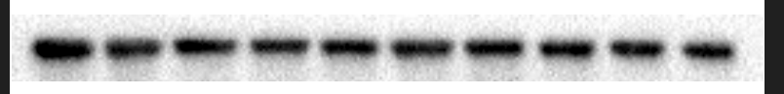
GAPDH
36kDa

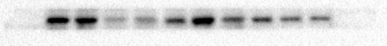
GPX4
22kDa

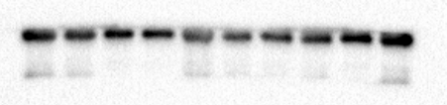
GAPDH
36kDa

3 Raw pictures for Fig 5g
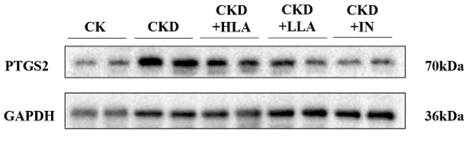

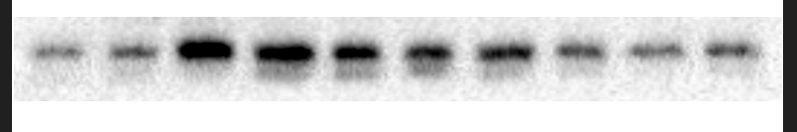
PTGS2
70kDa
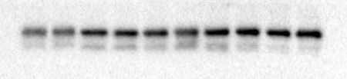
GAPDH
36kDa

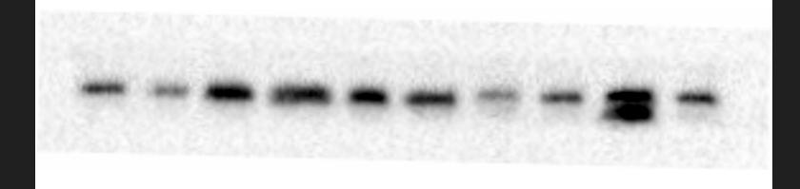
PTGS2
70kDa

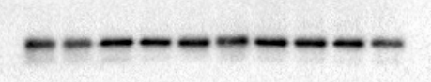
GAPDH
36kDa

4 Raw pictures for Fig 7a

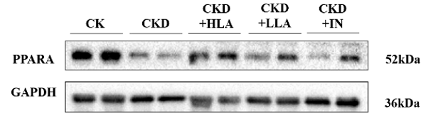
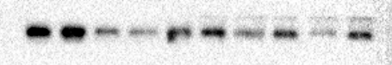
PPARA
52kDa

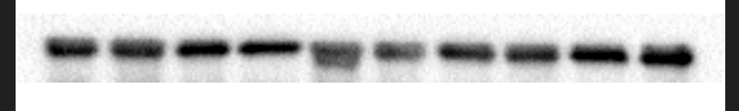
GAPDH
36kDa

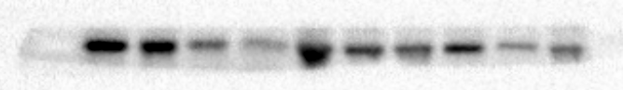
PPARA
52kDa
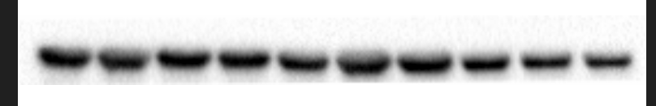
GAPDH
36kDa

5 Raw pictures for Fig 7b
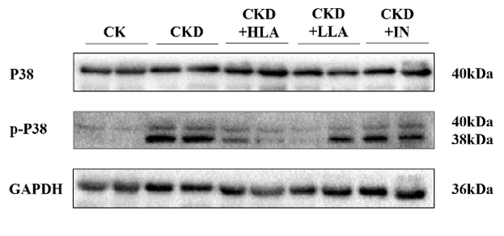
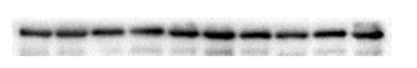
P38
40kDa
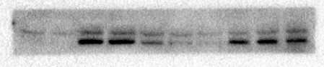
p-P38
40kDa
38kDa
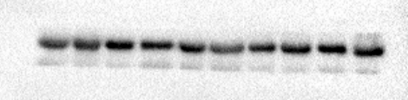
GAPDH
36kDa

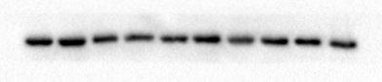
p-P38
40kDa
38kDa

P38
40kDa

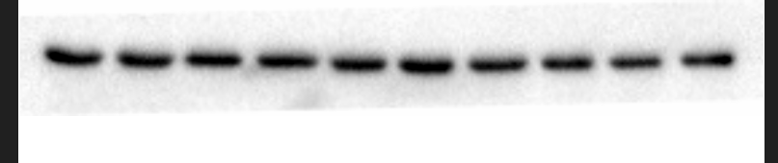
GAPDH
36kDa

