Supplementary Material

Dataset-based Assessment of Heavy Metals Pollution in Taihu Lake Fish and Their Health Risk

Xiaobo Liu^{1#}, Congtian Lin^{2,3#}, Yangyu Wu¹, Haining Huang¹, Liting Zhu¹, Ru Jiang^{4*}, Qiansheng Huang^{1,3*}

¹Key Lab of Urban Environment and Health, Institute of Urban Environment, Chinese Academy of Sciences, Xiamen 361021, PR China
²Key Laboratory of Animal Ecology and Conservational Biology, Institute of Zoology, Chinese Academy of Sciences, Beijing 100101, PR China
³National Basic Science Data Center, Beijing 100190, China
⁴Department of Obstetrics and Gynecology, The First Affiliated Hospital of Nanchang University, Nanchang 330006, PR China

#These authors contributed equally to the paper.
*Corresponding author: Tel/fax: +86 -592-6190542.
E-mail address: qshuang@iue.ac.cn, jiangru2007@sina.com
The authors declare no actual or potential competing financial interests

Legends
Table S1 Checklist of Taihu Lake fish classification information.
Table S2 Concentrations of heavy metals in the whole body of fish.
Figure S1 Location of study area. The red star marks the specific location of Taihu Lake in China.
Figure S2 Literature selection process and results.
Figure S3 Target hazard factor (THQ) factor in adults and children due to ingestion of heavy metals in Taihu Lake fish. The graph on the left indicates the THQ values for children consuming different types of fish, and the graph on the right indicates the THQ values for adults consuming different types of fish, with different colors representing different heavy metals.

Table S1 Checklist of Taihu fish classification information
Species | Living habit | Feeding habit
Hypophthalmichthys molitrix | upper | omnivorous
Hemiculter leucisculus | upper | omnivorous
Aristichthys nobilis | middle-upper | omnivorous
Coilia ectenes Seale | middle-upper | omnivorous
Toxabramis swinhonis | middle-upper | omnivorous
Cultrichthys erythropterus | middle-upper | carnivorous
Culter alburnus | middle-upper | carnivorous
Chanodichthys dabryi | middle-upper | carnivorous
Acheilognathus rhombeus | middle-upper | carnivorous
Parabramis pekinensis | middle-lower | herbivorous
Ctenopharyngodon idellus | middle-lower | herbivorous
Megalobrama amblycephala | middle-lower | herbivorous
Hemibarbus maculatus | middle-lower | carnivorous
Saurogobio dabryi | middle-lower | omnivorous
Acheilognathus macropterus | middle-lower | omnivorous
Neosalanx taihuensis | middle-lower | carnivorous
Paracanthobrama guichenoti | middle-lower | carnivorous
Silurus asotus | bottom | carnivorous
Carassius auratus | bottom | omnivorous
Cyprinus carpio | bottom | omnivorous
Pelteobagrus fulvidraco | bottom | omnivorous
Hemisalanx prognathus | bottom | carnivorous
Carassius carassius | bottom | omnivorous

Table S2 Concentrations of heavy metals in the whole body of fish.
 | Heavy metals (mg/kg)
 |  | Hg | Pb | Cd | As | Zn | Cr
Herbivorous fish | Median | 0.075 | 0.038 | 0.0115 | 0.144 | 30.5 | 0.351
Herbivorous fish | Mean | 0.082 | 0.1065 | 0.01475 | 0.2015 | 31.2 | 0.423
Herbivorous fish | SNWM | 0.076 | 0.0961 | 0.0154 | 0.1924 | 28.6285 | 0.3737
Omnivorous fish | Median | 0.102 | 0.2764 | 0.05 | 0.228 | 82.71 | 0.37
Omnivorous fish | Mean | 0.1532 | 3.6813 | 0.2669 | 1.0634 | 126.242 | 1.4731
Omnivorous fish | SNWM | 0.1287 | 3.9595 | 0.334 | 1.1279 | 124.464 | 1.5883
Carnivorous fish | Median | 0.075 | 0.113 | 0.028 | 0.3155 | 67.215 | 0.364
Carnivorous fish | Mean | 0.1181 | 1.3846 | 0.3246 | 3.99 | 100.4 | 0.9639
Carnivorous fish | SNWM | 0.1252 | 0.7703 | 0.6482 | 0.5993 | 65.6883 | 0.3958

Figure S1 Location of study area. The red star marks the specific location of Taihu Lake in China.

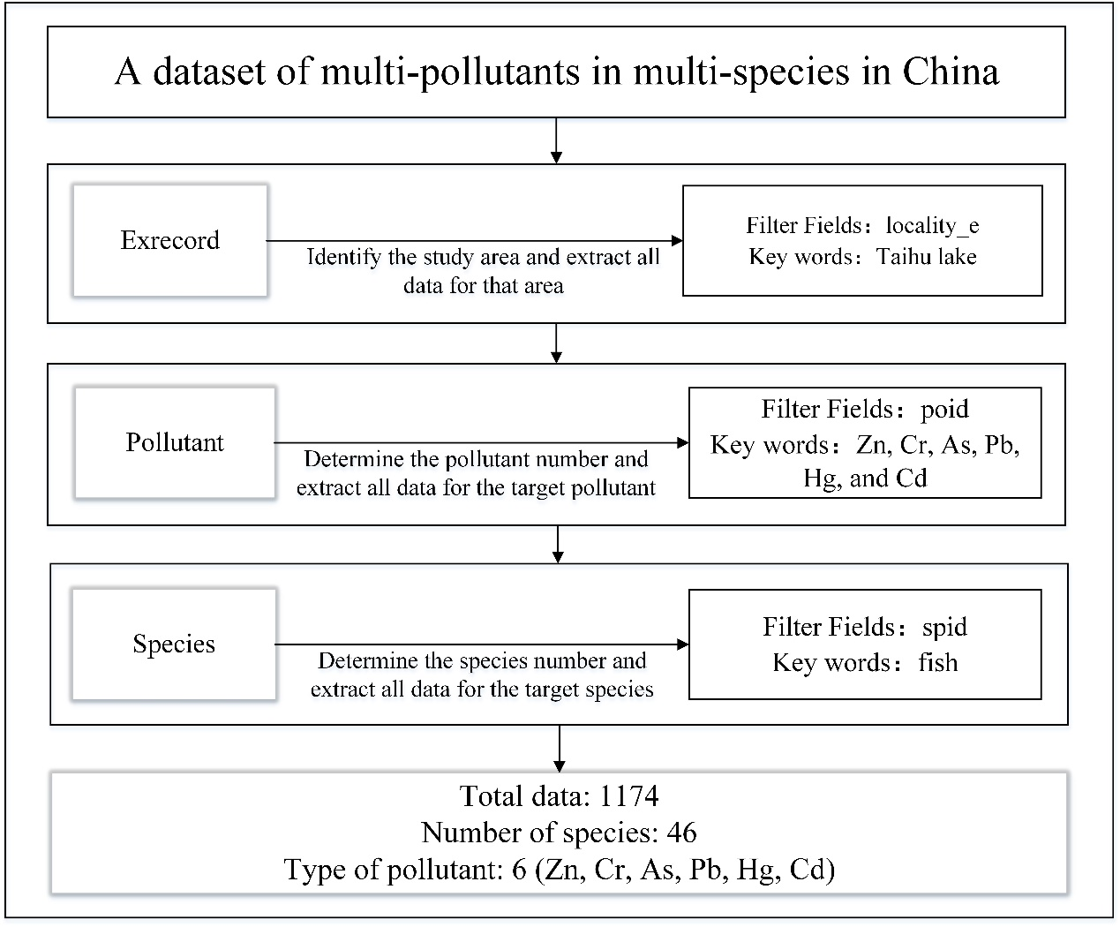
Figure S2 Literature selection process and results.

Figure S3
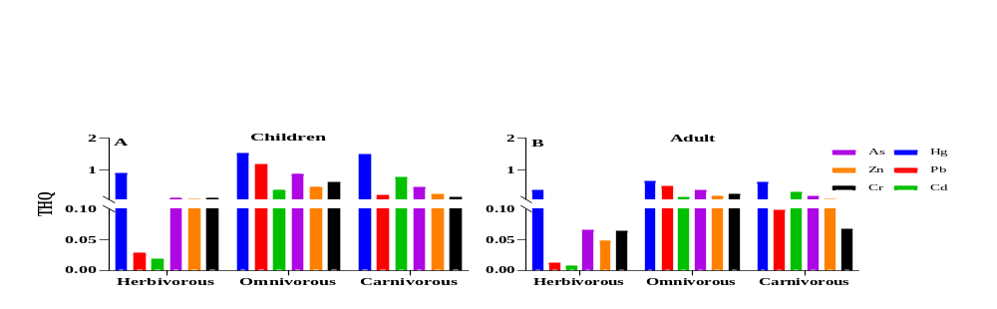
Figure S3 Target hazard factor (THQ) factor in adults and children due to ingestion of heavy metals in Taihu Lake fish.The graph on the left indicates the THQ values for children consuming different types of fish, and the graph on the right indicates the THQ values for adults consuming different types of fish, with different colors representing different heavy metals.

