Appendix 1. The organization of the transition matrix

To illustrate the organization of the transition matrix, let us consider the following example.

Example 1. Consider the following transition matrix:

$$P_{1,:,:}=\left[\begin{matrix}1 & 0 & 0 \\ 0 & 1 & 0 \\ 0 & 0 & 1\end{matrix}\right],P_{2,:,:}=\left[\begin{matrix}0 & 1 & 0 \\ 0 & 1 & 0 \\ 0 & 1 & 0\end{matrix}\right],P_{3,:,:}=\left[\begin{matrix}1/3 & 1/3 & 1/3 \\ 1/3 & 1/3 & 1/3 \\ 1/3 & 1/3 & 1/3\end{matrix}\right].$$

This transition matrix represents the likelihood of opinion shifts in opinion space $m=3$. According to the transition matrix, an agent who has opinion $x_{1}$ is a conformist who completely follows the opinion of an influence source. In turn, agents who hold position $x_{2}$ are so-called stubborn agents who do not change their opinions in the presence of peer influence. Agents with opinion $x_{3}$ act in a purely random fashion regardless of who influences them.

Appendix 2. The flexibility of the model

First, we demonstrate that the classic voter model¹ can be easily obtained as a special case of our model.

Example 2. Let us consider $m=2$. To comply with established traditions whereby the binary opinion space is enriched with the spin interpretation, we denote $x_{1}=-1$ and $x_{2}=1$. The following transition matrix

$$P_{1,:}=P_{2,:}=\left[\begin{matrix}1 & 0 \\ 0 & 1\end{matrix}\right]$$

establishes opinion dynamics that reproduces the voter model, in which randomly chosen agents alter their opinions to those of influence sources.

By applying a binary relation to the opinion space (in other words, by introducing geometry in that space), we obtain an opportunity to encapsulate the concepts of bounded confidence and negative influence. We state that an agent makes a positive shift if their opinion moves towards the source of influence. A negative shift occurs if a user’s opinion moves in the opposite direction.

Example 3. Let us assume that $m=3$. Consider the following transition matrix slice:

$$P_{2,:,:}=\left[\begin{matrix}0.75 & 0 & 0.25 \\ 0 & 1 & 0 \\ 0.25 & 0.25 & 0.5\end{matrix}\right].$$

In this case, the agent with the middle-side opinion $x_{2}$ may be influenced positively (with probability 0.75) and negatively (with probability 0.25) by opinion $x_{1}$. If influence comes from opinion $x_{3}$, then the focal agent may (i) hold their opinion (with probability 0.25), (ii) make a positive shift (with probability 0.5), and (iii) make a negative shift (with probability 0.25). In turn, if two agents with similar opinions $x_{2}$ communicate, then their opinions do not change.

The notion of bounded confidence is based on the idea that an individual perceives (positive) influence only if the opinion of the influence source is not too far from their own opinion². Bounded confidence may take a strict form—that is, only agents with sufficiently similar opinions may influence each other—or a mild form, whereby agents with different opinions may communicate but with a small probability^{3,4}.

Example 4. Consider two slices of a transition matrix ($m=4$):

$$P_{1,:,:}=\left[\begin{matrix}1 & 0 & 0 & 0 \\ 0.5 & 0.5 & 0 & 0 \\ 1 & 0 & 0 & 0 \\ 1 & 0 & 0 & 0\end{matrix}\right],P_{4,:,:}=\left[\begin{matrix}0 & 0 & 0.2 & 0.8 \\ 0 & 0 & 0.3 & 0.7 \\ 0 & 0 & 0.5 & 0.5 \\ 0 & 0 & 0 & 1\end{matrix}\right].$$

In this case, agents with opinion $x_{1}$ may be influenced by only those who have the nearest opinion $x_{2}$; they do not accept influence from more distant positions (strict bounded confidence assumption). Instead, agents who occupy the right edge of the opinion space may follow distant positions (by making a one-step opinion shift $x_{4}→x_{3}$) but with a decreasing rate (mild bounded confidence assumption).

In Example 4, we do not pay attention to so-called leapfrog opinion shifts—situations when an agent’s opinion $x_{s}$ moves towards the opinion of an influence source $x_{l}$, with a magnitude that is higher than the distance between $x_{s}$ and $x_{l}$. In this case, the focal agent’s opinion skips the influence source’s one. Leapfrog opinion shifts are rarely considered in the theoretical studies but nonetheless may be encountered in empirical environments^{5–7}. In principle, such situations may be attributed to measurement errors⁸.
Acting in a similar fashion, one could adjust the values of the transition matrix to represent more complex microscopic assumptions on social influence, such as moderated positive influence or combinations of positive and negative influence in which coexistence may take quite nontrivial forms^{7,9}.
If the binary relation on the opinion space is introduced, then the limit $m→∞$ provides an approximation of a continuous opinion space (without loss of generality, we may consider the interval $\left[0,1\right]$), which has gained substantial attention in the literature¹⁰.

Appendix 3. Mean-field approximation
Let us begin with some auxiliary facts. The probability of the opinion shift $x_{s}→x_{k}$ after influence from an agent with opinion $x_{l}$ is the product of (i) the probability of selecting an agent with opinion $x_{s}$, (ii) the probability of choosing one of her peers with opinion $x_{l}$, and (iii) the quantity $p_{s,l,k}$. Because the social network is a complete graph, we obtain

$$\operatorname{Pr}\left[o_{i}\left(t+1\right)=x_{k},o_{i}\left(t\right)=x_{s},o_{i←}\left(t\right)=x_{l}\right]=\frac{Y_{s}\left(t\right)}{N}\frac{Y_{l}\left(t\right)-δ_{s,l}}{N}p_{s,l,k},$$

where $δ_{s,l}$ is the Kronecker delta:

$$δ_{s,l} =\left\{\begin{aligned}0, &s≠l, \\ 1, &s=l.\end{aligned}\right.$$

As such, the probability of the occurrence of the shift that ends on opinion $x_{k}$ can be written as

$$\sum_{s=1}^{m}{\sum_{l=1}^{m}{\frac{Y_{s}\left(t\right)}{N}\frac{Y_{l}\left(t\right)-δ_{s,l}}{N}P_{s,l,k}}}.$$

To obtain the probability of the shift that ends on opinion $x_{k}$ but does not begin on opinion $x_{k}$ (i.e., the likelihood that the population of agents holding opinion $x_{k}$ will increase by one), we should slightly modify the previous expression by adding the factor $1-δ_{s,k}$:

$$\operatorname{Pr}\left[Y_{k}\left(t+1\right)=Y_{k}\left(t\right)+1\right]=\sum_{s=1}^{m}{\sum_{l=1}^{m}{\frac{Y_{s}\left(t\right)}{N}\left(1-δ_{s,k}\right)\frac{Y_{l}\left(t\right)-δ_{s,l}}{N}p_{s,l,k}}}.$$

Let us rewrite this equation in a more complex form that nonetheless will be useful in the following computations:

$$\operatorname{Pr}\left[Y_{f}\left(t+1\right)=Y_{f}\left(t\right)+1\right]=\sum_{s=1}^{m}{\sum_{l=1}^{m}{\sum_{k=1}^{m}{\frac{Y_{s}\left(t\right)}{N}\left(1-δ_{s,f}\right)\frac{Y_{l}\left(t\right)-δ_{s,l}}{N}p_{s,l,k}δ_{k,f}}}}.$$

Analogously, the chance that the population of agents having opinion $x_{f}$ will decrease by one (it may occur if and only if a randomly chosen agent with opinion $x_{f}$ will change it) is given by:

$$\operatorname{Pr}\left[Y_{f}\left(t+1\right)=Y_{f}\left(t\right)-1\right]=\sum_{s=1}^{m}{\sum_{l=1}^{m}{\sum_{k=1}^{m}{\frac{Y_{s}\left(t\right)}{N}δ_{s,f}\frac{Y_{l}\left(t\right)-δ_{s,l}}{N}p_{s,l,k}\left(1-δ_{k,f}\right)}}}.$$

Given that we know agents’ opinions at time $t$, the expectation of the number of agents with opinion $x_{f}$ at the next time step $t+1$ is given by:

$$E\left[Y_{f}\left(t+1\right)\right]=Y_{f}\left(t\right)+\operatorname{Pr}\left[Y_{f}\left(t+1\right)=Y_{f}\left(t\right)+1\right]-\operatorname{Pr}\left[Y_{f}\left(t+1\right)=Y_{f}\left(t\right)-1\right].$$

Substituting expressions for $\operatorname{Pr}\left[Y_{f}\left(τ+1\right)=Y_{f}\left(τ\right)+1\right]$ and $\operatorname{Pr}\left[Y_{f}\left(τ+1\right)=Y_{f}\left(τ\right)-1\right]$ into the previous formula, we get:

$$E\left[Y_{f}\left(t+1\right)\right]=Y_{f}\left(t\right)+\sum_{s,l,k}{\frac{Y_{s}\left(t\right)}{N}\frac{Y_{l}\left(t\right)-δ_{s,l}}{N}p_{s,l,k}\left[\left(1-δ_{s,f}\right)δ_{k,f}-δ_{s,f}\left(1-δ_{k,f}\right)\right]}$$

or:

$$E\left[Y_{f}\left(t+1\right)\right]=Y_{f}\left(t\right)+\sum_{s,l,k}{\frac{Y_{s}\left(t\right)}{N}\frac{Y_{l}\left(t\right)-δ_{s,l}}{N}p_{s,l,k}\left(δ_{k,f}-δ_{s,f}\right)}.$$

Let us summarize our findings. If we know agents’ opinions at time $t$, then their opinions at time $t+1$ are given by:

$$E\left[Y_{f}\left(t+1\right)\right]=Y_{f}\left(t\right)+\sum_{s,l,k}{\frac{Y_{s}\left(t\right)}{N}\frac{Y_{l}\left(t\right)-δ_{s,l}}{N}p_{s,l,k}\left(δ_{k,f}-δ_{s,f}\right)}, f∈\left\{1,…,m\right\}.$$

For large values of $N$, we can state that:

$$\frac{Y_{l}\left(t\right)-δ_{s,l}}{N}≈\frac{Y_{l}\left(t\right)}{N}$$

and replace $E\left[Y_{f}\left(t+1\right)\right]$ with $Y_{f}\left(t+1\right)$:
$$Y_{f}\left(t+1\right)=Y_{f}\left(t\right)+\sum_{s,l,k}{\frac{Y_{s}\left(t\right)}{N}\frac{Y_{l}\left(t\right)}{N}p_{s,l,k}\left(δ_{k,f}-δ_{s,f}\right)}.$$

Establishing scaled time $τ=\frac{t}{N}$ and scaled time step $δτ=\frac{1}{N}$, we get:

$$Y_{f}\left(τ+δτ\right)=Y_{f}\left(τ\right)+\sum_{s,l,k}{\frac{Y_{s}\left(τ\right)}{N}\frac{Y_{l}\left(τ\right)}{N}p_{s,l,k}\left(δ_{k,f}-δ_{s,f}\right)}.$$

Dividing both sides of the equation by $N$ and introducing the normalized quantity $y_{s}\left(τ\right)=\frac{Y_{s}\left(τ\right)}{N}$, we obtain:

$$\frac{y_{f}\left(τ+δτ\right)-y_{f}\left(τ\right)}{δτ}=\sum_{s,l,k}{y_{s}\left(τ\right)y_{l}\left(τ\right)p_{s,l,k}\left(δ_{k,f}-δ_{s,f}\right)}$$

Because $N$ is large, then $δτ→0$, and we finally come to the nonlinear autonomous system of differential equations:

$$\frac{dy_{f}\left(τ\right)}{dτ}=\sum_{s,l,k}{y_{s}\left(τ\right)y_{l}\left(τ\right)p_{s,l,k}\left(δ_{k,f}-δ_{s,f}\right)}, f∈\left\{1,…,m\right\} \left(A1\right)$$

which should be equipped with the initial condition:

$$y_{f}\left(0\right)=y^{f}, f∈\left\{1,…,m\right\}, \left(A2\right)$$

where $\sum_{f=1}^{m}{y^{f}}=1$ and $y^{f}∈\left[0, 1\right]$. Note that one of the equations in (A1) is redundant.
Equilibrium points of system (1) are given by:

$$\left\{\begin{aligned}g_{f}=0, f∈\left\{1,…,m\right\}, \\ y_{1}+…+y_{m}=1, \\ y_{f}∈\left[0,1\right], f∈\left\{1,…,m\right\},\end{aligned}\right.$$

where we use the notation:

$$g_{f}=\sum_{s,l,k}{y_{s}y_{l}p_{s,l,k}\left(δ_{k,f}-δ_{s,f}\right)}.$$

Due to the fact that the right side of (A1) is a polynomial, we can guarantee that Cauchy problem (A1)^(A2) has a unique solution, which is an analytic function of parameters $p_{s,l,k}$ and $y^{f}$. In other words, small changes in $p_{s,l,k}$ and $y^{f}$ lead to small perturbations of the solution.
If $m=2$, which corresponds to the binary opinion space, then system (A1) takes the quite simple form:

$$\left\{\begin{aligned}{\dot{y}}_{1}=-p_{1,1,2}y_{1}^{2}+\left(p_{2,1,1}-p_{1,2,2}\right)y_{1}y_{2}+p_{2,2,1}y_{2}^{2}, \\ {\dot{y}}_{2}=p_{1,1,2}y_{1}^{2}+\left(p_{1,2,2}-p_{2,1,1}\right)y_{1}y_{2}-p_{2,2,1}y_{2}^{2}.\end{aligned} (A3)\right.$$

One of two equations in system (A3) is unnecessary. Substituting $y_{1}=1-y_{2}$ into the first one, we get:

$$g_{1}=ay_{1}^{2}+by_{1}+c,$$

where:

$$\begin{matrix}a=-p_{1,1,2}+p_{1,2,2}-p_{2,1,1}+p_{2,2,1}, \\ b=p_{2,1,1}-p_{1,2,2}-2p_{2,2,1}, \\ c=p_{2,2,1}.\end{matrix}$$

If $y_{1}^{*}∈\left[0,1\right]$ is an equilibrium point, then it should admit equation:

$$g_{1}\left(y_{1}^{*}\right)=0.$$

The sign of the quantity:

$${\dot{g}}_{1}\left(y_{1}^{*}\right)=2ay_{1}^{*}+b$$

determines the stability properties of this equilibrium.

Appendix 4. Dataset organization
Dataset contains information on the dynamics of political preferences of a large-scale sample $I$ (approximately 1.6 M) of VKontakte (the most popular Russian social network) users. The sample was made by randomly choosing active (at least one platform interaction per month) individuals who meet a set of natural criteria (see Refs.^{6,7} for details). Further, the sample was additionally cleared of isolated subgroups of online friends in such a way that the resulting social network (whereby edges represent online friends) consists of one (giant) connected component. Note that only 0.7% of all nodes were removed during this procedure.
Users’ opinions were estimated on a continuous opinion scale $\left[0,1\right]$, where extreme positions 0 and 1 represent maximal opposition and support for the current Russian government correspondingly. Dataset is organized as three opinion snapshots made in February, July, and December 2018: $\hat{o}\left(t_{1}\right),\hat{o}\left(t_{2}\right),$ and $\hat{o}\left(t_{3}\right)$, where the symbol “^” emphasizes that it provides only estimations of opinions. These estimations were made by applying a machine-learning methodology. Users’ subscriptions to Vkontakte information sources were used as features, reflecting the fact that individuals tend to consume information coherent with their current opinions. As such, the dynamics of users’ subscriptions to information sources should reflect the dynamics of their opinions.
The second component of Dataset is the symmetric adjacency matrix $\hat{A}$, the elements ${\hat{a}}_{ij}∈\left\{0,1\right\}$ of which represent friendship connections between the sample users at time point $t_{2}$. As was mentioned above, the corresponding social network is a connected graph.
As a result, each user $i$ from Dataset is characterized by the sequence of their own opinions ${\hat{o}}_{i}\left(t_{1}\right),{\hat{o}}_{i}\left(t_{2}\right),$ and ${\hat{o}}_{i}\left(t_{3}\right)$ and by the sequence of average opinions of their friends ${\hat{o}}_{-i}\left(t_{1}\right),{\hat{o}}_{-i}\left(t_{2}\right),$ and ${\hat{o}}_{-i}\left(t_{3}\right)$, where

$${\hat{o}}_{-i}\left(t\right)=\frac{\sum_{j}{{\hat{a}}_{ij}o_{j}\left(t\right)}}{\sum_{j}{{\hat{a}}_{ij}}}$$

Note that Dataset is built under the assumption that friendship connections are static, representing one of its main disadvantages.

Appendix 5. Transition matrix estimation
Let us now describe how we integrate Dataset information into the model. We will consider the case $m=2$; other situations are elaborated analogously. We discretize the empirical opinion scale $\left[0,1\right]$ by endowing users who have opinion values from the interval $\left[0,0.5\right]$ with new opinions $x_{1}$ (say, $x_{1}=-1$). Analogously, those who have opinions from the interval $\left[0.5,1\right]$ are marked with $x_{2}$ (say, $x_{2}=1$). A similar procedure is applied on average opinions of users’ friends. Next, for each $s,l$, and $k$, we calculate quantity $p_{s,l,k}$ as follows:

$$p_{s,l,k}=\frac{\#\left\{i∈I | \left({\hat{o}}_{i}\left(t_{1}\right)=x_{s}\right)\&\left({\hat{o}}_{-i}\left(t_{1}\right)=x_{l}\right)\&\left({\hat{o}}_{i}\left(t_{2}\right)=x_{k}\right)\right\}}{\#\left\{i∈I | \left({\hat{o}}_{i}\left(t_{1}\right)=x_{s}\right)\&\left({\hat{o}}_{-i}\left(t_{1}\right)=x_{l}\right)\right\}}, (A4)$$

where $\#\left\{…\right\}$ denotes the cardinal number of the set. To put it simply, (A4) is the fraction of individuals who made opinion change $x_{s}→x_{k}$ among those whose opinion is $x_{s}$ and whose friends’ average opinion is equal to $x_{l}$. To avoid noise, we additionally require that the opinion shift should have a magnitude of more than 0.05 on the continuous scale. Note that in (A4), we first use two snapshots to calibrate the transition matrix’s elements. Acting analogously, one can estimate the transition matrix from second and third opinion snapshots.
We should say that substantial opinion diversity, presented in Dataset, ensures that all combinations of $x_{s}$ and $x_{l}$ are available in sufficient quantity, providing the opportunity to estimate all the transition matrix elements (see Table A1).

Table A1
The joint distribution of users’ opinions and opinions of their online friends (the first opinion snapshot, $m=10$)
 |  | The average opinion of online friends
 |  | $$x_{1}$$ | $$x_{2}$$ | $$x_{3}$$ | $$x_{4}$$ | $$x_{5}$$ | $$x_{6}$$ | $$x_{7}$$ | $$x_{8}$$ | $$x_{9}$$ | $$x_{10}$$
User’s opinion | $$x_{1}$$ | 371 | 699 | 3,833 | 21,084 | 24,955 | 6,934 | 1,332 | 376 | 147 | 44
User’s opinion | $$x_{2}$$ | 246 | 486 | 2,761 | 19,626 | 27,570 | 7,475 | 1,359 | 409 | 124 | 45
User’s opinion | $$x_{3}$$ | 323 | 595 | 3,307 | 27,307 | 49,928 | 15,408 | 2,750 | 745 | 217 | 75.0
User’s opinion | $$x_{4}$$ | 624 | 1,002 | 5,064 | 45,533 | 105,023 | 36,341 | 6,148 | 1,546 | 544 | 151
User’s opinion | $$x_{5}$$ | 1,318 | 2,111 | 9,915 | 90,305 | 277,315 | 107,562 | 18,666 | 4,586 | 1,575 | 405
User’s opinion | $$x_{6}$$ | 825 | 1,253 | 4,932 | 41,661 | 193,936 | 100,509 | 20,220 | 5,237 | 1,833 | 439
User’s opinion | $$x_{7}$$ | 470 | 614 | 2,142 | 14,414 | 78,395 | 56,749 | 14,657 | 4,079 | 1,293 | 350
User’s opinion | $$x_{8}$$ | 245 | 336 | 1,206 | 6,922 | 37,826 | 34,854 | 11,471 | 3,495 | 1,170 | 319
User’s opinion | $$x_{9}$$ | 179 | 222 | 722 | 3,451 | 17,376 | 19,377 | 8,136 | 2,703 | 1,006 | 273
User’s opinion | $$x_{10}$$ | 58 | 63 | 254 | 1,305 | 5,553 | 5,716 | 2,679 | 1,063 | 457 | 119

It is also important to note that our algorithm of the transition matrix estimation assumes many-to-one interactions (because we approximate the influence directed on a user by the average opinion of their friends), whereas our model is built on the idea of one-to-one interactions. One could suggest transforming the model and using the many-to-one assumption in simulations; however, we do not do so. The reason is rather technical—the averaging procedure may not be applicable for discrete opinion spaces.

Appendix 6. Stability analysis of the case $m=3$.

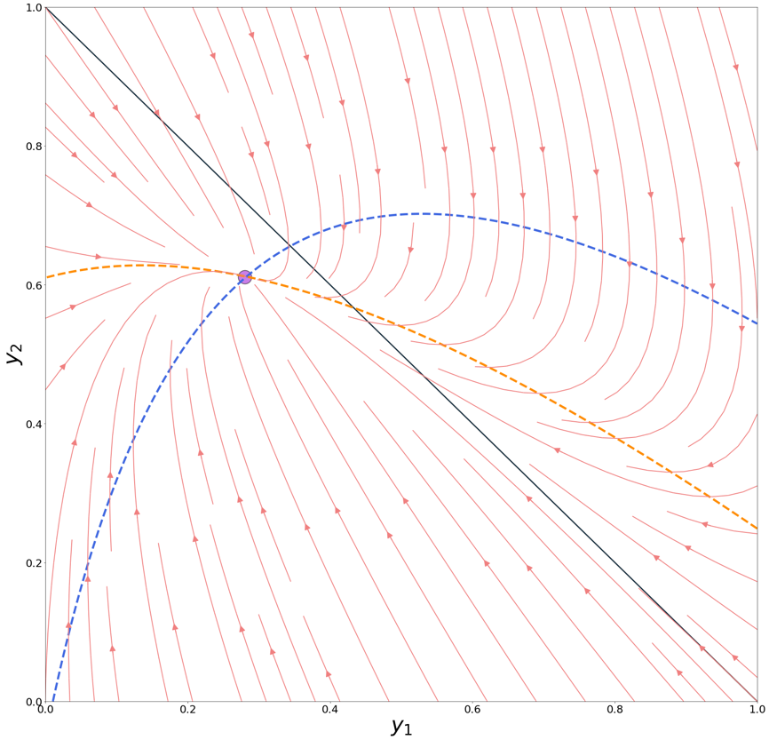
Figure A1. Dashed lines portray the curves $g_{1}\left(y_{1},y_{2}\right)=0$ (blue) and $g_{2}\left(y_{1},y_{2}\right)=0$ (orange). Their intersection marks the equilibrium point. The black solid line plots $y_{1}+y_{2}=1$. We are interested in the area $y_{1}+y_{2}≤1$ beneath this line. The phase portrait of the system demonstrates that the equilibrium point is an asymptotically stable nodal sink (the Jacobian matrix at the equilibrium point has two different negative eigenvalues).

Appendix 7. Definition of the assortativity coefficient

The assortativity coefficient

$$C\left(A,o\left(t\right)\right)=\frac{\sum_{i,j}{\left(a_{ij}-\frac{k_{i}k_{j}}{2q}\right)o_{i}\left(t\right)o_{j}\left(t\right)}}{\sum_{i,j}{\left(k_{i}δ_{ij}-\frac{k_{i}k_{j}}{2q}\right)}o_{i}\left(t\right)o_{j}\left(t\right)}∈\left[-1,1\right] (A5)$$

measures whether the system at hand is homophilic (connected nodes tend to have similar opinions). In (A5), vector $o\left(t\right)={\left[\begin{matrix}o_{1}\left(t\right) & … & o_{N}\left(t\right)\end{matrix}\right]}^{T}$ stands for current agents’ opinions, adjacency matrix $A=\left[a_{ij}\right]∈{\left\{0,1\right\}}^{N×N}$ describes the structure of social network $G$, and $q$ is the number of edges in the network. $k_{i}$ represents node $i$’s degree: $k_{i}=\sum_{i=1}^{N}{a_{ij}}$. To put it simply, (A5) measures how similar the neighboring opinions are, compared with the configuration in which edges are placed at random. For homophilic networks (most empirically observed social networks are homophilic), metric (A5) takes positive values (assortative mixing).

Appendix 8. Synthetic networks

Table A2
Properties of synthetic networks
Network model | Parameter(s) | Brief description
Erdős–Rényi | 15000 edges | The model places a predefined number of edges between the nodes at random. The resulting network has no common features with real social graphs (ignoring sparsity that can be obtained for small values of the parameter) but may serve as their simplest (apart from the complete graph) approximation.
Random geometric graph | Threshold distance 0.05 | The nodes are randomly placed in the unit square. Each pair of nodes is connected if and only if they are distant for no more than the threshold value. The model allows us to obtain the “structured” graphs containing communities (organized geographically), the presence of which is a prominent signature of real social networks.
Watts–Strogatz | Each node is connected to 15 nearest ones, probability of rewiring $p_{rew}=0$ (WS1) | Initially, nodes are placed in the ring topology, in which each node is connected to a predefined number of nearest ones. Edges are rewired at random with the probability $p_{rew}$. If $p_{rew}=0$, then we obtain clustered networks (with an average clustering coefficient $≈0.69$) that feature high values of average path length  ($≈72$). A tiny increase in the value of the rewiring probability ($p_{rew}=0.01$) leads to networks that are still highly clustered (average clustering $≈0.67$) but characterized by a small average path length ($≈7.6$) – so-called small-world networks. If $p_{rew}=1$, then the model generates graphs with no clustering but with even lower values of the average path length ($≈3$).
Watts–Strogatz | Each node is connected to 15 nearest ones, $p_{rew}=0.01$ (WS2)
Watts–Strogatz | Each node is connected to 15 nearest ones, $p_{rew}=1$ (WS3)
Barabási–Albert | Each new node is attached to seven already existing ones | The model adds new nodes in the system sequentially, connecting them with existing ones at random, following the preferential attachment rule. The resulting networks follow the power law degree distribution, which is widely observed in real social networks.
Note: all model parameters are tuned to ensure that the resulting networks are connected and have approximately the same density (or the same number of edges $q$).

Appendix 9. Tenfold transition matrix organization
Applying the algorithm presented in Appendix 5, one can estimate the transition matrix in the case of the tenfold opinion space. In tables A3–A5, we present some slices of this matrix. In these tables, bolded columns indicate the probabilities of holding the current opinion (the most popular strategy observed). Importantly, the presence of both positive and negative influence can be found in these slices: if we increase $\left|x_{s}-x_{l}\right|$, then the probability that a user’s opinion will be changed is raised, and changes both towards and outwards (see Table A4) influencing opinion become more likely. A more profound analysis of Dataset opinion dynamics can be found in Ref.⁷. The full version of the tenfold transition matrix can be found in the Online Supplementary Materials.

Table A3
Slice $P_{1,:,:}$
0.942 | 0.038 | 0.003 | 0.009 | 0.009 | 0.000 | 0.000 | 0.000 | 0.000 | 0.0
0.938 | 0.044 | 0.005 | 0.006 | 0.005 | 0.000 | 0.003 | 0.000 | 0.000 | 0.0
0.945 | 0.042 | 0.007 | 0.003 | 0.002 | 0.000 | 0.000 | 0.000 | 0.000 | 0.0
0.947 | 0.037 | 0.008 | 0.004 | 0.003 | 0.001 | 0.000 | 0.000 | 0.000 | 0.0
0.939 | 0.036 | 0.009 | 0.006 | 0.005 | 0.003 | 0.001 | 0.001 | 0.000 | 0.0
0.924 | 0.043 | 0.009 | 0.008 | 0.007 | 0.004 | 0.002 | 0.001 | 0.001 | 0.0
0.925 | 0.045 | 0.009 | 0.006 | 0.008 | 0.002 | 0.002 | 0.002 | 0.000 | 0.0
0.908 | 0.065 | 0.006 | 0.003 | 0.000 | 0.009 | 0.003 | 0.006 | 0.000 | 0.0
0.896 | 0.067 | 0.037 | 0.000 | 0.000 | 0.000 | 0.000 | 0.000 | 0.000 | 0.0
0.881 | 0.048 | 0.000 | 0.000 | 0.000 | 0.000 | 0.048 | 0.024 | 0.000 | 0.0

Table A4
Slice $P_{5,:,:}$
0.002 | 0.001 | 0.011 | 0.080 | 0.854 | 0.051 | 0.002 | 0.000 | 0.000 | 0.000
0.001 | 0.004 | 0.009 | 0.067 | 0.873 | 0.040 | 0.004 | 0.001 | 0.001 | 0.000
0.001 | 0.004 | 0.010 | 0.070 | 0.874 | 0.038 | 0.003 | 0.000 | 0.000 | 0.000
0.001 | 0.002 | 0.008 | 0.060 | 0.896 | 0.031 | 0.001 | 0.000 | 0.000 | 0.000
0.001 | 0.001 | 0.005 | 0.054 | 0.895 | 0.041 | 0.002 | 0.001 | 0.000 | 0.000
0.000 | 0.001 | 0.005 | 0.059 | 0.871 | 0.059 | 0.004 | 0.000 | 0.000 | 0.000
0.001 | 0.001 | 0.005 | 0.068 | 0.837 | 0.078 | 0.008 | 0.001 | 0.000 | 0.000
0.000 | 0.002 | 0.008 | 0.068 | 0.827 | 0.083 | 0.011 | 0.003 | 0.000 | 0.000
0.000 | 0.001 | 0.005 | 0.066 | 0.826 | 0.090 | 0.009 | 0.003 | 0.000 | 0.001
0.000 | 0.003 | 0.013 | 0.090 | 0.790 | 0.092 | 0.005 | 0.005 | 0.000 | 0.003
Note: probabilities of negative shifts are denoted with lower font size numbers

Table A5
Slice $P_{10,:,:}$
0.000 | 0.0 | 0.000 | 0.000 | 0.000 | 0.000 | 0.018 | 0.000 | 0.125 | 0.857
0.000 | 0.0 | 0.000 | 0.000 | 0.000 | 0.018 | 0.018 | 0.000 | 0.161 | 0.804
0.000 | 0.0 | 0.005 | 0.000 | 0.005 | 0.005 | 0.000 | 0.014 | 0.096 | 0.876
0.001 | 0.0 | 0.000 | 0.000 | 0.006 | 0.005 | 0.005 | 0.005 | 0.081 | 0.897
0.000 | 0.0 | 0.000 | 0.001 | 0.002 | 0.004 | 0.004 | 0.005 | 0.064 | 0.919
0.001 | 0.0 | 0.000 | 0.001 | 0.001 | 0.002 | 0.005 | 0.005 | 0.076 | 0.909
0.000 | 0.0 | 0.000 | 0.000 | 0.002 | 0.002 | 0.006 | 0.007 | 0.079 | 0.904
0.001 | 0.0 | 0.001 | 0.000 | 0.000 | 0.003 | 0.006 | 0.005 | 0.074 | 0.910
0.000 | 0.0 | 0.000 | 0.000 | 0.005 | 0.000 | 0.002 | 0.014 | 0.079 | 0.900
0.000 | 0.0 | 0.000 | 0.000 | 0.000 | 0.000 | 0.000 | 0.018 | 0.071 | 0.912

Appendix 10. Data noisiness.

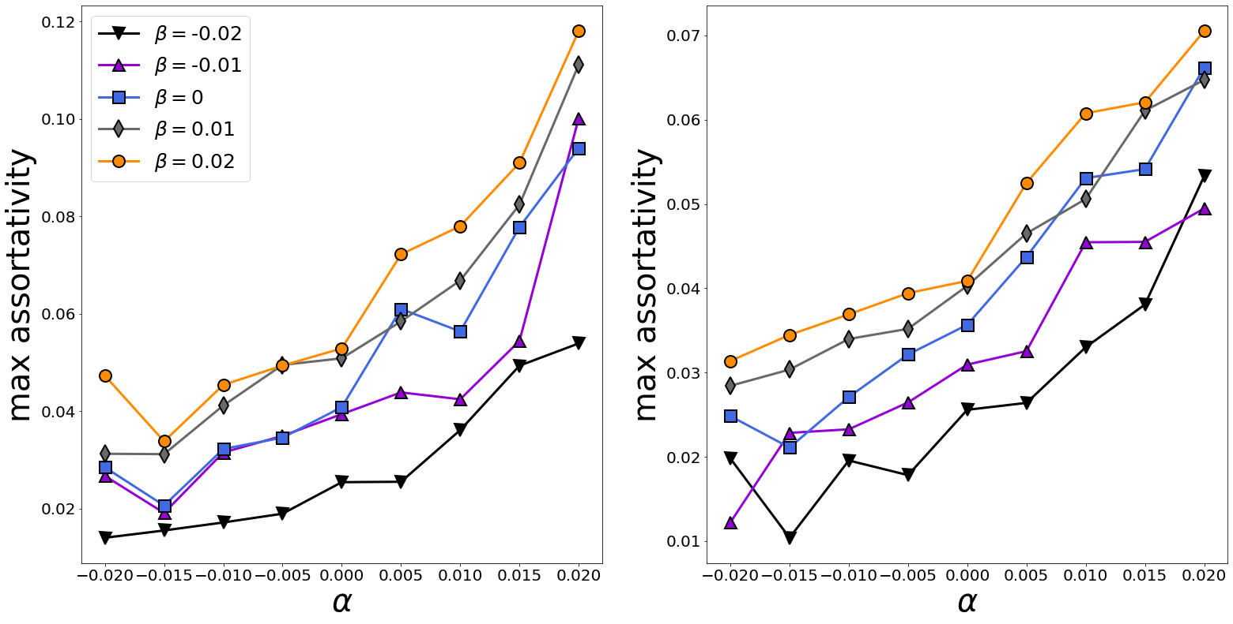
Figure A2. Maximal value of assortativity (during a single experiment) as a function of $α$, separated by $β$ for two network topologies (left panel – random geometric, right panel – Erdős–Rényi).

Appendix 11.
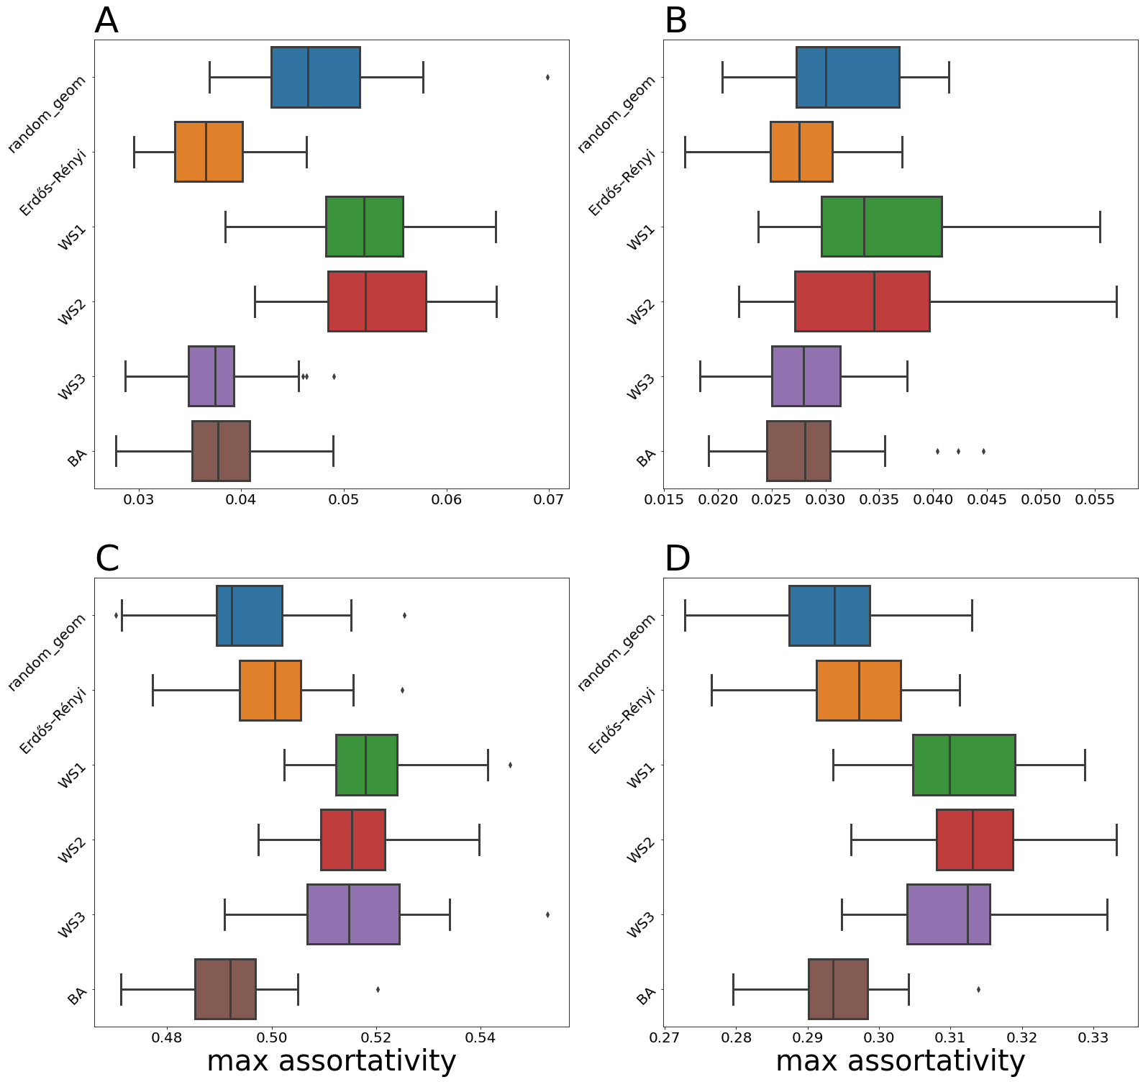
Figure A3. The effect of topology on the assortativity coefficient for different combinations of selectivity and personalization levels: $γ=0,δ=0$ (panel A), $γ=0,δ=0.4$ (panel B), $γ=0.6,δ=0$ (panel C), $γ=1,δ=0.8$ (panel D). All results are derived for $m=10$.

Appendix 12. Influence of variations in selectivity and personalization on the system behavior
Figures 6–9 demonstrate that variations in $δ^{*}$ and especially in $γ^{*}$ will lead to asynchronous behavior of the macroscopic metrics. More precisely, Figures A4–A7 plot simulation runs if selectivity and personalization are $γ=0.2,δ=0$ (personalization is removed – see Figure A4), $γ=0.2,δ=0.2$ (the level of personalization is increased – see Figure A5), $γ=0.1,δ=0.1$ (the assortativity rate is decreased – see Figure A6), and $γ=0.3,δ=0.1$ (the assortativity rate is increased – see Figure A7). Initial opinions are drawn from distribution $y_{1}\left(0\right)=0.07,y_{2}\left(0\right)=0.79,y_{3}\left(0\right)=0.14$. Common colors represent the same metrics. Changes in the personalization level and, especially, in the assortativity rate response for making macroscopic metrics achieve reference values at different time points.

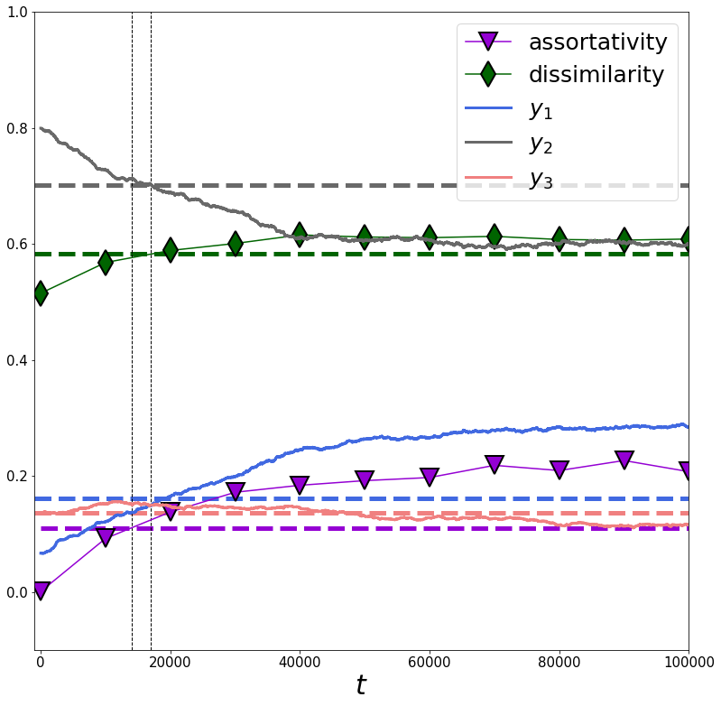
Figure A4. Macroscopic metrics achieve reference values with a little level of asynchrony (vertical dashed lines mark the time points at which macroscopic metrics coincide with the empirical reference values).

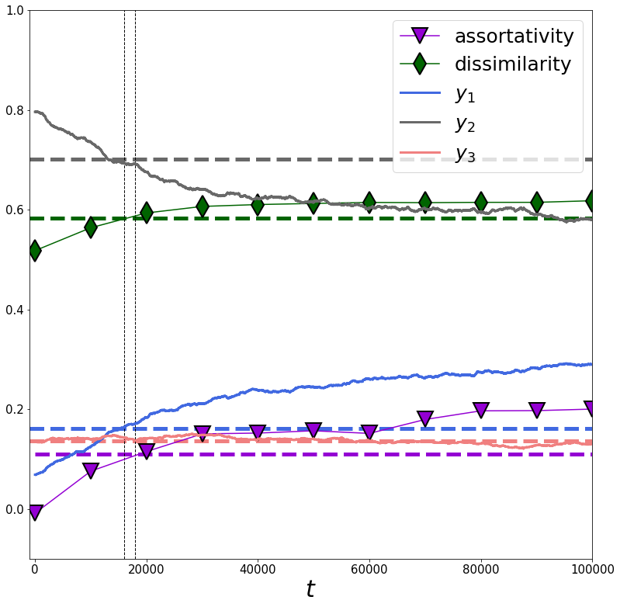
Figure A5. Macroscopic metrics achieve reference values with a little level of asynchrony (vertical dashed lines mark the time points at which macroscopic metrics coincide with the empirical reference values).
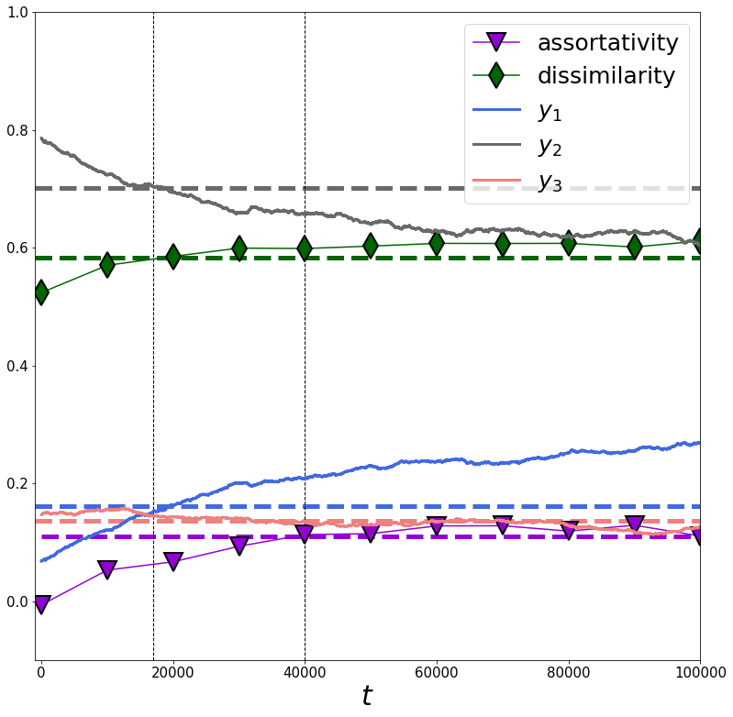
Figure A6. Macroscopic metrics achieve reference values at sufficiently different time points (vertical dashed lines mark the time points at which macroscopic metrics coincide with the empirical reference values).
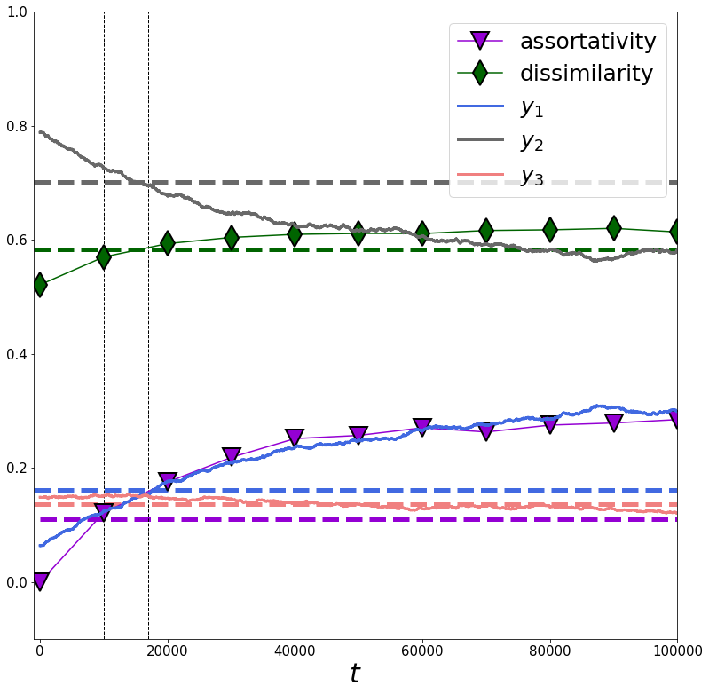
Figure A7. Macroscopic metrics achieve reference values at sufficiently different time points (vertical dashed lines mark the time points at which macroscopic metrics coincide with the empirical reference values).

References
1. Clifford, P. & Sudbury, A. A model for spatial conflict. Biometrika 60, 581–588 (1973).
2. Flache, A. et al. Models of Social Influence: Towards the Next Frontiers. J. Artif. Soc. Soc. Simul. 20, (2017).
3. Kurahashi-Nakamura, T., Mäs, M. & Lorenz, J. Robust clustering in generalized bounded confidence models. J. Artif. Soc. Soc. Simul. 19, (2016).
4. Mäs, M. & Flache, A. Differentiation without distancing. Explaining bi-polarization of opinions without negative influence. PloS One 8, e74516 (2013).
5. Friedkin, N. E., Proskurnikov, A. V. & Bullo, F. Group dynamics on multidimensional object threat appraisals. Soc. Netw. 65, 157–167 (2021).
6. Kozitsin, I. V. Formal models of opinion formation and their application to real data: evidence from online social networks. J. Math. Sociol. 0, 1–28 (2020).
7. Kozitsin, I. V. Opinion dynamics of online social network users: a micro-level analysis. J. Math. Sociol. 0, 1–41 (2021).
8. Carpentras, D. & Quayle, M. The sensitivity of the Deffuant model to measurement error. (2021).
9. Takács, K., Flache, A. & Mäs, M. Discrepancy and Disliking Do Not Induce Negative Opinion Shifts. PLOS ONE 11, e0157948 (2016).
10. Mastroeni, L., Vellucci, P. & Naldi, M. Agent-Based Models for Opinion Formation: A Bibliographic Survey. IEEE Access 7, 58836–58848 (2019).

