Supporting Information “Engineering Printable PNIPAM/HPC Thermochromic Hydrogels through Multi-Parameter Optimization for Energy-Efficient Smart Windows”

Sajad Rasouli, Maryam Ataeefard*

Department of Printing Science and Technology, Institute for Color Science and Technology, P.O. Box: 32465-654, Tehran, Iran

* Corresponding author: Maryam Ataeefard (ataeefard-m@icrc.ac.ir)

This auxiliary information contains supportive evidences to strengthen the claims created in the main text.

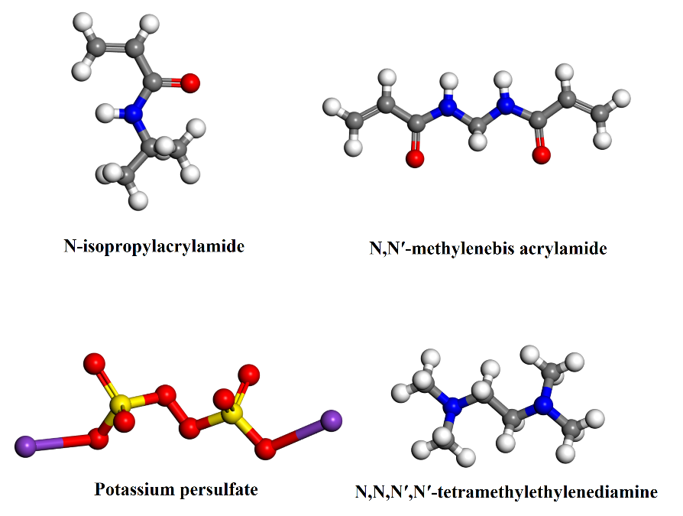
Figure SI1. Molecular structures of the chemical reagents used in the synthesis of the NIPAM-based hydrogel. In the molecular representations, blue, red, yellow, white, and purple spheres correspond to nitrogen (N), oxygen (O), sulfur (S), hydrogen (H), and potassium (K) atoms, respectively.

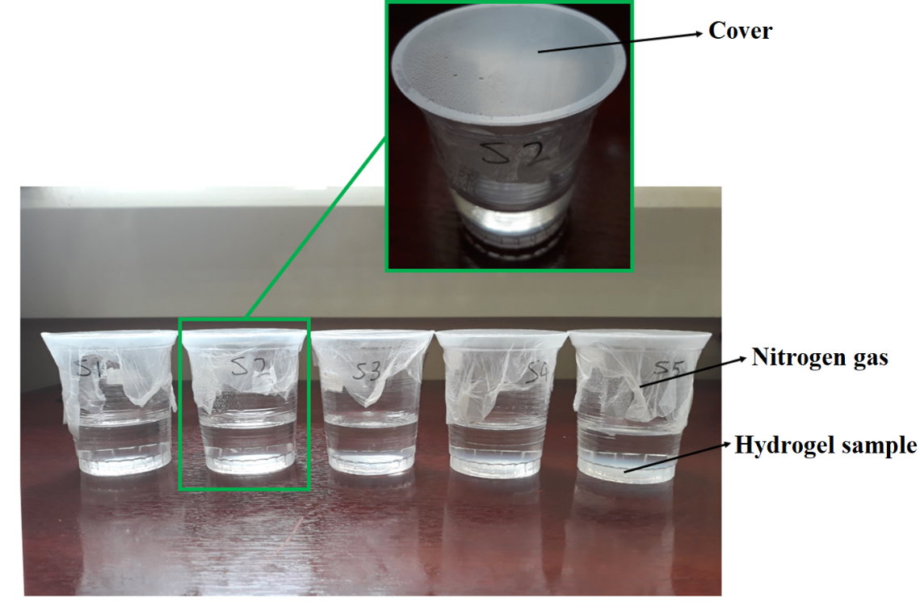
Figure SI2. Hydrogel samples sealed in nitrogen-filled containers during the polymerization process.

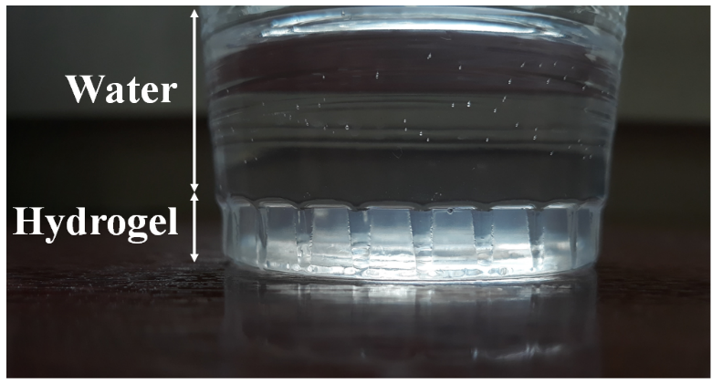
Figure SI3. Water-saturation step of the synthesized hydrogel (sample S3 shown as a representative example).

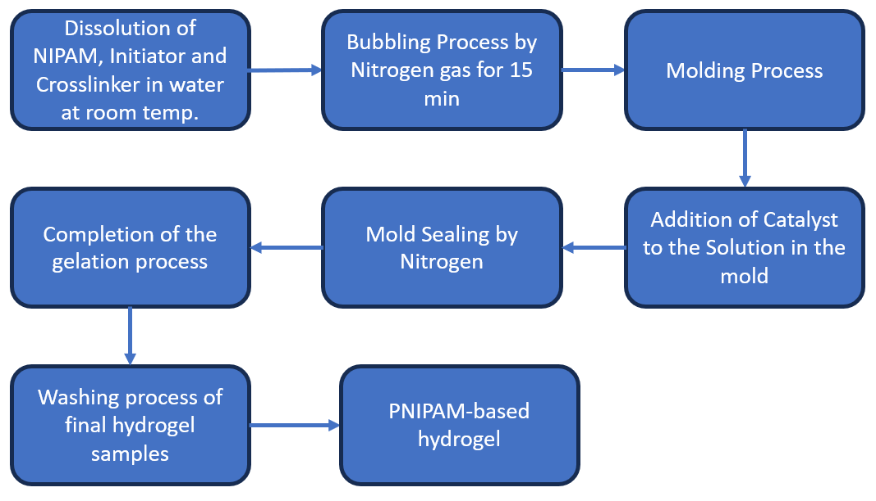
Figure SI4. Schematic illustration of the synthesis procedure for the NIPAM-based hydrogel.

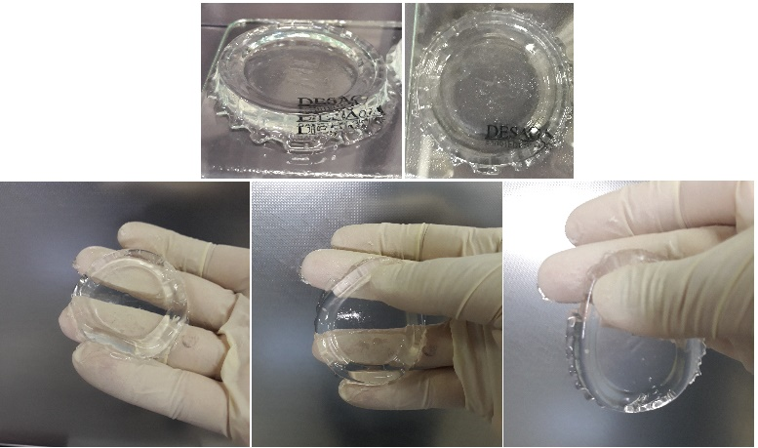
Figure SI5. Representative image of the S3 hydrogel after washing with deionized water.

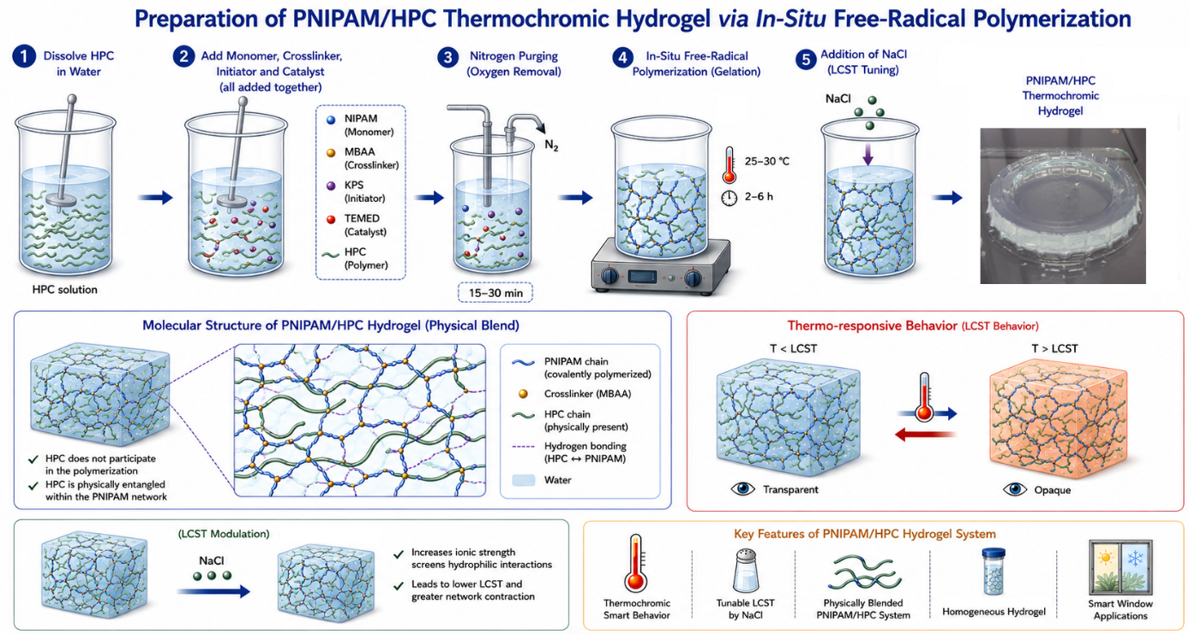
Figure SI6. The preparation procedure of PNIPAM/HPC hydrogels using in-situ polymerization, and a representative picture of the resulting NIPAM/HPC hydrogel

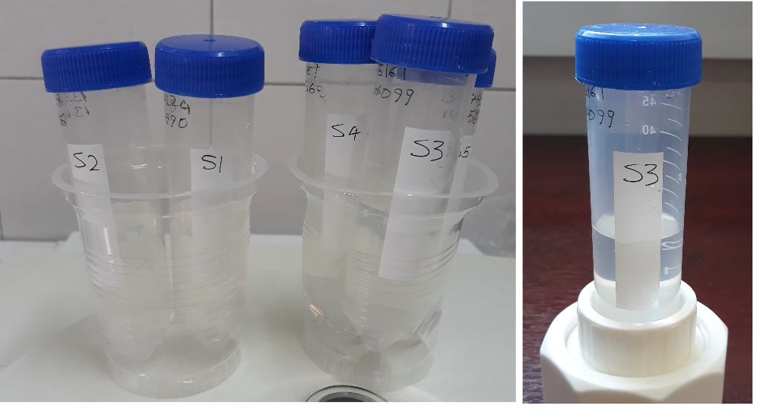
Figure SI7. The immersed hydrogel samples in water during the swelling test.

Table SI1. Characteristic FTIR (extracted from Figure 5a) absorption bands identified in the synthesized hydrogel samples and their corresponding vibrational assignments.
Wave Length (cm⁻¹) | Functional group | Type
780±20 | C-H | Bending
1125 | CH₃ | Vibration
1375,1385 | –C(CH3)2 | Symmetric deformation
1461 | CH₃ | Asymmetric deformation
1414, 1617 | C=C, –C=C | Stretching
1650 | C=O | Stretching (secondary amide)
2865,2930 | C-H | Asymmetric and symmetric  stretching vibration
3098, 3265, 3429 | N-H | Stretching in the secondary amides
3400 | O-H | Water

Table SI2. Parameters used in the Flory–Rehner calculations and the resulting crosslink density values for hydrogel samples S1–S5.
S5 | S4 | S3 | S2 | S1 | Sample
111.00±1.0 | 89.00±0.9 | 93.80±0.9 | 102.80±1.0 | 76.60±0.8 | m_{i} (mg)
2830.60±31 | 2323.20±25 | 2780.00±30 | 3689.20±38 | 4088.60±40 | m_{i} (mg)
0.0357 | 0.0349 | 0.0307 | 0.0253 | 0.0170 | V_{p}
8.033×10⁻⁶ | 7.698×10⁻⁶ | 6.114×10⁻⁶ | 4.338×10⁻⁶ | 2.153×10⁻⁶ | CD (mol/g)
24.50 | 25.10 | 28.63 | 34.88 | 52.37 | SR

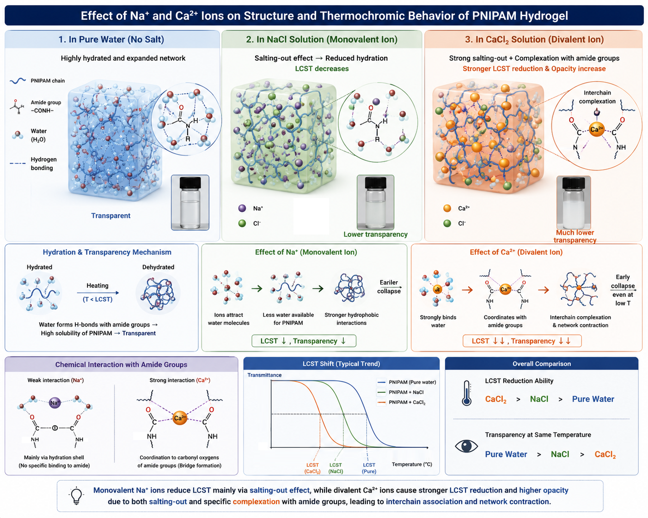Figure SI8. Schematic of the mechanism of action of Na⁺ and Ca²⁺ ions on the optical features of the PNIPAM hydrogels.

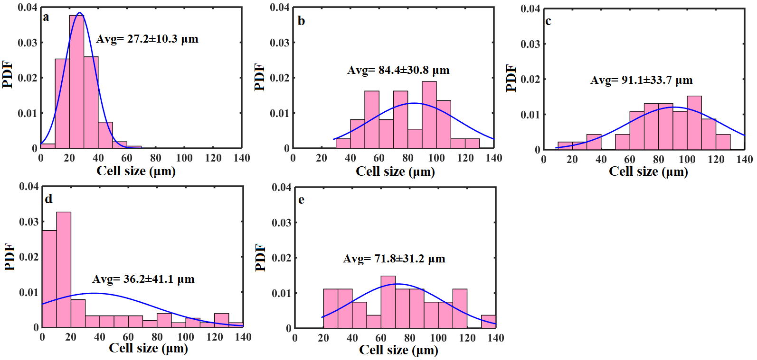
Figure SI9. Probability density functions (PDFs) of pore-size distributions extracted from the SEM images shown in Figure 14-3.

