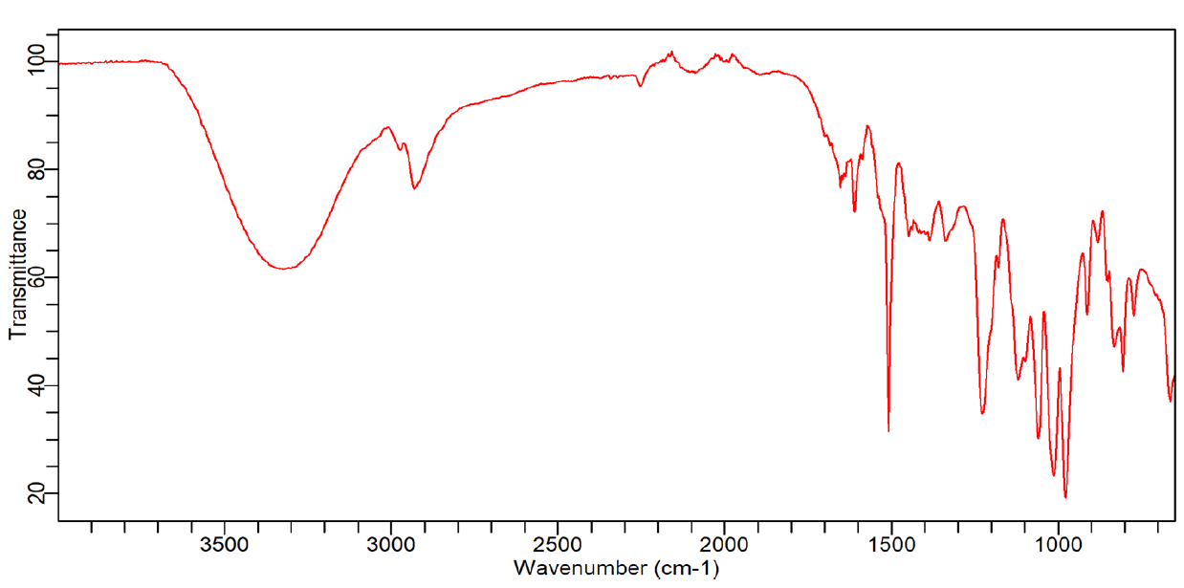
Supplementary figure 1: FTIR spectrum of Niazimicin
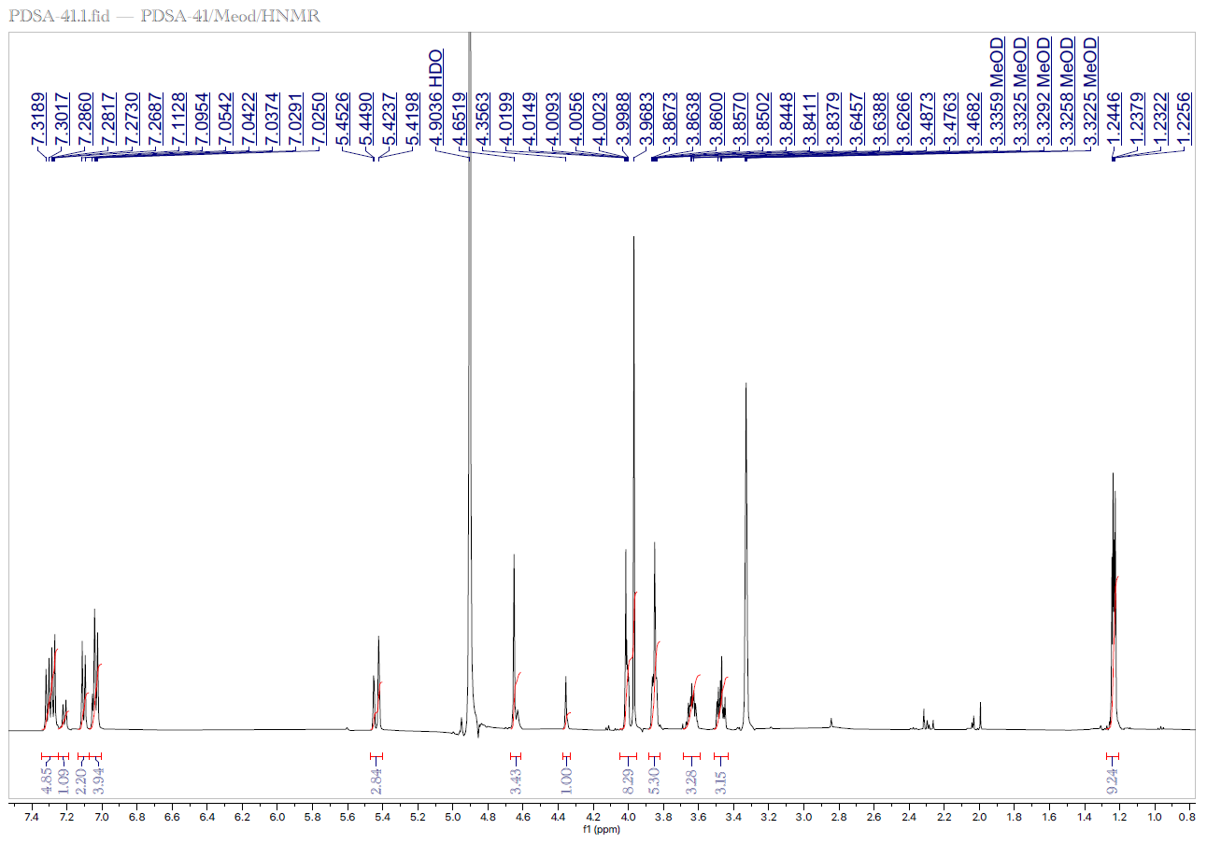
Supplementary figure 2: ¹HNMR spectrum of Niazimicin
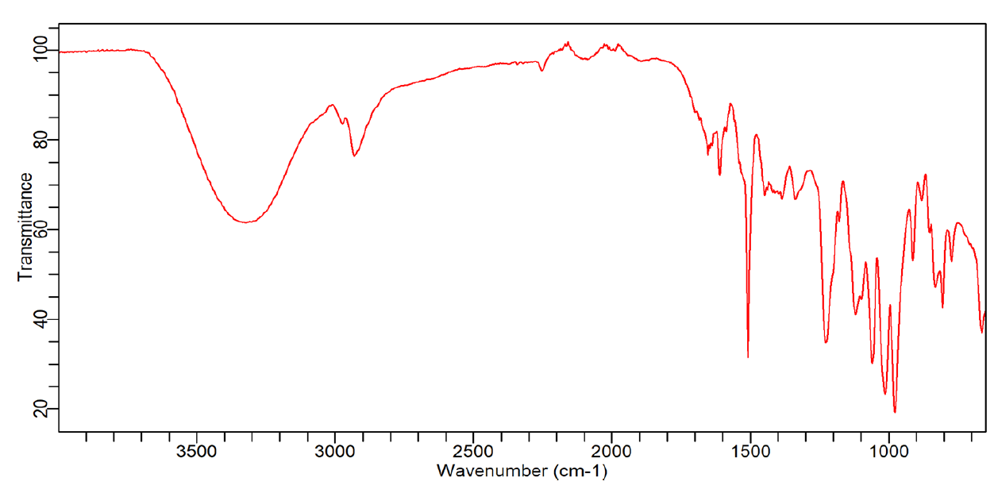
Supplementary figure 3: FTIR spectrum of Wajidinol
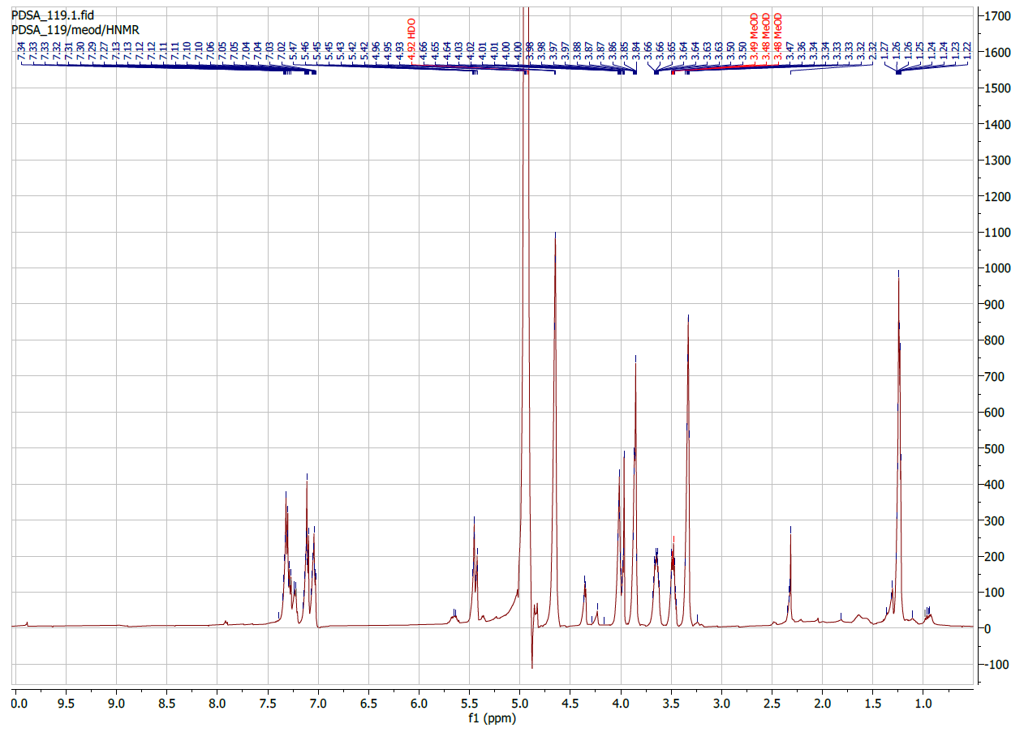
Supplementary figure 4: ¹HNMR spectrum of Wajidinol
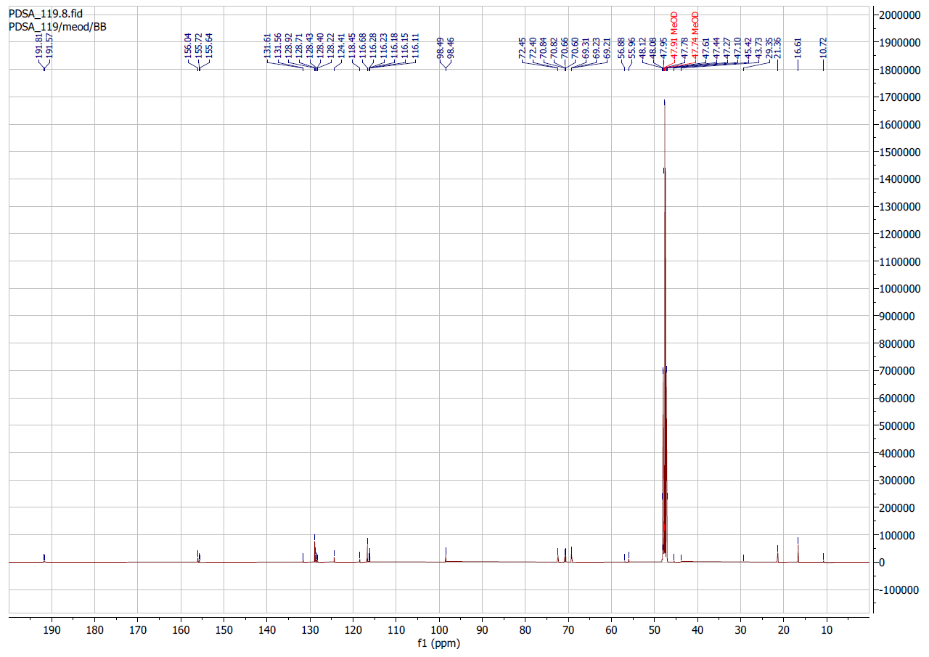
Supplementary figure 5: ¹³CNMR spectrum of Wajidinol
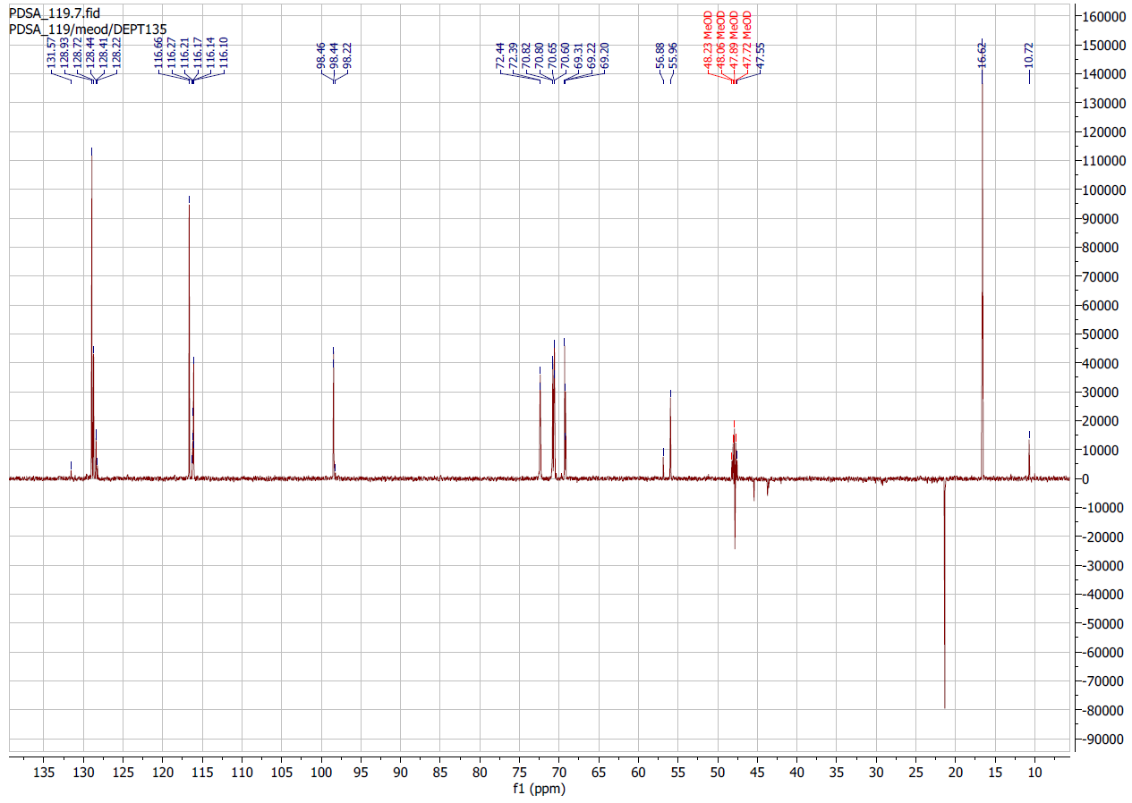
Supplementary figure 6: DEPT-135 spectrum of Wajidinol
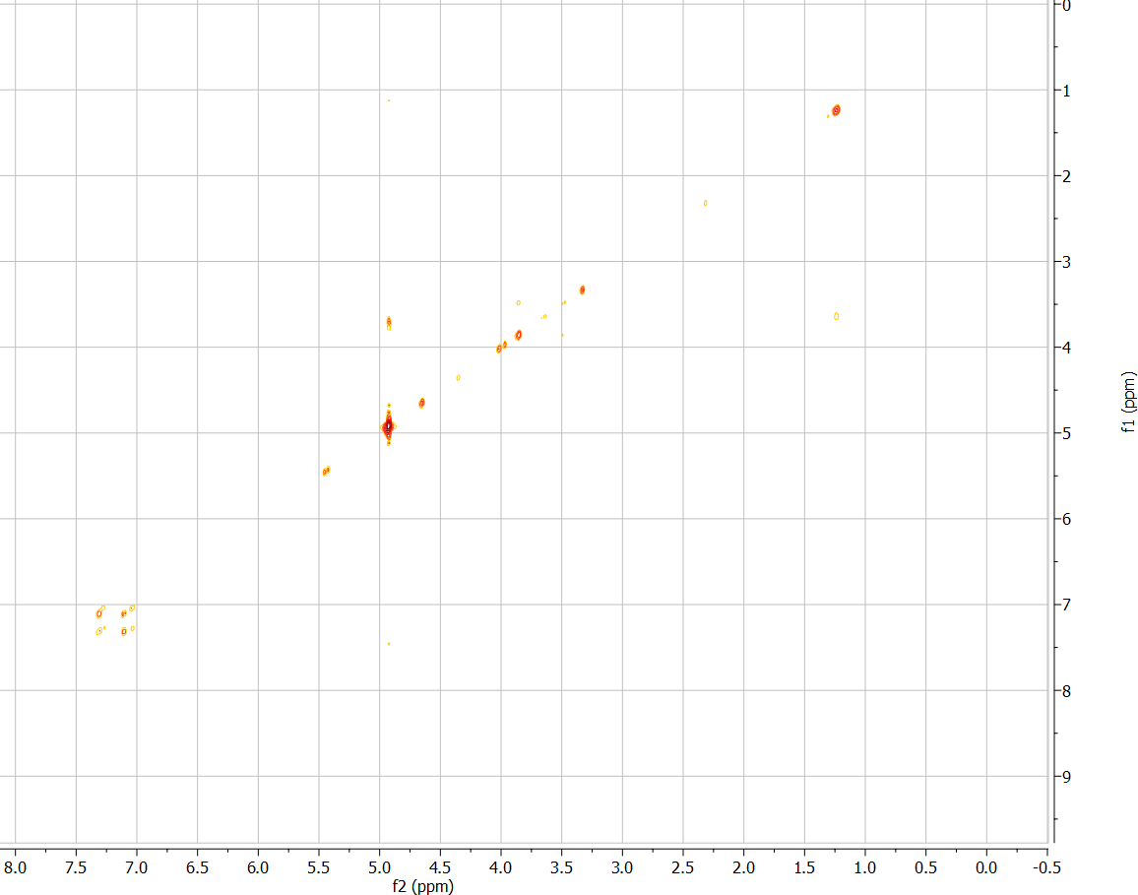
Supplementary figure 7: ¹H-¹H COSY spectrum of Wajidinol
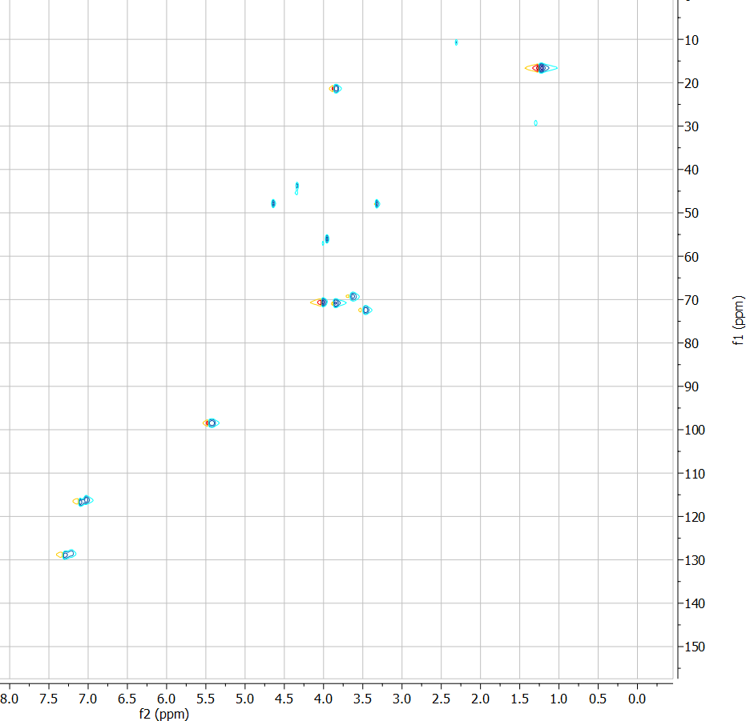
Supplementary figure 8: ¹H-¹³C HSQC spectrum of Wajidinol
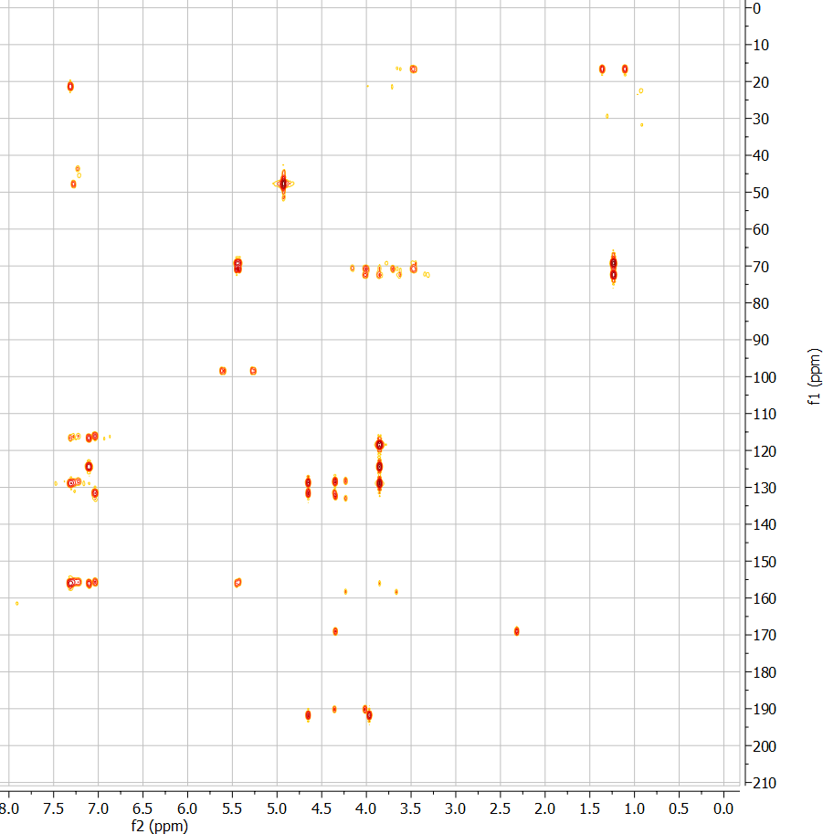
Supplementary figure 9: ¹H-¹³C HMBC spectrum of Wajidinol

