Supplementary material
Joint pain-depression burden profiles and subsequent ADL disability in older adults with arthritis: a five-cohort population-based study
Table S0. Cross-cohort harmonization of entry criteria, included waves, pain, depression and ADL definitions.
Cohort | Included waves | Arthritis and age entry | Pain definition | Depression measure | ADL definition
HRS | 2004, 2006, 2008, 2010, 2012 | R7ARTHRE=1 and R7AGEY_B>=50 at baseline | Derived psev from C104/C105; any pain=psev>=1 | RAND CES-D-8 | RAND ADL5A, 0-5 limitations; Any-ADL>=1
SHARE | Source waves 1, 2, 4, 5, 6 | Baseline arthritis indicator and age>=50 in source wave 1 | Source waves 1, 2, 4: pain_s=1; source waves 5, 6: painlv>=1 | EURO-D (0-12) | Harmonized basic ADL count, 0-3; Any-ADL>=1
ELSA | 2002, 2004, 2006, 2008, 2010 | r1arthre=1 and r1agey>=50 at baseline | r{w}painfr=1 | CES-D continuous score | Harmonized basic ADL count, 0-3; Any-ADL>=1
CHARLS | 2013, 2015, 2018, 2020 | 2013 r2arthre=1 and r2agey>=50 | Validated binary pain_flag from the authorized harmonized analysis panel | CES-D-6 continuous score | Five reconstructed basic ADL items; count 0-5; Any-ADL>=1
MHAS | 2012, 2015, 2018, 2021, 2024 | 2012 c32=1 and age>=50 at baseline | c45_{wave}=1 | CES-D-9 sum score | Five basic ADL items; count 0-5; Any-ADL>=1
Pain was harmonized as a binary indicator within each cohort. Depression scores were retained on their native scales and standardized within cohort and wave before profile modelling. The CHARLS pain_flag was inherited from the authorized harmonized analysis panel; its source provenance should be retained with the local data-use record.

Table S1. HRS — baseline characteristics of trajectory classes.
Trajectory | N | Age | Female_pct | Pain_w1 | Depression_w1 | ADL_w1
Highest composite burden | 523 | 63.19 | 0.74 | 0.75 | 2.74 | 0.7
Intermediate | 394 | 67.61 | 0.69 | 0.0 | 1.48 | 0.13
Lowest composite burden | 750 | 66.76 | 0.66 | 0.0 | 1.02 | 0.08
Pain-predominant | 243 | 63.51 | 0.69 | 1.0 | 1.91 | 0.41
Pain-predominant (2) | 349 | 66.62 | 0.68 | 0.48 | 1.93 | 0.31

Table S2. HRS - autoregressive cross-lagged panel model standardized coefficients.
Transition | Outcome | N | beta_auto | beta_cross1 | beta_cross2
1->2 | pain | 3438 | 0.407 | 0.111 | 0.065
1->2 | depression | 3438 | 0.555 | 0.092 | 0.068
1->2 | adl | 3438 | 0.54 | 0.066 | 0.052
2->3 | pain | 3339 | 0.409 | 0.108 | 0.091
2->3 | depression | 3339 | 0.525 | 0.051 | 0.107
2->3 | adl | 3339 | 0.533 | 0.014 | 0.043
3->4 | pain | 2736 | 0.401 | 0.116 | 0.136
3->4 | depression | 2736 | 0.518 | 0.091 | 0.098
3->4 | adl | 2736 | 0.654 | 0.013 | 0.088
4->5 | pain | 2401 | 0.438 | 0.083 | 0.11
4->5 | depression | 2401 | 0.56 | 0.092 | 0.143
4->5 | adl | 2401 | 0.649 | 0.033 | 0.059

Table S1. SHARE — baseline characteristics of trajectory classes.
Trajectory | N | Age | Female_pct | Pain_w1 | Depression_w1 | ADL_w1
Highest composite burden | 579 | 64.09 | 0.78 | 1.0 | 3.6 | 0.26
Intermediate | 218 | 64.68 | 0.69 | 0.0 | 2.34 | 0.04
Lowest composite burden | 137 | 62.61 | 0.58 | 1.0 | 2.15 | 0.08
Pain-predominant | 254 | 64.17 | 0.67 | 1.0 | 2.89 | 0.15
Pain-predominant (2) | 180 | 65.56 | 0.7 | 1.0 | 3.08 | 0.18

Table S2. SHARE - autoregressive cross-lagged panel model standardized coefficients.
Transition | Outcome | N | beta_auto | beta_cross1 | beta_cross2
1->2 | pain | 3842 | 0.217 | 0.053 | 0.023
1->2 | depression | 3842 | 0.507 | 0.031 | 0.102
1->2 | adl | 3842 | 0.586 | 0.016 | 0.096
2->3 | pain | 2189 | 0.223 | 0.086 | -0.022
2->3 | depression | 2189 | 0.462 | 0.018 | 0.027
2->3 | adl | 2189 | 0.504 | 0.003 | 0.131
3->4 | pain | 1938 | 0.202 | 0.154 | 0.063
3->4 | depression | 1938 | 0.514 | 0.025 | 0.07
3->4 | adl | 1938 | 0.598 | -0.015 | 0.096
4->5 | pain | 1759 | 0.348 | 0.132 | -0.006
4->5 | depression | 1759 | 0.458 | 0.051 | 0.108
4->5 | adl | 1759 | 0.7 | 0.004 | 0.06

Table S1. ELSA — baseline characteristics of trajectory classes.
Trajectory | N | Age | Female_pct | Pain_w1 | Depression_w1 | ADL_w1
Highest composite burden | 519 | 63.81 | 0.69 | 1.0 | 2.66 | 0.76
Intermediate | 229 | 66.3 | 0.77 | 0.0 | 2.12 | 0.21
Lowest composite burden | 266 | 64.06 | 0.67 | 0.0 | 0.51 | 0.09
Pain-predominant | 282 | 65.23 | 0.62 | 1.0 | 1.66 | 0.39
Pain-predominant (2) | 119 | 65.71 | 0.75 | 1.0 | 2.29 | 0.54

Table S2. ELSA - autoregressive cross-lagged panel model standardized coefficients.
Transition | Outcome | N | beta_auto | beta_cross1 | beta_cross2
1->2 | pain | 2587 | 0.365 | 0.106 | 0.117
1->2 | depression | 2587 | 0.503 | 0.09 | 0.108
1->2 | adl | 2587 | 0.544 | 0.062 | 0.1
2->3 | pain | 2076 | 0.414 | 0.079 | 0.114
2->3 | depression | 2076 | 0.51 | 0.071 | 0.102
2->3 | adl | 2076 | 0.543 | 0.063 | 0.102
3->4 | pain | 1720 | 0.426 | 0.104 | 0.118
3->4 | depression | 1720 | 0.52 | 0.053 | 0.101
3->4 | adl | 1720 | 0.524 | 0.062 | 0.111
4->5 | pain | 1527 | 0.436 | 0.06 | 0.082
4->5 | depression | 1527 | 0.538 | 0.094 | 0.082
4->5 | adl | 1527 | 0.56 | 0.074 | 0.082

Table S1. CHARLS — baseline characteristics of trajectory classes.
Trajectory | N | Age | Female_pct | Pain_w1 | Depression_w1 | ADL_w1
Highest composite burden | 172 | 60.53 | 0.77 | 1.0 | 13.99 | 0.72
Intermediate | 157 | 61.69 | 0.55 | 0.0 | 11.0 | 0.41
Lowest composite burden | 824 | 60.42 | 0.47 | 0.0 | 10.1 | 0.32
Pain-predominant | 224 | 60.21 | 0.66 | 0.0 | 11.7 | 0.47
Pain-predominant (2) | 269 | 59.74 | 0.71 | 0.0 | 12.91 | 0.54

Table S2. CHARLS - autoregressive cross-lagged panel model standardized coefficients.
Transition | Outcome | N | beta_auto | beta_cross1 | beta_cross2
1->2 | pain | 1578 | 0.184 | 0.196 | 0.068
1->2 | depression | 1578 | 0.486 | 0.056 | 0.083
1->2 | adl | 1578 | 0.374 | -0.012 | 0.13
2->3 | pain | 1683 | 0.306 | 0.115 | 0.013
2->3 | depression | 1683 | 0.285 | 0.079 | 0.081
2->3 | adl | 1683 | 0.448 | 0.05 | 0.066
3->4 | pain | 1649 | 0.356 | 0.085 | 0.021
3->4 | depression | 1649 | 0.361 | 0.1 | 0.144
3->4 | adl | 1649 | 0.502 | 0.073 | 0.117

Table S1. MHAS — baseline characteristics of trajectory classes.
Trajectory | N | Age | Female_pct | Pain_w1 | Depression_w1 | ADL_w1
Highest composite burden | 242 | 67.17 | 0.86 | 1.0 | 5.37 | 0.72
Intermediate | 161 | 64.2 | 0.75 | 0.67 | 4.3 | 0.24
Lowest composite burden | 91 | 62.99 | 0.65 | 0.36 | 3.07 | 0.21
Pain-predominant | 152 | 62.74 | 0.79 | 0.62 | 4.03 | 0.32
Pain-predominant (2) | 90 | 63.5 | 0.78 | 0.53 | 4.6 | 0.66

Table S2. MHAS - autoregressive cross-lagged panel model standardized coefficients.
Transition | Outcome | N | beta_auto | beta_cross1 | beta_cross2
1->2 | pain | 1413 | 0.213 | 0.08 | 0.11
1->2 | depression | 1413 | 0.443 | 0.094 | 0.068
1->2 | adl | 1413 | 0.331 | 0.093 | 0.123
2->3 | pain | 1263 | 0.244 | 0.109 | 0.081
2->3 | depression | 1263 | 0.47 | 0.067 | 0.104
2->3 | adl | 1263 | 0.346 | 0.072 | 0.07
3->4 | pain | 992 | 0.246 | 0.106 | 0.113
3->4 | depression | 992 | 0.439 | 0.089 | 0.078
3->4 | adl | 992 | 0.458 | 0.003 | 0.155
4->5 | pain | 865 | 0.234 | 0.1 | 0.112
4->5 | depression | 865 | 0.497 | 0.072 | 0.03
4->5 | adl | 865 | 0.435 | 0.049 | 0.104

Table S3. Baseline-ADL-adjusted sensitivity analysis: OR of Any-ADL disability at the final wave, highest versus lowest composite burden, adjusted for age and sex (primary) and additionally for baseline disability (baseline ADL count).
Cohort | Age- and sex-adjusted OR (95% CI) | Baseline-ADL-adjusted OR (95% CI)* | N (highest) | N (lowest)
HRS (USA) | 9.26 (6.91–12.40) | 6.42 (4.73–8.72) | 523 | 750
SHARE (multiple European countries) | 2.42 (1.43–4.08) | 1.62 (0.99–2.67) | 579 | 137
ELSA (England) | 8.66 (5.74–13.05) | 3.97 (2.61–6.02) | 519 | 266
CHARLS (China) | 2.82 (1.99–4.00) | 2.06 (1.40–3.03) | 156 | 594
MHAS (Mexico) | 4.24 (2.45–7.33) | 3.58 (2.05–6.25) | 242 | 91
Pooled (random effects) | 4.77 (2.67–8.54) | 3.18 (1.87–5.38) | 2019 | 1838
*Baseline-ADL-adjusted model additionally controls for baseline ADL count. Baseline pain and depression are not entered because they are constituents of the profile exposure. Pooled age- and sex-adjusted OR 4.77 (95% CI 2.67–8.54, I²=90%); pooled baseline-ADL-adjusted OR 3.18 (95% CI 1.87–5.38, I²=87%).
Table S4. Composite-burden class selection: Bayesian Information Criterion (BIC) and minimum class size by number of classes (k) for each cohort. k=5 was used as a common-structure choice; it was not assumed to be the BIC optimum in every cohort.
Cohort | k=3  BIC (min class %) | k=4  BIC (min class %) | k=5  BIC (min class %) | k=6  BIC (min class %) | k=7  BIC (min class %)
HRS | 24184 (20.4%) | -13667 (0.5%) | -33503 (10.8%) | -24074 (0.4%) | -29911 (0.4%)
SHARE | -13733 (19.3%) | -21454 (14.1%) | -24551 (10.0%) | -28525 (4.9%) | -31290 (4.4%)
ELSA | 14085 (22.3%) | -13538 (8.4%) | -14390 (8.4%) | -23576 (9.4%) | -26462 (5.7%)
CHARLS | -15199 (10.4%) | -30580 (10.4%) | -37628 (9.5%) | -40683 (9.1%) | -40763 (0.1%)
MHAS | 5053 (23.0%) | -2941 (9.6%) | -3610 (12.2%) | -5448 (0.5%) | -8373 (4.8%)
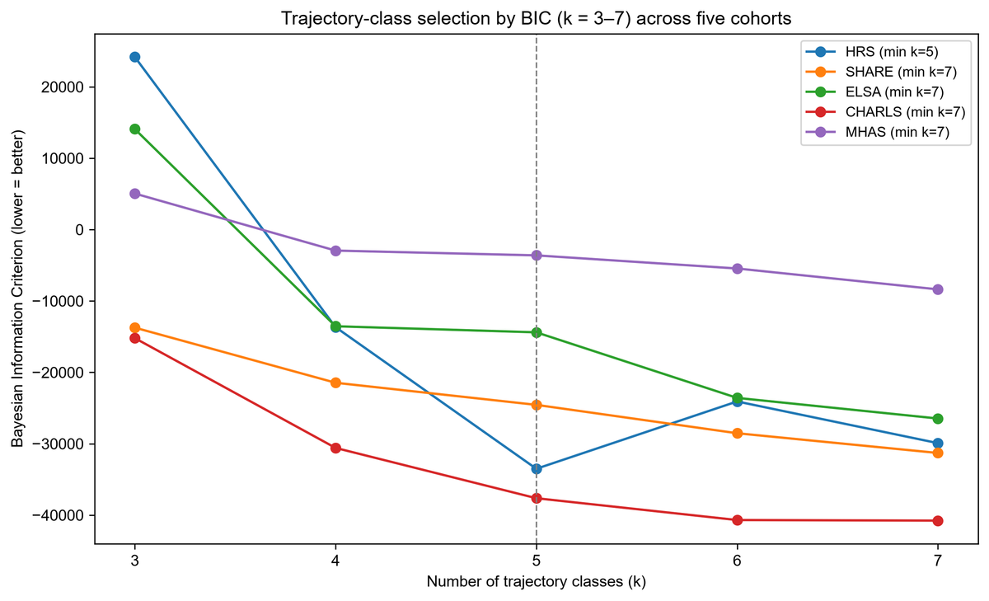
Figure S1. Bayesian Information Criterion by number of composite-burden classes (k=3–7) for each cohort. Lower is better; the dashed line marks the k=5 common-structure choice (see Table S4 for minimum class sizes).

Figure S2. Selection into complete pain-depression profiles.
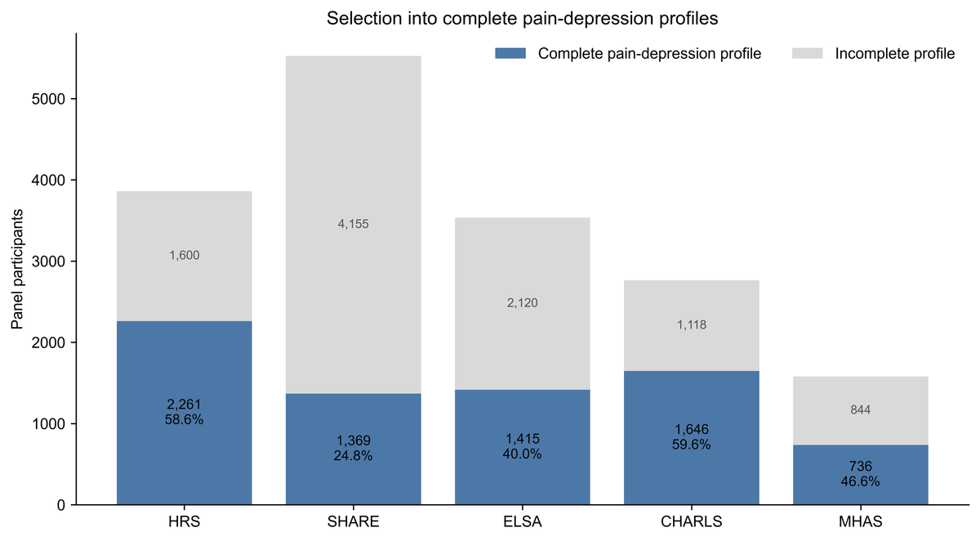
Numbers above the blue segment are retained participants and retention percentages; grey segments are excluded for incomplete pain-depression profiles. The accompanying table shows baseline differences between retained and excluded participants.
Table S5. Included versus excluded participants: baseline comparison.
Cohort | Selection group | N | Age | Female_pct | Pain_w1 | Depression_w1 | ADL_w1
HRS | Included profile | 2261 | 65.71 | 0.689 | 0.356 | 1.74 | 0.3
HRS | Excluded profile | 1600 | 75.74 | 0.644 | 0.35 | 1.93 | 0.63
SHARE | Included profile | 1369 | 64.25 | 0.713 | 0.841 | 3.06 | 0.18
SHARE | Excluded profile | 4155 | 68.76 | 0.675 | 0.849 | 3.45 | 0.32
ELSA | Included profile | 1415 | 64.7 | 0.691 | 0.65 | 1.94 | 0.45
ELSA | Excluded profile | 2120 | 69.69 | 0.607 | 0.688 | 2.43 | 0.64
CHARLS | Included profile | 1646 | 60.41 | 0.577 | 0.104 | 11.27 | 0.44
CHARLS | Excluded profile | 1118 | 64.06 | 0.623 | 0.106 | 11.54 | 0.66
MHAS | Included profile | 736 | 64.64 | 0.784 | 0.715 | 4.48 | 0.46
MHAS | Excluded profile | 844 | 70.23 | 0.699 | 0.636 | 4.48 | 0.57

Table S6. GMM classification stability across random seeds.
Cohort | N complete | Mean ARI vs seed 12 | Minimum ARI | Mean maximum posterior | Minimum class %
HRS | 2261 | 0.566 | 0.502 | 1.000 | 10.79
SHARE | 1369 | 0.663 | 0.597 | 1.000 | 4.38
ELSA | 1415 | 0.780 | 0.632 | 0.986 | 8.41
CHARLS | 1646 | 0.967 | 0.919 | 1.000 | 9.54
MHAS | 736 | 0.550 | 0.371 | 1.000 | 14.67
ARI compares class assignments from ten alternative random seeds with the seed=12 fit; maximum posterior is a within-fit certainty measure and does not replace stability assessment.

Table S7. Incident-ADL sensitivity analysis among participants without baseline ADL limitation.
Cohort | OR (95% CI) | N eligible | Events
HRS | 7.34 (5.21–10.35) | 1868 | 411
SHARE | 1.26 (0.75–2.11) | 1182 | 217
ELSA | 4.54 (2.81–7.35) | 965 | 201
CHARLS | 2.85 (1.80–4.53) | 983 | 301
MHAS | 3.77 (1.93–7.36) | 534 | 206
Pooled (RE), I2=88% | 3.44 (1.85–6.37) | 5532
Incident ADL was defined as final-wave ADL >=1 among participants with baseline ADL=0; models were adjusted for baseline age and sex.
Table S8. Selection-weighted sensitivity analysis for complete pain-depression profiles.
Cohort | Weighted OR (95% CI) | N | Profile selection rate
HRS | 8.88 (6.66–11.86) | 2259 | 58.6%
SHARE | 3.41 (1.93–6.01) | 1368 | 24.8%
ELSA | 8.26 (5.43–12.57) | 1415 | 40.0%
CHARLS | 2.87 (2.00–4.13) | 1646 | 59.6%
MHAS | 4.22 (2.41–7.41) | 736 | 46.6%
Pooled (RE), I2=87% | 5.05 (3.03–8.42) | 7424
Weights were stabilized using baseline age, sex, pain, depression, ADL and missingness indicators and trimmed at the 1st and 99th percentiles; robust standard errors were used.

Table S9. Internal incremental-prediction comparison of baseline severity and burden-class models.
Cohort | N | AUC baseline | AUC baseline+class | ΔAUC (CV5) | LR χ² | df | P
HRS | 2259 | 0.747 | 0.776 | 0.029 | 107.48 | 4 | 2.51e-22
SHARE | 1368 | 0.733 | 0.742 | 0.010 | 24.91 | 3 | 1.61e-05
ELSA | 1415 | 0.775 | 0.790 | 0.015 | 40.75 | 4 | 3.03e-08
CHARLS | 1326 | 0.687 | 0.702 | 0.015 | 31.44 | 3 | 6.85e-07
MHAS | 736 | 0.627 | 0.642 | 0.015 | 16.95 | 4 | 0.002
AUC values are five-fold out-of-fold estimates from the common complete-case sample. The likelihood-ratio test compares the combined baseline-severity-plus-class model with the baseline-severity model. This is internal validation, not external validation or clinical utility assessment.
Table S10. Sensitivity of the selection-weighted pooled estimate to propensity floors and weight trimming.
Rule | Pooled OR (95% CI) | I² | 95% prediction interval
p05_q01q99 | 5.05 (3.03–8.42) | 87% | 1.57–16.26
p01_q01q99 | 5.05 (3.03–8.42) | 87% | 1.57–16.26
p05_q05q95 | 5.05 (3.03–8.41) | 87% | 1.57–16.26
p05_q01q99: propensity floor 0.05 with 1st–99th percentile trimming; p01_q01q99: floor 0.01 with 1st–99th trimming; p05_q05q95: floor 0.05 with 5th–95th trimming. These checks address analyst choices under measured selection predictors and do not remove unmeasured selection bias.

Note: Figures 1–3 (burden-profile plots, forest plot, grouped OR bars) are presented in the main manuscript. All construction scripts and aggregate tables/figures are provided in the submission package; locally generated class assignments remain subject to cohort data-use agreements. The random-effects meta-analysis output, SPSS syntax (code/spss/) and step-by-step reproduction manual (code/reproduction_manual.md) are also provided.

