Supplementary figures: BRD2 Exon 3 (E3) and Exon 13 (E13) Gel pictures. (E3- Exon 3 & E13- Exon 13). (A, B, C – Compbined Gel pictures of Exon 3 and Exon 13), (D – Gel picture of Exon 13 alone)
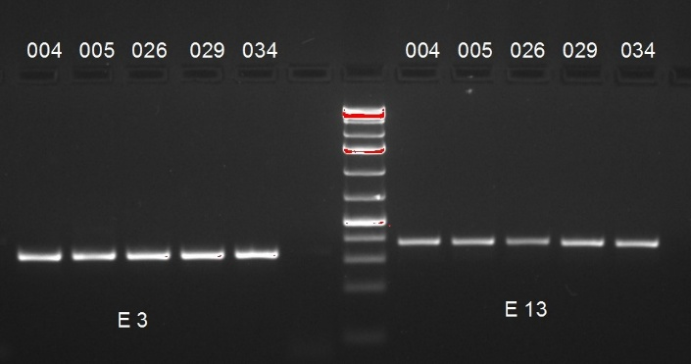
A.
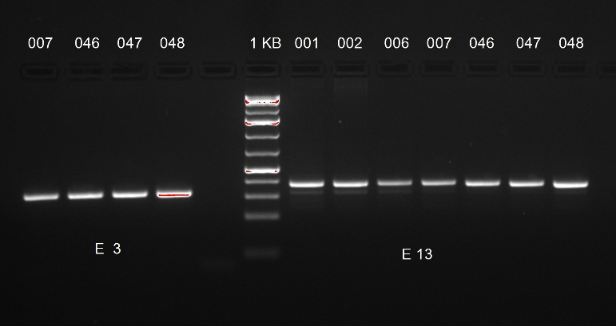
B.

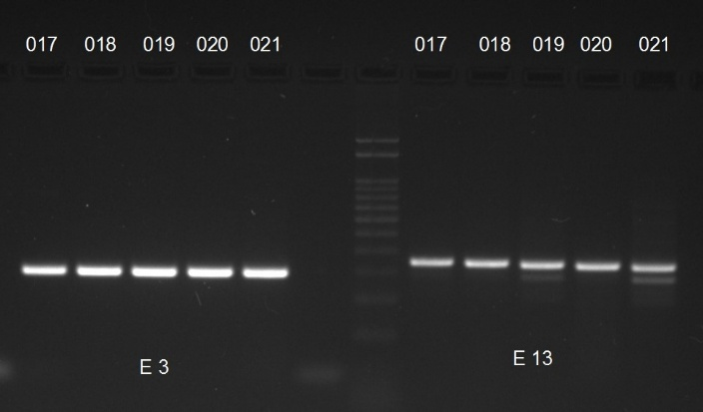
C.
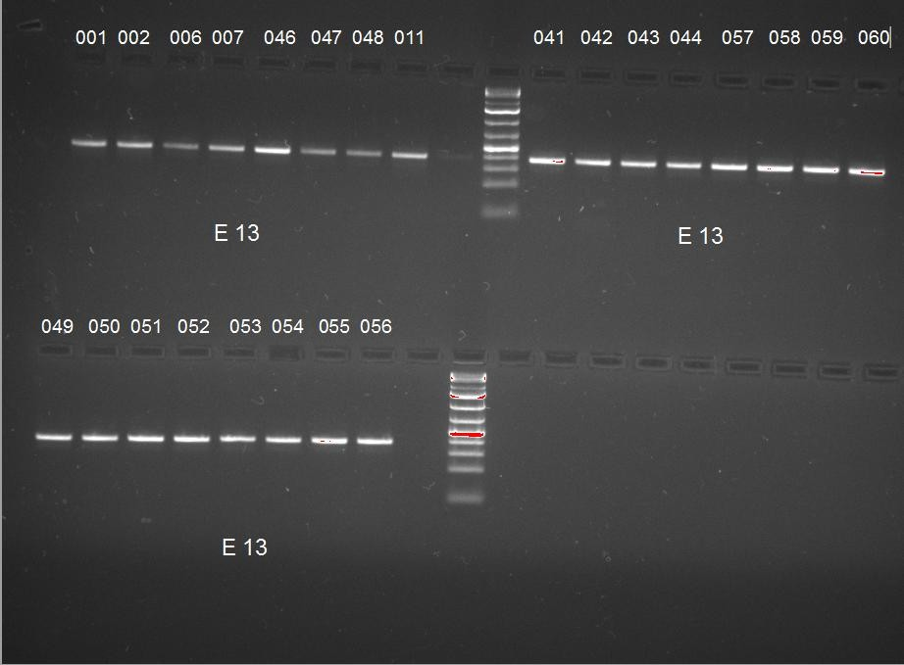
D.

