Supporting Information For
In-Situ Plasmonic Tracking Oxygen Evolution Revealing Multistage Oxygen Diffusion and Accumulating Inhibition
Jun-Gang Wangª, Lifang Shi^{c}, Yingying Suª, Liwei Liu^{c}, Jing Xie^{d}, Yang Tianª and Di Li^{* a, b}
ª School of Chemistry and Molecular Engineering, East China Normal University, Shanghai 200241, P. R. China
^{b} The Key Laboratory of Bioorganic Phosphorus Chemistry & Chemical Biology, Ministry of Education, Tsinghua University, Beijing, 100084, P. R. China
^{c} Institute of Optics and Electronics, Chinese Academy of Sciences, Chengdu 610209, P. R. China
^{d} Institute of Microelectronics, Chinese Academy of Sciences, Beijing 100029, P. R. China

Table of Contents
1. Experimental Section S3
2. Electrochemical Seed-Mediated Deposition of Cu NPs on ITO Electrode S4
3. Characterization of Electrochemical Deposited Cu NPs S12
4. Oxygen Evolution on the Cu NPs Electrodes S16
5. Principle of the Single-Wavelength Monitoring Strategy S22
6. In-situ Extinction Spectroelectrochemical Analysis S25
7. Concentration Overpotential for Oxygen Evolution Reaction S33
8. FDTD Simulation for Oxygen Evolution at the Electrode-Electrolyte Interface S39
9. Numerical Simulation for Oxygen Diffusion at the Electrode-Electrolyte Interface S40
10. Elimination of Interfacial Dissolved Oxygen at the Electrode-Electrolyte Interfaces S43
References S45

Experimental Section
Chemicals
Copper sulfate (CuSO₄, ≥ 99.5 %) was purchased from J&K Scientific Ltd. (Shanghai, China). Potassium hydroxide (KOH, ≥ 85.0 %), sodium perchlorate monohydrate (NaClO₄ H₂O, ≥ 99.0 %), potassium ferricyanide (K₃Fe(CN)₆, ≥ 99.5 %), Acetone (analytical reagent), isopropanol (analytical reagent) and ethanol (analytical reagent) and hydrofluoric acid (analytical reagent) were purchased from Sinopharm Chemical Reagent Co., Ltd. (Shanghai, China). All reagents were of analytical grade and were used as received without any further purification. The solution was prepared using deionized water. Deionized water filtered by a Milli-Q system at a resistivity of > 18.2 MΩ cm and then re-filtered by 200 nm membrane filters was used throughout the experiments. ITO-coated glass (sheet resistance 20−30 Ω sp⁻¹; 1 mm) was purchased from Shenzhen Laibao Technology Co. Ltd. (Shenzhen China).
Electrochemical Deposition of Cu NPs on ITO
The ITO-coated glass was firstly cleansed with ethanol, and washed successively in acetone, isopropanol and water with at least 30 min under sonication, and dried under a flow of nitrogen gas. Then the ITO electrodes were incubated in 0.1 M HF for 30 s and rinsed three times with copious deionized water. Subsequently, the electrodes were treated with O₂ plasmon for 5 min (Harrick, PDC-32G-II, USA).¹⁻² A saturated calomel reference electrode (SCE) was used as reference electrode, and a Pt wire was used as the counter electrode for deposition of Cu seeds and subsequent growth of Cu NPs on the ITO electrode.
For the electrodeposition of Cu NPs, a deposition solution containing 1.0 mM CuSO₄ and 0.10 M NaClO₄ was used. First, a potential step from 0.20 to - 0.60 V was applied on the deposition solution, then the open circuit potential of the ITO working electrode was changed from 0.20 to - 0.01 V (vs. SCE). The morphology of the Cu seeds and bare ITO electrode was shown in the Figure S6. Second, the as prepared Cu seeds on ITO electrode (abbreviated to Cu seeds/ITO electrode) was served as the working electrode for subsequent growth of Cu NPs in the same electrochemical cell. The growth of Cu NPs was performed by a cyclic voltammetry during a dynamic potential range from – 0.10 to – 0.30 V (vs. SCE) with different deposition cycles, at a scan rate of 0.05 V s⁻¹. Then, the as-prepared electrode (abbreviated to Cu NPs/ITO electrode) was removed from the deposition solution and rinsed copiously with deionized water. Last, the Cu NPs/ITO electrode was dried under a gentle stream of nitrogen before its utilization for gas evolution reaction.
Simulations
Full-wave electromagnetic simulation was performed on a commercial software (LUMERICAL, FDTD Solution) and finite element models (FEM) simulation was carried out by COMSOL Multiphysics 5.3a software (COMSOL Inc.) on a high-performance desktop workstation (16 G RAM). For FDTD simulations, the perfectly matched layers were used along the propagation directions and the spatial grids’ size in all axes was set to 2.0 nm. Consider the proposed model, the complex refractive index of Cu₂O, CuO and Cu(OH)₂ were taken from literatures.³⁻⁴ Both magnetic- and electric- field enhancement maps under different excitation wavelength were calculated in FDTD using frequency domain field. The extinction spectra of proposed configurations were conducted using a regular plane-wave with a pulse length of 2.6 fs. The power monitor is located in a plane 14 nm away from the metal film.

Electrochemical Seed-Mediated Deposition of Cu NPs on ITO Electrode
In classical nucleation theory, nucleation of a new solid phase on a heterogeneous interface has to overcome a free energy barrier related to the thermodynamic costs for forming a critical cluster of atoms.⁵ During electrodeposition, this nucleation energy barrier can be effectively regulated by changing the local electrochemical supersaturation at the electrode-electrolyte interface through adjusting the applied overpotential on the reduction reaction.⁶ The driving force induced by reaction, charge transfer and diffusion as well as crystallization overpotential work together on the electrodeposition process.⁷ Considering the difficulty in identification of each overpotential contribution, here we referred to nucleation (η_{n}) and growth (η_{g}) overpotential for explicit describing Cu electrodeposition (Figure S1). During initial nucleation stage, an essential prerequisite for nucleation of Cu embryos was a sufficient overpotential, which enabled to surmount the large free energy barrier (ΔG_{n}). After nucleation occurs, attributed to the lowering free energy barrier (ΔG_{g}) for the growth of Cu seeds, a lower overpotential was competent in subsequent growth process. Because of the lower free energy barrier, it was more thermodynamic favorable to introduce a Cu adatom on a Cu nuclei interface than re-nucleation on a non-homologous heterogeneous interface. Taken together the difference of the free energy barrier in both nucleation and growth, an electrochemical seed-mediated strategy enabled the efficient adjustment the Cu electrodeposition (Figure S1, a and b).
To construct the plasmonic-enhanced system, the copper seeds were firstly deposited on ITO electrode at a fixed polarization nucleation pulse (Figure 1, a, i and Figure S1, c). With the prior deposition of copper seeds, a positive shift ca. 20 mV (vs. SCE) of the reduction potential for copper ions reduction to copper reduced from – 0.12 to – 0.10 V (vs. SCE), indicating the elimination of the activation energy for Cu²⁺ reduction on the electrode (Figure S2). Hence, it provided the discrete preferential nucleation sites for subsequent copper deposition, avoiding the random heterogeneous nucleation. For achieving high copper seeds coverage, the cathodic polarization potential was optimized without the disturbance from side reaction, such as hydrogen evolution reaction. The detailed electrochemical and time-of-flight secondary ion mass spectrometry analysis was shown in Figure S3-S4. Figure S3 indicated that the amount of charge during the nucleation increased drastically accompanied by the Cu coverages reduction beyond – 0.60 V vs. SCE. It should be noted that the immoderate enhancement of polarization overpotential resulted in the co-electrolysis of Cu electrodeposition and hydrogen evolution that required extra amount charge to complete the nucleation step. Specifically, hydrogen evolution competed with the Cu nucleation and restrained the diffusion of the Cu²⁺ to the electrode surface, as indicated by the decreased diffusion coefficient of Cu²⁺ from 2.20×10⁶ cm² s⁻¹ at – 0.60 V to 1.98 ×10⁶ cm² s⁻¹ at – 0.90 V (Figure S4). In order to eliminate the co-electrocatalysis of hydrogen evolution and increase the efficiency of Cu electrodeposition, a polarization potential at – 0.6 V vs. SCE was chosen for the initial Cu nucleation and followed by a relative lower polarization potential window from – 0.10 to – 0.30 V vs. SCE for subsequent growth of the presence Cu nuclei (Figure S5).
The diffusion coefficient of Cu²⁺ during electrochemical deposition condition was acquired from Cottrell equation. In brief, the bare ITO electrode was submerged in the solution containing 1 mM CuSO₄ and 0.1 M NaClO₄ with a Pt wire counter electrode and a SCE reference electrode (Figure S4). The current transients were recorded for electrodeposition of Cu NPs by applying a potential step from 0.20 V to various termination potential (− 0.50, − 0.60, − 0.70, − 0.80 and − 0.90 V vs. SCE). The current decay was linear with t^{–1/2}, and it indicated a planar diffusion regime emerged caused by the overlapping of growing hemispherical diffusion layers, which provided mass transport for nanocrystal growth in the process of copper nucleation.⁸⁻⁹ The diffusion coefficient could be obtained from the slop of i versus t^{-1/2} plot based on the Cottrell equation:¹⁰
$i=nFA{D_{{Cu}^{2+}}}^{1/2}c_{{Cu}^{2+}}π^{-1/2}t^{-1/2}$ (2-1)
where n is the number of transferred electrons (n = 2), F is the Faraday’s constant (96485 C mol⁻¹), D_{Cu2+} and C_{Cu2+} is the diffusion coefficient and the bulk concentration of Cu²⁺ (1 mM), A is the geometric area of the bare ITO electrode 1.5 cm² (width 7.5 mm and length 20 mm). The calculated diffusion coefficient for copper electrodeposition on a bare ITO electrode under cathodic polarization potential (− 0.60 V) was 2.2×10⁻⁶ cm² s⁻¹, which was on the same magnitude compared to the diffusion coefficient of Cu²⁺ in water (5.0 ×10⁻⁶ cm² s⁻¹)¹¹ and the polarographic diffusion coefficient of copper ions (7.2 ×10⁻⁶ cm² s⁻¹).¹² Note that no remarkable initial current spine caused by the charging of the double electric layer was observed (Figure S3, a-e).
It could be concluded that the growth rate of copper nuclei was extremely rapid. The rising portion of the transient current was not experimentally accessible under our conditions, thus the estimation of the nucleation mechanism (i.e., instantaneous or progressive) of copper nanoparticles was not possible from the transient current curves.¹³ However, it was reasonable to conjecture that the electrochemical reduction process of Cu²⁺ described here experienced an instantaneous nucleation process on a bare ITO electrodes based on the fact that no noteworthy charging phase was observed.¹⁴ The electrochemical formed copper seeds exhibited higher coverage and favorable mono-dispersity than progressive nucleation, which could avoid seriously coupling of the diffusion layer of the adjacent copper nanoparticles and mitigate deteriorative inhomogeneity of the particle size.

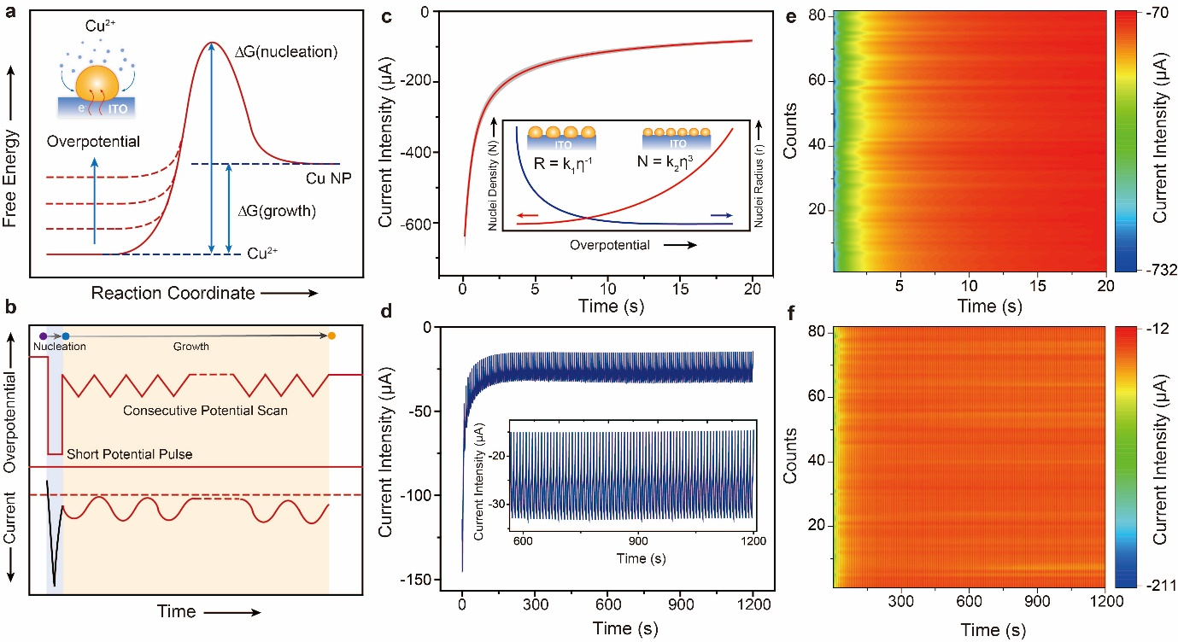
Figure S1. (a) Schematic illustration of the free energy evolution during electrodeposition of Cu NPs. The nucleation energy barrier of Cu seeds decreased with increasing of the applied overpotential. (b) Schematic of the electrochemical seed-mediated growth of Cu NPs on ITO electrode. This strategy had two main steps: firstly, the seeding step under enhanced cathodic polarization; secondly, the growth step with lower cathodic polarization. The schematic of overpotential and relative current for electrochemical deposition of Cu NPs were shown in top and bottom panel, respectively. (c) The experimental chronoamperometry profile for the seeding step at − 0.60 V (vs. SCE), 20 s. The dark region represented the standard error for five independent measurements. Inset showed schematic of the dependence of the nucleation density, nuclei radius on the applied overpotential for Cu deposition. (d) The experimental current profile for the growth step within a potential scanned ranging from − 0.10 to − 0.30 V (vs. SCE), at a scan rate of 0.05 V s⁻¹, 150 cycles. Inset showed the enlarged view of the current profile. (e) The contour plots of chronoamperometry profiles for the seeding step within independent 82 measurements. (f) The contour plots of relative current profiles for the growth step within independent 82 measurements. Both homogeneity and stability of the electrochemical seed-mediated growth of Cu NPs enabled reproducible fabrication of Cu NPs/ITO electrodes and circumvented the challenge of handling nanoparticles that were easily aggregated.

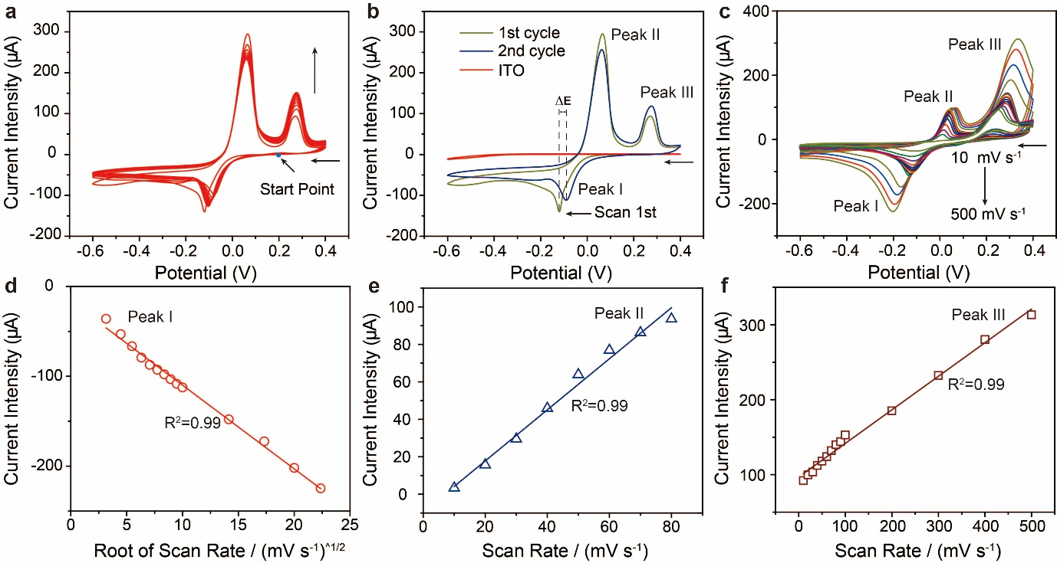
Figure S2. (a) Cylic voltammograms (CV) for electrodeposition of Cu nanoparticles on a bare ITO electrode in 1.0 mM CuSO₄ and 0.10 M NaClO₄ at a potential range from − 0.60 to 0.40 V (vs. SCE), at a scan rate of 0.05 V s⁻¹. The start potential located at 0.20 V. Owing to the Cu nanoparticles deposited on the ITO electrode, the increased electrode surface area contributed to the gradual enhancement of Cu oxidation peak current. (b) The comparison of CV curves between first cycle (green line) and the second cycle (blue line) in 1.0 mM CuSO₄ and 0.10 M NaClO₄, at a scan rate of 0.05 V s⁻¹. The control cyclic voltammetry of bare ITO electrode (red line) in 0.10 M NaClO₄, at a scan rate of 0.05 V s⁻¹. The presence of Cu nanoparticles on the ITO electrode enabled the decrease of the nucleation energy barrier which facilitated the growth of Cu nanoparticles. (c) Scan rate dependence of CV curves for a bare ITO electrode in 1.0 mM CuSO₄ and 0.10 M NaClO₄, at various scan rates 0.01, 0.02, 0.03, 0.04, 0.05, 0.06, 0.07, 0.08, 0.09, 0.10, 0.20, 0.30, 0.40 and 0.50 V s⁻¹. The cathodic peak I was assigned to the reduction of Cu²⁺ to Cu. The other two anodic peak II and III was ascribed to the oxidation of Cu to Cu⁺ and Cu to Cu²⁺, respectively. The dependence of the peak currents of peak I on the square root of the scan rate, revealing a diffusion-controlled kinetic process during reduction of Cu²⁺. Meanwhile, the dependence of the peak currents of peak II (e) and III (f) on scan rate. It indicated that both the anodic processes were involved in surface reaction-controlled manner.

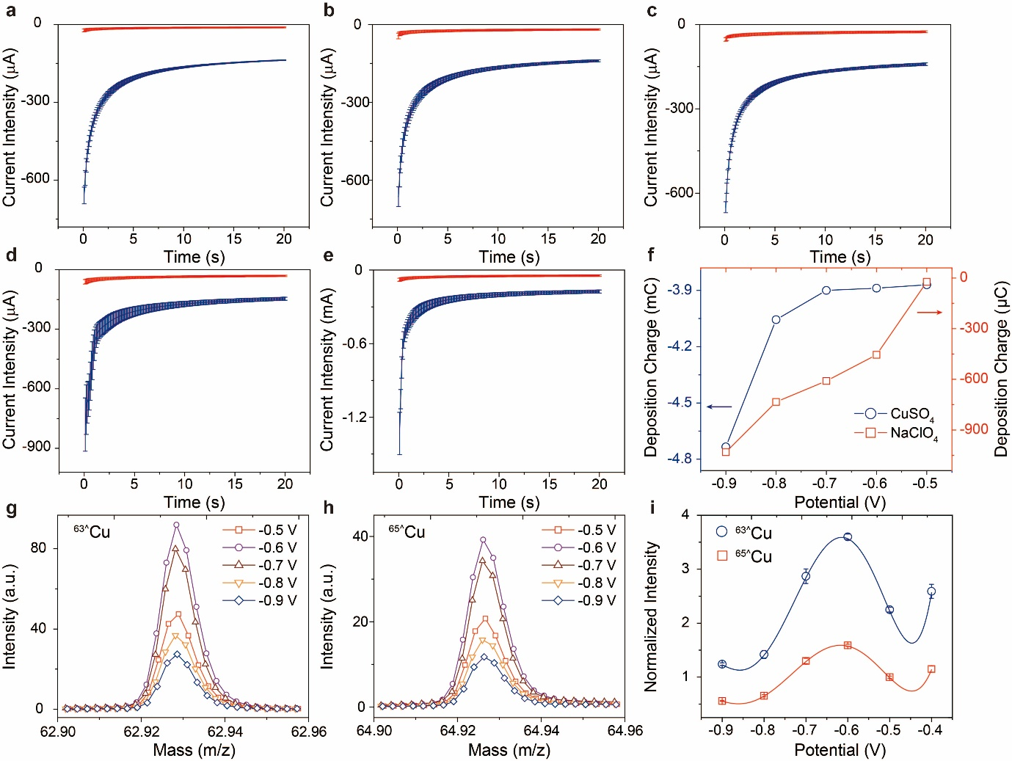
Figure S3. Transient current recorded during a potential step from 0.20 to − 0.50 V (a), − 0.60 V (b), − 0.70 V (c), − 0.80 V (d) and − 0.90 V (e) vs SCE for a bare ITO electrode in 1.0 mM CuSO₄ and 0.10 M NaClO₄ (blue line) and 0.10 M NaClO₄ (red line), respectively. The error bar represented the standard error within three independent measurements. (f) The dependence of deposition charge during chronoamperometry measurements on the applied cathodic polarized potential in 1.0 mM CuSO₄ and 0.10 M NaClO₄ (blue circle) and 0.10 M NaClO₄ (red square), respectively. The dependence of the isotopic mass peak intensity of ^{63^}Cu (g) and ^{65^}Cu (h) on the applied cathodic polarized potential. (i) The comparison between the mass intensity of ^{63^}Cu and ^{65^}Cu on the applied cathodic polarized potential. The error bar represented the standard error within three independent measurements.

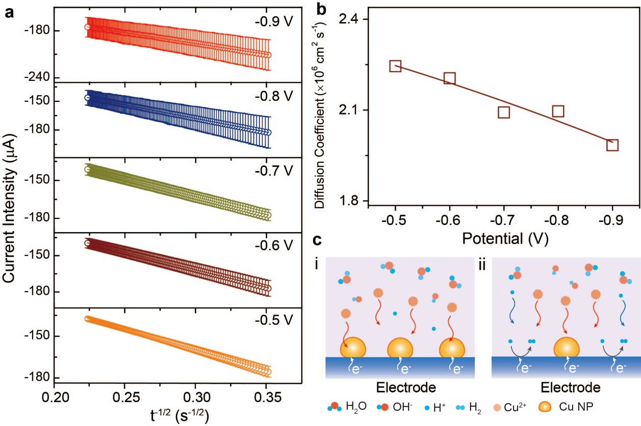
Figure S4. (a) The plots of transient current as a function of t^{-1/2} between 8 and 20 s after potential step from 0.20 V to various terminal potential (− 0.50, − 0.60, − 0.70, − 0.80 and − 0.90 vs. SCE) applied on the ITO electrode in 1.0 mM CuSO₄ and 0.10 M NaClO₄. The error bar represented the standard error within three independent measurements. (b) The diffusion coefficient of Cu²⁺ under various cathodic polarization was evaluated by using the extracted slopes of linear fitting lines shown in (a) based on Cottrell equation. The fitting line of the diffusion coefficient was used to visualize the trends. (c) Schematic of the diffusion of Cu²⁺ and subsequent cathodic nucleation of Cu NPs on the electrode surface under appropriate cathodic polarization (i). With the enhancement of cathodic polarization, the co-reduction occurrence of both Cu²⁺ and H⁺ on the electrode-electrolyte interface (ii).

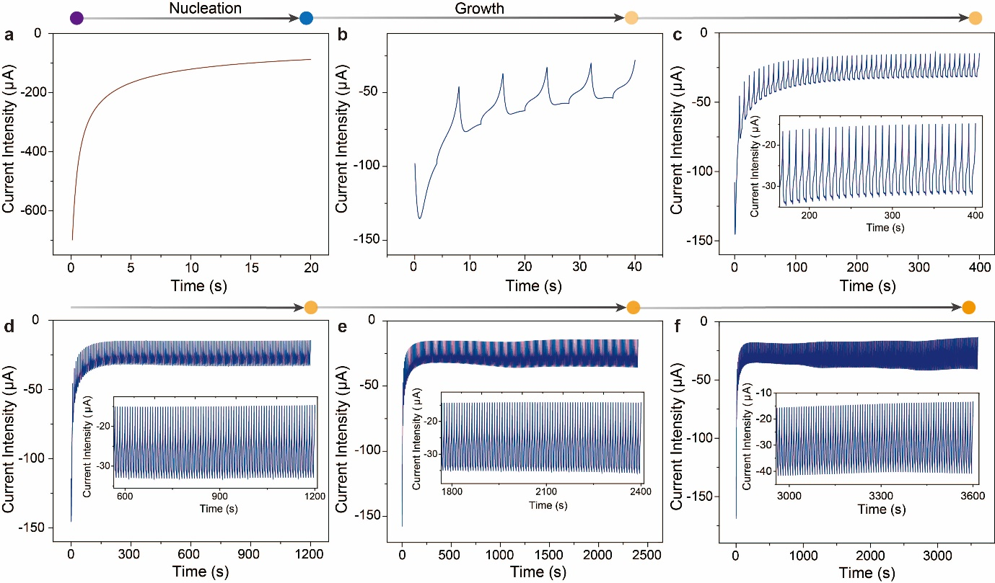
Figure S5. The experimental current profiles for the seeding step (a) and subsequent growth step within a potential scanned range from − 0.10 to − 0.30 V (vs. SCE), at a scan rate of 0.05 V s⁻¹, 5 (b), 50 (c), 150 (d), 300 (e), and 450 (f) cycles. Inset showed the enlarged view of the current profile in c-f.

Characterization of Electrochemical Deposited Cu NPs
Electrochemical seed-mediated growth of Cu NPs was adopted to fabricated plasmonic-enhanced system for single-wavelength monitoring interfacial reactions at the electrode-electrolyte interface. Owing to the enlarged nanoparticle size, the extinction cross section was increased gradually and tend to saturate after deposition 150 cycles (Figure 1, shown in main text). Therefore, the electrodes obtained by electrochemical deposition for 150 cycles were used for composition analysis and the following measurements. To provide more composition information of the electrodeposited Cu NPs, time of flight secondary ion mass spectrometry (ToF-SIMS) measurements were performed to determine that the elemental composition of the nanostructures consisted of primarily Cu (Figure S7, a). The isotope imaging of ^{63^}Cu and ^{65^}Cu on the electrode showed consistent value with the natural isotope distribution of Cu and indicated that the copper nanoparticles were homogeneously distributed on the electrode surface without obvious aggregation and agglomeration due to the emulative nucleation processes under severe cathodic polarization (Figure S7). The electrodeposited Cu nanoparticles were further characterized by powder X-ray diffraction (XRD) and despite the diffraction spectrum exhibited weak crystallinity, the characteristic diffraction peak assigned to Cu (111) facet was still recognized (Figure S7, b). Figure S7, c showed the high-resolution image of Cu NPs. The lattice fringes ca. 0.21 nm could be indexed to the Cu (111) plane of face-centered cubic Cu, which indicated that the major exposed planes were Cu (111) of face-centered cubic Cu in accordance with the above XRD results. In addition, high-angle annular dark-field imaging and energy‐dispersive X‐ray spectroscopy (EDX) analysis revealed Cu NPs possessed a nanosphere morphology with a diameter of ca. 160 nm which was agreed well with the AFM measurements (164 nm) (Figure 1). Due to the relative lower cathodic polarization window from – 0.10 to – 0.30 V vs. SCE applied for the Cu nuclei growth, it could explain the growth of the Cu NPs were mainly exposed by Cu (111) facet because of its low surface energies insufficient to facilitate the growth of high-index facets.¹⁵

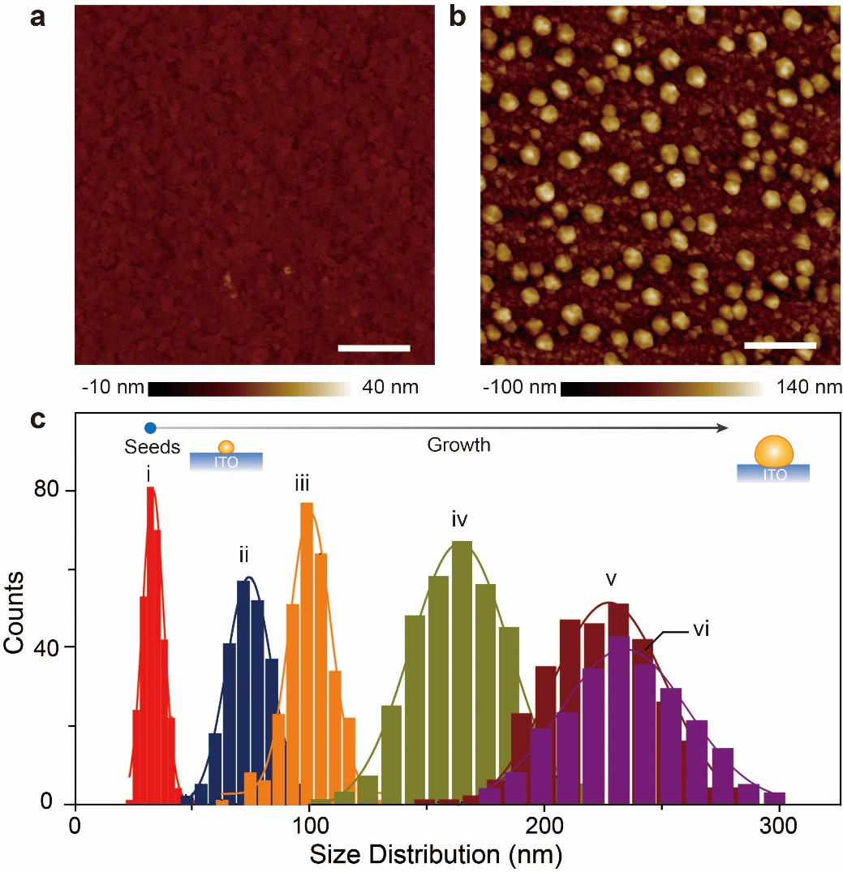
Figure S6. The AFM images of a bare ITO electrode (a) and Cu nanoparticles (b) with 450 deposition cycles (scale bar is 1 μm). (c) The size distribution of Cu seeds (i) and Cu nanoparticles at different deposition cycles (ii 5, iii 50, iv 150, v 300, and vi 450 cycles). Inset showed schematic of Cu nanoparticle structure on the ITO electrode. Note that the generation of Gaussian size distribution was caused by the fluctuations in Cu NPs growth, including the evolution of local heterogeneous diffusion layer around Cu nuclei and concurrent Ostwald ripening effect.

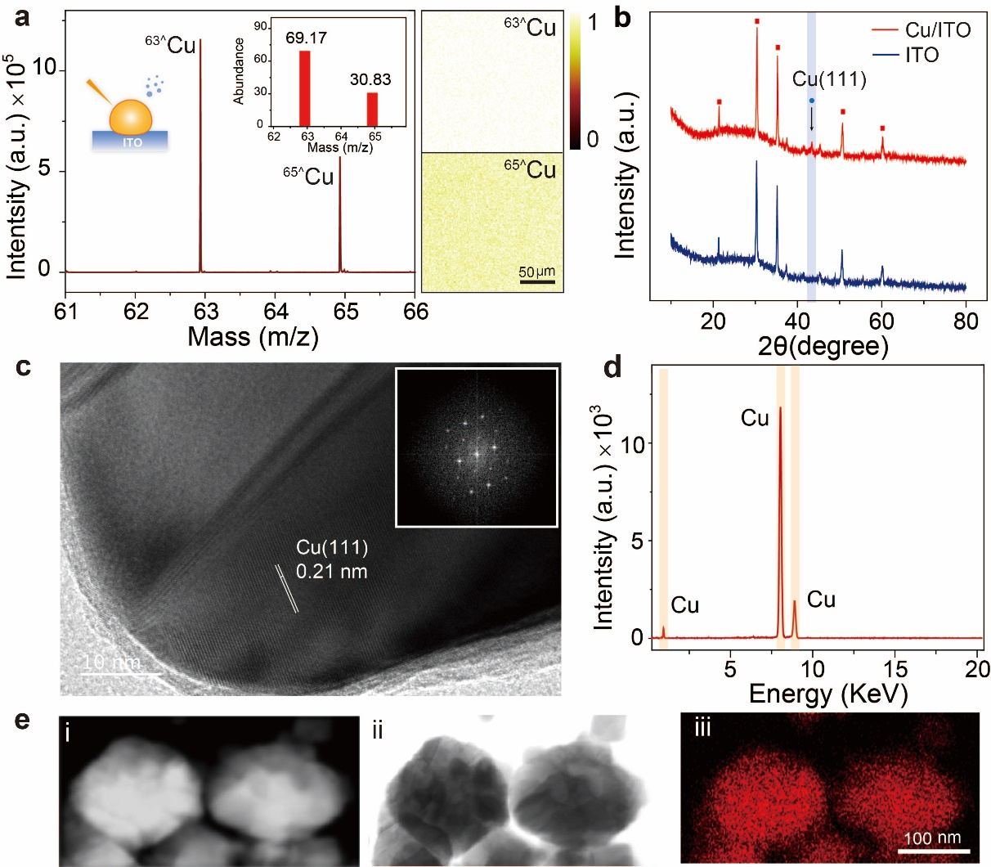
Figure S7. (a) Negative secondary ion mass spectra of Cu species on the Cu NPs/ITO electrode. The presence of Cu in the formed nanoparticle was confirmed by the isotope peaks of Copper on the ITO electrode (⁶³^Cu and ⁶⁵^Cu). It was same with the natural isotope distribution of copper (Inset). The imaging of Cu isotopes (⁶³^Cu and ⁶⁵^Cu) were shown on the right panel. The homogenous distribution of Cu isotopes indicated the homogeneity for the electrochemical deposited Cu NPs on the ITO electrode. (b) X-ray diffraction patterns of the ensemble Cu NPs/ITO electrode (red line) and bare ITO electrode (bare line). The 2θ peak at 43.3° corresponding to the (111) planes of the Cu nanoparticle (PDF 00-004-0836) was further confirmed by the HR-TEM image. (c) HR-TEM image of the electrochemical deposited Cu nanoparticles. Inset showed the corresponding fast Fourier transform (FFT) pattern of Cu (111). HR-TEM images exhibited the interplanar distances of Cu (111) lattice planes, confirming the electrochemical deposited Cu nanoparticle were mainly composed by the Cu (111) plane. (d) EDX spectrum of the ensemble Cu nanoparticles. (e) High-angle annular dark-field imaging image (i), HR-TEM image (ii) and EDX mapping (iii) of electrochemical growing Cu NPs.

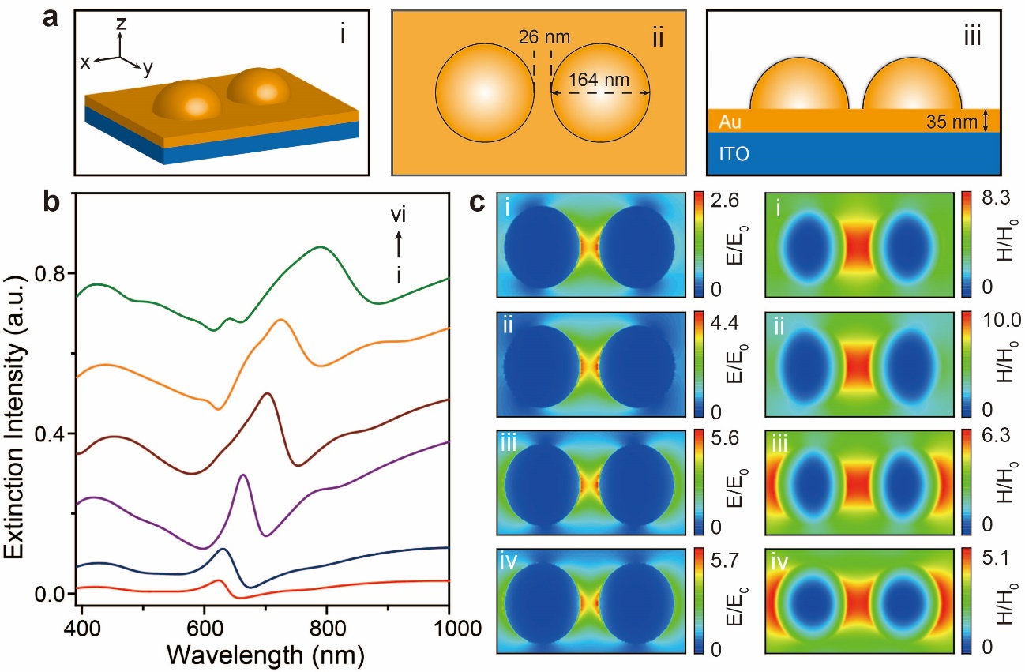
Figure S8. (a) Schematic of proposed plasmonic-enhanced system. (i) Schematic of the plasmonic-enhanced system consisting of the Cu nanoparticles, Cu thin film, and ITO electrode. (ii) Top-view of the representative standalone plasmonic structure with geometric parameters. (iii) Cross-sectional side-view of the device. (b) Simulated extinction spectra of a standalone Cu dimer and thin film on an ITO substrate. The diameter of the nanodimer was set to 34, 74, 100, 164, 227, 234 nm from i to vi, with a 35 nm thickness and 26 nm gap in between. (c) Top-view electric (i-iv, left panel) and magnetic (i-iv, right panel) field snapshots for the near field confinement at the relative plasmonic resonance wavelengths (i: 900 nm, ii: 800 nm, iii: 500 nm, and iv: 400 nm) in Figure 1d.

Oxygen Evolution on the Cu NPs Electrodes
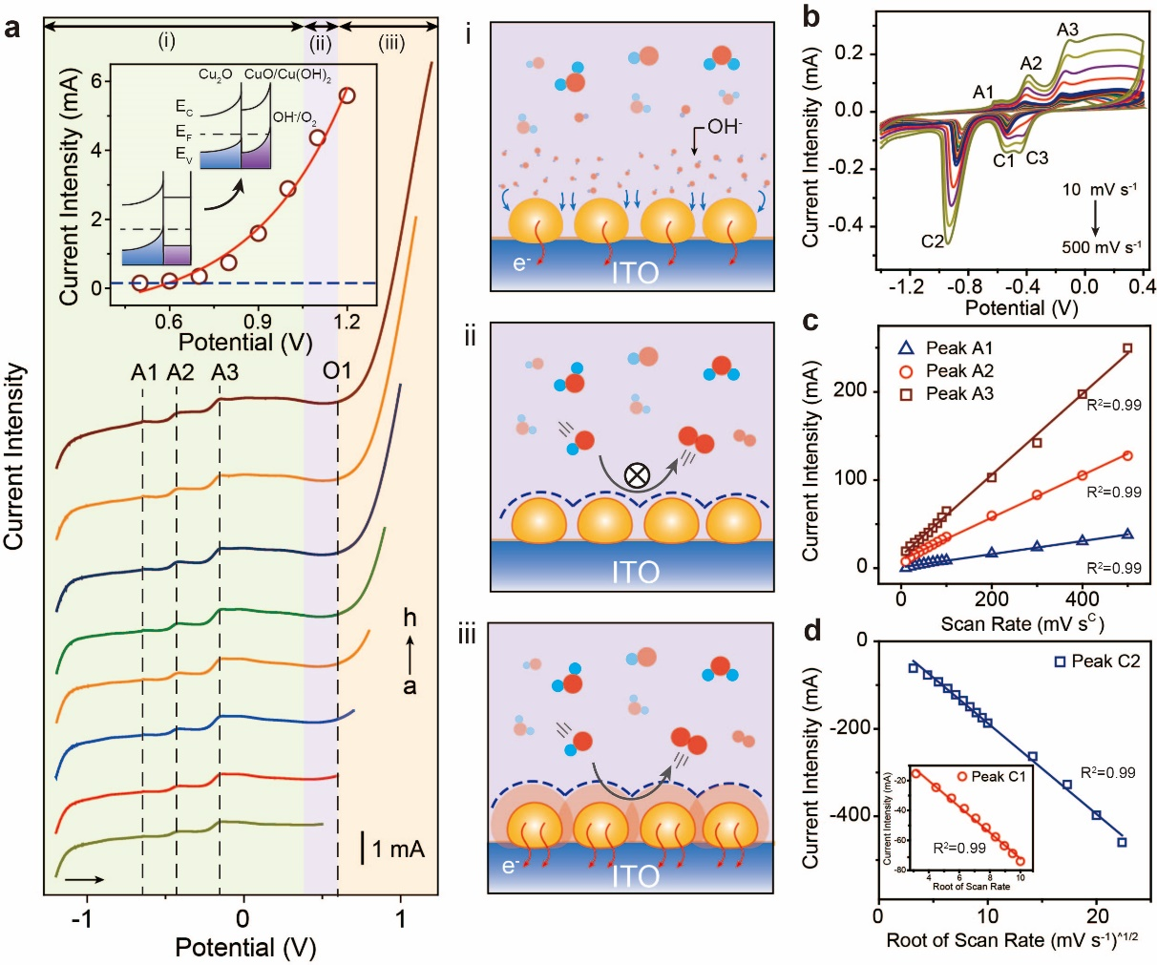
Figure S9. Oxygen evolution reaction on Cu NPs electrode. (a) The linear scan curves for a Cu NPs/ITO electrode in 0.10 M KOH solution with various termination potential (a-h: 0.50, 0.60, 0.70, 0.80, 0.90, 1.00, 1.10 and 1.20 V), at a scan rate of 0.01 V s⁻¹ (the graphs were vertically shifted for ease of comparison). Inset: the band gap transition in the transpassive region. The schematic illustrations of various interfacial processes during oxygen evolution reaction (i-iii). (b) Scan rate dependence of CV curves for a Cu NPs/ITO electrode in a solution of 0.10 M KOH. Scan rate: 0.01, 0.02, 0.03, 0.04, 0.05, 0.06, 0.07, 0.08, 0.09, 0.10, 0.20, 0.30, 0.40, and 0.50 V s⁻¹. (c) The dependence of anodic peak current at peak A1, A2, and A3 on scan rate. (d) The dependence of cathodic peak current at peak C1 and C2 on the square root of the scan rate.

Linear potential scan measurements were used to track dynamic interfacial processes at the EEIs (Figure S9). The dynamic interfacial process exhibited three characteristic regions with increasing potential: (1) At the interface active region (< 0.30 V vs. Pt unless otherwise stated, all the potential referenced to a Pt quasi-reference electrode), the process of OH⁻ adsorption took place, assigning to the peak located at − 0.63 V (peak A1). With the increasing of potential to greater than − 0.39 V, the adsorbed phase on the copper surface eventually reconstructed, resulting in the formation of a Cu₂O layer, which was indicated by the presence of peak A2.¹⁶ With further enhancement in anodic polarization, the arising of broad peak A3 was attributed to the accompaniment of both electrooxidation of Cu(I) to Cu(II) and the formation of CuO and Cu(OH)₂ (Region i, a detailed kinetic analysis shown in Figure S9); (2) At the interfacial passive region (0.30 V ~ 0.60 V), the formation of a thicker and complex Cu oxides and hydroxides passive film restrained the interfacial oxidation, and no obvious catalytic activity towards oxygen evolution was observed (Region ii); (3) At the interfacial transpassive region (> 0.60 V), the gradually enhanced dehydration process accompanied by a structural transformation from an amorphous to a crystalline structure, providing an electron-conductive pathway for oxygen evolution (Region iii). The crossing of the CuO/Cu(OH)₂ layer valence band and the Fermi level caused an enrichment of positive holes in this transpassive region, that significantly improved the oxygen evolution efficiency (Figure S9, a inset). The proposed interfacial reaction mechanisms on Cu NPs electrode in alkaline solution were expressed as:
$Cu+{OH}^{-}→{Cu(OH)}_{ad}+e^{-}$ (4-1)
$2Cu+2{OH}^{-}→{Cu}_{2}O+H_{2}O+2e^{-}$ (4-2)
${Cu}_{2}O+H_{2}O+2{OH}^{-}→2{Cu(OH)}_{2}+2e^{-}$ (4-3)
${Cu}_{2}O+2{OH}^{-}→2CuO+H_{2}O+2e^{-}$ (4-4)
${Cu(OH)}_{2}→CuO+H_{2}O$ (4-5)
The influence of the sweep rate on both anodic and cathodic polarization was shown in Figure S9, b. The cathodic peaks C1 was assigned to the electrochemical reduction of CuO to Cu₂O. The other peak C2 was caused by the simultaneous reduction of both Cu₂O and CuO to Cu.¹⁷ During kinetic analysis, a linear relationship between anodic peak currents and the scan rate indicated a surface reaction controlled kinetic in anodic processes (Figure S9, b, Peak A1, A2 and A3). Meanwhile, the cathodic processes (Peak C1 and C2) exhibited a linear function as the square root of the scan rates, indicating a diffusion-controlled mass transport in these processes (Figure S9, c). Interestingly, a gradually emerging cathodic peak located at − 0.45 V was found at relative high scan rate (> 0.20 V s⁻¹) which was assigned to the reduction from Cu(OH)₂ to Cu₂O. Taken together with kinetic analysis of interfacial reactive species, the linear scan voltammetry enabled to reasonably elucidate their compositions and distinguish controlled manner of interfacial reactions under polarization.
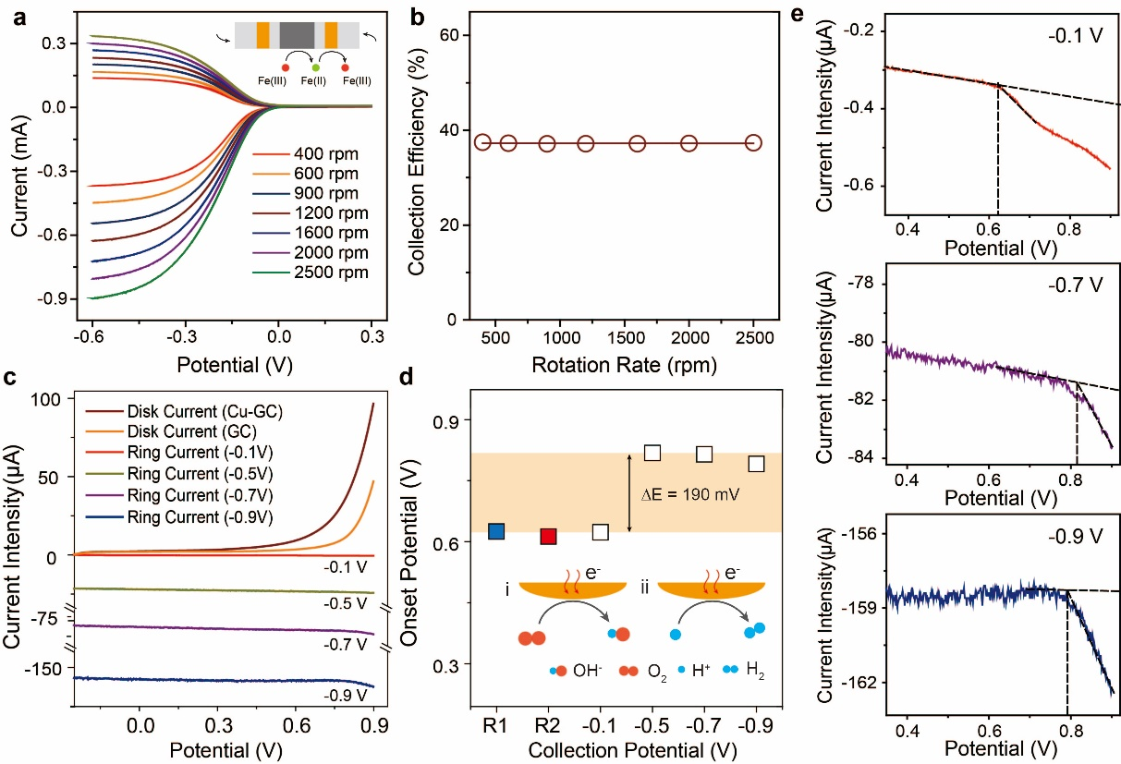
Figure S10. The evaluation of the apparent ring collection efficiency for a glass carbon-disc and Pt-ring RRDE. (a) The CVs of the glass carbon-disc in 0.10 M KOH solution containing 5 mM K₃[Fe(CN)₆] at 0.01 V s⁻¹ under different rotation rates (400, 600, 900, 1200, 1600, 2000 and 2500 rpm). Inset showed schematic of the estimation for the ring collection efficiency of a glass carbon-disc and Pt-ring RRDE. (b) The corresponding disk and ring current ratio (the apparent ring collection efficiency = I_{r}/I_{d}) at ring potential 0.30 V (vs Pt). (c) The linear scan curves for OER on a Cu NPs/GC disc electrode and the collection current curves at various collection potential on a Pt ring electrode. (d) The comparison of onset potential for RRDE experiments at different collection potentials and conventional linear scans for a Cu NPs/ITO (R1, blue square) and a Cu NPs/GC (R2, red square) electrode. Inset: the competing reaction of proton reduction during oxygen reduction. (e) The representative onset potential for collection of electrochemical generated oxygen on the Pt collection electrode at − 0.10, − 0.70 and − 0.90 V.

In order to estimate the collection efficiency of the RRDE, the reversible single electron transfer reaction of ferrocyanide/ferricyanide (Fe(CN)₆³⁻/Fe(CN)₆⁴⁻) was used as the model reaction. With the potential of the disc working electrode scanning toward to the cathodic polarized direction, the increased cathodic current was assigned to the reduction of the ferricyanide to ferrocyanide at the disc working electrode (generator). The oxidation current for products oxidation was instantaneous collected on the ring electrode (collector).
${Fe(CN)}_{6}^{3-}+e^{-}→{Fe(CN)}_{6}^{4-}$(Generator)
${Fe(CN)}_{6}^{4-}→{Fe(CN)}_{6}^{3-}+e^{-}$(Collector)
Hence the empirical collection efficiency (N_{e}) was estimated based on the limiting current ratio of the ring and disc. Both the cathodic and anodic limiting currents were proportional to the square root of the scan rate, the evident increase of both generator and collector currents were observed (Figure S10, a). Owing to the independence of empirical collection efficiency on the rotation rate, the estimated empirical collection efficiency ca. 37 % was nearly constant under different rotation rate (Figure S10, b).
We further performed rotating-ring disc electrode (RRDE) measurements to collect oxygen at various polarization potentials to explore more insights into OER. We found that at collection potential − 0.10 V vs. Pt, the collected current on Pt ring electrode showed negligible cathodic current only noticeable increasing beyond 0.60 V which was assigned to the oxygen reduction and indicated an onset potential at 0.60 V of oxygen evolution at the disk electrode. It was consistent with the value extracted from the linear potential scan results (Figure S9, a). As decreasing the collection potential, the coupled reactions via co-electrolysis of protons on the Pt ring electrode restrained OER performance and resulted in a negative shift of ca. 0.19 V in the onset potential of OER (Figure S10). We emphasized that the deterioration in the onset potential for oxygen collection suggested a significant exacerbated competing reaction kinetic between the oxygen and proton reduction. Furthermore, the polarization current increased ca. 69.5 times from − 0.10 to − 0.90 V indicated the evident enhancement in the hydrogen evolution reaction (HER) rate. Such an increased cathodic polarization on this scale resulted in a significant rise in interfacial reaction rates of competing hydrogen evolution reaction assuming the reaction was kinetically controlled.¹⁸⁻²¹ Similar results were observed in co-electrolysis of protons with the addition of O₂, which provided direct evidence for the presence of oxygen in RRDE experiments.²² Such significant suppression for oxygen collection by competing co-electrolysis reaction hampered the accurate identification of oxygen at the EEIs.

Principle of the Single-Wavelength Monitoring Strategy
The plasmonic properties of metal nanoparticles can be described by solving the Maxwell equation using classical electrodynamic Mie theory.²³⁻²⁴ According to Mie theory, the analytical solution to the scattered fields generated by a plane wave incident on a homogeneous plasmonic nanoparticle leaded to the extinction, scattering and absorption cross-section²⁵⁻²⁶: the general expressions for the scattering and extinction cross sections from the Mie theory can be expressed as
$σ_{ext}=\frac{2π}{{\left|k\right|}^{2}}\sum_{L=1}^{∞}{(2L+1)}Re\left[a_{n}+b_{n}\right]$ (5-1)
where k is the incoming wavevector and L are integers corresponding to the diploe, quadrupole and hexapole contributions etc. Here, the a_{L} and b_{L} composed of the Riccati-Bessel functions are given by:
$a_{L}=\frac{{{mΨ}_{L}(mx)Ψ_{L}^{'}(x)-Ψ}_{L}^{'}(mx)Ψ_{L}(x)}{{{mΨ}_{L}(mx)ζ_{L}^{'}(x)-Ψ}_{L}^{'}(mx)ζ_{L}(x)}$ (5-2)
$b_{L}=\frac{Ψ_{L}(mx)Ψ_{L}^{'}(x){-mΨ}_{L}^{'}(mx)Ψ_{L}(x)}{Ψ_{L}(mx)ζ_{L}^{'}(x)-mΨ_{L}^{'}(mx)ζ_{L}(x)}$ (5-3)
where m=n_{n}/n_{m}, n_{n} and n_{m} is the refractive index of the nanoparticle and surrounding medium, respectively. And x = Rk_{m}, R is the radius of the nanoparticle, k_{m} is the wavenumber of incident light. When the size of the plasmonic nanoparticles is relative smaller than the wavelength of the incident light, taking into account the contribution from dipole term, the extinction cross-section of the plasmonic particle can be given by:
$σ_{ext}(ω,R)=18π\frac{ωVε_{m}^{3/2}}{c}\frac{ε_{2}(ω,R)}{[ε_{1}(ω,R)+2ε_{m}]^{2}+ε_{2}(ω,R)^{2}}$ (5-4)
where c is the speed of the light and R is the radius of the nanoparticle, V is the volume of the nanoparticle, ω is the frequency of the incident light and ε_{m} is the dielectric constant of the surrounding medium, ε is the dielectric constant of the nanoparticle, ε = ε₁ + iε₂. ε₁ and iε₂ are real and complex parts of the material dielectric constant, respectively.²⁵ Based on this equation, the optical properties of the plasmonic nanoparticles can be engineered by tuning their size and dielectric properties of the surrounding and material of the nanoparticle.²⁷ The extinction cross-section will increase when the medium’s dielectric function decrease. The dependence of the LSPR extinction cross-section on the surrounding dielectric environment enables the ultrasensitive detection of the minor changes in surrounding medium. Note that the plasmonic extinction cross-section is proportion to a negative half power of dielectric function of surrounding medium. Conventionally, the plasmonic sensing application is to detect changes in the bulk refractive index of surrounding environment by monitoring the LSPR peak wavelength shifts through spectroscopic extinction measurements (eq. 5-5 and 5-6).
$ω_{max}=\frac{ω_{p}}{\sqrt{2ε_{m}+1}}$ (5-5)
$λ_{max}=λ_{p}\sqrt{2n_{m}^{2}+1}$ (5-6)
where ω_{max} is the LSPR peak frequency and ω_{p} is the plasma frequency of the bulk metal. The λ_{max} and λ_{p} corresponding to the wavelength of LSPR peak and the plasma frequency of the bulk metal. Here, the λ = 2πc/ω and the relationship between dielectric constant and index of refraction ε_{m} = n². Hence, the LSPR peak wavelength shift is approximately linear with changes in refractive index of the surrounding medium over small ranges of n.²⁶ For collection full extinction spectra, the monochromator and grating as well as multichannel photodetector are essential to identify the plasmonic peak shifts. In order to facilitate the in-situ spectroscopic monitoring interfacial electrochemical reactions, the single-wavelength extinction monitoring strategy was developed with superior sensitivity for electrochemical reactions on the EEIs and eliminated the necessity for intricate optical apparatuses.
Figure 3c showed a schematic relationship between extinction (I), potential (E) and wavelength (λ) (I-λ–E plot) for a plasmonic nanoparticle, where the extinction axis was vertical to the sheet. During the dynamic potential scan, the interfacial processes at the EEIs induced the fluctuation of the refractive index nearby the electrode surface, which leaded to a systematic transition from original state (S1, I₁–λ₁–E₁) to reaction condition (S2, I₂–λ₂–E₂). With known the relationship between the refractive index and the extinction peak intensity at a certain wavelength, it enabled the optical probing interfacial electrochemical reactions on the electrode surface which constituted by plasmonic components. As the interfacial reaction proceeding, the fluctuation of the confined products concentration resulted in a remarkable change of the refractive index around the plasmonic elements, which contributed significantly to the dynamics in extinction spectra. For instance, the electrochemically generated gas phase species on the plasmonic elements excluded the surrounding electrolyte and decreased the refractive index. It resulted in a prominent enhancement of its extinction intensity at a constant λ. Of note, the plasmonic elements in our system not only served as the electrochemical catalytic active sites for electrochemical reaction, but also as the optical module for signal transduction in which electrochemical reaction information was convert to remarkable optical signal. Therefore, based on the fluctuation of the extinction intensity at a constant λ during dynamic potential scan, it enabled ultrasensitive feedback of the interfacial reaction information on the EEIs.

In-situ Extinction Spectroelectrochemical Analysis
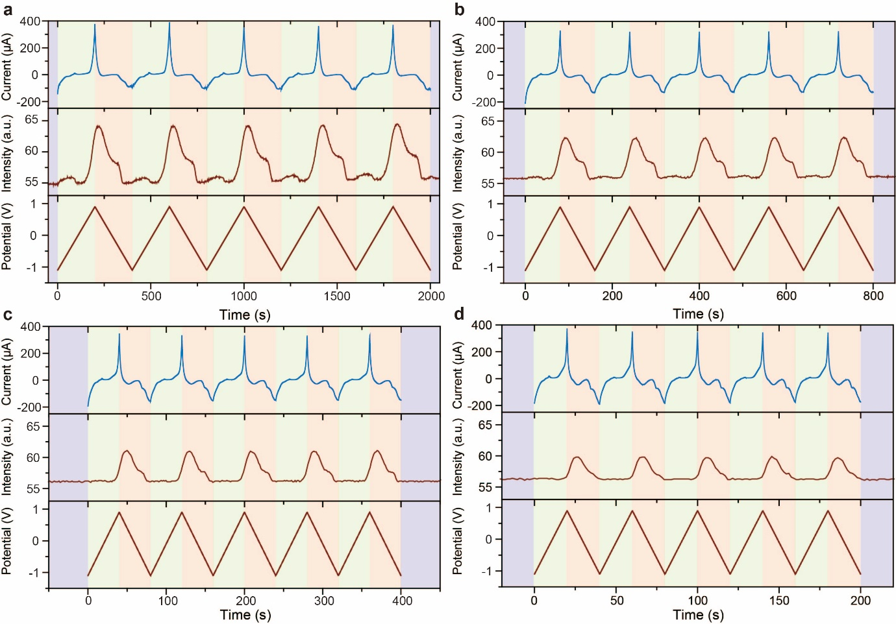
Figure S11. Consecutive CV curves (top panel) and in-situ extinction voltammetry (middle panel) for a Cu NPs/ITO electrode in 0.10 KOH solution for oxygen evolution reaction in potential range from − 1.10 to 0.90 V vs Pt, at various scan rates 0.01, 0.025, 0.05 and 0.10 V s⁻¹. The applied triangle wave type potential versus time during scan shown in bottom panel.

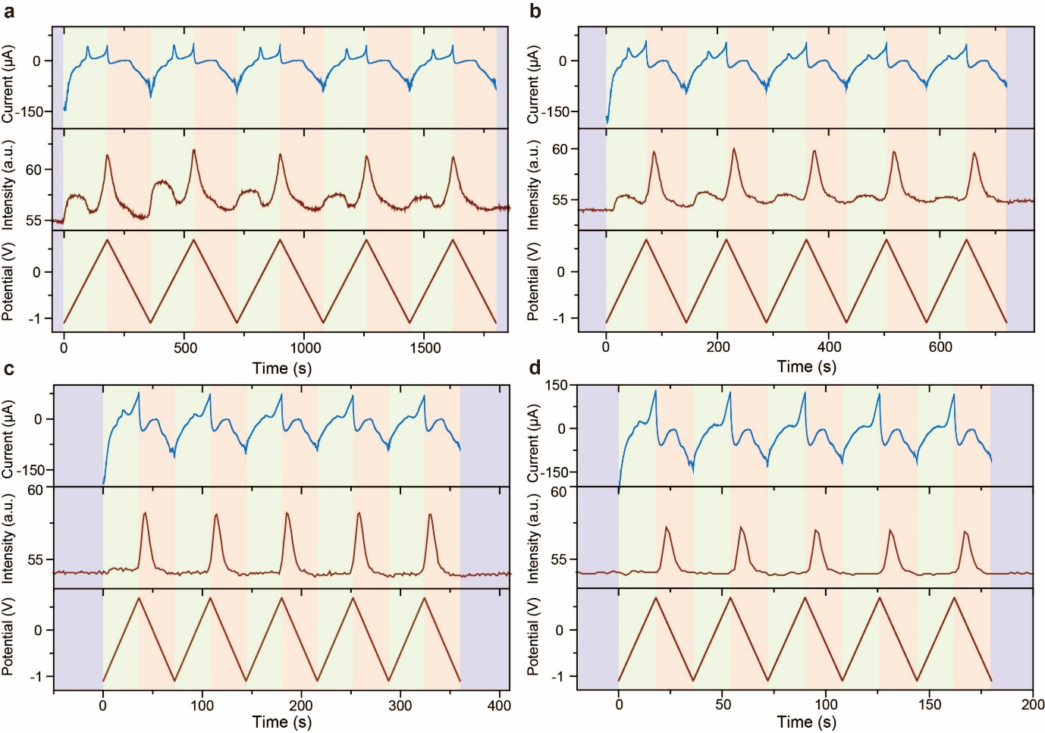
Figure S12. Consecutive CV curves (top panel) and in-situ extinction voltammetry (middle panel) for a Cu NPs/ITO electrode in 0.10 KOH solution for oxygen evolution reaction in potential range from − 1.10 to 0.70 V vs Pt, at various scan rates 0.01, 0.025, 0.05 and 0.10 V s⁻¹. The applied triangle wave type potential versus time during scan shown in bottom panel.

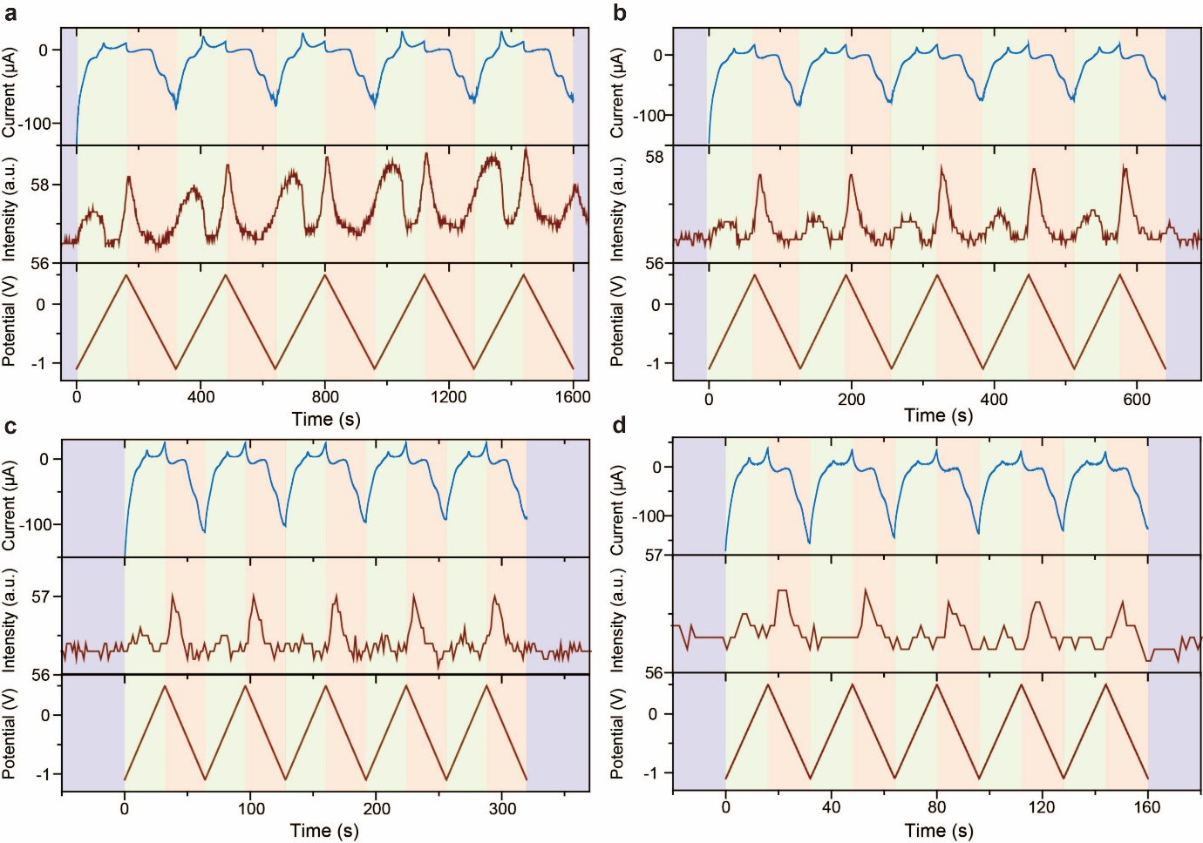
Figure S13. Consecutive CV curves (top panel) and in-situ extinction voltammetry (middle panel) for a Cu NPs/ITO electrode in 0.10 KOH solution for oxygen evolution reaction in potential range from − 1.10 to 0.50 V vs Pt, at various scan rates 0.01, 0.025, 0.05 and 0.10 V s⁻¹. The applied triangle wave type potential versus time during scan shown in bottom panel.

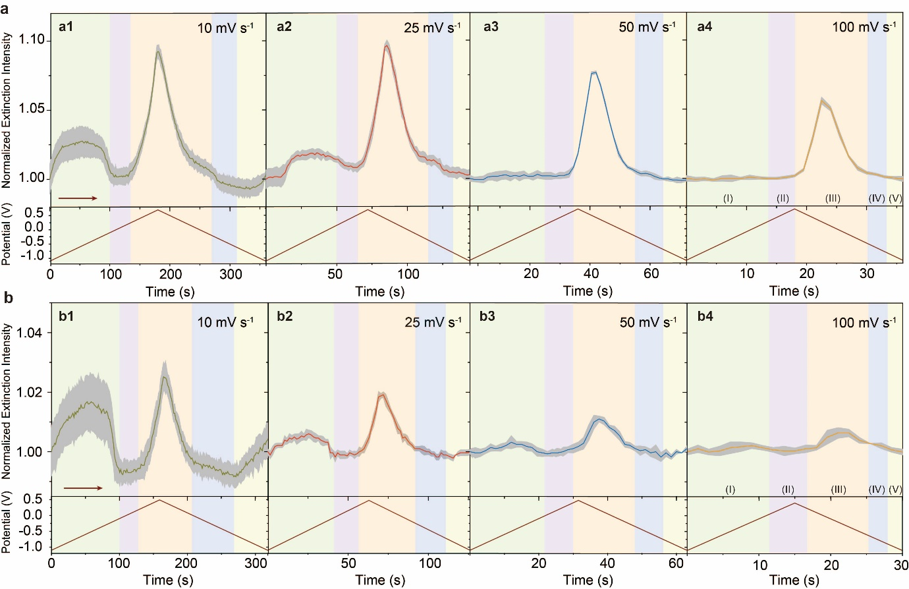
Figure S14. (a) In-situ extinction profiles for a Cu NP/ITO electrode in 0.10 KOH solution for oxygen evolution reaction in potential range from − 1.10 to 0.70 V vs Pt, at various scan rates 0.01 (a1), 0.025 (a2), 0.05 (a3) and 0.10 (a4) V s⁻¹. (b) In-situ extinction profiles for a Cu NP/ITO electrode in 0.10 KOH solution for oxygen evolution reaction in potential range from − 1.10 to 0.50 V vs Pt, at various scan rates 0.01 (b1), 0.025 (b2), 0.05 (b3) and 0.10 (b4) V s⁻¹. The dark region represented the standard error during consecutive five potential scan.

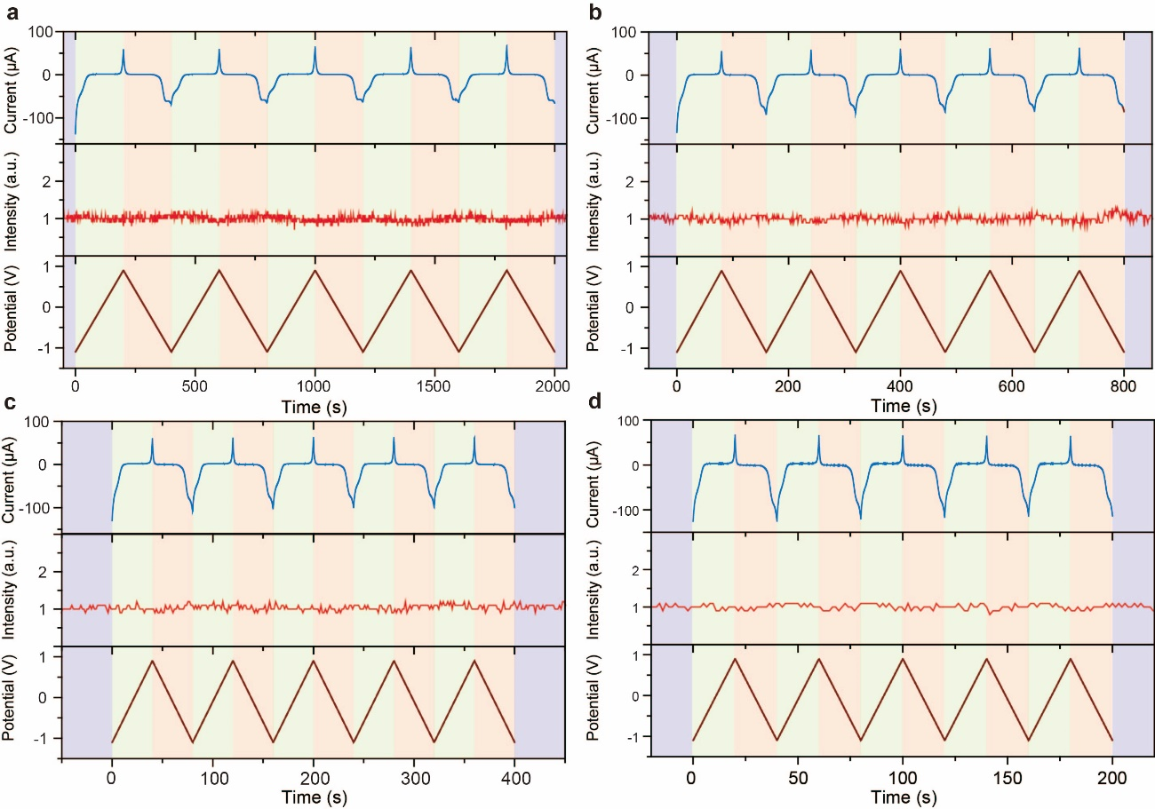
Figure S15. Consecutive CV curves (top panel) and in-situ extinction voltammetry (middle panel) for a bare ITO electrode in 0.10 KOH solution for oxygen evolution reaction in potential range from − 1.10 to 0.90 V vs Pt, at various scan rates 0.01, 0.025, 0.05 and 0.10 V s⁻¹. The applied triangle wave type potential versus time during scan shown in bottom panel.

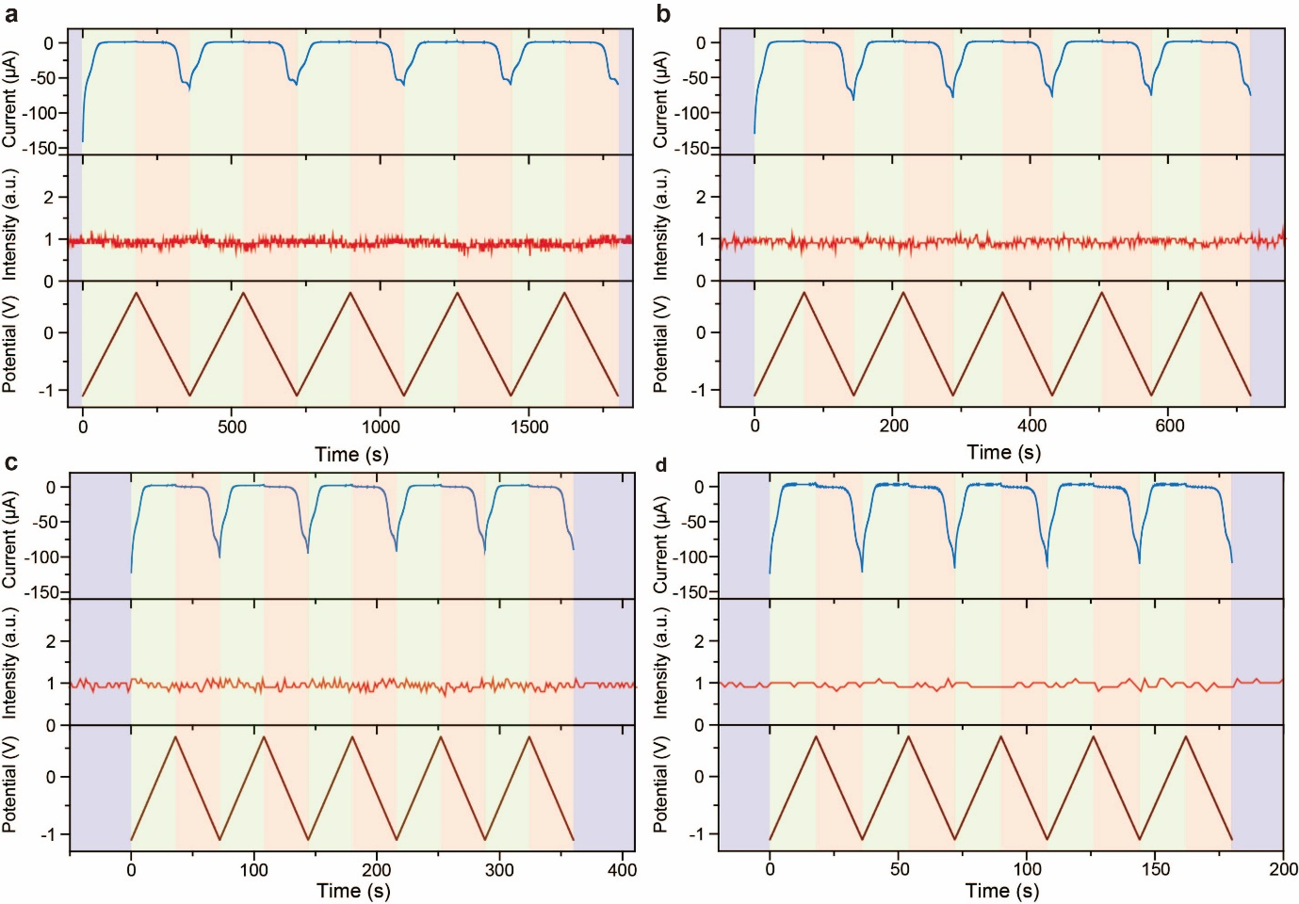
Figure S16. Consecutive CV curves (top panel) and in-situ extinction voltammetry (middle panel) for a bare ITO electrode in 0.10 KOH solution for oxygen evolution reaction in potential range from − 1.10 to 0.70 V vs Pt, at various scan rates 0.01, 0.025, 0.05 and 0.10 V s⁻¹. The applied triangle wave type potential versus time during scan shown in bottom panel.

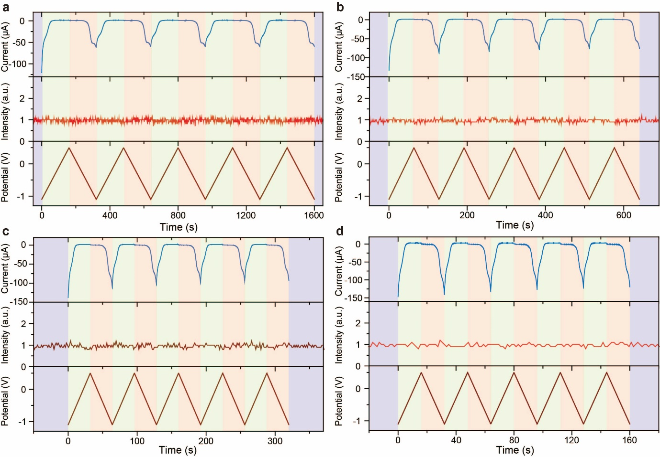
Figure S17. Consecutive CV curves (top panel) and in-situ extinction voltammetry (middle panel) for a bare ITO electrode in 0.10 KOH solution for oxygen evolution reaction in potential range from − 1.10 to 0.50 V vs Pt, at various scan rates 0.01, 0.025, 0.05 and 0.10 V s⁻¹. The applied triangle wave type potential versus time during scan shown in bottom panel.

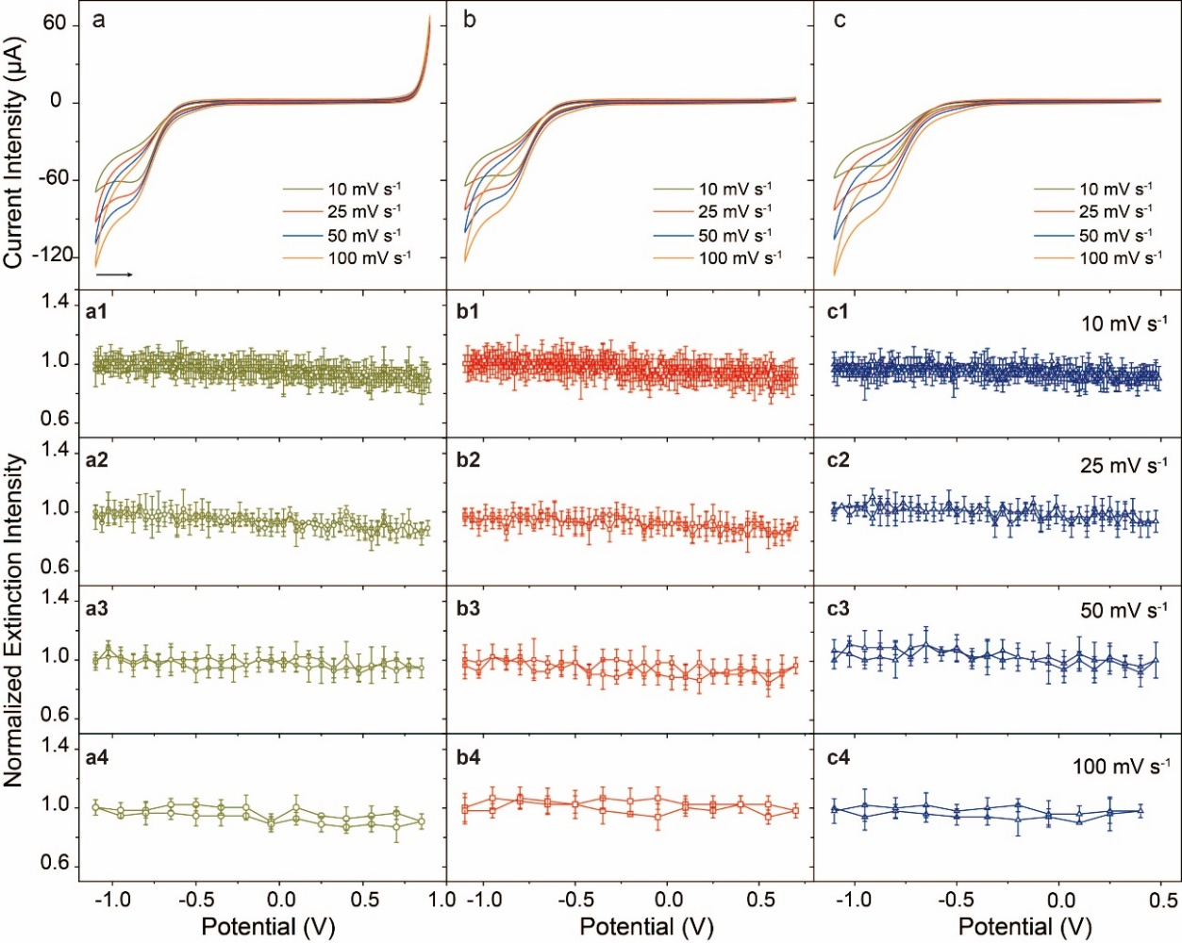
Figure S18. CV curves for a bare ITO electrode in 0.10 KOH solution for oxygen evolution reaction in potential range from − 1.10 to 0.90 V vs Pt, at various scan rates 0.01 (a1), 0.025 (a2), 0.05 (a3) and 0.10 (a4) V s⁻¹; − 1.10 to 0.70 V vs Pt, at various scan rates 0.01 (b1), 0.025 (b2), 0.05 (b3) and 0.1 (b4) V s⁻¹; − 1.10 to 0.5 0V vs Pt, at various scan rates 0.01 (c1), 0.025 (c2), 0.05 (c3) and 0.10 (c4) V s⁻¹. The error bar represented the standard error during consecutive five potential scan. The corresponding CV curves at different potential scan range were shown in (a), (b) and (c), respectively.

Concentration Overpotential for Oxygen Evolution Reaction
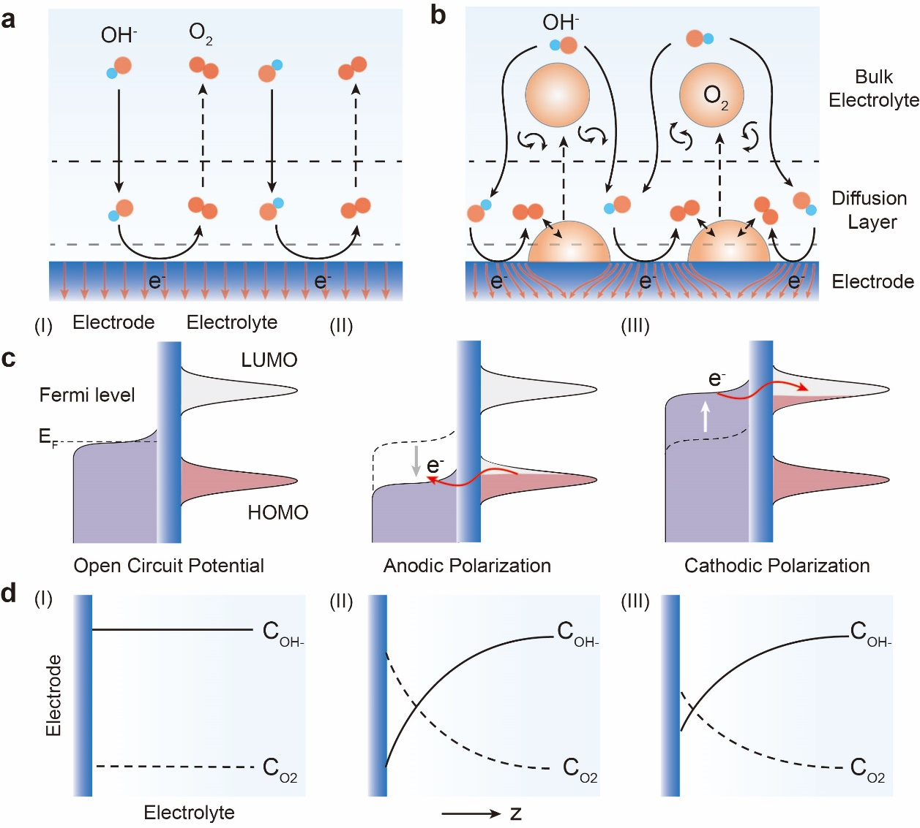
Figure S19. Schematic for the diffusion of reactant and product and electrochemical processes during oxygen evolution reaction at the electrode-electrolyte interface in absence (a) and presence (b) surface gas bubble at the electrode surface. (c) The corresponding energy level for the oxygen evolution electrode at open circuit potential (I), anodic polarization (II) and cathodic polarization (III). (d) The concentration distribution of OH⁻ and O₂ in the diffusion layer at open circuit potential (I), anodic polarization (II) and cathodic polarization (III).
The difference in the concentrations of electrochemical reactants and products at the electrode-electrolyte interface compared those in the bulk electrolyte contributed to the generation of the concentration overpotential loss (η_{c}) (Figure S19). In order to quantify this loss during oxygen evolution reaction, a one-dimension diffusion model was developed. The deviation of the concentration potential (η_{c}) as a function of current density (i) for the oxygen evolution at the electrode-electrolyte interface followed the similar derivation across SiO_{x} nanomembrane overlayer.²⁸⁻²⁹ The current derivation for the oxygen evolution reaction (OER), 4OH⁻- 4e⁻ → O₂ + 2H₂O, offered a general expression η_{c} for reaction O + ne⁻ → R.
$η_{c}=E(z=0)-E(z=d)$ (7-1)
where E was the potential at distance z from the electrode-electrolyte interface (z was vertical coordinate), d was the height of the oxygen diffusion boundary from the electrode surface. According to the Nernst Equation³⁰, the potential E could be expressed as:
$E=E_{{OH}^{-}/O_{2}}^{°’}+\frac{RT}{nF}ln\frac{C_{{OH}^{-}}^{4}}{C_{O_{2}}}$ (7-2)
where T is absolute temperature, R is the gas constant, F is the Faraday’s constant and n was the electron transfer number (n = 4). Moreover, the formal potential E_{OH}⁻_{/O2}°’ = E_{OH}⁻_{/O2}° + β, where E_{OH}⁻_{/O2}° was the standard reduction potential and β was the contribution from the activity coefficients for both OH⁻ and O₂. Based on the diffusion equations, the diffusive fluxes for OH⁻ and O₂ were described by Fick’s Law, assuming without obvious gas bubble evolution.³¹ The concentration gradient closed to the electrode-electrolyte interface prompted these species diffusion across the diffusion layer. Hence, the diffusive fluxes of OH⁻ and O₂ were expressed as:
$J_{{OH}^{-}}=-D_{{OH}^{-}}\frac{dC_{{OH}^{-}}}{dz}$ (7-3)
$J_{O_{2}}=-D_{O_{2}}\frac{dC_{O_{2}}}{dz}$ (7-4)
In order to describe the solubility of OH⁻ and the oversaturation of O₂ in the diffusion layer, the partition coefficient Φ was defined as the ratio between the solubility of OH⁻ and the oversaturation of O₂ in the diffusion layer and their concentration in bulk electrolyte (C_{OH-, b} and C_{O2, b}):
$Φ({OH}^{-})=\frac{C_{{OH}^{-}, d}}{C_{{OH}^{-},b}}$ (7-5)
$Φ(O_{2})=\frac{C_{O_{2}, d}}{C_{O_{2},b}}$ (7-6)
Based on the Faraday’s law and equations 7-5 and 7-6, the current density for OH⁻ and O₂ was estimated, respectively:
$i_{{OH}^{-}}=-2FD_{{OH}^{-}}\frac{Φ({OH}^{-})C_{{OH}^{-},b}-C_{{OH}^{-}, s}}{d}$ (7-7)
$i_{O_{2}}=-4FD_{O_{2}}\frac{Φ(O_{2})C_{O_{2},b}-C_{O_{2}, s}}{d}$ (7-8)
where C_{OH-, s} and C_{O2, s} was denoted as the concentration of OH⁻ and O₂ at the electrode-electrolyte interface, respectively, d was the thickness of a Nernst diffusion layer (a boundary layer). Under the mass transfer limited conditions, the limiting current for OH⁻ and O₂ was expressed as:
$i_{{l, OH}^{-}}=-2FD_{{OH}^{-}}\frac{Φ({OH}^{-})C_{{OH}^{-},b}}{d}$ (7-9)
$i_{{l,O}_{2}}=-4FD_{O_{2}}\frac{Φ(O_{2})C_{O_{2},b}}{d}$ (7-10)
According to the Bulter-Volmer equation, cathodic and anodic branches under mass transport limitation was written as:
$i_{{l, OH}^{-}}=i_{0}\left[Φ({OH}^{-})exp\left(\frac{(1-α)neη}{kT}\right)\right]$ (7-11)
$i_{{l,O}_{2}}=i_{0}\left[Φ(O_{2})exp\left(\frac{-αneη}{kT}\right)\right]$ (7-12)
where n was the number of electrons transferred during evolution reaction which was 4 in our case, i₀ here denoted the exchange current density, α was the charge transfer coefficient, η was the overpotential corresponding to the thermodynamic equilibrium, both C_{OH-, s} and C_{O2, s} were zero at the electrode surface and the i_{l, OH-} and i_{l, O2} were the limiting current density of OH⁻ oxidation (anodic polarization) and O₂ reduction (cathodic polarization), respectively. During the oxygen evolution reaction under anodic polarization, i_{l, OH-} was the main contributor for the current density in which i_{l, O2} was neglected. Hence, we obtained the equations to estimate C_{OH-, s} and C_{O2, s}, respectively.
$C_{{OH}^{-},s}=Φ({OH}^{-})C_{{OH}^{-},b}\left(1-\frac{i}{i_{{l, OH}^{-}}}\right)$ (7-13)
$C_{O_{2},s}=Φ(O_{2})C_{O_{2},b}\left(1-\frac{i}{i_{{l,O}_{2}}}\right)$ (7-14)
Combining equations 7-11, 7-12 and 7-2, the potential at the electrode interface, E(z = 0) and the potential in diffusion layer, E(z = d) were obtained:
$E(z=0)=E_{{OH}^{-}/O_{2}}^{°’}+\frac{RT}{nF}ln\frac{{\left(Φ({OH}^{-})C_{{OH}^{-},b}\left(1-\frac{i}{i_{{l, OH}^{-}}}\right)\right)}^{4}}{Φ(O_{2})C_{O_{2},b}\left(1-\frac{i}{i_{{l,O}_{2}}}\right)}$ (7-15)
$E(z=d)=E_{{OH}^{-}/O_{2}}^{°’}+\frac{RT}{nF}ln\frac{C_{{OH}^{-}, b}^{4}}{C_{O_{2},b}}$ (7-16)
When we substituted the equations 7-15 and 7-16 into equation 7-1, the concentration overpotential, η_{c} induced by the oversaturation of oxygen was expressed as:
$η_{c}=\frac{RT}{nF}ln{\left(Φ({OH}^{-})\left(1-\frac{i}{i_{{l, OH}^{-}}}\right)\right)}^{4}{\left(Φ(O_{2})\left(1-\frac{i}{i_{{l,O}_{2}}}\right)\right)}^{-1}$ (7-17)
In order to understand the influence from saturation of oxygen during anodic polarization on the gas evolution reaction, the linear scan voltammetry (LSV) was precisely modeled and the bulk mass transport losses (η_{m}), kinetic losses (η_{k}), electrolyte ohmic losses (η_{o}) and concentration overpotential (η_{c}) were considered.
$η_{t}=η_{m}+η_{k}+η_{o}+η_{c}$ (7-18)
Here, the ohmic iR losses (η_{o}) had been corrected in LSV curves based on electrochemical impedance spectroscopy. On the basis of the same electrode geometry and active catalytic sites, both η_{k} and η_{m} were the same for the electrochemical measurements and electrochemical extinction measurements. Hence, the different overpotential for electrochemical measurements and electrochemical extinction measurements were mainly contributed from the concentration overpotential. The LSV curves in both electrochemical and in-situ extinction measurements were fitted by a nonlinear fitting (Figure S20). Interestingly, when the increased current density approached to the limiting current density under enhanced anodic polarization, the limitation of the model could be evident. It offered evidence for the presence diffusion limitation under anodic polarization. According to the fitting parameter, the difference concentration overpotential (η_{c}) ca. 0.20 V vs. Pt between in-situ extinction measurement and electrochemical measurements was estimated.
Under practical electrochemical measurements, the total current density was composed by the sum of convention, migration, diffusion and electric double layer charging. In general, it was expressed by the sum of the Faradaic and non-Faradic portion for the total current density:
$i_{t}=i_{c}+i_{m}+i_{d}+i_{ec}$ (7-19)
$i_{t}=i_{F}+i_{nF}$ (7-20)
During the electrochemical measurements, the record current included both the Faradaic and non-Faradic current (i_{F} + i_{nF}). However, during in-situ extinction measurements, the fluctuation of extinction intensity directly represented the oxygen concentration fluctuation at the electrode-electrolyte interface. Therefore, the correlation between the extinction intensity and the Faradaic current intensity could be established, so we could use the extinction intensity to denote the Faradaic current intensity (i_{F}). In an anodic polarization, oxygen evolution at the electrode surface was proceeding during persistent polarization, the relative measured current density was given by:
$i_{e}=nF\frac{D_{O_{2}}}{d}(C_{O2, s}^{e}-C_{O2, b})=i_{F}+i_{nF}$ (7-21)
$i_{ext}=nF\frac{D_{O_{2}}}{d}(C_{O2, s}^{ext}-C_{O2, b})=i_{F}$ (7-22)
where i_{e} and i_{ext} were the measured current during electrochemical and in-situ electrochemical extinction measurements, respectively, d was the thickness of the diffusion layer, C_{O2, b} was the bulk concentration, D_{O2} was the diffusion coefficient of the dissolved oxygen in the electrolyte, F is Faraday’s constant, n was the electron number involved in the reaction, C_{O2, s}^{e} and C_{O2, s}^{ext} were the apparent oxygen concentration at the electrode surface measured by electrochemical and in-situ extinction measurements, respectively. Due to the influence from the non-Faradaic current on the measured oxygen concentration, it could be found that C_{O2, s}^{e} > C_{O2, s}^{ext}. The accumulation of oxygen in the diffusion layer contributed to the shift of electrode potential (concentration polarization), which was simplified expressed by a Nernstian equation:³²
$η_{c}=2.3\frac{RT}{nF}log\frac{C_{O2,s}}{C_{O2, b}}$ (7-23)
Considering C_{O2, s}^{e} > C_{O2, s}^{ext}, hence, the η_{c} obtained in electrochemical procedures was larger than that measured during in-situ extinction measurement, which gave the distinct evidence for the difference in the measured concentration polarization potential and relative onset potential. Most importantly, the above analysis demonstrated that in-situ extinction measurement provided direct information related to Faradaic process without the interference from the non-Faradaic components, which possessed the capacity to precisely determine the relevant parameters in gas evolution reactions such as concentration overpotential and onset potential etc.

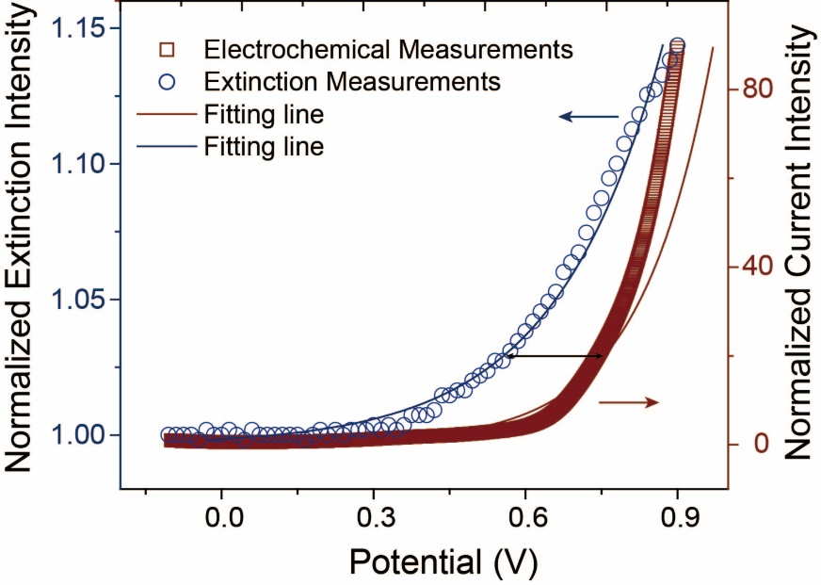
Figure S20. Comparison the difference of concentration overpotential between electrochemical measurement and in-situ extinction spectroelectrochemistry. The fitting line were based on the proposed model and it was suitable for fitting the data at low and intermediate current density.

FDTD Simulation for Oxygen Evolution at the Electrode-Electrolyte Interface
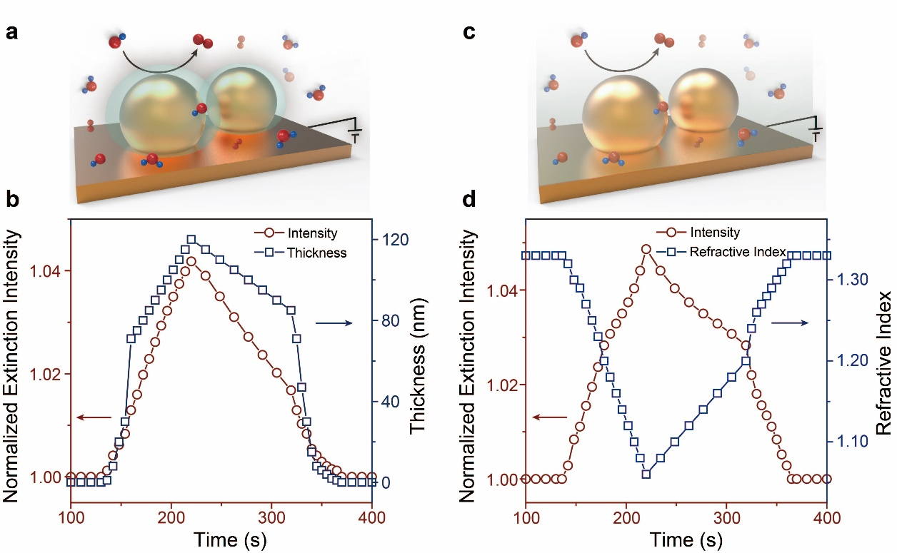
Figure S21. (a) Schematic illustration of the electrogenerated oxygen gradient around the plasmonic nanoparticles. (b) Simulated normalized extinction intensity as a function of the thickness of oxygen gradient from 0 to 120 nm. (c) Schematic illustration of the electrogenerated oxygen induced dielectric environment change around the plasmonic nanoparticles. (d) Simulated normalized extinction intensity as a function of environment refractive index from 1.33 to 1.06. In order to simulated the influence of oxygen evolution on the extinction intensity, we established two models to simulate the different thickness of oxygen gradient and various environment refractive index around plasmonic nanoparticles, respectively. In all cases, the extinction intensity enhanced with increasing the thickness of oxygen gradient and decreasing of refractive index of the surrounding dielectric medium, respectively. Both simulated extinction intensity evolutions were agreed well with in-situ extinction measurements (Figure 2e), further indicated the capability of plasmonic single wavelength strategy in revealing details on the interfacial dynamics during oxygen evolution reaction.

Numerical Simulation for Oxygen Diffusion at the Electrode-Electrolyte Interface
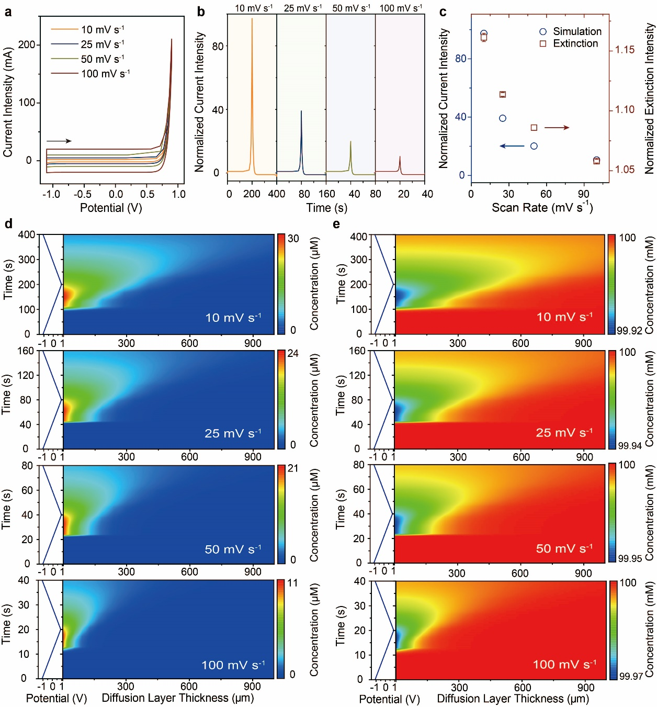
Figure S22. (a) Numerical simulation CV curves for oxygen evolution reaction in potential range from − 1.10 to 0.90 V, at various scan rates 0.01, 0.025, 0.05 and 0.10 V s⁻¹. (b) The normalized temporal current intensity for oxygen evolution reaction at various scan rates 0.01, 0.025, 0.05 and 0.10 V s⁻¹. In order to eliminate the charging effect on the evaluation of oxygen evolution reaction, the charging current at each scan rate serves as the reference for normalization. (c) The comparison between experimental extinction intensity and numerical simulation current intensity dependent on the square root of the scan rate. Numerical simulation of potential dependent evolution of oxygen diffusion layer (contour plots) (d) and hydroxyl (e) along the axial direction of the EEIs at various scan rates 0.01, 0.025, 0.05 and 0.10 V s⁻¹.

In order to reveal the oxygen and hydroxide distribution at the electrode-electrolyte interface, one-dimension finite element modelling was established. Assuming the presence of a large quantity supporting electrolyte to increase the conductivity of the electrolyte without any perturbance on the interfacial electrochemical reaction. Hence, the resistance of the solution was relatively low and the induced electric field was negligible. To describe the interfacial mass transfer of the reactant and product species involved in the electrochemical reaction, we adopted Fick’s 2nd law to illustrate the chemical mass transport of the electroactive species OH⁻ and O₂:³³
$\frac{∂c_{i}}{∂t}=∇∙(D_{i}∇c_{i})$ (8-1)
At the initial stage, a uniform concentration distribution at the bulk electrolyte (x = L) and no product was present in bulk. At the electrode surface (x = 0), the reactant OH⁻ lost on electron to form 0.25 equivalent oxygen. The electrochemical interfacial reaction was expressed as the reductive form:
1/4 O₂ + 1/2 H₂O + e⁻→ OH⁻ (8-2)
The current density of this reaction was calculated by the Bulter-Volmer equation for an oxidation:¹⁰
$i_{a}=nFk_{0}\left(c_{{OH}^{-}}exp\left(\frac{(n-α)Fη}{RT}\right)-c_{O_{2}}exp\left(\frac{-αFη}{RT}\right)\right)$ (8-3)
where F is the Faraday’s constant (96485 C mol⁻¹), k₀ was the heterogeneous rate constant of the reaction (5e-16 m s⁻¹, which was taken from the rate determining step for formation of the peroxide intermediate HOO during oxygen evolution reaction)³⁴, α was the cathodic transfer coefficient (0.5) and η was the overpotential at the working electrode relative to the equilibrium potential of the redox couple of OH⁻ and O₂. Furthermore, based on Faraday’s law, the electrode surface boundary condition was drawn in which the flux of the reactant and product species (N_{i}) were proportional to their current density (i_{a}):
$-n∙N_{i}=\frac{ν_{i}i_{a}}{nF}$ (8-4)
Considering the oxygen evolution reaction at the Cu NPs/ITO electrode was performed at relatively large overpotential under kinetic control, the polarized current was assumed to be independent of the thermodynamic performance of electrocatalysts. Hence, with enhancement of the anodic polarization, a diffusional concentration profile was developed which showed dynamic behavior as a function of distance from the electrode surface. Based on the numerical simulation, the dynamic oxygen and hydroxide concentration profile during dynamic potential and the corresponding cyclic voltammetry curves scan was identified shown in Figure S22. With the elimination of the charging current through the normalization the total current intensity respecting to the capacitive charging current, the temporal current intensity indicated a similar trend with the in-situ extinction voltammetry measurements as a function of potential scan rate. It demonstrated that the extinction voltammetry could directly reflect the dynamic oxygen evolution at the electrode-electrolyte interface without interference from the non-Faradaic processes (Figure S22, a-c). Moreover, the numerical simulation of the potential-dependent concentration profiles of both reactant (hydroxide) and products (oxygen) revealed that the conspicuous confinement for oxygen in diffusion layer at high potential scan rate (Figure S22, d-e) and in line with the in-situ extinction measurements (Figure 4, in main text). Both these results further confirmed that the in-situ electrochemical extinction measurements enabled the real time monitoring the dynamic diffusion profiles of oxygen during dynamic potential scan without complex optical marker and corroborated the oxygen diffusion limiting effect on oxygen evolution reaction at the electrode-electrolyte interface, which was hampered in conventional electrochemical measurements.

Elimination of Interfacial Dissolved Oxygen at the Electrode-Electrolyte Interfaces
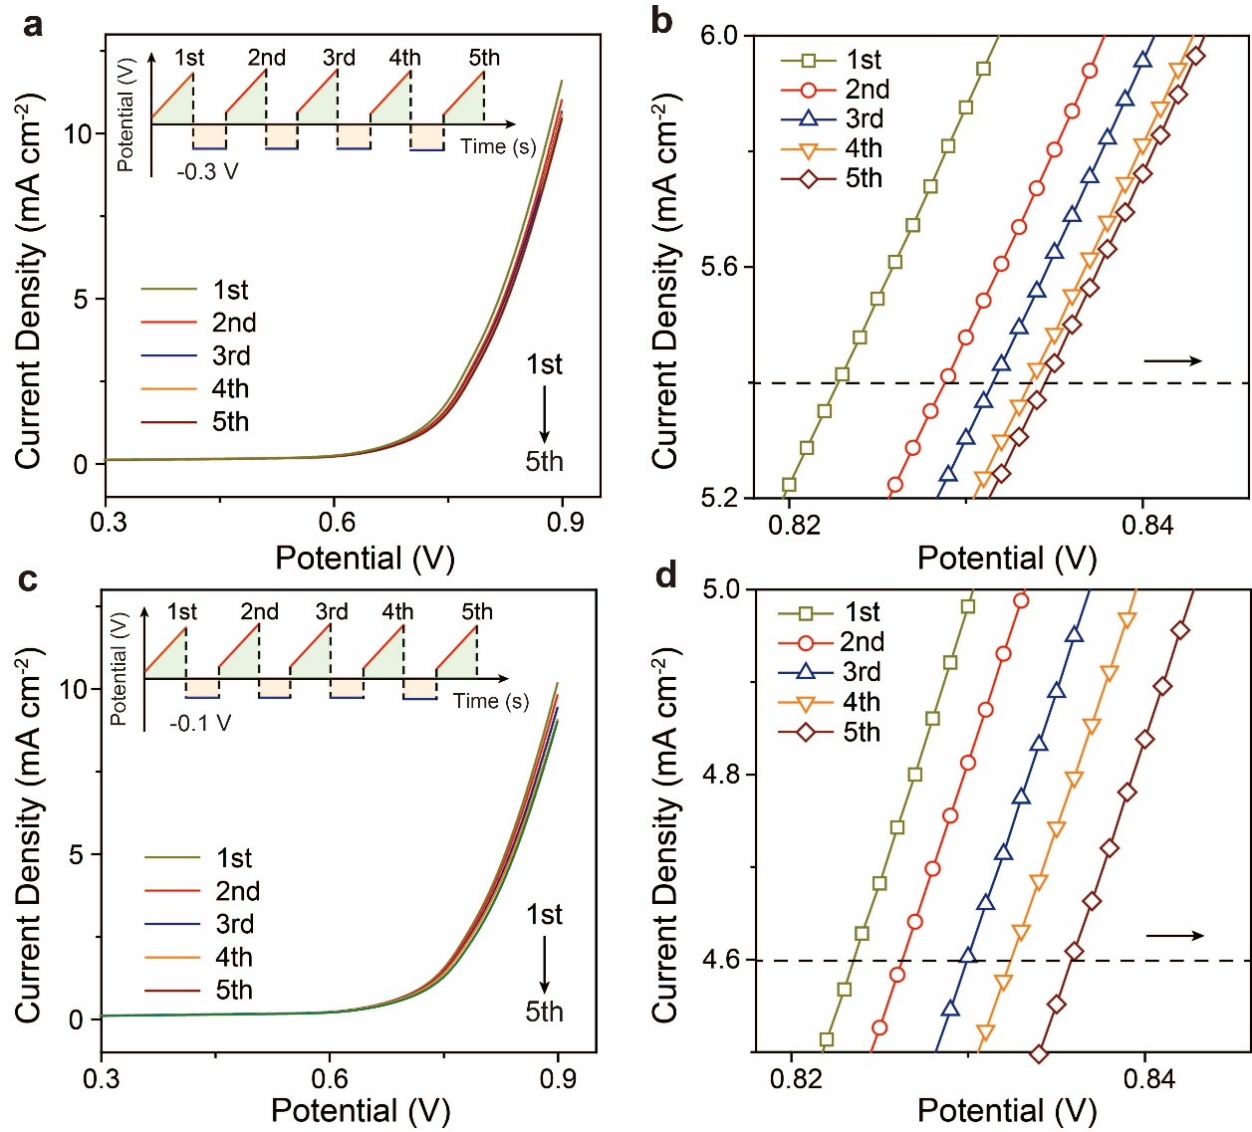
Figure S23. Linear sweep voltammetry curves of Cu electrode followed reduction potential multi-pulse (a − 0.30 V and c − 0.10 V) in 0.10 M KOH solution at a scan rate of 0.01 V s⁻¹. The enlarged cathodic shift of the oxygen evolution potential as consecutive reduction potential pulses (b − 0.30 V and d − 0.10 V).

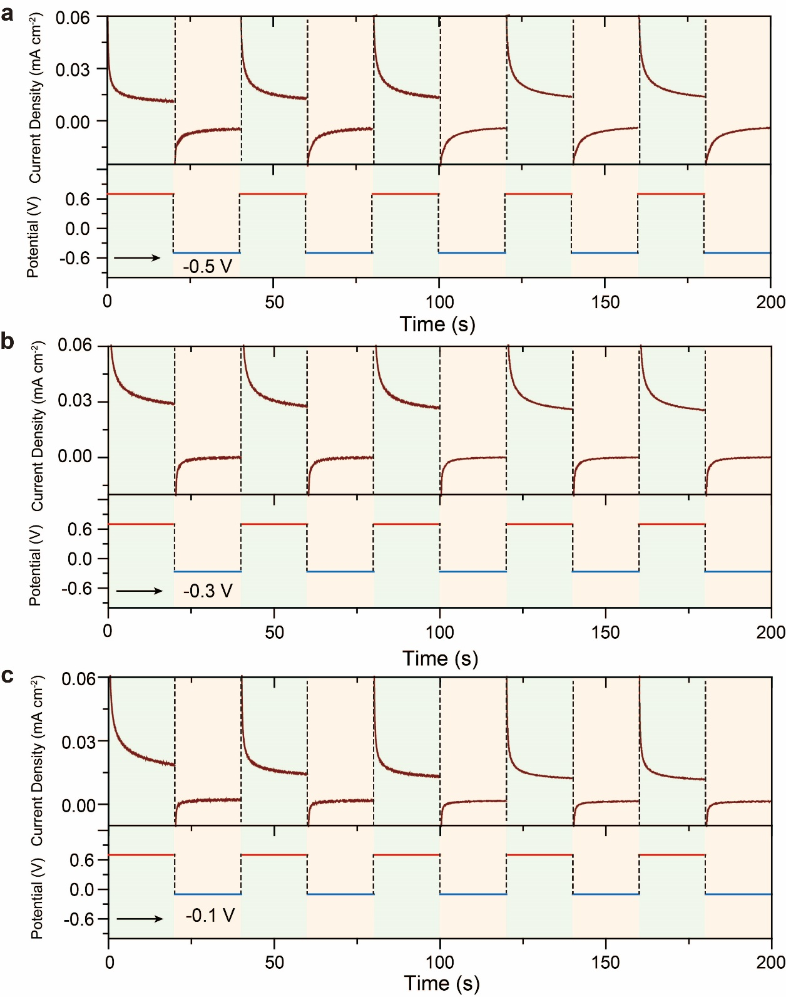
Figure S24. Chronoamperometry curves on Cu electrode obtained from the programmed potential scan: (a) anodic potential 0.70 V, step time 20 s; cathodic potential − 0.50 V, step time 20 s; (a) anodic potential 0.70 V, step time 20 s; cathodic potential − 0.30 V, step time 20 s; (a) anodic potential 0.70 V, step time 20 s; cathodic potential − 0.10 V, step time 20 s.

References
(1) Steinhauer, C.; Jungmann, R.; Sobey, T. L.; Simmel, F. C.; Tinnefeld, P., DNA Origami as a Nanoscopic Ruler for Super-Resolution Microscopy. Angew. Chem., Int. Ed. 2009, 48, 8870-8873.
(2) Wang, J.-G.; Hua, X.; Li, M.; Long, Y.-T., Mussel-Inspired Polydopamine Functionalized Plasmonic Nanocomposites for Single-Particle Catalysis. ACS Appl. Mater. Interfaces 2017, 9, 3016-3023.
(3) Johnson, P. B.; Christy, R. W., Optical Constants of the Noble Metals. Physical Review B 1972, 6, 4370-4379.
(4) Ribbing, C. G.; Roos, A., Copper Oxides (Cu₂O, CuO). Handbook of Optical Constants of Solids, Palik, E. D., Ed. Academic Press: Boston, 1998; 875-882.
(5) Plieth, W., Electrochemistry for Materials Science. Elsevier: 2008; 195-229
(6) Pei, A.; Zheng, G.; Shi, F.; Li, Y.; Cui, Y., Nanoscale Nucleation and Growth of Electrodeposited Lithium Metal. Nano Lett. 2017, 17, 1132-1139.
(7) Winand, R., Electrocrystallization: Fundamental Considerations and Application to High Current Density Continuous Steel Sheet Plating. J. Appl. Electrochem. 1991, 21, 377-385.
(8) El-Deab, M. S., On the Preferential Crystallographic Orientation of Au Nanoparticles: Effect of electrodeposition time. Electrochim. Acta 2009, 54, 3720-3725.
(9) Wang, J.; Cao, X.; Li, L.; Li, T.; Wang, R., Electrochemical Seed-Mediated Growth of Surface-Enhanced Raman Scattering Active Au(111)-Like Nanoparticles on Indium Tin Oxide Electrodes. J. Phys. Chem. C 2013, 117, 15817-15828.
(10) Bard, A. J., Faulkner, L. R., Electrochemical Methods, Foundamentals and Applications. John wiley and Sons Inc: New York, 2001; 482.
(11) Emanuel, A.; Olander, D. R., Diffusion Coefficients of Copper Sulfate in Water and Water in n-Butyl Alcohol. J. Chem. Eng. Data 1963, 8, 31-32.
(12) Hillson, P. J., The Mechanism of the Reaction at a Cu/Cu²⁺ Electrode. Trans. Faraday Soc. 1954, 50, 385-393.
(13) Finot, M. O.; Braybrook, G. D.; McDermott, M. T., Characterization of Electrochemically Deposited Gold Nanocrystals on Glassy Carbon Electrodes. J. Electroanal. Chem. 1999, 466, 234-241.
(14) Praig, V. G.; Piret, G.; Manesse, M.; Castel, X.; Boukherroub, R.; Szunerits, S., Seed-Mediated Electrochemical Growth of Gold Nanostructures on Indium Tin Oxide Thin Films. Electrochim. Acta 2008, 53, 7838-7844.
(15) Vitos, L.; Ruban, A. V.; Skriver, H. L.; Kollár, J., The Surface Energy of Metals. Surf. Sci. 1998, 411, 186-202.
(16) Bogdanowicz, R.; Ryl, J.; Darowicki, K.; Kosmowski, B., Ellipsometric Study of Oxide Formation on Cu Electrode in 0.1 M NaOH. J. Solid State Electrochem. 2009, 13, 1639-1644.
(17) Abd el Haleem, S. M.; Ateya, B. G., Cyclic Voltammetry of Copper in Sodium Hydroxide Solutions. J. Electroanal. Chem. Interfacial Electrochem. 1981, 117, 309-319.
(18) He, M.; Li, C.; Zhang, H.; Chang, X.; Chen, J. G.; Goddard, W. A.; Cheng, M.-j.; Xu, B.; Lu, Q., Oxygen Induced Promotion of Electrochemical Reduction of CO₂ via co-electrolysis. Nat. Commun. 2020, 11, 3844.
(19) Sheng, W.; Myint, M.; Chen, J. G.; Yan, Y., Correlating the Hydrogen Evolution Reaction Activity in Alkaline Electrolytes with the Hydrogen Binding Energy on Monometallic Surfaces. Energy Environ. Sci. 2013, 6, 1509-1512.
(20) Zheng, J.; Sheng, W.; Zhuang, Z.; Xu, B.; Yan, Y., Universal Dependence of Hydrogen Oxidation and Evolution Reaction Activity of Platinum-Group Metals on pH and Hydrogen Binding Energy. Sci. Adv. 2016, 2, e1501602.
(21) Gao, R.; Edwards, M. A.; Qiu, Y.; Barman, K.; White, H. S., Visualization of Hydrogen Evolution at Individual Platinum Nanoparticles at a Buried Interface. J. Am. Chem. Soc. 2020, 142, 8890-8896.
(22) Tao, H. B.; Xu, Y.; Huang, X.; Chen, J.; Pei, L.; Zhang, J.; Chen, J. G.; Liu, B., A General Method to Probe Oxygen Evolution Intermediates at Operating Conditions. Joule 2019, 3, 1498-1509.
(23) Link, S.; El-Sayed, M. A., Size and Temperature Dependence of the Plasmon Absorption of Colloidal Gold Nanoparticles. J. Phys. Chem. B 1999, 103, 4212-4217.
(24) Bohren, C. F., Huffman, D. R., Absorption and scattering of light by small particles. John Wiley & Sons, 2008; 82-129.
(25) Kumar, A.; Kim, S.; Nam, J.-M., Plasmonically Engineered Nanoprobes for Biomedical Applications. J. Am. Chem. Soc. 2016, 138, 14509-14525.
(26) Mayer, K. M.; Hafner, J. H., Localized Surface Plasmon Resonance Sensors. Chem. Rev. 2011, 111, 3828-3857.
(27) Anderson, L. J. E.; Mayer, K. M.; Fraleigh, R. D.; Yang, Y.; Lee, S.; Hafner, J. H., Quantitative Measurements of Individual Gold Nanoparticle Scattering Cross Sections. J. Phys. Chem. C 2010, 114, 11127-11132.
(28) Labrador, N. Y.; Songcuan, E. L.; De Silva, C.; Chen, H.; Kurdziel, S. J.; Ramachandran, R. K.; Detavernier, C.; Esposito, D. V., Hydrogen Evolution at the Buried Interface between Pt Thin Films and Silicon Oxide Nanomembranes. ACS Catal. 2018, 8, 1767-1778.
(29) Esposito, D. V., Membrane-Coated Electrocatalysts—An Alternative Approach To Achieving Stable and Tunable Electrocatalysis. ACS Catal. 2018, 8, 457-465.
(30) Feiner, A. S.; McEvoy, A. J., The Nernst Equation. J. Chem. Educ. 1994, 71, 493.
(31) Barbero, C. A., Ion Exchange at the Electrode/Electrolyte Interface Studied by Probe Beam Deflection Techniques. Phys. Chem. Chem. Phys. 2005, 7, 1885-1899.
(32) Kempler, P. A.; Coridan, R. H.; Lewis, N. S., Effects of Bubbles on the Electrochemical Behavior of Hydrogen-Evolving Si Microwire Arrays Oriented against Gravity. Energy Environ. Sci. 2020, 13, 1808-1817.
(33) Compton, R. G., Banks, C. E, Understanding voltammetry. World Scientific: 2018.
(34) Alobaid, A.; Wang, C.; Adomaitis, R. A., Mechanism and Kinetics of HER and OER on NiFe LDH Films in an Alkaline Electrolyte. J. Electrochem. Soc. 2018, 165, J3395-J3404.

