Supplementary Information
Indirect electrification enables the 2°C goal without reliance on carbon dioxide removal

Author list
Hitomi Eto¹, Shotaro Mori^{1*}, Ken Oshiro², Shinichiro Fujimori^{1,3,4}

Affiliations
- Kyoto University, C1-3, Kyotodaigaku-Katsura, Nishikyo-ku, Kyoto, Japan
- Hokkaido University, Sapporo, Japan
- National Institute for Environmental Studies (NIES), Tsukuba, Japan
- International Institute for Applied System Analysis (IIASA), Laxenburg, Austria

* Corresponding author
Shotaro Mori: mori.shotaro.2n@kyoto-u.ac.jp

Supplementary Note 1 | Feasibility assessment
For the feasibility assessment, we followed Brutschin et al. (2021)¹ and examined 26 indicators grouped into four categories: technological, geophysical, economic, and socio-cultural dimensions. For each indicator, we defined a medium-concern threshold and a high-concern threshold. If the estimated value was below the medium-concern threshold, feasibility was evaluated as low difficulty. If it was equal to or above the medium-concern threshold but below the high-concern threshold, it was evaluated as medium difficulty. If it was equal to or above the high-concern threshold, it was evaluated as high difficulty. This study assessed feasibility only; desirability was outside the scope of the evaluation. The calculation methods for each indicator are described below. Threshold values are provided in Table 2.
For the power sector, the evaluation covered solar power, wind power, biomass power, and biomass power with CCS. The indicator was defined as the 10-year change in the share of each technology in total electricity generation. The indicator for wind power was calculated using Eq. (1), where t denotes the year.

$${Wind Share Scale-up}_{t} = {Wind Share}_{t}-{Wind Share}_{t-10}$$ | (1)

For the demand side, the evaluation covered electricity, biofuels, and hydrogen in the industry sector; electricity and biofuels in the buildings sector; and electricity, biofuels, and hydrogen in the transportation sector. Low-carbon energy carriers also include ammonia and synthetic fuels. However, these fuels can utilize the existing infrastructure and require little or no modification of end-use equipment. Therefore, concerns on the demand side were considered to be minor. Additionally, because green hydrogen production and CO₂ capture were already evaluated on the supply side, ammonia and synthetic fuels were excluded from the feasibility assessment in this study. No hydrogen use was assumed in the buildings sector, and it was therefore excluded from the evaluation. The indicator was defined as the 10-year change in the share of each energy carrier in total final energy consumption within the respective sector. Brutschin et al. (2021)¹ evaluated only electricity and biofuels in the transportation sector. In contrast, this study expanded the scope to include additional energy carriers and applied the same threshold values. The indicator for electricity in the transportation sector was calculated using Eqs. (2) and (3).

$${Electricity share Scale-up}_{t} = {Electricity Share}_{t} - {Electricity Share}_{t-10}$$ | (2)
$${Electricity Share}_{t}= \frac{{Electricity Demand in the Transport Sector}_{t}}{{Final Energy Demand in the Transport Sector}_{t}}×100$$ | (3)

To assess the expansion of green hydrogen production, we evaluated the amount of electricity converted to hydrogen via electrolysis. The indicator was defined as the 10-year change in the share of electricity consumed for electrolytic hydrogen production relative to total electricity generation. The indicator for green hydrogen production was calculated using Eqs. (4) and (5).

$${Electricity Share Scale-up }_{t} = {Electricity Share }_{t} - {Electricity Share }_{t-10}$$ | (4)
$${Electricity Share }_{t} = \frac{{Electricity Demand for Electrolysis}_{t}}{{Total Electricity Generation}_{t}}×100$$ | (5)

To evaluate the expansion of DAC as a CO₂ capture technology, we assessed the increase in the share of electricity consumption for DAC relative to total electricity generation. Although DAC may use energy sources other than electricity (e.g., bioenergy) as heat inputs, they were treated as equivalent to electricity for the purpose of the calculation. The indicator for DAC was calculated using Eqs. (6) and (7).

$${Electricity Share Scale-up}_{t} = {Electricity Share }_{t} - {Electricity Share }_{t-10}$$ | (6)
$${Electricity Share }_{t}= \frac{{Electricity Demand for DAC}_{t}}{{Total Electricity Generation}_{t}}×100$$ | (7)

For the assessment of geophysical feasibility, we evaluated solar energy (primary energy), secondary energy produced from wind in the power sector, bioenergy (primary energy), and geological CO₂ storage. The indicators were defined as the annual supply of solar, wind, and bioenergy, and cumulative CO₂ geological storage.
For the assessment of economic feasibility, we first evaluated energy investment costs. This indicator was defined as the ratio of energy investment in the mitigation scenario to that in the corresponding Baseline scenario. The calculation is presented below. The investment-effort indicator was calculated using Eq. (8).

$${Investment Effort in Energy Supply }_{t} = \frac{Investment(mitigation)_{t}}{Investment (Baseline)_{t}}$$ | (8)

For the assessment of carbon pricing, we used two indicators: (1) the carbon price calculated with a 5% discount rate, and (2) the magnitude of the increase in the carbon price over 10 years. For indicator (2), only a high-concern threshold was defined. The carbon-price level and carbon-price change indicators were calculated using Eqs. (9) and (10), respectively.

$${Carbon price level (npv) }_{t }= {Carbon price }_{t}×{1.05}^{-(t-2020)}$$ | (9)
$${Carbon price change }_{t } = \frac{{Carbon price }_{t }}{{Carbon price }_{t-10 }+ 1}$$ | (10)

For the assessment of stranded assets in coal-fired power generation, we used the share of stranded capacity relative to the total installed capacity as the indicator. The stranded-asset indicator was calculated using Eq. (11).

$${{Stranded Coal}_{ } }_{t } = \frac{{{Stranded capacity of coal power plants}_{ } }_{t }}{{Capacity of coal power plants }_{t }}×100$$ | (11)

For the assessment of socio-cultural feasibility, we evaluated the reductions in final energy demand (total, transportation, buildings, and industry sectors). The indicator was defined as the 10-year rate of decline in energy demand. The energy-demand decline indicator was calculated using Eq. (12).

$${ Energy Demand Decline}_{t} = - \left(\frac{{ Energy Demand}_{t}- {Energy Demand}_{t-10} }{{Energy Demand}_{t-10}}\right)×100$$ | (12)

Supplementary Note 2 | Sensitivity analysis
To clarify the impact of the assumptions adopted in this study on CDRoff, a sensitivity analysis was conducted. The analysis focused on three elements: CO₂ emissions, socioeconomic conditions, and low-carbon technologies, for which a total of 13 scenarios were defined. In all scenarios, CDRoff, in which the use of CDR was limited, served as the baseline, from which changes in assumptions or additional constraints were applied. The scenarios are presented in Supplementary Table 5. Scenarios without emission constraints corresponding to each SSP were also prepared, but they were not included in the sensitivity analysis and are therefore not shown in Supplementary Table 5. The emission pathways of CO₂-FFI for the scenarios with altered emission constraints are shown in Supplementary Figure 8. Note that CO₂ from solvents and waste is not included in the CO₂-FFI reported in Supplementary Figure 8.
No solutions were obtained for the CCS3 and noBECDAC scenarios. Feasibility assessments were also conducted for these scenarios. The results showed that, in all scenarios defined for the sensitivity analysis, a promotion of indirect electrification was observed, which was similar to that observed in CDRoff, and the overall trends in the feasibility assessment were largely comparable (Supplementary Figure 9). When constraints were applied to CO₂ capture technologies or bioenergy, some differences in the expansion of energy shares on the demand side were observed; however, none of these differences were sufficient to overturn the structural characteristics of CDRoff or the main challenges associated with its implementation.

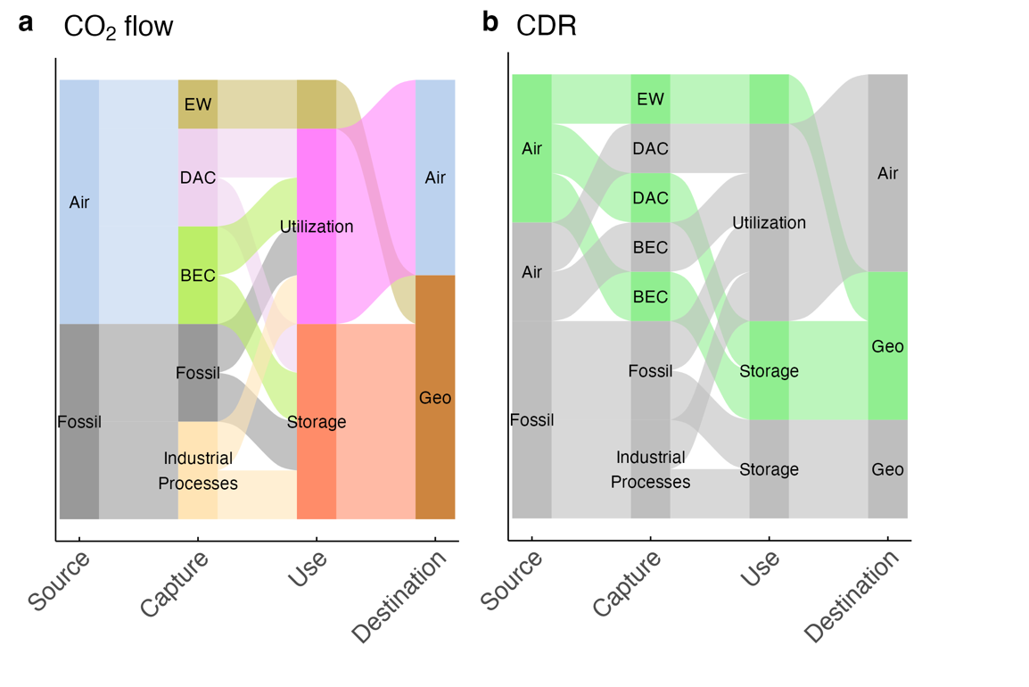
Supplementary Figures
Supplementary Figure 1 | CO₂ flows and CDR classification. a The CO₂ flows in CDR and CCUS. b Classification of CDR (green) and non-CDR (gray).

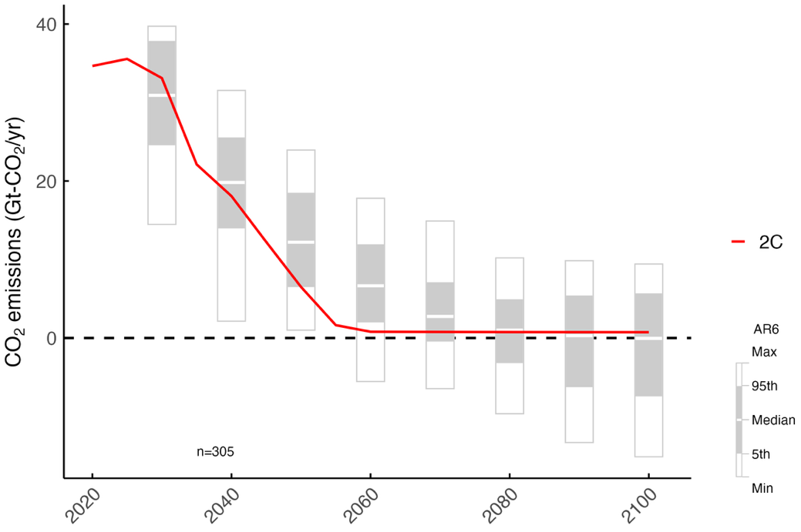

Supplementary Figure 2 | CO₂ emission pathways (Only CO₂-FFI emissions are included). Box plots show the AR6 C3 scenario and "n" denotes the number of available scenarios.
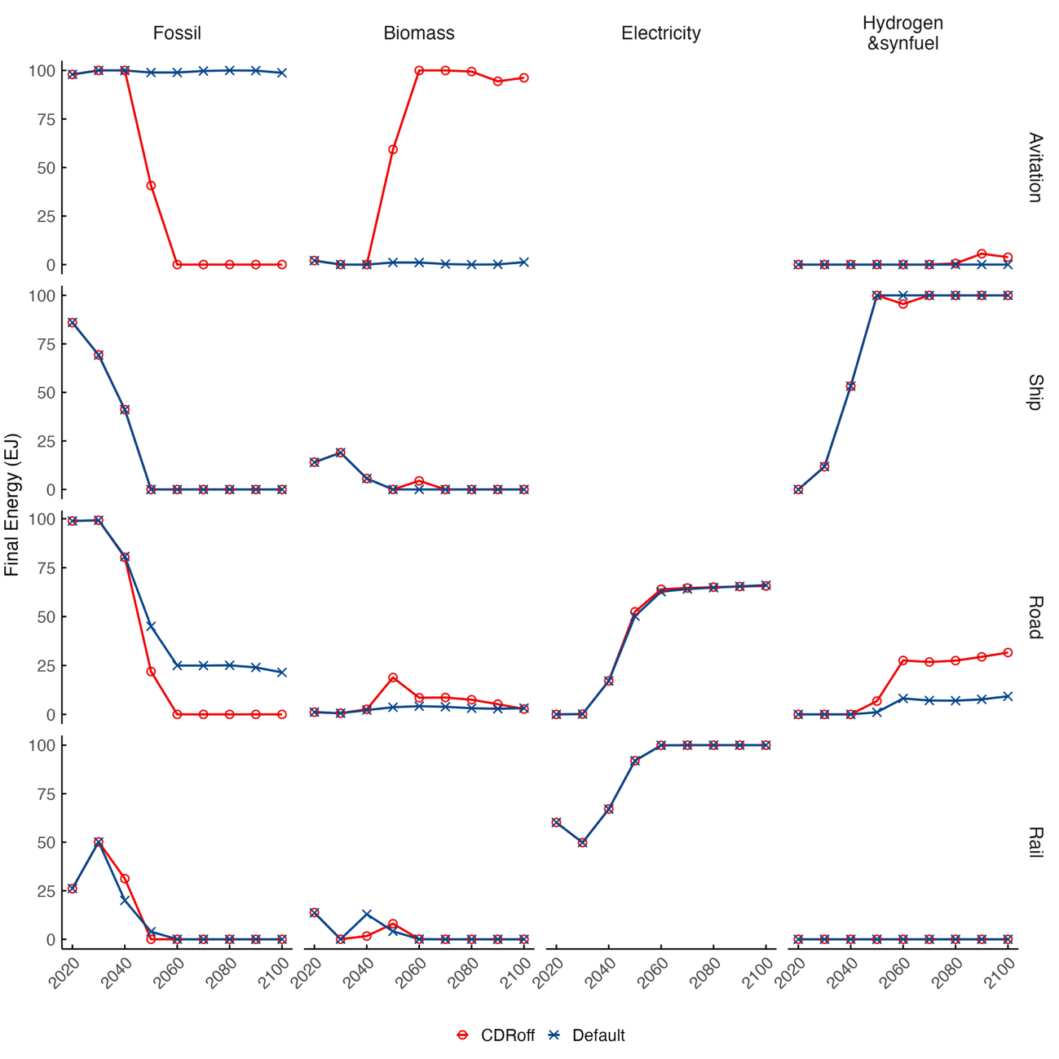

Supplementary Figure 3 | Changes in energy consumption by transportation sector (fossil fuels, bioenergy, electricity, hydrogen, and synthetic fuels).
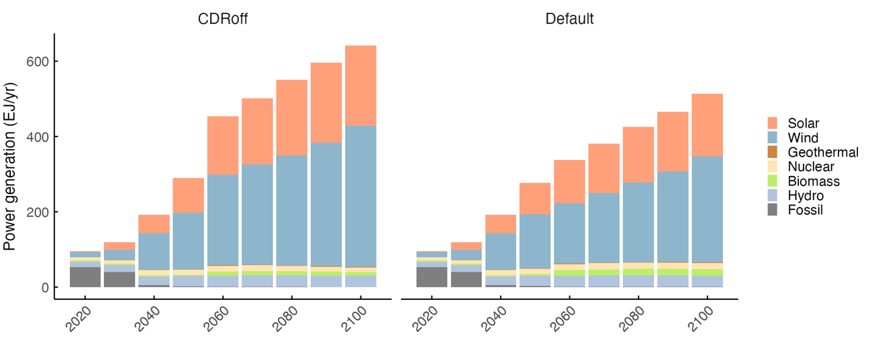
Supplementary Figure 4 | Power generation.

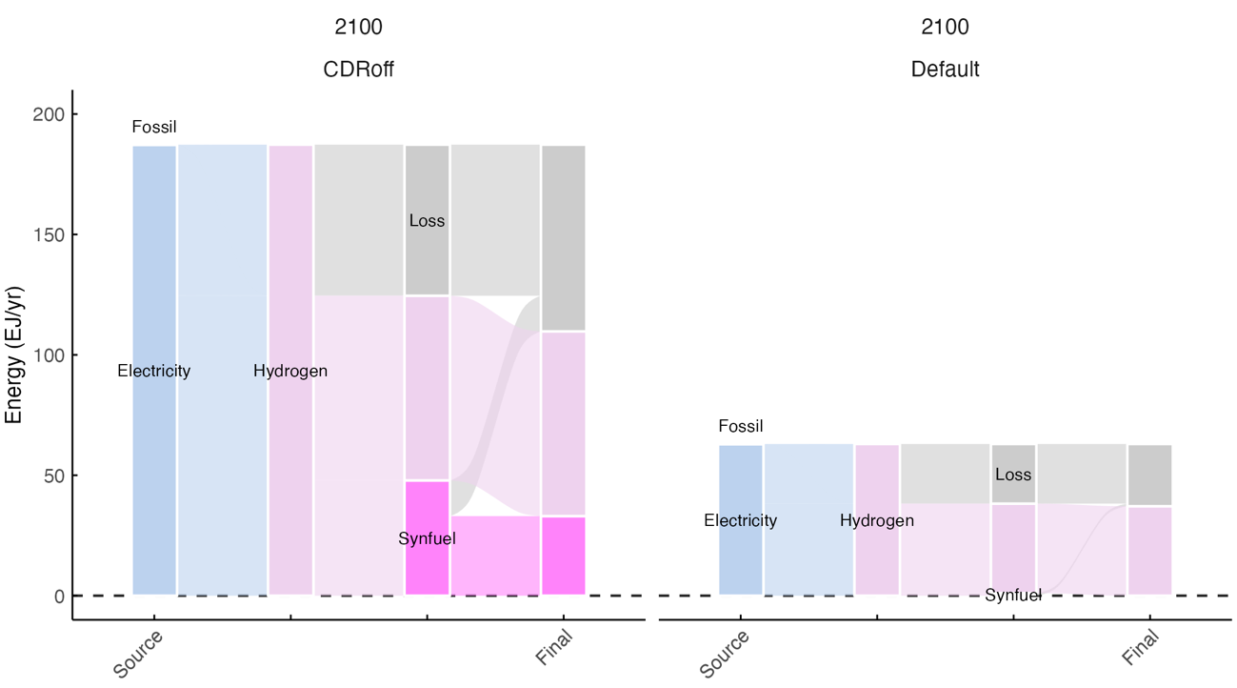

Supplementary Figure 5 | Energy flows associated with hydrogen and synfuel production (2100). Fossil is categorized under "Source" to account for their role in hydrogen production.

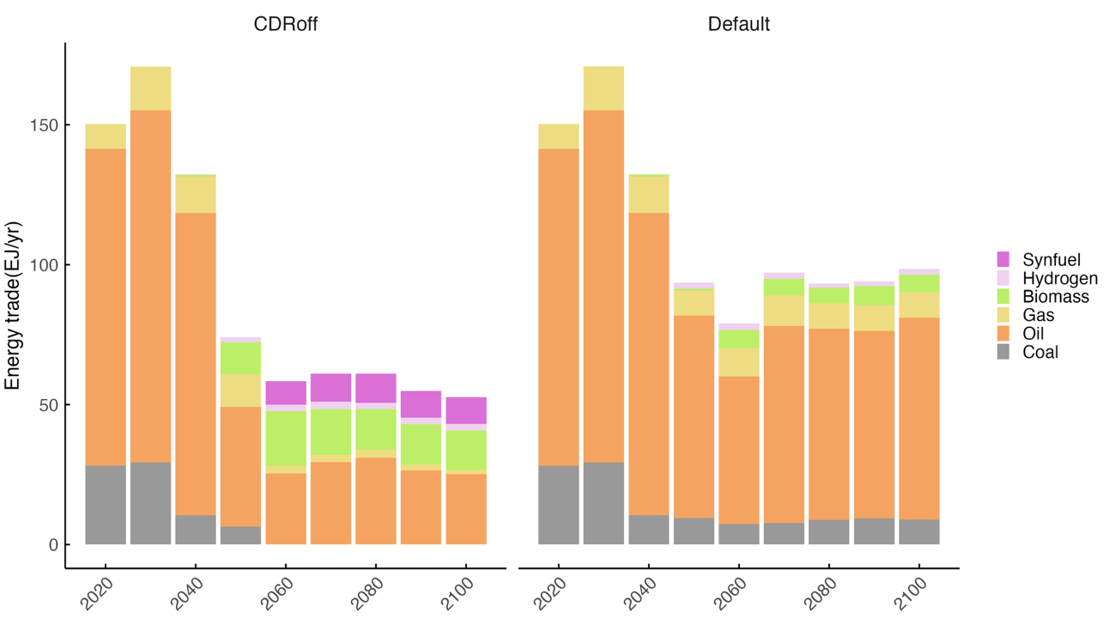
Supplementary Figure 6 | Energy trade.

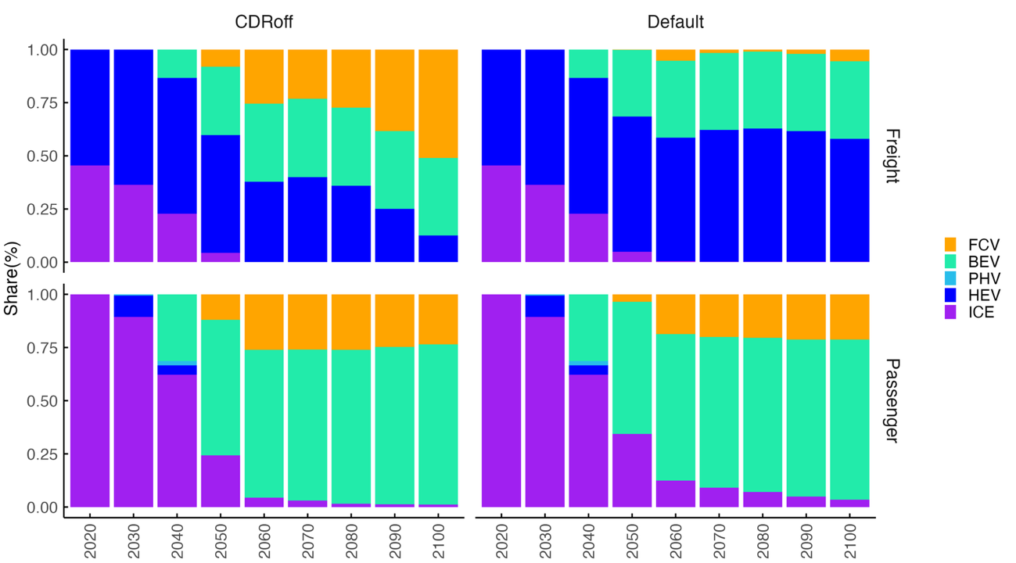
Supplementary Figure 7 | Stock shares by vehicle type in road transportation (freight and passenger).
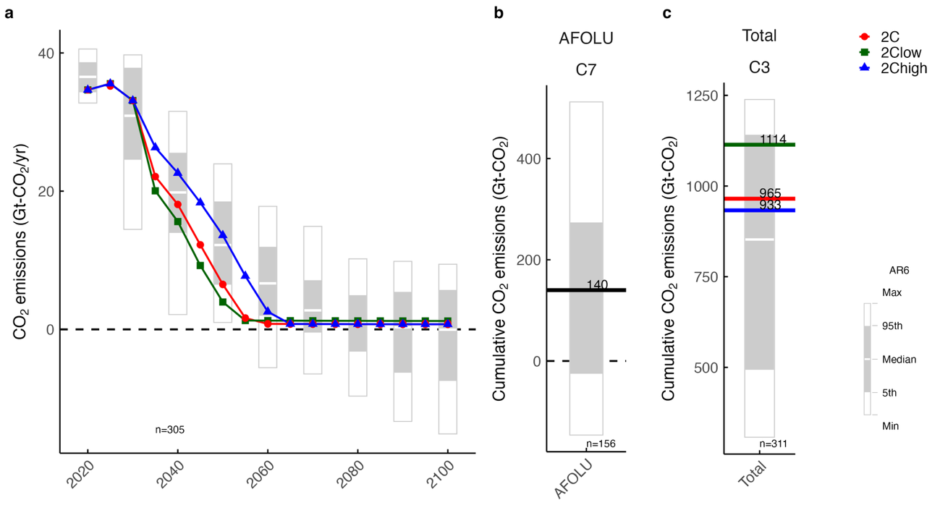Supplementary Figure 8 | CO₂ emission pathways and cumulative emissions. a CO₂-FFI emission pathways (2020–2100). Box plots represent the AR6 C3 scenario. b Cumulative CO₂ emissions from the AFOLU sector (2020–2100) under the AR6C7 scenario. c Comparison of the total cumulative CO₂ emissions (2020–2100) with the AR6 C3 scenario.

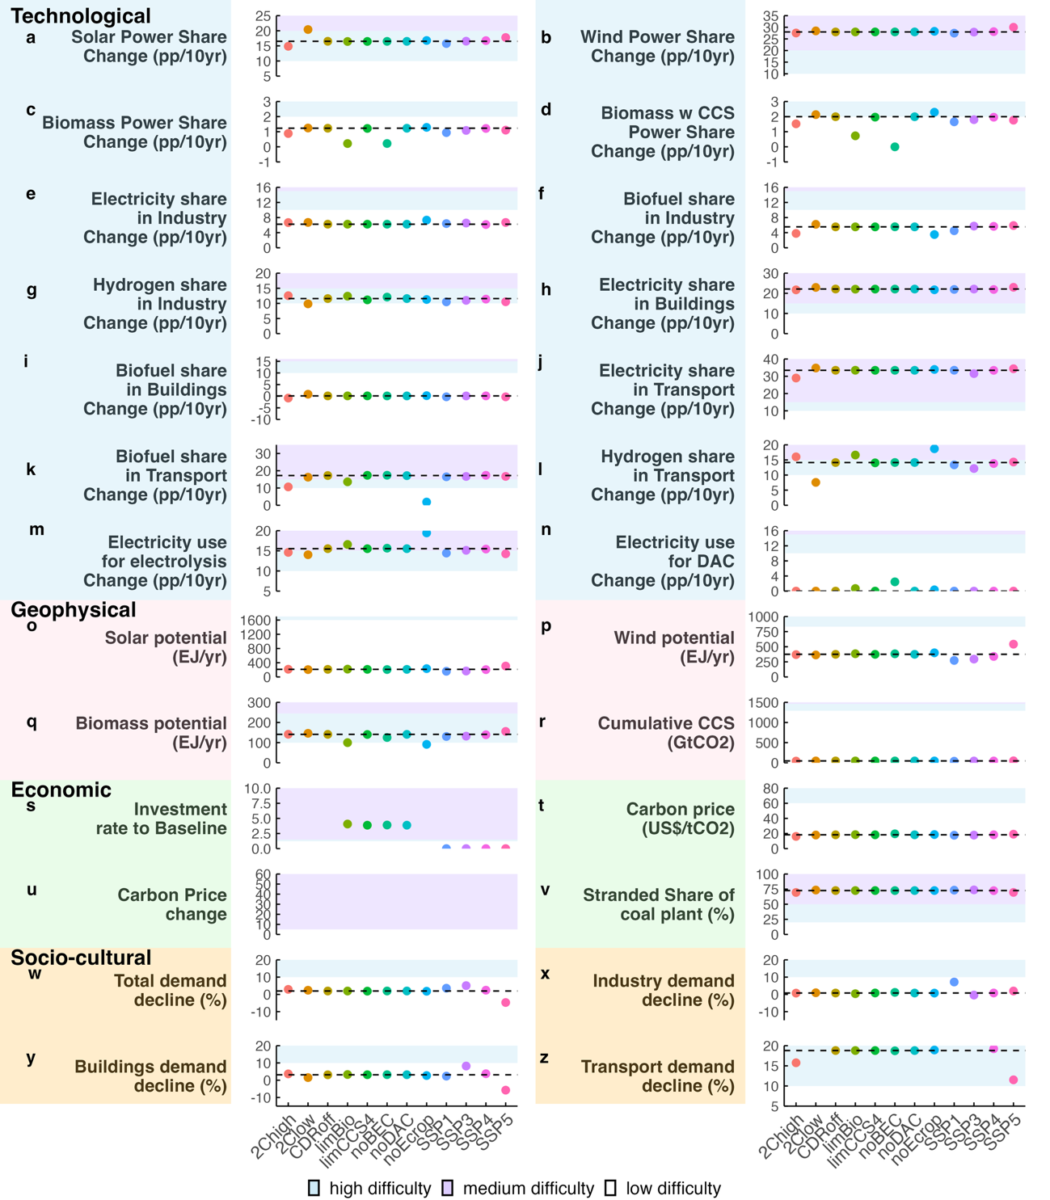

Supplementary Figure 9 | Feasibility assessment of sensitivity-analysis scenarios relative to the CDRoff scenario. For each indicator and scenario, results are shown for the time point at which the highest level of feasibility difficulty is observed; therefore, the reported values do not necessarily correspond to the same period. The CDRoff scenario is used as the reference, shown by the dashed line, and the displayed ranges are limited accordingly. Feasibility levels are color-coded, with purple denoting high difficulty and blue denoting medium difficulty; thresholds are not shown. a–n Technological feasibility: solar PV (a), wind power (b), biomass power (c), and biomass power with CCS (d); industry sector: electricity (e), bioenergy (f), and hydrogen (g); buildings sector: electricity (h) and bioenergy (i); transportation sector: electricity (j), bioenergy (k), and hydrogen (l); electricity required for hydrogen production via electrolysis relative to total electricity generation (m); and electricity consumption for DAC (n). o–r Geophysical feasibility: solar PV (o), wind power (p), bioenergy (q), and cumulative geological CO₂ storage (r). s–v, Economic feasibility: energy investment relative to the Baseline scenario (s), carbon price (t, u), and stranded assets from coal-fired power plants (v). w–z Socio-cultural feasibility: reductions in total final energy demand (w), and final energy demand in the industry (x), buildings (y), and transportation sectors (z).

Supplementary Tables

Supplementary Table 1 | Assumptions for CO₂ capture technologies applied to industrial process emissions (excluding the cement sector).
 | CO₂ capture applied to industrial process
Initial capital cost (US$/t-CO₂) | 162
O & M cost (US$/t-CO₂) | 6
Electricity consumption (GJ/t-CO₂) | 4.3
Lifetime (year) | 30
CO₂ capture rate | 90%

Supplementary Table 2 | Assumptions for DAC (values for 2020).
 | L-DAC | S1-DAC | S2-DAC
Initial capital cost (US$/t-CO₂) | 1146 | 430 | 510
O & M cost (US$/t-CO₂ yr) | 42 | 150 | 150
Electricity consumption (GJ/t-CO₂) | 1.3 | 0.6 | 2.5
Heat consumption (GJ/t-CO₂) | 5.3 | 4.4 | -
Lifetime (year) | 20 | 15 | 15
Availability year (year) | 2030 | 2040 | 2040

Supplementary Table 3 | Assumptions for EW (values for 2020).
 | EW
Rock particle size (μm) | 20
Initial capital cost (US$/t-CO₂) | 47
O & M cost (US$/t-CO₂ yr) | 197
Electricity consumption (GJ/t-CO₂) | 0.73

Supplementary Table 4 | Upper limits of annual EW deployment by region.
 | Annual EW deployment (Gt-CO₂/yr)
Canada | 0.096
United States | 0.401
EU15 | 0.197
EU10 | 0.061
EU3 | 0.037
Russia | 0.309
Mexico | 0.057
Brazil | 0.165
Middle East | 0.093
Turkey | 0.059
Japan | 0.011
China | 0.320
India | 0.420
Republic of Korea | 0.004
Thailand | 0.057
Vietnam | 0.000
Indonesia | 0.134
Malaysia | 0.021
Other Southeast Asia | 0.105
Other South Asia | 0.104
Other East Asia | 0.012
Other West Asia | 0.086
Other Western Europe | 0.000
Other Eastern Europe | 0.099
Other Northern Europe | 0.018
Australia | 0.079
Other Oceania | 0.006
Other South America | 0.210
South Africa | 0.031
North Africa | 0.571
Other Africa | 0.072
World total | 3.835

Supplementary Table 5 | Scenario for sensitivity analysis.
Scenario | Difference from CDRoff | Emission Pathway | Socio-economic scenario
CDRoff | - | 2C | SSP2
2Clow | More stringent in the first half of the century; cumulative emissions of 933 Gt-CO₂ | 2Clow | SSP2
2Chigh | Less stringent than CDRoff in the first half of the century; cumulative emissions of 1114 Gt-CO₂ | 2Chigh | SSP2
limCCS4 | Limited geological storage to 4 Gt-CO2/year | 2C | SSP2
limCCS3 | Limited geological storage to 3 Gt-CO₂/yr | 2C | SSP2
limBio | Bioenergy supply limited to 100 EJ/yr | 2C | SSP2
noEcrop | Energy crop supply set to zero | 2C | SSP2
noBEC | BEC implementation set to zero | 2C | SSP2
noDAC | DAC implementation set to zero | 2C | SSP2
noBECDAC | Both BEC and DAC implementation set to zero | 2C | SSP2
SSP1 | Service demand changed to the SSP1 level | 2C | SSP1
SSP3 | Service demand changed to the SSP3 level; some high-efficiency devices on the demand side not newly introduced | 2C | SSP3
SSP4 | Service demand changed to the SSP4 level | 2C | SSP4
SSP5 | Service demand changed to the SSP5 level; reduced cost for coal liquefaction units | 2C | SSP5

