Freshwater Ecosystems Relative Disturbance to Identify Key Conservation Priorities in Water-stressed Countries
Vijaykumar Bejagam¹✉, Ibrahim Nourein Mohammed¹

¹ Civil and Environmental Engineering Department, Khalifa University, P. O. Box 127788, Abu Dhabi, 22424, United Arab Emirates

Table of Contents
Supplementary Methods A 4
A1. Study Area 4
A2. Datasets 4
A3. Land cover Naturalness Index (LCN) 5
A4. FWADSS application for assessment of freshwater ecosystem assets (FEAs) 5
Supplementary Methods B: Workflow of FWADSS application 7
B1.Area of Interest selection 7
B2. Time period of analysis selection 8
B3. Assets and Analysis selection 8
B4. Land Cover Naturalness (LCN) weights 9
B5. Results 11
References 37

List of Figures
Supplementary Figure 1. Spatial distribution of freshwater ecosystem assets (FEAs) across study region countries. FEAs comprise Ramsar sites, mangroves, oases, lakes, and stream/wadi networks. Only streams with more than 10% water occurrence were considered in this study 14
Supplementary Figure 2. Climate classification map of study region countries based on the Köppen–Geiger climate classification 15
Supplementary Figure 3. Country-specific wettest seasons used in the analysis. Wettest months were determined for each country based on the months with the highest water occurrence. The selected wettest-season months were used to calculate relative disturbance and land-cover naturalness. 16
Supplementary Figure 4. Schema of FWADSS graphical user interface with different panels. 17

List of Tables
Supplementary Table 1. Datasets utilized in the development of FWADSS 18
Supplementary Table 2. Summary of freshwater ecosystem assets (FEAs), including asset type, count, and corresponding area or length 19
Supplementary Table 3. Country-wise summary of freshwater ecosystem assets, including the count and total area of each asset type. 20
Supplementary Table 4. List of Ramsar sites in the study region, showing changes in surface water and wetland extent between 2016 and 2025. 21
Supplementary Table 5. List of lakes in the study region, showing changes in surface water extent between 2016 and 2025. Unnamed lakes in the HydroLAKES dataset were merged by country and grouped as “Other lakes.” 30
Supplementary Table 6. Country-wise summary of stream/wadi networks in the study region, classified as low- and high-order streams. Streams with a stream order <3 were classified as low-order streams. 32
Supplementary Table 7. Country- wise changes in wetland area extent in the Mangrove FEAs in the study region between 2016 and 2025. 34
Supplementary Table 8. List of Oases in the study region, showing changes in surface water and wetland extent between 2016 and 2025. 35

Supplementary Methods A

A1. Study Area
For this work, we selected the countries that represent two geographic regions (015 and 145) representing the northern Africa and western Asia regional groupings following the M49 code⁷. The United Nations M49 Standard Country or Area Codes is adopted for the classification of Sustainable Development Goals indicators.

A2. Datasets
This study utilizes 10 m spatial resolution near real-time land use/land cover (NRT LULC) data derived from Sentinel-2 imagery using deep learning approaches¹. The dataset, known as Dynamic World, is available in near real time through the Google Earth Engine platform and classifies land cover into nine categories. In this study, the flooded vegetation class was used as a proxy for wetlands. Although the dataset defines flooded vegetation as a transient class that may differ from conventional wetland definitions, it was adopted as a proxy because validation checks indicated a strong spatial overlap between flooded vegetation and known wetland areas.
The oasis dataset presented in this study was obtained from the Atlas of Saharan and Arabian Oases project developed by the LabOasis Foundation (www.laboasis.org). A total of 776 oases has been identified across the western Asia and northern Africa region. These oases were classified into four typologies based on their hydro-geomorphological configuration: mountain, wadi, erg, and depression. In this study, only oases classified as depression and visible water source were selected, as they are characterized by large, visible geological depressions, resulting in a subset of 49 oases. In these depression oases, water supply is sustained by the convergence of subsurface micro-streams.
The wetlands of international importance (Ramsar Sites) dataset was obtained from the Ramsar Sites Information Service (www.ramsar.org). These sites are recognized not only for their significance at the national level but also for their global importance to humanity. A total of 2,527 Ramsar Sites are designated worldwide, of which 168 sites were selected for this study based on their geographic location. Among these, 137 sites have clearly defined boundaries, while the remaining 31 sites are represented only by point location information.
A high-resolution global mangrove dataset (HGMF_2020) was used in this study². This dataset is derived from Sentinel-2 imagery and was generated using object-based image analysis combined with a random forest algorithm. The overall classification accuracy is reported as 95.2%, based on validation using a standard remote sensing error matrix and bootstrapping methods. As mangrove patches are often irregular and represented by multiple polygons, all mangrove features within each country were merged for analysis.
Lakes not included in the Ramsar Sites list were categorized as other lakes in this study. The lake dataset was obtained from the HydroLAKES database³, developed by the Global HydroLAB at McGill University, Canada. This dataset includes lakes with a minimum surface area of 10 ha. Further processing involved merging lakes without defined names into the other lakes category.
The HydroRIVERS dataset was used in this study to represent the global river network⁴, with a spatial resolution of 15 arc-seconds. HydroRIVERS derives river networks from the flow direction grid of HydroSHEDS combined with long-term discharge estimates. Streams are delineated where the upstream catchment area exceeds 10 km², the long-term discharge exceeds 0.1 m³/s, or both conditions are met. Each stream segment includes attribute information such as river length, catchment area, average long-term discharge, and Strahler order. To further refine the dataset, water occurrence (i.e., frequency of water presence) derived from the Joint Research Centre (JRC) Global Surface Water dataset ⁵ was integrated with the river network. This information was used to filter out intermittently dry or non-perennial streams by applying occurrence-based thresholds. The list of datasets used in this study were also tabulated in Table S1.

A3. Land cover Naturalness Index (LCN)
The Land Cover Naturalness Index (LCN)⁸ “describes the state and trend of land use/land cover (LULC) within the basin/country, according to the amount of human-induced transformation present.” A basin in its undisturbed state, with intact forests and wetlands, generally maintains a sufficient quantity and quality of water to support indigenous flora and fauna. Naturalness exists on a gradient from completely natural to completely artificial or human dominated (Machado, 2004). Human conversion of lands and waterways are associated with increases in pollutant loads (non-point source from agriculture, point-source from urban and industrial), changes to infiltration and runoff regimes, and losses of regulating services (flood mitigation, erosion prevention, water purification). The Naturalness Index is, therefore, a proxy indicator for the degree to which these naturally occurring functions are preserved within the basin. It is based on similar efforts to categorize and quantify this gradient over landscapes, such as Machado’s index of naturalness⁹ and the hemeroby index^{10,11}.
LCN index quantifies climate and human-induced transformations in land cover on a scale from 0 to 100, ranging from completely artificial to completely natural¹². Landscapes with intact forests, wetlands, waterbodies and shrubs typically exhibit high LCN values, whereas human-modified areas such as urban build-up lands and croplands tend to have values lower LCN values. Thus, the LCN index serves as a proxy for evaluating the degree to which a landscape is preserved for natural functioning.

A4. FWADSS application for assessment of freshwater ecosystem assets (FEAs)
The freshwater assets decision support system (FWADSS) provides an interactive platform for mapping, visualizing, and assessing FWAs across the study region. It is spatially explicit framework that helps in guiding the prioritization, protection, and restoration of freshwater ecosystems. FEAs included in the FWADSS are Ramsar sites, Oasis, Mangroves, Lakes and streams/wadi networks (including the riparian areas). All these together provide the essential ecosystem services such biodiversity habitat, ground water recharge, carbon storage and cultural habitat. They also function as indicators of hydrological changes in a region experiencing increasing pressure from climate variability, groundwater abstraction, land-use change, agricultural expansion, urbanization, and infrastructure development. Many FEAs in the region are spatially fragmented, seasonally dynamic, and poorly represented in conventional monitoring systems. Remote sensing and cloud-based geospatial platforms therefore provide an efficient and consistent approach for mapping their distribution and temporal changes. Such mapping is necessary to support conservation planning, water-resource management, ecosystem restoration and climate adaptation. The detailed architecture of FWADSS was shown in Figure 6.
The tool integrates satellite-derived land-cover information with spatial datasets representing oases, Ramsar sites, mangroves, lakes, and stream/wadi networks. It provides an interactive interface for defining the area of interest, selecting ecosystem assets, adjusting analysis parameters, visualizing spatial outputs, and exporting summary statistics. The application uses a split-map layout to allow direct visual comparison between the selected time periods. The FWADSS GUI was shown in Figure S4. Users can define the analysis area using a country boundary, a custom polygon drawn on the map, or a pasted GeoJSON geometry. For country-level analyses, a user-defined buffer can be applied to the national boundary to include adjacent HVFEs. This is particularly useful in regions where wetlands, mangroves, and lakes occur near borders or coastlines.
FWADSS produces spatial outputs and summary statistics describing the changes in the FEAs. These outputs allow users to identify areas where FEAs are experiencing increasing landscape disturbance, as well as areas where land-cover conditions appear relatively stable or show positive naturalness trends. The application also supports the export of maps and tabular summaries, enabling further analysis and reporting. By combining FEAs layers with dynamic land-cover information, FWADSS provides a consistent and scalable framework for regional freshwater ecosystem assessment. The system is particularly useful for screening large areas, identifying potential disturbance hotspots, and supporting conservation or restoration prioritization across data-scarce regions of the study region domain.

Supplementary Methods B: Workflow of FWADSS application

B1.Area of Interest selection
- The user can select an Area of Interest (AOI) using one of the three options available under AOI Mode:
- Country – Select this option to perform the analysis for one of the MENA countries.
- Custom AOI – Select this option to manually draw an AOI on the map viewer.
- GeoJSON – Select this option if you already have a custom AOI in GeoJSON format.
- When Country mode is selected, choose the required country from the Country dropdown list. The user can also define a buffer distance around the selected country to include assets that are located near or just outside the country boundary.
- When Custom AOI mode is selected, use the Draw a Shape tool on the map viewer to draw the AOI.
- When GeoJSON mode is selected, paste the GeoJSON text into the provided input box. The corresponding shape will appear on the map viewer.
- If your AOI is available in another format, such as Shapefile, KML, or another GIS format, convert it to GeoJSON first. This can be done using online tools or GIS software. For example, users can use https://mapshaper.org/ to convert files to GeoJSON. Alternatively, GIS software such as ArcGIS or QGIS can also be used to perform the conversion.
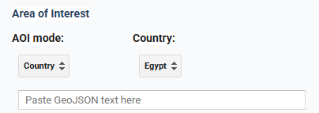
Area of Interest options
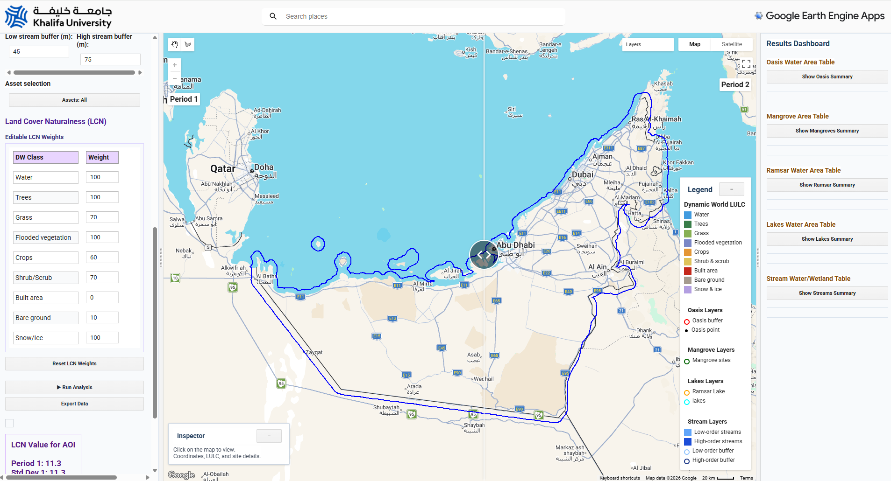
AOI display in the map viewer

B2. Time period of analysis selection
- Once the AOI is finalized, the user must select two time periods to analyze changes in freshwater assets. The Period 1 and Period 2 dropdown menus contain monthly options starting from 2016 up to the latest available month.
- The latest available month is updated automatically based on the date on which the application is used. The final selectable month will be the previous month relative to the date of application use.
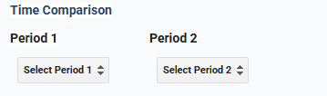
Time period selection for the analysis

B3. Assets and Analysis selection
- Once the time periods of analysis are selected, the user must specify the buffer distance for Oasis and Ramsar sites. Since these assets are location-based, the analysis will be performed within the defined buffered area. The user can also run the analysis using the default buffer values.
- The next option in the panel is Min Water Occurrence (%), which ranges from 0% to 100%. Each stream or wadi has a water occurrence value, representing the frequency with which water was present. Based on the selected occurrence threshold, streams will be filtered and included in the analysis. The default value is 50%. The user should select this value carefully, as the study region falls within arid and hyper-arid climate zones.
- After the streams are filtered, they are classified using the Low-Order Max stream order value. The default value is 3. Streams with an order less than or equal to 3 will be classified as low-order streams, while streams with a higher order will be classified as high-order streams. The maximum stream order value is 7. Once the stream order threshold is selected, the user must enter the buffer distances for both low-order streams and high-order streams.
- After all required values are entered, the user can select the assets to be included in the analysis. To include all assets, choose Select All. Alternatively, the user can select specific assets for analysis.
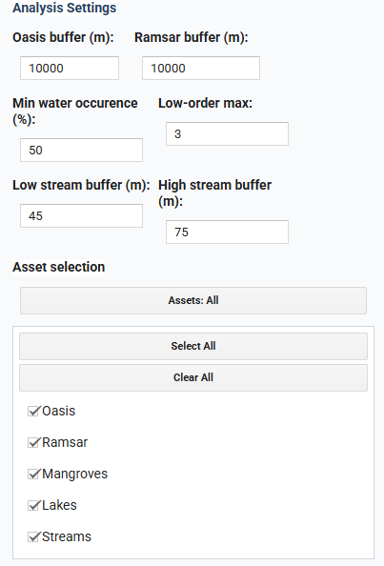
Analysis and asset selection settings

B4. Land Cover Naturalness (LCN) weights
- Predefined weights are assigned to each land cover class. The user can edit these weights as required for the analysis. The weights range from 0 to 100, where 0 indicates a land cover class that has been fully converted from its natural structure, and 100 indicates that the naturalness of the class is fully conserved.
- The user also has the option to reset the LCN weights to their default values.
- Once all required inputs are entered, click Run Analysis to analyze the freshwater ecosystem assets for the selected time periods and selected asset types.

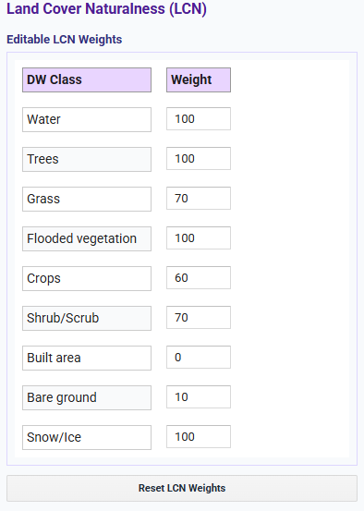
Default weight of land cover naturalness in FWADSS
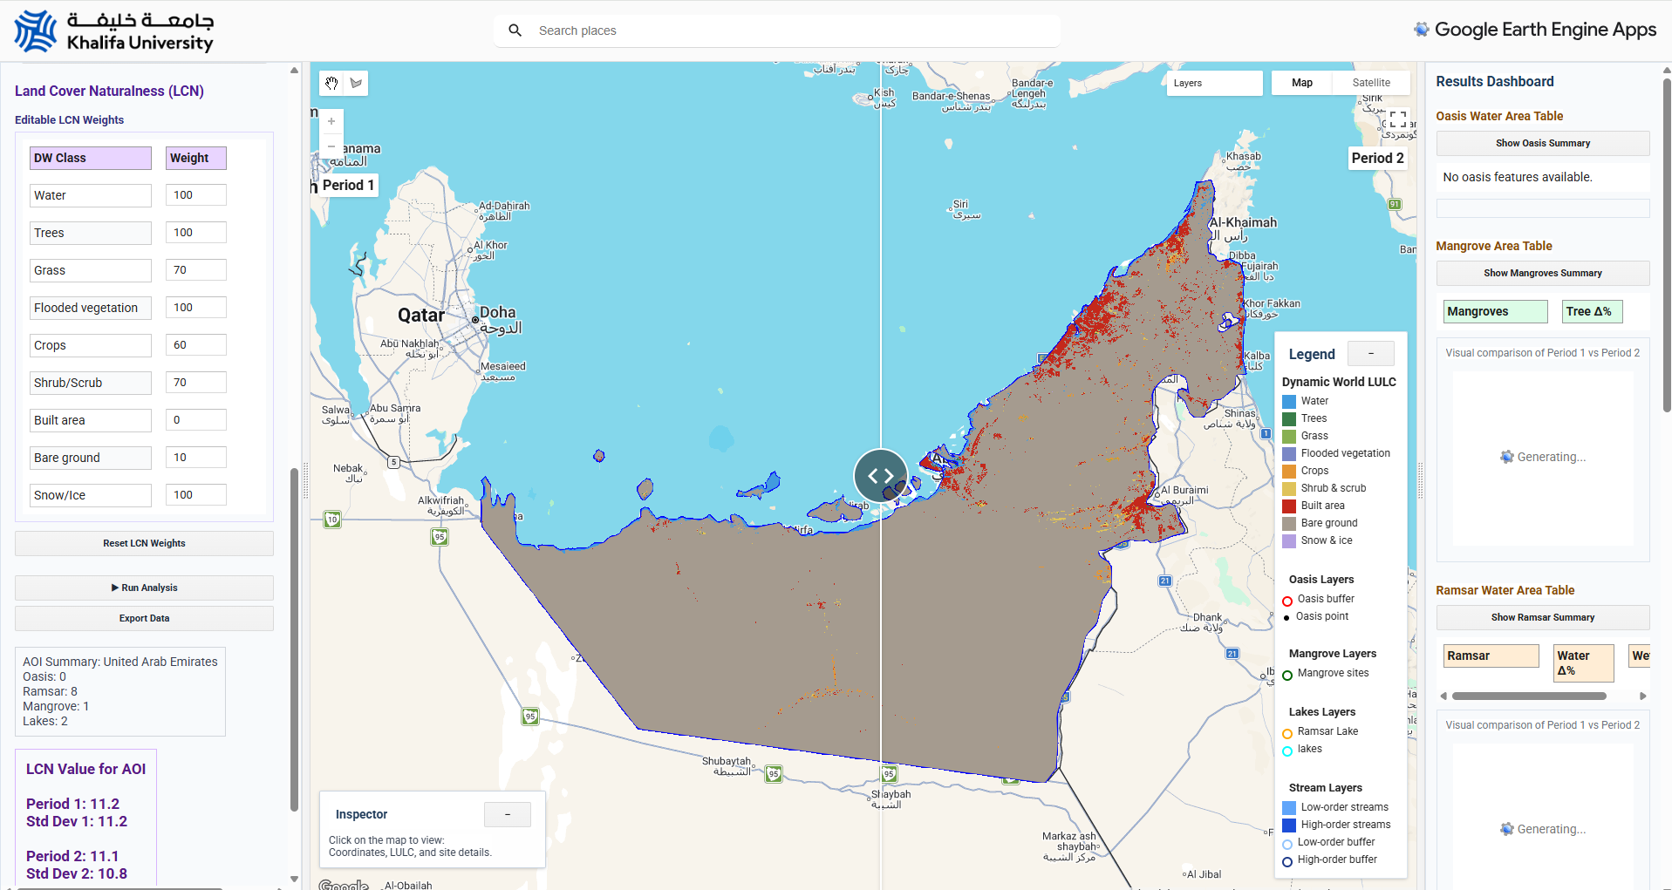
Example of dynamic world landcover map for selected periods

B5. Results
- Once the user clicks the Run Analysis button, the selected AOI will be displayed in the map viewer, and a sequence of results will appear in the left panel under the Results section.
- First, FWADSS displays the list and number of freshwater ecosystem assets present within the selected AOI. Below the AOI summary, the Land Cover Naturalness (LCN) values for Period 1 and Period 2 are displayed, along with the change in LCN between the two periods.
- Once the freshwater assessment is completed, the Processing tab shows the status as Completed. It also displays the number of images used for the selected time periods and AOI.
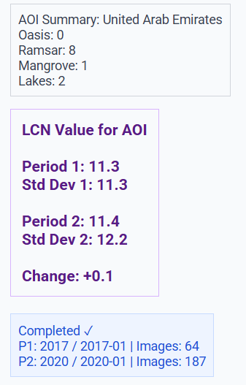
AOI and LCN summary after the analysis run
- After the analysis is completed, all assets within the AOI, along with their surface water/wetland extent for Period 1 and Period 2, will be displayed in the left and right map viewers. The user can compare changes between the two periods using the Swipe tool.
- In the Results Dashboard panel, a summary is shown for each asset available or selected within the AOI. This summary includes the total area of each asset category covered by surface water/wetland for Period 1 and Period 2.
- Below the summary, a detailed table displays the surface water/wetland extent for each asset, including the change values between the two periods.
- Bar graphs are also displayed below the table for better visualization of the results. These graphs can be downloaded for further analysis.
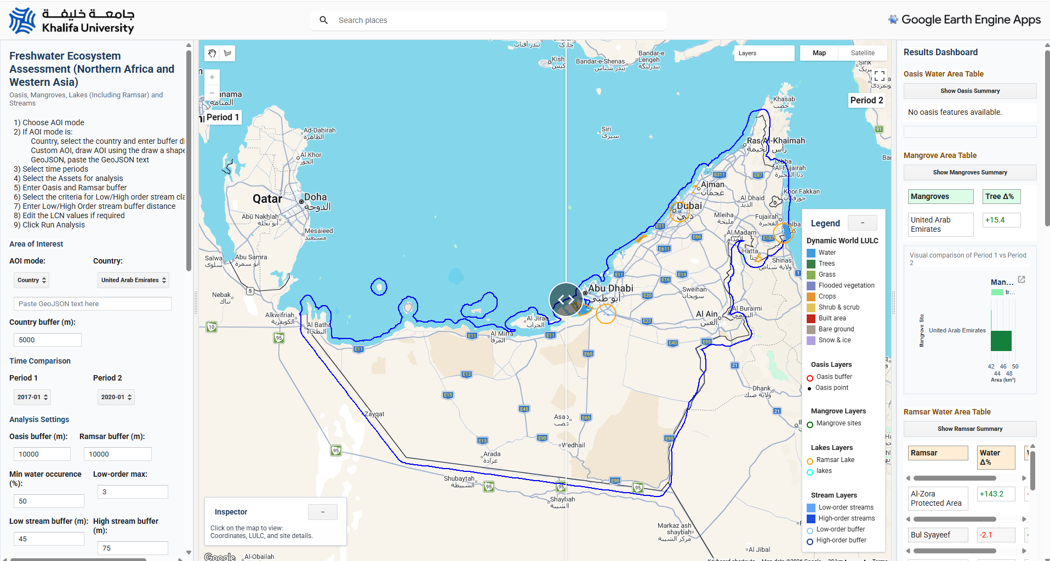
Example of freshwater ecosystem assessment results for two periods

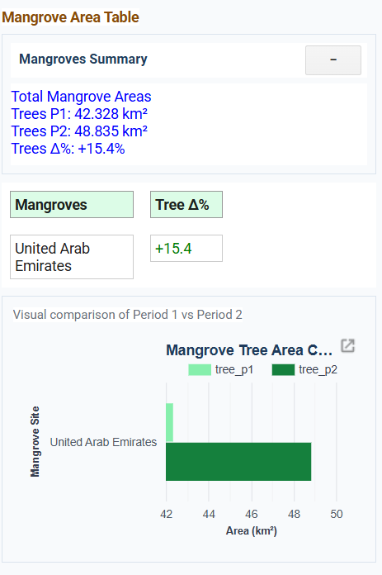 | 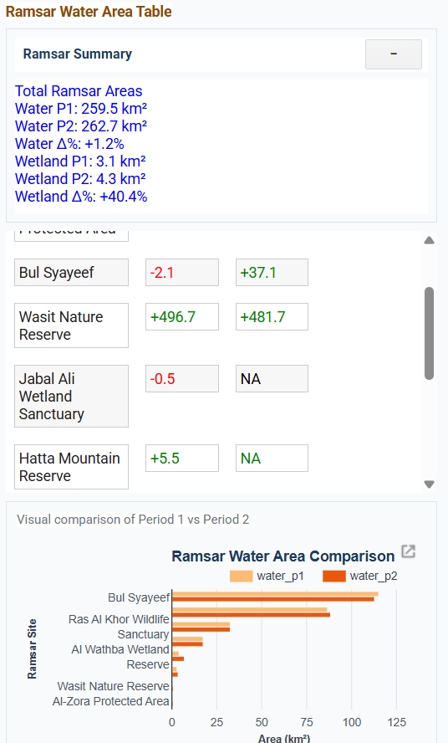 | 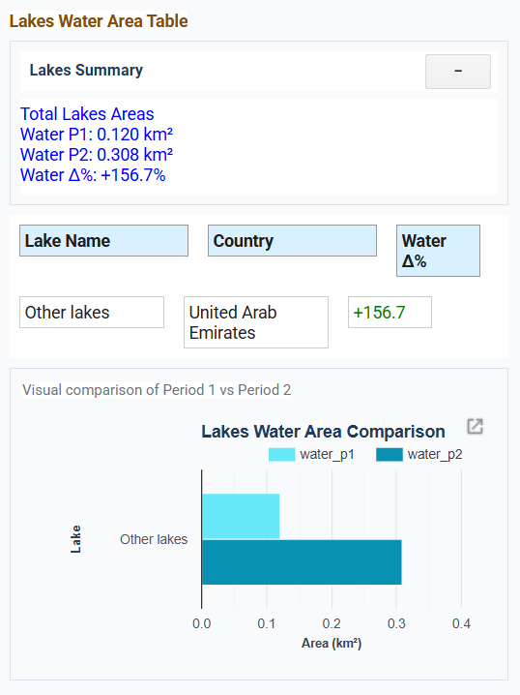
Assessment results of different assets in the form of tables and bar graphs

- The user can also view results for individual assets using the Inspect tool. Once the assessment is complete, the user can click on any asset displayed on the map viewer. The asset summary will then be displayed in the Inspect panel.
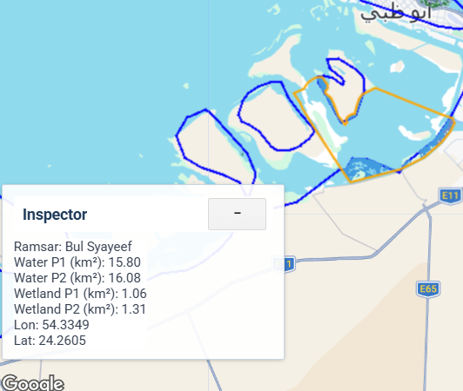
Inspector tools displaying the information about the selected asset

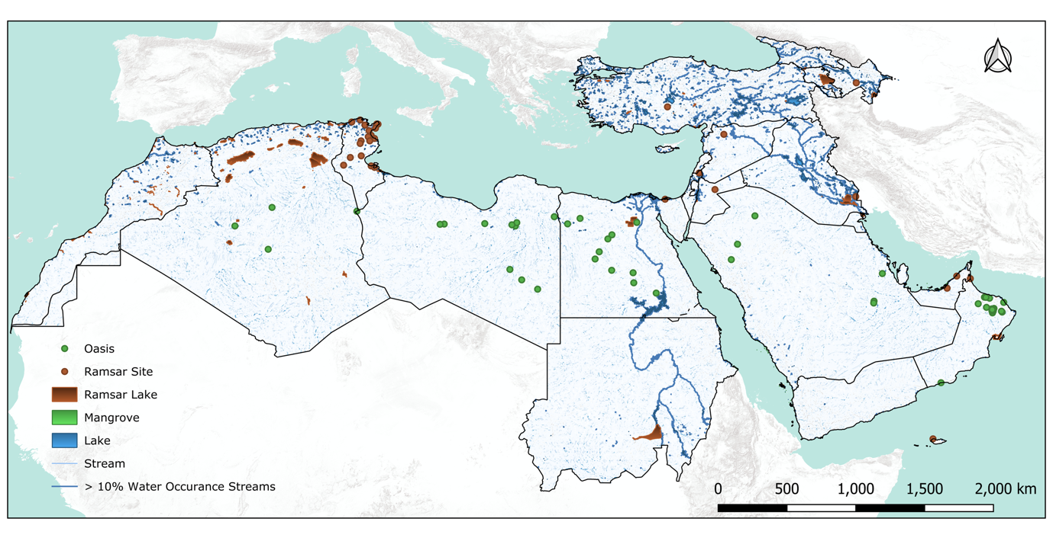
Supplementary Figure 1. Spatial distribution of freshwater ecosystem assets (FEAs) across study region countries. FEAs comprise Ramsar sites, mangroves, oases, lakes, and stream/wadi networks. Only streams with more than 10% water occurrence were considered in this study

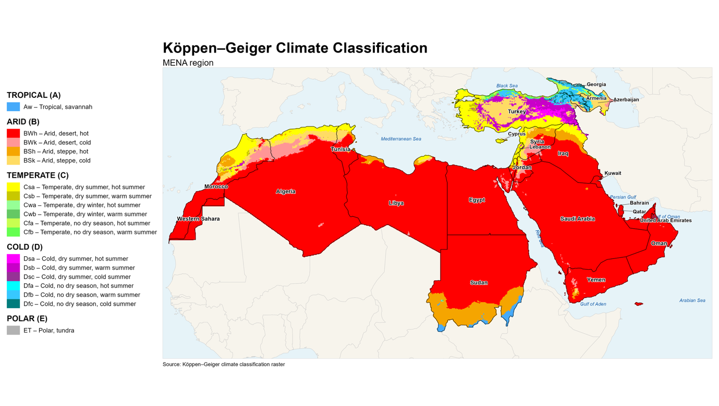
Supplementary Figure 2. Climate classification map of study region countries based on the Köppen–Geiger climate classification

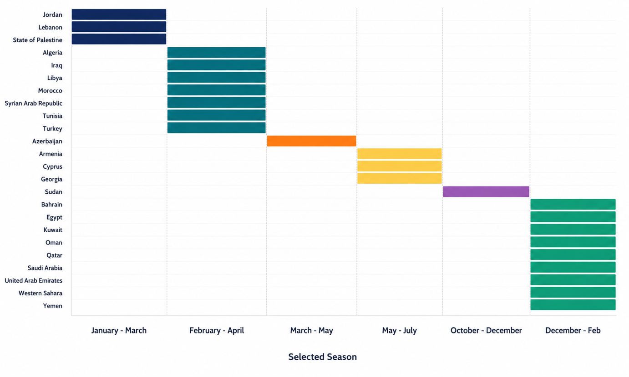
Supplementary Figure 3. Country-specific wettest seasons used in the analysis. Wettest months were determined for each country based on the months with the highest water occurrence. The selected wettest-season months were used to calculate relative disturbance and land-cover naturalness.

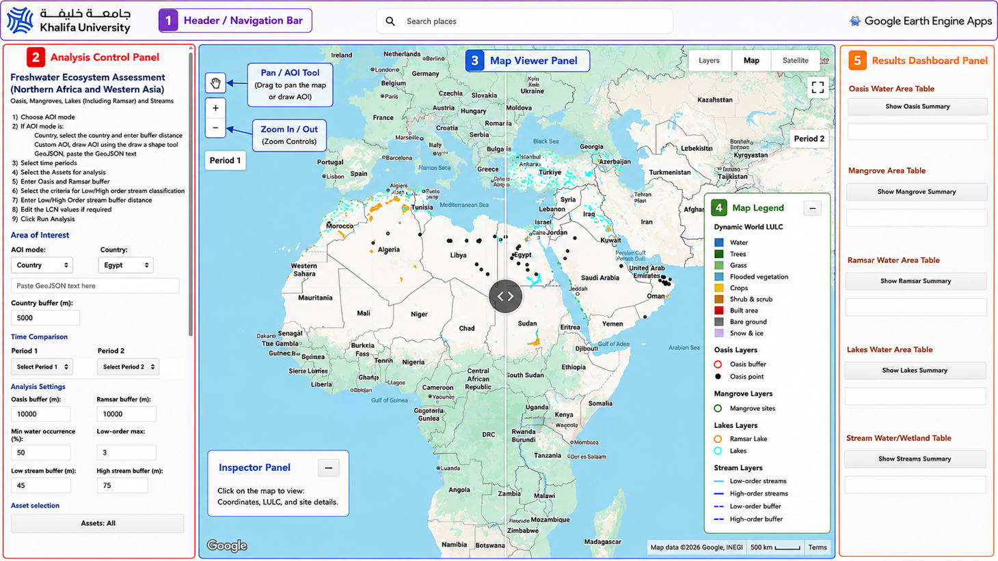
Supplementary Figure 4. Schema of FWADSS graphical user interface with different panels.

Supplementary Table 1. Datasets utilized in the development of FWADSS
Dataset | Description | Spatial Resolution | Temporal Coverage
Dynamic World V1¹ | Near real-time land use/land cover dataset | 10 m | (2016–present)
Atlas of Saharan and Arabian Oases (www.laboasis.org) | Oasis inventory | - | Static
Ramsar Sites Information Service (RSIS)  (www.ramsar.org) | Global inventory of wetlands of international importance designated under the Ramsar Convention. | Vector polygons and points | static
High-Resolution Global Mangrove Forests (HGMF 2020)² | Global mangrove distribution dataset derived from Sentinel-2 | 10 m | 2020
HydroLAKES³ | Global database of lakes and reservoirs | Vector polygons | Static
HydroRIVERS⁴ | Global river network | 15 arc-seconds | Static
JRC Global Surface Water⁵ | Global surface water occurrence dataset | 30 m | 1984–present
MOD44W Water Mask⁶ | Global land-water mask | 250 m | Annual

Supplementary Table 2. Summary of freshwater ecosystem assets (FEAs), including asset type, count, and corresponding area or length
Asset | Count | Area/length
Ramsar | 168 | 71999.15 km²
Mangrove | - | 205.263 km²
Oasis | 49 | 15386 Km²
Lake | - | 33859.4 km²
Stream | - | 54742 km*
*Streams with >10% water occurrence
*For Oasis sites, a buffer 10km was used in this study

Supplementary Table 3. Country-wise summary of freshwater ecosystem assets, including the count and total area of each asset type.
Region | Country | Oasis  (km²) | Mangrove  (km²) | Ramsar  (km²) | Lakes  (km²) | Streams (Km) >10% occurrence
Northern Africa | Algeria | 942 | 0 | 30328.13 | 1449.79 | 2599.06
Western Asia | Armenia | 0 | 0 | 4935.11 | 1283.41 | 657.66
Western Asia | Azerbaijan | 0 | 0 | 3285.80 | 936.05 | 2213.66
Western Asia | Bahrain | 0 | 0.28 | 0.00 | 0.72 | 0.00
Western Asia | Cyprus | 0 | 0 | 11.07 | 7.59 | 103.80
Northern Africa | Egypt | 3454 | 1.92 | 3412.32 | 8102.30 | 7015.89
Western Asia | Georgia | 0 | 0 | 23.00 | 239.25 | 1497.81
Western Asia | Iraq | 0 | 0 | 4316.00 | 5263.71 | 10246.33
Western Asia | Jordan | 0 | 0 | 375.00 | 757.46 | 374.18
Western Asia | Kuwait | 0 | 0 | 509.48 | 2.92 | 48.70
Western Asia | Lebanon | 0 | 0 | 0.00 | 5.50 | 24.50
Northern Africa | Libya | 3454 | 0 | 0.00 | 289.66 | 364.27
Northern Africa | Morocco | 0 | 0 | 3023.99 | 450.93 | 2156.49
Western Asia | Oman | 5652 | 1.87 | 2138.75 | 5.01 | 86.43
Western Asia | Palestine | 0 | 0 | 0.00 | 0.00 | 110.08
Western Asia | Qatar | 0 | 7.549 | 0.00 | 0.26 | 28.20
Western Asia | Saudi Arabia | 1884 | 85.568 | 106.09 | 64.26 | 611.78
Northern Africa | Sudan | 0 | 5.557 | 9464.09 | 1344.78 | 6602.16
Western Asia | Syria | 0 | 0 | 314.00 | 1173.12 | 1702.94
Northern Africa | Tunisia | 0 | 0 | 6780.57 | 690.04 | 1056.31
Western Asia | Turkey | 0 | 0 | 2158.87 | 11407.02 | 16593.16
Western Asia | UAE | 0 | 80.44 | 188.88 | 38.69 | 193.49
Northern Africa | Western Sahara | 0 | 0 | 0.00 | 0.00 | 0.00
Western Asia | Yemen | 0 | 22.08 | 314.00 | 6.92 | 57.20

Supplementary Table 4. List of Ramsar sites in the study region, showing changes in surface water and wetland extent between 2016 and 2025.
Country | Ramsar Site | Surface Water 2016 (Km2) | Surface Water 2025 (Km2) | Surface Water (% change) | Wetland 2016 (Km2) | Wetland 2025 (Km2) | Wetland (% change)
Algeria | Aulnaie de Aïn Khiar | 0 | 0 |  | 0.09 | 0.01 | -84.48
Algeria | Chott Ain El Beida | 1.4 | 1.72 | 22.45 | 0.04 | 0.09 | 116.29
Algeria | Chott de Zehrez Chergui | 20.89 | 70.43 | 237.17 | 0 | 0
Algeria | Chott de Zehrez Gharbi | 73.81 | 27.23 | -63.11 | 0.63 | 0
Algeria | Chott Ech Chergui | 303.68 | 355.43 | 17.04 | 4.06 | 0.5 | -87.78
Algeria | Chott El Beïdha-Hammam Essoukhna | 45.41 | 49.69 | 9.41 | 0.29 | 0.47 | 59.89
Algeria | Chott El Hodna | 60.96 | 29.56 | -51.51 | 0.36 | 0.1 | -71.02
Algeria | Chott Melghir | 3.99 | 106.82 | 2580.28 | 0.07 | 0.03 | -55.09
Algeria | Chott Merrouane et Oued Khrouf | 179.99 | 177.37 | -1.46 | 21.22 | 19.21 | -9.48
Algeria | Chott Oum El Raneb | 8.64 | 6.71 | -22.31 | 0 | 0.06
Algeria | Chott Sidi Slimane | 0 | 0 |  | 0 | 0
Algeria | Chott Tinsilt | 0.97 | 10.73 | 1003.41 | 0.02 | 0.78 | 5053.07
Algeria | Complexe de zones humides de la plaine de Guerbes-Sanhadja | 5.49 | 7.06 | 28.58 | 5.58 | 8.25 | 47.82
Algeria | Dayet El Ferd | 7.82 | 4.46 | -43.05 | 0.06 | 0 | -99.87
Algeria | Garaet Annk Djemel et El Merhsel | 13.11 | 38.71 | 195.35 | 0 | 0
Algeria | Garaet El Taref | 84.88 | 127.55 | 50.28 | 0 | 0
Algeria | Garaet Guellif | 13.72 | 17.03 | 24.13 | 0 | 0
Algeria | Garaet Timerganine | 0 | 1.12 |  | 0 | 0.16
Algeria | Grande Sebkha d'Oran | 199.36 | 170.18 | -14.64 | 6.74 | 3.57 | -46.98
Algeria | Grotte karstique de Ghar Boumâaza | 0.02 | 0 | -80.09 | 0 | 0
Algeria | Gueltates Afilal | 0 | 0.03 | 1196.43 | 0 | 0
Algeria | Ile de Rachgoun | 0.45 | 0.44 | -2.42 | 0 | 0
Algeria | La Réserve Naturelle du Lac des Oiseaux | 0.66 | 0.51 | -22.26 | 0.06 | 0.07 | 25.7
Algeria | La Vallée d'Iherir | 0.02 | 0.02 | 52.29 | 0 | 0
Algeria | Lac Boulhilet | 0 | 0.02 |  | 0 | 0
Algeria | Lac de Télamine | 8.96 | 8.94 | -0.26 | 1.28 | 0.82 | -36.28
Algeria | Lac du barrage de Boughezoul | 3.75 | 1.96 | -47.66 | 0.18 | 0.05 | -69.96
Algeria | Lac Fetzara | 8.08 | 26.76 | 231.36 | 26.72 | 24.08 | -9.86
Algeria | Le Cirque de Aïn Ouarka | 0.05 | 0.01 | -76.31 | 0 | 0
Algeria | Les Gueltates d'Issakarassene | 0 | 0 |  | 0 | 0
Algeria | Les Salines d'Arzew | 20.62 | 7.72 | -62.55 | 0.02 | 0
Algeria | Marais de Bourdim | 0.01 | 0 | -100 | 0.11 | 0.15 | 42.08
Algeria | Marais de la Macta | 14.34 | 0.8 | -94.4 | 4.81 | 3.19 | -33.64
Algeria | Marais de la Mekhada | 52.4 | 29.94 | -42.86 | 8.03 | 21.21 | 164.02
Algeria | Oasis de Moghrar et de Tiout | 0.02 | 0 | -97.15 | 0 | 0
Algeria | Oasis de Ouled Saïd | 0 | 0 | -100 | 0 | 0
Algeria | Oasis de Tamantit et Sid Ahmed Timmi | 0.61 | 2.02 | 229.98 | 0.44 | 0.06 | -85.55
Algeria | Oglat Ed Daïra | 1.04 | 0 | -100 | 0 | 0
Algeria | Oum Lâagareb | 0.18 | 0.01 | -97.01 | 0.13 | 0.13 | -0.6
Algeria | Réserve Intégrale du Lac El Mellah | 11.67 | 11.48 | -1.67 | 0.4 | 0.48 | 20.52
Algeria | Réserve Intégrale du Lac Oubeïra | 21.62 | 21.45 | -0.79 | 0.04 | 0.06 | 61.01
Algeria | Réserve Intégrale du Lac Tonga | 17.88 | 2.75 | -84.62 | 3.77 | 10.67 | 183.46
Algeria | Réserve Naturelle du Lac de Béni-Bélaïd | 2.81 | 2.8 | -0.39 | 0.04 | 0 | -90.24
Algeria | Réserve Naturelle du Lac de Réghaïa | 6.45 | 6.44 | -0.11 | 0.07 | 0.04 | -49.54
Algeria | Sebkhet Bazer | 13.47 | 13.28 | -1.41 | 0.74 | 1.08 | 46.65
Algeria | Sebkhet El Hamiet | 3.94 | 1.14 | -71.19 | 0.55 | 0.39 | -28.93
Algeria | Sebkhet El Melah | 10.26 | 6.71 | -34.62 | 0.51 | 0.1 | -80.17
Algeria | Sebkhet Ezzmoul | 36.61 | 40.27 | 10.01 | 0.02 | 0.03 | 22.88
Algeria | Tourbière du Lac Noir | 0.03 | 0.03 | -1.24 | 0 | 0
Algeria | Vallée de l'oued Soummam | 4.99 | 2.09 | -58.2 | 0.12 | 0 | -97.07
Armenia | Khor Virap Marsh | 0 | 0 |  | 0 | 0 | 674.51
Armenia | Lake Arpi | 20.64 | 22.22 | 7.63 | 0.06 | 0.05 | -10.82
Armenia | Lake Sevan | 1276.52 | 1277.39 | 0.07 | 2.57 | 0.94 | -63.4
Armenia | Madatapa Lake | 3.56 | 4.02 | 13.02 | 0.28 | 0.16 | -42.73
Azerbaijan | Agh-Ghol | 36.11 | 34.89 | -3.38 | 70.9 | 73.86 | 4.17
Azerbaijan | Ghizil-Agaj | 2.73 | 0 | -99.92 | 0.2 | 0 | -99.88
Azerbaijan | Lake Sevan | 0.15 | 0.32 | 114.3 | 0 | 0.03 | 1524.41
Cyprus | Larnaca Salt Lake | 0.38 | 0.38 | 1.07 | 0.02 | 0.02 | -14.89
Egypt | Lake Bardawil | 108.79 | 109.11 | 0.29 | 0.04 | 0.12 | 224.42
Egypt | Lake Qarun Protected Area | 245.74 | 248.87 | 1.27 | 0.72 | 0.53 | -26.36
Egypt | Wadi El Rayan Protected Area | 81.52 | 80.75 | -0.94 | 1.22 | 1.81 | 49.08
Georgia | Bugdasheni Lake | 0.33 | 0.34 | 5.35 | 0.01 | 0.01 | 63.54
Georgia | Ispani Mire | 0 | 0 |  | 0 | 0
Georgia | Lake Arpi | 5.71 | 6.56 | 14.92 | 0.03 | 0.01 | -62.86
Georgia | Madatapa Lake | 6.38 | 8.44 | 32.33 | 0.7 | 0.52 | -26.39
Iraq | Central Marshes | 178.18 | 245.92 | 38.02 | 804.81 | 454.68 | -43.5
Iraq | Hammar Marsh | 668.81 | 598.36 | -10.53 | 524.15 | 505.74 | -3.51
Iraq | Hawizeh Marsh | 36.59 | 15.48 | -57.71 | 46.55 | 24.43 | -47.52
Iraq | Mubarak Al-Kabeer Reserve | 17.07 | 20.44 | 19.75 | 0 | 0
Iraq | Sawa Lake | 4.15 | 0 | -99.98 | 0 | 0
Israel | Fifa Nature Reserve | 0.02 | 0.01 | -60.06 | 0 | 0
Israel | Hula Nature Reserve | 6.74 | 5.45 | -19.08 | 1.48 | 1.47 | -0.56
Jordan | Azraq Oasis | 19.12 | 10.44 | -45.41 | 0 | 0.34 | 16515.04
Jordan | Fifa Nature Reserve | 0.79 | 0.29 | -63.55 | 0.06 | 0.03 | -47.39
Kuwait | Mubarak Al-Kabeer Reserve | 284.37 | 442.24 | 55.51 | 0 | 0.01 | 453.53
Libya | Bahiret el Bibane | 0.61 | 0.61 | 0.76 | 0 | 0
Morocco | Aguelmams Sidi Ali - Tifounassine | 2.71 | 1.44 | -47.1 | 0.03 | 0 | -99.36
Morocco | Archipel et dunes d'Essawira | 10.99 | 10.66 | -3.02 | 0.14 | 0.01 | -94.37
Morocco | Assif Mgoun | 0.06 | 0.01 | -85.87 | 0 | 0 | -100
Morocco | Assifs Ahançal-Melloul | 1.65 | 0.37 | -77.48 | 0 | 0
Morocco | Assifs Réghaya-Aït Mizane | 0 | 0 | -100 | 0 | 0
Morocco | Baie d'Ad-Dakhla | 425.99 | 429.21 | 0.76 | 0.13 | 0.44 | 232.89
Morocco | Baie de Khnifiss | 38.62 | 33.14 | -14.19 | 10.56 | 6.12 | -42.09
Morocco | Barrage Al Massira | 79.47 | 11.51 | -85.52 | 0.1 | 0.01 | -90.85
Morocco | Barrage Mohammed V | 28.4 | 20.96 | -26.21 | 0.45 | 3.06 | 579.34
Morocco | Cap des Trois Fourches | 41.25 | 41.2 | -0.11 | 0 | 0
Morocco | Cap Ghir-Imsouane | 22.54 | 22.07 | -2.1 | 0 | 0.01 | 590.91
Morocco | Complexe de Sidi Moussa-Walidia | 20.88 | 19.13 | -8.39 | 5.8 | 6.39 | 10.17
Morocco | Complexe du bas Loukkos | 6.38 | 6.16 | -3.45 | 4.11 | 5.89 | 43.32
Morocco | Complexe du bas Tahaddart | 15.08 | 20.94 | 38.92 | 2.88 | 6.56 | 127.36
Morocco | Côte Aftissate-Boujdour | 66.92 | 66.75 | -0.25 | 0 | 0
Morocco | Côte des Bokkoyas | 32.2 | 33.93 | 5.38 | 0 | 0
Morocco | Embouchure de la Moulouya | 3.78 | 3.47 | -8.21 | 2.84 | 1.23 | -56.81
Morocco | Embouchure de l'oued Dr'a | 5.16 | 4.36 | -15.62 | 0.46 | 0 | -99.68
Morocco | Embouchures des oueds Chbeyka-Al Wa'er | 77.13 | 77.39 | 0.33 | 0 | 0.12 | 4489.97
Morocco | Haut Oued Lakhdar | 0.7 | 0.1 | -85.62 | 0 | 0
Morocco | Lac d'Afennourir | 0.81 | 0.43 | -47.66 | 0.03 | 0 | -88.2
Morocco | Lacs d'Imouzzer du Kandar | 1.23 | 0.06 | -94.94 | 0 | 0
Morocco | Lacs Isly-Tislite | 2.73 | 2.6 | -4.67 | 0 | 0
Morocco | Lagune et barrage de Smir | 2.64 | 4.35 | 64.8 | 0 | 0 | -92.55
Morocco | Lagune et barrage de Smir | 2.64 | 4.35 | 64.8 | 0 | 0 | -92.55
Morocco | Littoral de Jbel Moussa | 2.01 | 1.99 | -1.22 | 0 | 0
Morocco | Marais et côte du Plateau de Rmel | 1.4 | 0.63 | -54.93 | 0.1 | 0.23 | 130.04
Morocco | Merja de Fouwarate | 1.4 | 1.62 | 15.87 | 0.49 | 0.35 | -29.06
Morocco | Merja Sidi Boughaba | 0.83 | 0.72 | -13.5 | 0.22 | 0.04 | -79.89
Morocco | Merja Zerga | 15.32 | 16.76 | 9.41 | 4.52 | 9.77 | 116.27
Morocco | Moyenne Dr'a | 9.41 | 0.07 | -99.21 | 0.16 | 0 | -99.78
Morocco | Oasis du Tafilalet | 0.92 | 0.08 | -91.32 | 0.01 | 0
Morocco | Oued Assaquia Al Hamra à La'youne | 4.29 | 4.66 | 8.43 | 0.01 | 0.2 | 1933.69
Morocco | Oued Tizguite | 0.18 | 0.09 | -50.39 | 0 | 0
Morocco | Sebkha Bou Areg | 110.5 | 110.65 | 0.13 | 0.92 | 0.8 | -12.79
Morocco | Sebkha Zima | 3.39 | 0.37 | -89.02 | 0.17 | 0
Morocco | Sebkhat Imlili | 1.83 | 0 | -100 | 0 | 0
Morocco | Zones humides de l'oued El Maleh | 4.25 | 3.31 | -22.07 | 0.01 | 0.02 | 168.55
Morocco | Zones humides de Souss-Massa | 9.06 | 8.57 | -5.43 | 0.3 | 0.11 | -62.55
Oman | Al Ansab Wetland | 0.1 | 0.09 | -0.99 | 0.03 | 0.04 | 10.44
Oman | Hatta Mountain Reserve | 1.48 | 2.13 | 43.94 | 0 | 0
Oman | Mangrove and Alhafeya Protected Area in Khor Kalba | 62.12 | 61.2 | -1.47 | 1.26 | 1.33 | 5.72
Oman | Qurm Nature Reserve | 0.16 | 0.16 | -2.89 | 0.38 | 0.34 | -9.56
Oman | Wetlands Reserve in Al Wusta Governorate | 753.69 | 742.92 | -1.43 | 1.96 | 2.35 | 19.71
Saudi Arabia | Farasan Islands Biosphere Reserve | 91.8 | 91.54 | -0.28 | 1.41 | 1.35 | -4.9
Sudan | Khor Abu Habil Inner Delta | 238.2 | 214.59 | -9.91 | 163.79 | 251.11 | 53.31
Syria | Sabkhat al-Jabbul Nature Reserve | 59.27 | 90.47 | 52.64 | 0.69 | 0.81 | 17.5
Tunisia | Bahiret el Bibane | 264.05 | 261.5 | -0.96 | 0.4 | 0.44 | 8.73
Tunisia | Barrage de Sidi El Barrak | 40.69 | 30.48 | -25.1 | 0.77 | 0.28 | -64.13
Tunisia | Barrage de Sidi Saad | 8.41 | 6.88 | -18.21 | 0.23 | 0.09 | -59.66
Tunisia | Barrage Lebna | 44.6 | 38.15 | -14.45 | 1.19 | 0.47 | -60.59
Tunisia | Barrage Merguellil | 3.46 | 0.04 | -98.83 | 0.35 | 0.04 | -88.35
Tunisia | Barrage Mlaabi | 47.54 | 44.03 | -7.39 | 1.02 | 0.35 | -65.08
Tunisia | Barrage Oued El Hajar | 75.51 | 72.26 | -4.3 | 1.05 | 0.14 | -86.22
Tunisia | Barrage Oued Ermal | 6.06 | 2.34 | -61.31 | 0.89 | 0.22 | -75.47
Tunisia | Barrage Sidi Abdelmoneem | 5.18 | 1.57 | -69.73 | 0.42 | 0.28 | -34.58
Tunisia | Chott El Jerid | 1.35 | 0.45 | -66.71 | 0 | 0
Tunisia | Chott Elguetar | 0.02 | 0.27 | 1139.02 | 0.01 | 0
Tunisia | Complexe des zones humides de Barrage Ghdir El Goulla et Barrage El Mornaguia | 8.49 | 7.57 | -10.8 | 0.91 | 1.07 | 17.03
Tunisia | Complexe des zones humides de Sebkhet Oum Ez-Zessar et Sebkhet El Grine | 84.16 | 91.24 | 8.42 | 10.53 | 5.68 | -46.06
Tunisia | Garâa Sejenane | 0.65 | 0.23 | -64.27 | 0.98 | 0.72 | -26.64
Tunisia | Golfe de Boughrara | 156.46 | 159.49 | 1.93 | 0.15 | 0.06 | -60.63
Tunisia | Ichkeul | 94.98 | 89.47 | -5.8 | 2.55 | 1.74 | -31.79
Tunisia | Lagunes du Cap Bon oriental | 101.77 | 101.43 | -0.33 | 1.14 | 0.27 | -76.3
Tunisia | Réserve Intï¿½grale du Lac Oubeï¿½ra | 0.81 | 0.81 | 0.58 | 0 | 0
Tunisia | Réserve Intï¿½grale du Lac Tonga | 4.24 | 0.59 | -86.18 | 0.07 | 3.18 | 4360.4
Tunisia | Réserve naturelle de Saddine | 0.08 | 0 | -97.86 | 0 | 0
Tunisia | Salines de Monastir | 137.61 | 136.06 | -1.12 | 2.33 | 1.53 | -34.29
Tunisia | Sebkhet Halk Elmanzel et Oued Essed | 95.57 | 93.64 | -2.02 | 0.61 | 0.11 | -81.37
Tunisia | Sebkhet Kelbia | 77.19 | 0.25 | -99.68 | 0.77 | 0
Tunisia | Sebkhet Noual | 73.33 | 3.93 | -94.64 | 0.02 | 0.01 | -68.54
Tunisia | Sebkhet Sejoumi | 23.56 | 22.52 | -4.39 | 1.69 | 1.89 | 11.83
Tunisia | Sebkhet Sidi Elhani | 172.5 | 151.66 | -12.08 | 0.06 | 0 | -93.43
Tunisia | Sebkhet Soliman | 2.73 | 3.11 | 13.98 | 2.66 | 2.27 | -14.9
Turkey | Akyatan Lagoon | 77.9 | 79 | 1.41 | 7.05 | 8.94 | 26.76
Turkey | Gediz Delta | 123.93 | 124.63 | 0.57 | 9.85 | 11.28 | 14.48
Turkey | Göksu Delta | 72.29 | 71.58 | -0.98 | 4.92 | 4.81 | -2.24
Turkey | Khor Virap Marsh | 0.07 | 0 | -97.39 | 0.35 | 0.02 | -93.94
Turkey | Kizilirmak Delta | 112.29 | 118.87 | 5.86 | 38.78 | 36.41 | -6.1
Turkey | Kizören Obrouk | 0.03 | 0.03 | -2.1 | 0 | 0
Turkey | Lake Burdur | 132.79 | 118.96 | -10.42 | 1.08 | 0.67 | -37.36
Turkey | Lake Kus | 165.91 | 154.21 | -7.05 | 3.49 | 15.27 | 337.93
Turkey | Lake Kuyucuk | 1.2 | 0 | -99.99 | 0.09 | 0.05 | -42.56
Turkey | Lake Seyfe | 16.59 | 14.12 | -14.87 | 0.19 | 0 | -98.81
Turkey | Lake Uluabat | 136.75 | 119.94 | -12.29 | 20.32 | 32.77 | 61.24
Turkey | Meke Maar | 0.28 | 0.01 | -97.1 | 0.01 | 0 | -100
Turkey | Nemrut Caldera | 7.58 | 12.44 | 64.25 | 0 | 0
Turkey | Sultan Marshes | 42.82 | 18.92 | -55.81 | 42.39 | 44.16 | 4.17
Turkey | Yumurtalik Lagoons | 125.14 | 133.17 | 6.42 | 12.82 | 14.54 | 13.38
United Arab Emirates | Al Wathba Wetland Reserve | 3.48 | 3.86 | 11.05 | 0.07 | 0.05 | -33.03
United Arab Emirates | Al-Zora Protected Area | 0.36 | 0.27 | -25.9 | 0.14 | 0.17 | 24.81
United Arab Emirates | Bul Syayeef | 108.56 | 113.3 | 4.37 | 1.11 | 2.04 | 83.17
United Arab Emirates | Hatta Mountain Reserve | 1.48 | 2.13 | 43.94 | 0 | 0
United Arab Emirates | Jabal Ali Wetland Sanctuary | 17.57 | 17.7 | 0.74 | 0 | 0
United Arab Emirates | Mangrove and Alhafeya Protected Area in Khor Kalba | 87.87 | 86.58 | -1.47 | 1.26 | 1.33 | 5.72
United Arab Emirates | Ras Al Khor Wildlife Sanctuary | 30.43 | 29.89 | -1.75 | 0.66 | 0.96 | 45.64
United Arab Emirates | Wasit Nature Reserve | 0.44 | 0.48 | 9.25 | 0.03 | 0.02 | -18.79
Yemen | Detwah Lagoon | 110.61 | 109.82 | -0.71 | 0.02 | 0.01 | -55.77

Supplementary Table 5. List of lakes in the study region, showing changes in surface water extent between 2016 and 2025. Unnamed lakes in the HydroLAKES dataset were merged by country and grouped as “Other lakes.”
Country | Lake name | Surface Water 2016 (Km2) | Surface Water 2025 (Km2) | Surface Water (% change)
Algeria | Other lakes | 166.53 | 129.08 | -22.48
Armenia | Other lakes | 19.71 | 19.2 | -2.57
Azerbaijan | Mingechaurskoye | 413.61 | 414.73 | 0.27
Azerbaijan | Other lakes | 355.73 | 370.18 | 4.06
Bahrain | Other lakes | 0.41 | 0.39 | -4.75
Cyprus | Other lakes | 2.29 | 2.65 | 15.67
Egypt | Great Bitter | 198.99 | 198.48 | -0.26
Egypt | Nasser | 4704.62 | 4890.45 | 3.95
Egypt | Other lakes | 511.85 | 866.39 | 69.27
Egypt | Toshka 1 | 0.09 | 538.59 | 626177.13
Egypt | Toshka 2 | 93.34 | 495.4 | 430.73
Georgia | Other lakes | 220.08 | 221.36 | 0.58
Iraq | Buhayrat ath Tharthar | 1612.57 | 1518.17 | -5.85
Iraq | Dukan | 120.35 | 120.29 | -0.05
Iraq | Habbaniyah | 522.65 | 332.55 | -36.37
Iraq | Other lakes | 1057.18 | 1087.26 | 2.85
Iraq | Razazah | 436.89 | 334.58 | -23.42
Israel | Other lakes | 166.09 | 161.7 | -2.64
Israel | Tiberias | 161.56 | 161.96 | 0.25
Jordan | Dead Sea | 599.2 | 585.67 | -2.26
Jordan | Other lakes | 96.54 | 99.45 | 3.02
Kuwait | Other lakes | 1.76 | 1.8 | 2.39
Lebanon | Other lakes | 5.44 | 5.5 | 1.22
Libya | Other lakes | 115.44 | 86.54 | -25.03
Morocco | Lac des Ait-Aadel | 3.41 | 3.32 | -2.55
Morocco | Other lakes | 292.48 | 226.99 | -22.39
Oman | Other lakes | 0.53 | 0.75 | 41.96
Qatar | Other lakes | 0.02 | 0 | -100
Saudi Arabia | Other lakes | 55.93 | 54.63 | -2.33
Sudan | Jebel Aulia Reservoir | 702.26 | 673.11 | -4.15
Sudan | Other lakes | 153.09 | 154.56 | 0.96
Sudan | Roseires Reservoir | 224.39 | 224.39 | 0
Tunisia | Other lakes | 259.82 | 209.73 | -19.28
Turkey | Acigol | 63.51 | 65.66 | 3.38
Turkey | Adiyaman | 9.8 | 10.71 | 9.28
Turkey | Aksehir | 98.93 | 27.13 | -72.58
Turkey | Almus Baraji | 12.6 | 20.15 | 59.99
Turkey | Altinkaya Baraji | 73.58 | 73.54 | -0.06
Turkey | Ataturk Dam | 694.22 | 694.66 | 0.06
Turkey | Beysehir | 626.96 | 625.1 | -0.3
Turkey | Cildir | 36.77 | 117.02 | 218.27
Turkey | Eber | 29.12 | 5.53 | -80.99
Turkey | Egridir | 454.42 | 438.56 | -3.49
Turkey | Ercek | 106.19 | 105.66 | -0.49
Turkey | Hazar | 77.32 | 77.45 | 0.17
Turkey | Hirfanli | 184.03 | 182.71 | -0.71
Turkey | Iznik | 290.52 | 299.68 | 3.15
Turkey | Keban Baraji | 399 | 399.05 | 0.01
Turkey | Other lakes | 1811.84 | 1730.79 | -4.47
Turkey | Tuz | 1015.02 | 869.7 | -14.32
Turkey | Van | 3567.81 | 3555.85 | -0.34
United Arab Emirates | Other lakes | 0.43 | 0.94 | 119.62
Yemen | Other lakes | 4.69 | 6.39 | 36.16

Supplementary Table 6. Country-wise summary of stream/wadi networks in the study region, classified as low- and high-order streams. Streams with a stream order <3 were classified as low-order streams.

Country | Stream group | Surface Water 2016 (Km2) | Surface Water 2025 (Km2) | Surface Water (% change) | Wetland 2016 (Km2) | Wetland 2025 (Km2) | Wetland (% change)
Algeria | low | 24.25 | 14.30 | -41.04 | 0.05 | 0.09 | 100.66
Algeria | high | 35.79 | 32.34 | -9.66 | 0.21 | 0.24 | 15.84
Armenia | low | 1.87 | 2.08 | 11.27 | 0.04 | 0.06 | 24.52
Armenia | high | 6.31 | 7.32 | 16.08 | 0.01 | 0.03 | 199.98
Azerbaijan | low | 10.74 | 12.15 | 13.14 | 6.76 | 7.41 | 9.52
Azerbaijan | high | 62.05 | 66.99 | 7.96 | 5.56 | 6.41 | 15.23
Bahrain | low
Bahrain | high
Cyprus | low | 0.12 | 0.14 | 20.00
Cyprus | high
Egypt | low | 109.50 | 117.09 | 6.93 | 2.89 | 2.44 | -15.69
Egypt | high | 604.74 | 628.41 | 3.91 | 13.88 | 24.63 | 77.42
Georgia | low | 7.68 | 7.48 | -2.56 | 0.04 | 0.11 | 151.90
Georgia | high | 36.25 | 33.34 | -8.03 | 0.78 | 0.75 | -4.01
Iraq | low | 57.86 | 49.49 | -14.46 | 6.14 | 4.19 | -31.70
Iraq | high | 723.27 | 696.04 | -3.76 | 55.40 | 52.39 | -5.42
Israel | low | 0.48 | 0.93 | 93.42
Israel | high | 6.90 | 6.91 | 0.17
Jordan | low | 0.33 | 0.40 | 21.99
Jordan | high | 8.94 | 9.00 | 0.69
Kuwait | low | 0.67 | 0.67 | 0.00
Kuwait | high
Lebanon | low
Lebanon | high
Libya | low | 1.52 | 1.52 | 0.00
Libya | high | 0.61 | 0.25 | -59.49
Morocco | low | 11.94 | 10.58 | -11.42 | 0.15 | 0.20 | 29.97
Morocco | high | 53.43 | 27.66 | -48.24 | 1.02 | 1.53 | 49.29
Palestine | low
Palestine | high
Qatar | low | 0.57 | 0.58 | 2.27 | 0.04 | 0.04 | 0.00
Qatar | high
Sudan | low | 94.72 | 96.35 | 1.72 | 6.15 | 6.50 | 5.80
Sudan | high | 1562.89 | 1633.42 | 4.51 | 55.36 | 76.84 | 38.78
Syria | low | 45.10 | 44.75 | -0.78 | 0.24 | 0.77 | 218.83
Syria | high | 397.76 | 373.23 | -6.17 | 5.68 | 12.66 | 122.77
Tunisia | low | 2.41 | 2.24 | -6.68 | 0.36 | 0.15 | -57.74
Tunisia | high | 6.07 | 6.06 | -0.19 | 0.42 | 0.39 | -8.16
Turkey | low | 103.15 | 118.78 | 15.16 | 4.27 | 3.32 | -22.41
Turkey | high | 529.38 | 583.68 | 10.26 | 7.99 | 7.54 | -5.69
United Arab Emirates | low | 4.55 | 4.55 | 0.01 | 0.01 | 0.31 | 2314.98
United Arab Emirates | high
Western Sahara | low
Western Sahara | high
Yemen | low | 0.32 | 0.31 | -4.35
Yemen | high | 0.79 | 0.68 | -14.03

Supplementary Table 7. Country- wise changes in wetland area extent in the Mangrove FEAs in the study region between 2016 and 2025.
Country | Wetland 2015 (Km2) | Wetland 2025 (Km2) | Wetland (% change)
Bahrain | 0.21 | 0.25 | 20.56
Egypt | 1.32 | 1.4 | 6.27
Oman | 1.21 | 1.14 | -5.93
Qatar | 5.38 | 5.98 | 11.27
Saudi Arabia | 38.2 | 41.63 | 8.99
Sudan | 3.62 | 4.1 | 13.42
United Arab Emirates | 45.75 | 45.77 | 0.06
Yemen | 15.3 | 15.39 | 0.57

Supplementary Table 8. List of Oases in the study region, showing changes in surface water and wetland extent between 2016 and 2025.
Country | Oasis | Surface Water 2016 (Km) | Surface Water 2025 (Km) | Surface Water (% change) | Wetland 2016 (Km) | Wetland 2025 | Wetland (% change)
Algeria | GhadamesÂ Oasis | 0.11 | 0.15 | 45.54 | 0 | 0.08
Algeria | Hassi GaraÂ Oasis | 0 | 0 | 0 | 0 | 0
Algeria | Igostene Oasis | 0.04 | 0.04 | -11.05 | 0 | 0
Algeria | TimimounÂ Oasis | 0 | 0 |  | 0 | 0
Egypt | Abu MinqarÂ Oasis | 0.18 | 0.17 | -6.09 | 0.19 | 0.02 | 89.47
Egypt | BahariyaÂ Oasis | 4.11 | 4.76 | 15.77 | 0.3 | 0.18 | 40
Egypt | BarisÂ Oasis | 0.08 | 0.1 | 18.32 | 0.05 | 0.11
Egypt | DakhlaÂ Oasis | 0.95 | 0.95 | 0.56 | 0.31 | 0.18 | 41.94
Egypt | El HeizÂ Oasis | 0.11 | 0.18 | 59.64 | 0.02 | 0.01 | 50
Egypt | FarafraÂ Oasis | 1.91 | 0.49 | -74.17 | 1.19 | 0.04 | 96.64
Egypt | FayyumÂ Oasis | 0.86 | 0.97 | 12.84 | 0 | 0
Egypt | KhargaÂ Oasis | 1.42 | 1.57 | 10.79 | 1.06 | 1.41 | -33.02
Egypt | KurkurÂ Oasis | 0 | 0 |  | 0 | 0
Egypt | QaraÂ Oasis | 6.67 | 8.78 | 31.63 | 0.89 | 0.53 | 40.45
Egypt | SiwaÂ Oasis | 61.49 | 54.56 | -11.27 | 1.48 | 1.16 | 21.62
Libya | Al JaghbubÂ Oasis | 0.23 | 0 | -98.39 | 0 | 0
Libya | Al KufraÂ Oasis | 0 | 0 | 0 | 0 | 0
Libya | AwjillahÂ Oasis | 0.03 | 0.05 | 71.81 | 0 | 0.02
Libya | BuzaymahÂ Oasis | 1.15 | 0.86 | -25.82 | 0 | 0
Libya | GhadamesÂ Oasis | 0.14 | 0.15 | 11.99 | 0.1 | 0.08 | 20
Libya | Jakharrad Oasis | 0 | 0 |  | 0 | 0
Libya | JaluÂ Oasis | 0 | 0 | -100 | 0 | 0
Libya | MaradahÂ Oasis | 9.89 | 8.3 | -16.04 | 0.21 | 0.12 | 42.86
Libya | SoknaÂ Oasis | 0.72 | 0.25 | -64.94 | 0.11 | 0.01 | 90.91
Libya | TazirbuÂ Oasis | 0 | 0 |  | 0 | 0
Libya | WaddanÂ Oasis | 0.21 | 0.34 | 58.85 | 0 | 0
Oman | Al BuwaitenÂ Oasis | 0.17 | 0.33 | 87.2 | 0.02 | 0.02 | 0
Oman | Al FathÂ Oasis | 0.01 | 0.01 | 45.16 | 0 | 0
Oman | Al JammaÂ Oasis | 0.01 | 0.06 | 428.92 | 0 | 0
Oman | Al Khashabah Oasis | 0.12 | 0.41 | 229.54 | 0.01 | 0.02
Oman | Al MudaybiÂ Oasis | 0.01 | 0.01 | 20.97 | 0 | 0
Oman | Al Muktra Oasis | 0.12 | 0.4 | 239.16 | 0.01 | 0.02
Oman | Al RuddahÂ Oasis | 0.01 | 0.01 | 17.75 | 0 | 0
Oman | Al WasilÂ Oasis | 0 | 0 |  | 0 | 0
Oman | BidiyahÂ Oasis | 0 | 0 |  | 0 | 0
Oman | DarisÂ Oasis | 0 | 0.03 |  | 0 | 0
Oman | Hayl Al GhafÂ Oasis | 9.3 | 9.67 | 3.92 | 0.01 | 0.04
Oman | HibraÂ Oasis | 0.94 | 0.96 | 2.69 | 0 | 0
Oman | LizqÂ Oasis | 0.07 | 0.12 | 84.7 | 0.01 | 0.01 | 0
Oman | Maâ€™basÂ Oasis | 1.99 | 2.32 | 16.23 | 0 | 0.01
Oman | ManahÂ Oasis | 0.1 | 0.21 | 108.43 | 0 | 0.13
Oman | SalalahÂ Oasis | 8.91 | 9 | 0.97 | 0.02 | 0.13
Oman | SinawÂ Oasis | 0.13 | 0.33 | 155.65 | 0.01 | 0.03
Oman | UyunÂ Oasis | 0.04 | 0.16 | 294.57 | 0 | 0
Saudi Arabia | Al AhsaÂ Oasis | 0.49 | 0.22 | -56.25 | 0.04 | 0.07 | -75
Saudi Arabia | Al HafayerÂ Oasis | 0 | 0 |  | 0 | 0
Saudi Arabia | Dumat Al-JandalÂ Oasis | 1.77 | 4.01 | 127.05 | 0.01 | 0.02
Saudi Arabia | MogayraÂ Oasis | 0.05 | 0.06 | 38.45 | 0 | 0
Saudi Arabia | TaymaÂ Oasis | 0.11 | 0.09 | -14.11 | 0.07 | 0.01 | 85.71
Saudi Arabia | YabrinÂ Oasis | 0 | 0 |  | 0 | 0

References
1. Brown, C. F. et al. Dynamic World, Near real-time global 10 m land use land cover mapping. Sci. Data 9, (2022).
2. Jia, M. et al. Mapping global distribution of mangrove forests at 10-m resolution. Sci. Bull. (Beijing). 68, (2023).
3. Messager, M. L., Lehner, B., Grill, G., Nedeva, I. & Schmitt, O. Estimating the volume and age of water stored in global lakes using a geo-statistical approach. Nat. Commun. 7, (2016).
4. Lehner, B. & Grill, G. Global river hydrography and network routing: Baseline data and new approaches to study the world’s large river systems. Hydrol. Process. 27, 2171–2186 (2013).
5. Pekel, J. F., Cottam, A., Gorelick, N. & Belward, A. S. High-resolution mapping of global surface water and its long-term changes. Nature 540, (2016).
6. Carroll, M. , D. C. , T. J. , S. R. , H. A. , W. M. , S. C. , G. R. , S. S. , B. A. , B.-R. M. , & F. M. MODIS/Terra Land Water Mask Derived from MODIS and SRTM L3 Global 250m SIN Grid V061 [Dataset]. NASA Land Processes Distributed Active Archive Center https://doi.org/10.5067/MODIS/MOD44W.061.
7. United Nations Statistics Division. Standard country or area codes for statistical use (M49). . https://unstats.un.org/unsd/methodology/m49/, (accessed 21 October 2025). (1999).
8. Vollmer, D. et al. Integrating the social, hydrological and ecological dimensions of freshwater health: The Freshwater Health Index. Science of The Total Environment 627, 304–313 (2018).
9. Sukopp, H. Human-caused impact on preserved vegetation. in Landscape and Urban Planning vol. 68 (2004).
10. Paracchini, M. , C. C. Implementation of a EU wide indicator for the rural-agrarian landscape – In support of COM(2006) 508 “Development of agri-environmental indicators for monitoring the integration of environmental concerns into the Common Agricultural Policy.” JRC 68008, Joint Research Centre Institute for Environment Sustainability, Publications Office, Luxembourg (2011).
11. Walz, U. & Stein, C. Indicators of hemeroby for the monitoring of landscapes in Germany. J. Nat. Conserv. 22, (2014).
12. Machado, A. An index of naturalness. J. Nat. Conserv. 12, 95–110 (2004).

