Supplementary materials
A dual-responsive GA-functionalized Mn-MSN nanoplatform for targeted delivery of CD-2e and enhanced therapy of hepatocellular carcinoma
Yuqing Zhengª, Zhihang Liª, Yan Maª, Hao Panª, Lianrui Caoª, Yuqing Niª, Cong Li^{a, b,*} Lijiang Chen^{a, b,*}
ªSchool of Pharmaceutical Science, Liaoning University, Shenyang110036, China
^{b}Liaoning Key Laboratory of New Drug Research & Development, Shenyang110036, China
Corresponding author:
*Associate Prof. Cong Li, E-mail: 735049942@qq.com
*Prof. Lijiang Chen, E-mail: clj1172023@163.com

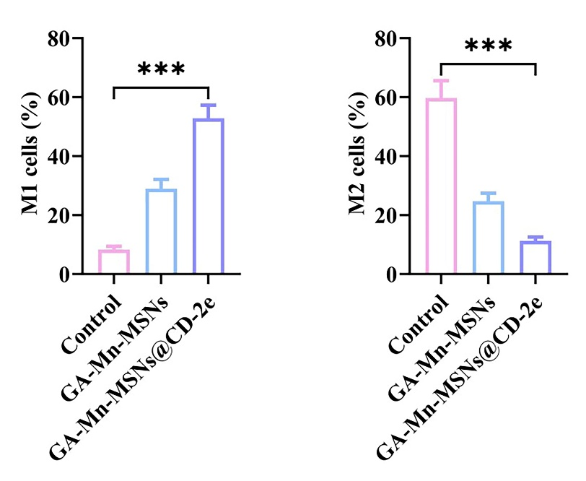
Fig. S1 FCM results showing the expression of CD86 and CD206 in macrophages (F4/80⁺) after treatment with different groups.

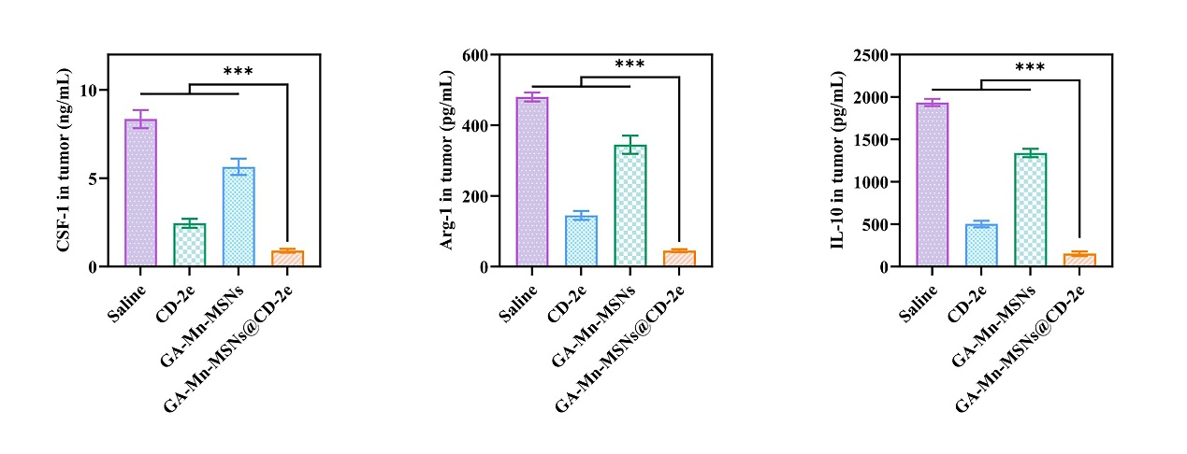
Fig. S2 Secretion levels of the cytokines CSF-1, Arg-1 and IL-10 in tumor tissues measured by ELISA.

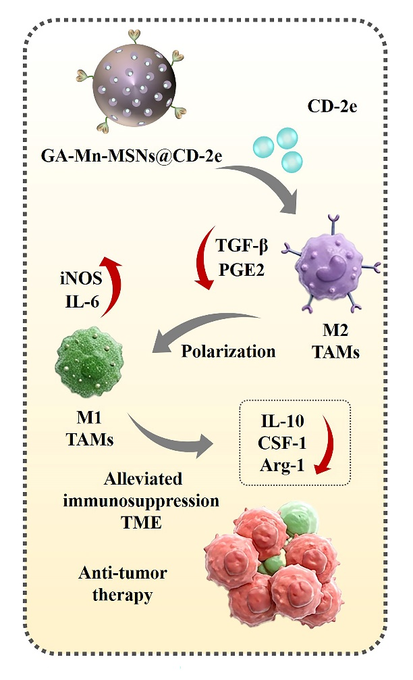
Fig. S3 Schematic illustration of the mechanism by which GA-Mn-MSNs@CD-2e improves the tumor immune microenvironment and enhances antitumor efficacy through regulation of TAM polarization.

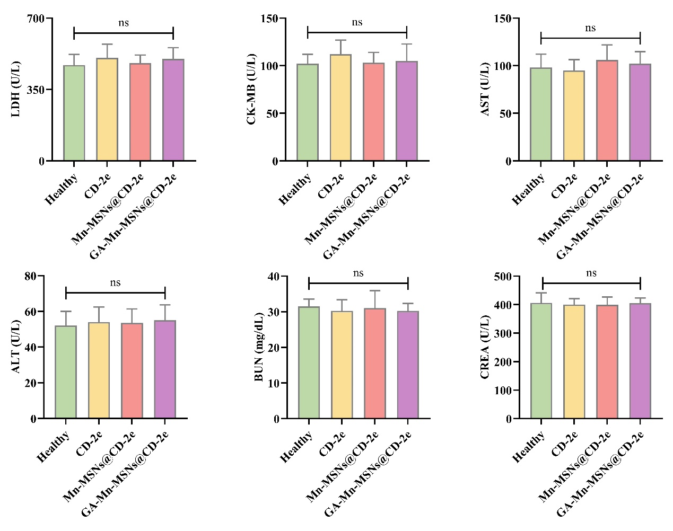
Fig. S4 Levels of LDH, CK-MB, AST, ALT, BUN, and CREA.

