Additional figures

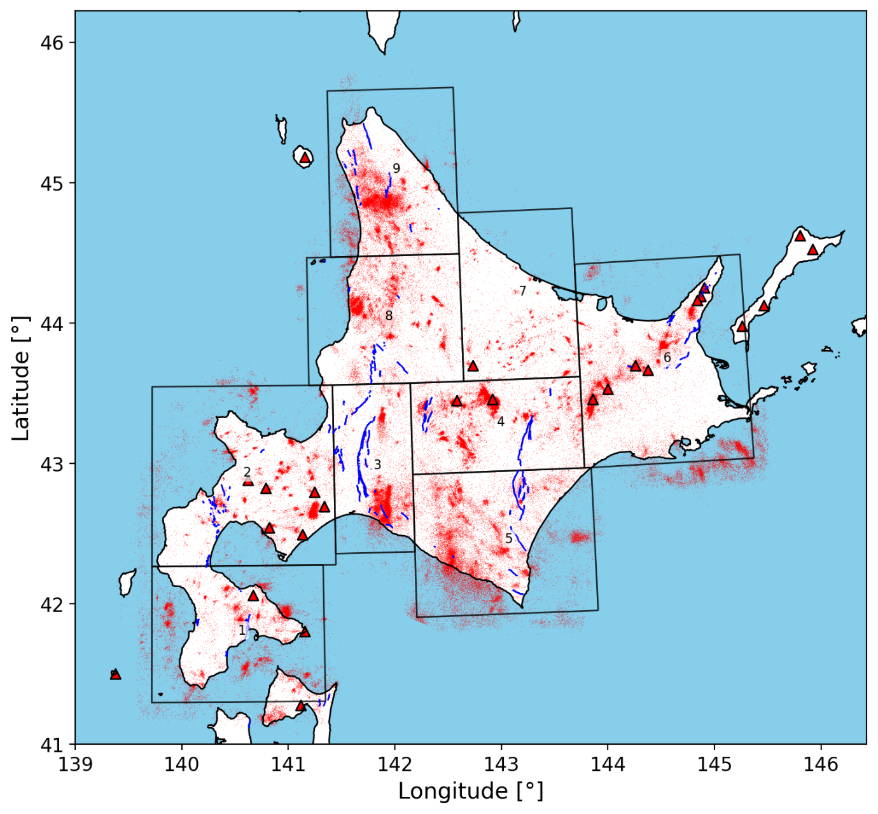
Figure SF1. Absolute event locations determined by NonLinLoc for the detected events in Hokkaido. Only event with depths less than 50 km and above the subducting Pacific slab contours are shown.

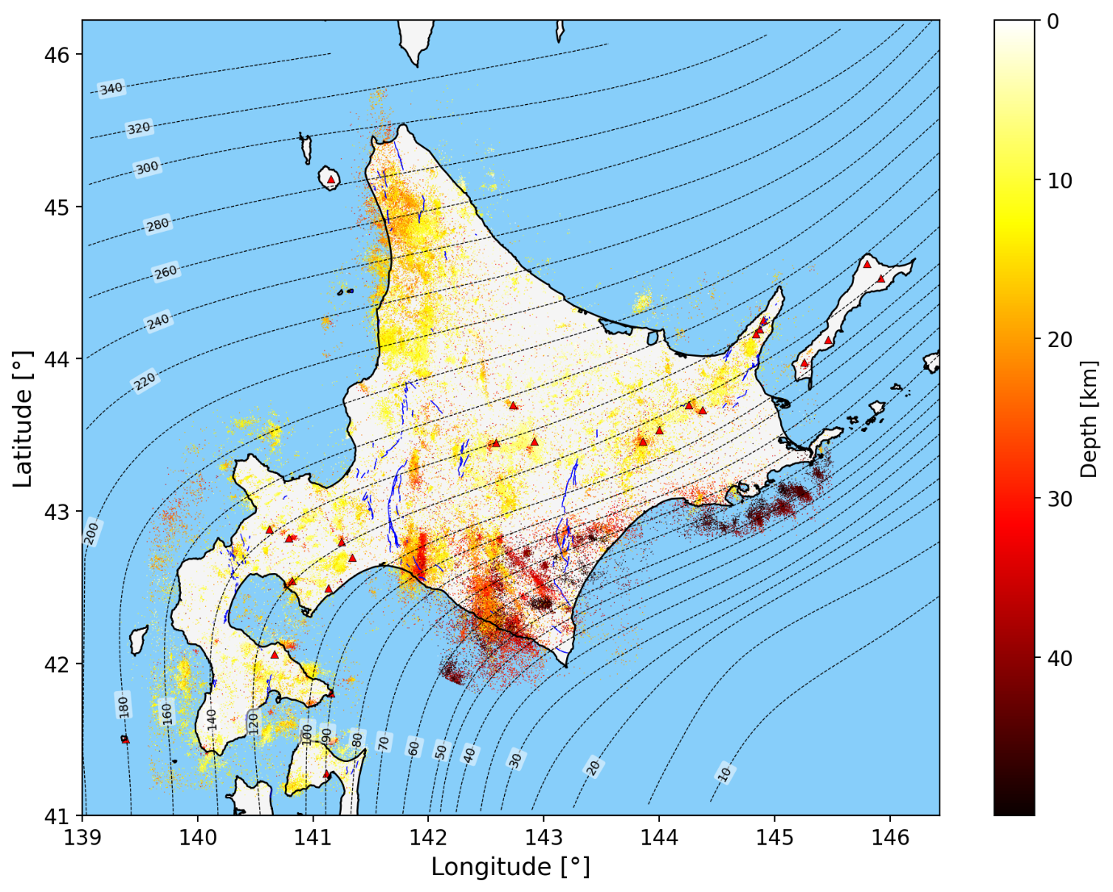
Figure SF2. Depth distribution of events determined by NonLinLoc. Contour lines represent the depth to the top surface of the pacific slab by Iwasaki et al. (2015). Only event with depths less than 50 km and above the subducting Pacific slab contours are shown.

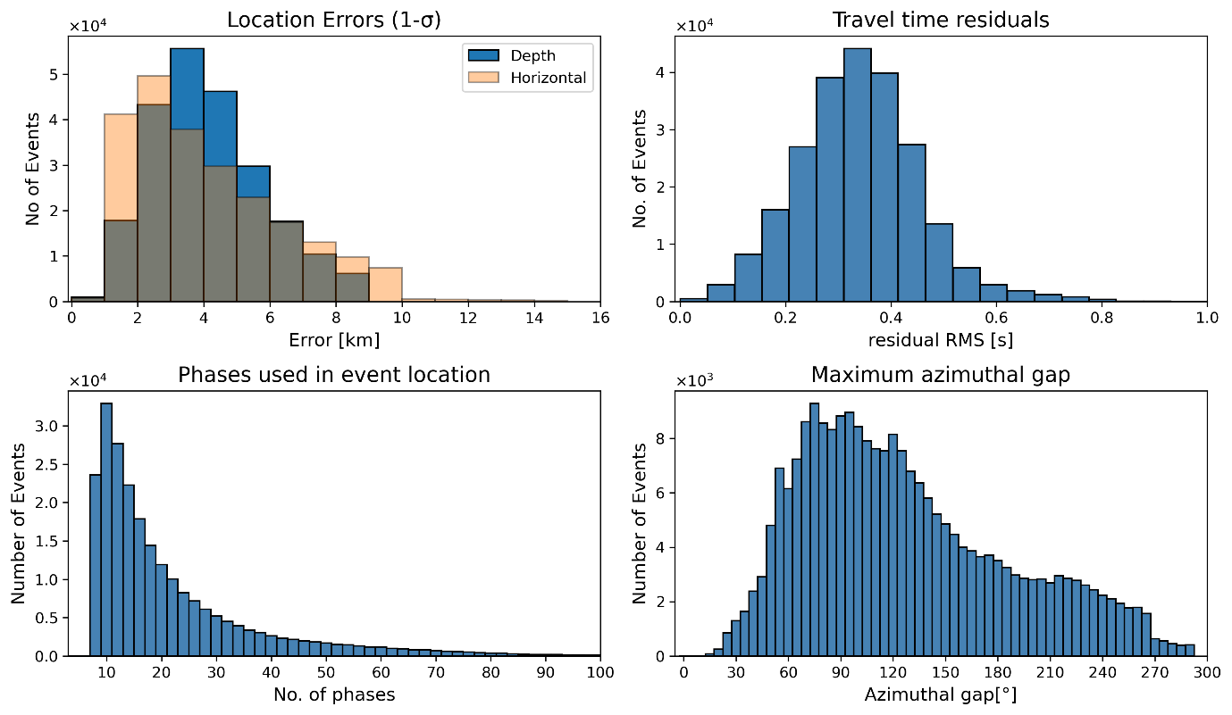
Figure SF3. Absolute event location statistics as determined by NonLinLoc for the events shown in SF1 and SF2.

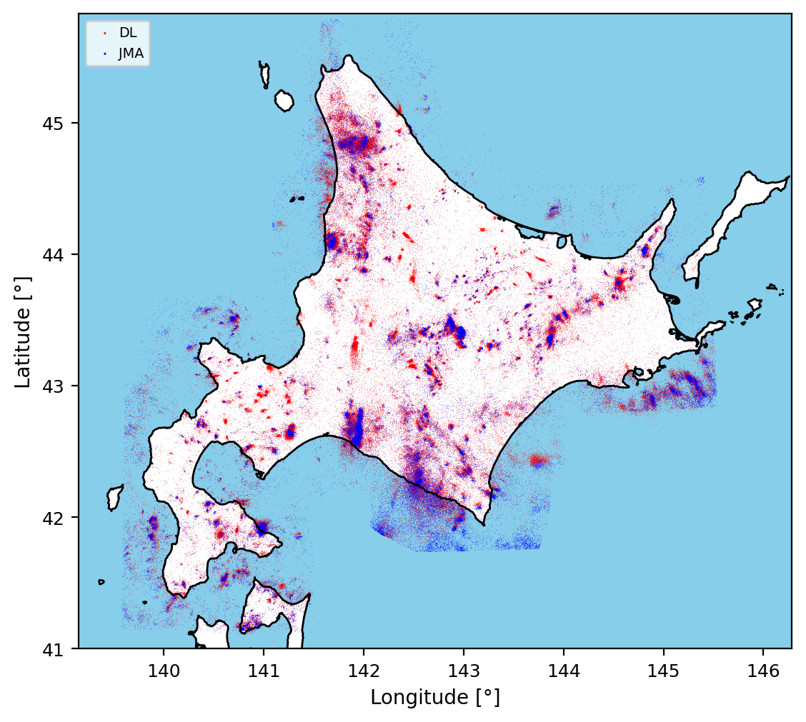
Figure SF4. Locations of events detected by deep learning and located using NonLinLoc in this study (red) vs JMA events (blue). All events are filtered to depths less than 50 km and above the Pacific slab, onshore and within 50 km from shore. Detected events with location errors (horizontal and depth errors) larger than 10km, rms larger than 0.8, and back azimuthal gap larger than 270° were removed.

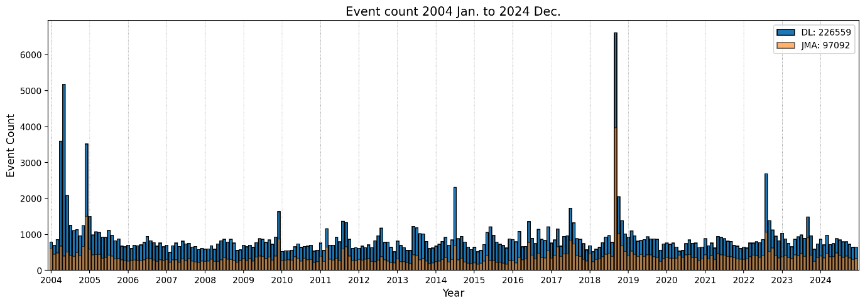
Figure SF5. Comparison of event frequency per month between JMA events and events detected by deep learning (DL) in this study during the period between January 2004 and December 2024. It can be seen that deep learning detected more than double the number of events in the JMA catalog.

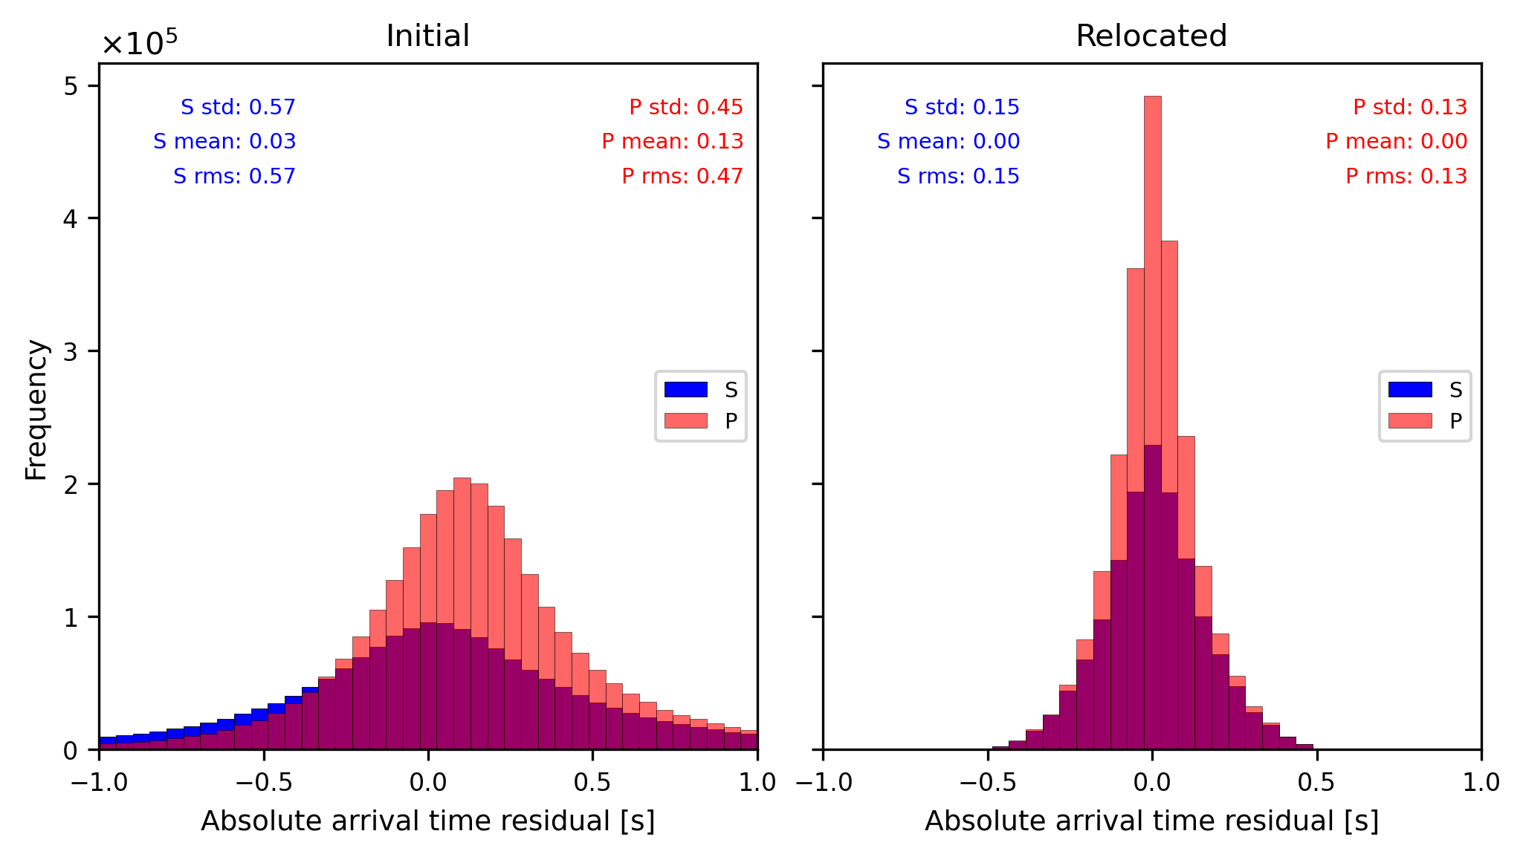
Figure SF6. Absolute arrival time residuals before and after event relocation. After relocation, the standard deviations of the root mean square (RMS) residuals of absolute travel times decreased from 0.57 s and 0.45 s to 0.15 s and 0.13 s for S and P phases, respectively.

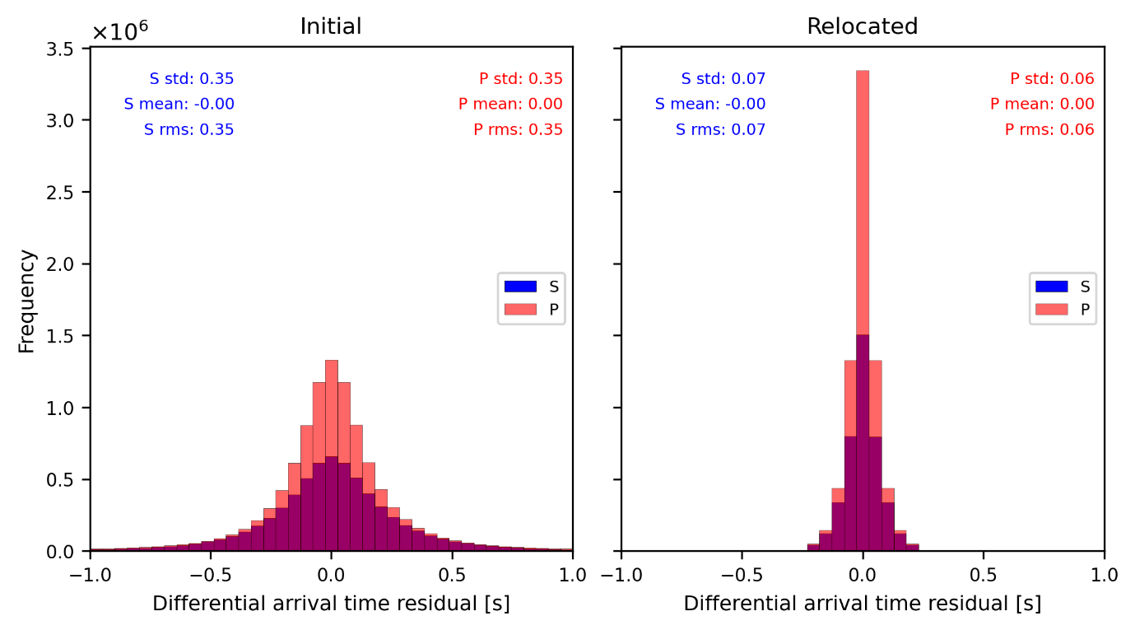
Figure SF7. Differential arrival time residuals before and after relocation. The standard deviations of the RMS residuals of differential arrival times decreased from 0.35 s to 0.07 s for S phases and from 0.35 s to 0.06 s for P phases.

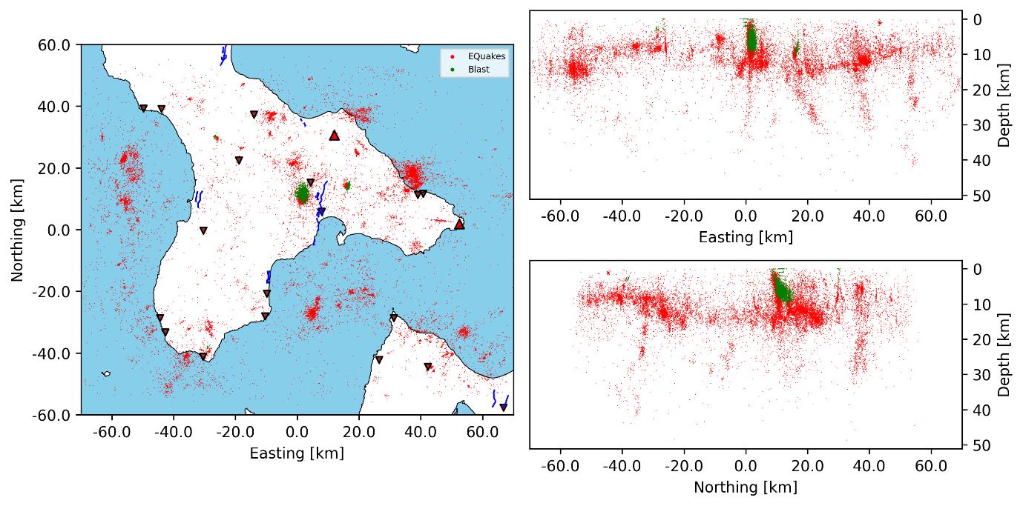
Figure SF8. Detected events vs blast locations in region 1.

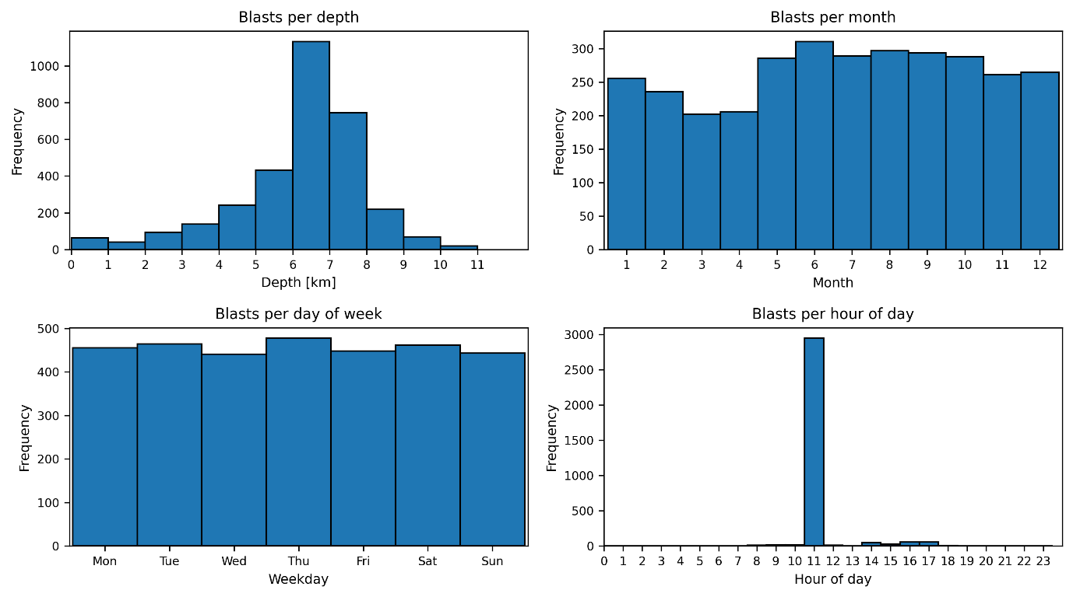
Figure SF9. Blast temporal characteristics in region 1.

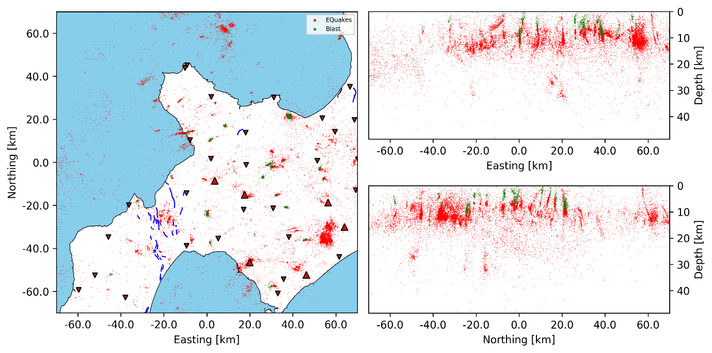
Figure SF10. Detected events vs blast locations in region 2.

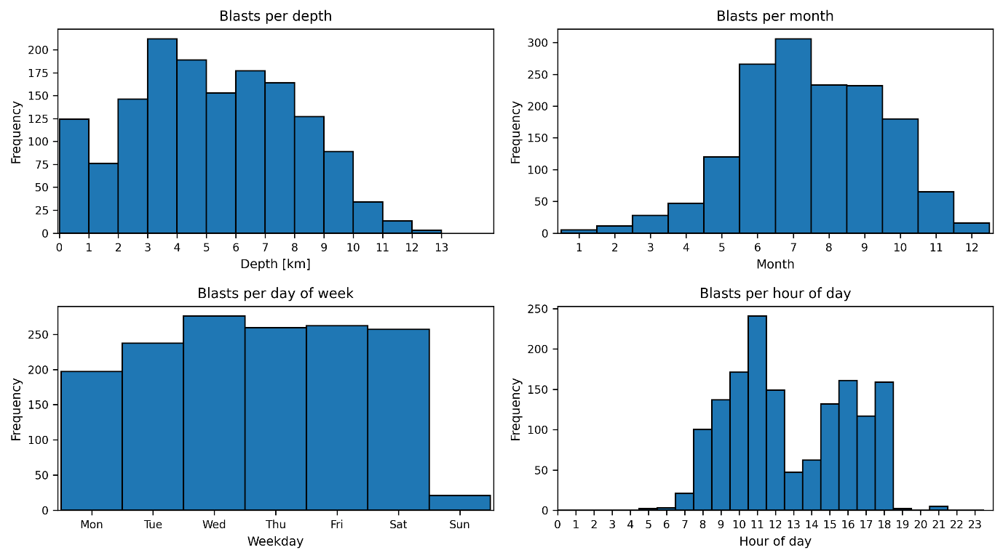
Figure SF11. Blast temporal characteristics in region 2.

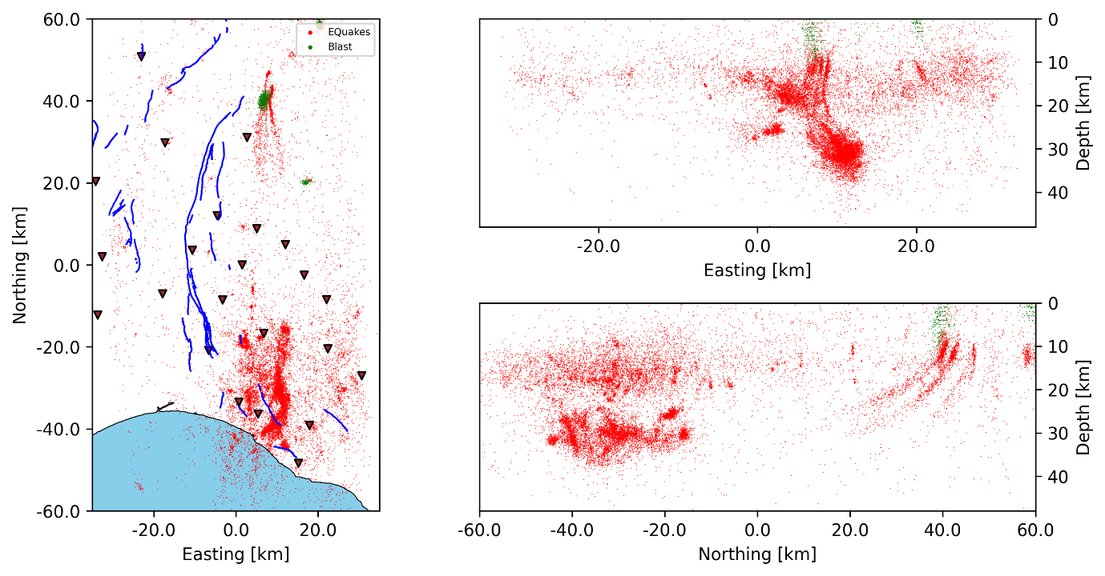
Figure SF12. Detected events vs blast locations in region 3.

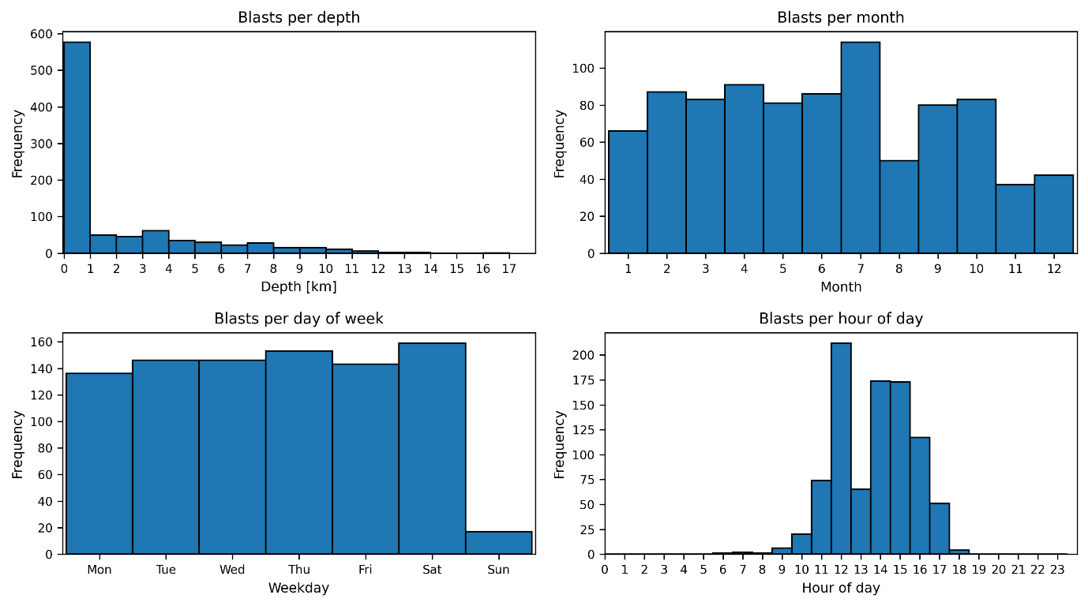
Figure SF13. Blast temporal characteristics in region 3.

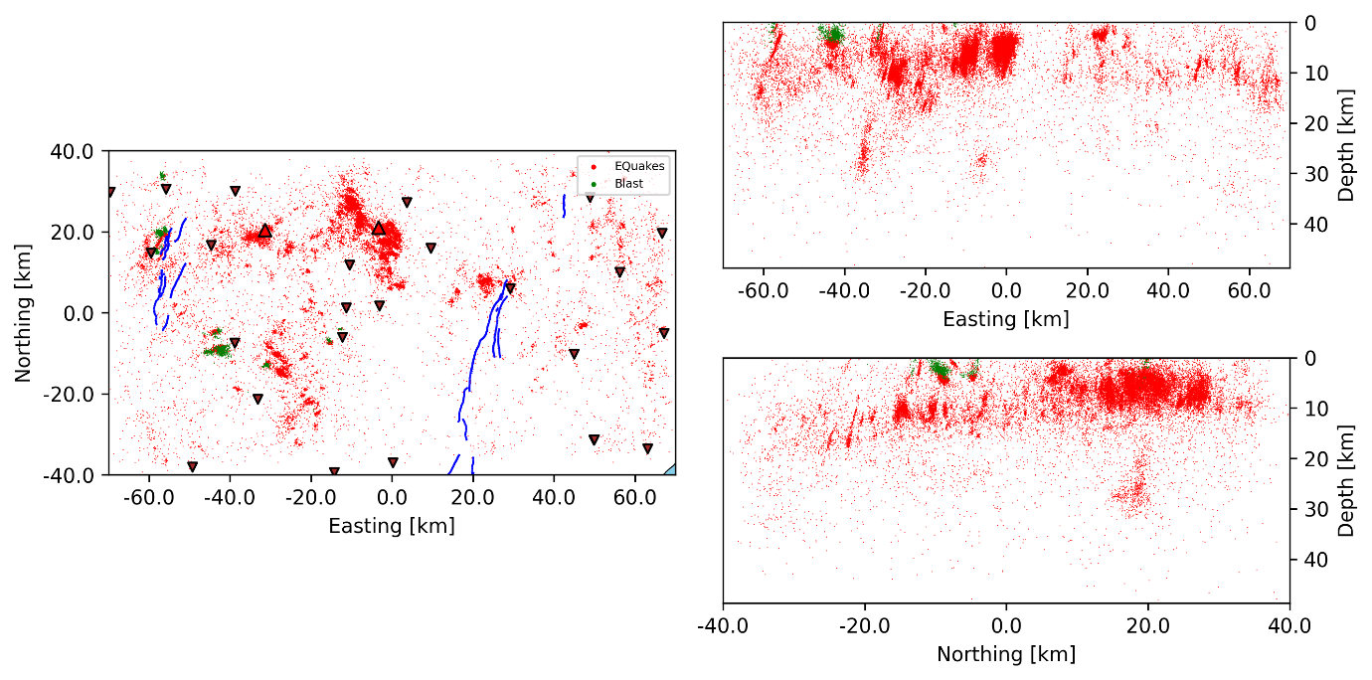
Figure SF14. Detected events vs blast locations in region 4.

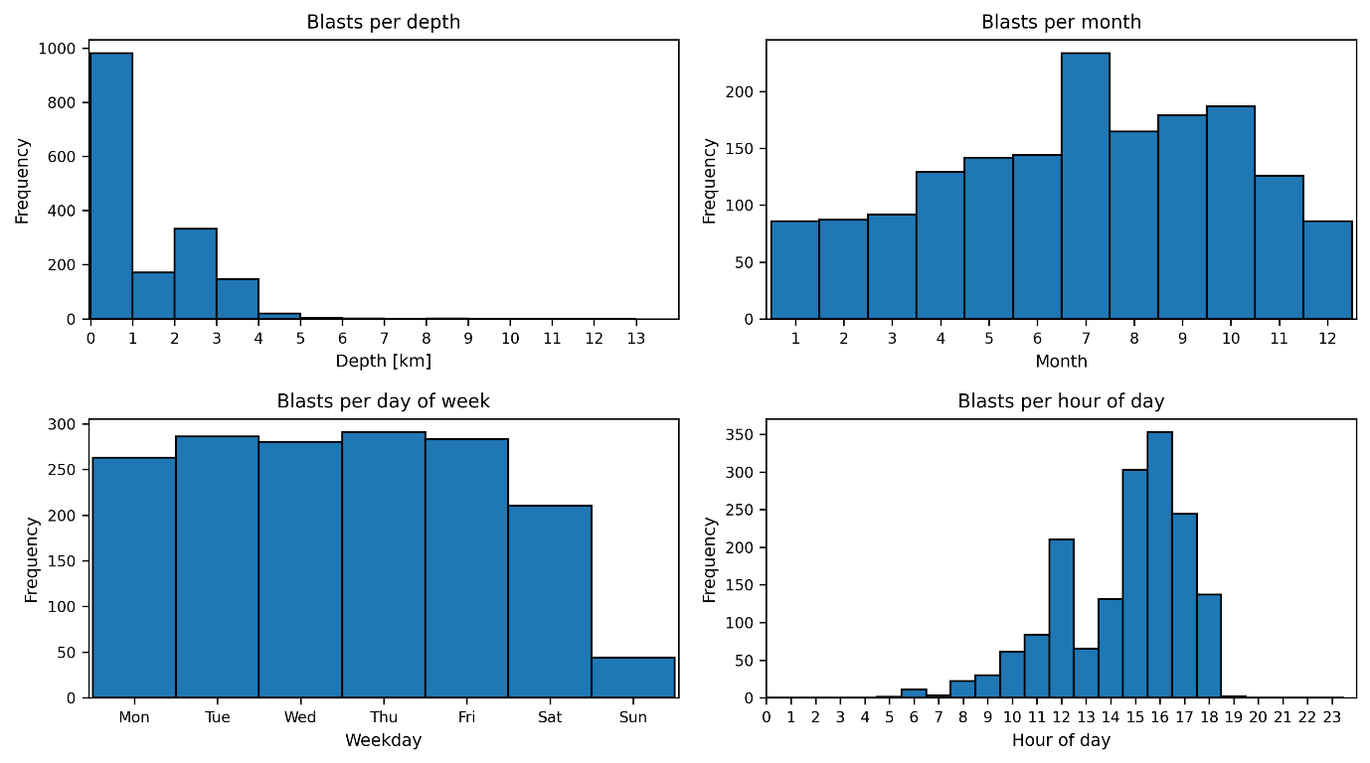
Figure SF15. Blast temporal characteristics in region 4.

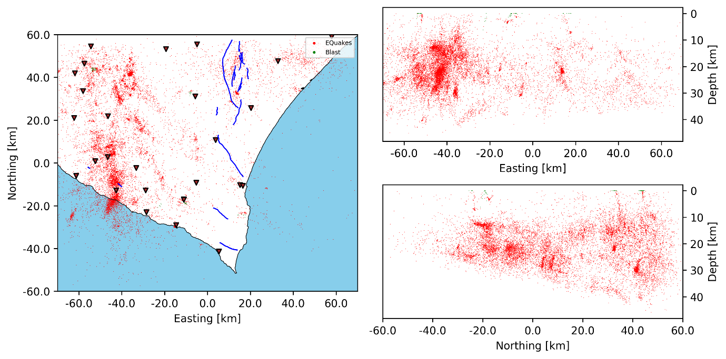
Figure SF16. Detected events vs blast locations in region 5.

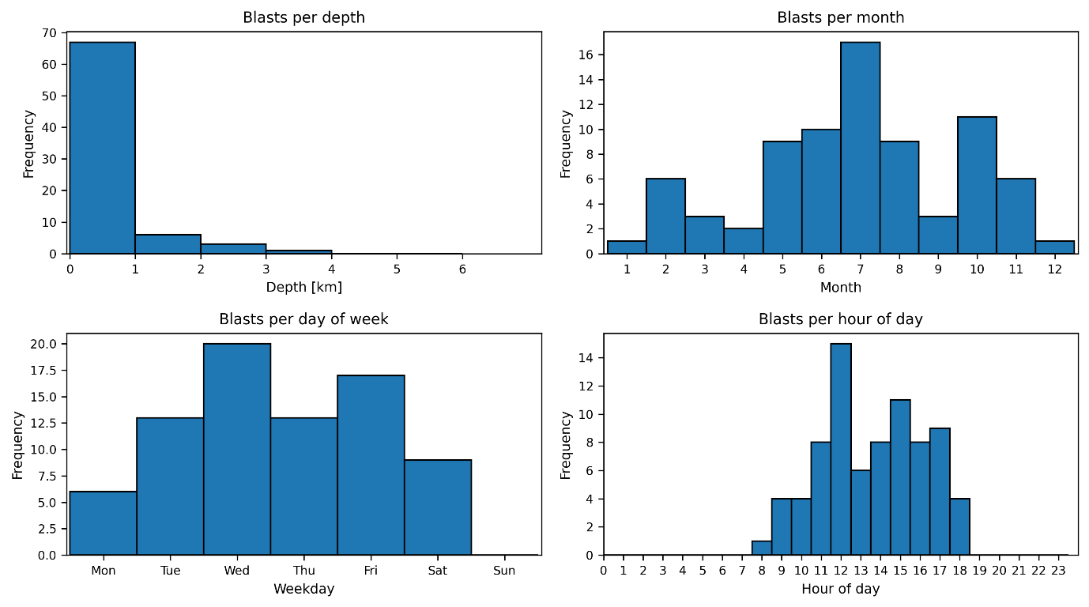
Figure SF17. Blast temporal characteristics in region 5.

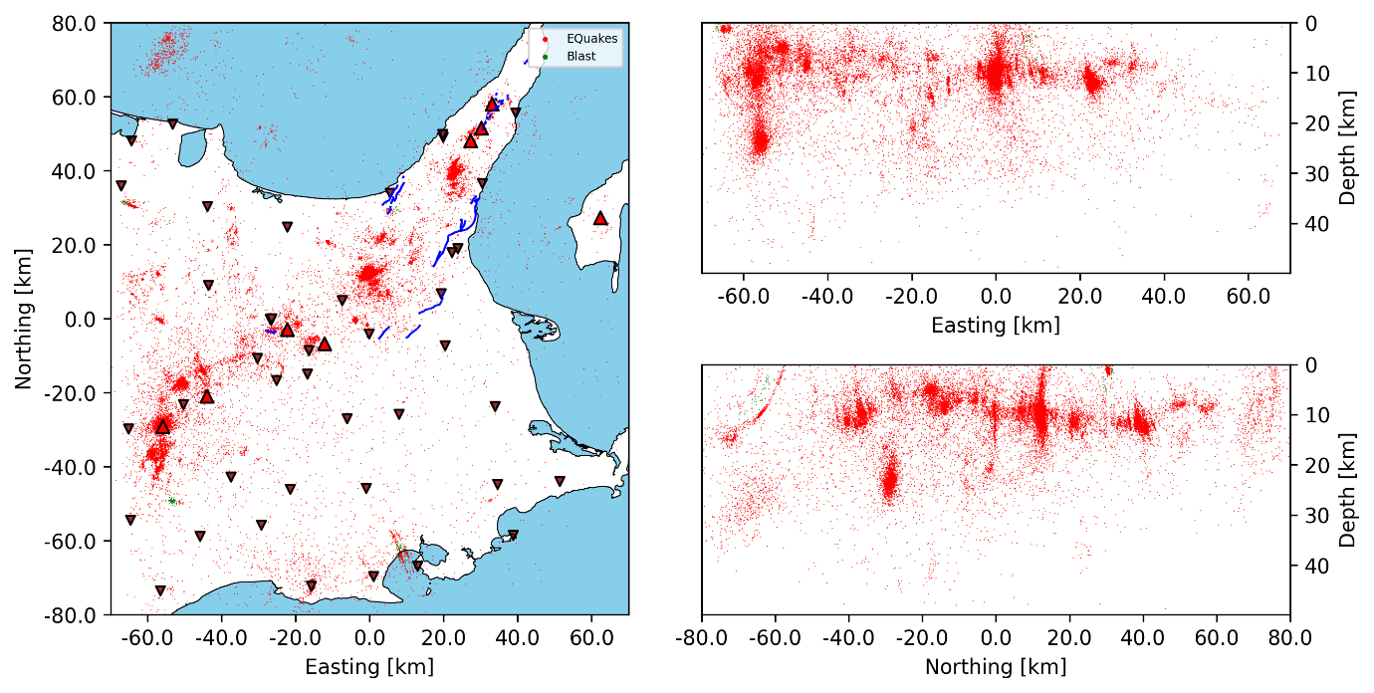
Figure SF18. Detected events vs blast locations in region 6.

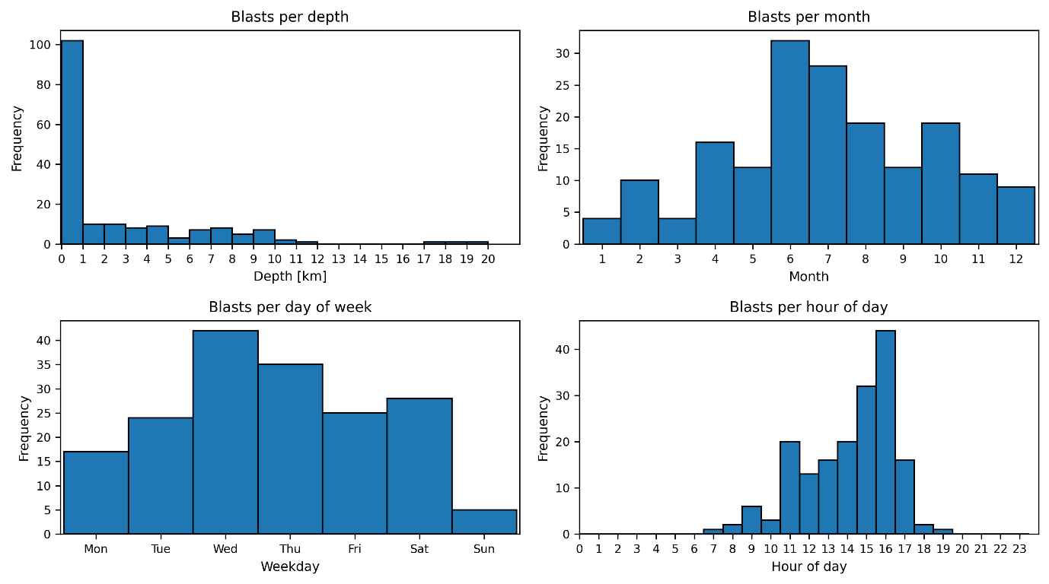
Figure SF19. Blast temporal characteristics in region 6.

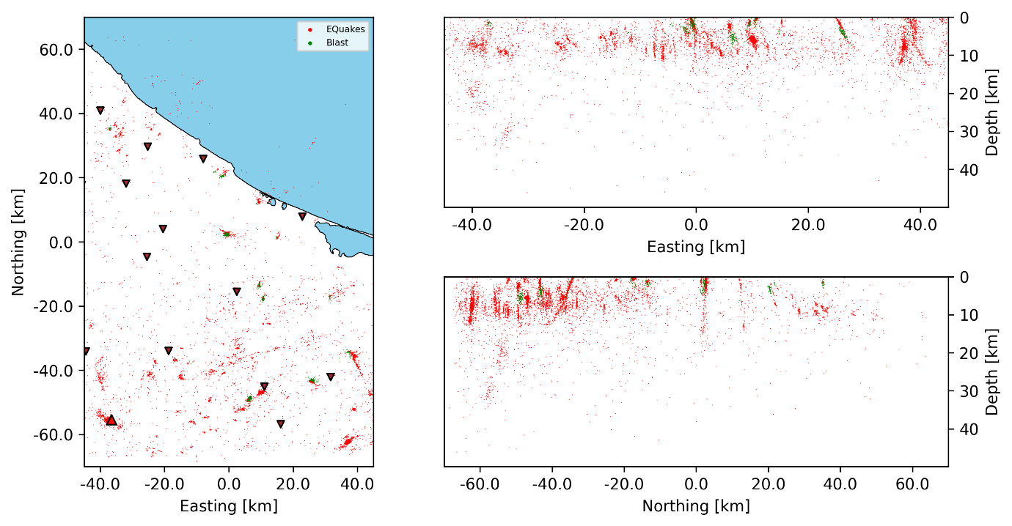
Figure SF20. Detected events vs blast locations in region 7.

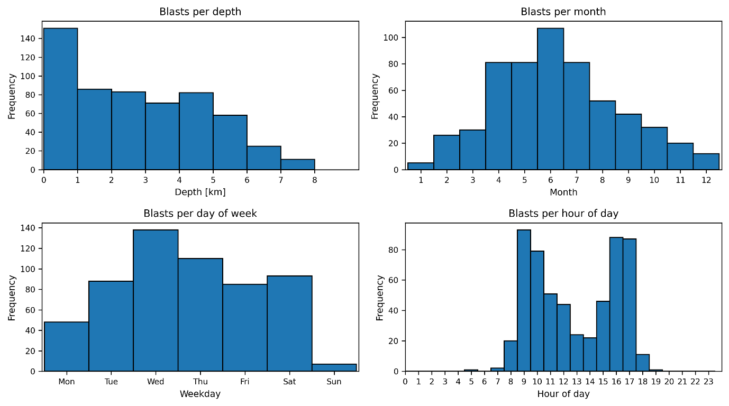
Figure SF21. Blast temporal characteristics in region 7.

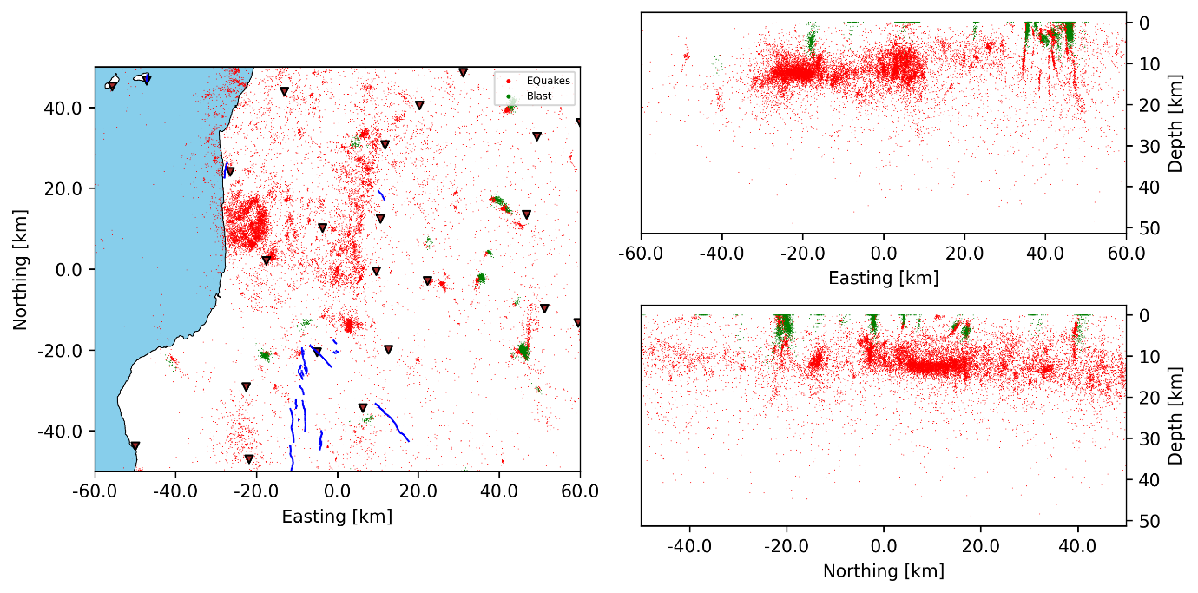
Figure SF22. Detected events vs blast locations in region 8.

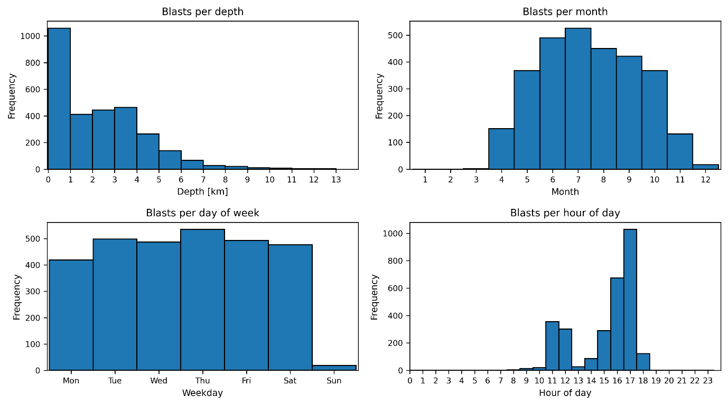
Figure SF23. Blast temporal characteristics in region 8.

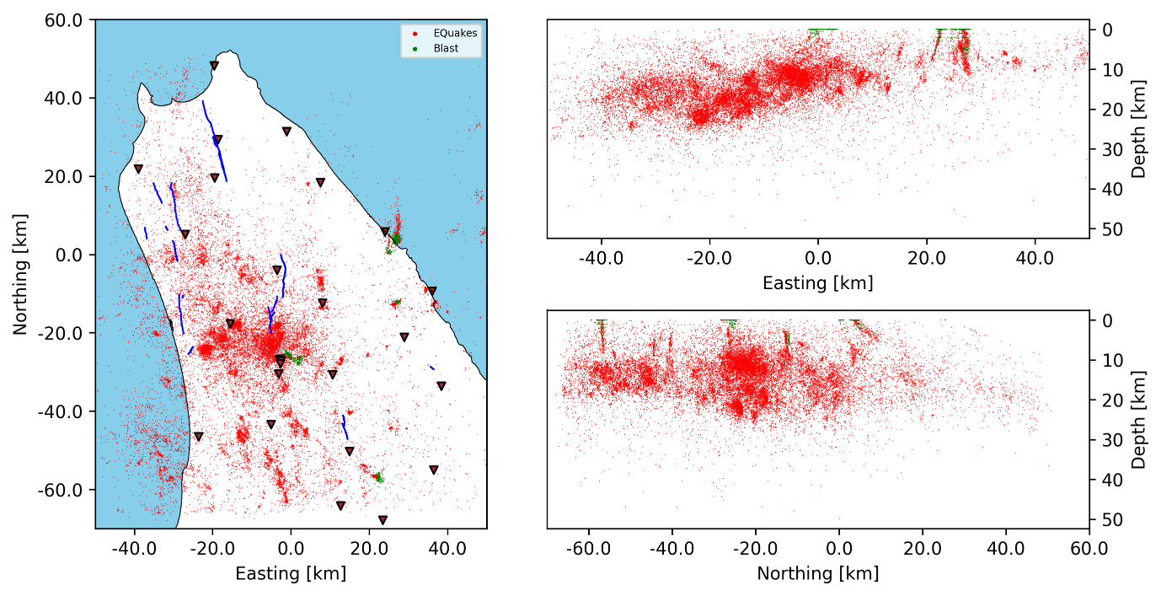
Figure SF24. Detected events vs blast locations in region 9.

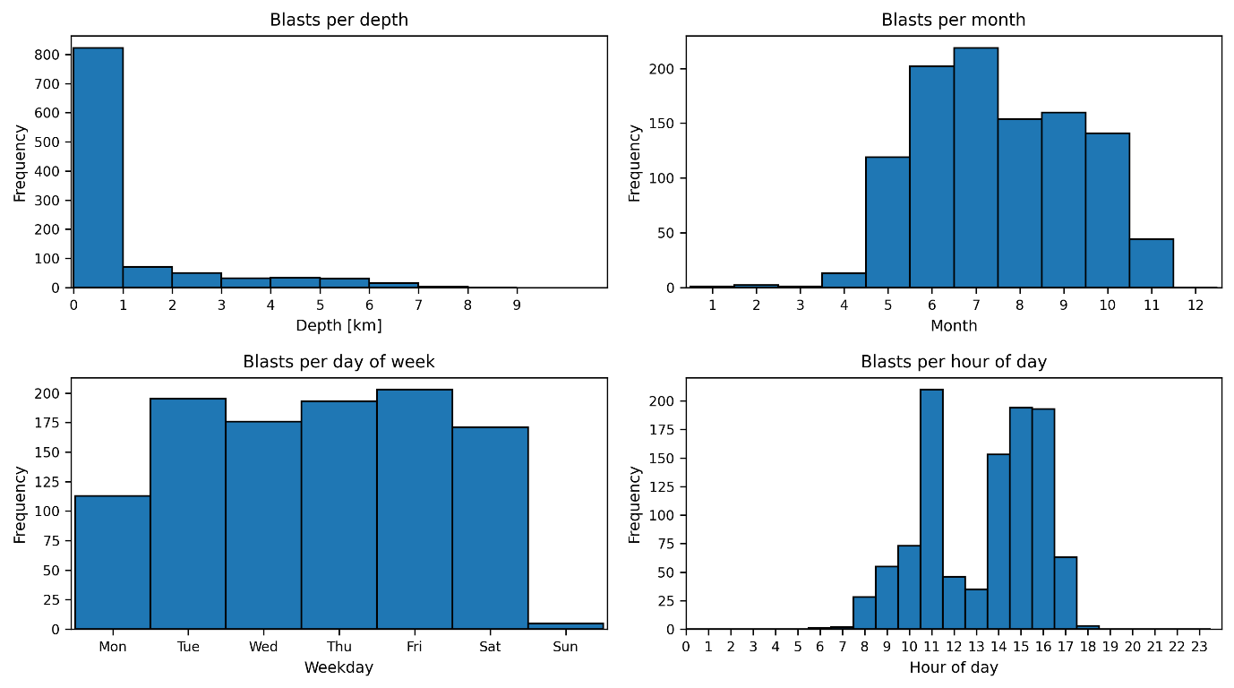
Figure SF25. Blast temporal characteristics in region 9.

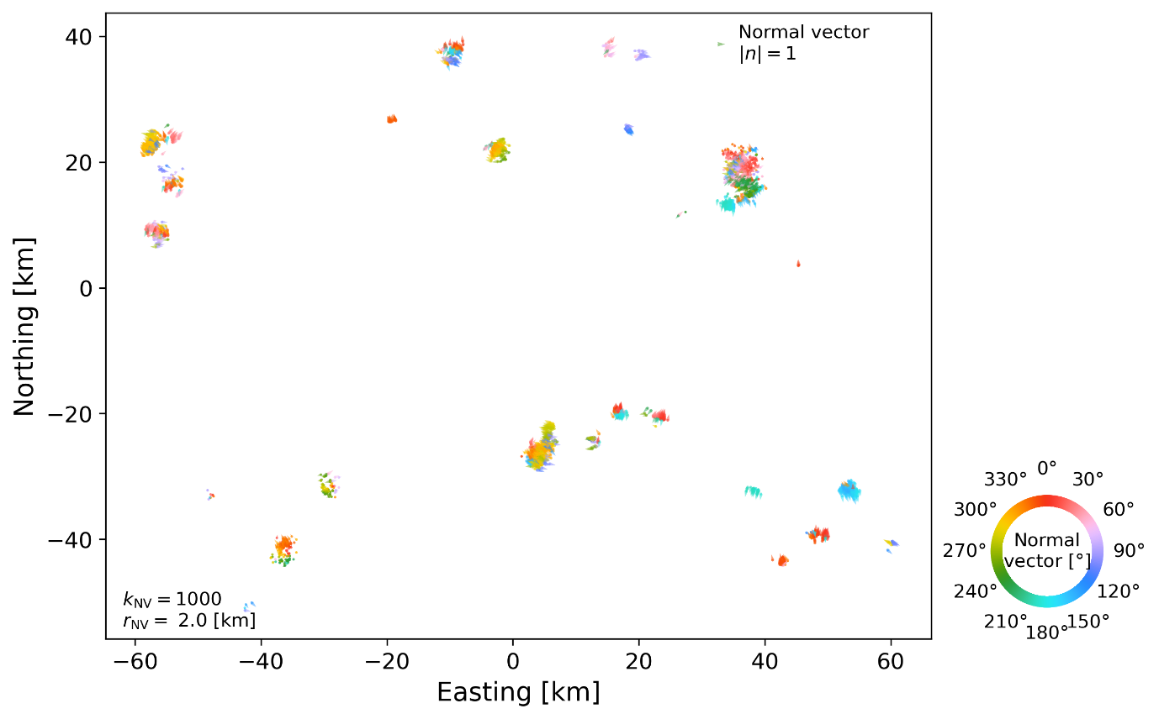
Figure SF26. Surface projections of 3D point cloud normal vectors in region 1. Colored arrows represent the direction of the horizontal component of the upward facing normal vector.

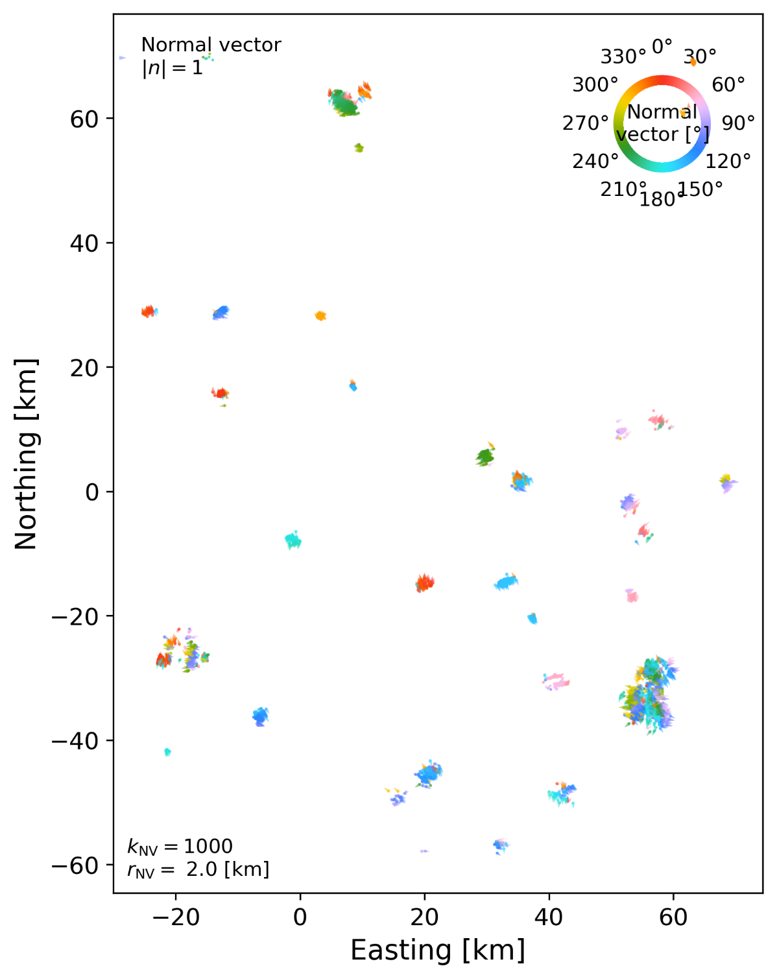
Figure SF27. Surface projections of 3D point cloud normal vectors in region 2. Colored arrows represent the direction of the horizontal component of the upward facing normal vector.

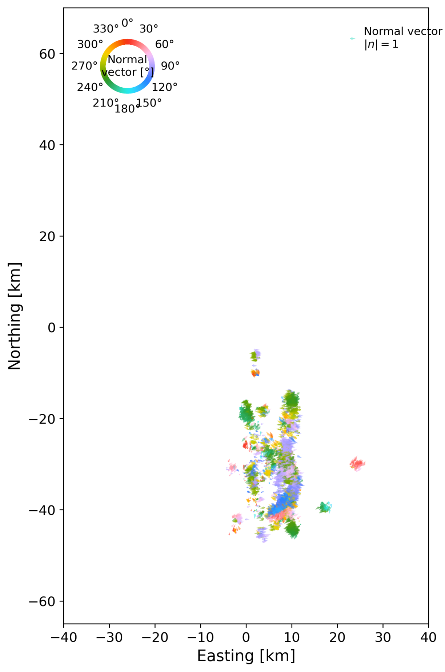
Figure SF28. Surface projections of 3D point cloud normal vectors in region 3. Colored arrows represent the direction of the horizontal component of the upward facing normal vector.

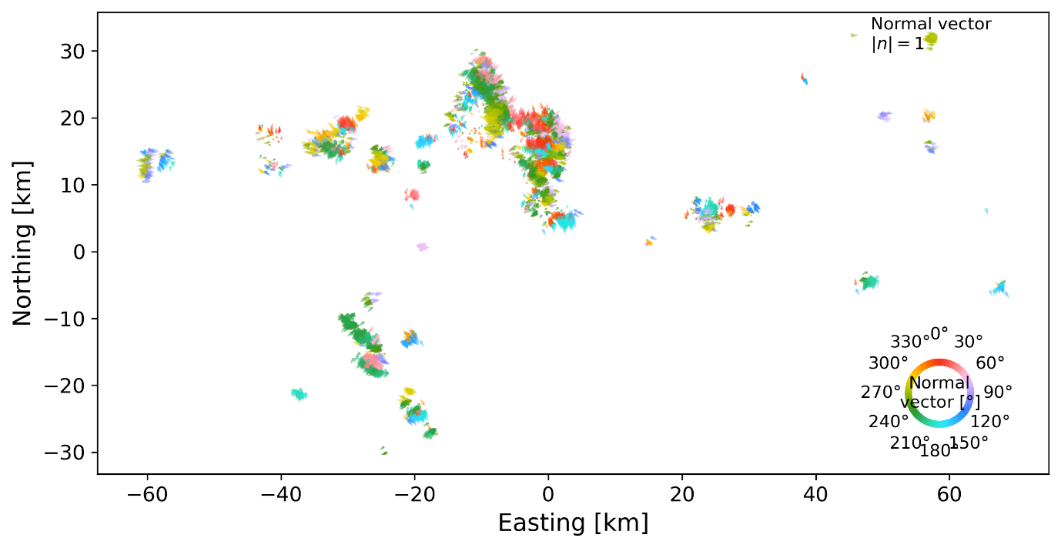
Figure SF29. Surface projections of 3D point cloud normal vectors in region 4. Colored arrows represent the direction of the horizontal component of the upward facing normal vector.

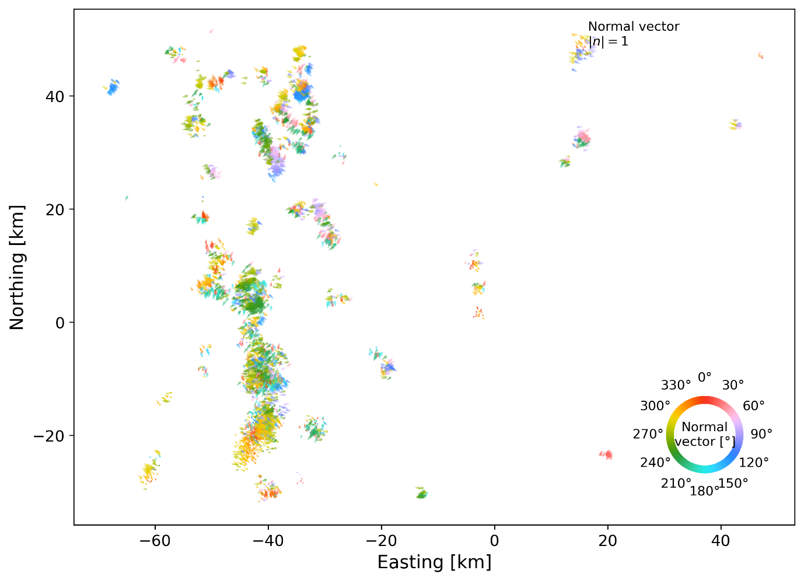
Figure SF30. Surface projections of 3D point cloud normal vectors in region 5. Colored arrows represent the direction of the horizontal component of the upward facing normal vector.

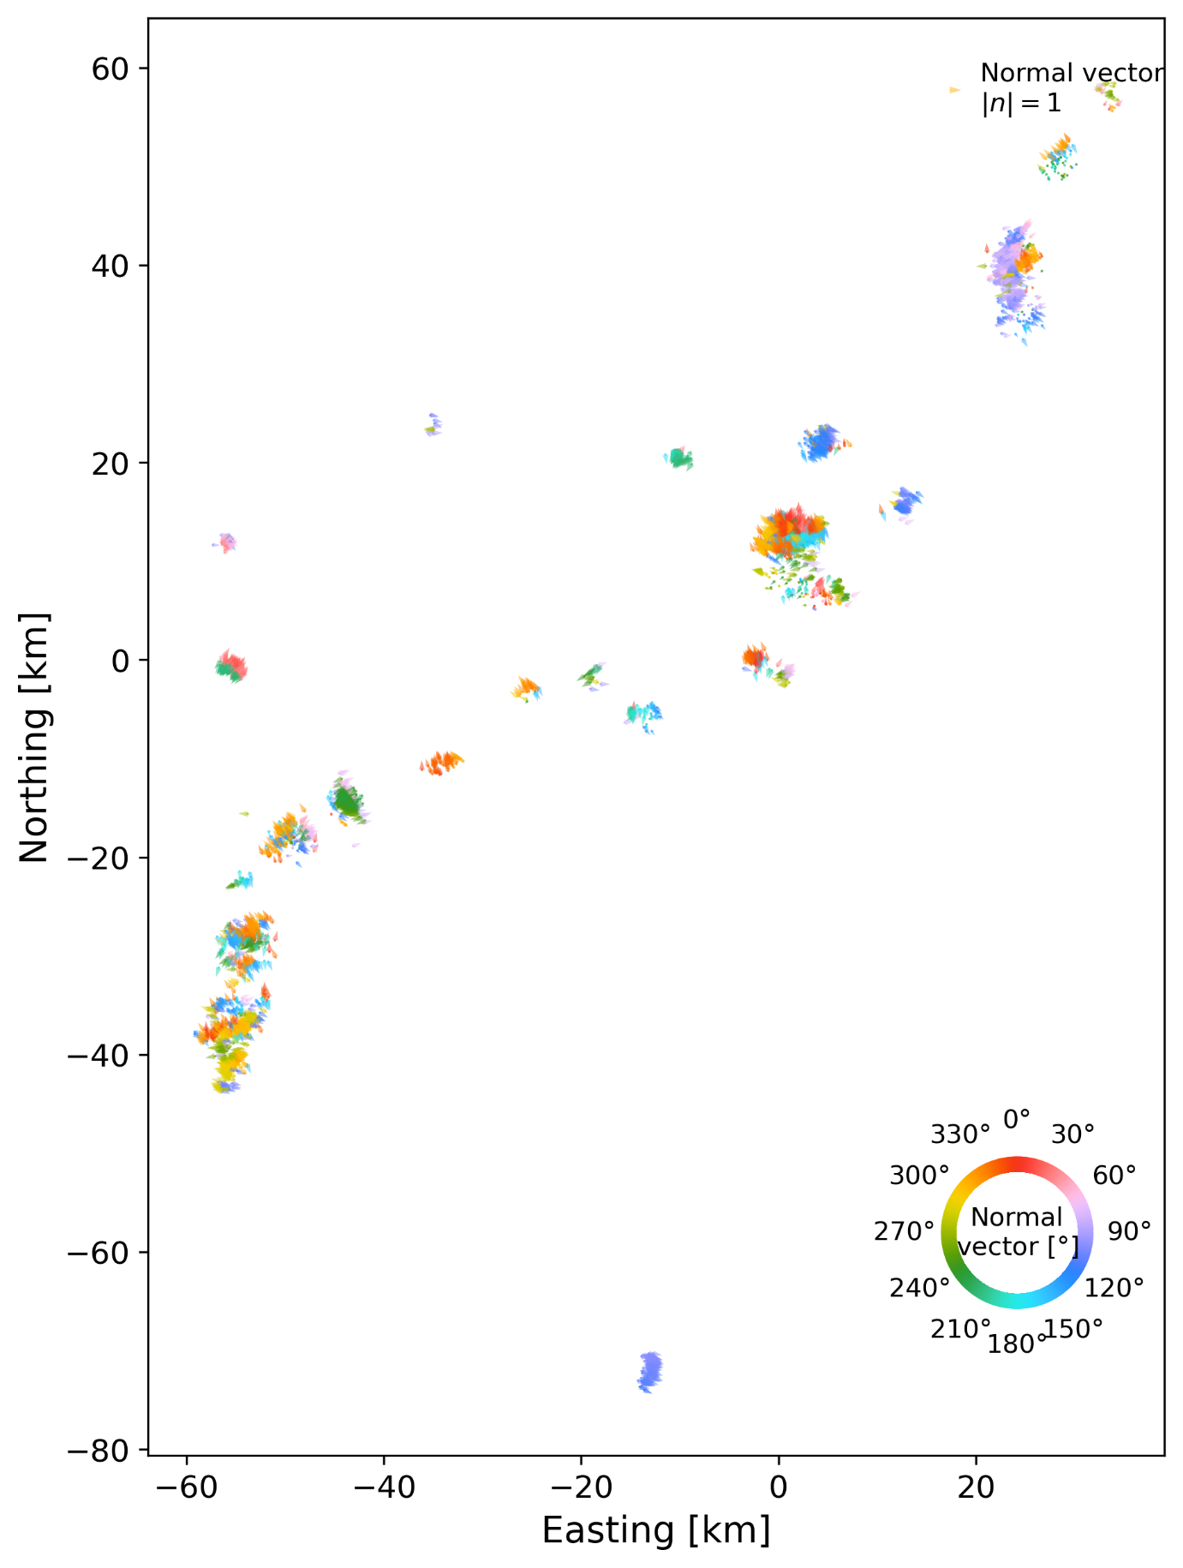
Figure SF31. Surface projections of 3D point cloud normal vectors in region 6. Colored arrows represent the direction of the horizontal component of the upward facing normal vector.

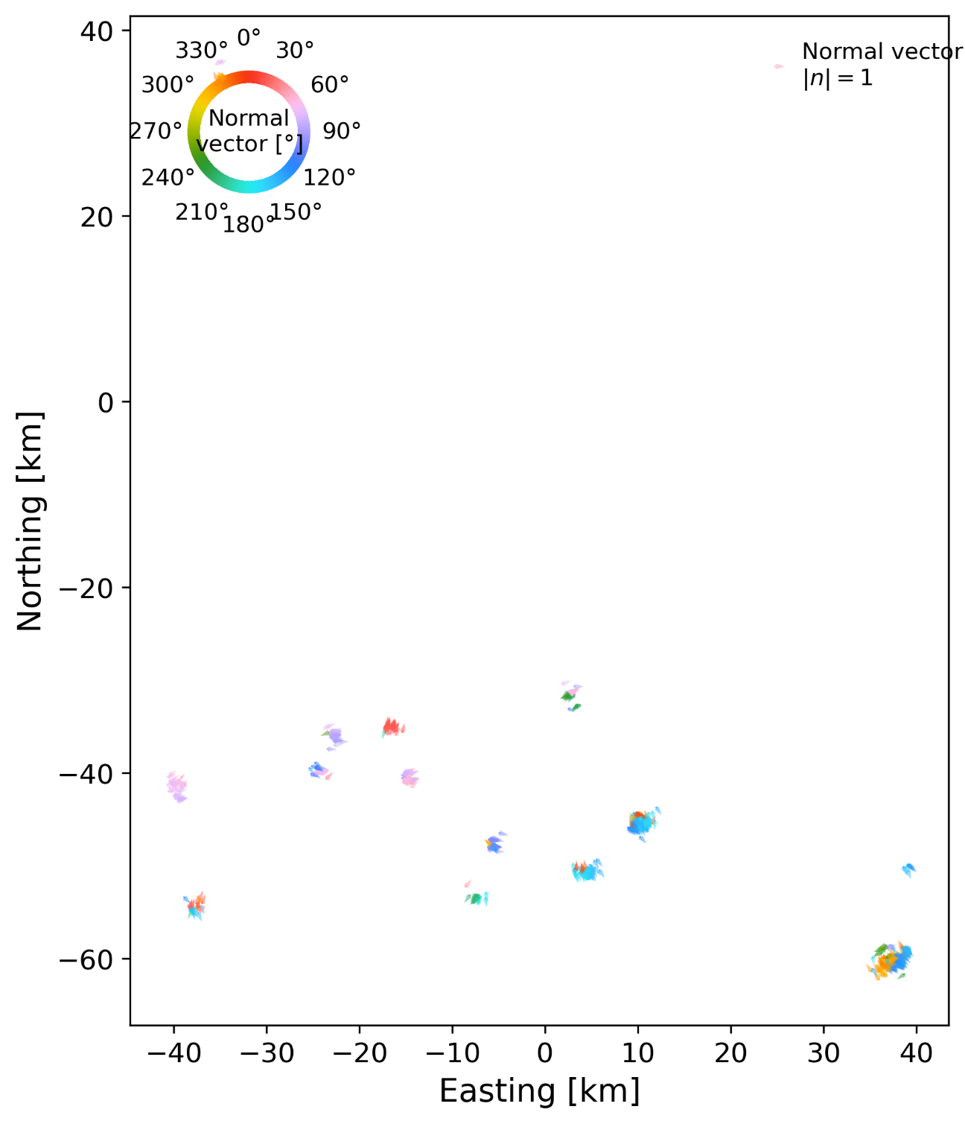
Figure SF32. Surface projections of 3D point cloud normal vectors in region 7. Colored arrows represent the direction of the horizontal component of the upward facing normal vector.

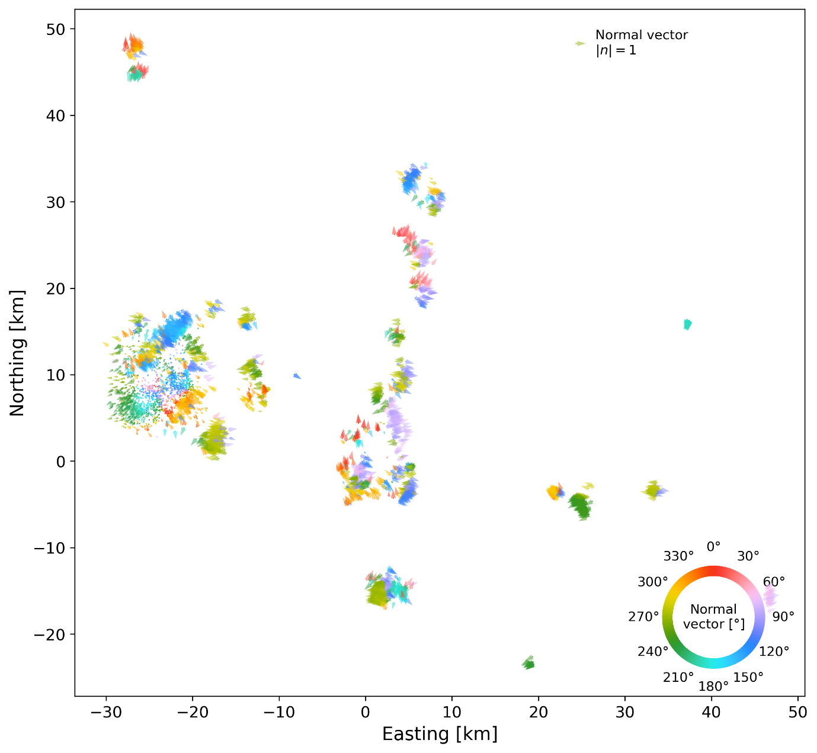
Figure SF33. Surface projections of 3D point cloud normal vectors in region 8. Colored arrows represent the direction of the horizontal component of the upward facing normal vector.

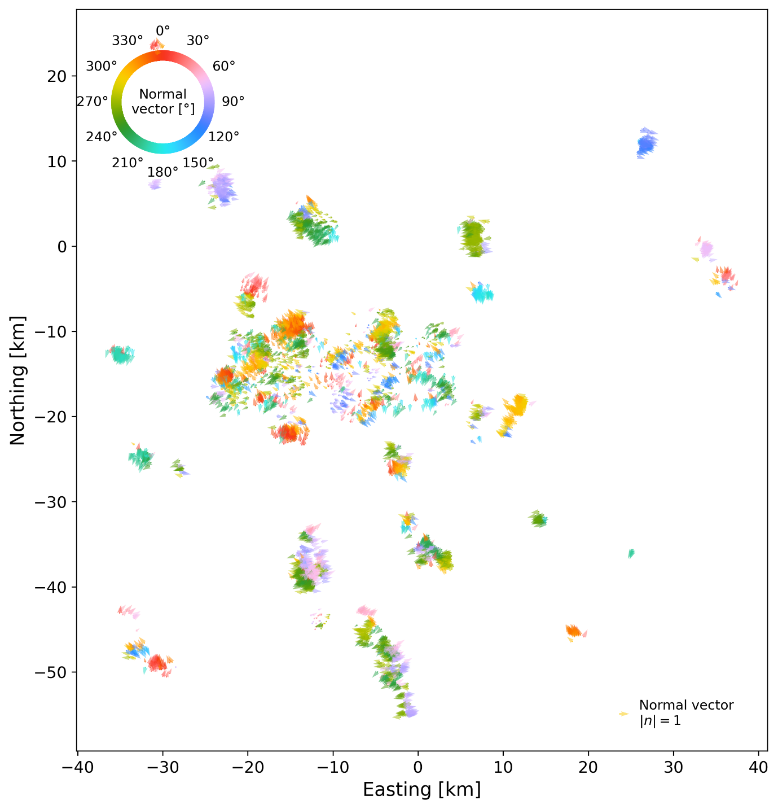
Figure SF34. Surface projections of 3D point cloud normal vectors in region 9. Colored arrows represent the direction of the horizontal component of the upward facing normal vector.

Tables

Table ST1. Parameters used for clustering and fault quality control per subregion.
 |  | Subregion
 |  | 1 | 2 | 3 | 4 | 5 | 6 | 7 | 8 | 9
Clustering parameter | $$m_{\text{clSize}}$$ | 20 | 20 | 10 | 20 | 10 | 20 | 3 | 20 | 10
Clustering parameter | $$m_{\text{pts}}$$ | 20 | 10 | 5 | 10 | 10 | 3 | 3 | 20 | 3
Clustering parameter | $$ε$$ | 0.5 | 0. | 0.5 | 0.5 | 0. | 0.5 | 0. | 0. | 0.
Fault Quality | $θ^{\text{EV}}$(°) | 30 | 50 | 30 | 30 | 30 | 30 | 30 | 30 | 30
Fault Quality | $$m^{\text{EV}}$$ | 20 | 20 | 20 | 20 | 10 | 20 | 10 | 20 | 20

For a description of the symbols see the main text.

Table ST2 Comparison between fault plane parameters of eight moderate to large past earthquakes in inland Hokkaido.
 | F-net moment-tensor solution |  |  |  | This study |  |  |  | Fault plane comparison
Event | Depth  (km) | Plane 1  (Strike$°$/dip$°$) | Plane 2  (Strike$°$/dip$°$) |  | Plane  (Strike$°$/dip$°$) | Depth range  (km) | MAD ($°$) |  | Lateral offset (km) | Depth offset (km) |  | Angular deviation ($°$)
E-Iburi 2018 Mw6.6 | 37.0 | 134 / 30 | 349 / 65 |  | 358.0 / 72.4 | 24.4 – 37.0 | 17.8 |  | 0.00 | 0.82 | 11.4
E-Iburi 2018 Mw5.4 | 37.7 | 353 / 43 | 159 / 48 |  | 358.0 / 72.4 | 24.4 – 37.0 | 17.8 |  | 0.48 | 0.69 | 30.0
E-Iburi 2018 Mw5.1 | 31.3 | 209 / 50 | 320 / 67 |  | 205.4 / 50.3 | 22.1 – 24.6 | 23.0 |  | 0.66 | 2.90 | 9.5
E-Iburi 2019 Mw5.5 | 33.3 | 131 / 24 | 350 / 71 |  | 344.0 / 80.0 | 27.9 – 31.1 | 9.0 |  | 0.32 | 2.25 | 10.7
Iburi 2014 Mw5.4 | 3.2 | 240 / 59 | 7 / 45 |  | 8.6 / 61.7 | 5.9 – 14.8 | 46.7 |  | 0.00 | -6.05 | 16.7
Uchiura bay 2016 Mw5.2 | 10.5 | 126 / 40 | 2 / 65 |  | 129.9 / 30.5 | 11.2 – 13.1 | 15.4 |  | 1.07 | -0.95 | 9.8
Rumoi 2004 Mw5.7 | 8.6 | 178 / 47 | 23 / 46 |  | 346.8 / 16.9 | 12.2 – 12.8 | 20.0 |  | 2.80 | -3.48 | 33.5
Soya 2022 Mw5.1 | 4.7 | 1 / 44 | 184 / 46 |  | 173.5 / 56.5 | 10.4 – 14.0 | 23.6 |  | 1.10 | -5.66 | 13.3
For F-net moment tensor solutions, parameters marked in bold represent the plane with the closest matching orientation compared to the fault plane orientation determined in this study. MAD is the mean angular difference between the extracted fault plane normal and the constituent point cloud normal vectors.

