SUPPLEMENTARY FILE
Coaxial Electrospinning-Derived Hollow SiBCN Ceramic Fibers with Multiscale Heat-Transfer Suppression for High-Temperature Thermal Insulation
Hongli Liuª, Jie Wangª, Peng Chu^{a,} *, Manmeng Zuoª, Yuhao Liuª, Qingmiao Dingª, Liangliang Fu ^{b}, Zihao Wang^{c}
a College of Aeronautical Engineering, Civil Aviation University of China, Tianjin, 300300, China
b Key Laboratory on Resources Chemicals and Material of the Ministry of Education, Shenyang University of Chemical Technology, Shenyang, 110142, China
c China Construction Sixth Engineering Bureau Corp., Ltd, 300457, China
*Corresponding Authors. E-mail address: pchu@cauc.edu.cn
- Physicochemical Characterization
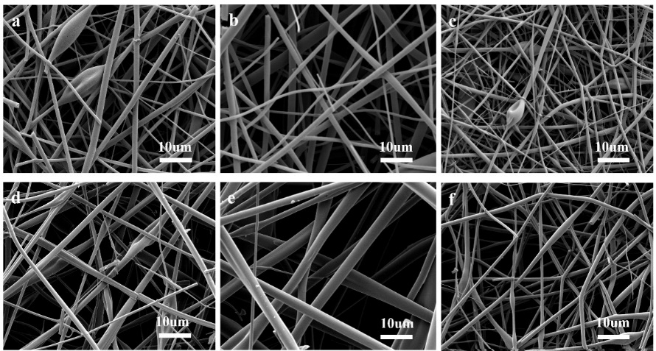
Fig. S1 SEM images of fibers obtained from electrostatic spinning performed at different spinning voltages: (a) 16 kV, (b) 18 kV, (c) 20 kV. SEM images of fibers obtained by electrostatic spinning with different shell-core flow rate ratios: (d) 2:1, (e) 3:1, (f) 4:1.

