Supplemental:
Table S1: The modified Udden-Wentworth scale outlining categories of grain size.
Aggregate Name | Size range
Boulders | >256 mm
Cobbles | 64 - 256 mm
Pebbles | 32 - 64 mm
Gravel | 2 - 32 mm
Sand | 62.5 μm - 2 mm
Silt | < 62.5 μm

Table S2: BEHI categories and corresponding index values used in this study.
Bank Erosion Risk | Root depth to bank height | Root density (%) | Surface protection (%) | Bank Angle (°) | Index totals
Very Low  (index value) | 1.0-0.9  1.0-1.9 | 100-80  1.0-1.9 | 100-80  1.0-1.9 | 0-20  1.0-1.9 | 4-7.6
Low  (index value) | 0.89-0.5  2.0-3.9 | 79-55  2.0-3.9 | 79-55  2.0-3.9 | 21-60  2.0-3.9 | 7.7-15.6
Moderate  (index value) | 0.49-0.3  4.0-5.9 | 54-30  4.0-5.9 | 54-30  4.0-5.9 | 61-80  4.0-5.9 | 15.7-23.6
High  (index value) | 0.29-0.15  6.0-7.9 | 29-15  6.0-7.9 | 29-15  6.0-7.9 | 81-90  6.0-7.9 | 23.7-31.6
Very High  (index value) | 0.14-0.05  8.0-9.0 | 14-5  8.0-9.0 | 14-10  8.0-9.0 | 91-119  8.0-9.0 | 31.7-36
Extreme  (index value) | <0.05  10 | <5  10 | <10  10 | <119  10 | >36

Table S3: Elemental analysis of riverbed sediments. Concentrations reported as %.
Site | Site type | Lon | Lat | Mg | Al | Si | P | K | Ca
1 | T_nm | 30°01.091′E | 1°45.372′S | 0.7496 | 6.07 | 24.104 | 0.0189 | 1.7468 | 0.0659
2 | T_nm | 30°01.284′E | 1°44.964′S | 0.5901 | 6.8538 | 22.82 | 0.0244 | 1.7602 | 0.0631
3 | R | 30°01.815′E | 1°44.873′S | 0.5908 | 8.1957 | 20.116 | 0.0135 | 3.2876 | 0.0695
4 | R | 30°02.204′E | 1°44.922′S | 0.5808 | 8.4176 | 26.356 | 0.0131 | 2.8504 | 0.0805
5 | T_m | 30°03.063′E | 1°45.720′S | 0.4909 | 7.0116 | 23.078 | 0.0237 | 1.6563 | 0.0658
6 | R | 30°03.155′E | 1°45.702′S | 0.5436 | 6.78 | 24.871 | 0.0187 | 1.4022 | 0.05295
7 | T_m | 30°03.486′E | 1°46.246′S | 0.5537 | 6.7084 | 26.716 | 0.0248 | 1.6667 | 0.056
8 | R | 30°03.995′E | 1°46.229′S | 0.4678 | 5.7917 | 29.476 | 0.0154 | 1.3483 | 0.0495
9 | T_m | 30°04.779′E | 1°48.127′S | 0.4888 | 5.3818 | 29.522 | 0.0135 | 0.9729 | 0.03965
10 | R | 30°05.354′E | 1°48.475′S | 0.5846 | 5.0175 | 27.319 | 0.0255 | 1.058 | 0.0415
11 | R | 30°05.755′E | 1°48.714′S | 0.4096 | 5.1883 | 31.192 | 0.0117 | 1.0258 | 0.0468
Site | SITE TYPE | LON | LAT | TI | V | CR | MN | FE | CU
1 | T_nm | 30°01.091′E | 1°45.372′S | 0.4342 | 0.0186 | 0.0118 | 0.0407 | 6.9667 | 0.0025
2 | T_nm | 30°01.284′E | 1°44.964′S | 0.518 | 0.0238 | 0.0176 | 0.0424 | 9.9915 | 0.0034
3 | R | 30°01.815′E | 1°44.873′S | 0.486 | 0.026 | 0.0309 | 0.0245 | 15.507 | 0.00335
4 | R | 30°02.204′E | 1°44.922′S | 0.5285 | 0.0188 | 0.0135 | 0.018 | 4.5348 | 0.0019
5 | T_m | 30°03.063′E | 1°45.720′S | 0.4798 | 0.0213 | 0.0245 | 0.0236 | 10.873 | 0.0031
6 | R | 30°03.155′E | 1°45.702′S | 0.5644 | 0.0224 | 0.0215 | 0.0289 | 9.6032 | 0.0029
7 | T_m | 30°03.486′E | 1°46.246′S | 0.7608 | 0.0229 | 0.0135 | 0.0378 | 5.3125 | 0.0032
8 | R | 30°03.995′E | 1°46.229′S | 0.5713 | 0.0145 | 0.0067 | 0.0198 | 3.3445 | 0.0017
9 | T_m | 30°04.779′E | 1°48.127′S | 0.9238 | 0.0214 | 0.0061 | 0.0141 | 3.36105 | 0.002
10 | R | 30°05.354′E | 1°48.475′S | 0.4136 | 0.01405 | 0.0095 | 0.016 | 5.5668 | 0.0019
11 | R | 30°05.755′E | 1°48.714′S | 0.6335 | 0.0133 | 0.0052 | 0.0129 | 2.6504 | 0.0014
Site | SITE TYPE | LON | LAT | ZN | AS | RB | SR | ZR | BA
1 | T_nm | 30°01.091′E | 1°45.372′S | 0.0036 | 0.0026 | 0.008 | 0.0033 | 0.0183 | 0.0302
2 | T_nm | 30°01.284′E | 1°44.964′S | 0.006 | 0.0037 | 0.0082 | 0.005 | 0.0197 | 0.0303
3 | R | 30°01.815′E | 1°44.873′S | 0.0039 | 0.017 | 0.0159 | 0.0076 | 0.0334 | 0.0542
4 | R | 30°02.204′E | 1°44.922′S | 0.0034 | 0.0061 | 0.0171 | 0.0045 | 0.0183 | 0.0301
5 | T_m | 30°03.063′E | 1°45.720′S | 0.0064 | 0.0455 | 0.0063 | 0.0055 | 0.0243 | 0.0296
6 | R | 30°03.155′E | 1°45.702′S | 0.0074 | 0.0113 | 0.0052 | 0.006 | 0.034 | 0.021
7 | T_m | 30°03.486′E | 1°46.246′S | 0.0075 | 0.0405 | 0.0106 | 0.007 | 0.0589 | 0.0293
8 | R | 30°03.995′E | 1°46.229′S | 0.004 | 0.0149 | 0.0068 | 0.004 | 0.0337 | 0.0218
9 | T_m | 30°04.779′E | 1°48.127′S | 0.0036 | 0.0128 | 0.0054 | 0.0034 | 0.0834 | 0.0217
10 | R | 30°05.354′E | 1°48.475′S | 0.0037 | 0.0205 | 0.0036 | 0.0053 | 0.0342 | 0.0273
11 | R | 30°05.755′E | 1°48.714′S | 0.0028 | 0.0083 | 0.0052 | 0.003 | 0.0382 | 0.0172
Site | SITE TYPE | LON | LAT | PB
1 | T_nm | 30°01.091′E | 1°45.372′S | 0.0023
2 | T_nm | 30°01.284′E | 1°44.964′S | 0.0043
3 | R | 30°01.815′E | 1°44.873′S | 0.00785
4 | R | 30°02.204′E | 1°44.922′S | 0.0027
5 | T_m | 30°03.063′E | 1°45.720′S | 0.0228
6 | R | 30°03.155′E | 1°45.702′S | 0.0033
7 | T_m | 30°03.486′E | 1°46.246′S | 0.0165
8 | R | 30°03.995′E | 1°46.229′S | 0.0063
9 | T_m | 30°04.779′E | 1°48.127′S | 0.0018
10 | R | 30°05.354′E | 1°48.475′S | 0.0034
11 | R | 30°05.755′E | 1°48.714′S | 0.0018

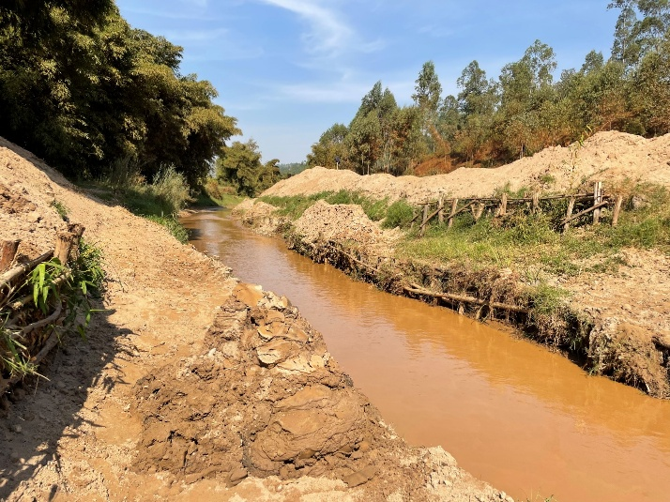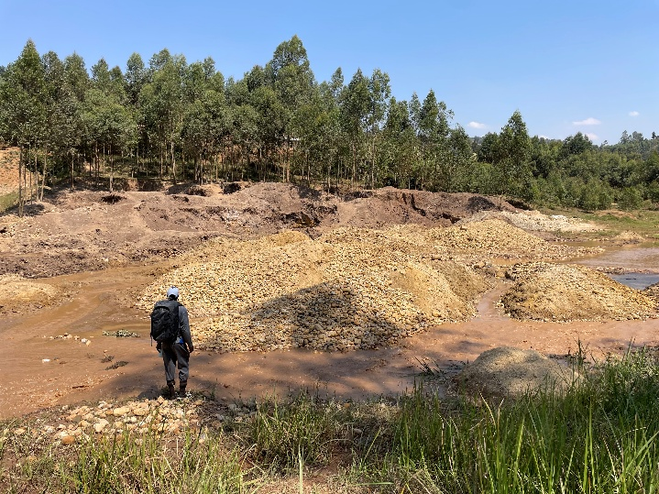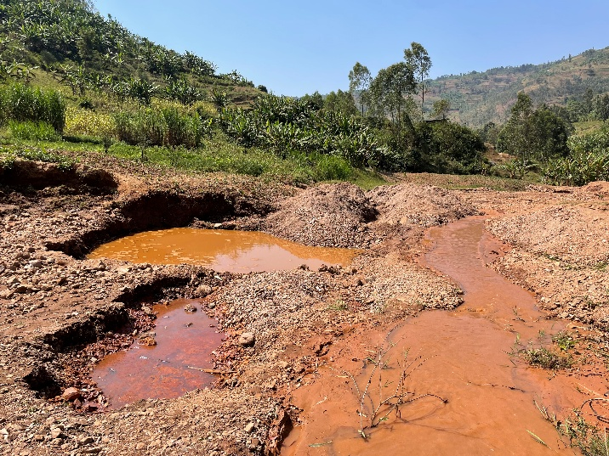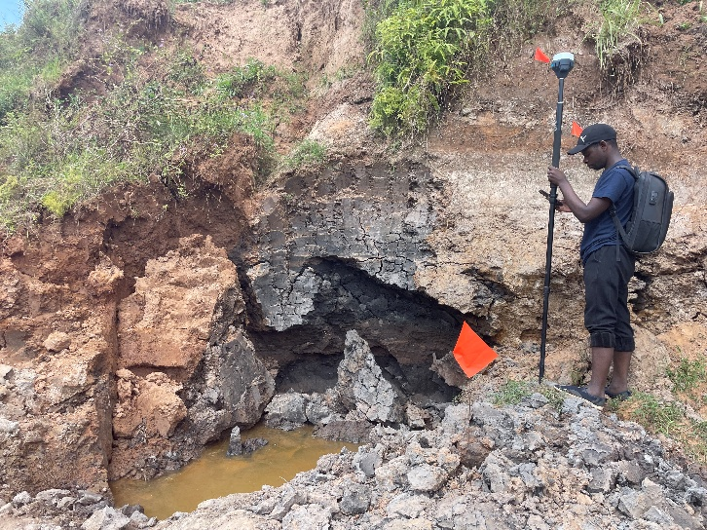
d)
c)
a)
b)
Figure S1: Aggregate (a, b) and tin (b, c, d) in the Rusine River.
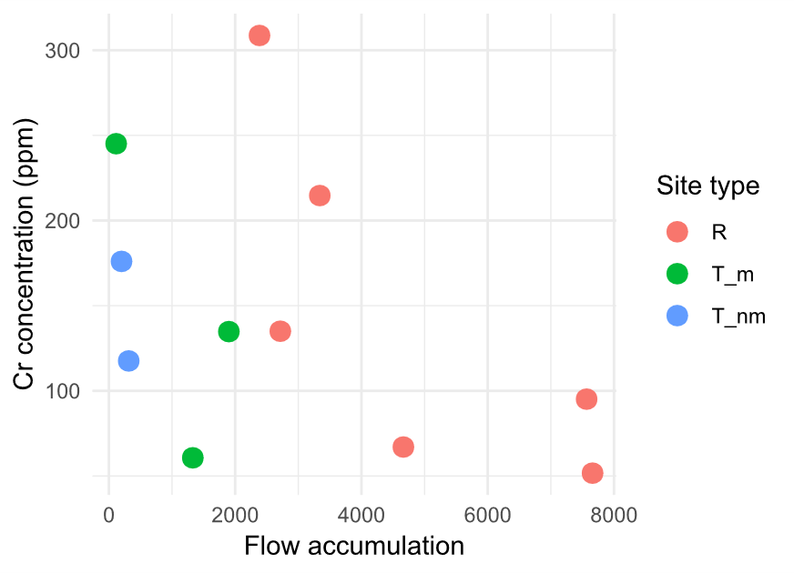
Figure S2: Chromium concentration of riverbed sediments by site type along a gradient of CUDA.

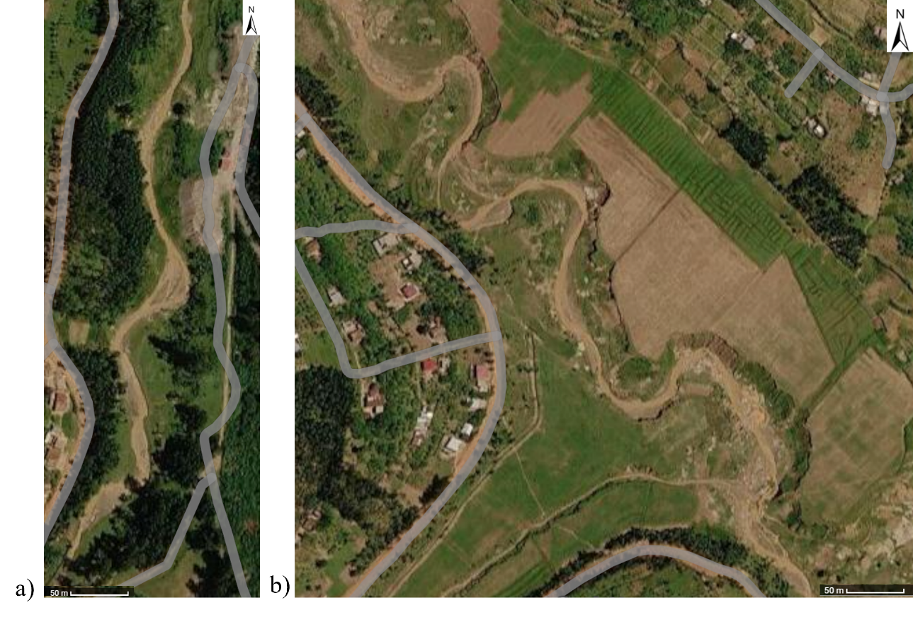
Figure S3: Satellite imagery of stretches of the Rusine River a) shortly downstream of mining and b) affected by mining. The sinuosity of the water course increases in mining stretches.

