Electronic Supplementary Material for Efficacy and Safety of

Henagliflozin in Adults with

Type 2 Diabetes Mellitus: A

Systematic Review and

Meta-Analysis of Randomized

Controlled Trials

Mohamed Ahmed^{1*} (0009-0009-5681-0292), Mohamed Emad¹, Moamen Salah¹, Ahmed Adel², Noaman Ramadan³, Rehab Khaled⁴, Aya Arif⁵ & Abdulhamid Shaban⁶

¹Faculty of Medicine, Assiut University, Assiut, Egypt

²General practitioner, Ministry of Health and Population, Minia, Egypt

³Intern doctor, Al-Hussein Hospital, Al Azhar University, Cairo, Egypt

⁴School of Medicine, Newgiza University, Giza, Egypt

⁵Intern doctor, Helwan University, Helwan, Egypt

⁶University of Tripoli, Faculty of Medicine

*Correspondence to: Mohamed Magdi; Faculty of
Medicine, Assiut University, Assiut, Egypt; Postal
Code:71511; Tel: 201515606751, E-mail:
medomagdi2001@gmail.com

Appendix

Secondary outcomes of the study 3
ESM Table 1 The 37 excluded full-text articles with the reason for each exclusion 4
ESM Table 2 Summary of secondary outcomes (continuous) 6
ESM Table 3 Summary of secondary outcomes (categorical) 7
Forest Plots 8
ESM Fig. 1 Risk of bias summary 17
ESM Fig. 2 Change in fasting plasma glucose, FPG 8
ESM Fig. 3 Change in post-prandial plasma glucose, PPG 9
ESM Fig. 4 Change in body weight, Kg 10
ESM Fig. 5 Change in SBP, mmHg 11
ESM Fig. 6 Change in DBP, mmHg 11
ESM Fig. 7 Incidence of adverse events 12
ESM Fig. 8 Incidence of serious adverse events 12
ESM Fig. 9 Incidence of discontinuation due to adverse event 13
ESM Fig. 10 Incidence of hypoglycemia 13
ESM Fig. 11 Incidence of hypotension 14
ESM Fig. 12 Incidence of genital infections 14
ESM Fig. 13 Incidence of urinary tract infections 15
ESM Fig. 14 Incidence of DKA 15

Secondary outcomes of the study

- Efficacy outcomes:
  - Glycaemic control: (change in fasting plasma glucose, FPG) and (change in post-prandial plasma glucose, PPG)
  - Cardio-metabolic outcomes: (Change in body weight, Kg - Change in systolic blood pressure, mmHg - Change in diastolic blood pressure, mmHg)

- Safety outcomes: (incidence of adverse events, incidence of serious adverse events, discontinuation due to adverse events, incidence of specific adverse events like hypoglycemia, diabetic ketoacidosis, genital or mycotic or urinary tract infections)

Abbreviations: a, henagliflozin 5 mg in the intervention group; b, henagliflozin 10 mg in the intervention group.

ESM Table 1 The 37 excluded full-text articles with the reason for each exclusion
Study | Reason
SGLT2i: beyond the glucose-lowering effect | Study design ( not RCT )
Pharmacokinetic, Pharmacodynamic, and Safety Profiles of Proline Henagliflozin in Chinese Subjects with Varying Degrees of Liver Dysfunction | Outcome ( the safety with liver disease )
Sodium-glucose cotransporter 2 inhibition through henagliflozin ameliorates cognitive impairment in patients with type 2 diabetes | Outcome ( cognitive impairment ) and Comparator ( NO control group )
Efficacy and safety of henagliflozin combined with continuous subcutaneous insulin infusion in the treatment of Chinese inpatients with type 2 diabetes mellitus based on a continuous glucose monitoring system: protocol of a multicentre, open-label, inpatient, randomised, controlled trial | Intervention ( combined with SC insulin )
Pharmacokinetics and Pharmacodynamics of Henagliflozin, a Novel Selective Inhibitor of Sodium-Glucose Co-transporter Type 2, in Healthy and T2DM Chinese Subjects | Study design ( minimal follow up duration )
SGLT 2 inhibitors: Searching for the best in class | Population ( included heart failure only ) and Comparator ( no placebo group )
SGLT2 Inhibitors and Kidney Diseases: A Clinical Perspective | Intervention ( not included Henagliflozin )
SGLT2 Inhibitors and the Diabetic Kidney | Intervention ( not included Henagliflozin )
Tolerability, Pharmacokinetic, and Pharmacodynamic Profiles of Henagliflozin, a Novel Selective Inhibitor of Sodium-Glucose Cotransporter 2, in Healthy Subjects Following Single- and Multiple-dose Administration | Comparator ( no placcebo group ) and Study design ( minimal follow up duration and not RCT )
Investigational Agents Targeting SGLT1 and SGLT2 in the Treatment of Type 2 Diabetes Mellitus | Comparator ( compare between 2 different groups and not included Henagliflozin )
Pharmacokinetics of Henagliflozin in Dialysis Patients with Diabetes | Study design and Comparator ( pharmacokinetics without placebo and minimal follow up duration )
SGLT2 inhibitors: not every drug has the same effect | Intervention ( Henagliflozin not included in the study )
Effects of Food and Multiple-dose Administration on the Pharmacokinetic Properties of HR20033, a Sustained-release Formulation of Henagliflozin and Metformin for the Treatment of Diabetes, in Healthy Chinese Volunteers | Study design ( minimal follow up duration ) and Population ( minimal sample size )
Kidney-Protective Effects of SGLT2 Inhibitors | Intervention ( the study about SGLT2 group as general not for specific drug ) and Outcome ( Kidney protective effect only )
Effects of Food on the Pharmacokinetic Properties and Mass Balance of Henagliflozin in Healthy Male Volunteers | Comparator ( no placebo group )
SGLT2 Inhibitors: The Sweet Success for Kidneys | Intervention ( not include henagliflozin )
Pharmacokinetics and Pharmacodynamics of Henagliflozin, a Sodium Glucose Co-Transporter 2 Inhibitor, in Chinese Patients with Type 2 Diabetes Mellitus | Comparator ( 2 drugs interaction and no placebo group )
SGLT2 Inhibitors: Physiology and Pharmacology | Intervention ( Henagliflozin not included in the study )
SGLT2 Inhibitors and Renal Function ( Renal effects of SGLT2 inhibitors: an update ) | Intervention ( the study about SGLT2 group as general not for specific drug ) and Outcome ( Kidney protective effect only )
Novel and Unexpected Functions of SGLTs | Study design ( not RCT )
Are All SGLT2 Inhibitors Created Equal? | Intervention ( Henagliflozin not included in the study )
More CREDENCE for SGLT2 Inhibition | Intervention ( Henagliflozin not included in the study )
Class effect for SGLT-2 inhibitors: a tale of 9 drugs | Intervention ( Henagliflozin not included in the study )
Renoprotective Effects of SGLT2 Inhibitors | Intervention ( Henagliflozin not included in the study )
SGLT2 inhibition: a new era in renoprotective medicine? | Intervention ( Henagliflozin not included in the study ) and Study design ( not RCT )
Recommendations on the Proper Use of SGLT2 Inhibitors | Intervention ( the study about SGLT2 group as general not for specific drug ) and Study design ( not RCT )
SGLT2 inhibition and kidney protection | Intervention ( Henagliflozin not included in the study ) and Study design ( not RCT )
SGLT2 inhibitors in the real world: too good to be true? | Intervention ( Henagliflozin not included in the study )
SGLT2 inhibitors | Intervention ( Henagliflozin not included in the study )
SGLT2 Inhibitors-Sweet Success for Diabetic Kidney Disease? | Intervention ( the study about SGLT2 group as general not for specific drug ) and Outcome ( Kidney effect only )
SGLT2 Inhibitors for Type 2 Diabetes | Intervention ( Henagliflozin not included in the study ) and Study design ( not RCT )
The expanding resume of SGLT2 inhibitors | Intervention ( Henagliflozin not included in the study ) and Study design ( not RCT )
Further insights into SGLT2 inhibitors | Intervention ( Henagliflozin not included in the study ) and Study design ( not RCT )
Henagliflozin Increases Serum and Salivary Levels of High-Molecular-Weight Adiponectin in Patients with Type 2 Diabetes in the Community | Study design ( not RCT ) and Outcome ( Serum and Salivary Levels of High-Molecular-Weight Adiponectin in Patients with Type 2 Diabetes )
An update of SGLT1 and SGLT2 inhibitors in early phase diabetes-type 2 clinical trials | Study design ( not RCT ) and Comparator ( no placebo )
SGLT2 inhibitors and the kidney: Effects and mechanisms | Intervention ( Henagliflozin not included in the study ) and Study design ( not RCT )
Combination of retagliptin and henagliflozin as add-on therapy to metformin in patients with type 2 diabetes inadequately controlled with metformin: A multicentre, randomized, double-blind, active-controlled, phase 3 trial | Control group ( Active control group )

ESM Table 2 Summary of secondary outcomes (continuous)
 |  |  | Lu 2021 |  | Weng 2021 |  | Zhang 2025
 |  |  | Lu a | Lu b | Weng a | Weng b | Zhang 2025
FPG | Improvement from baseline | Hemagliflozin | Not reported | Not reported | -2.06  (-2.32, -1.80) | -2.23  (-2.49, -1.97) | −1.92 (−2.41, −1.44)
FPG | Improvement from baseline | Placebo | Not reported | Not reported | -0.34  (-0.60, -0.07) | -0.34  (-0.60, -0.07) | −1.17 (−1.65, −0.69)
FPG | Comparison with placebo |  | Statistically significant | Statistically significant | Statistically significant | Statistically significant | Statistically significant
PPG | Improvement from baseline | Hemagliflozin | Not  reported | Not reported | -4.05  (-4.45, -3.64) | -3.92  (-4.32, -3.52) | Not reported
PPG | Improvement from baseline | Placebo | Not reported | Not reported | -1.19  (-1.62, -0.76) | -1.19  (-1.62, -0.76) | Not reported
PPG | Comparison with placebo |  | Statistically significant | Statistically significant | Statistically significant | Statistically significant | Not reported
Body Weight | Improvement from baseline | Hemagliflozin | Not reported | Not reported | -2.64  (-3.00, -2.29) | -2.61  (2.96, -2.25) | −3.55 (−4.25, −2.85)
Body Weight | Improvement from baseline | Placebo | Not reported | Not reported | -1.39  (-1.74, -1.03) | -1.39  (-1.74, -1.03) | −2.23 (−3.01, −1.45)
Body Weight | Comparison with placebo |  | Statistically significant | Statistically significant | Statistically significant | Statistically significant | Statistically significant
SBP | Improvement from baseline | Hemagliflozin | Not reported | Not reported | -6.5  (-8.2, -4.9) | -8.5  (-10.2, -6.8) | −8.77 (−13.73, −3.80)
SBP | Improvement from baseline | Placebo | Not reported | Not reported | -2.0  (-3.6, -0.3) | -2.0  (-3.6, -0.3) | −2.57 (−6.42, 1.28)
SBP | Comparison with placebo |  | Statistically significant | Statistically significant | Statistically significant | Statistically significant | Not statistically significant
DBP | Improvement from baseline | Hemagliflozin | Not reported | Not reported | -2.7  (-3.8, -1.5) | -3.5  (-4.6, -2.4) | −4.28 (−6.65, −1.91)
DBP | Improvement from baseline | Placebo | Not reported | Not reported | -0.7  (-1.8, 0.4) | -0.7  (-1.8, 0.4) | −1.00 (−3.52, 1.52)
DBP | Comparison with placebo |  | Statistically significant | Statistically significant | Statistically significant | Statistically significant | Not statistically significant

ESM Table 3 Summary of secondary outcomes (categorical)

Improvement from baseline reported as mean difference (95% CI), mmol/mol, E for event, T for total.

Studies  Outcomes | Lu 2021 |  |  |  |  |  |  |  |  | Weng 2021 |  |  |  |  |  |  |  |  |  |  |  | Zhang 2025
Studies  Outcomes | Lu a |  |  |  | Lu b |  |  |  |  | Weng a |  |  |  |  |  | Weng b
Studies  Outcomes | Henagliflozin 5 mg |  | Placebo |  | Henagliflozin 10 mg |  | Placebo |  |  | Henagliflozin 5 mg |  |  | Placebo |  |  | Henagliflozin 10 mg |  |  | Placebo |  |  | Henagliflozin 10 mg |  |  | Placebo
Studies  Outcomes | E | T | E | T | E | T | E | T | E |  | T | E |  | T | E |  | T | E |  | T | E |  | T | E |  | T
Adverse events | 120 | 152 | 124 | 153 | 120 | 152 | 124 | 153 | 132 |  | 165 | 115 |  | 163 | 137 |  | 162 | 115 |  | 163 | 14 |  | 69 | 14 |  | 73
Serious adverse events | 6 | 152 | 10 | 153 | 6 | 152 | 10 | 153 | 13 |  | 165 | 7 |  | 163 | 5 |  | 162 | 7 |  | 163 | 0 |  | 69 | 3 |  | 73
Discontinuation due to adverse events | 2 | 152 | 3 | 153 | 6 | 152 | 3 | 153 | 4 |  | 165 | 2 |  | 163 | 4 |  | 162 | 2 |  | 163 | - |  | 69 | - |  | 73
Hypoglycemia | 4 | 152 | 2 | 153 | 4 | 152 | 2 | 153 | 0 |  | 165 | 0 |  | 163 | 0 |  | 162 | 0 |  | 163 | 3 |  | 69 | 0 |  | 73
Hypotension | 0 | 152 | 0 | 153 | 1 | 152 | 0 | 153 | 1 |  | 165 | 0 |  | 163 | 0 |  | 162 | 0 |  | 163 | 0 |  | 69 | 1 |  | 73
Diabetic ketoacidosis | 0 | 152 | 0 | 153 | 0 | 152 | 0 | 153 | - |  | 165 | - |  | 163 | - |  | 162 | - |  | 163 | - |  | 69 | - |  | 73
Genital infections | 0 | 152 | 0 | 153 | 0 | 152 | 0 | 153 | 3 |  | 165 | 0 |  | 163 | 1 |  | 162 | 0 |  | 163 | - |  | 69 | - |  | 73
Urinary tract infections | 5 | 152 | 7 | 153 | 6 | 152 | 7 | 153 | 5 |  | 165 | 10 |  | 163 | 5 |  | 162 | 10 |  | 163 | 1 |  | 69 | 0 |  | 73

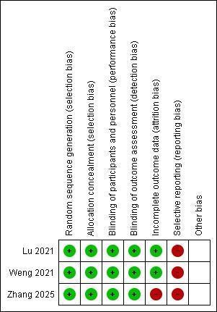

ESM Fig. 1 Risk of bias assessment.

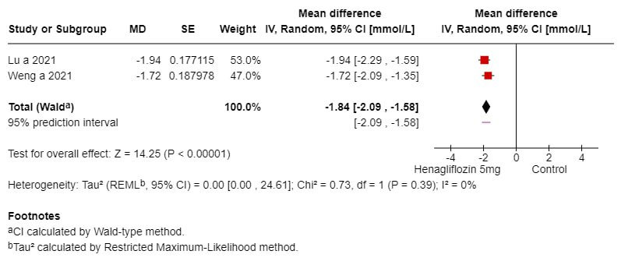
Forest Plots
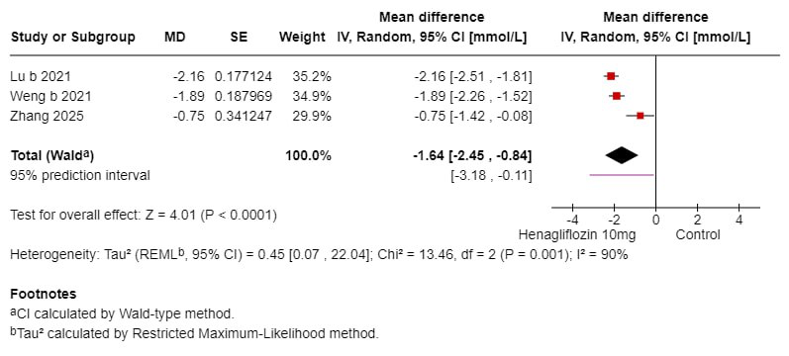
ESM Fig. 2 Change in fasting plasma glucose, FPG

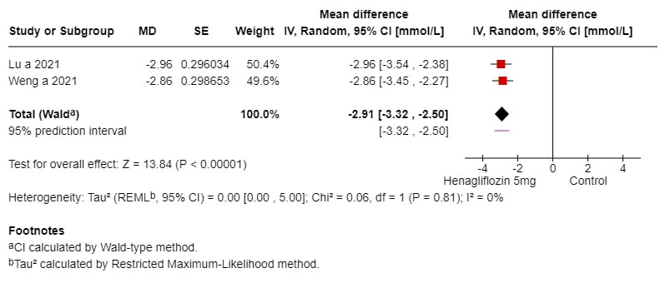
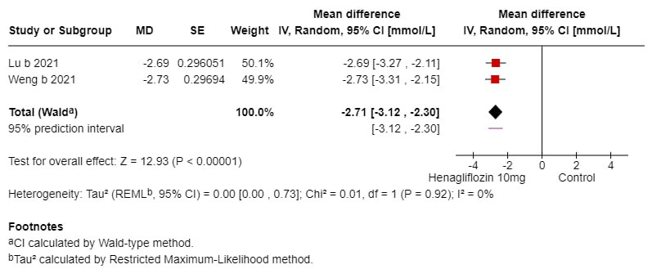
ESM Fig. 3 Change in post-prandial plasma glucose, PPG

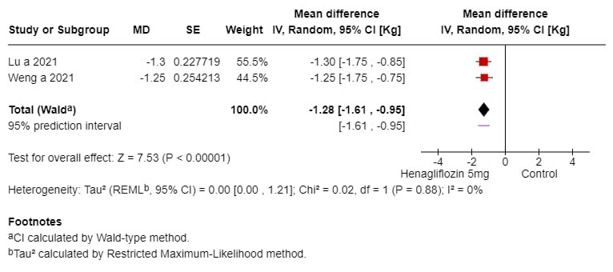
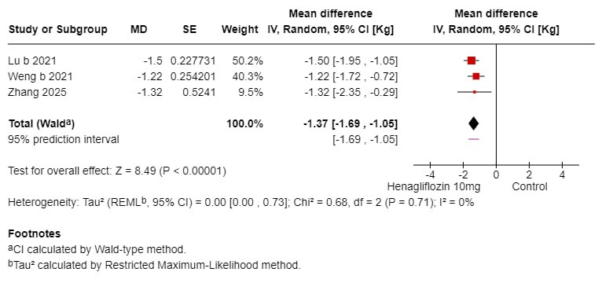

ESM Fig. 4 Change in body weight, Kg

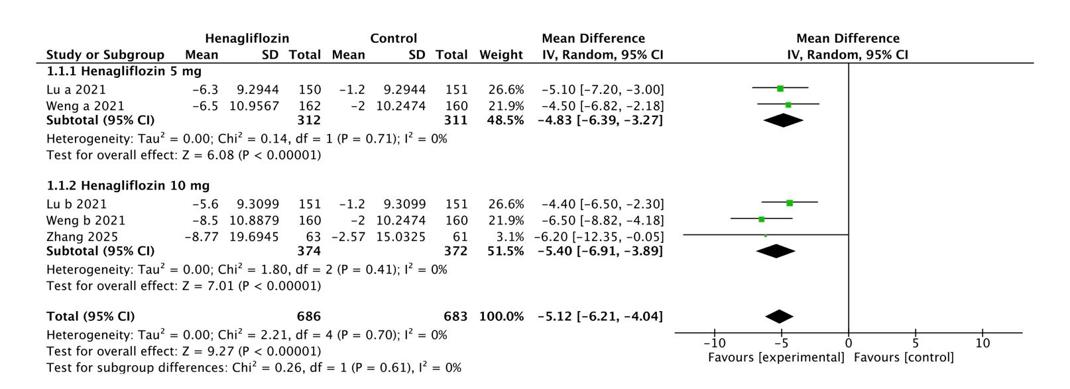
ESM Fig. 5 Change in SBP, mmHg

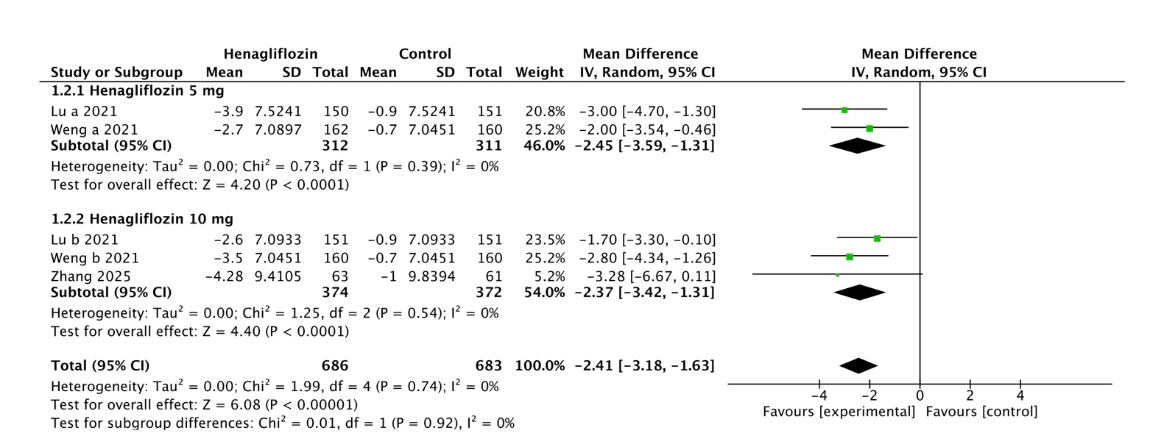
ESM Fig. 6 Change in DBP, mmHg

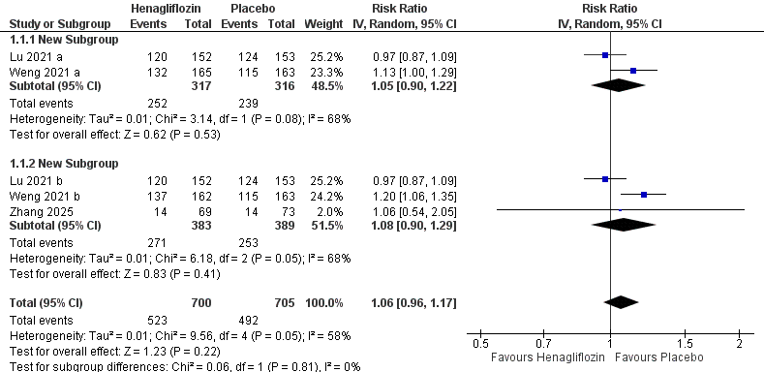

ESM Fig. 7 Incidence of adverse events

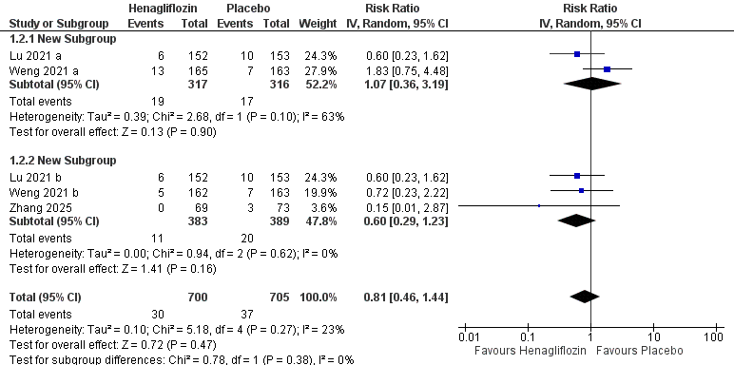

ESM Fig. 8 Incidence of serious adverse events

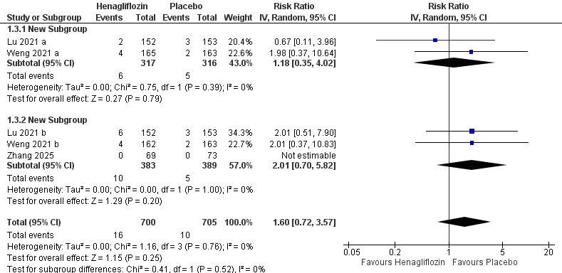

ESM Fig. 9 Incidence of discontinuation due to adverse events

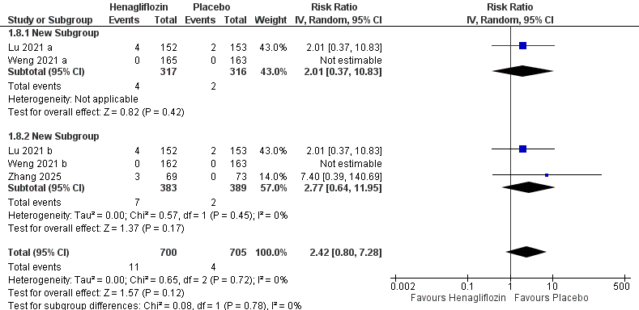

ESM Fig. 10 Incidence of hypoglycemia

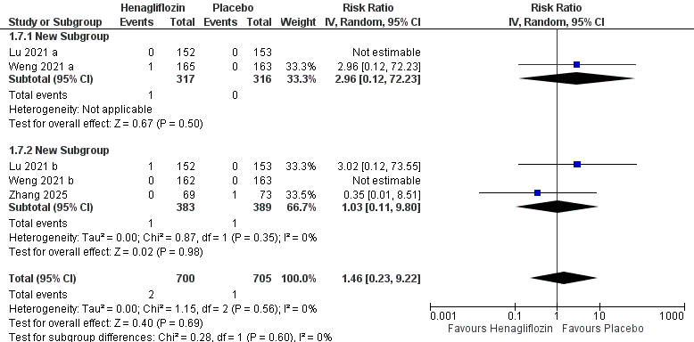

ESM Fig. 11 Incidence of hypotension

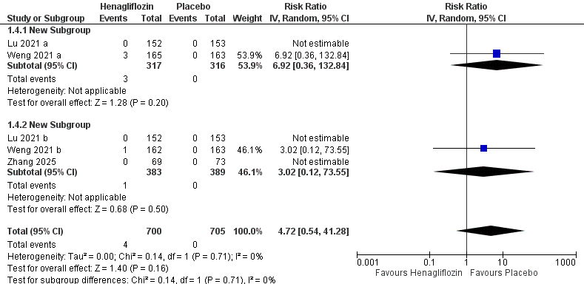

ESM Fig. 12 Incidence of genital infections

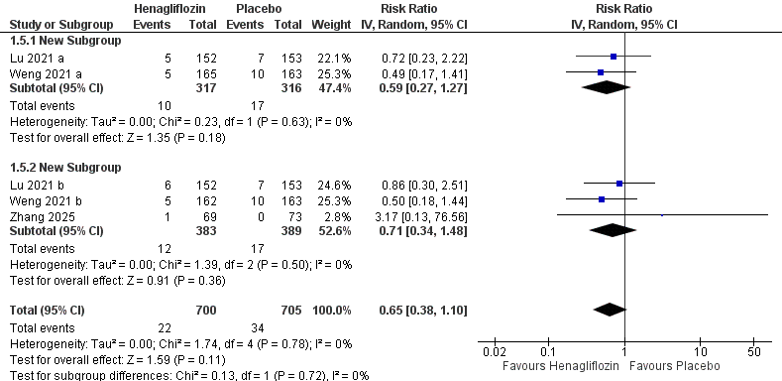

ESM Fig. 13 Incidence of urinary tract infections

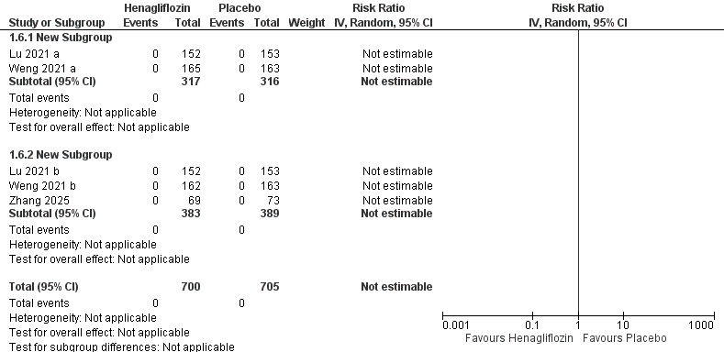

ESM Fig. 14 Incidence of DKA

