Supplementary Information
Direct-Write Transfer Printing of Low-Loss Copper Interconnects onto Arbitrary Substrates

Yuxin Jiao¹, Andrew Gleadall², Timothy D. Hall³, Majid Minary-Jolandan^{1*}
¹ Department of Mechanical Engineering, The University of Texas at Dallas, Richardson, TX, USA
² Wolfson School of Mechanical and Manufacturing Engineering, Loughborough University, Loughborough, Leicestershire LE11 3TU, UK
³ Faraday Technology Inc, Dayton, OH, USA
*Corresponding author: majid.minary@utdallas.edu

Poly(vinylidene fluoride-co-trifluoroethylene) [P(VDF-TrFE)] was dissolved in a 2:1 v/v cyclohexanone: acetone mixture at 138 mg mL⁻¹ and stirred at 50 °C for 4–5 hours. Fibers were deposited by electrospinning at 15–18 kV across a 15 cm needle-to-collector distance onto a rotating drum (4000 rpm) to produce the aligned nonwoven mat used as the transfer substrate. The woven fabric substrate was prepared by twisting the electrospun mats into fibers and manually weaving them into a textile.
To transfer onto electrospun and woven fabric substrates, the copper film was delaminated using two methods: direct deposition and peeling for electrospun fibers, and a pick-and-place approach with water-assisted lift-off for woven fabrics. For the electrospun nonwoven substrate, the stainless-steel print bed served directly as the electrospinning collector, allowing P(VDF-TrFE) fibers to be deposited onto the patterned copper surface and then peeled away as a composite film. For water-assisted lift-off, deionized water was applied with a pipette to the copper-steel interface to lift the copper from the steel substrate. The water's surface tension separates the copper from the steel, causing the copper to float to the surface. The free-standing copper film was then manually lifted and placed onto the target substrate.
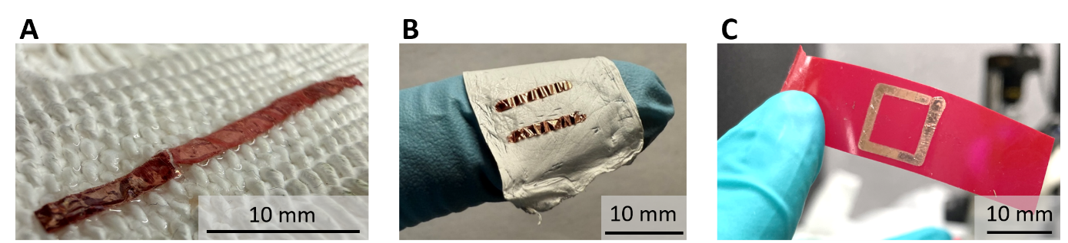
Figure S1 Transfer of copper traces onto substrates of diverse material and texture. (A) Copper trace transferred onto a woven fabric. (B) Copper traces transferred onto a nonwoven fabric conforming to a gloved finger. (C) Closed rectangular copper loop transferred onto an electroplating tape substrate.

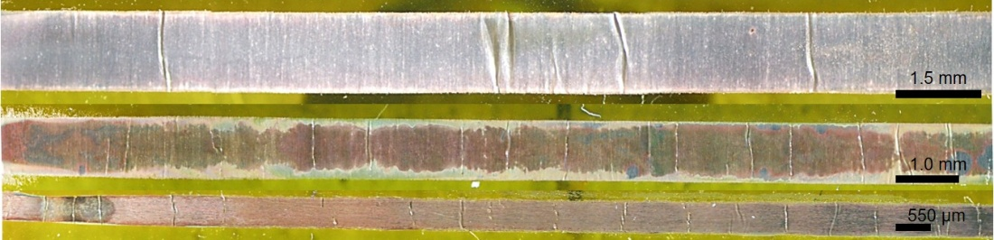
Figure S2 Linewidth resolution of transferred copper. Copper traces with linewidths from 1.5 mm down to 550 µm transfer intact. Scale bars, 1.5 mm (top), 1.0 mm (middle), 550 µm (bottom).

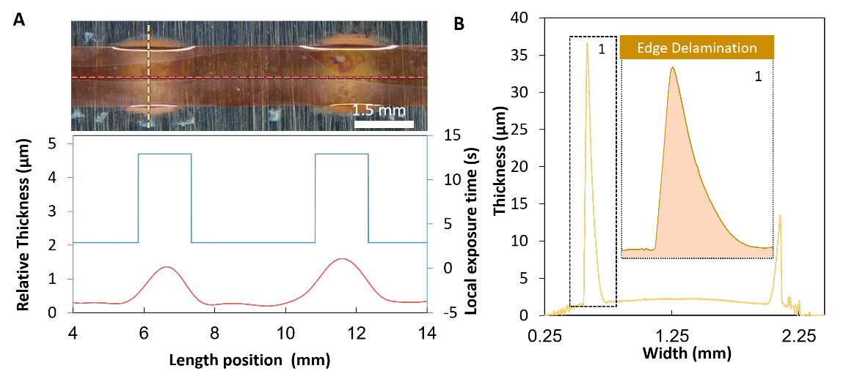
Figure S3 Print-path control of local film thickness and edge delamination. (A) Top: optical image of a start-stop printed trace; the red dashed line marks the longitudinal profilometry scan position, and the yellow dashed line marks the transverse scan position. Scale bar, 1.5 mm. White lifted regions at the film edges at dwell sites capture the onset of edge-preferential delamination in situ. Bottom: relative film thickness along the trace length (red, left axis) overlaid with programmed local exposure time (blue, right axis); thickness peaks coincide with dwell locations, confirming that programmed nozzle pauses selectively thicken the copper at defined positions. (B) Transverse thickness profile at a dwell site (yellow), showing sharp thickness peaks at the trace edges relative to the film interior. The dashed box and label "1" mark the edge delamination site enlarged in the inset (Edge Delamination), where preferential accumulation of material and stress at the contact-line periphery initiates a natural peel front, enabling spatially controlled delamination without mechanical intervention or chemical release agents.

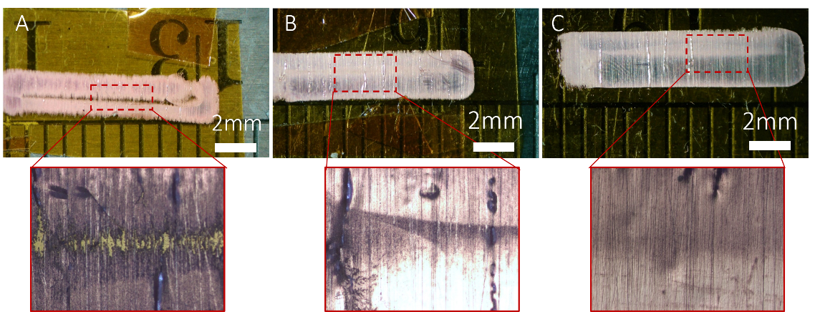
Figure S4 Effect of applied current on seam closure between overlapping parallel lines. The toolpath traces a 10 mm line, steps 0.75 mm across, and returns along the parallel track; with a printed linewidth of ~1.5 mm, the two passes overlap by 50% of their width. Each sample was deposited over 10 layers at a 50% duty cycle. Red dashed boxes mark the regions magnified below each panel. (A) At 10 mA, the seam between the two passes remains unfilled, exposing the substrate along the junction. (B) and (C) At 12 and 15 mA, the seam closes completely and the film is continuous across the junction. Scale bars, 2 mm.

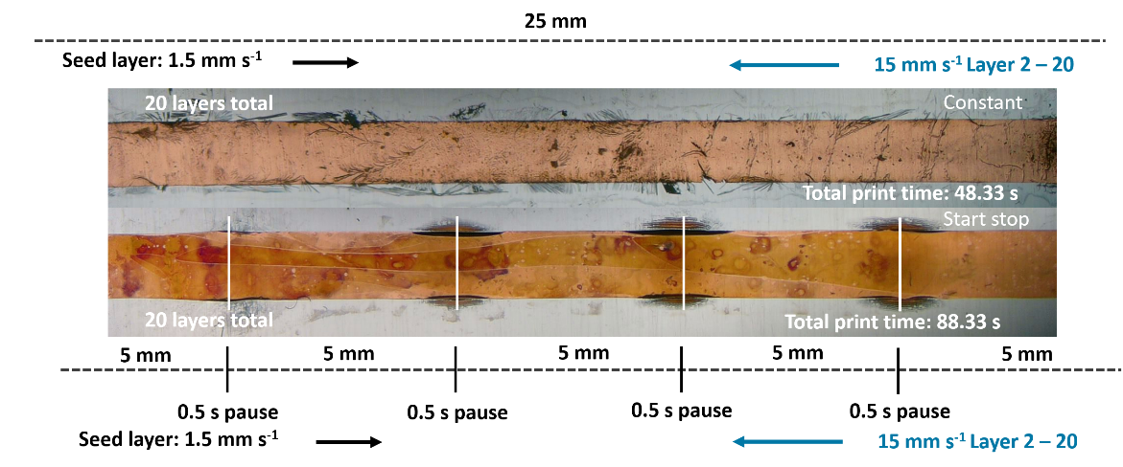
Figure S5 Start-stop versus constant-motion print profiles. Two 25 mm traces were printed with identical charge delivery: a seed layer at 1.5 mm s⁻¹ followed by repeat layers at 15 mm s⁻¹, 20 layers in total. The constant-motion trace (top) was printed without interruption, for a total print time of 48.33 s. The start-stop trace (bottom) divided each pass into five 5 mm segments separated by four programmed 0.5 s pauses per layer, for a total print time of 88.33 s. The pauses locally extend electrolyte exposure, thickening the film at the pause sites and triggering premature delamination there, visible as white lifted regions; the constant-motion trace shows no periodic thickness features.

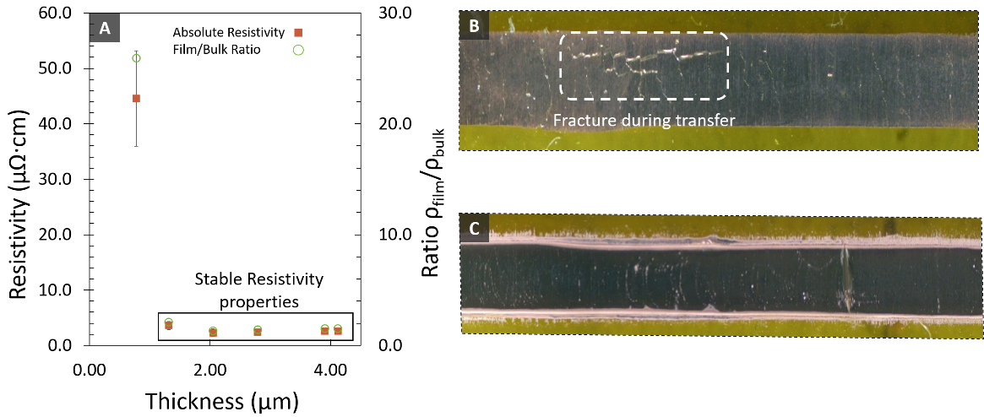
Figure S6 Resistivity and transfer integrity of confined-electrodeposited copper films across thickness. (A) Four-point-probe resistivity (red squares, left axis) and film-to-bulk ratio (green circles, right axis) versus film thickness, extended to include a ~780 nm film. Resistivity drops steeply below ~2 µm and stabilizes in the 2–4 µm regime (boxed region). (B) Optical image of a ~780 nm film after transfer, showing fracture across the film width within the dashed region, confirming that sub-micrometer films lack sufficient mechanical integrity for clean transfer. (C) Optical image of a pristine 2 µm film after transfer, showing a continuous, intact film with no visible fracture.

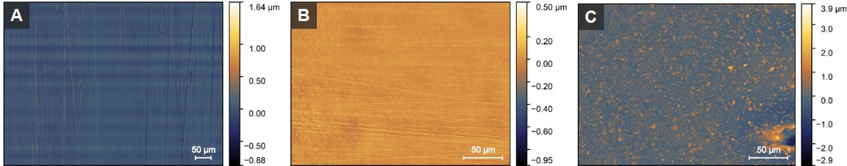
Figure S7 Laser confocal height maps of (A) polished stainless steel, (B) copper substrate side, and (C) copper nozzle side.

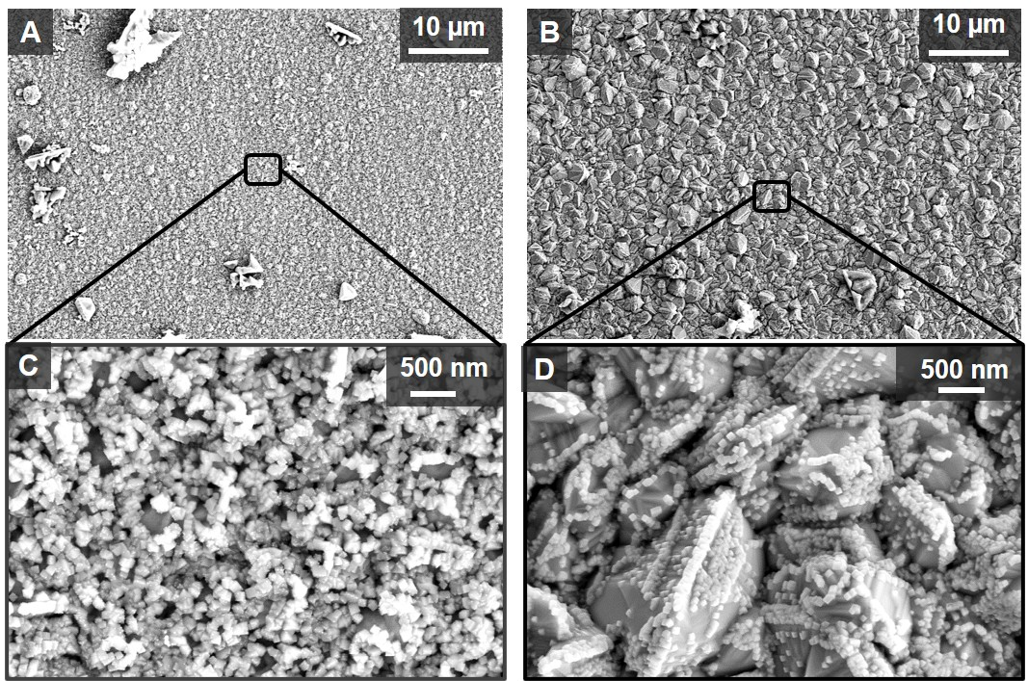
Figure S8 Nozzle-side grain morphology of delaminated confined-electrodeposited copper at two film thicknesses. (A, C) Plan-view SEM of the nozzle-facing surface of a ~1.2 µm thick film at overview (A, scale bar 10 µm) and high magnification (C, scale bar 500 nm), showing a dense, uniform population of small equiaxed grains. (B, D) Plan-view SEM of the nozzle-facing surface of a 3.5 µm thick film at overview (B, scale bar 10 µm) and high magnification (D, scale bar 500 nm), showing coarser, faceted grains with a nodular habit.

Estimation of Conductor Loss
The deposition methods compared in Figure 5A differ in both resistivity and surface roughness. A single figure of merit combines the two properties and ranks each method by the conductor loss of a transmitted signal. The effective surface resistance serves this role and is computed from two inputs per material, the resistivity ρ and the surface roughness R_{q}, at a common frequency f. The skin depth is evaluated first, at each material’s own resistivity:
$δ = \sqrt{\frac{ρ}{πfμ_{0}}}$ (S1)
where μ₀ = 4π × 10⁻⁷ H.m⁻¹. Equation S1 is the good-conductor limit with μ_{r} ≈ 1 (relative permeability), valid for copper across the full band ¹.
At high frequency, current travels in a thin sheet at the conductor surface, one skin depth δ thick, with loss set by the sheet's resistance:
$R_{s,smooth} = \sqrt{πfμ₀ρ}$ (S2)
where R_{s,smooth} is the surface resistance (mΩꞏsq⁻¹) of an ideally smooth, for a flat surface¹. Whether roughness matters is a question of scale. Texture far below δ is invisible to the current, which averages over it and flows straight. Texture approaching δ forces the sheet to drape over every peak and valley, lengthening the path and raising dissipation. Hammerstad and Jensen condensed this scale competition into a single factor,
$K_{SR}= 1 +\left(\frac{2}{π}\right)\arctan\left[1.4{\left(\frac{R_{q}}{δ}\right)}^{2}\right]$ (S3)
giving
$R_{s,eff}= K_{SR}×R_{s,smooth}$ (S4)
where K_{SR} is the dimensionless Hammerstad–Jensen surface-roughness correction factor, R_{q} is the root-mean-square surface roughness (µm), and R_{s,eff} is the effective surface resistance (mΩꞏsq⁻¹) of the rough conductor; only the ratio of texture height to sheet thickness enters ².
The factor runs from 1 for a surface the current cannot feel to a saturation value of 2 when the current fully tracks the terrain. The bound of 2 follows from the model's geometry: Morgan's calculations treat the surface as two-dimensional transverse grooves, and a current that fully traces the groove walls travels at most roughly twice the flat-surface path, doubling the dissipation ³.
The underlying fit was constructed for the low-roughness regime (R_{q} < 2 µm). Beyond this range, the arctan form itself saturates once R_{q} exceeds δ - but real losses do not saturate. Three-dimensional nodular topography introduces two additional loss mechanisms absent from the groove picture - field scattering and surface inductance - neither of which is subject to a factor-of-two ceiling, so measured enhancements can exceed 2. For such surfaces, formulations like the Huray snowball model are preferred ⁴. These limits define how the correction applies to the present comparison. The transferred films operate deep inside the accurate regime (R_{q}/δ ≤ 0.12, K_{SR} ≤ 1.01 at 20 GHz), where all roughness models converge to unity and the computed surface resistance is insensitive to model choice. Many printed conductors instead carry roughness of 1 to 29 µm, beyond the validity bound and at or near saturation (K_{SR} = 1.6 to 2.0), and for these entries the model understates the true loss. The loss ratios in Table S1 are therefore lower bounds, and the comparison is conservative toward the printed conductors.
All films compared are thicker than the skin depth, so thickness drops out of the loss. The skin depth then feeds two independent terms in Equations S2 (for smooth-surface resistance where resistivity sets the baseline loss) and S3 (roughness correction where roughness scales the baseline by 1 to 2). The two terms combine into effective surface resistance in Equation S4. Conductor attenuation is proportional to the effective surface resistance at fixed line geometry. The loss ratio between two conductors is therefore independent of geometry,
$\frac{α_{1}}{α_{2}}= \frac{R_{s,eff,1}}{R_{s,eff,2}}$ (S5)
where α₁ and α₂ are the conductor attenuation coefficients of the two films and R_{s,eff,1} and R_{s,eff,2} are their effective surface resistances at the same frequency. Equation S5 generates the loss multiples in Table S1, evaluated at 20 GHz against the best confined-electrodeposited film.
Reported roughness values are areal means S_{q} and are taken as R_{q} in Equation S3. The correction factor saturates at 2, so Equation S3 underpredicts the penalty of surfaces much rougher than the skin depth^{2,4}. The multiples quoted for rough printed conductors are therefore lower bounds. The reference film sits at R_{q}/δ ≈ 0.1, inside the validated low-roughness regime.

Table S1 Surface resistance and conductor-loss comparison of confined-electrodeposited and printed copper at 20 GHz. Skin depth δ = √(ρ/πfμ₀) and effective surface resistance R_{s,eff} = K_{SR}·√(πfμ₀ρ), with the roughness correction K_{SR} defined in equation S3. The loss ratio, R_{s,eff}/R_{s,eff,ref,} is taken relative to the 30-layer film and equals the conductor-loss ratio at matched line geometry (α ∝ R_{s,eff}).
Deposition method | Material | ρ (µΩ·cm) | S_{q} (µm) | δ (µm) | K_{SR} | R_{s,eff} (mΩ. sq⁻¹) | Loss ratio | Ref.
Confined electrodeposition (this work)
Confined ED | Cu | 3.39 | 0.070 | 0.655 | 1.01 | 52.3 | 1.2 | This work
Confined ED | Cu | 3.61 | 0.058 | 0.676 | 1.01 | 53.7 | 1.3 | This work
Confined ED | Cu | 2.29 | 0.059 | 0.539 | 1.01 | 43.0 | 1.0 | This work
Confined ED | Cu | 2.43 | 0.066 | 0.555 | 1.01 | 44.4 | 1.1 | This work
Confined ED | Cu | 3.06 | 0.040 | 0.623 | 1.00 | 49.3 | 1.2 | This work
Confined ED | Cu | 2.60 | 0.057 | 0.574 | 1.01 | 45.7 | 1.1 | This work
Confined ED | Cu | 3.35 | 0.065 | 0.651 | 1.01 | 51.9 | 1.2 | This work
Confined ED | Cu | 2.20 | 0.056 | 0.528 | 1.01 | 42.1 | 1.0 (ref.) | This work
Inkjet and ink-based
Inkjet | Cu NP | 4.53 | 0.10 | 0.757 | 1.02 | 60.7 | 1.4 | ⁵
Inkjet | Cu NP | 3.63 | 0.50 | 0.678 | 1.41 | 75.7 | 1.8 | ⁵
Inkjet | Cu NP | 7.69 | 3.00 | 0.987 | 1.95 | 152.0 | 3.6 | ⁵
Inkjet (3-step sinter) | Cu NP | 7.90 | 0.0124 | 1.000 | 1.00 | 79.0 | 1.9 | ⁶
Dip-coat, laser-sintered | Cu | 12.0 | 0.10 | 1.233 | 1.01 | 97.9 | 2.3 | ⁷
Inkjet (H₂ plasma) | Cu complex ion | 3.23 | 0.0062 | 0.640 | 1.00 | 50.5 | 1.2 | ⁸
Inkjet (H₂ thermal) | Cu complex ion | 37.54 | 0.218 | 2.180 | 1.01 | 173.7 | 4.1 | ⁸
Inkjet | Cu NP | 28.0 | 29.2 | 1.883 | 2.00 | 297.1 | 7.1 | ⁹
Screen printing and doctor blade
Screen printing | Cu† | 2.00 | 0.22 | 0.503 | 1.17 | 46.4 | 1.1 | ¹⁰
Screen printing | Cu–Ag MOD | 8.32 | 0.279 | 1.027 | 1.07 | 86.4 | 2.1 | ¹¹
Screen printing | Cu | 12.5 | 0.23 | 1.258 | 1.03 | 102.3 | 2.4 | ¹²
Doctor blade | Ni-plated CPN | 14.78 | 1.45 | 1.368 | 1.64 | 177.1 | 4.2 | ¹³
Doctor blade | Cu CPN | 12.2 | 3.90 | 1.243 | 1.95 | 191.8 | 4.6 | ¹³
Doctor blade | Cu NP | 19.98 | 12.04 | 1.591 | 1.99 | 250.2 | 5.9 | ¹³
Screen print | Ag ink | 16.60 | 3.470 | 1.450 | 1.92 | 219.9 | 5.2 | ¹⁴
† Screen-printed sacrificial Al paste converted to Cu by galvanic displacement, then thickened by Cu electroplating; the measured conductor is electroplated Cu (~100 µm).
NP: nanoparticle; MOD: metal–organic decomposition; CPN: Cu precursor/nanoparticle.

Supplementary references
1 Wheeler, H. A. Formulas for the Skin Effect. Proceedings of the IRE 30, 412-424, doi:10.1109/JRPROC.1942.232015 (1942).
2 Hammerstad, E. & Jensen, O. in 1980 IEEE MTT-S International Microwave symposium Digest. 154.
3 Morgan, S. P., Jr. Effect of Surface Roughness on Eddy Current Losses at Microwave Frequencies. Journal of Applied Physics 20, 352-362, doi:10.1063/1.1698368 (1949).
4 Chiang, Y. C. et al. Enhancing the high-frequency signal performance through surface morphological modification of Cu interconnects. Measurement 250, 117071, doi:ARTN 117071
10.1016/j.measurement.2025.117071 (2025).
5 Kang, J. S. et al. Inkjet printed electronics using copper nanoparticle ink. J Mater Sci: Mater Electron 21, 1213-1220, doi:10.1007/s10854-009-0049-3 (2010).
6 Chan, H.-J., Huang, B.-C., Wang, L.-W., Liao, K.-H. & Lo, C.-Y. Porosity reduction in inkjet-printed copper film by progressive sintering on nanoparticles. Thin Solid Films 627, 33-38, doi:10.1016/j.tsf.2017.02.062 (2017).
7 Olsen, E. & Overmeyer, L. Laser sintering of copper conductive traces on primer pre-treated additive manufactured 3D surfaces. Flex. Print. Electron. 6, 015006, doi:10.1088/2058-8585/abdbfd (2021).
8 Kwon, Y.-T., Lee, Y.-I., Kim, S., Lee, K.-J. & Choa, Y.-H. Full densification of inkjet-printed copper conductive tracks on a flexible substrate utilizing a hydrogen plasma sintering. Applied Surface Science 396, 1239-1244, doi:10.1016/j.apsusc.2016.11.122 (2017).
9 Pervan, D. et al. Additive Manufacturing of Electrically Conductive Multi-Layered Nanocopper in an Air Environment. Nanomaterials 14, 753, doi:10.3390/nano14090753 (2024).
10 Lee, W. H., Chen, Y.-X. & Lin, H. H. A novel electrochemical deposition of copper conductor on flexible printed circuit boards. Electrochemistry Communications 183, 108090, doi:10.1016/j.elecom.2025.108090 (2026).
11 Beltran, V. V. et al. Enhancing the electric conductivity and surface smoothness of photosintered copper films on polyimide substrates. Additive Manufacturing 115, 105072, doi:10.1016/j.addma.2025.105072 (2026).
12 Kim, Y. et al. Use of copper ink for fabricating conductive electrodes and RFID antenna tags by screen printing. Current Applied Physics 12, 473-478, doi:10.1016/j.cap.2011.08.003 (2012).
13 Jang, Y.-R., Jeong, R., Kim, H.-S. & Park, S. S. Fabrication of solderable intense pulsed light sintered hybrid copper for flexible conductive electrodes. Scientific Reports 11, 14551, doi:10.1038/s41598-021-94024-8 (2021).
14 Hong, H., Hu, J. & Yan, X. UV Curable Conductive Ink for the Fabrication of Textile-Based Conductive Circuits and Wearable UHF RFID Tags. ACS Appl. Mater. Interfaces 11, 27318-27326, doi:10.1021/acsami.9b06432 (2019).

