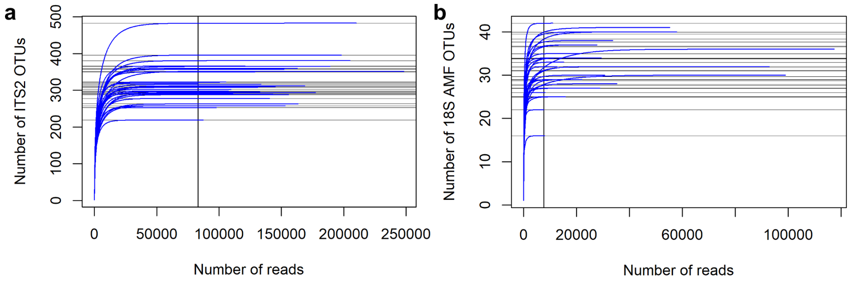
Supplementary Figures
Supplementary Figure 1: OTU accumulation curves for each soil sample for (a) ITS2 and (b) 18S. Horizontal gray lines indicate asymptotic OTU richness of each sample, and vertical black lines indicate the minimum read count across all samples.
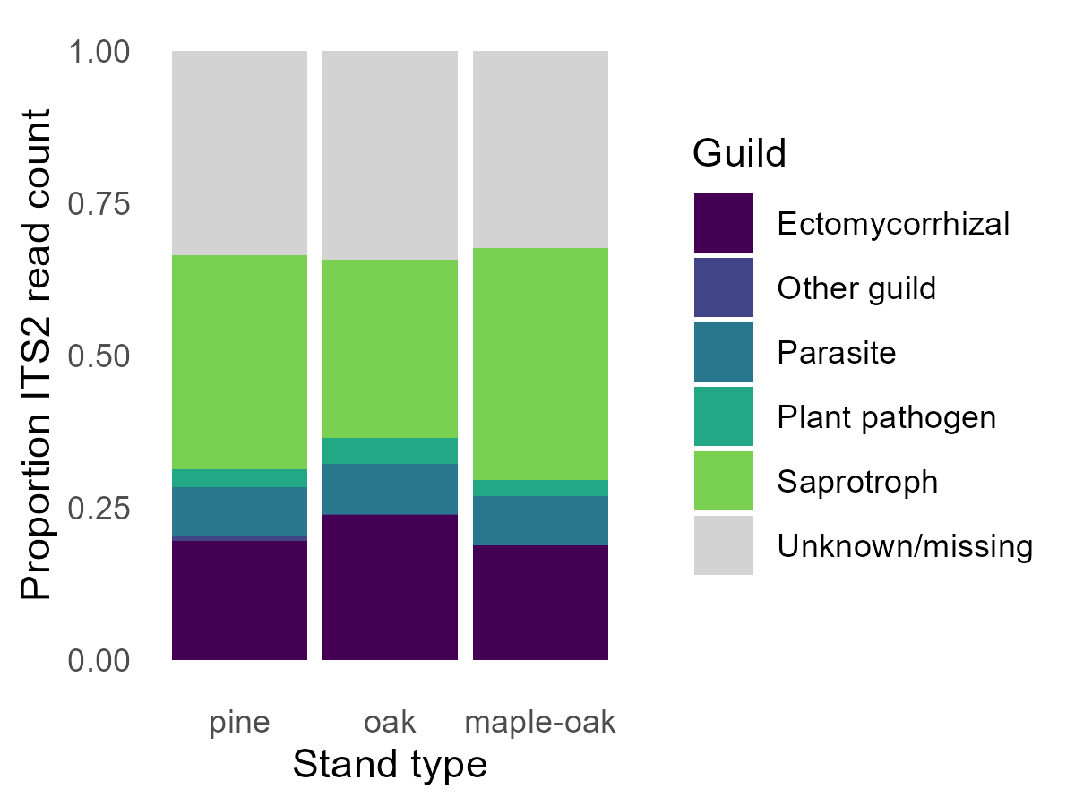
Supplementary Figure 2: Proportion ITS2 reads by guild based on assignment with the FungalTraits database..
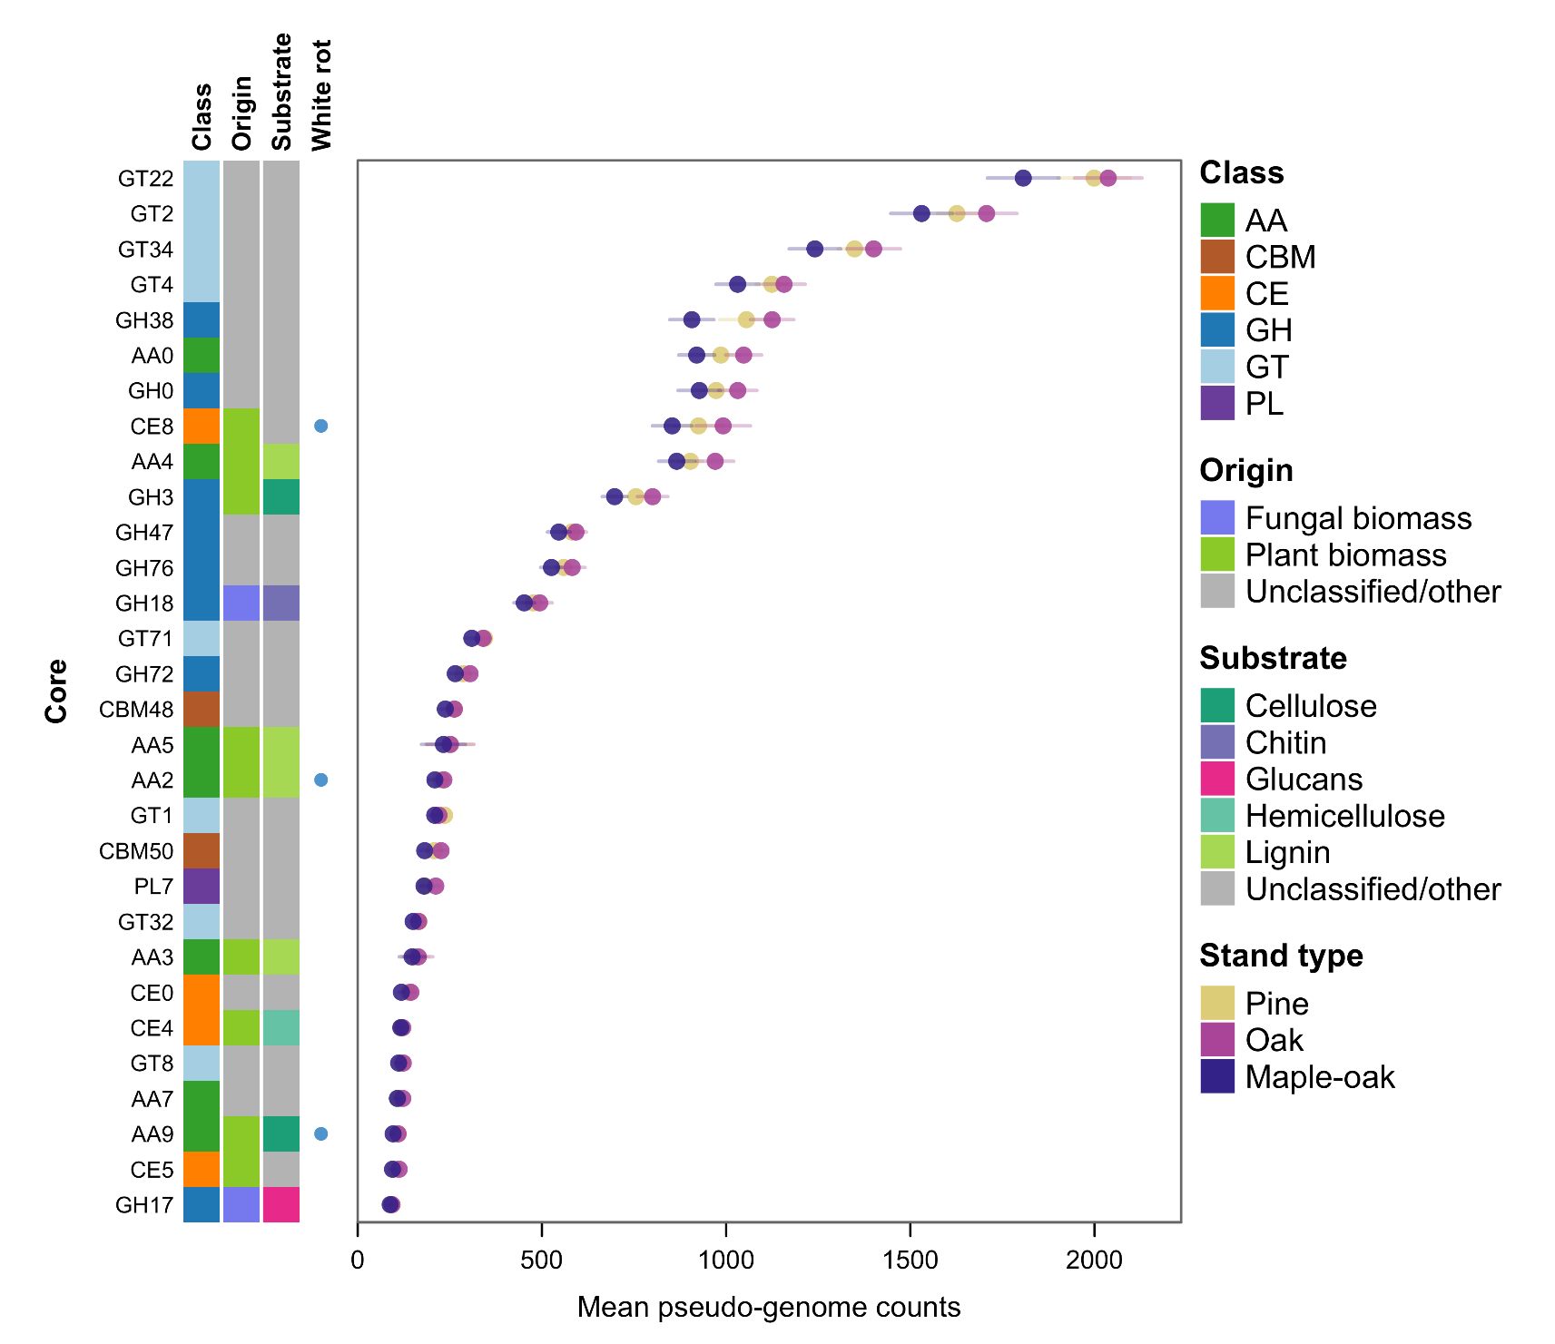
Supplementary Figure 3: The 30 CAZyme families with the highest overall mean pseudo-genome count across stand types. Mean counts across samples are shown as dots colored by stand type, ±1 standard error, split by core (detected in all stands), shared (detected in 2 or more stands), or named by the single stand in which they were detected (all of the top 30 CAZymes were detected in all stand types). All top 30 enzymes were detected in all stand types (core). Enzymes are annotated (left) by their CAZyme family class, predicted substrate, and biomass target, as well as if they are associated with white-rot lignin degradation (Floudas et al., 2012).

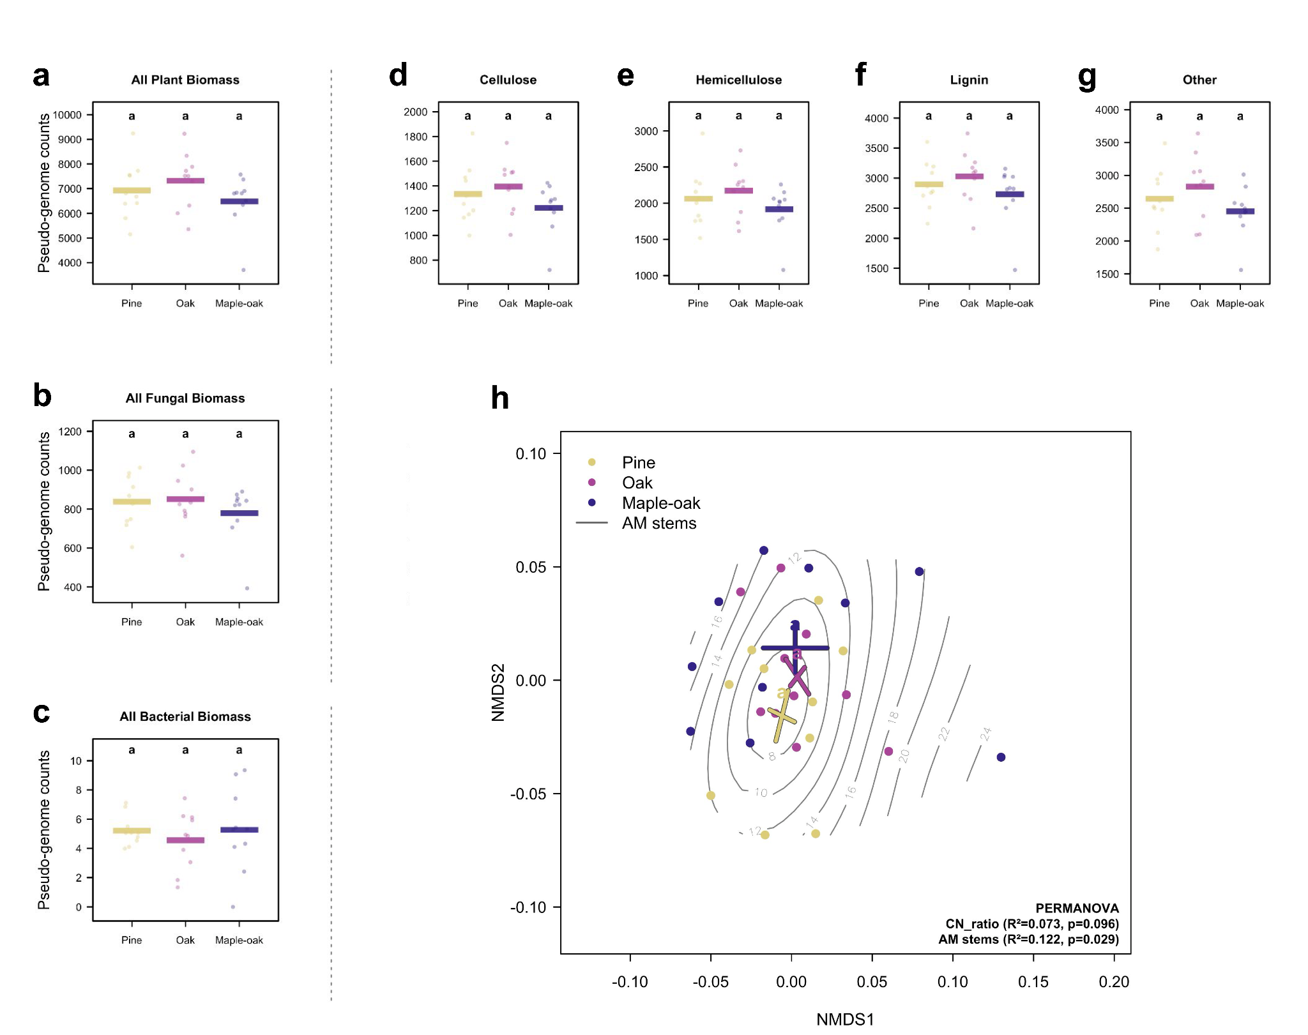
Supplementary Figure 4: Pseudo-genome counts of CAZyme genes known to attack various carbon substrates in soil associated with (a) plant biomass, (b) fungal biomass (chitin and glucans), and (c) bacterial biomass (peptidoglycan), as well as the individual components of plant biomass (d-g). Pseudo-genome counts = gene read counts / genome equivalents. Differences between stand types tested using Tweedie or Gaussian linear model depending on zero-inflation with pairwise differences calculated using emmeans. (h) NMDS using Bray-Curtis distances of annotated CAZyme families, with centroids showing standard error (stress = 0.238). PERMANOVA showing significant and marginally significant predictors of CAZyme composition (n=29), and significant centroid differences between stand type (p<0.05).

Supplementary Tables
Supplementary Table 1: CAZyme gene families mapped to the substrates upon with they act, and from what type of biomass those substrates originate. CAZyme to gene family mappings were only created when CAZymes were known to have high substrate-specificity with those compounds. Gene family to substrate mappings were made based on the Cazy database CAZypedia (https://www.cazypedia.org), and/or the referenced papers. Biomass types include plant, fungal, and bacterial, based on the main components in and between cell walls in each of those organismal groups. Information on white-rot associated enzymes were taken from Floudas et al. (2012).

Supplementary Table 2: (a) Results of linear models testing effects of single environmental predictors on OTU richness by guild and (b) results of envfits testing effects of single environmental predictors on fungal community composition.

Supplementary Table 3: (a) Results of linear models testing differences in total fungal CAZyme pseudo-genome counts among stand types, binned in substrate and biomass origin categories and (b) PERMANOVA results testing the drivers of the composition of annotated CAZyme families across all stand types.
fao

