Supplemental Information

Bracovirus sneaks into apoptotic bodies transmitting immunosuppressive signaling driving by integration-mediated eIf5A hypusination
Gui-Fang Zhou，Chang-Xu Chen, Qiu-Chen Cai, Xiang Yan, Nan-Nan Peng, Xing-Cheng Li, Ji-Hui Cui, Yun-Feng Han, Qi Zhang, Jiang-Hui Meng, Hong-Mei Tang, Chen-hui Cai, Jin Long, and Kai-Jun Luo

Supplemental Figures S1-S10.
Supplemental Tables S1-S3.

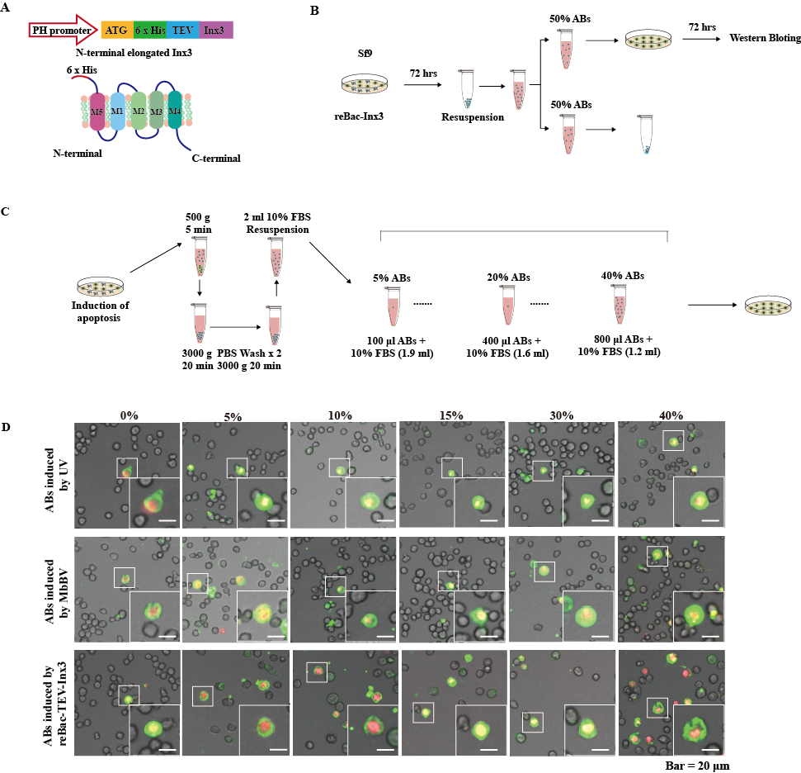
Supplementary Figure 1. Flowchart showing the generation of apoptotic bodies, Related to Figure 2.
(A) Structure model of N-terminal extended Inx3.
(B) Schematic showing the flow of apoptotic bodies equipartition experiment.
(C) Method of creating dilution gradient of apoptotic bodies.
(D) Apoptosis detection of recipient Sf9 cells incubated with apoptotic bodies induced by UV, MbBV and re-Bac-Inx3, Bar = 20 𝜇m.

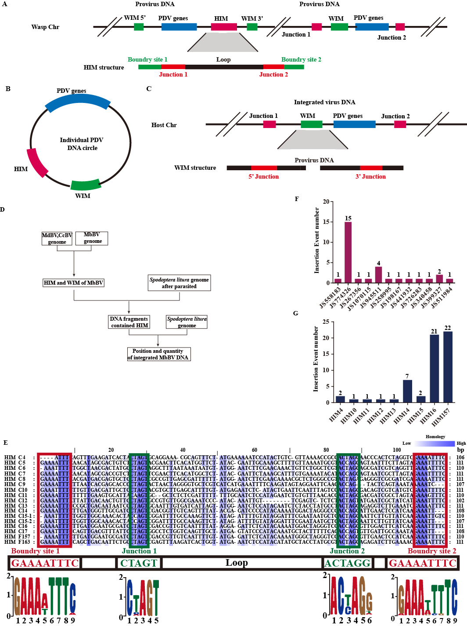

Supplementary Figure S2. Bracovirus primarily integrate via HIM sites, Related to Figure 2.
- HIM and WIM in genome of wasp. The provirus DNA of PDV in the wasp genome
contained HIM and wasp integrated motif (WIM) sites. HIM includes two boundary sites, two junction sites, and a loop. The mature viral particles have multiple dsDNA circles, some of them contained HIM and WIM sites. In the host chromosome, integrase and HIM binding are integrated into the host genome.
- HIM and WIM in the individually present in the PDV circle.
(C) Integration of HIM and WIM in host the host chromosome.
(D) Analysis of the host genome integrated by MbBV.
(E) The host integration sites (HIMs) of MbBV genome. MbBV has 17 HIMs and 15 of them located in dsDNA circle, while 2 of them appeared in short scaffolds. All the HIMs have 2 Boundary sites (BS) and 2 Junction sites (JS).
(F) The number of HIM Junction sites in the genome.
(G) The number of HIMs in the genome. Circle 14, 16 and short scaffold F157 have the most integration quantity.

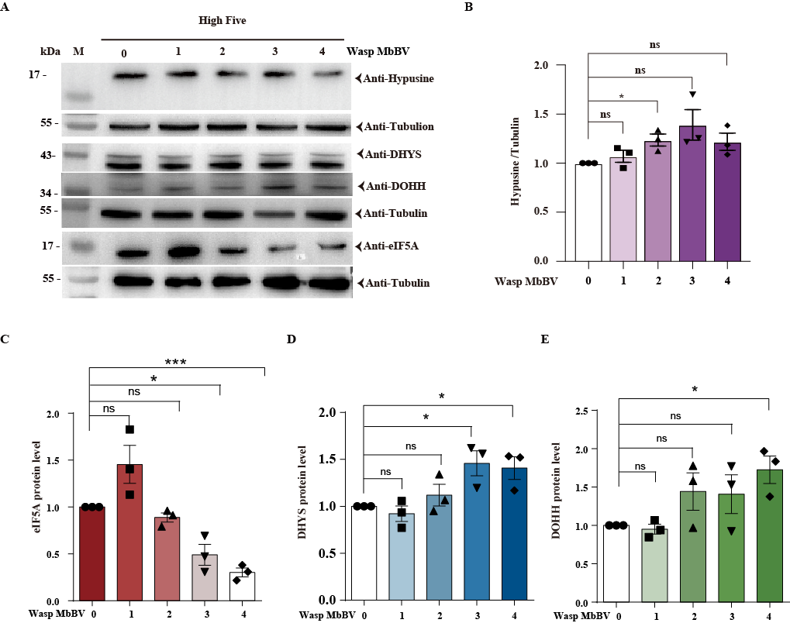
Supplementary Figure 3. Bracovirus integration triggered eIF5A hypusination, Related to Figure 3.
(A-E) In vitro, the protein level of eIF5A, Hypusine, DHYS, and DOHH changes in High Five cells infected by MbBV for 72 h. The column summarized the level of eIF5A, hypusine, DHYS, and DOHH in High Five cells, normalized to the total protein level. Comparisons were performed using t-test. *indicates p<0.05; ***p<0.001. Error bars represent SEM. Data represents three independent experiments.

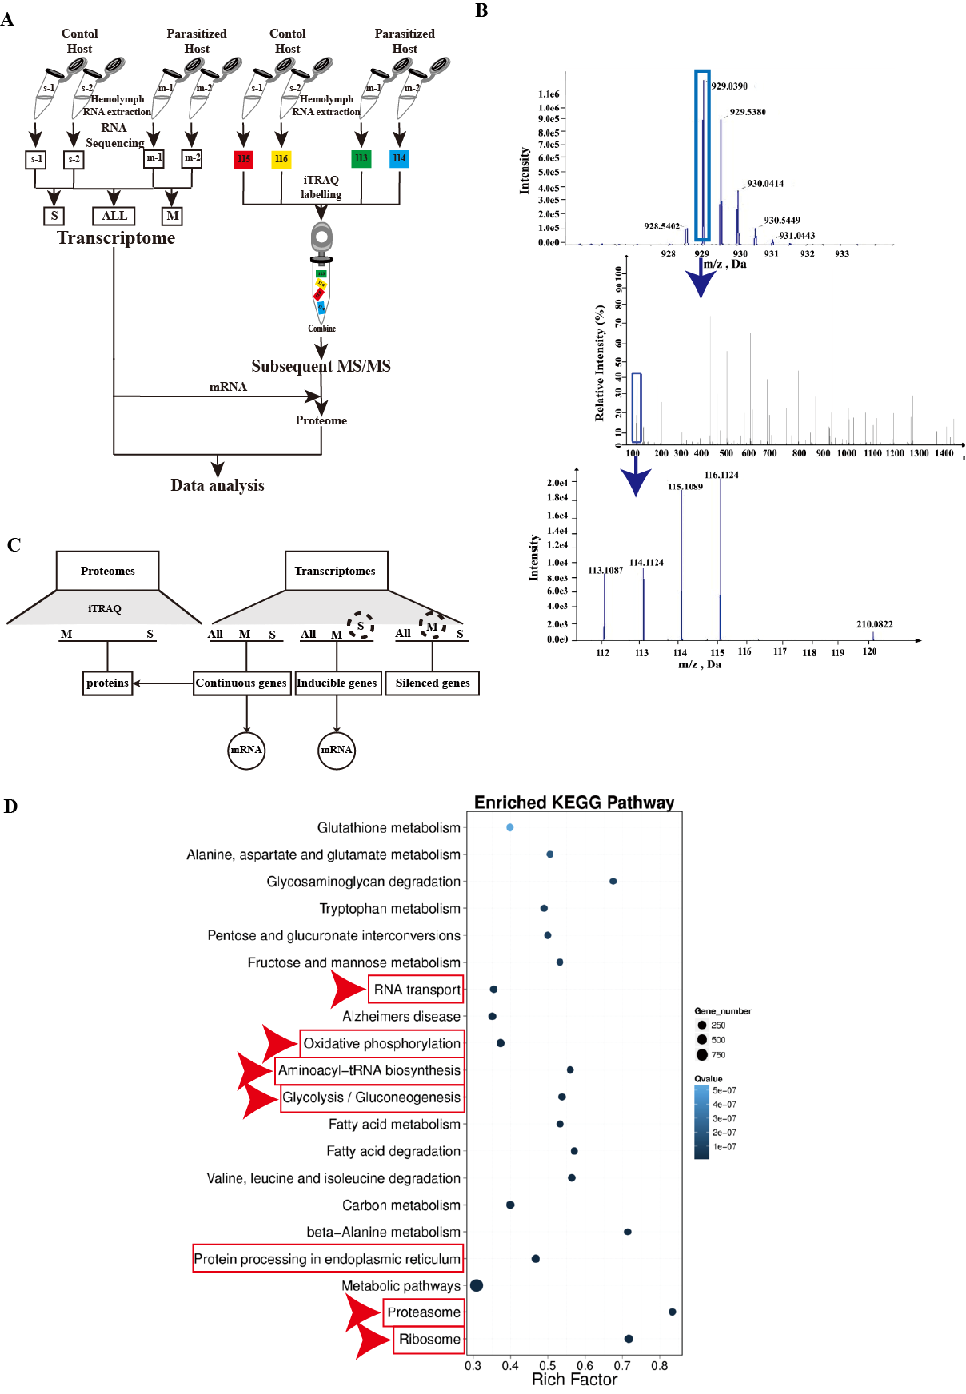

Supplementary Figure 4. Bracovirus integration triggered eIF5A hypusination，Related to Figure 3.
(A) The method of sample collection from hemocytes used MS/MS.
(B) Identified proteins.
(C) The methods of iTRAQ and transcription analysis.
(D) Signaling pathway enrichment by KEGG pathway analysis indicated that the proteins in 6-day p.p. hemocytes were associated with ten signaling pathways. Comparation mRNA with proteins in hemocytes.

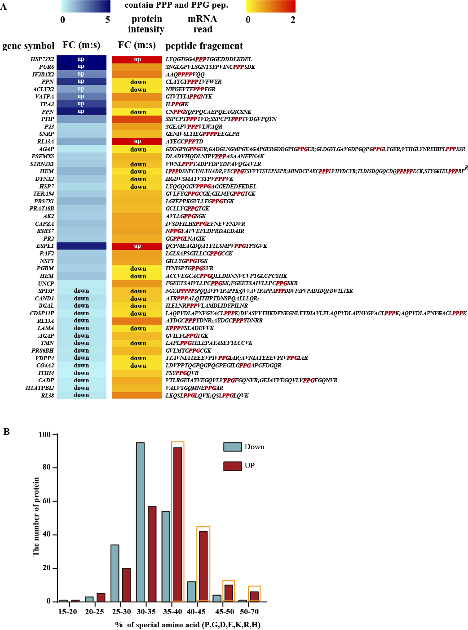
Supplementary Figure S5. PPP and PPG proteins involved in eIF5A hypusination translation, Related to Figure 3.
- Heatmap of 48-multiple proline proteins.
- The percentage of proline, glycine and charged amino acid in the up-regulated and down-regulated proteins in 6-day p.p hemocytes was analyzed by protein sequence.
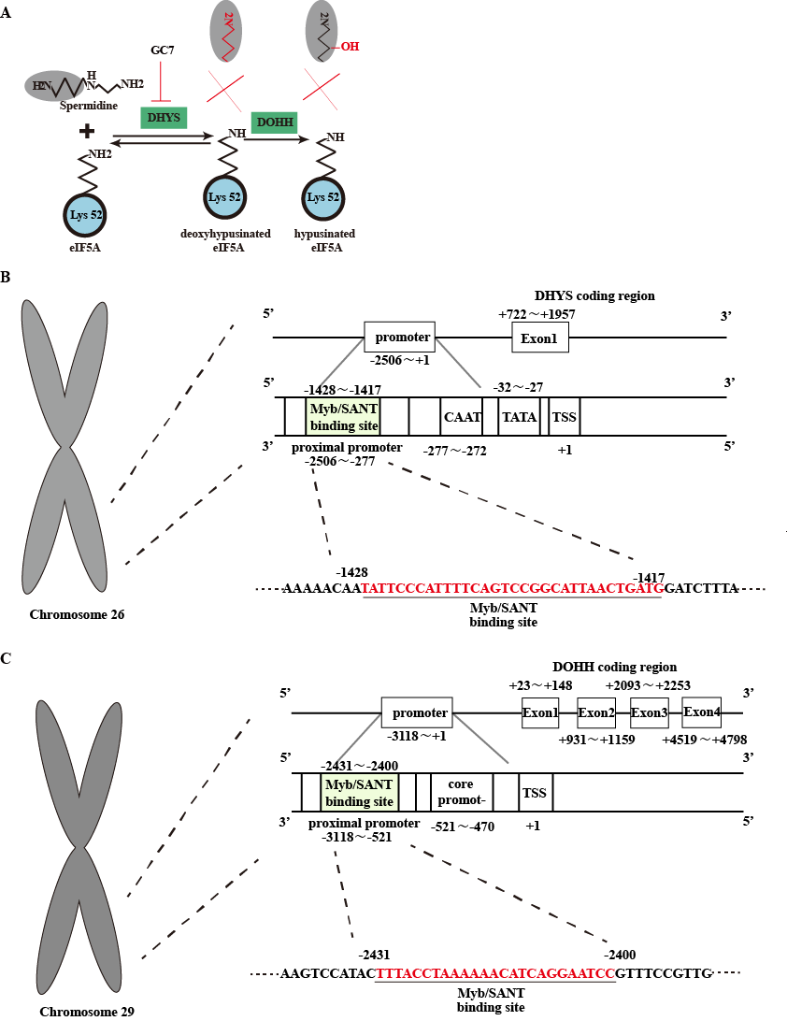

Supplementary Figure S6. Bracovirus integrated viral genes dependent eIF5A hypusination translation pattern, Related to Figure 4.
- Schematic of the mechanism of action of the inhibitor GC7 in eIF5A hypusination pathway.
(B) Schematic of the predicted promoter sequence of DHYS in Chromosome 26 of S. litura.
(C) Schematic of the predicted promoter sequence of DOHH in Chromosome 29 of S. litura.
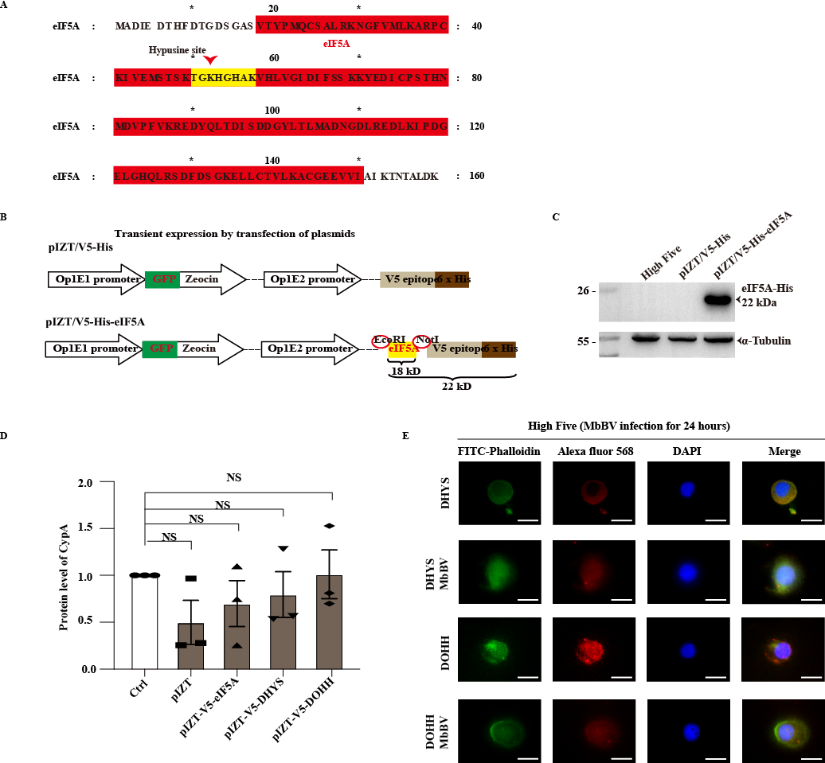

Supplementary Figure 7. MbBV activated hypusination pathway via promoting eIF5A the nucleocytoplasmic transport，Related to Figure 5.
(A) The sequence of eIF5A and predicted hypusination site.
(B) The structure of pIZT-V5/His-eIF5A.
(C) Ectopic expression eIF5A.
(D) The detection of CypA expression under ectopic expression of eIF5A, DHYS, and DOHH.
(E) The location of DHYS and DOHH in MbBV infected High Five cells.

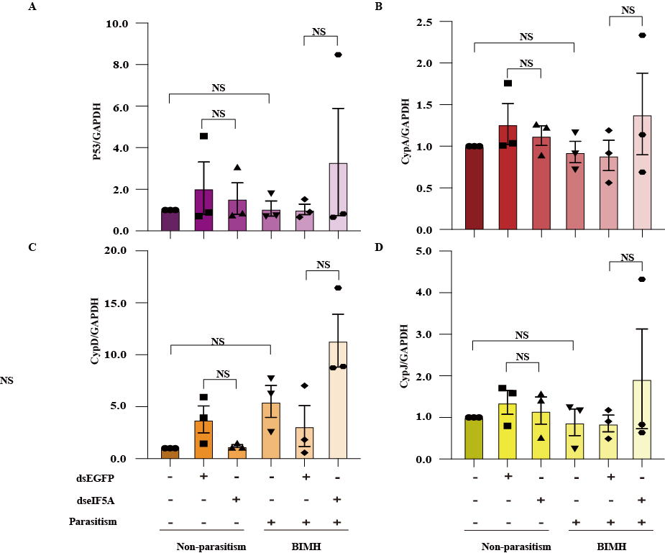

Supplementary Figure 8. Bracovirus integration-mediated eIF5A hypusination drives persistence apoptosis, Related to Figure 6.
(A-D) dsRNA feeding plus parasitism detected apoptosis related proteins, P53 (B), CypA, CypD (C), and CypJ (D). NS, no significant difference. Error bars represent SEM. Data represents three independent experiments.

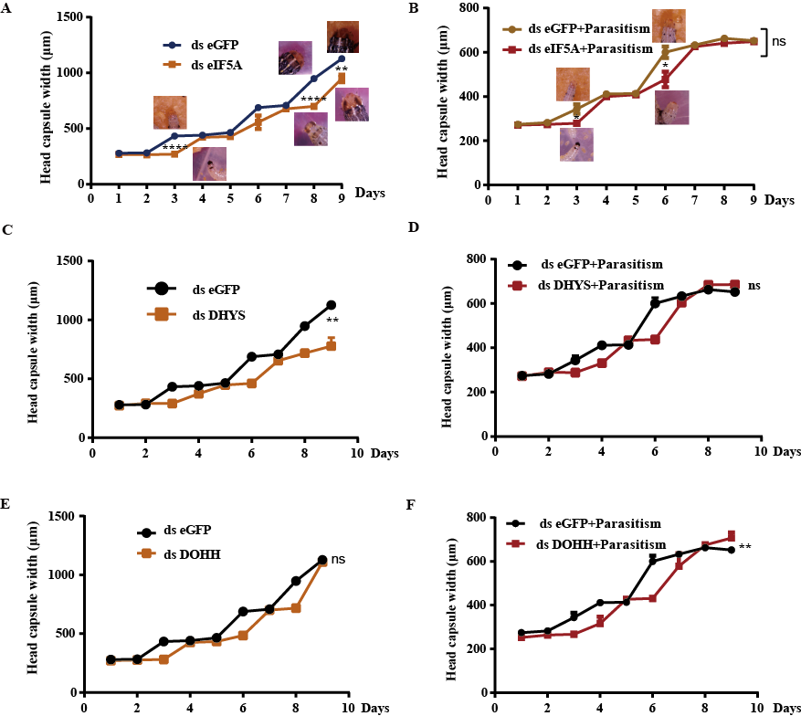

Supplementary Figure 9. Bracovirus integration-mediated eIF5A hypusination drives persistence apoptosis, Related to Figure 6.
(A) The effect of dsRNA of eIF5A on the width of the head shell of S. litura.
(B) The effect of the silencing eIF5A after parasitism on the width of the head shell of S. litura.
(C) The effect of dsRNA of DHYS on the width of the head shell of S. litura.
(D) The effect of the silencing DHYS after parasitism on the width of the head shell of S. litura.
(E) The effect of dsRNA of DOHH on the width of the head shell of S. litura.
(F) The effect of the silencing DOHH after parasitism on the width of the head shell of S. litura. Comparisons were performed using t-test. *indicates p<0.05; **p<0.01; ***p<0.001; ****p<0.0001. Error bars represent SEM. Data represents three independent experiments.
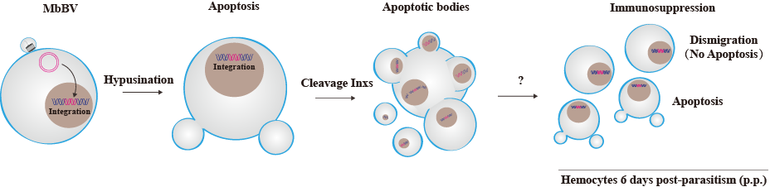
Supplementary Figure 10. The schematic present MbBV mediated hypusination promoting apoptosis, Related to Figure 7.
Schematic depicting the method of MbBV integration into the host genome, which triggered hypusination to maintain apoptosis; Cleavage of Inxs promotes apoptotic cells to disassemble to form apoptotic bodies; It is still unknown why recipient cells show different immunosuppressive patterns: apoptosis and non-apoptotic dismigration.

Table S1 Location of HIM on MbBV genome（Related to Figure 2)
Name | Length（bp） | Contig | Contig start | Contig end | Identity（%） | E value | Reference | Ref start | Ref end | Identity（%） | E value
HIM C4 | 106 | Node 169 | 675 | 780 | 100 | 1.00E-56 | HIM E | 5 | 111 | 89.72 | 1.00E-30
HIM C5 | 111 | Node 118 | 101 | 211 | 100 | 1.00E-59 | HIM A | 1 | 111 | 92.79 | 1.00E-42
HIM C6 | 110 | Node62 | 530 | 639 | 100 | 5.00E-59 | HIM C | 2 | 111 | 94.55 | 8.00E-47
HIM C7 | 111 | Node 36 | 1112 | 1222 | 100 | 1.00E-59 | HIM B | 1 | 111 | 89.19 | 4.00E-33
HIM C8 | 111 | Node 8 | 1904 | 2014 | 100 | 1.00E-59 | HIM F | 1 | 111 | 91.89 | 3.00E-40
HIM C9 | 107 | Node 21 | 1461 | 1355 | 100 | 3.00E-57 | HIM G | 1 | 32 | 90.63 | 2.00E-07
HIM C10 | 111 | Node 34 | 1978 | 2088 | 100 | 1.00E-59 | HIM I | 1 | 111 | 90.99 | 7.00E-38
HIM C11 | 110 | Node 65 | 5159 | 5304 | 100 | 5.00E-59 | HIM H | 1 | 110 | 90 | 7.00E-35
HIM C12 | 102 | Node 45 | 3399 | 3510 | 100 | 2.00E-39 | HIM M | 1 | 102 | 85.29 | 1.00E-20
HIM C13 | 111 | Node 22 | 20 | 130 | 100 | 1.00E-59 | HIM K1 | 1 | 111 | 86.49 | 6.00E-26
HIM C13 | 111 | Node 83 | 3360 | 3420 | 100 | 1.00E-59 | HIM K2 | 1 | 111 | 86.49 | 6.00E-26
HIM C14 | 108 | Node 25 | 2614 | 2721 | 100 | 8.00E-58 | HIM J | 1 | 107 | 87.96 | 1.00E-26
HIM C15-1 | 110 | Node 13 | 14434 | 14543 | 100 | 5.00E-59 | HIM L | 2 | 108 | 84.11 | 9.00E-19
HIM C15-2 | 107 | Node 13 | 14437 | 14543 | 100 | 3.00E-57 | HIM L | 1 | 108 | 84.11 | 8.00E-19
HIM C16 | 111 | Node 18 | 5491 | 5601 | 100 | 1.00E-59 | HIM N | 1 | 111 | 98.2 | 6.00E-57
HIM C17 | 108 | JS1091994 | 147 | 254 | 100 | 9.00E-55 | HIM D | 1 | 108 | 89.81 | 1.00E-33
HIM F157 | 110 | Node 92 | 1032 | 1141 | 100 | 5.00E-59 | HIM N | 2 | 111 | 94.55 | 8.00E-47
HIM F163 | 111 | Node 7 | 1621 | 1731 | 100 | 1.00E-59 | HIM K1 | 1 | 111 | 89.19 | 4.00E-33

Table S2 Sequencing scaffold with detected MbBV integration events（Related to Figure 2)

Scaffold  name | Length (bp) | Align  length (bp) | Chr  location | Start  position | End  position | Scaffold  Indentity(%) | Scaffold  E-value | Integrated  MbBV HIM | Integrated  Length (bp) | HIM  Indentity(%) | HIM  E-value
JS198167 | 115 | 80 | Chr 15 | 2327116 | 2327195 | 100 | 6.00E-38 | HIM-C15 | 21 | 100 | 5.00E-08
JS258995 | 122 | 85 | Chr 14 | 13432697 | 13432781 | 100 | 6.00E-41 | HIM-C14 | 29 | 100 | 7.00E-13
 |  |  |  |  |  |  |  | HIM-C16 | 29 | 93 | 4.00E-08
 |  |  |  |  |  |  |  | HIM-F157 | 28 | 92 | 2.00E-07
JS267356 | 123 | 86 | Chr 2 | 7752027 | 7752112 | 100 | 2.00E-41 | HIM-C15 | 21 | 100 | 5.00E-08
JS340458 | 132 | 99 | Chr 18 | 7868119 | 7868217 | 100 | 3.00E-49 | HIM-C14 | 27 | 100 | 1.00E-11
 |  |  |  |  |  |  |  | HIM-C16 | 30 | 90 | 3.00E-06
 |  |  |  |  |  |  |  | HIM-F157 | 30 | 96 | 5.00E-11
JS399327 | 139 | 104 | Chr 24 | 11032953 | 11033056 | 100 | 3.00E-52 | HIM-C4 | 26 | 100 | 5.00E-11
JS441932 | 142 | 107 | Chr 16 | 8527437 | 8527543 | 100 | 5.00E-54 | HIM-C10 | 29 | 96 | 3.00E-10
JS558183 | 150 | 115 | Chr 1 | 812835 | 812949 | 100 | 1.00E-58 | HIM-C11 | 30 | 100 | 2.00E-13
JS726283 | 161 | 129 | Chr 17 | 2306467 | 2306595 | 97 | 7.00E-60 | HIM-C13 | 29 | 100 | 9.00E-13
JS774326 | 174 | 74 | Chr 6 | 2697040 | 2697113 | 98 | 8.00E-32 | HIM-F157  HIM-C16  HIM-C14 | 29  29  29 | 100  100  93 | 1.00E-012  1.00E-012  6.00E-008
JS774326 | 174 | 74 | Chr 7 | 2355900 | 2355973 | 98 | 8.00E-32
JS774326 | 174 | 74 | Chr 9 | 254485 | 254558 | 98 | 8.00E-32
JS774326 | 174 | 74 | Chr 10 | 872221 | 872294 | 98 | 8.00E-32
JS774326 | 174 | 74 | Chr 12 | 7120307 | 7120380 | 98 | 8.00E-32
JS774326 | 174 | 74 | Chr 16 | 964612 | 964685 | 98 | 8.00E-32
 |  |  |  | 13504369 | 13504442 | 98 | 8.00E-32
JS774326 | 174 | 74 | Chr 17 | 4404909 | 4404982 | 98 | 8.00E-32
JS774326 | 174 | 72 | Chr 22 | 12983318 | 12983389 | 98 | 1.00E-30
JS774326 | 174 | 74 | Chr 25 | 4915130 | 4915203 | 98 | 8.00E-32
JS774326 | 174 | 74 | Chr 26 | 4729308 | 4729381 | 97 | 2.00E-29
 |  |  |  | 2024715 | 2024788 | 98 | 8.00E-32
JS774326 | 174 | 74 | Chr 29 | 4619303 | 4619376 | 98 | 8.00E-32
JS945511 | 265 | 123 | Chr 14 | 12914023 | 12914145 | 100 | 3.00E-63 | HIM-C16  HIM-F157  HIM-C14 | 31  30  31 | 100  100  93 | 1.00E-013  4.00E-013  6.00E-009
JS945511 | 265 | 123 | Chr 19 | 6729355 | 6729477 | 100 | 3.00E-63
JS945511 | 265 | 123 | Chr 20 | 7656105 | 7656227 | 100 | 3.00E-63
JS945511 | 265 | 123 | Chr 27 | 14210419 | 14210541 | 100 | 3.00E-63
JS1070115 | 474 | 440 | Chr 9 | 10758449 | 10758777 | 95.6 | 1.00E-40 | HIM-C14 | 30 | 100 | 7.00E-13
 |  |  |  |  |  |  |  | HIM-C16 | 30 | 93 | 4.00E-08
 |  |  |  |  |  |  |  | HIM-F157 | 29 | 93 | 2.00E-07
JS816730 | 188 | 37 | Chr 11 | 9134679 | 9134715 | 100 | 4.00E-12 | HIM-C7 | 30 | 100 | 5.00E-09
JS511984 | 146 | 37 | Chr 29 | 14090259 | 14090295 | 100 | 3.00E-12 | HIM-C12 | 29 | 100 | 2.00E-08

Table S3 Rich in proline glycine and charged amino acid proteins in Spodoptera litura hemocytes parasitised by Microplitis bicoloratus （Related to Figure 4）
Sequenc ID | Protein Name | M/S result | Protein Mass | Protein Length | Special amino acid | % Cov (special amino acid）
XP_022822255.1 | CypA | Up | 22053.31 | 203 | 80 | 39.41
XP_022825266.1 | CypD | Up | 17750.10 | 165 | 64 | 38.79
XP_022835740.1 | CypJ | Up | 17892.19 | 161 | 64 | 39.75
XP_022817682.1 | P53 | Up | 51410.20 | 472 | 215 | 45.55
AOH69092.1 | Vank86 | Up | 19863.00 | 172 | 61 | 35.47
YP_239406.1 | Vank92 | Up | 19167.88 | 167 | 61 | 36.53
YP_239402.1 | Vank101 | Up | 21485.36 | 186 | 76 | 40.86
XP_022828589.1 | eIF5A | / | 17524.84 | 160 | 71 | 44.38
XP_022828595.1 | DHYS | Up | 41166.13 | 371 | 126 | 33.96
XP_022830968.1 | DOHH | Up | 34099.50 | 304 | 116 | 38.16

