Supplementary Table S1. Sensitivity analysis of METS-VF and incident stroke based on multiple imputation and complete case analysis (Cox regression models).
METS-VF | Multiple imputation analysis |  | Complete case analysis
 | HR (95% CI) | P value | HR (95% CI) | P value
Q1 (Ref) | 1.00 |  | 1.00
Q2 | 1.23 (0.90–1.69) | 0.19 | 1.37 (0.75–2.49) | 0.30
Q3 | 1.66 (1.23–2.23) | 0.001 | 1.58 (0.84–2.96) | 0.16
Q4 | 1.83 (1.36–2.48) | <0.001 | 1.70 (0.76–3.80) | 0.20
METS-VF, metabolic score for visceral fat; HR, hazard ratio; CI, confidence interval.

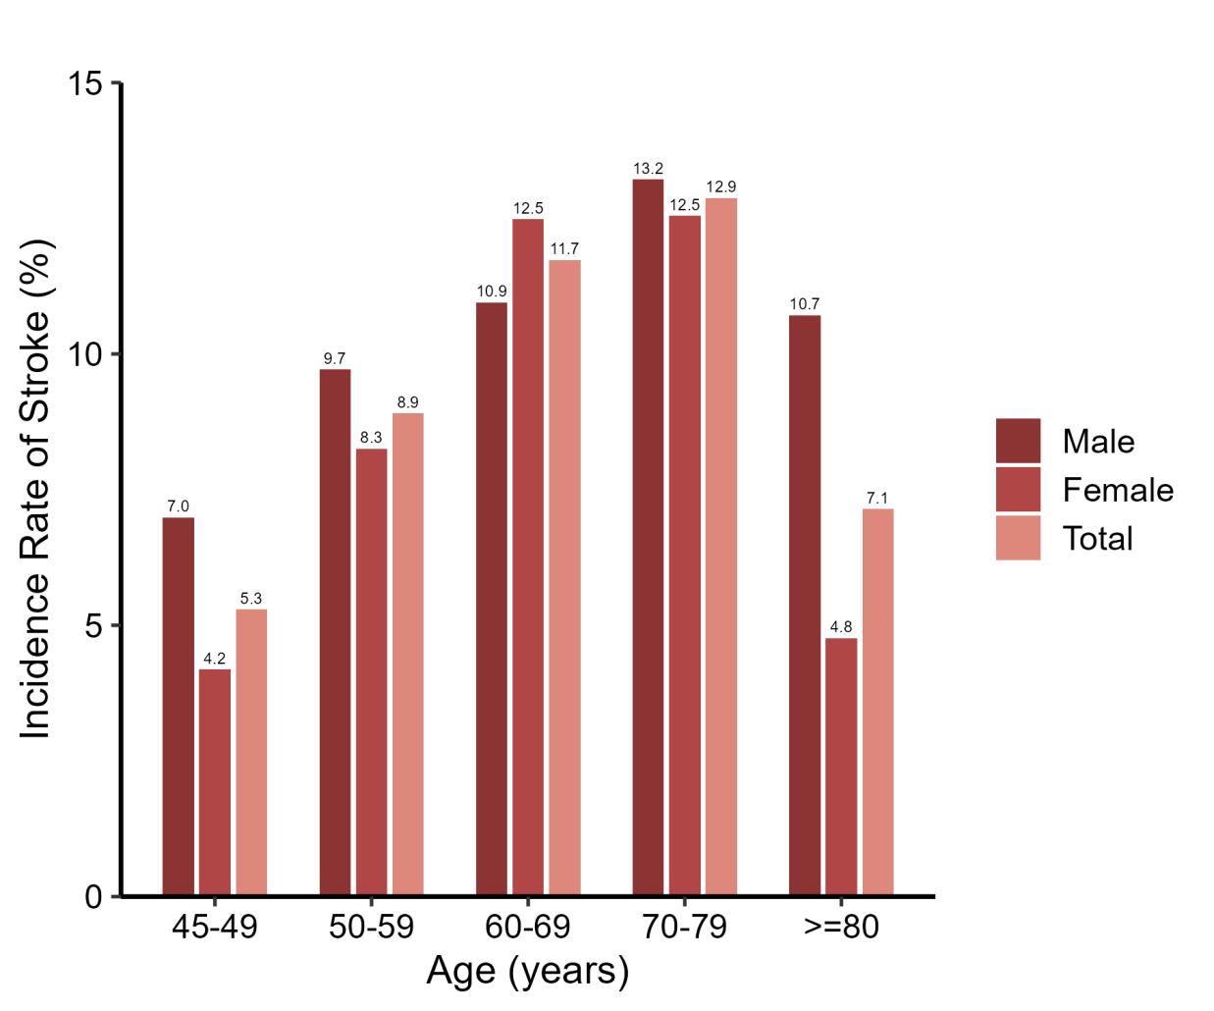
Supplementary Figure. S1 Age- and sex-specific incidence rates of stroke.Bar chart illustrating the incidence rates of stroke (%) across five age groups, stratified by sex. The incidence of stroke generally increased with age in both men and women, peaking in the 70–79 age group. In each age group, male participants exhibited a higher stroke incidence compared to females, with the overall population trends represented in purple.

