Supplementary Materials:
Supplementary Table S1. Search strategy for each database
Database | Search strategy
PubMed/MEDLINE | (("Diabetic Foot"[Mesh] OR "Diabetic Foot Ulcer*" OR "diabetic foot ulcer*" OR DFU OR "diabetic foot infection*" OR DFI)  AND  ("Bacteria"[Mesh] OR bacteria* OR microorganism* OR pathogen* OR microbiology)  AND  ("Drug Resistance, Bacterial"[Mesh] OR "antimicrobial resistance" OR "antibiotic resistance" OR susceptibility OR resistance)  AND  ("Saudi Arabia" OR Kuwait OR Bahrain OR Qatar OR Oman OR "United Arab Emirates" OR GCC))
Web of Science | TS=(  ("diabetic foot" OR "diabetic foot ulcer*" OR DFU OR  "diabetic foot infection*" OR DFI)  AND  (bacteri* OR microorganism* OR pathogen* OR microbiology)  AND  ("antimicrobial resistance" OR "antibiotic resistance"  OR susceptibility OR resistance)  AND  ("Saudi Arabia" OR Kuwait OR Bahrain OR Qatar  OR Oman OR "United Arab Emirates"  OR GCC OR "Gulf Cooperation Council")  )
Embase (via Ovid) | (  exp diabetic foot/  OR diabetic foot ulcer*.mp.  OR diabetic foot infection*.mp.  OR DFU.mp.  OR DFI.mp.  )  AND  (  exp bacteria/  OR bacteri*.mp.  OR microorganism*.mp.  OR pathogen*.mp.  OR microbiology.mp.  )  AND  (  exp drug resistance/  OR antimicrobial resistance.mp.  OR antibiotic resistance.mp.  OR susceptibility.mp.  OR resistance.mp.  )  AND  (  Saudi Arabia.mp.  OR Kuwait.mp.  OR Bahrain.mp.  OR Qatar.mp.  OR Oman.mp.  OR United Arab Emirates.mp.  OR GCC.mp.  OR Gulf Cooperation Council.mp.  )
Google Scholar | "diabetic foot ulcer" bacteria Saudi Arabia Kuwait Oman Bahrain Qatar United Arab Emirates"
N.B.: Searches were limited to studies published between January 2005 and February 2025

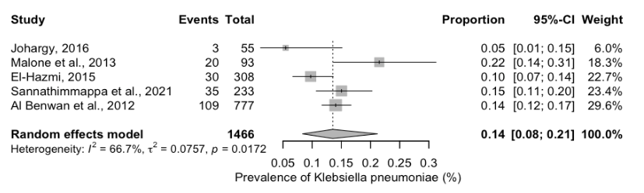
Figure S2a. Forest plot showing the pooled prevalence of Klebsiella pneumoniae isolates from DFU samples.
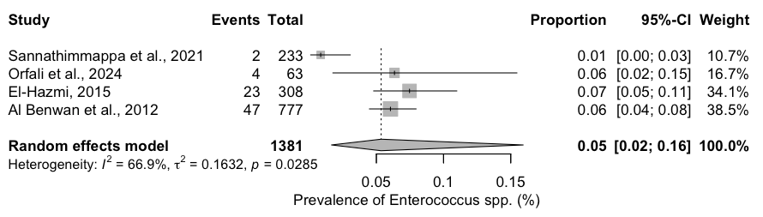
Figure S2b. Forest plot showing the pooled prevalence of Enterococcus spp isolates from DFU samples
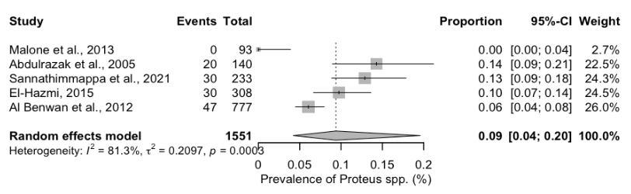
Figure S2c. Forest plot showing the pooled prevalence of Proteus spp isolates from DFU samples

Table S1. The prevalence of bacterila isolates from DFU in GCC
Study no. | Authors, Year | Pathogens Identified
1 | Al Benwan et al., 2012 | Staphylococcus aureus
1 | Al Benwan et al., 2012 | Pseudomonas aeruginosa
1 | Al Benwan et al., 2012 | Anaerobes
1 | Al Benwan et al., 2012 | Proteus mirabilis
1 | Al Benwan et al., 2012 | Enterococcus spp.
1 | Al Benwan et al., 2012 | Escherichia coli
1 | Al Benwan et al., 2012 | Klebsiella pneumoniae
2 | Alhubail, A., et al., 2020 | Enterococcus spp.
2 | Alhubail, A., et al., 2020 | Staphylococcus aureus
2 | Alhubail, A., et al., 2020 | Coagulase-negative S. aureus
2 | Alhubail, A., et al., 2020 | Streptococcus agalactiae
2 | Alhubail, A., et al., 2020 | Pseudomonas aeruginosa
2 | Alhubail, A., et al., 2020 | Klebsiella oxytoca
2 | Alhubail, A., et al., 2020 | Enterobacter species
2 | Alhubail, A., et al., 2020 | Escherichia coli
2 | Alhubail, A., et al., 2020 | Proteus mirabilis
2 | Alhubail, A., et al., 2020 | Candida spp.
3 | Messenger, G., et al., 2018 | Staphylococcus aureus
3 | Messenger, G., et al., 2018 | GNB
4 | Abdulrazak et al., 2005 | Staphylococcus aureus
4 | Abdulrazak et al., 2005 | Pseudomonas aeruginosa
4 | Abdulrazak et al., 2005 | Proteus mirabilis
4 | Abdulrazak et al., 2005 | Candida spp.
5 | Hassan Amir, et al. 2020 | Staphylococcus aureus
5 | Hassan Amir, et al. 2020 | Group B Streptococci
5 | Hassan Amir, et al. 2020 | Enterococcus spp.
5 | Hassan Amir, et al. 2020 | Coagulase-negative S. aureus
5 | Hassan Amir, et al. 2020 | Pseudomonas aeruginosa
5 | Hassan Amir, et al. 2020 | Klebsiella pneumoniae
5 | Hassan Amir, et al. 2020 | Acinetobacter baumannii
5 | Hassan Amir, et al. 2020 | Escherichia coli
5 | Hassan Amir, et al. 2020 | Citrobacter spp.
5 | Hassan Amir, et al. 2020 | Proteus mirabilis
6 | Sannathimmappa, M. B., et al., 2021 | Staphylococcus aureus
6 | Sannathimmappa, M. B., et al., 2021 | Streptococcus agalactiae
6 | Sannathimmappa, M. B., et al., 2021 | Staphylococcus epidermidis
6 | Sannathimmappa, M. B., et al., 2021 | Enterococcus spp.
6 | Sannathimmappa, M. B., et al., 2021 | Pseudomonas aeruginosa
6 | Sannathimmappa, M. B., et al., 2021 | Escherichia coli
6 | Sannathimmappa, M. B., et al., 2021 | Klebsiella pneumoniae
6 | Sannathimmappa, M. B., et al., 2021 | Proteus mirabilis
6 | Sannathimmappa, M. B., et al., 2021 | Enterobacter spp.
6 | Sannathimmappa, M. B., et al., 2021 | Citrobacter spp.
6 | Sannathimmappa, M. B., et al., 2021 | Morganella morganii
6 | Sannathimmappa, M. B., et al., 2021 | Acinetobacter baumannii
7 | Malone, M., et al., 2013 | Staphylococcus aureus
7 | Malone, M., et al., 2013 | Escherichia coli
7 | Malone, M., et al., 2013 | Klebsiella pneumoniae
7 | Malone, M., et al., 2013 | Pseudomonas aeruginosa
8 | Johargy, A. K. , 2016 | Staphylococcus aureus
8 | Johargy, A. K. , 2016 | Escherichia coli
8 | Johargy, A. K. , 2016 | Pseudomonas aeruginosa
9 | Orfali, R., et al., 2024 | Serratia marcescens
9 | Orfali, R., et al., 2024 | Escherichia coli
9 | Orfali, R., et al., 2024 | Proteus mirabilis
9 | Orfali, R., et al., 2024 | Pseudomonas aeruginosa
9 | Orfali, R., et al., 2024 | Staphylococcus aureus
9 | Orfali, R., et al., 2024 | Enterobacter cloacae
9 | Orfali, R., et al., 2024 | Morganella morganii
9 | Orfali, R., et al., 2024 | Alcaligens faecalis
9 | Orfali, R., et al., 2024 | Proteus penneri
9 | Orfali, R., et al., 2024 | Citrobacter spp.
9 | Orfali, R., et al., 2024 | Klebsiella pneumoniae
9 | Orfali, R., et al., 2024 | Klebsiella oxytoca
9 | Orfali, R., et al., 2024 | Sphingomonas paucimobilis
9 | Orfali, R., et al., 2024 | Enterococcus spp.
9 | Orfali, R., et al., 2024 | Staphylococcus warneri
9 | Orfali, R., et al., 2024 | Dermacoccus nishinomiyaensis
9 | Orfali, R., et al., 2024 | Kocuria kristinae
9 | Orfali, R., et al., 2024 | Staphylococcus lentus
10 | Alkhatieb, M. T., et al., 2024 | Staphylococcus aureus
10 | Alkhatieb, M. T., et al., 2024 | Escherichia coli
10 | Alkhatieb, M. T., et al., 2024 | Pseudomonas aeruginosa
10 | Alkhatieb, M. T., et al., 2024 | Candida spp.
11 | El-Hazmi M. M., 2015 | Pseudomonas aeruginosa
11 | El-Hazmi M. M., 2015 | Escherichia coli
11 | El-Hazmi M. M., 2015 | Stenotrophomonas maltophilia
11 | El-Hazmi M. M., 2015 | Staphylococcus aureus
12 | Al-Mijalli, S. H. S. , 2021 | Staphylococcus aureus
12 | Al-Mijalli, S. H. S. , 2021 | Streptococcus Agalactiae
13 | Saleem, M., et al., 2025 | Staphylococcus aureus
13 | Saleem, M., et al., 2025 | Clostridium spp.
13 | Saleem, M., et al., 2025 | Peptostreptococcus
13 | Saleem, M., et al., 2025 | Staphylococcus epidermidis
13 | Saleem, M., et al., 2025 | Enterococcus spp.
13 | Saleem, M., et al., 2025 | Streptococcus agalactiae
13 | Saleem, M., et al., 2025 | Escherichia coli
13 | Saleem, M., et al., 2025 | Klebsiella pneumoniae
13 | Saleem, M., et al., 2025 | Pseudomonas aeruginosa
13 | Saleem, M., et al., 2025 | Proteus mirabilis
13 | Saleem, M., et al., 2025 | Acinetobacter baumannii
13 | Saleem, M., et al., 2025 | Enterobacter cloacae
13 | Saleem, M., et al., 2025 | Prevotella spp.
13 | Saleem, M., et al., 2025 | Bacteroides fragilis
14 | Aldawish, M., & Alayed, M. (2018) | Pseudomonas aeruginosa
14 | Aldawish, M., & Alayed, M. (2018) | Klebsiella oxytoca
14 | Aldawish, M., & Alayed, M. (2018) | Staphylococcus aureus
14 | Aldawish, M., & Alayed, M. (2018) | Streptococcus agalactiae
15 | Aldhfyan, Y., et al., 2018 | Enterococcus spp.
15 | Aldhfyan, Y., et al., 2018 | Staphylococcus aureus
15 | Aldhfyan, Y., et al., 2018 | Acinetobacter baumannii
15 | Aldhfyan, Y., et al., 2018 | Escherichia coli
15 | Aldhfyan, Y., et al., 2018 | Proteus mirabilis
15 | Aldhfyan, Y., et al., 2018 | Klebsiella pneumoniae
16 | Alkhatieb, M., et al., 2022 | Escherichia coli
16 | Alkhatieb, M., et al., 2022 | Staphylococcus aureus
16 | Alkhatieb, M., et al., 2022 | Klebsiella pneumoniae
16 | Alkhatieb, M., et al., 2022 | Streptococcus agalactiae
16 | Alkhatieb, M., et al., 2022 | Pseudomonas aeruginosa
16 | Alkhatieb, M., et al., 2022 | Morganella morganii
16 | Alkhatieb, M., et al., 2022 | Proteus mirabilis

