Supplementary information for

Slot-Die-Printed Sodium-Embedded Alumina Enables High-Performance, Wafer-Scale MoS₂ Electronics

Yonghyun Albert Kwon^{1,†}, Jihyun Kim^{2,†}, Sae Byeok Jo³, Dong Gue Roe,⁴ Dongjoon Rhee², Dae Woo Kim¹, Joohoon Kang^{2,}*, and Jeong Ho Cho^{1,}*

¹Department of Chemical and Biomolecular Engineering, Yonsei University, Seoul 03722, Republic of Korea
²School of Advanced Materials Science and Engineering, Sungkyunkwan University (SKKU), Suwon 16419, Republic of Korea
³School of Chemical Engineering, Sungkyunkwan University (SKKU), Suwon 16419, Republic of Korea
⁴School of Electrical and Electronic Engineering, Yonsei University, Seoul 03722, Republic of Korea

†Yh.A.K. and Ji.K. contributed equally to this work

*Correspondence should be addressed to joohoon@skku.edu (J.K.) and jhcho94@yonsei.ac.kr (J.H.C.)

Supplementary Fig. 1. Precursor solutions and electrochemically exfoliated MoS₂ flakes. (a) Photograph of SEA precursor solution (left) and MoS₂ nanosheet dispersion (right) for slot-die coating. (b) AFM image of MoS₂ nanosheets. (c, d) Histograms showing thickness and lateral size distributions of MoS2 nanosheets.

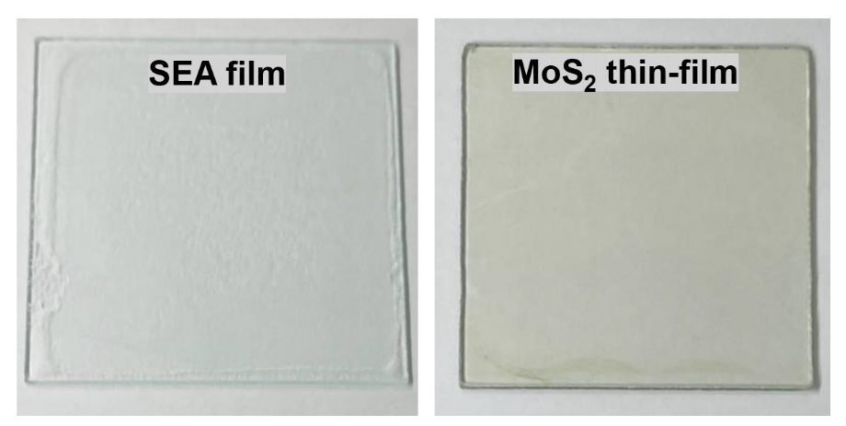
Supplementary Fig. 2. Photograph of as-coated SEA (left) and MoS₂ nanosheet (right) thin-films on transparent glass substrates.

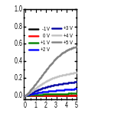
V_{G} =
Drain voltage (V)
Drain current (µA)
Supplementary Fig. 3. Representative output characteristics of the device.

Supplementary Fig. 4. Transfer characteristics of 49 FETs.

Supplementary Fig. 5. Plot comparing the field-effect mobility and processing temperature of large-area MoS₂ FETs. Dielectrics used for each device are described in the legend.

Supplementary Table 1. Summary of fabrication methods and the performance of various large-area MoS₂ FETs.

Method | Temperature  (°C) | Dielectric material | Mobility  (cm² V⁻¹ s⁻¹) | On/off  ratio | Ref
CVD | 550 | Al₂O₃ | 17.5 | 10⁶ | [1]
CVD | 550 | SiO₂ | 30 | 10⁶ | [2]
CVD | 550 | Al₂O₃ | 18.1 | 10⁸ | [3]
CVD | 650 | ZrO₂ | 17 | 10⁶ | [4]
CVD | 930 | Al₂O₃ | 55 | 10¹⁰ | [5]
Precursor  synthesis | 450 | SiO₂ | 14 | 10² | [6]
Precursor  synthesis | 1000 | SiO₂ | 4.7 | 10⁵ | [7]
ALD | 450 | SiO₂ | 13.9 | 10⁸ | [8]
Solution-based processing | 70 | h-BN | 0.15 | 600 | [9]
Solution-based processing | 90 | Ion-gel | 10⁻² | 10⁴ | [10]
Solution-based processing | 200 | Ion-gel | 9.8 | 10⁵ | [11]
Solution-based processing | 250 | SEA | 112 | 10⁵ | This work
Solution-based processing | 300 | SiO₂ | 11 | 10⁶ | [12]
Solution-based processing | 450 | SiO₂ | 0.1 | 10 | [13]

Supplementary Fig. 6. Spatial maps of turn-on voltage (left) and current on/off ratio (right) for 49 devices.

Supplementary Fig. 7. Statistical distribution of electrical characteristics of FETs.

Supplementary Fig. 8. Photograph of MoS₂ inks with different concentrations (left) and corresponding thicknesses of slot-die-coated MoS₂ thin-films (right).

Supplementary Fig. 9. Electrical characteristics of MoS₂ FETs depending on film thickness. (a) Transfer characteristics of MoS₂ FETs formed with different ink concentrations and (b) the extracted electrical properties including conductivity and current on/off ratio as the ink concentration varies.

Supplementary Fig. 10. Electrical characteristics of MoS₂ FETs depending on TFSI doping concentrations. (a) Transfer characteristics and (b) electrical properties of MoS₂ FETs for different TFSI concentrations.

Supplementary Fig. 11. KPFM images of the coated MoS₂ surfaces for different TFSI concentrations and the extracted work functions.

Supplementary Fig. 12. Ramam and PL spectroscopy analysis of the coated MoS₂ surfaces for different TFSI concentrations. (a) Raman and (b) photoluminescence spectra of MoS₂ thin-films for various TFSI concentrations.

Supplementary Fig. 13. XPS analysis of the coated MoS₂ surfaces for different TFSI concentrations. (a) XPS spectra of MoS₂ thin-films treated with TFSI at different concentrations. The data were fitted to deconvolute Mo 3d_{3/2}, Mo 3d_{5/2}, and S 2s peaks. (b) Extracted Mo_{int}/Mo_{def} ratios and S/Mo ratios.

Supplementary Fig. 14. Electrical characteristics of MoS₂ FETs depending on annealing temperature. (a) Transfer characteristics of MoS₂ FETs for different annealing temperatures and (b) the extracted electrical properties.

Supplementary Fig. 15. Effect of annealing temperature on the work function of the MoS₂ thin-film.

Supplementary Fig. 16. Frequency-dependent dielectric properties measured at different temperatures.

Supplementary Fig. 17. Temperature-dependent transfer characteristics of MoS₂ FETs on SEA.

Supplementary Fig. 18. Temperature-dependent transfer characteristics of MoS₂ FETs on alumina dielectrics prepared by ALD (left) and solution processing (right).

Supplementary Fig. 19. Temperature-dependent electrical conductivity plots of MoS₂ FETs on alumina dielectrics prepared by ALD (left) and solution processing (right).

Supplementary Fig. 20. γ (= T₁/T₀) values of MoS₂ FETs on SEA and alumina dielectrics.

Supplementary Fig. 21. KPFM measurement of alumina dielectric. (a) spatial distribution of measured work function. (b) 2D fast Fourier transformed image.

References
1. Park, Y. J. et al. All MoS2-based large area, skin-attachable active-matrix tactile sensor. ACS Nano 13, 3023-3030 (2019).
2. Kang, K. et al. High-mobility three-atom-thick semiconducting films with wafer-scale homogeneity. Nature 520, 656-660 (2015).
3. Choi, M. et al. Flexible active-matrix organic light-emitting diode display enabled by MoS₂ thin-film transistor. Sci. Adv. 4, eaas8721 (2018).
4. Zhao, M. et al. Large-scale chemical assembly of atomically thin transistors and circuits. Nat. Nanotechnol. 11, 954-959 (2016).
5. Li, N. et al. Large-scale flexible and transparent electronics based on monolayer molybdenum disulfide field-effect transistors. Nat. Electron. 3, 711-717 (2020).
6. Lim, Y. R. et al. Wafer‐scale, homogeneous MoS₂ layers on plastic substrates for flexible visible‐light photodetectors. Adv. Mater. 28, 5025-5030 (2016).
7. Liu, K.-K. et al. Growth of large-area and highly crystalline MoS₂ thin layers on insulating substrates. Nano Lett. 12, 1538-1544 (2012).
8. Jeon, W., Cho, Y., Jo, S., Ahn, J. H. & Jeong, S. J. Wafer‐scale synthesis of reliable high‐mobility molybdenum disulfide thin films via inhibitor‐utilizing atomic layer deposition. Adv. Mater. 29, 1703031 (2017).
9. Kelly, A. G. et al. All-printed thin-film transistors from networks of liquid-exfoliated nanosheets. Science 356, 69-73 (2017).
10. Ippolito, S. et al. Covalently interconnected transition metal dichalcogenide networks via defect engineering for high-performance electronic devices. Nat. Nanotechnol. 16, 592-598 (2021).
11. Gao, X. et al. High-mobility patternable MoS₂ percolating nanofilms. Nano Res. 14, 2255-2263 (2021).
12. Lin, Z. Y. et al. Solution-processable 2D semiconductors for high-performance large-area electronics. Nature 562, 254-258 (2018).
13. Li, J., Naiini, M. M., Vaziri, S., Lemme, M. C. & Östling, M. Inkjet printing of MoS₂. Adv. Funct. Mater. 24, 6524-6531 (2014)

