SUPPLEMENTAL MATERIAL
Experimental procedures
Animal Experiments
A colony of the strain B6.Cg-Tg(SOD1*G93A)1Gur/J JAX catalogue stock number 004435; from now on hSOD1G93A or G93A) was purchased at The Jackson Laboratories (Bar Harbor, MN, USA). Mice were maintained in C57BL/6J background. Genotyping was performed following manufacturer’s instructions. After genotyping and weaning, animals were placed at 12:12 hours dark / light cycle, at 22±2°C temperature, 50%±10 relative humidity, in individual cages (at 21 days). Navitoclax (T2101, Targetmol) was diluted in 60% Phosal 50 PG (Lipoid), 30% PEG400 (Sigma, 91893) 10% EtOH. Navitoclax was administered by oral gavage at a dose of 50 mg kg–1 body during five consecutive days followed by 16 days of rest (N= 5 per group). Treatment cycles were repeated until clinical endpoint (righting reflex >20 s). Spinal cords and sciatic nerves were rapidly excised, frozen in liquid N₂ and stored at -80 ̊C. This study was approved by the Animal Research and Ethics Committee at the University of Lleida.
Cell culture
3T3 cells were maintained in Dulbecco’s Modified Eagle’s Medium (11965, Thermo Fisher Scientific), 10% FBS (10270, Thermo Fisher Scientific), 100 U/ml Penicillin-Streptomycin (15140-122, Thermo Fisher Scientific) at 37℃ and 5% CO2. For silencing, 20 nM (final concentration) of TARDBP siRNA mmsiTDP-43s: 5′-AGGAAUCAGCGUGCAUAUA-3′ mmsiTDP-43as: 5′-UAUAUGCACGCUGAUUCCU-3′ (siTDP) or scrambled siRNA (siCTL) was mixed in 100 µl Opti-MEM (31985062, Thermo Fisher Scientific) with 2 µl of RNAiMAX (13778100, Thermo Fisher Scientific) on the bottom of the well and incubated for 20 minutes at room temperature. 2 ml of DMEM (11965092, Thermo Fisher Scientific) supplemented with 10% FBS containing 100000 HeLa or 3T3 cells/well were seeded onto transfection mix. After 24 hours, transfection media was removed and changed to DMEM 10% FBS media. 48 hours post-transfection, cells were collected for posterior analyses.

Western Blot
Protein from platelets was extracted adding 100 µL of radioimmunoprecipitation (RIPA) buffer with Protease Inhibitor Cocktail (1X) to the pellet. After sonication, protein quantification was performed with Bradford assay (5000006, Bio-Rad). Fifteen μg of protein were loaded onto a 12% acrylamide SDS-PAGE gel. Membranes were blocked with I-Block (T2015, Thermo Fisher Scientific) for 1 hour and incubated overnight with primary incubated anti-TDP-43 (10782–2-AP, Proteintech) 1:1000 in TBS-T 0.05%. After primary antibody incubation, membranes were washed 3 times with TBS-T 0.05% and incubated with secondary antibody for 1h. Immobilon™ Western Chemiluminiscent HRP Substrate (WBKLS0500, Merck Millipore) was used for immunodetection. Membranes were stained with Coomassie Brilliant Blue G (27815, Sigma) for normalization. Specific bands were quantified with ImageLab v5.2.1 (Bio-Rad).

RNA extraction, cDNA synthesis and RT-qPCR
1 ml of TRIzol reagent (Thermo Fisher Scientific, AM9738) was added to 50-100 mg of tissue. The tissue was then mechanically homogenized using T 10 basic ULTRA-TURRAX® (IKA). 200 µl of chloroform was added to each sample and mixed. After 5 minutes of incubation at room temperature, the samples were centrifuged at 12,000 xg (15 mins, 4°C) to separate the phases. The aqueous phase was separated into a new tub and mixed by vortexing with 500 µl of isopropanol. After an incubation of 10 minutes at room temperature, RNA was precipitated through spun at 12,000 xg (10 mins, 4°C). The resulting supernatant was removed, and the pellet was washed with a 75% ethanol. After vortexing, the samples were centrifuged again at 12,000 xg (10 mins, 4°C). The supernatant was discarded, and the RNA pellet was allowed to air dry at room temperature. The RNA was resuspended with 50 µl of RNAse-free water, quantified with Nanodrop (Nanodrop technologies, ND-1000 UV/Vis Spectofotometer) and stored at -80°C until further use. One microgram of RNA was used for retrotranscription employing TaqMan Reverse Transcription Reagent using random hexamers (Thermo Scientific, N8080234). RT-qPCR experimets were performed using a CFX96 instrument (Bio-Rad, Hercules, California, USA) with SYBR select Master mix (Thermo Fisher Scientific, 4472908). Each 20 µL of reaction contained 4µL cDNA, 10 µL SYBR Select Master Mix, 0.2 nM of forward primer and 0.2 nM of reverse primer solutions and 4 µL PCR grade water. RT-qPCR run protocol was as follows: 50 °C for 2 minutes and 95 °C for 2 minutes, with the 95 °C for 15 seconds and 60 °C for 1 minute steps repeated for 40 cycles; and a melting curve test from 65°C to 95 °C at a 0.1 °C/s measuring rate. N=3-10 mice per group were used for RT-PCR experiments. Primers employed in these experiments are listed in Supplementary Table S1. Actb expression was used as housekeeping to normalize the other genes. Specific Adipor2 cryptic mRNA (primers annealed with cryptic exon) was normalized with Adipor2 normal transcript (the primers annealed with conserved exons).
Senescence-associated β-galactosidase activity
Briefly, paraformaldehyde-fixed frozen sections were incubated with X-gal solution (20 mg/ml X-Gal (SIGMA), 5 mM K₃Fe(CN)₆, 5 mM K₄Fe(CN)6 and 2 mM MgCl₂) in PBS at pH 6.0 overnight at 37 °C. To allow comparison between specimens, all samples were assayed simultaneously. Then, neurons were stained with Green Fluorescent Nissl Stain (Thermo Fisher Scientific, N21480) diluted 1:150 in PBS and incubated 20 minutes at room temperature. The slices were then washed 3x with PBS for 10 minutes at room temperature and 1x with PBS for 2 hours at room temperature. Nuclei were stained with DAPI (SIGMA, 32670). Images of the stained sections were taken using inverted microscope (Olympus, IX71S8F-2). Eight randomly selected areas of each mouse (N=2-3 per group) of the ventral horn of lumbar spinal cord sections were photographed at 20x magnification for visual analysis. The whole section of SA-β-Gal stained slices was photographed at 4x magnification.
Immunofluorescence
One control and one transgenic lumbar spinal cord were fixed in 4% paraformaldehyde made in PBS overnight at 4°C and cryopreserved in 30% sucrose in PBS 48 hours. The lumbar spinal cord was then cut at a 16 µm section depth and resulting seeded on a gelatin-coated slide. Samples were permeabilized with 0.3% Triton X-100 PBS for 30 min and blocked with 5% BSA in PBS for 1h at room temperature. The primary antibody 1:100 anti-p16 (abcam, ab54210) and 1:200 anti-GFAP (abcam, ab7260) were diluted in 0.3% Triton X-100 PBS and incubated overnight at 4°C. The slices were washed with PBS three times for 5 min at room temperature, followed by the secondary antibody (diluted 1:800 in PBS), goat anti-mouse Alexa Fluor 555 (Thermo Fisher Scientific, A21422) and goat anti-rabbit Alexa Fluor 488 (Thermo Fisher Scientific, A11008) incubation for 1h at room temperature in darkness. Sections were finally counterstained with 1 µg/ml 4,6-diamidino-2-phenylindole dihydrochloride (DAPI) in PBS for 10 min at RT and mounted on slides with Fluoromount-G® (Southern Biotech, 0100). Samples were imaged using a laser scanning confocal microscope Olympus FluoView FV10.
Immunohistochemistry
One control and one transgenic paraformaldehyd fixed paraffin embedded tissue slides were dried for 1h at 65º before pre-treatment procedure of deparaffinization, rehydration and epitope retrieval in the Pre-Treatment Module (Agilent Technologies-DAKO, PT-LINK) at 95°C for 20 min in 50x Tris/EDTA buffer, pH 9. For p21 immunohistochemical staining, p21WAF1/Cip1 antibody (Agilent Technologies-DAKO, clone SX118) 1:100 dilution was used. After incubation, the reaction was visualized with the EnVisionTM FLEX Detection Kit (Agilent Technologies-DAKO) using diaminobenzidine chromogen as a substrate. For p16 immunohistochemical staining, p16 INK4a antibody was used using CINtec® Histology Kit (ROCHE, clone E6H4) following manufacturer’s instructions. Sections were counterstained with hematoxylin.
Statistical Analysis
All statistical tests and graphs were performed using GraphPad Prism 6 (GraphPad Software). Normalized mRNA expression was analyzed with ordinary Two-way ANOVA test of the variables time and genotype. For multiple comparisons between genotypes, Bonferroni’s multiple comparisons test was used. In SA-beta-gal activity experiments, p‐value was determined by Chi-square’s test. To evaluate relationship between p16 and Adipor2 cryptic mRNA levels a linear regression was tested.

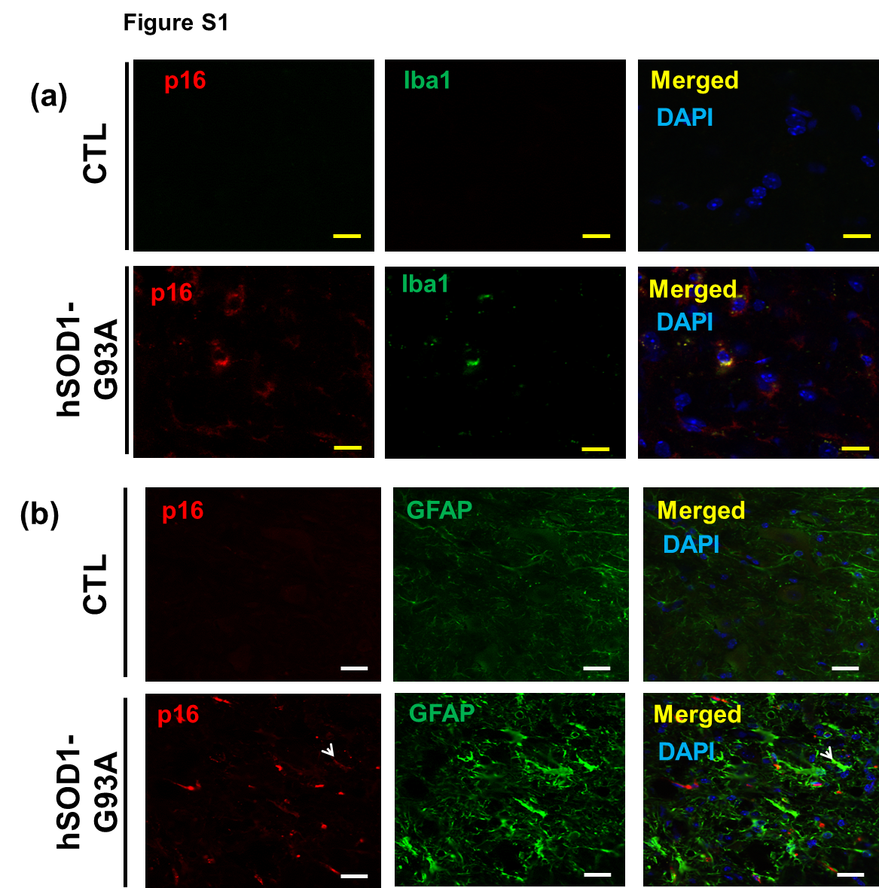
Figure S1. Cytoplasmic p16+ microglia (Iba1+) (a) and astrocytes (GFAP+) (b) are present in lumbar spinal cord of transgenic mice and absent in controls. Scale bar represents 500 µm. Representative images from independent experiments (n= 10 slices from at least 3 different animals from each genotype and age) are shown.

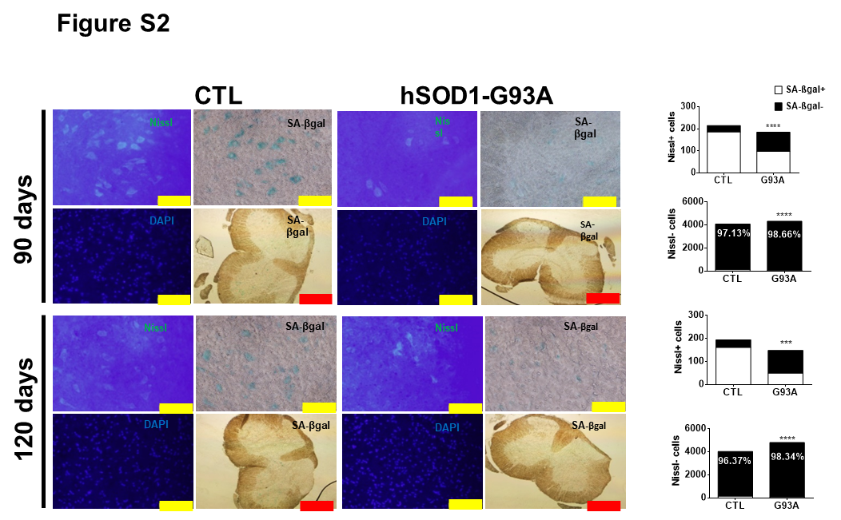
Figure S2. SA-beta-gal activity was decreased in 90- and 120-day-old hSOD1-G93A mice. Nissl+ cells are the main contributors of this activity, which is lower in ALS mice. In contrast, Nissl- cells exhibited a slight decrease in transgenic mice. ***p < 0.001; ****p < 0.0001. Yellow scale bar represents 500 µm and red scale bar represents 2500 µm.

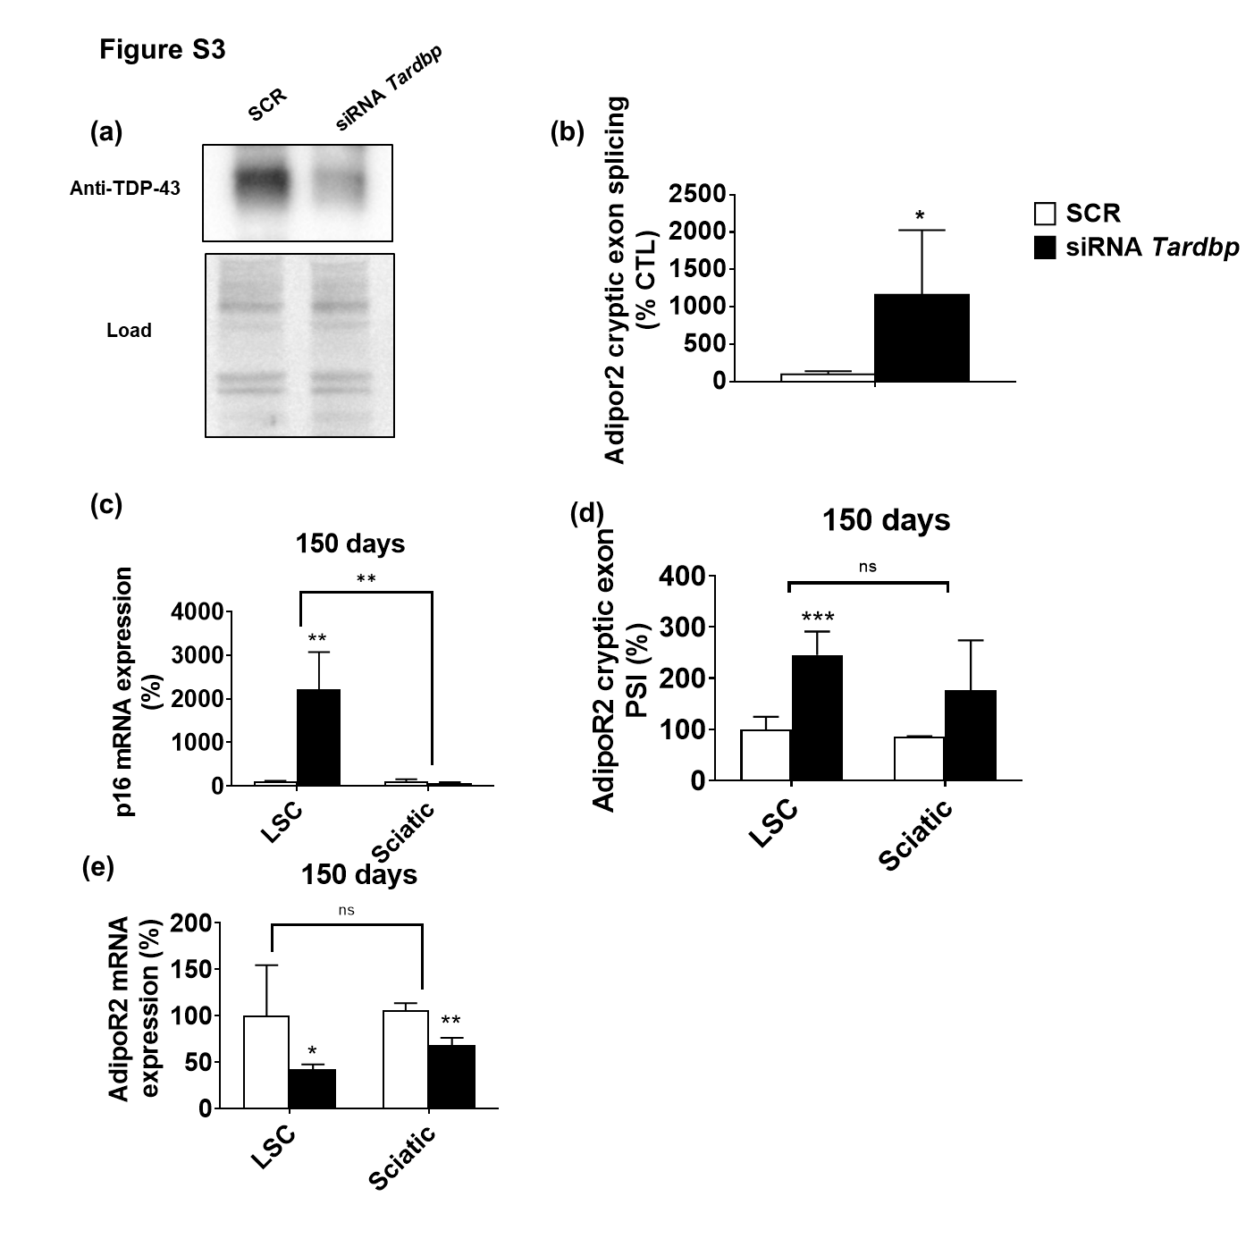
Figure S3. Adipor2 cryptic exon splicing is increased in Tardbp silenced murine cells. RT-qPCR of Adipor2 cryptic exon showed a high increase (a) and Western Blot analyses of TDP-43 confirmed the reduction of this protein in silenced 3T3 cells (b). *p < 0.05. Shown are data representative from 3 independent experiments. SASP markers and TDP-43 dysfunction are increased in LSC, but not sciatic nerve, from transgenic hSOD-G93A mice. Despite lack of increased p16 expression in sciatic nerve (c), similarly to LSC, cryptic exon in Adipor2 mRNA was more incorporated in sciatic nerves from 150-day-old transgenic mice (d), in association with diminished total Adipor2 mRNA in both locations (e). Il6, Adipor2, and cryptic Adipor2 expression are expressed as mean ±SEM. ns p > 0.05; *p < 0.05; ***p < 0.001; n=4 from each genotype and age.
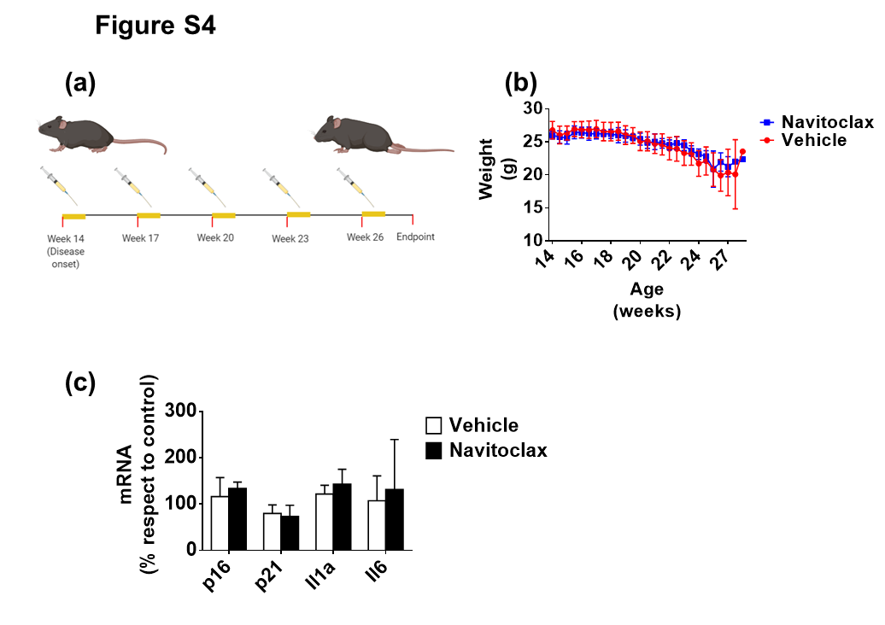
Figure S4. Senolytic treatment using Navitoclax does not slow the disease progression. A chronic treatment was established with five consecutive doses followed by two weeks of resting (a). Weight loss was not different between Navitoclax and vehicle experimental groups (b) as senescence and SASP genes (c). n=5 from each genotype.

Table 1. SYBR Green probes used in RT-qPCR analysis.

Table 1.
Gene | Sequence
Actb Fwd | GTGACGTTGACATCCGTAAAGA
Actb Rev | GCCGGACTCATCGTACTCC
p16 Fwd | CCCAACGCCCCGAACT
p16 Rev | GCAGAAGAGCTGCTACGTGAA
Il1a Fwd | AGCGCTCAAGGAGAAGACC
Il1a Rev | CCAGAAGAAAATGAGGTCGG
Il6 Fwd | ACCAGAGGAAATTTTCAATAGGC
Il6 Rev | TGATGCACTTGCAGAAAACA
Ifna Fwd | ATGGCTAGGCTCAGCACTTTC
Ifna Rev | CTCACTCAGACTTGCCAGCA
Ifnb Fwd | AGCTCCAAGAAAGGACGAACA
Ifnb Rev | GCCCTGTAGGTGAGGTTGAT
Adipor2 Fwd | TGTTTGTAAGGTGTGGGAAGG
Adipor2 Rev | GTTGCCCGTCTCTGTGTGTAT
Adipor2 cryptic Fwd | AGAAGTGGAGTTACAATTGTG
Adipor2 cryptic Rev | AAACAAACTCTTCCATTCGTT
p21 Fwd | TTGCCAGCAGAATAAAAGGTG
p21 Rev | TTTGCTCCTGTGCGGAAC

