Supplementary

Machine learning-assisted construction of CDs@Fe-SA nanozymes colorimetric paper-based sensing of acrolein in baked food

Guo-Qi Zhang¹, Hui-Ting Hu¹, Shi-jun Tang³, Wen-Cai Jiang¹, Lei Jia¹, Si-Yu Yang¹, Xiao-Mei Li¹, Zhi-Bo Hou^{2*}, Yan Zhao^{1*}
1: Department of Chemisty, School of Science, Xihua University, Chengdu 610039, China
2: Department of Mathematics, School of Science, Xihua University, Chengdu 610039, China
3: Sichuan Engineering Research Center for lntelligent Control and Simulation Testing Technology of New EnergyVehicles, Xihua University, Chengdu 610039, China

*Corresponding author: Zhi-Bo Hou, Yan Zhao
Phone: +8618382270862
Full postal address: No. 999 Hongguang Road, PiDu District, Chengdu, China
E-mail: houzhibo@mail.xhu.edu.cn; yanzhao@mail.xhu.edu.cn;

Fig. S1 The BET test results of Fe-SA.

Fig. S2 Double reciprocal plots of CDs (A), Fe-SA(B), CDs@Fe-SA(C) with respect to H₂O₂; Double reciprocal plots of CDs (D), Fe-SA (E), CDs@Fe-SA (F) with respect to TMB.

Fig. S3 (A) pH of the buffer solution during incubation; (B) Incubation time; (C) Incubation temperature; (D) Reaction time; (E) Reaction temperature; (F) NAC concentration; (G)CDs concentration; (H)Fe-SA concentration

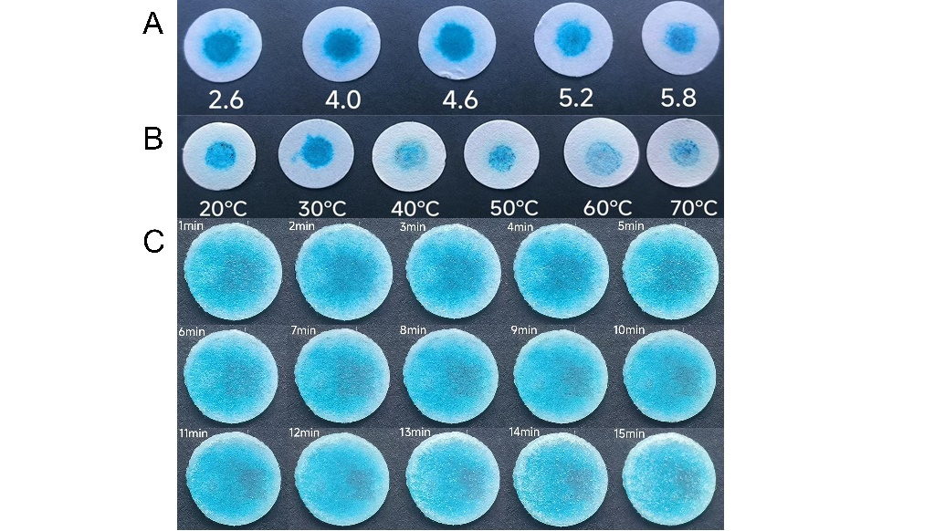
Fig. S4 (A) pH of buffer solution; (B) Reaction temperature; (C) Reaction time

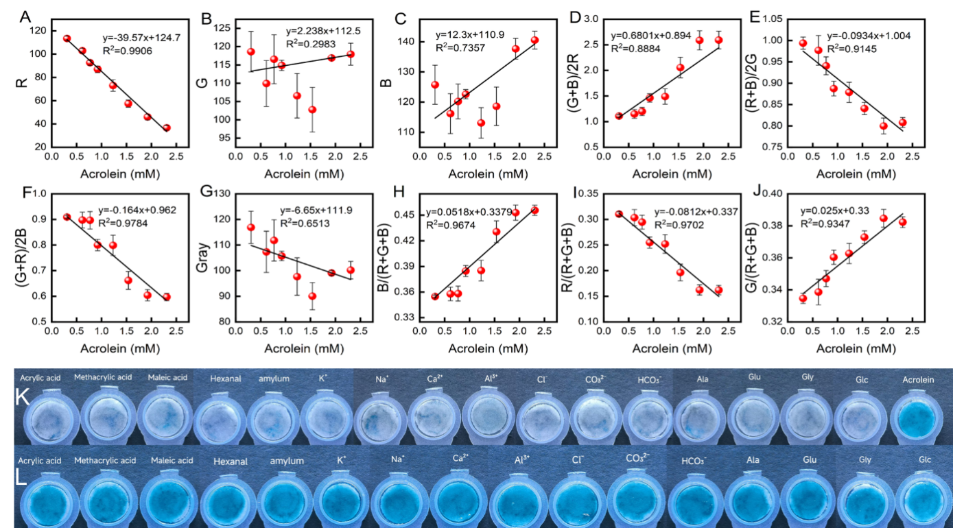
.
Fig. S5 Selection experiment (K) and interference experiment (L) of acrolein.

Table. S1 Comparison of BET data for CDs@Fe-SA and Fe-SA.
Materials | CDs@Fe-SA | Fe-SA
S_{BET} (m²·g⁻¹) | 705.7 | 904.8
Total pore volume (cm³·g⁻¹) | 0.639 | 0.803
Average pore diameter (nm) | 3.622 | 3.548
Pore diameter (nm) | 3.07-108.5 | 3.06-143.8

Table. S2 Comparison of kinetic parameters of CDs, Fe-SA, and CDs@Fe-SA.
Catalyst | Substance | K_{m} (mM) | V_{max} $×$10⁻⁸ (M·s⁻¹)
CDs | H₂O₂ | 1.209 | 412
CDs | TMB | 1.37 | 484
Fe-SA | H₂O₂ | 0.72 | 512
Fe-SA | TMB | 1.11 | 518
CDs@Fe-SA | H₂O₂ | 0.522 | 608
CDs@Fe-SA | TMB | 0.892 | 531

Table. S3 Detection of acrolein in real samples by microplate reader and recovery method (n=3)
Sample | Spiked (mM) | Found (mM) | Recovery (%) | RSD (%)
French fries | 0.0 | 0.120 | - | -
French fries | 0.2 | 0.215 | 101.5 | 0.71
French fries | 0.4 | 0.401 | 97.25 | 0.38
French fries | 0.8 | 0.814 | 100.3 | 0.56
Biscuit | 0.0 | 0.085 | - | -
Biscuit | 0.2 | 0.199 | 97.00 | 1.54
Biscuit | 0.4 | 0.409 | 101.0 | 0.37
Biscuit | 0.8 | 0.801 | 99.50 | 0.95
Bread | 0.0 | 0.360 | - | -
Bread | 0.2 | 0.215 | 99.50 | 2.13
Bread | 0.4 | 0.421 | 101.3 | 0.36
Bread | 0.8 | 0.806 | 98.75 | 0.57

Table. S4 Detection of acrolein in real samples by paper-based spiked recovery method (n=3)
Sample | Spiked (mM) | Found (mM) | Recovery (%) | RSD (%)
French fries | 0.0 | 0.103 | - | -
French fries | 0.8 | 1.030 | 115.9 | 3.67
French fries | 1.2 | 1.387 | 107.0 | 3.82
French fries | 1.6 | 1.942 | 115.0 | 3.85
Biscuit | 0.0 | 0.095 | - | -
Biscuit | 0.8 | 0.971 | 109.5 | 2.73
Biscuit | 1.2 | 1.368 | 106.1 | 4.06
Biscuit | 1.6 | 1.747 | 103.3 | 1.24
Bread | 0.0 | 0.350 | - | -
Bread | 0.8 | 0.876 | 105.1 | 1.60
Bread | 1.2 | 1.283 | 104.0 | 4.08
Bread | 1.6 | 1.853 | 113.6 | 4.67

